Appendix: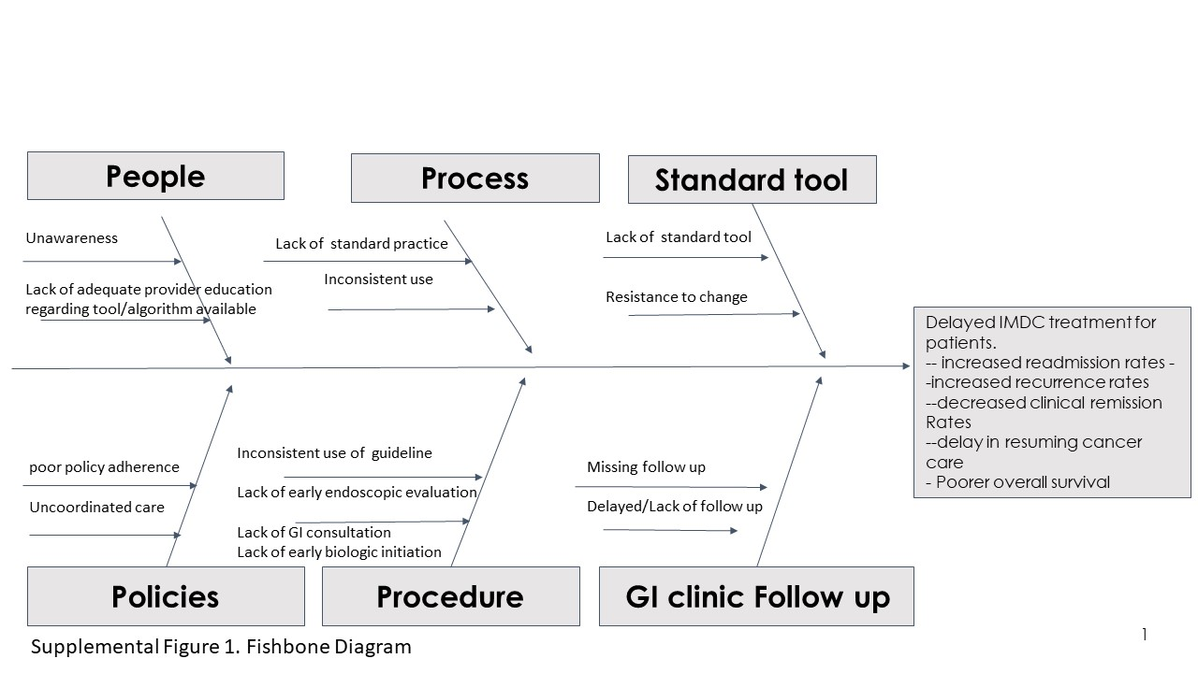
Supplemental Figure 1: Fishbone diagram of cause and effect of the quality improvement process which identifies current problems contributing to delayed IMDC treatment and resulting in unfavorable patient outcomes.
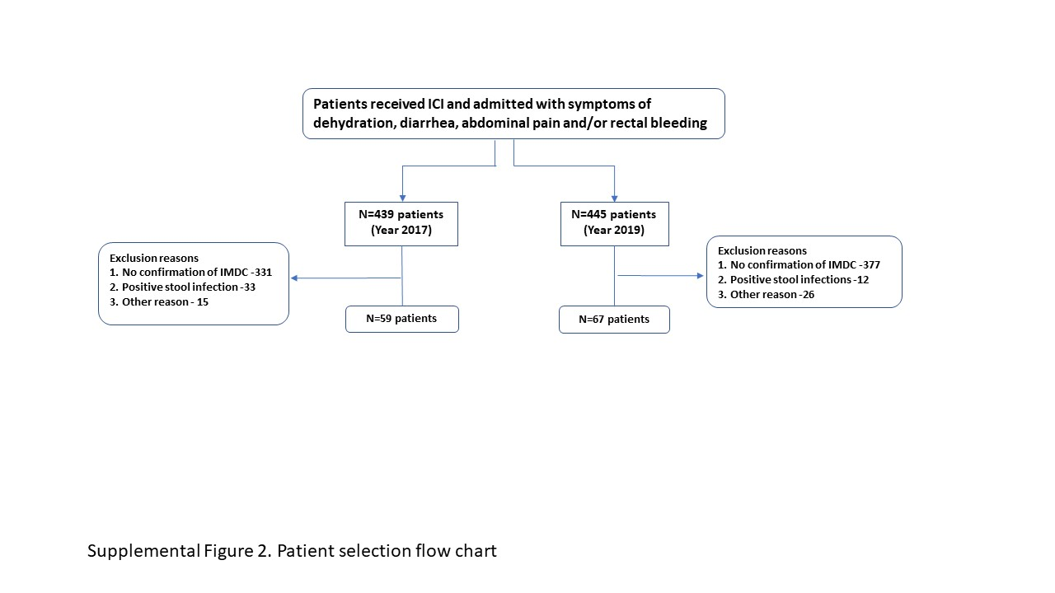
Supplemental Figure 2: Patient selection flow chart of patients admitted with IMDC symptoms and included in the study after confirming presence of grade ≥2 IMDC per CTCAE guidelines.

