Supporting information

Highly porous uniformly sized amidoxime-functionalized cellulose droplets prepared by a microfluidic method with monohydrate N-methylmorpholine N-oxide and their metal filter applications
Seung-Yeop Baek and Soo-Young Park
School of Applied Chemical Engineering, Polymeric Nano Materials Laboratory, Kyungpook National University, Daegu 41566, Republic of Korea. E-mail: psy@knu.ac.kr

Text S1. First, water containing the cellulose beads was replaced with ethanol and acetone by a pipette, sequentially. A cylindrical sample holder (diameter 20 mm, height 20 mm) to contain cellulose beads and surrounding steel mesh walls through which to drain the acetone was prepared. The bottom part (0.5 cm high) contained the beads, and the upper part with surrounding steel mesh walls (#500) drained the acetone and to mix with the outside liquid CO₂. The sample holder was filled with the cellulose beads (0.1 g, undried) in acetone (2 mL), sealed with a steel mesh cap, positioned at the bottom of the sample chamber in the CPD container. Dry ice (330 g), which had been crushed into small pieces before, was then filled into the CPD sample chamber containing the sample holder. The top layer was closed, and the dry ice completely melted into liquid CO₂. The CPD container was shaken for 30 min to mix the acetone and liquid CO₂ through the steel mesh. The temperature and pressure in the CPD container were controlled to maintain 35°C and 70 atm for 30 min by heating the water bath slowly (1°C min⁻¹). The generated gas was vented, and the sample was removed from the CPD container.

Table S1. N, C, H, and O contents (wt%) of cellulose, CN-cellulose, and O-cellulose beads from EA analysis
Atom | Cellulose | CN-Cellulose | O-Cellulose
N | 0 | 4.31 | 10.05
C | 42.37 | 46.39 | 43.86
H | 6.21 | 6.06 | 6.18
O | 51.42 | 43.24 | 39.91

Table S2. Kinetics parameters (k and q_{e}) and r² values of the pseudo-first- and second-order equations for adsorption of Cu²⁺/phthalate complex on O-cellulose beads, which were calculated from curve-fitting with the modified first- and second-order equations of (4) and (6), respectively
Initial conc.  (ppm) | First order |  |  | Second order
Initial conc.  (ppm) | $$k_{1}$$  (min⁻¹) | $$q_{e1}$$  (mgꞏg⁻¹) | $$r^{2}$$ | $k_{2}×$10⁻³  (gꞏmg⁻¹ꞏmin⁻¹) | $$q_{e2}$$  (mgꞏg⁻¹) | $$h$$  (mgꞏg⁻¹ꞏmin⁻¹) | $$r^{2}$$
47.4 | 0.0019 | 21.0094 | 0.9500 | 0.1171 | 28.7356 | 0.0966 | 0.9948
80.5 | 0.0020 | 35.2815 | 0.9783 | 0.0657 | 41.4938 | 0.1131 | 0.9996
167.4 | 0.0027 | 42.3281 | 0.9835 | 0.0915 | 51.3347 | 0.2411 | 0.9998
261.9 | 0.0034 | 42.4981 | 0.9802 | 0.1280 | 53.5906 | 0.3677 | 0.9998
358.7 | 0.0034 | 45.9402 | 0.9674 | 0.1191 | 61.0874 | 0.4446 | 0.9998
461.5 | 0.0039 | 50.2847 | 0.9712 | 0.1205 | 68.4932 | 0.5654 | 0.9998
729.0 | 0.0041 | 51.1632 | 0.9660 | 0.1348 | 70.4722 | 0.6696 | 0.9997
1010.3 | 0.0049 | 50.6678 | 0.9526 | 0.1692 | 81.3008 | 1.1186 | 0.9992

Table S3. Isotherm parameters of Langmuir and Freundlich models for adsorption of Cu²⁺/phthalate complex on O-cellulose beads obtained by curve-fitting of the isotherm curve using equations (7) and (9) for Langmuir and Freundlich models, respectively; —means not applicable
 | Langmuir | Freundlich
q_{m} (mg·g⁻¹) | 82.3 | —
K (L·mg⁻¹) | 0.013 | 0.015
r² | 0.99 | 0.95
n⁻¹ | — | 0.25

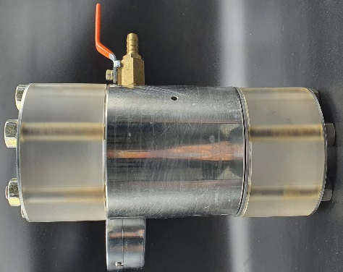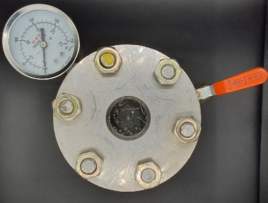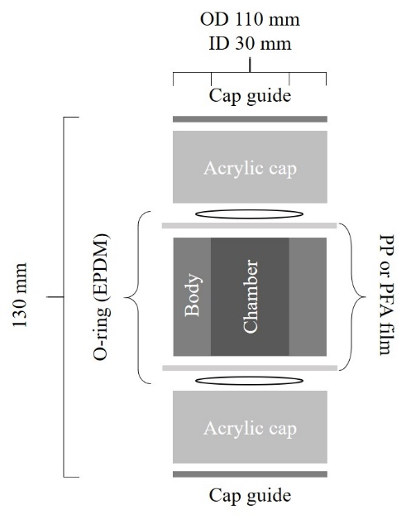

Fig. S1. (a) Side and (b) top views of the CPD container with (c) its schematic design.

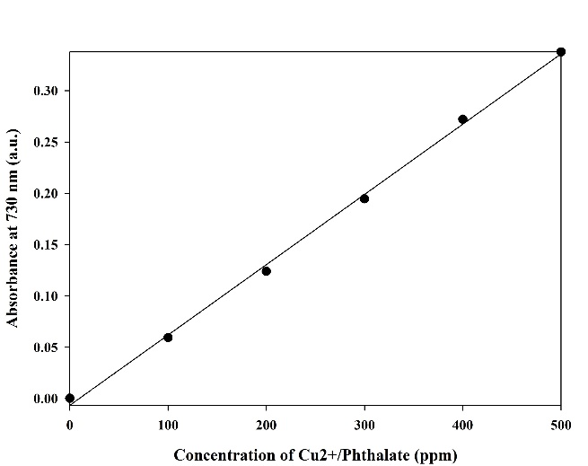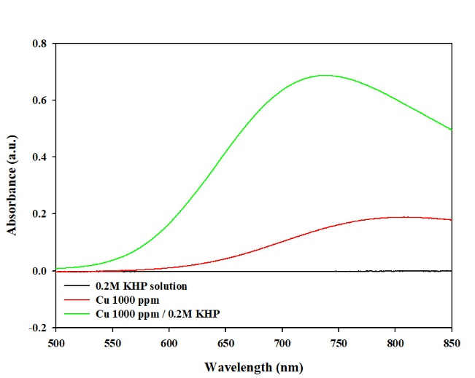
(a)
(b)
Fig. S2. (a) UV-vis spectra of the Cu(NO₃)₂ (1000 ppm), KHP (0.2 M), and Cu²⁺/phthalate complex aqueous solutions (1000 ppm/0.2 M) and (b) the calibration curve (730 nm) at different concentrations. The Cu²⁺/phthalate complex aqueous solution was prepared by dissolving Cu(NO₃)₂ (controlled) and KHP (4.08 g, 0.2 M, excess) in water (100 mL).

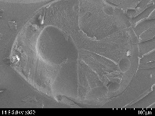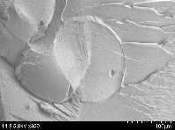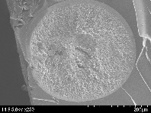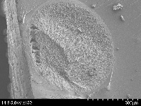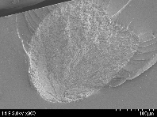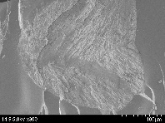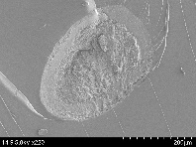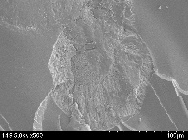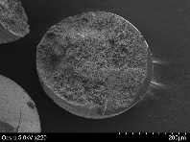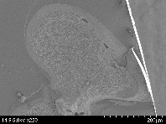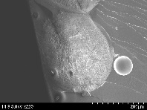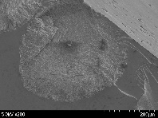
(i)
(ii)
(iii)
(iv)
(v)
(vi)
(a)
(b)
Fig. S3. SEM images of the cellulose beads prepared from the (a) S and (b) M cell/NMMO droplets prepared at T_{coa} = (i) 10°C, (ii) 20°C, (iii) 30°C, (iv) 40°C, (v) 50°C, and (vi) 60°C.

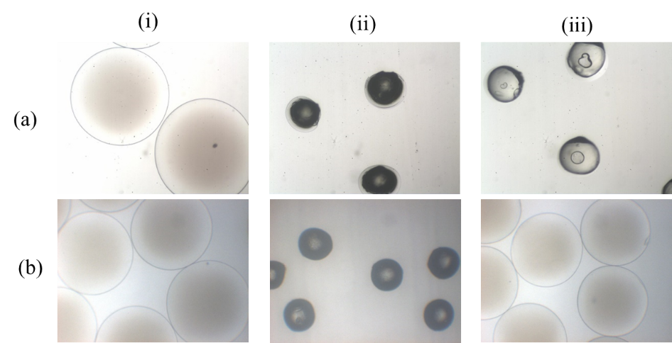
Fig. S4. Optical microscopy images of cellulose (M-M) beads prepared at a 4 wt% cellulose concentration in the dope (a) without and (b) with crosslinking (i) before (in water) and (ii) after drying (at 25°C for 2 h by a vacuum oven), and (iii) after reswelling of the dried cellulose beads.

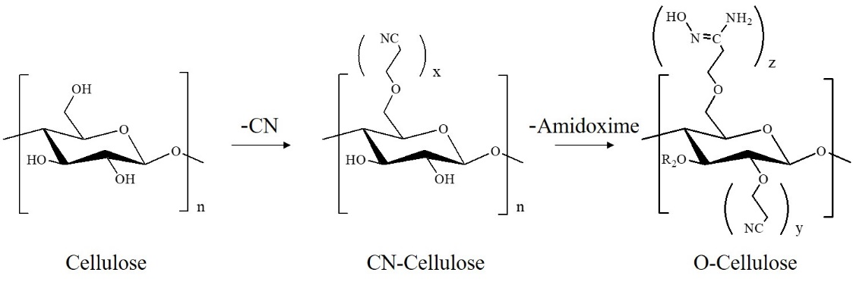
Scheme S1. Scheme of the amidoxime functionalization for calculating the degree of conversion from –OH to –CN groups (x) for CN-cellulose beads and from –CN to oxime groups (z) for O-cellulose beads, where x represents the number of –CN groups converted among three –OH groups, z represents the number of the converted –CN groups to the amidoxime groups, and y exhibits the number of unconverted –CN groups so that $x=z+y$.

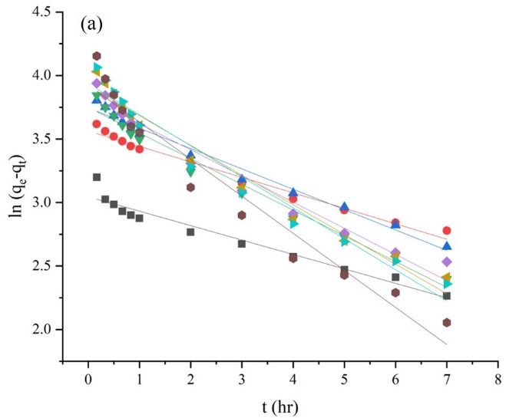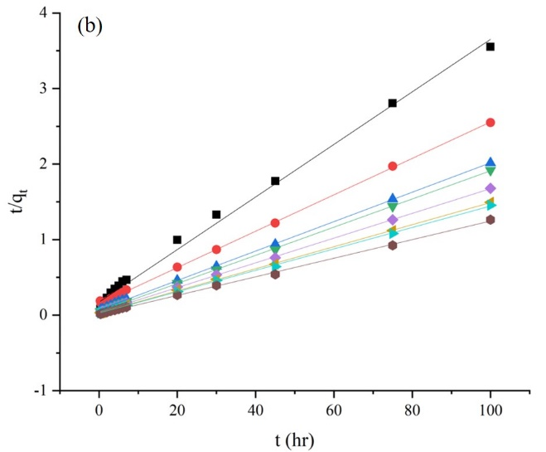
Fig. S5. Linear kinetics plots of the pseudo (a) first and (b) second-order models using data in Figure 9(a) and (b), respectively.

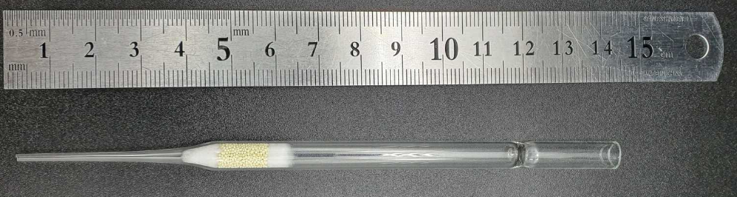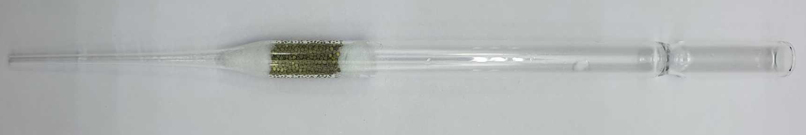
(a)
(b)
1 cm
Fig. S6. Photographic image of the column filled with the O-cellulose beads (70 mg) (a) before and (b) after passing the Cu²⁺/phthalate complex aqueous solution (initial concentration, 500 ppm).

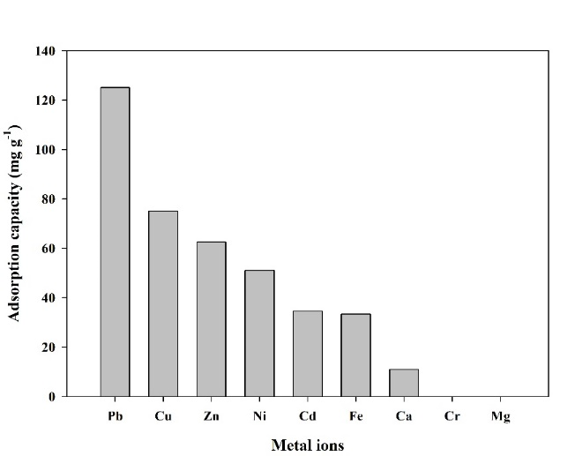
Fig. S7. Adsorption capacity of the Pb²⁺, Cu²⁺, Zn²⁺, Ni²⁺, Cd²⁺, Fe³⁺, Ca²⁺, Cr³⁺, and Mg²⁺ ions 24 h after the O-cellulose beads (70 mg) was inserted into the 1000 ppm aqueous metal-ion solutions. The metal-ion concentrations were measured by ICP.

