Supplementary Materials for

Future climate change will decrease the carbon stock in three-quarters of global protected areas

This PDF file includes:

Materials and Methods
Figs. S1 to S11
Tables S1 to S7
References

Materials and Methods

The Lund-Potsdam-Jena Dynamic Global Vegetation Model (LPJ-DGVM) was developed by Lund University, Postdam Center for Climate Impact Research, and Jena Max-Planck Institute of Biogeography. Based on Biome3 model, LPJ-DGVM divides vegetation functional types (PFT) into 10 categories, mainly considering the processes of vegetation photosynthesis, respiration, decomposition of litter, vegetation growth and death, and introduces the interference mechanism of fire ¹. LPJ-DGVM simulates the carbon cycle between plants, atmosphere and soil, simulates the hydrological cycle and vegetation productivity in a more realistic way, and has also been widely used to simulate evapotranspiration and carbon flux in different regions of the world ². The carbon cycle in LPJ model mainly includes photosynthesis, autotrophic respiration and heterotrophic respiration (http://www.pik-potsdam.de/~bloh/lpjml/).
（1）Photosynthesis
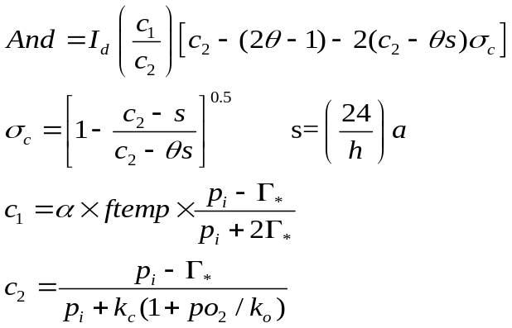 （1）
In which,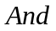 is the daylight contract rate, 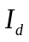represents effective radiation absorbed by photosynthesis，𝜃- is the synergistic control factor of light energy and Rubisco enzyme, h represents the length of a day, 𝛼 is the intrinsic quantum efficiency of CO₂ absorption, 𝛤∗- represents the compensation point of CO₂, 𝑝_{𝑖} is the intercellular CO₂ bias, 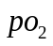 is the O₂ bias of the environment, 𝑓𝑡𝑒𝑚𝑝- is the temperature control factor, 𝑎, 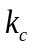, 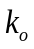 are constants respectively.
（2）Autotrophic respiration
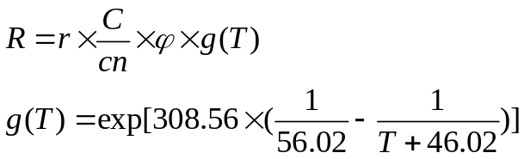 （2）
In which, R is the rate of respiration maintained by plants, C is vegetation carbon content, cn represents the vegetation C/N ratio, r is the respiration rate maintained by vegetation at 10℃, 𝜑 is the phenological state of vegetation
（3）Heterotrophic respiration
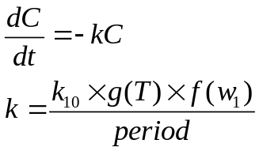 （3）
In which, k is the decomposition rate, T is the soil temperature, 𝑤₁ is the soil moisture of the first layer, 𝑓(𝑤₁) is the influence function of soil moisture on decomposition rate, kC is the decomposed carbon, 𝑘₁₀ is the decomposition rate of soil organic matter at 10℃.

Figures
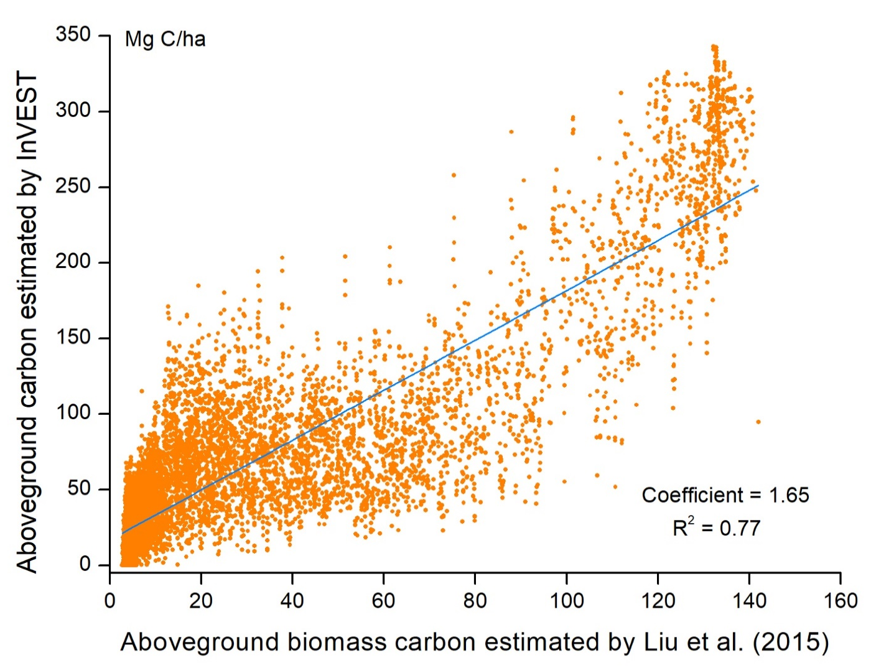
Fig. S1
The validation of the global terrestrial carbon storage dataset against aboveground biomass carbon estimated by Liu et al. (2015)³. We randomly selected 10000 sample points globally and compared them with Liu et al. based on microwave remote sensing data. We selected the average value of aboveground biomass carbon from 1994-2012.

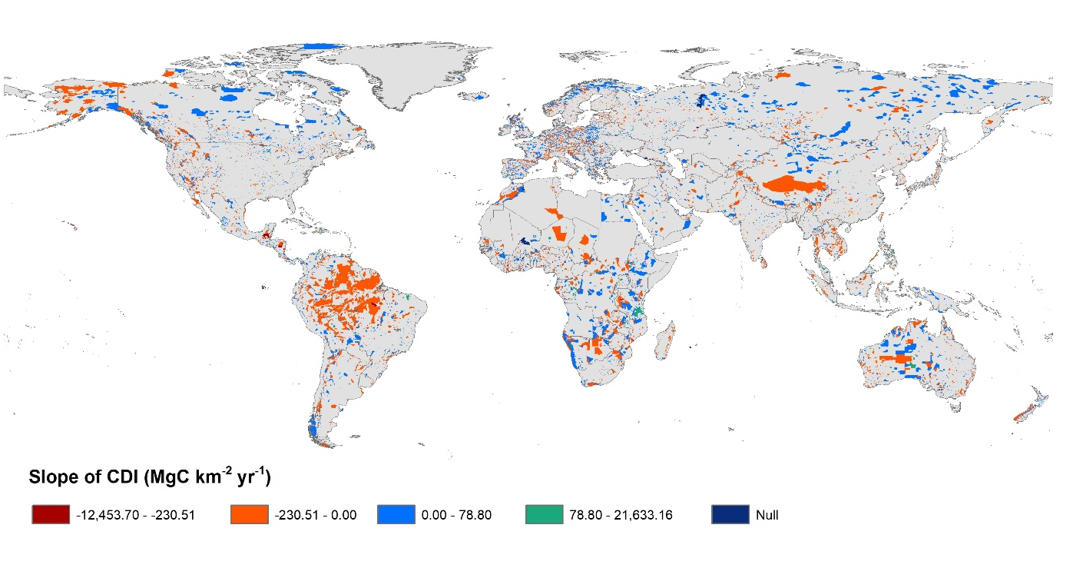
Fig. S2
Trend analysis of the carbon density index within global protected areas from 1994-2015. CDI is calculated using models 1-4, and CDI fluctuations are calculated using model 7. The red patches represent the areas of greatest reduction of the carbon density index of protected areas from 1994-2015.

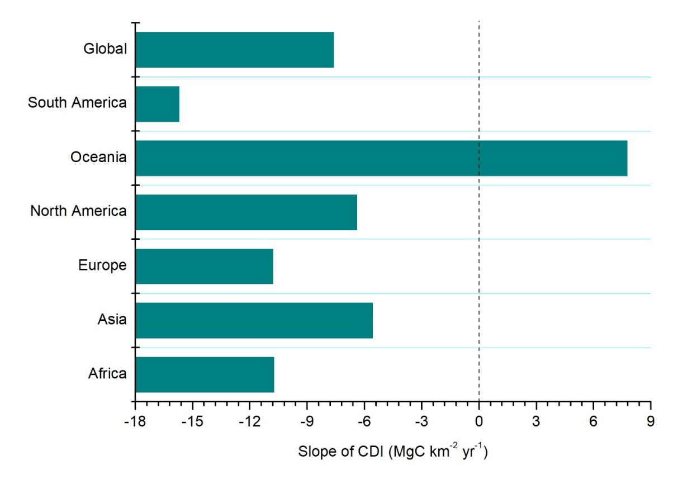
Fig. S3
Change of the carbon density index by continent from 1994-2015. The carbon density index of protected areas inside continents at the left side of the black line is decreasing.

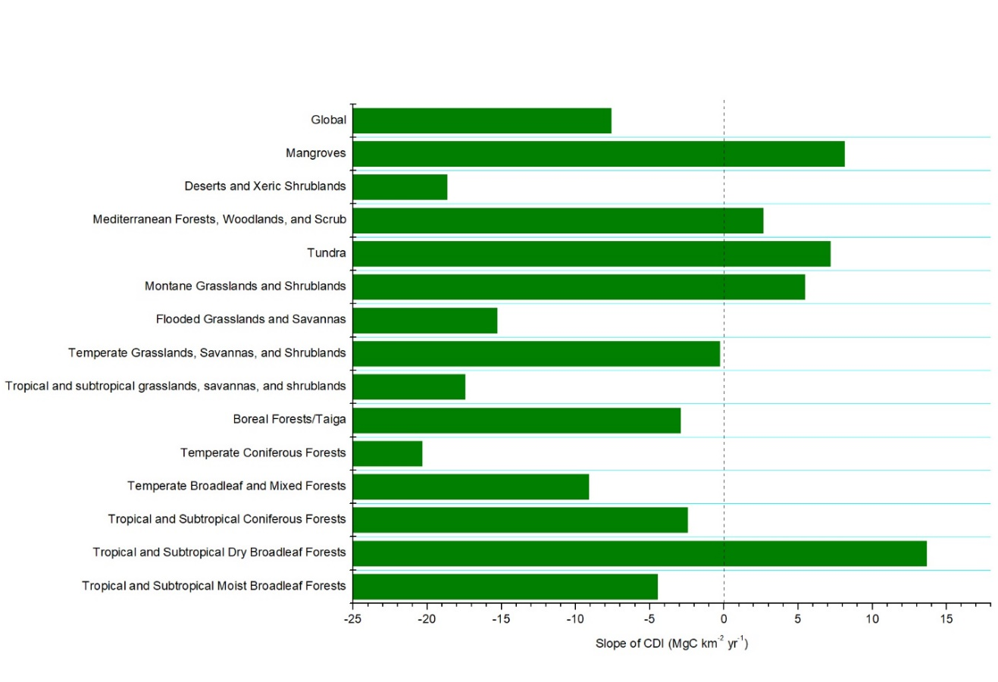
Fig. S4
Change of the carbon density index within ecoregions from 1994-2015. The carbon density index of protected areas inside ecoregions at the left side of the dotted vertical line is decreasing.

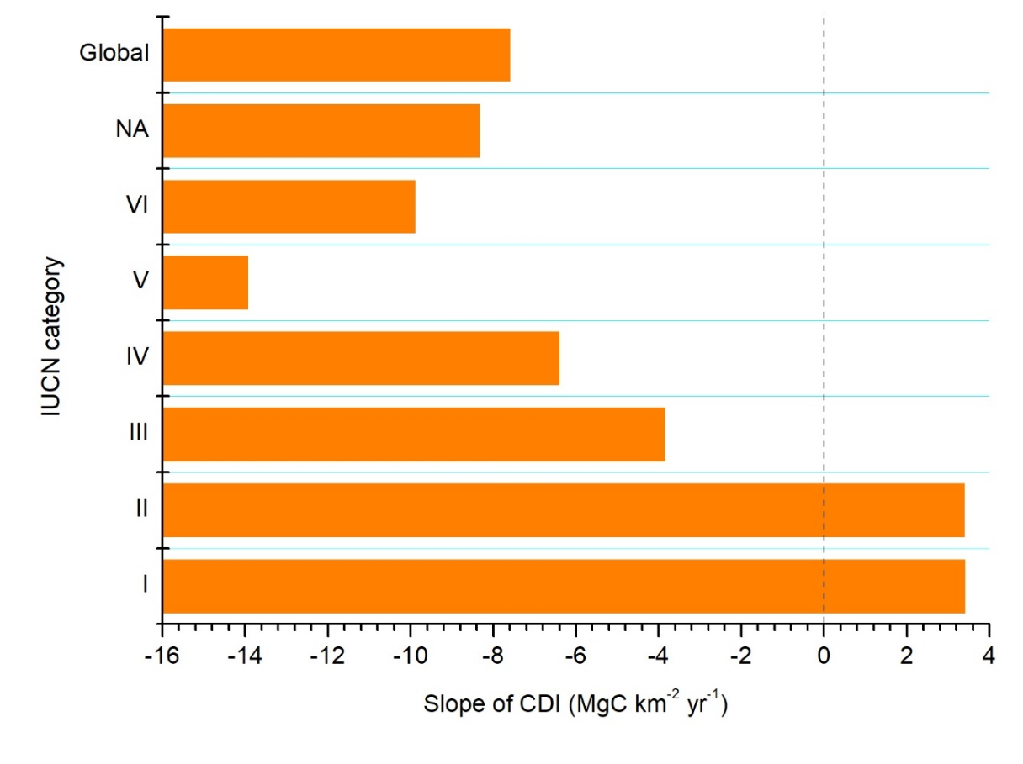
Fig. S5
Change of the carbon density index by IUCN category from 1994-2015. The bars at the left side of the dotted line represents the carbon density index of the corresponding protected areas inside IUCN categories is in an order decrease.

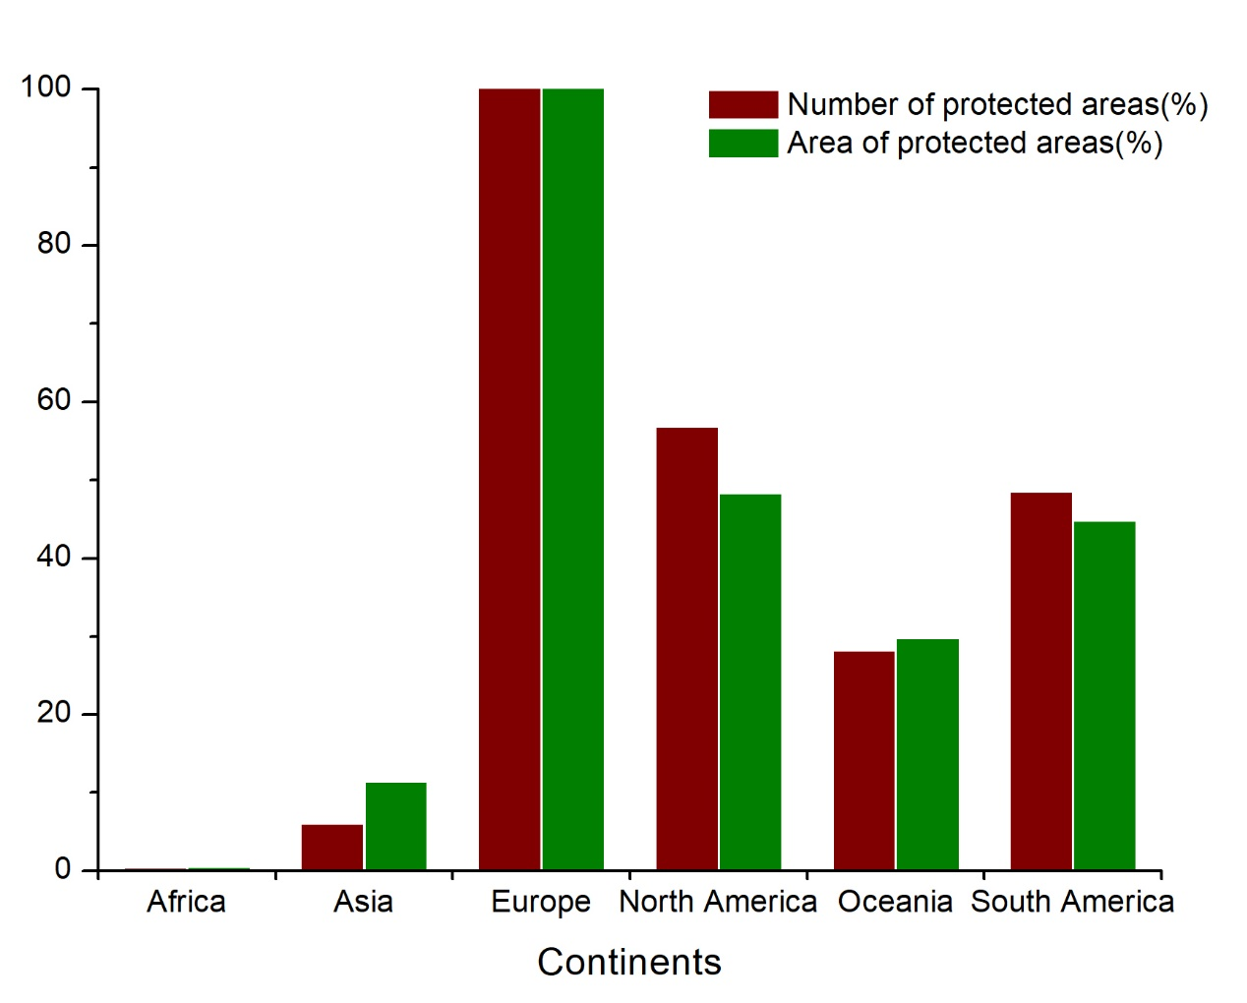
Fig. S6
Threat of climate change on the carbon density index by continent between the periods 1994-2015 and 2020-2032. The red bars show the share of protected areas threatened by climate change for each continent. The green bars show the share of the area of protected areas threatened by climate change by continent.

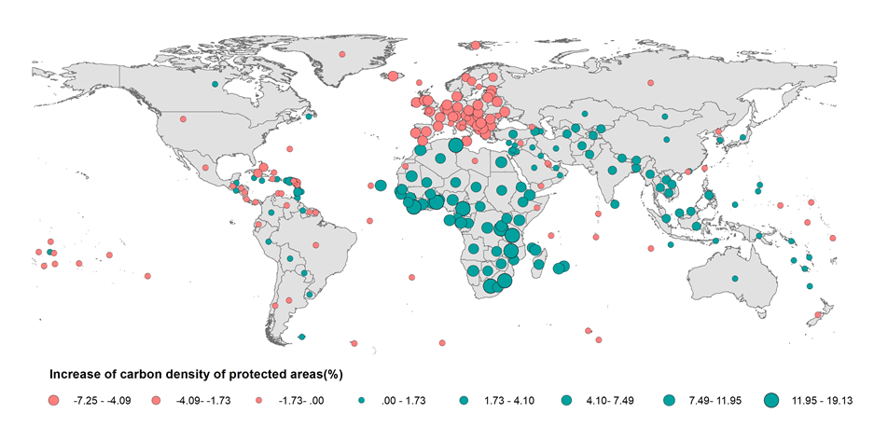
Fig. S7
Increase of the carbon density of protected areas at national scale. The increase denotes the difference between the periods 1994-2015 and 2020-2032 within protected areas due to climate change.

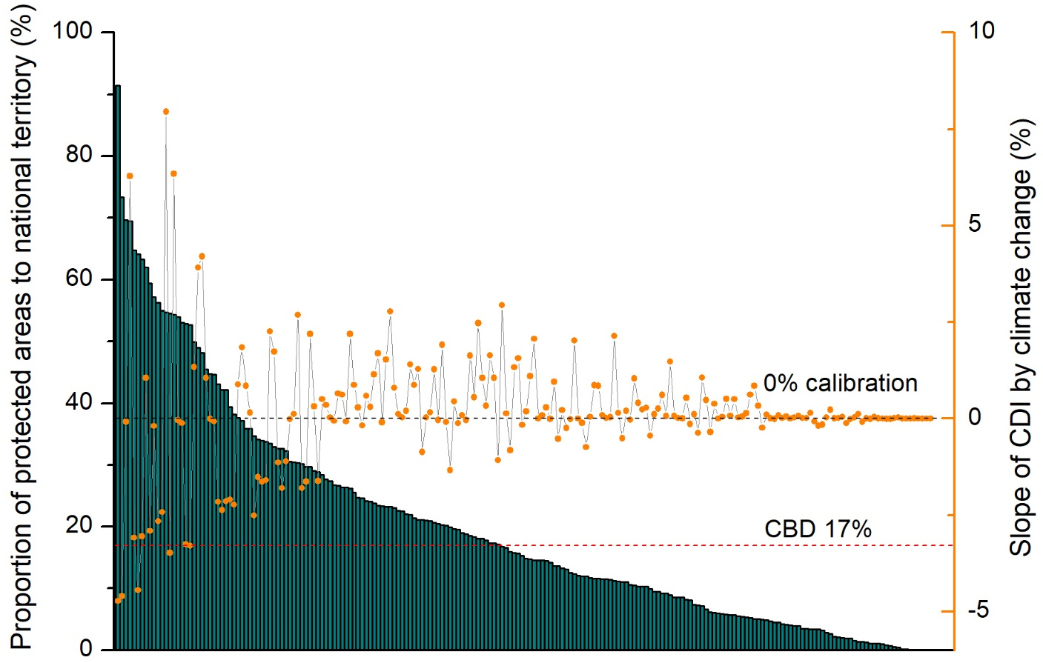
Fig. S8
Proportion of protected areas within countries. Countries above the horizontal black dotted line show an increase of the carbon density index. Countries above the red line have met their CBD obligation of protecting 17% of the total area.

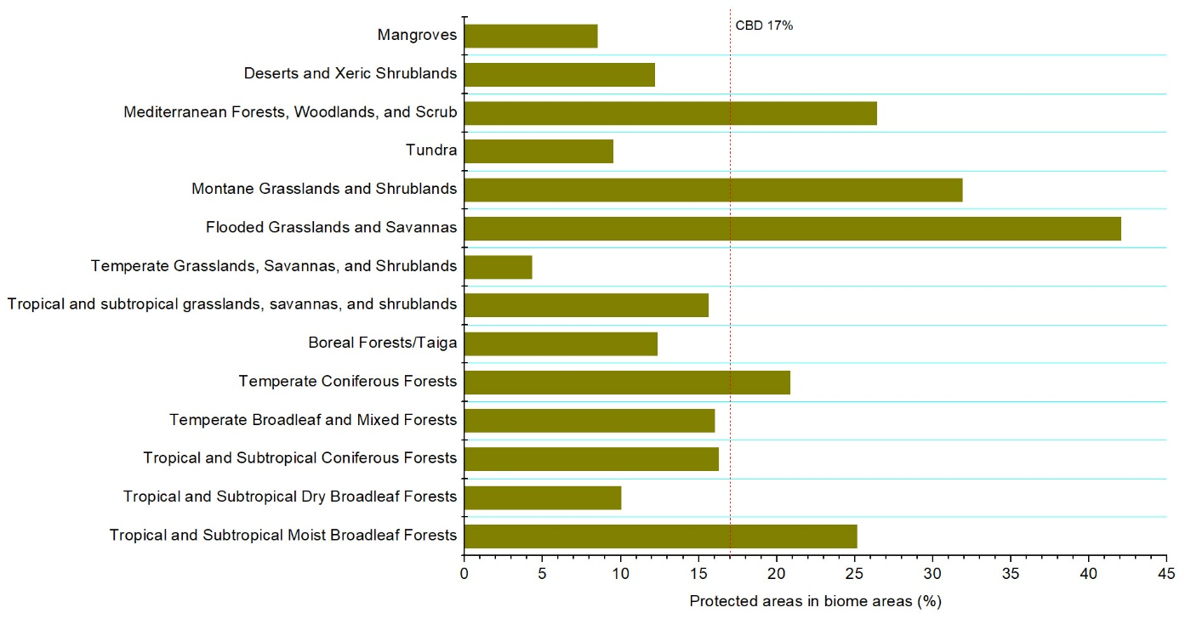
Fig. S9
Proportion of protected land by biome. Biome areas at the right of the vertical dotted line have met their CBD obligation to protect 17% of the area.

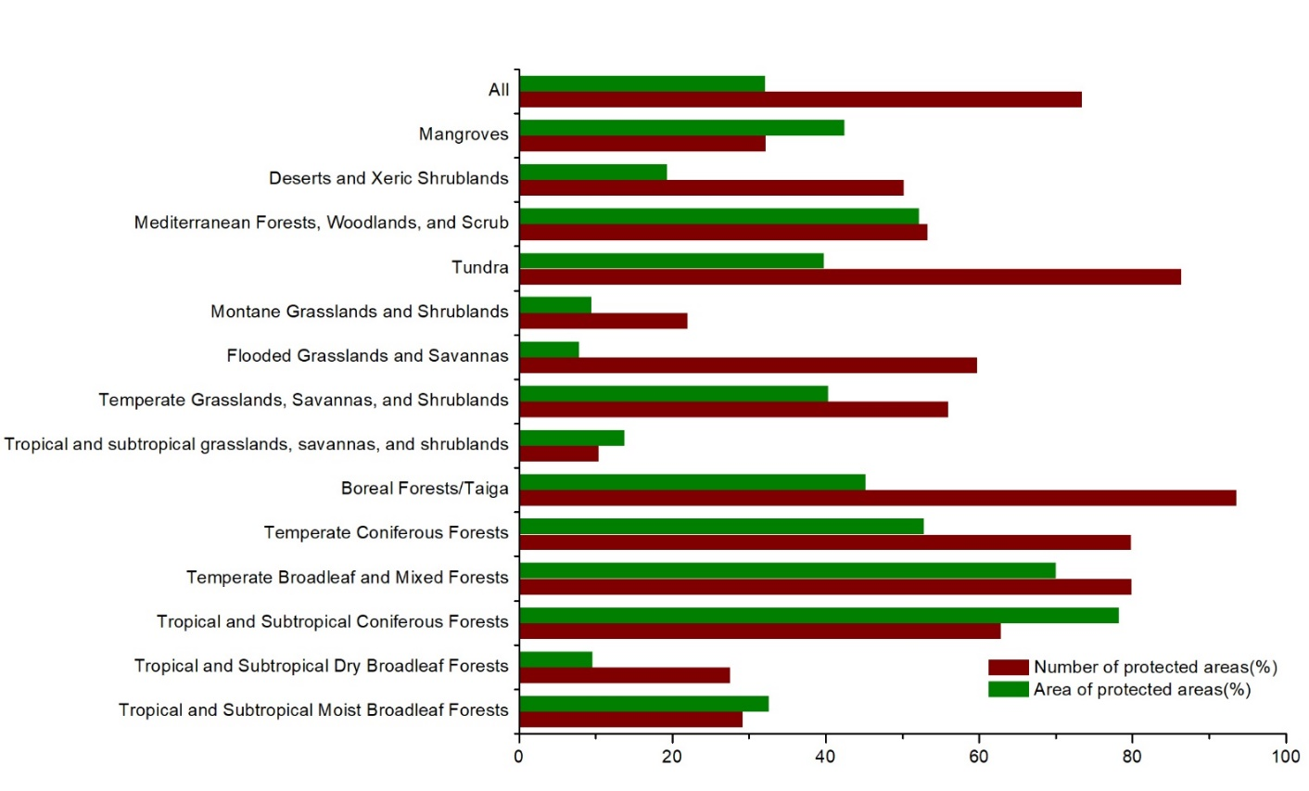
Fig. S10
Threat of climate change on the carbon density index within ecoregions between the periods 1994-2015 and 2020-2032. The red bars show the share of protected areas threatened by climate change inside ecoregions. The green bars show the share of land of protected areas threatened by climate change for each ecoregion.

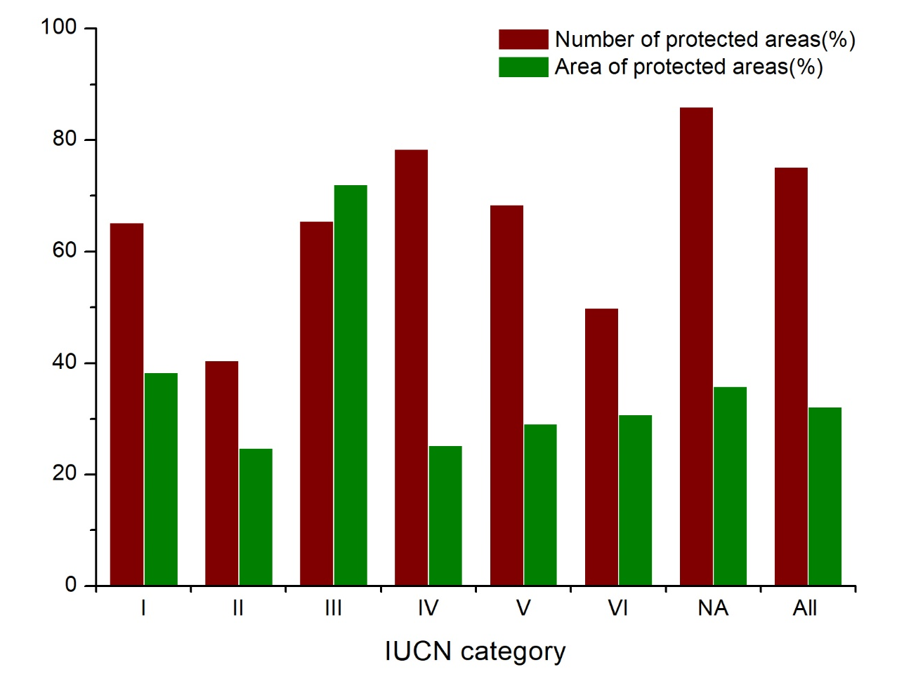
Fig. S11
Threat of climate change on the carbon density index within IUCN categories between the periods 1994-2015 and 2020-2032. The red bars show the share of protected areas threatened by climate change for each IUCN category. The green bars show the share of land of protected areas threatened by climate change by IUCN category.

Tables

Table S1.
Estimated Effects of climate on the carbon density index (CDI)
CDI | Global | Europe | Asia | Africa | North America | Oceania | South America
Wind speed | -0.000218*** | 0.000670*** | 0.00561*** | -0.00796*** | -0.00148*** | 0.0000822 | 0.00401***
 | (0.0000839) | (0.0000993) | (0.000455) | (0.000479) | (0.000159) | (0.000279) | (0.000489)
Temperature | -0.0000367* | 0.000219*** | -0.0000588 | -0.00172*** | -0.000139*** | -0.000157 | -0.000237*
 | (0.0000206) | (0.0000230) | (0.0000826) | (0.000131) | (0.0000378) | (0.000123) | (0.000124)
Precipitation | 0.00342** | 0.0156*** | -0.00172 | -0.00539 | 0.000261 | -0.0168** | 0.0301***
 | (0.00165) | (0.00349) | (0.00654) | (0.00378) | (0.00398) | (0.00743) | (0.00493)
Constant | 9.632*** | 9.441*** | 9.458*** | 9.582*** | 9.809*** | 10.19*** | 9.966***
 | (0.00126) | (0.00130) | (0.00542) | (0.00980) | (0.00228) | (0.00800) | (0.00929)
Observations | 1793417 | 787600 | 169686 | 138556 | 466399 | 166298 | 64878
PAs FE | YES | YES | YES | YES | YES | YES | YES
Year FE | NO | NO | NO | NO | NO | NO | NO
F | 4.844*** | 52.03*** | 51.09*** | 165.6*** | 32.15*** | 2.115*** | 31.84***
Notes: *** p<0.01, ** p<0.05, * p<0.1. FE denotes the fixed effects approach and RE represents the random effects approach.

Table S2.
Estimated Effects of temperature bins on the carbon density index (CDI, InVEST model)
CDI | Global | Europe | Asia | Africa | North America | Oceania | South America
Wind speed | -0.000131 | 0.000772*** | 0.00645*** | -0.00888*** | -0.00162*** | 0.000398 | 0.00369***
 | (0.0000885) | (0.000105) | (0.000511) | (0.000528) | (0.000171) | (0.000302) | (0.000588)
Precipitation | 0.00444** | 0.0241*** | -0.0116 | -0.0127** | 0.00467 | -0.0156** | 0.0324***
 | (0.00202) | (0.00373) | (0.00745) | (0.00641) | (0.00417) | (0.00765) | (0.00550)
<10°F | 0.0000256* | 0.0000335* | 0.00000815 | -0.0115 | 0.0000363** | -0.00332 | -0.00128
 | (0.0000134) | (0.0000203) | (0.0000433) | (0.0378) | (0.0000169) | (0.0240) | (0.0172)
10-20°F | -0.0000163 | -0.0000141 | -0.00000218 | 0.0120 | -0.0000284 | 0.00172 | -0.00208
 | (0.0000177) | (0.0000204) | (0.0000782) | (0.0189) | (0.0000276) | (0.00441) | (0.00568)
20-30°F | -0.0000193** | -0.0000241*** | 0.000000135 | 0.0141** | -0.00000543 | -0.000539* | 0.000271
 | (0.00000959) | (0.00000934) | (0.0000531) | (0.00626) | (0.0000197) | (0.000312) | (0.000785)
30-40°F | 0.0000106* | 0.0000103* | -0.0000130 | -0.00141** | -0.00000374 | -0.0000826 | -0.000283
 | (0.00000610) | (0.00000578) | (0.0000364) | (0.000577) | (0.0000140) | (0.0000863) | (0.000218)
40-50°F | -0.00000100 | -0.0000282*** | 0.000133*** | 0.0000292 | 0.0000224 | 0.0000691** | -0.00000753
 | (0.00000541) | (0.00000522) | (0.0000347) | (0.000124) | (0.0000137) | (0.0000284) | (0.0000720)
50-60°F | -0.00000237 | 0.0000213*** | 0.0000273 | -0.000402*** | -0.00000535 | -0.0000497*** | -0.0000357
 | (0.00000517) | (0.00000551) | (0.0000329) | (0.0000485) | (0.0000120) | (0.0000176) | (0.0000385)
60-70°F | 0.0000297*** | 0.0000477*** | 0.0000253 | 0.000129*** | -0.0000721*** | 0.000125*** | 0.000133***
 | (0.00000524) | (0.00000662) | (0.0000280) | (0.0000220) | (0.0000113) | (0.0000201) | (0.0000300)
70-80°F | 0.0000412*** | 0.0000836*** | 0.0000419** | 0.0000292** | 0.0000345*** | -0.0000537** | -0.0000171
 | (0.00000470) | (0.0000105) | (0.0000174) | (0.0000139) | (0.00000939) | (0.0000251) | (0.0000131)
80-90°F | 0.0000315*** | 0.000132*** | -0.0000125 | 0.0000736*** | 0.0000825*** | 0.0000633** | -0.0000303***
 | (0.00000411) | (0.0000193) | (0.00000997) | (0.0000138) | (0.00000789) | (0.0000262) | (0.00000900)
>90°F | 0.0000740*** | 0.000252** | 0.00000315 | 0.000198*** | -0.0000743** | -0.000284*** | -0.0000367
 | (0.0000178) | (0.000110) | (0.0000413) | (0.0000467) | (0.0000364) | (0.0000882) | (0.0000569)
Constant | 9.623*** | 9.454*** | 9.430*** | 9.436*** | 9.797*** | 10.17*** | 9.958***
 | (0.000729) | (0.000899) | (0.00335) | (0.00320) | (0.00163) | (0.00310) | (0.00301)
Observations | 1616456 | 731775 | 144421 | 120465 | 412618 | 154172 | 53005
PAs FE | YES | YES | YES | YES | YES | YES | YES
Year FE | NO | NO | NO | NO | NO | NO | NO
F | 25.70*** | 24.52*** | 16.21*** | 44.79*** | 21.62*** | 6.395*** | 9.300***
Notes: *** p<0.01, ** p<0.05, * p<0.1. FE denotes the fixed effects approach and RE represents the random effects approach.

Table S3.
Estimated Effects of temperature bins on the carbon density index (CDI, LPJ model)
CDI | Global | Europe | Asia | Africa | North America | Oceania | South America
Wind speed | 0.000753 | 0.00188*** | 0.0247*** | -0.0324*** | 0.0360*** | 0.00543* | -0.236***
 | (0.00118) | (0.000235) | (0.00435) | (0.00253) | (0.00410) | (0.00294) | (0.0142)
Precipitation | -0.179*** | -0.0605*** | 0.155** | 0.207*** | -0.515*** | -0.375*** | -0.799***
 | (0.0254) | (0.00804) | (0.0620) | (0.0318) | (0.0965) | (0.0695) | (0.146)
<10°F | -0.00183*** | 0.00198*** | -0.000187 | 0.569*** | -0.00620*** | 0.145 | -0.404
 | (0.000178) | (0.0000446) | (0.000380) | (0.193) | (0.000389) | (0.205) | (0.437)
10-20°F | -0.00314*** | -0.00220*** | 0.00462*** | -0.0568 | -0.00722*** | -0.0172 | 0.148
 | (0.000241) | (0.0000446) | (0.000680) | (0.0922) | (0.000683) | (0.0400) | (0.145)
20-30°F | -0.00125*** | -0.000287*** | -0.0000802 | 0.0837*** | -0.00620*** | -0.00384 | -0.00159
 | (0.000130) | (0.0000207) | (0.000454) | (0.0304) | (0.000497) | (0.00298) | (0.0197)
30-40°F | -0.000393*** | 0.000325*** | -0.00144*** | -0.0154*** | -0.00179*** | -0.000277 | 0.00743
 | (0.0000836) | (0.0000130) | (0.000314) | (0.00274) | (0.000350) | (0.000841) | (0.00499)
40-50°F | -0.00114*** | -0.000921*** | -0.000221 | -0.00276*** | -0.00427*** | -0.000223 | 0.00900***
 | (0.0000731) | (0.0000117) | (0.000302) | (0.000589) | (0.000334) | (0.000283) | (0.00177)
50-60°F | 0.00194*** | -0.000241*** | -0.00103*** | -0.000431* | 0.0128*** | 0.000227 | 0.00263***
 | (0.0000695) | (0.0000123) | (0.000285) | (0.000233) | (0.000290) | (0.000173) | (0.000961)
60-70°F | 0.000526*** | 0.00128*** | -0.000217 | -0.0000428 | -0.00354*** | 0.00118*** | 0.00879***
 | (0.0000690) | (0.0000147) | (0.000241) | (0.000108) | (0.000272) | (0.000194) | (0.000740)
70-80°F | -0.00232*** | -0.000856*** | 0.00117*** | -0.000767*** | -0.00920*** | -0.00191*** | -0.000405
 | (0.0000595) | (0.0000226) | (0.000145) | (0.0000683) | (0.000223) | (0.000231) | (0.000349)
80-90°F | 0.000274*** | -0.00249*** | -0.000294*** | 0.000425*** | 0.00594*** | -0.00111*** | -0.00312***
 | (0.0000500) | (0.0000400) | (0.0000806) | (0.0000654) | (0.000179) | (0.000233) | (0.000226)
>90°F | -0.000473** | 0.000370 | 0.00163*** | 0.000206 | 0.00676*** | -0.00403*** | -0.0178***
 | (0.000215) | (0.000250) | (0.000344) | (0.000224) | (0.000789) | (0.000753) | (0.00149)
Constant | 6.037*** | 6.120*** | 5.805*** | 6.536*** | 5.987*** | 5.983*** | 5.709***
 | (0.00948) | (0.00199) | (0.0287) | (0.0152) | (0.0384) | (0.0299) | (0.0843)
Observations | 1108012 | 496429 | 101122 | 107828 | 253863 | 103670 | 45100
PAs FE | YES | YES | YES | YES | YES | YES | YES
Year FE | NO | NO | NO | NO | NO | NO | NO
F | 273.2*** | 2152.2*** | 18.87*** | 46.63*** | 520.9*** | 17.07*** | 24.24***
Notes: *** p<0.01, ** p<0.05, * p<0.1. FE denotes the fixed effects approach and RE represents the random effects approach.

Table S4.
CDI trend verification based on InVEST and LPJ model
Area | Type | Number of PAs | Trends of CDI
Global | Conclusion dissimilarity | 37268 | 19.29%
Global | Conclusion similarity | 155894 | 80.71%
Africa | Conclusion dissimilarity | 26 | 0.36%
Africa | Conclusion similarity | 7252 | 99.64%
Asia | Conclusion dissimilarity | 366 | 3.43%
Asia | Conclusion similarity | 10298 | 96.57%
Europe | Conclusion dissimilarity | 687 | 0.60%
Europe | Conclusion similarity | 113944 | 99.40%
North America | Conclusion dissimilarity | 23750 | 57.55%
North America | Conclusion similarity | 17515 | 42.45%
South America | Conclusion dissimilarity | 1655 | 44.66%
South America | Conclusion similarity | 2051 | 55.34%
Oceania | Conclusion dissimilarity | 10784 | 69.05%
Oceania | Conclusion similarity | 4834 | 30.95%
Notes: Conclusion similarity means the same effect of climate change on CDI of PAs based on InVEST and LPJ model, either decreasing or increasing; Conclusion dissimilarity means the different effect of climate change on CDI of PAs based on InVEST and LPJ model, with one decreasing and the other increasing.

Table S5.
CDI trend verification based on InVEST and LPJ model to national territory
ISO | Number of protected areas |  | Proportion of protected areas
ISO | Conclusion dissimilarity | Conclusion similarity | Conclusion dissimilarity | Conclusion similarity
MAR | 0 | 281 | 0.00% | 100.00%
AFG | 0 | 9 | 0.00% | 100.00%
AGO | 0 | 12 | 0.00% | 100.00%
AIA | 2 | 0 | 100.00% | 0.00%
ALA | 0 | 20 | 0.00% | 100.00%
ALB | 0 | 54 | 0.00% | 100.00%
AND | 0 | 9 | 0.00% | 100.00%
ARE | 22 | 6 | 78.57% | 21.43%
ARG | 128 | 203 | 38.67% | 61.33%
ARM | 0 | 35 | 0.00% | 100.00%
ATG | 0 | 3 | 0.00% | 100.00%
AUS | 8347 | 1875 | 81.66% | 18.34%
AUT | 0 | 1526 | 0.00% | 100.00%
AZE | 0 | 35 | 0.00% | 100.00%
BDI | 0 | 14 | 0.00% | 100.00%
BEL | 0 | 1984 | 0.00% | 100.00%
BEN | 0 | 28 | 0.00% | 100.00%
BES | 1 | 2 | 33.33% | 66.67%
BFA | 0 | 62 | 0.00% | 100.00%
BFA;NER;BEN | 0 | 1 | 0.00% | 100.00%
BGD | 0 | 38 | 0.00% | 100.00%
BGR | 0 | 1343 | 0.00% | 100.00%
BHS | 15 | 0 | 100.00% | 0.00%
BIH | 0 | 10 | 0.00% | 100.00%
BLR | 0 | 142 | 0.00% | 100.00%
BLR;POL | 0 | 1 | 0.00% | 100.00%
BLZ | 52 | 19 | 73.24% | 26.76%
BMU | 9 | 1 | 90.00% | 10.00%
BOL | 77 | 79 | 49.36% | 50.64%
BRA | 929 | 1094 | 45.92% | 54.08%
BRB | 4 | 2 | 66.67% | 33.33%
BRN | 0 | 29 | 0.00% | 100.00%
BTN | 0 | 19 | 0.00% | 100.00%
BWA | 0 | 18 | 0.00% | 100.00%
CAF | 0 | 25 | 0.00% | 100.00%
CAN | 4557 | 2359 | 65.89% | 34.11%
CAN;USA | 0 | 1 | 0.00% | 100.00%
CHE | 0 | 5893 | 0.00% | 100.00%
CHE;ITA | 0 | 1 | 0.00% | 100.00%
CHL | 63 | 81 | 43.75% | 56.25%
CHN | 11 | 689 | 1.57% | 98.43%
CIV | 0 | 240 | 0.00% | 100.00%
CIV;GIN | 0 | 1 | 0.00% | 100.00%
CMR | 0 | 45 | 0.00% | 100.00%
COD | 0 | 47 | 0.00% | 100.00%
COG | 1 | 20 | 4.76% | 95.24%
COG;CMR;CAF | 0 | 1 | 0.00% | 100.00%
COL | 273 | 326 | 45.58% | 54.42%
COM | 0 | 3 | 0.00% | 100.00%
CPV | 0 | 4 | 0.00% | 100.00%
CRI | 39 | 105 | 27.08% | 72.92%
CRI;PAN | 1 | 0 | 100.00% | 0.00%
CUB | 135 | 0 | 100.00% | 0.00%
CUW | 5 | 2 | 71.43% | 28.57%
CXR | 0 | 1 | 0.00% | 100.00%
CYM | 6 | 2 | 75.00% | 25.00%
CYP | 1 | 76 | 1.30% | 98.70%
CZE | 0 | 3798 | 0.00% | 100.00%
DEU | 0 | 22663 | 0.00% | 100.00%
DEU;SVK;ALB;AUT;BEL;BGR;ESP;HRV;ITA;ROU;SVN;UKR | 0 | 1 | 0.00% | 100.00%
DJI | 0 | 2 | 0.00% | 100.00%
DMA | 6 | 2 | 75.00% | 25.00%
DNK | 0 | 1986 | 0.00% | 100.00%
DOM | 44 | 17 | 72.13% | 27.87%
DZA | 0 | 10 | 0.00% | 100.00%
ECU | 25 | 25 | 50.00% | 50.00%
EGY | 0 | 32 | 0.00% | 100.00%
ERI | 0 | 3 | 0.00% | 100.00%
ESP | 203 | 2455 | 7.64% | 92.36%
EST | 0 | 8743 | 0.00% | 100.00%
ETH | 0 | 95 | 0.00% | 100.00%
FIN | 149 | 12396 | 1.19% | 98.81%
FJI | 17 | 0 | 100.00% | 0.00%
FLK | 1 | 0 | 100.00% | 0.00%
FRA | 0 | 3697 | 0.00% | 100.00%
FRA;ESP | 0 | 1 | 0.00% | 100.00%
GAB | 0 | 26 | 0.00% | 100.00%
GBR | 0 | 7333 | 0.00% | 100.00%
GEO | 0 | 84 | 0.00% | 100.00%
GHA | 2 | 105 | 1.87% | 98.13%
GIB | 0 | 1 | 0.00% | 100.00%
GIN | 1 | 103 | 0.96% | 99.04%
GLP | 12 | 34 | 26.09% | 73.91%
GMB | 0 | 10 | 0.00% | 100.00%
GNB | 0 | 13 | 0.00% | 100.00%
GNQ | 1 | 10 | 9.09% | 90.91%
GRC | 81 | 916 | 8.12% | 91.88%
GRD | 20 | 4 | 83.33% | 16.67%
GRL | 8 | 0 | 100.00% | 0.00%
GTM | 93 | 159 | 36.90% | 63.10%
GUF | 12 | 15 | 44.44% | 55.56%
GUM | 2 | 0 | 100.00% | 0.00%
GUY | 1 | 4 | 20.00% | 80.00%
HKG | 0 | 14 | 0.00% | 100.00%
HND | 56 | 16 | 77.78% | 22.22%
HRV | 0 | 870 | 0.00% | 100.00%
HTI | 3 | 1 | 75.00% | 25.00%
HUN | 0 | 870 | 0.00% | 100.00%
IDN | 0 | 353 | 0.00% | 100.00%
IMN | 0 | 20 | 0.00% | 100.00%
IND | 0 | 341 | 0.00% | 100.00%
IRL | 0 | 540 | 0.00% | 100.00%
IRN | 4 | 129 | 3.01% | 96.99%
IRQ | 6 | 17 | 26.09% | 73.91%
ISL | 29 | 66 | 30.53% | 69.47%
ISR | 13 | 231 | 5.33% | 94.67%
ITA | 0 | 3374 | 0.00% | 100.00%
JAM | 84 | 38 | 68.85% | 31.15%
JEY | 0 | 10 | 0.00% | 100.00%
JOR | 3 | 27 | 10.00% | 90.00%
JPN | 175 | 4139 | 4.06% | 95.94%
KAZ | 4 | 35 | 10.26% | 89.74%
KEN | 8 | 248 | 3.13% | 96.88%
KGZ | 0 | 30 | 0.00% | 100.00%
KHM | 0 | 40 | 0.00% | 100.00%
KOR | 7 | 1273 | 0.55% | 99.45%
KWT | 6 | 6 | 50.00% | 50.00%
LAO | 0 | 29 | 0.00% | 100.00%
LBN | 0 | 15 | 0.00% | 100.00%
LBR | 0 | 12 | 0.00% | 100.00%
LCA | 14 | 3 | 82.35% | 17.65%
LIE | 0 | 44 | 0.00% | 100.00%
LKA | 0 | 643 | 0.00% | 100.00%
LSO | 0 | 2 | 0.00% | 100.00%
LSO;ZAF | 0 | 1 | 0.00% | 100.00%
LTU | 0 | 1023 | 0.00% | 100.00%
LUX | 0 | 184 | 0.00% | 100.00%
LVA | 0 | 1110 | 0.00% | 100.00%
MDG | 2 | 95 | 2.06% | 97.94%
MEX | 802 | 205 | 79.64% | 20.36%
MKD | 0 | 78 | 0.00% | 100.00%
MLI | 0 | 28 | 0.00% | 100.00%
MLT | 0 | 162 | 0.00% | 100.00%
MMR | 0 | 54 | 0.00% | 100.00%
MNE | 0 | 6 | 0.00% | 100.00%
MNG | 15 | 89 | 14.42% | 85.58%
MNG;RUS | 0 | 2 | 0.00% | 100.00%
MNP | 2 | 0 | 100.00% | 0.00%
MOZ | 0 | 43 | 0.00% | 100.00%
MRT | 0 | 1 | 0.00% | 100.00%
MSR | 0 | 1 | 0.00% | 100.00%
MTQ | 13 | 15 | 46.43% | 53.57%
MUS | 0 | 14 | 0.00% | 100.00%
MWI | 0 | 57 | 0.00% | 100.00%
MYS | 0 | 153 | 0.00% | 100.00%
MYT | 0 | 20 | 0.00% | 100.00%
NAM | 0 | 144 | 0.00% | 100.00%
NCL | 15 | 4 | 78.95% | 21.05%
NER | 0 | 14 | 0.00% | 100.00%
NFK | 1 | 1 | 50.00% | 50.00%
NGA | 0 | 968 | 0.00% | 100.00%
NIC | 27 | 51 | 34.62% | 65.38%
NLD | 0 | 362 | 0.00% | 100.00%
NOR | 100 | 1774 | 5.34% | 94.66%
NPL | 0 | 38 | 0.00% | 100.00%
NZL | 2334 | 2946 | 44.20% | 55.80%
OMN | 2 | 2 | 50.00% | 50.00%
PAK | 1 | 134 | 0.74% | 99.26%
PAN | 17 | 20 | 45.95% | 54.05%
PER | 90 | 113 | 44.33% | 55.67%
PHL | 0 | 183 | 0.00% | 100.00%
PLW | 8 | 2 | 80.00% | 20.00%
PNG | 10 | 24 | 29.41% | 70.59%
POL | 0 | 3006 | 0.00% | 100.00%
PRI | 40 | 3 | 93.02% | 6.98%
PRT | 1 | 269 | 0.37% | 99.63%
PRY | 14 | 19 | 42.42% | 57.58%
PSE | 0 | 51 | 0.00% | 100.00%
QAT | 0 | 1 | 0.00% | 100.00%
REU | 0 | 23 | 0.00% | 100.00%
ROU | 0 | 1358 | 0.00% | 100.00%
RUS | 162 | 1930 | 7.74% | 92.26%
RWA | 0 | 7 | 0.00% | 100.00%
SAU | 26 | 31 | 45.61% | 54.39%
SDN | 0 | 1 | 0.00% | 100.00%
SEN | 0 | 106 | 0.00% | 100.00%
SGP | 0 | 2 | 0.00% | 100.00%
SJM | 0 | 1 | 0.00% | 100.00%
SLB | 1 | 0 | 100.00% | 0.00%
SLE | 0 | 36 | 0.00% | 100.00%
SLV | 130 | 4 | 97.01% | 2.99%
SPM | 1 | 0 | 100.00% | 0.00%
SRB | 0 | 321 | 0.00% | 100.00%
SSD | 0 | 24 | 0.00% | 100.00%
STP | 0 | 3 | 0.00% | 100.00%
SUR | 6 | 8 | 42.86% | 57.14%
SVK | 0 | 1701 | 0.00% | 100.00%
SVK;HUN | 0 | 1 | 0.00% | 100.00%
SVN | 0 | 2356 | 0.00% | 100.00%
SWE | 13 | 17365 | 0.07% | 99.93%
SWZ | 0 | 24 | 0.00% | 100.00%
TCA | 3 | 1 | 75.00% | 25.00%
TCD | 0 | 15 | 0.00% | 100.00%
TGO | 0 | 60 | 0.00% | 100.00%
THA | 0 | 183 | 0.00% | 100.00%
TJK | 0 | 21 | 0.00% | 100.00%
TKM | 0 | 29 | 0.00% | 100.00%
TLS | 0 | 18 | 0.00% | 100.00%
TTO | 24 | 16 | 60.00% | 40.00%
TUN | 0 | 95 | 0.00% | 100.00%
TUR | 0 | 11 | 0.00% | 100.00%
TWN | 13 | 43 | 23.21% | 76.79%
TZA | 4 | 773 | 0.51% | 99.49%
UGA | 0 | 703 | 0.00% | 100.00%
UKR | 0 | 1245 | 0.00% | 100.00%
UMI | 1 | 0 | 100.00% | 0.00%
URY | 3 | 12 | 20.00% | 80.00%
USA | 17543 | 14430 | 54.87% | 45.13%
UZB | 0 | 10 | 0.00% | 100.00%
UZB;KGZ;KAZ | 0 | 1 | 0.00% | 100.00%
VCT | 14 | 0 | 100.00% | 0.00%
VEN | 34 | 73 | 31.78% | 68.22%
VGB | 6 | 2 | 75.00% | 25.00%
VIR | 8 | 0 | 100.00% | 0.00%
VNM | 0 | 140 | 0.00% | 100.00%
VUT | 5 | 1 | 83.33% | 16.67%
WSM | 2 | 0 | 100.00% | 0.00%
ZAF | 5 | 1486 | 0.34% | 99.66%
ZMB | 2 | 517 | 0.39% | 99.61%
ZMB;ZWE | 0 | 1 | 0.00% | 100.00%
ZWE | 0 | 181 | 0.00% | 100.00%
Notes: Conclusion similarity means that the same trend of climate change on CDI based on InVEST and LPJ model, either decreasing or increasing; Conclusion dissimilarity means that the different trend of climate change on CDI based on InVEST and LPJ model, with one decreasing and the other increasing.

Table S6.
Global land cover categories defined by European Space Agency and re-classified based on IPCC (2006)
Re-classified categories | Original classifications by European Space Agency (ESA).
Cropland | Rained cropland, Irrigated cropland, Mosaic cropland (>50%).
Cropland | Natural vegetation (tree, shrub, herbaceous cover) (<50%).
Cropland | Mosaic natural vegetation (tree, shrub, herbaceous cover) (>50%)
Cropland | Cropland (<50%).
Forest | Tree cover, broadleaved, evergreen, closed to open (>15%).
Forest | Tree cover, broadleaved, deciduous, closed to open (>15%).
Forest | Tree cover, needleleaved, deciduous, closed to open (>15%).
Forest | Tree cover, mixed leaf type (broadleaved and needleleaved).
Forest | Mosaic tree and shrub (>50%)/herbaceous cover (<50%).
Forest | tree cover, flooded, fresh or brakish water; tree cover, flooded, saline water.
Grassland | Mosaic herbaceous cover (50%).
Grassland | Tree and shrub (<50%).
Grassland | Grassland.
Wetland | Shrub or herbaceous cover, flooded, fresh-saline or brakish water.
Urban | Settlement.
Other | Shrubland.
Other | Lichens and mosses.
Other | Sparse vegetation (tree, shrub, herbaceous cover; Bare areas; Water).

Table S7.
Percentage of countries slope of CDI by climate change, and proportion of protected areas to national territory.
ISO3 | Country Name | Number of protected areas  (WDPA 2018) | Surface area (km²,worldbank 2017) | Area Protected  (WDPA 2018) | Slope of CDI by climate change (%) | Proportion of protected areas to national territory (%)
AFG | Afghanistan | 9 | 652860.00 | 10041.48 | 1.96% | 1.54%
AGO | Angola | 12 | 1246700.00 | 82898.65 | 7.24% | 6.65%
AIA | Anguilla | 2 | 85.50 | 0.01 | 0.34% | 0.01%
ALB | Albania | 54 | 28750.00 | 4933.07 | -6.27% | 17.16%
AND | Andorra | 9 | 470.00 | 162.90 | -7.25% | 34.66%
ARE | United Arab Emirates | 28 | 83600.00 | 12152.69 | 0.60% | 14.54%
ARG | Argentina | 331 | 2780400.00 | 348688.89 | -0.11% | 12.54%
ARM | Armenia | 35 | 29740.00 | 8439.54 | 1.76% | 28.38%
ATG | Antigua and Barbuda | 3 | 440.00 | 14.96 | -2.09% | 3.40%
AUS | Australia | 10222 | 7741220.00 | 1628245.69 | 0.17% | 21.03%
AUT | Austria | 1526 | 83879.00 | 47200.62 | -4.72% | 56.27%
AZE | Azerbaijan | 35 | 86600.00 | 9980.32 | 0.78% | 11.52%
BDI | Burundi | 14 | 27830.00 | 1408.57 | 16.80% | 5.06%
BEL | Belgium | 1984 | 30530.00 | 12033.20 | -5.31% | 39.41%
BEN | Benin | 28 | 114760.00 | 27310.47 | 4.83% | 23.80%
BES | Eustatius and Saba | 3 | 322.90 | 45.74 | -0.05% | 14.17%
BFA | Burkina Faso | 62 | 274220.00 | 25380.81 | 6.63% | 9.26%
BGD | Bangladesh | 38 | 147630.00 | 1647.75 | 3.55% | 1.12%
BGR | Bulgaria | 1343 | 111000.00 | 70257.42 | -4.81% | 63.29%
BHS | Bahamas, The | 15 | 13880.00 | 1820.44 | -1.86% | 13.12%
BIH | Bosnia and Herzegovina | 10 | 51210.00 | 713.10 | -6.04% | 1.39%
BLR | Belarus | 142 | 207600.00 | 20694.13 | -4.44% | 9.97%
BLZ | Belize | 71 | 22970.00 | 8237.58 | 0.44% | 35.86%
BMU | Bermuda | 10 | 50.00 | 0.57 | -0.46% | 1.14%
BOL | Bolivia | 156 | 1098580.00 | 300689.94 | 0.12% | 27.37%
BRA | Brazil | 2023 | 8515770.00 | 2599311.15 | -0.05% | 30.52%
BRB | Barbados | 6 | 430.00 | 4.32 | 0.32% | 1.00%
BRN | Brunei Darussalam | 29 | 5770.00 | 1396.69 | 2.43% | 24.21%
BTN | Bhutan | 19 | 38394.00 | 19169.72 | 2.69% | 49.93%
BWA | Botswana | 18 | 581730.00 | 194807.05 | 6.75% | 33.49%
CAF | Central African Republic | 25 | 622980.00 | 128814.48 | 6.19% | 20.68%
CAN | Canada | 6916 | 9984670.00 | 1148776.68 | 0.18% | 11.51%
CHE | Switzerland | 5893 | 41290.00 | 4584.39 | -4.57% | 11.10%
CHL | Chile | 144 | 756096.00 | 152745.12 | -0.44% | 20.20%
CHN | China | 700 | 9562911.00 | 1415585.98 | 1.27% | 14.80%
CIV | Cote d'Ivoire | 240 | 322460.00 | 97843.30 | 8.85% | 30.34%
CMR | Cameroon | 45 | 475440.00 | 69359.25 | 14.20% | 14.59%
COD | Congo, Dem. Rep. | 47 | 2344860.00 | 435526.46 | 8.81% | 18.57%
COG | Congo, Rep. | 21 | 342000.00 | 73070.93 | 4.10% | 21.37%
COL | Colombia | 599 | 1141749.00 | 166392.96 | 0.02% | 14.57%
COM | Comoros | 3 | 1861.00 | 432.78 | 6.59% | 23.26%
CPV | Cabo Verde | 4 | 4030.00 | 107.80 | 8.62% | 2.67%
CRI | Costa Rica | 144 | 51100.00 | 12575.55 | -0.72% | 24.61%
CUB | Cuba | 135 | 109880.00 | 8881.83 | -1.73% | 8.08%
CUW | Curacao | 7 | 444.00 | 50.81 | 0.33% | 11.44%
CXR | Christmas Island | 1 | 142.40 | 88.32 | 1.71% | 62.02%
CYM | Cayman Islands | 8 | 264.00 | 11.04 | 1.21% | 4.18%
CYP | Cyprus | 77 | 9250.00 | 2290.38 | 1.16% | 24.76%
CZE | Czech Republic | 3798 | 78870.00 | 33956.43 | -5.00% | 43.05%
DEU | Germany | 22663 | 357380.00 | 188266.01 | -6.25% | 52.68%
DJI | Djibouti | 2 | 23200.00 | 325.58 | 8.54% | 1.40%
DMA | Dominica | 8 | 750.00 | 228.30 | 0.38% | 30.44%
DNK | Denmark | 1986 | 42922.00 | 12397.39 | -5.61% | 28.88%
DOM | Dominican Republic | 61 | 48670.00 | 10192.07 | 0.80% | 20.94%
DZA | Algeria | 10 | 2381740.00 | 276575.22 | 7.31% | 11.61%
ECU | Ecuador | 50 | 256370.00 | 68741.72 | -0.22% | 26.81%
EGY | Egypt, Arab Rep. | 32 | 1001450.00 | 157531.11 | 8.45% | 15.73%
ERI | Eritrea | 3 | 117600.00 | 5936.25 | 6.64% | 5.05%
ESP | Spain | 2658 | 505940.00 | 267546.13 | -6.15% | 52.88%
EST | Estonia | 8743 | 45230.00 | 24894.97 | -4.40% | 55.04%
ETH | Ethiopia | 95 | 1104300.00 | 242474.76 | 6.40% | 21.96%
FIN | Finland | 12545 | 338420.00 | 109301.08 | -3.42% | 32.30%
FJI | Fiji | 17 | 18270.00 | 389.20 | 1.03% | 2.13%
FLK | (Malvinas) | 1 | 12400.90 | 10.11 | 0.16% | 0.08%
FRA | France | 3697 | 549087.00 | 165503.81 | -5.96% | 30.14%
GAB | Gabon | 26 | 267670.00 | 70126.12 | 8.37% | 26.20%
GBR | United Kingdom | 7333 | 243610.00 | 102643.71 | -5.08% | 42.13%
GEO | Georgia | 84 | 69700.00 | 8374.08 | -0.91% | 12.01%
GHA | Ghana | 107 | 238540.00 | 19497.72 | 6.61% | 8.17%
GIB | Gibraltar | 1 | 10.00 | 1.99 | -6.71% | 19.94%
GIN | Guinea | 104 | 245860.00 | 57152.76 | 11.95% | 23.25%
GLP | Guadeloupe | 46 | 1678.50 | 76.16 | -0.17% | 4.54%
GMB | Gambia, The | 10 | 11300.00 | 644.21 | 8.79% | 5.70%
GNB | Guinea-Bissau | 13 | 36130.00 | 6261.90 | 6.11% | 17.33%
GNQ | Equatorial Guinea | 11 | 28050.00 | 5506.69 | 2.25% | 19.63%
GRC | Greece | 997 | 131960.00 | 71913.02 | -6.38% | 54.50%
GRD | Grenada | 24 | 340.00 | 56.57 | 0.80% | 16.64%
GRL | Greenland | 8 | 410450.00 | 3497.84 | -0.32% | 0.85%
GTM | Guatemala | 252 | 108890.00 | 62318.68 | -0.33% | 57.23%
GUF | French Guiana | 27 | 83034.50 | 44085.32 | -0.22% | 53.09%
GUM | Guam | 2 | 540.00 | 11.69 | 0.24% | 2.17%
GUY | Guyana | 5 | 214970.00 | 18439.07 | 0.19% | 8.58%
HKG | Hong Kong SAR, China | 14 | 1105.00 | 305.50 | 1.27% | 27.65%
HND | Honduras | 72 | 112490.00 | 21186.62 | -0.20% | 18.83%
HRV | Croatia | 870 | 56590.00 | 41490.32 | -6.27% | 73.32%
HTI | Haiti | 4 | 27750.00 | 533.73 | -0.63% | 1.92%
HUN | Hungary | 870 | 93030.00 | 39258.79 | -5.61% | 42.20%
IDN | Indonesia | 353 | 1910931.00 | 197655.26 | 2.31% | 10.34%
IMN | Isle of Man | 20 | 570.00 | 19.17 | -5.46% | 3.36%
IND | India | 341 | 3287259.00 | 176182.04 | 2.67% | 5.36%
IRL | Ireland | 540 | 70280.00 | 11181.14 | -5.15% | 15.91%
IRN | Iran, Islamic Rep. | 133 | 1745150.00 | 165569.38 | 1.13% | 9.49%
IRQ | Iraq | 23 | 435050.00 | 23500.83 | 0.94% | 5.40%
ISL | Iceland | 95 | 103000.00 | 21724.87 | -4.09% | 21.09%
ISR | Israel | 244 | 22070.00 | 5873.00 | 2.43% | 26.61%
ITA | Italy | 3374 | 301340.00 | 115144.31 | -5.84% | 38.21%
JAM | Jamaica | 122 | 10990.00 | 2478.40 | 0.52% | 22.55%
JEY | Jersey | 10 | 125.20 | 2.46 | -5.96% | 1.97%
JOR | Jordan | 30 | 89320.00 | 4909.05 | 0.61% | 5.50%
JPN | Japan | 4314 | 377962.00 | 90887.81 | 1.27% | 24.05%
KAZ | Kazakhstan | 39 | 2724902.00 | 76508.14 | 1.04% | 2.81%
KEN | Kenya | 256 | 580370.00 | 100716.70 | 9.47% | 17.35%
KGZ | Kyrgyz Republic | 30 | 199949.00 | 18967.16 | 2.71% | 9.49%
KHM | Cambodia | 40 | 181040.00 | 47803.29 | 2.35% | 26.40%
KOR | Korea, Rep. | 1280 | 100280.00 | 13354.90 | 1.67% | 13.32%
KWT | Kuwait | 12 | 17820.00 | 3383.79 | 0.44% | 18.99%
LAO | Lao PDR | 29 | 236800.00 | 43473.11 | 3.00% | 18.36%
LBN | Lebanon | 15 | 10450.00 | 411.23 | 1.70% | 3.94%
LBR | Liberia | 12 | 111370.00 | 9960.42 | 16.50% | 8.94%
LCA | St. Lucia | 17 | 620.00 | 144.74 | -0.41% | 23.35%
LIE | Liechtenstein | 44 | 160.00 | 11.70 | -5.00% | 7.31%
LKA | Sri Lanka | 643 | 65610.00 | 23552.40 | 2.36% | 35.90%
LSO | Lesotho | 2 | 30360.00 | 6415.99 | 6.08% | 21.13%
LTU | Lithuania | 1023 | 65286.00 | 22066.18 | -4.72% | 33.80%
LUX | Luxembourg | 184 | 2590.00 | 2368.54 | -5.16% | 91.45%
LVA | Latvia | 1110 | 64490.00 | 22046.47 | -4.42% | 34.19%
MAR | Morocco | 281 | 446550.00 | 242789.11 | 11.67% | 54.37%
MDG | Madagascar | 97 | 587295.00 | 68390.87 | 7.42% | 11.65%
MEX | Mexico | 1007 | 1964380.00 | 300089.52 | -1.05% | 15.28%
MKD | Macedonia, FYR | 78 | 25710.00 | 3084.71 | -6.11% | 12.00%
MLI | Mali | 28 | 1240190.00 | 42590.65 | 4.41% | 3.43%
MLT | Malta | 162 | 320.00 | 205.36 | -6.92% | 64.17%
MMR | Myanmar | 54 | 676590.00 | 70111.63 | 3.95% | 10.36%
MNE | Montenegro | 6 | 13810.00 | 685.10 | -4.73% | 4.96%
MNG | Mongolia | 104 | 1564120.00 | 344450.06 | 0.91% | 22.02%
MNP | Northern Mariana Islands | 2 | 460.00 | 0.69 | 0.32% | 0.15%
MOZ | Mozambique | 43 | 799380.00 | 117742.32 | 7.49% | 14.73%
MRT | Mauritania | 1 | 1030700.00 | 663.61 | 9.32% | 0.06%
MSR | Montserrat | 1 | 100.70 | 11.18 | 1.34% | 11.10%
MTQ | Martinique | 28 | 1149.90 | 800.57 | -0.11% | 69.62%
MUS | Mauritius | 14 | 2040.00 | 118.07 | 8.81% | 5.79%
MWI | Malawi | 57 | 118480.00 | 19909.39 | 17.51% | 16.80%
MYS | Malaysia | 153 | 330800.00 | 34039.34 | 2.69% | 10.29%
MYT | Mayotte | 20 | 396.40 | 20.72 | 11.86% | 5.23%
NAM | Namibia | 144 | 824290.00 | 397167.44 | 8.72% | 48.18%
NCL | New Caledonia | 19 | 18580.00 | 863.16 | 0.14% | 4.65%
NER | Niger | 14 | 1267000.00 | 297068.59 | 7.21% | 23.45%
NFK | Norfolk Island | 2 | 42.80 | 5.01 | 0.40% | 11.71%
NGA | Nigeria | 968 | 923770.00 | 144525.16 | 10.01% | 15.65%
NIC | Nicaragua | 78 | 130370.00 | 34401.09 | -0.26% | 26.39%
NLD | Netherlands | 362 | 41540.00 | 12349.44 | -5.49% | 29.73%
NOR | Norway | 1874 | 385178.00 | 52435.55 | -3.85% | 13.61%
NPL | Nepal | 38 | 147180.00 | 37678.33 | 3.40% | 25.60%
NZL | New Zealand | 5280 | 267710.00 | 119945.97 | -0.01% | 44.80%
OMN | Oman | 4 | 309500.00 | 3290.90 | 0.83% | 1.06%
PAK | Pakistan | 135 | 796100.00 | 87789.50 | 1.80% | 11.03%
PAN | Panama | 37 | 75420.00 | 33645.39 | -0.16% | 44.61%
PER | Peru | 203 | 1285220.00 | 289349.76 | 0.15% | 22.51%
PHL | Philippines | 183 | 300000.00 | 53567.53 | 1.86% | 17.86%
PLW | Palau | 10 | 460.00 | 19.60 | 0.50% | 4.26%
PNG | Papua New Guinea | 34 | 462840.00 | 18378.15 | 0.72% | 3.97%
POL | Poland | 3006 | 312680.00 | 185824.48 | -4.89% | 59.43%
PRI | Puerto Rico | 43 | 8870.00 | 509.80 | 1.21% | 5.75%
PRT | Portugal | 270 | 92225.00 | 30078.29 | -5.50% | 32.61%
PRY | Paraguay | 33 | 406752.00 | 24475.74 | 0.05% | 6.02%
PSE | West Bank and Gaza | 51 | 6020.00 | 516.77 | 0.79% | 8.58%
QAT | Qatar | 1 | 11610.00 | 0.80 | -0.07% | 0.01%
REU | R_union | 23 | 2536.30 | 1762.76 | 9.04% | 69.50%
ROU | Romania | 1358 | 238390.00 | 81034.97 | -4.82% | 33.99%
RUS | Russian Federation | 2092 | 17098250.00 | 1812666.57 | -0.29% | 10.60%
RWA | Rwanda | 7 | 26340.00 | 2776.80 | 9.93% | 10.54%
SAU | Saudi Arabia | 57 | 2149690.00 | 183860.39 | 0.11% | 8.55%
SDN | Sudan | 1 | 1879357.50 | 8451.06 | 6.81% | 0.45%
SEN | Senegal | 106 | 196710.00 | 64771.99 | 5.26% | 32.93%
SGP | Singapore | 2 | 719.00 | 32.27 | 1.81% | 4.49%
SJM | Mayen Islands | 1 | 61261.10 | 12.07 | -1.79% | 0.02%
SLB | Solomon Islands | 1 | 28900.00 | 0.03 | 1.51% | 0.00%
SLE | Sierra Leone | 36 | 72300.00 | 4426.29 | 6.30% | 6.12%
SLV | El Salvador | 134 | 21040.00 | 1935.86 | 0.74% | 9.20%
SPM | Miquelon | 1 | 237.60 | 14.06 | 0.71% | 5.92%
SRB | Serbia | 321 | 88360.00 | 5462.60 | -5.55% | 6.18%
SSD | South Sudan | 24 | 644330.00 | 131034.11 | 9.39% | 20.34%
STP | Sao Tome and Principe | 3 | 960.00 | 470.53 | 7.98% | 49.01%
SUR | Suriname | 14 | 163820.00 | 32038.04 | -0.61% | 19.56%
SVK | Slovak Republic | 1701 | 49035.00 | 31781.00 | -4.75% | 64.81%
SWE | Sweden | 17378 | 447420.00 | 145968.41 | -3.47% | 32.62%
SWZ | Swaziland | 24 | 17360.00 | 1244.96 | 14.80% | 7.17%
TCA | Turks and Caicos Islands | 4 | 950.00 | 6.94 | -0.53% | 0.73%
TCD | Chad | 15 | 1284000.00 | 175564.74 | 6.95% | 13.67%
TGO | Togo | 60 | 56790.00 | 7022.22 | 16.42% | 12.37%
THA | Thailand | 183 | 513120.00 | 118116.89 | 3.46% | 23.02%
TJK | Tajikistan | 21 | 141376.00 | 53262.03 | 2.37% | 37.67%
TKM | Turkmenistan | 29 | 488100.00 | 23699.62 | 2.12% | 4.86%
TLS | Timor-Leste | 18 | 14870.00 | 1095.76 | 1.46% | 7.37%
TTO | Trinidad and Tobago | 40 | 5130.00 | 1488.17 | 1.10% | 29.01%
TUN | Tunisia | 95 | 163610.00 | 18344.51 | 19.13% | 11.21%
TUR | Turkey | 11 | 785350.00 | 1332.61 | 1.73% | 0.17%
TWN | China,Taiwan | 56 | 36245.30 | 7418.39 | -0.19% | 20.47%
TZA | Tanzania | 777 | 947300.00 | 517924.90 | 14.54% | 54.67%
UGA | Uganda | 703 | 241550.00 | 43596.07 | 5.84% | 18.05%
UKR | Ukraine | 1245 | 603550.00 | 19499.54 | -4.78% | 3.23%
URY | Uruguay | 15 | 176220.00 | 7227.87 | 0.00% | 4.10%
USA | United States | 31973 | 9831510.00 | 1184785.33 | -0.01% | 12.05%
UZB | Uzbekistan | 10 | 447400.00 | 8944.08 | 2.37% | 2.00%
VCT | St. Vincent and the Grenadines | 14 | 390.00 | 177.40 | 2.33% | 45.49%
VEN | Venezuela, RB | 107 | 912050.00 | 492686.59 | -0.07% | 54.02%
VGB | British Virgin Islands | 8 | 150.00 | 1.96 | 0.33% | 1.31%
VIR | Virgin Islands (U.S.) | 8 | 350.00 | 1.98 | 2.87% | 0.56%
VNM | Vietnam | 140 | 330967.00 | 47872.47 | 2.00% | 14.46%
VUT | Vanuatu | 6 | 12190.00 | 430.64 | 0.51% | 3.53%
WSM | Samoa | 2 | 2840.00 | 98.20 | 0.40% | 3.46%
ZAF | South Africa | 1491 | 1219090.00 | 220766.78 | 13.66% | 18.11%
ZMB | Zambia | 519 | 752610.00 | 279922.00 | 4.98% | 37.19%
ZWE | Zimbabwe | 181 | 390760.00 | 115967.91 | 7.41% | 29.68%

References

1. Sitch,S. et al. Evaluation of ecosystem dynamics, plant geography and terrestrial carbon cycling in the LPJ dynamic global vegetation model. Global Change Biology, 9,161-185 (2003).
2. Hickler, T. et al. Using a generalized vegetation model to simulate vegetation dynamics
in northeastern USA. Ecology, 85, 519-530 (2004)．
3. Liu, Y. Y. et al. Recent reversal in loss of global terrestrial biomass. Nature Climate Change 5, 470-474 (2015).

