Supporting Information for
A high-capacity dual-ion full battery based on nitrogen-doped carbon nanosphere anode and concentrated electrolyte
Hongzheng Wu^{1, 2}, Shenghao Luo^{1, 2}, Li Li³, Wenhui Yuan^{1, 2}*
¹School of Chemistry and Chemical Engineering, South China University of Technology, Guangzhou 510640, China.
²Guangdong Engineering Technology Research Centre of Advanced Insulating Coating, South China University of Technology-Zhuhai Institute of Modern Industrial Innovation, Zhuhai 519175, China.
³School of Environment and Energy, South China University of Technology, Guangzhou 510006, China.
*Corresponding author. E-mail: cewhyuan@scut.edu.cn
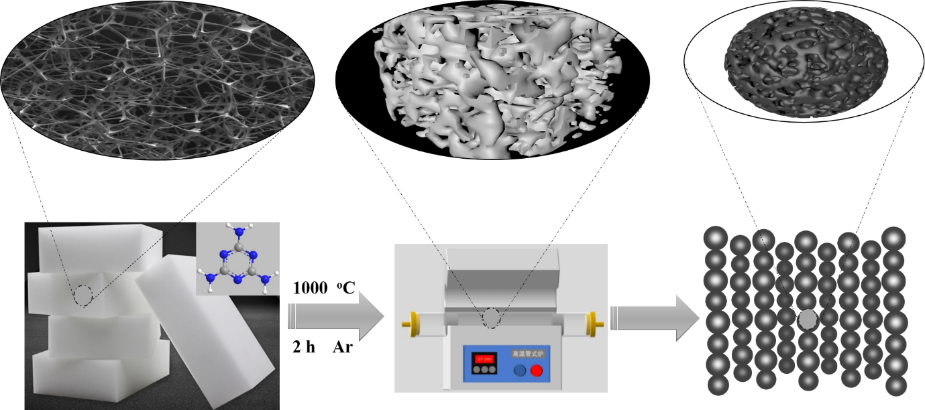
Scheme S1. Schematic diagram of the preparation process for 3D-NDCS
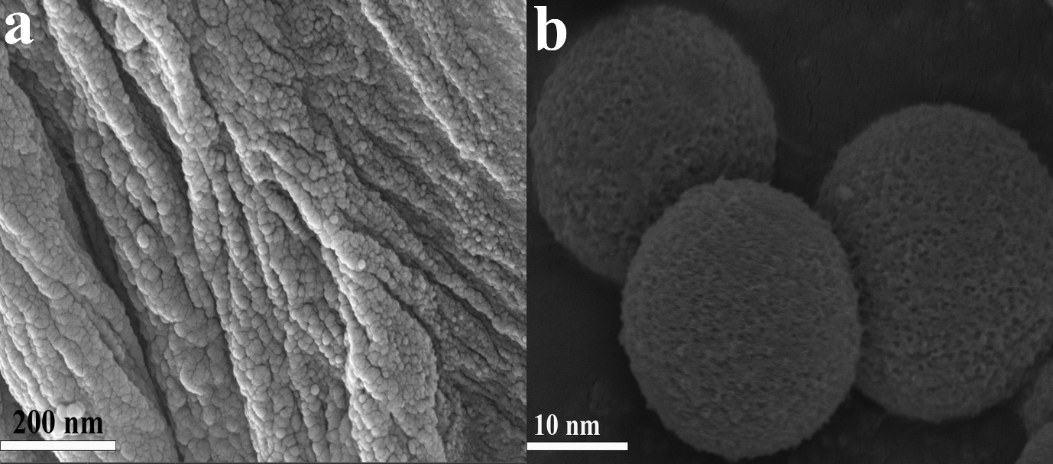
Figure S1. The SEM image of 3D-NDCS

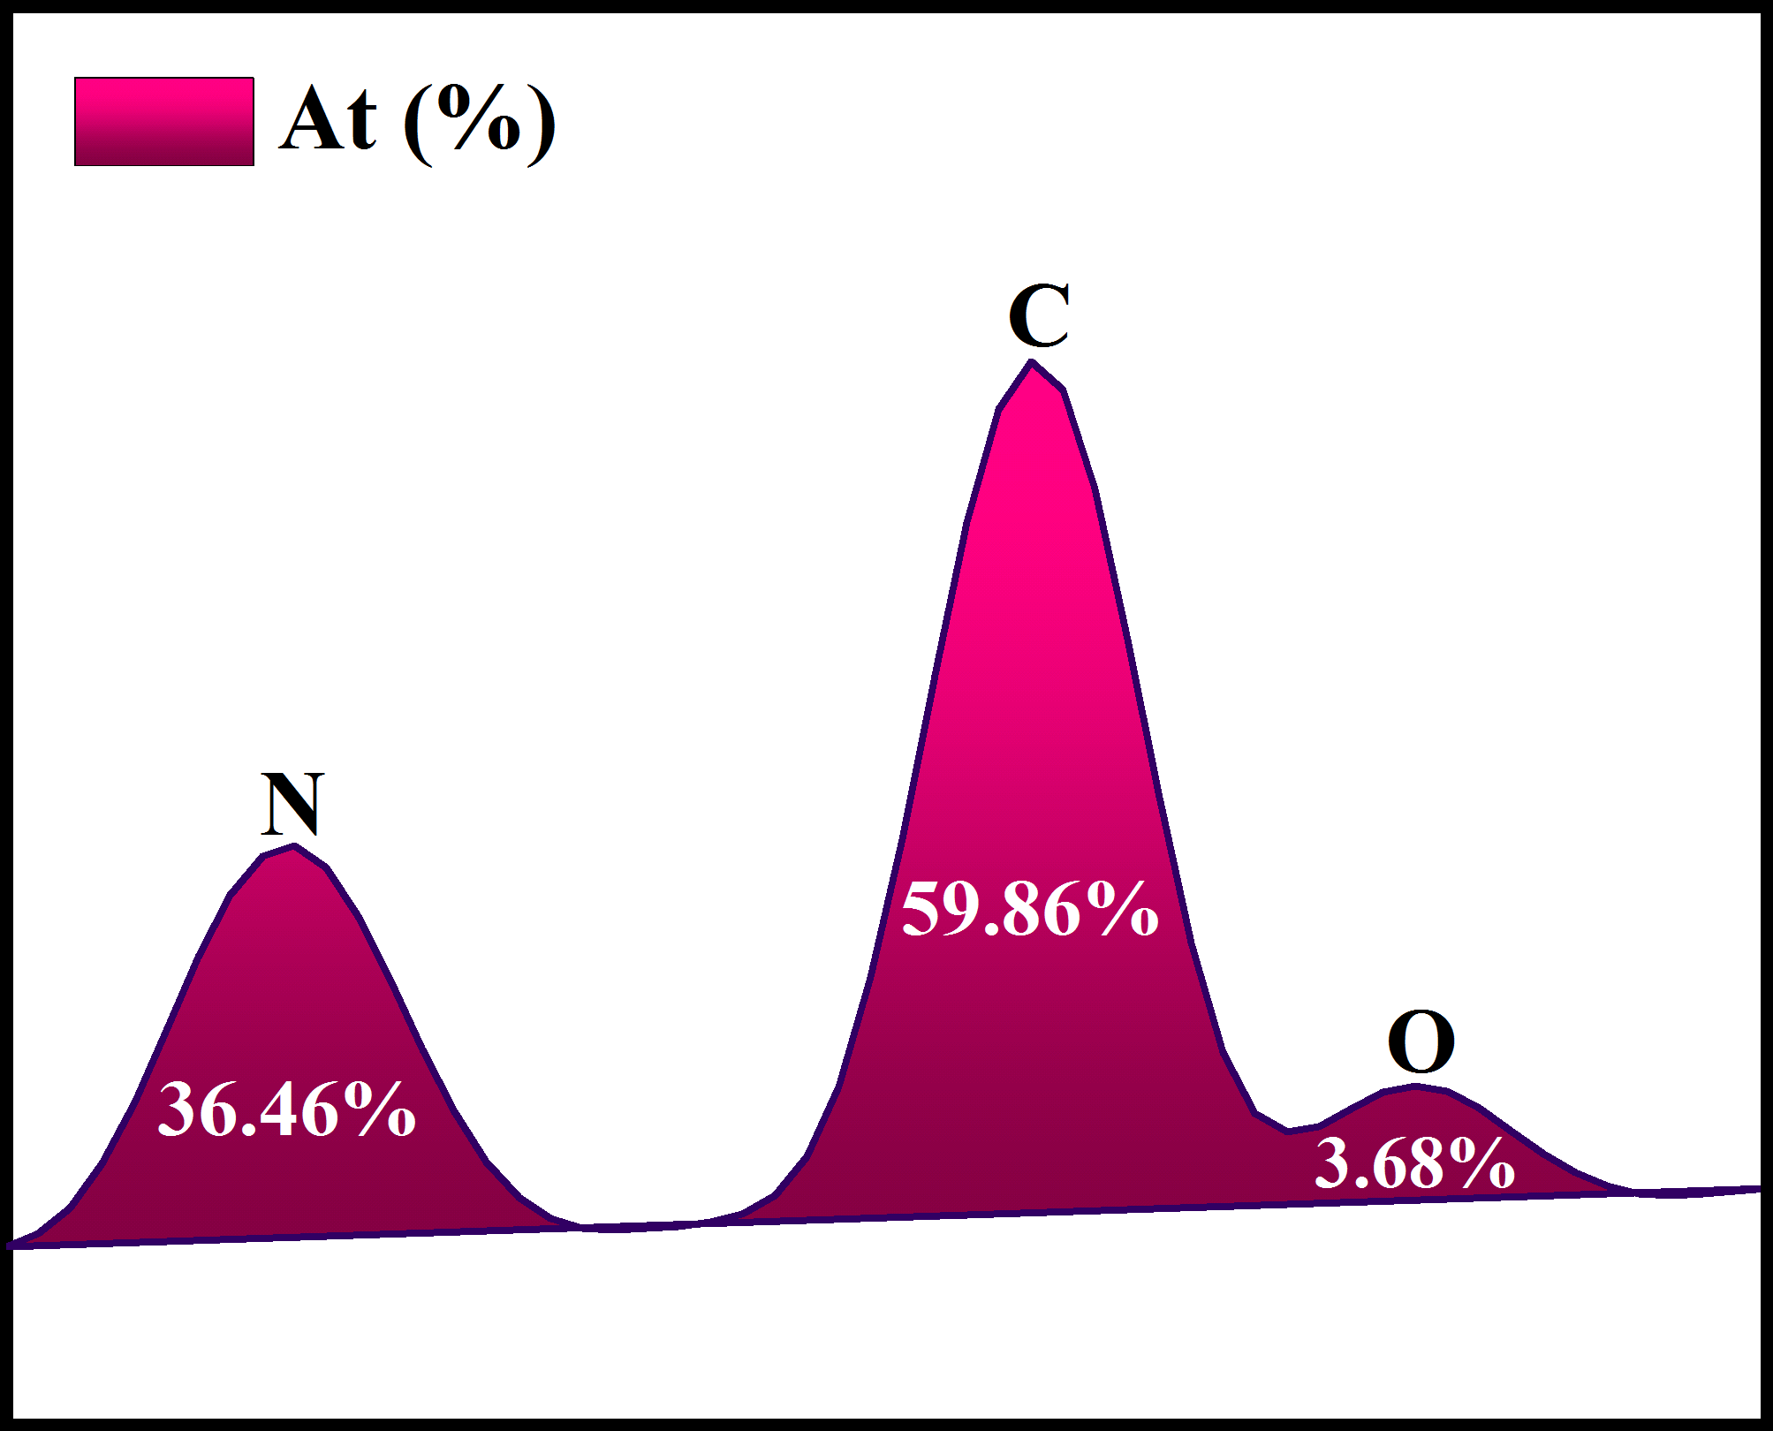
Figure S2. Content ratio of C, N and O elements from the EDX analysis.

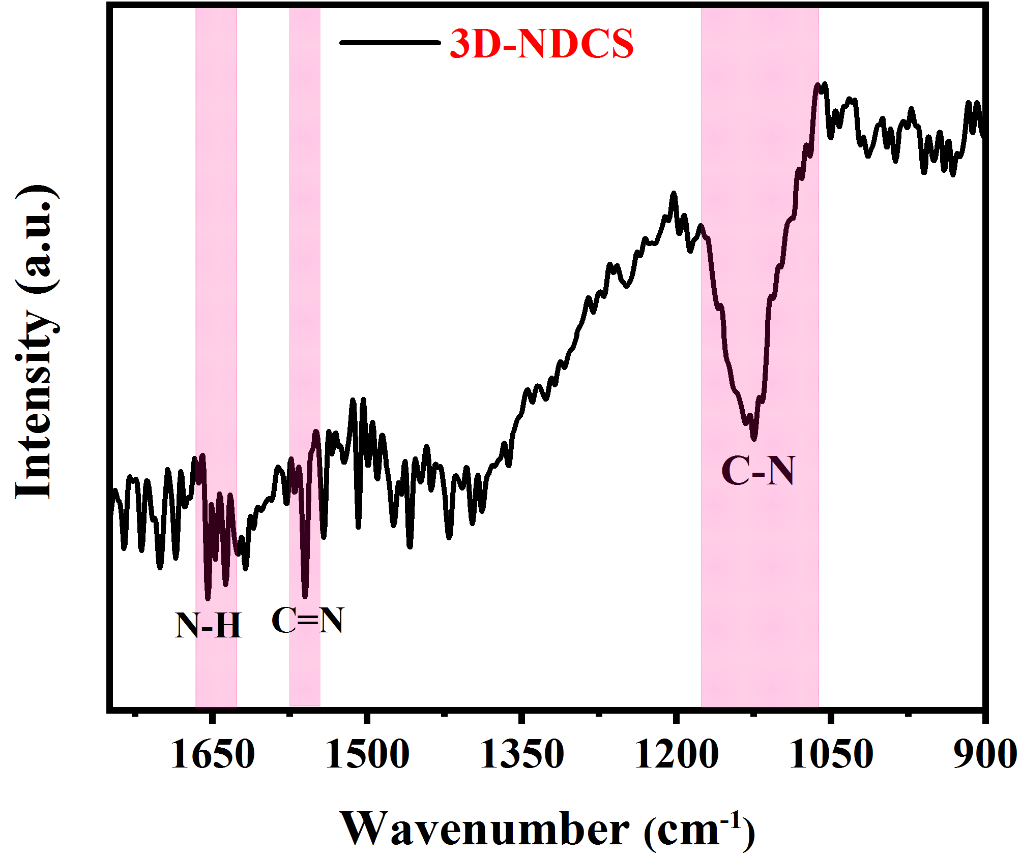
Figure S3. The FT-IR image of 3D-NDCS
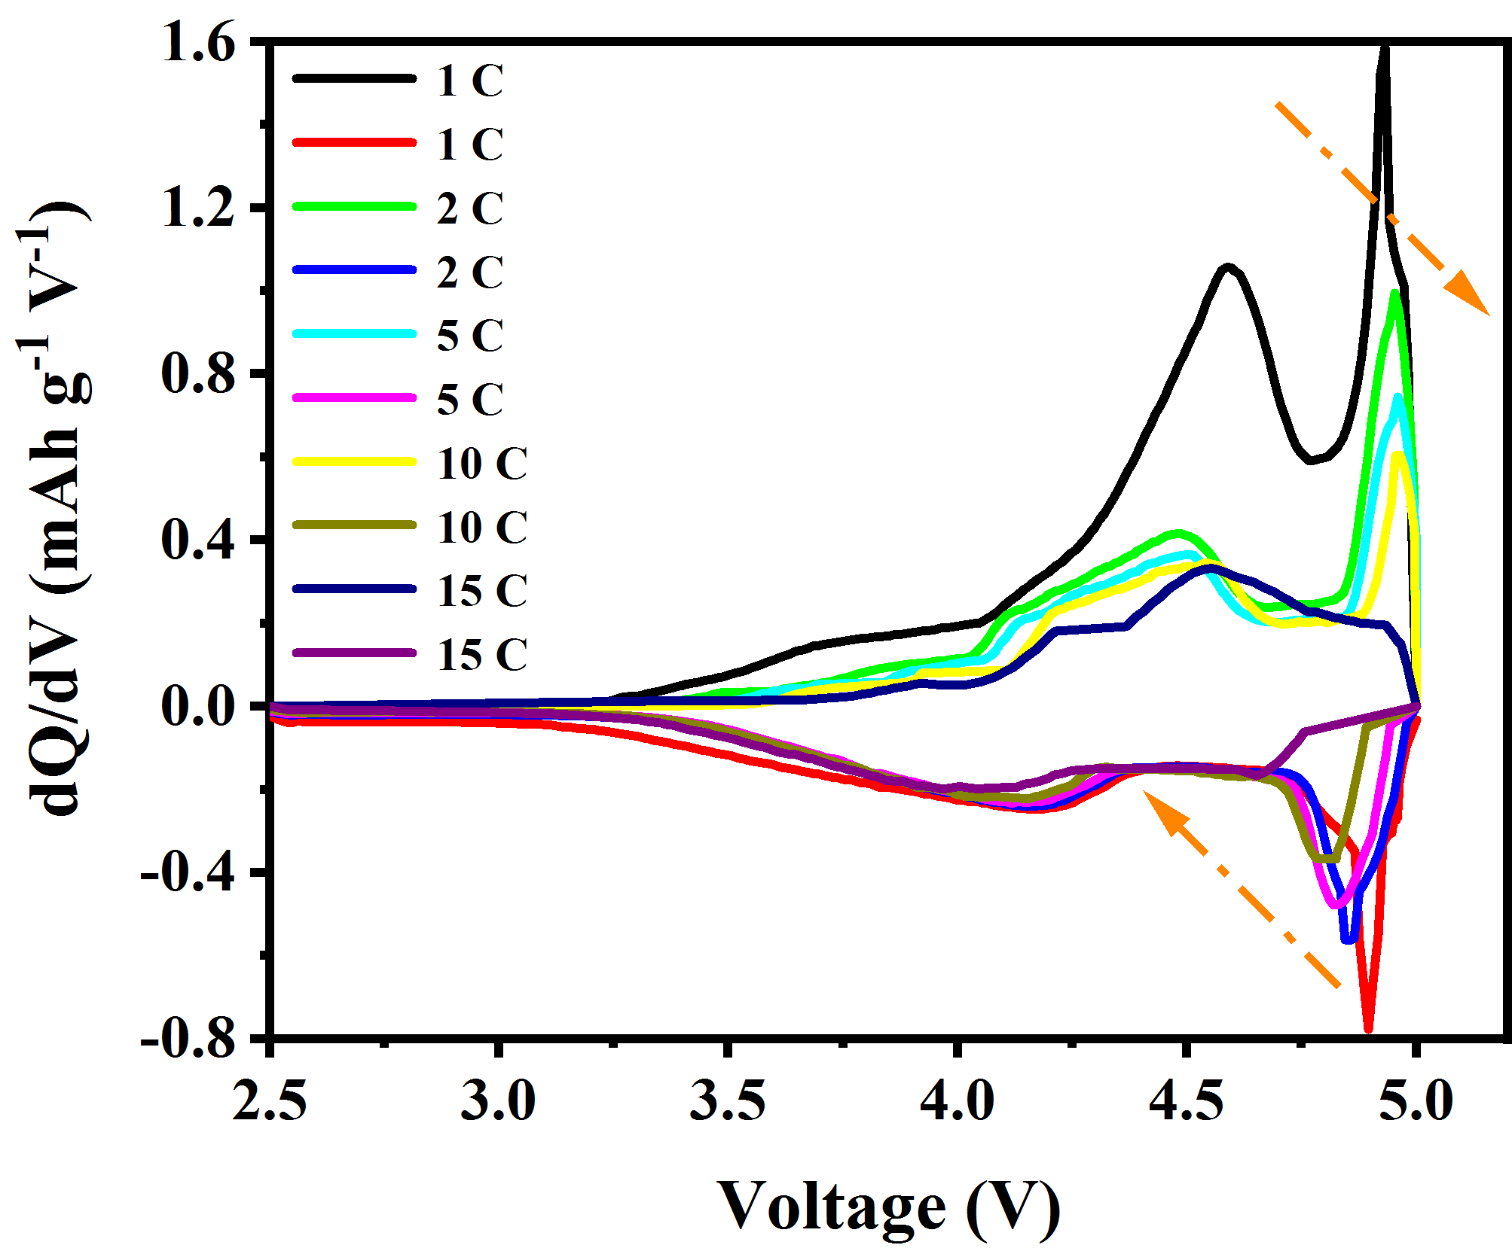
Figure S4. dQ/dV curves at different rates
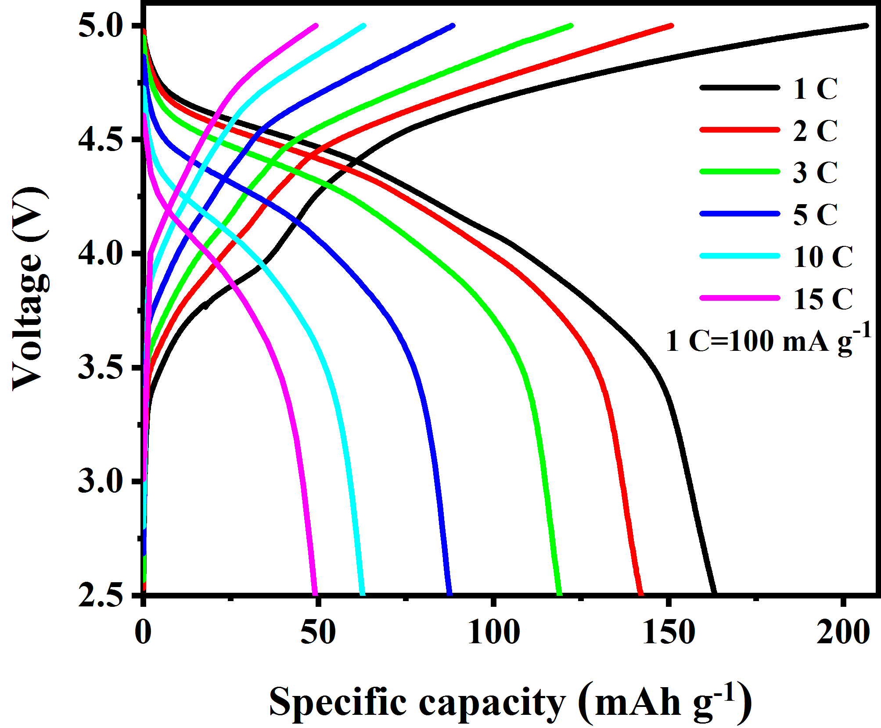
Figure S5. Galvanostatic charge-discharge curves under different rates based on the diluted electrolyted

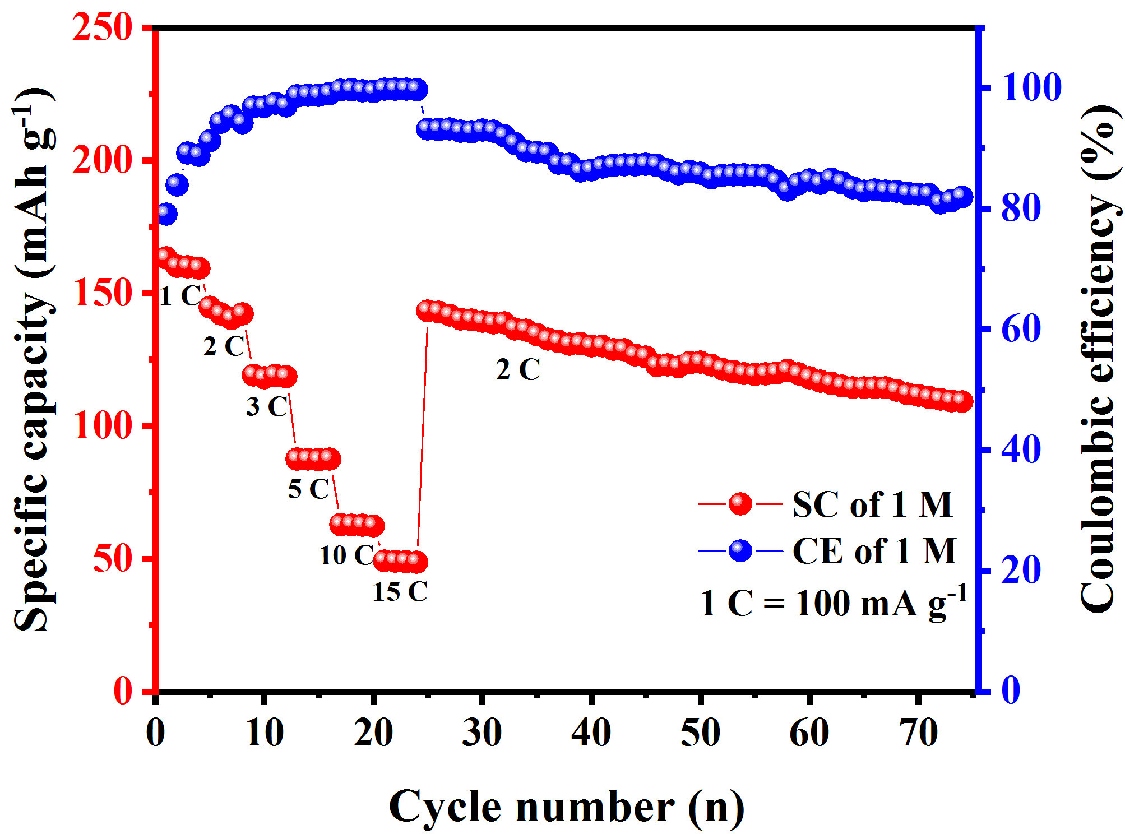
Figure S6. Rate capability performance based on diluted electrolyte
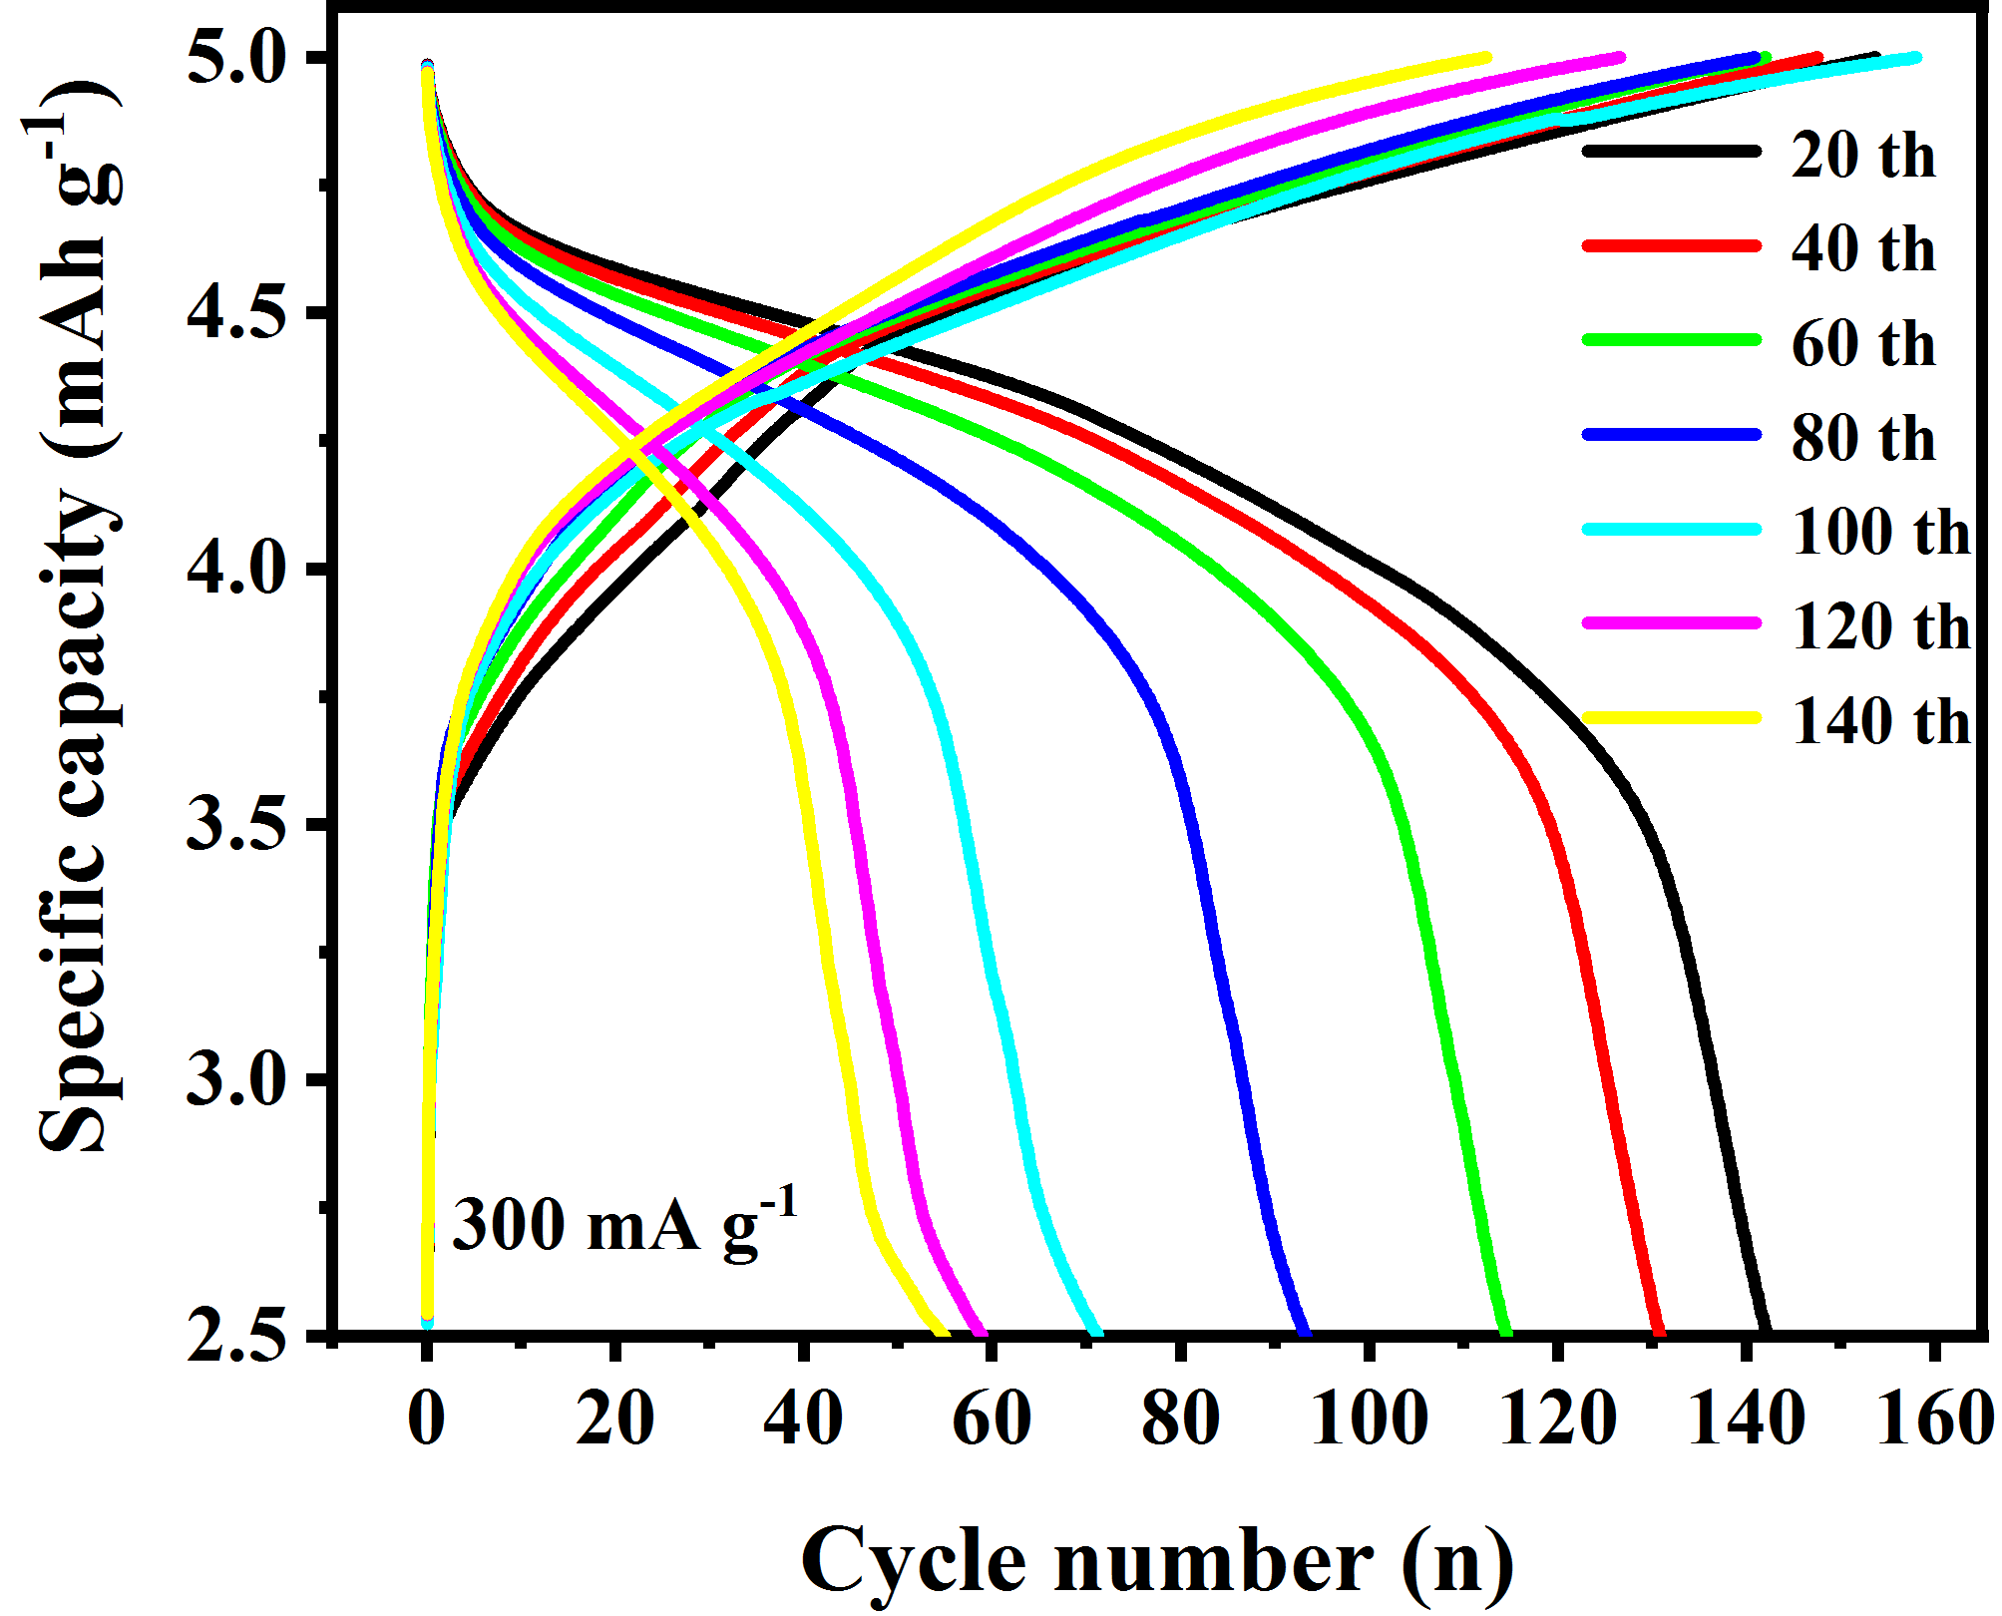
Figure S7. GCD curves of different cycles at 3 C based on diluted electrolyte

Figure S8. EIS curves and the corresponding equivalent circuit after different cycles based on the diluted electrolyte

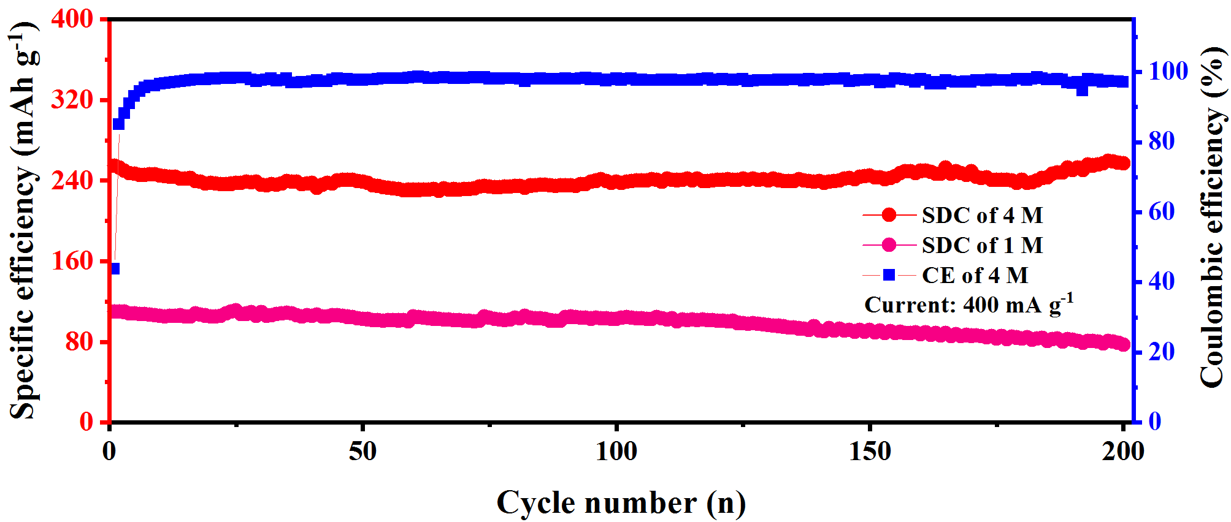
Figure S9. The long-term cycling performance of the concentrated/diluted electrolyte under 15 C.

Figure S10. High resolution N 1s characteristic peak
Figure S11. High resolution F 1s characteristic peak
Figure S12. High resolution F 1s characteristic peak
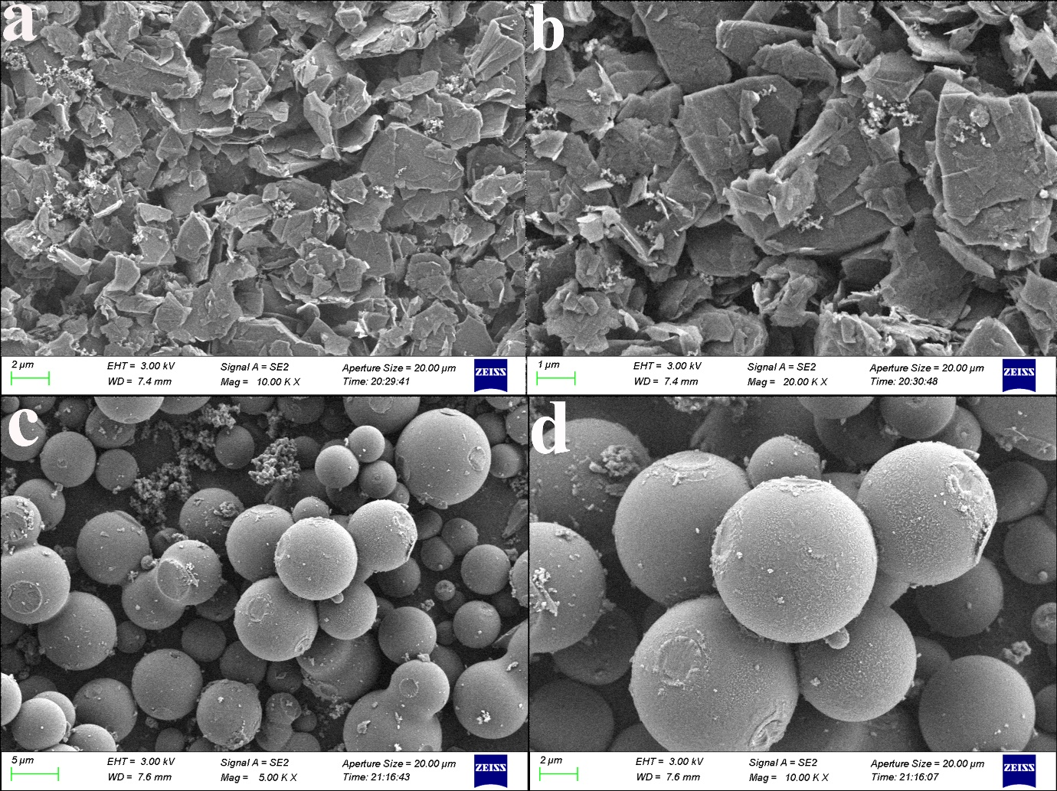
Figure S13. SEM images of cathode (a-b) and anode (c-d) after 200 cycles

