Supporting Information

Easily separated and sustainable cellulose-based adsorbent using a facile two-steps modification for highly efficient methylene blue removal
Keming Zhou,ª Lianpeng Yan,ª Rui Zhang,^{*a,b} and Xuedong Zhuª
a. Engineering Research Centre of Large Scale Reactor Engineering and Technology, Ministry of Education, School of Chemical Engineering, East China University of Science and Technology, 130 Meilong Road, Shanghai 200237, China.
b. Shanghai Key Laboratory of Green Chemistry and Chemical Processes, East China
Normal University, School of Chemistry and Molecular Engineering, Shanghai
200062, China.

* Corresponding authors.
E-mail address: r.zhang@ecust.edu.cn (R. Zhang).

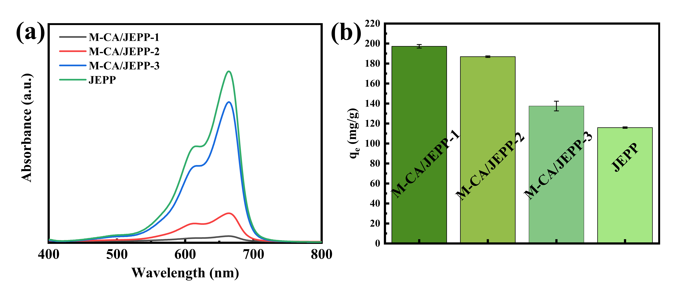
Fig. S1 UV-Vis absorption spectrum a) and the equilibrium adsorption capacity b) using different adsorbents, pH=11, initial dye concentration of 100 mg/L, 303 K and 10 mg of absorbents.
Fig. S2 The nitrogen adsorption-desorption isotherm of M-CA/JEPP.
The measurement of nitrogen adsorption-desorption isotherms and the Brunauer–Emmett–Teller (BET) surface area towards M-CA/JEPP was carried out. As seen from Figure S2, the isotherm could be classified as type IV with an apparent hysteresis loop, revealing the presence of mesopores. The BET specific surface area of M-CA/JEPP was 34.15 m²/g.
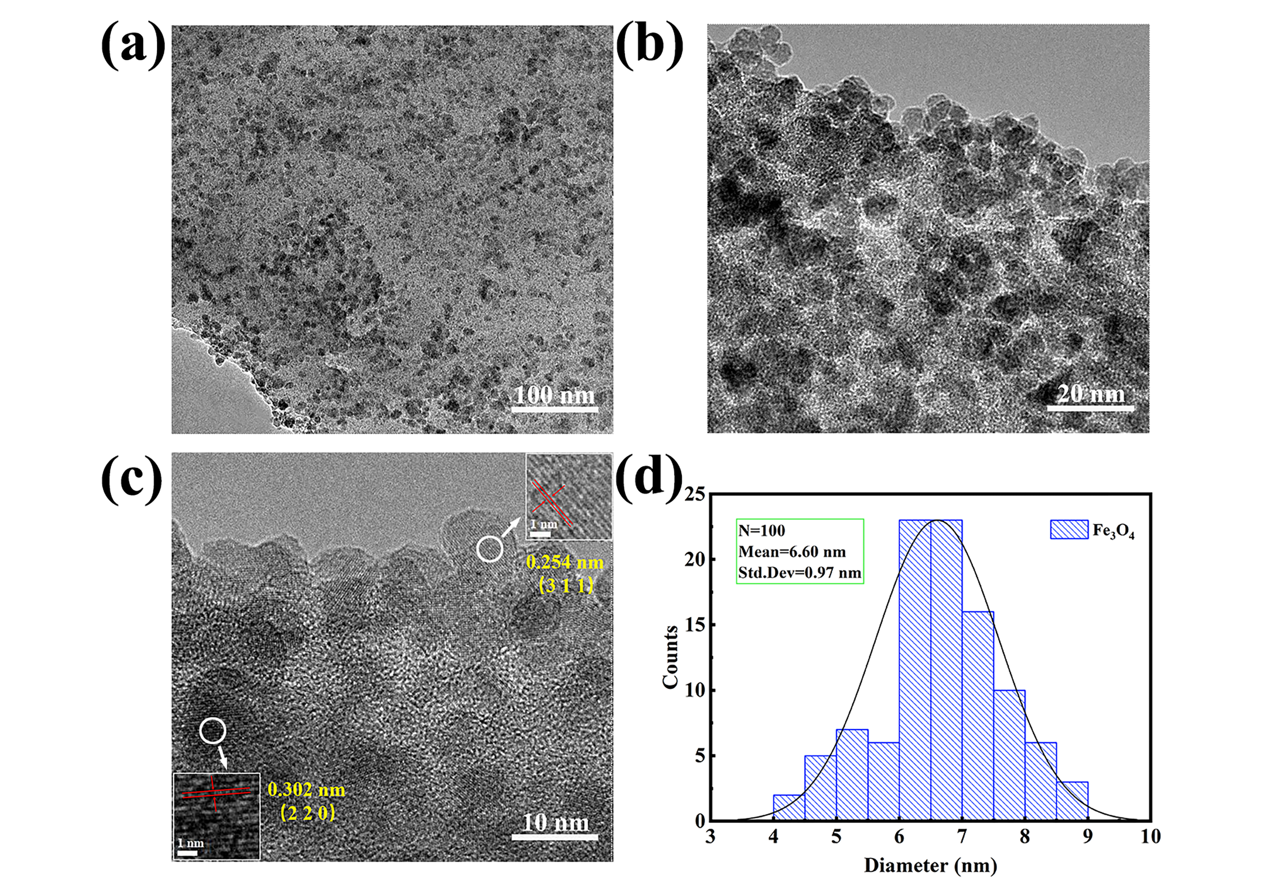
Fig. S3 TEM images of a-c) M-CA/JEPP; d) Size distribution histogram of the synthesized Fe₃O₄ nanoparticles.

Fig. S4 Thermodynamic fitting of MB adsorption at different concentrations.

Adsorption kinetic models:
Pseudo-first-order model:
$q_{t}=q_{e}\left(1-e^{-k_{1}t}\right)$ (S1)
Pseudo-second-order model:
$q_{t}=\frac{{q_{e}}^{2}k_{2}t}{1+q_{e}k_{2}t}$ (S2)
Intraparticle diffusion model:
$q_{t}=\frac{1}{β}\ln\left(αβ\right)+\frac{1}{β}\ln{t}$ (S3)
Elovich model:
$q_{t}=k_{p,i}t^{\frac{1}{2}}+C_{i}$ (S4)
where q_{t} (mg/g) and q_{e} (mg/g) are the adsorption capacity of dye adsorbed at time t (min) and at equilibrium, respectively. k₁ (min⁻¹) and k₂ (g mg⁻¹ min⁻¹) are rate constants for pseudo-first-order and pseudo-second-order models, respectively. α (mg g⁻¹ min) and β (g/mg) are the initial adsorption rate and the desorption coefficient for Elovich model, respectively. k_{p,i} (mg g⁻¹ min^{−0.5}) and C_{i} (mg/g) are the rate constant of the intraparticle diffusion model and the constant related to the thickness of the boundary layer, respectively.

Adsorption isotherm models:
Langmuir model:
$q_{e}=\frac{q_{max}k_{l}C_{e}}{1+k_{l}C_{e}}$ (S5)
Freundlich model:
$q_{e}={k_{f}C_{e}}^{1/n}$ (S6)
Temkin model:
$q_{e}=\frac{RT}{b_{T}}lnA_{T}+\frac{RT}{b_{T}}lnC_{e}, \frac{RT}{b_{T}}=B$ (S7)
where q_{max} (mg/g) and q_{e} (mg/g) are the maximum adsorption capacity and equilibrium adsorption capacity, respectively. C_{e} (mg/L) is the equilibrium concentration of dye solution; k_{l} (L/mg) and k_{f} [(mg/g)/(mg/L)^{1/n}] are empirical constants for Langmuir and Freundlich isotherms; b_{T}, A_{T} (L/g) and B (J/mol) are empirical constants for Temkin isotherm. R is gas constant (8.314 J mol⁻¹ K⁻¹) and T is temperature (K).

Separation factor:
$R_{L}=\frac{1}{1+k_{l}C_{0}}$ (S8)
where R_{L} is a dimensionless separation factor; C₀ (mg/L) is the initial dye concentration; k_{l} (L /mg) is empirical constants for Langmuir isotherm. The value of R_{L} predicts whether an adsorption system is irreversible (R_{L}=0), favorable (0<R_{L}<1), linear (R_{L}=1), or unfavorable (R_{L}>1).

Adsorption thermodynamic parameters were calculated as follows
$\ln{K_{d}=\frac{∆S}{R}}-\frac{∆H}{RT}$ (S9)
$K_{d}=\frac{q_{e}}{C_{e}}$ (S10)
$∆G=∆H-T∆S$ (S11)
where K_{d} is the distribution coefficient; C_{e} (mg/L) and q_{e} (mg/g) are the equilibrium concentration and adsorption capacity of dye solution, respectively. $∆G$ (kJ/mol), $∆S$(kJ mol⁻¹ K⁻¹) and $∆H$ (kJ/mol) are Gibbs free energy change, entropy change and enthalpy change, respectively. R is gas constant (8.314 J mol⁻¹ K⁻¹) and T is temperature (K).

Table S1 M-CA/JEPP Adsorbent Samples Made under Various Conditions
Samples | JEPP (g) | FeCl₃·6H₂O (g) | FeSO₄·7H₂O(g)
JEPP | 0.926 | 0 | 0
M:CA/JEPP-1 | 0.926 | 1.081 | 0.695
M:CA/JEPP-2 | 0.926 | 2.162 | 1.390
M:CA/JEPP-3 | 0.926 | 4.324 | 2.780

Table S2 Thermodynamic Parameters for Different Initial Concentrations of MB on M-CA/JEPP
Initial concentration (mg/L) | Temperature  (K) | Thermodynamic parameters
Initial concentration (mg/L) | Temperature  (K) | ΔH  (kJ/mol) | ΔS  [kJ/(mol K)] | ΔG  (kJ/mol)
50 | 303 | -5.755 | 0.026 | -13.558
50 | 313 | -5.755 | 0.026 | -13.816
50 | 323 | -5.755 | 0.026 | -14.073
50 | 333 | -5.755 | 0.026 | -14.331
100 | 303 | -9.752 | 0.009 | -12.463
100 | 313 | -9.752 | 0.009 | -12.553
100 | 323 | -9.752 | 0.009 | -12.642
100 | 333 | -9.752 | 0.009 | -12.731
150 | 303 | -4.039 | 0.014 | -8.268
150 | 313 | -4.039 | 0.014 | -8.407
150 | 323 | -4.039 | 0.014 | -8.547
150 | 333 | -4.039 | 0.014 | -8.686

