Extended Data Figures

Supplementary Table 1. Effect score of the bottom twenty mutations, with validations and references. Representations are the same as Table 1.
Mutation | VoC strains |  | Effect Score |  |  | Validations
Mutation |  |  |  |  |  | Stability |  |  | Affinity |  |  | Escape |  |  | References
R190S | γ |  | -0.0087 |  |  | － |  |  | － |  |  | － |  |  | NA
G446S | ο |  | -0.0087 |  |  | － |  |  | － |  |  | ＋ |  |  | NA
Q173H | None |  | -0.0095 |  |  | － |  |  | － |  |  | ＋ |  |  | NA
K1191N | None |  | -0.0120 |  |  | NA |  |  | NA |  |  | － |  |  | NA
D80Y | None |  | -0.0122 |  |  | ＋＋ |  |  | － |  |  | ＋＋ |  |  | NA
Y145- | None |  | -0.0149 |  |  | NA |  |  | NA |  |  | － |  |  | NA
H69- | α, ο |  | -0.0157 |  |  | NA |  |  | NA |  |  | － |  |  | (52)
P681R | δ |  | -0.0173 |  |  | NA |  |  | NA |  |  | ＋＋ |  |  | (33)
A570D | α |  | -0.0187 |  |  | ＋ |  |  | ＋ |  |  | － |  |  | NA
T572I | None |  | -0.0193 |  |  | ＋＋ |  |  | ＋ |  |  | ＋ |  |  | NA
R158- | None |  |  | -0.0243 |  |  | NA |  |  | NA |  |  | － |  |  | NA
L18F | β, γ |  |  | -0.0265 |  |  | － |  |  | － |  |  | ＋＋ |  |  | (6)
S98F | None |  |  | -0.0325 |  |  | － |  |  | － |  |  | ＋＋ |  |  | NA
P26S | γ |  |  | -0.0337 |  |  | － |  |  | － |  |  | ＋＋ |  |  | NA
Y144V | None |  |  | -0.0361 |  |  | － |  |  | ＋ |  |  | － |  |  | NA
L5F | None |  |  | -0.1210 |  |  | NA |  |  | NA |  |  | － |  |  | NA
W152C | None |  |  | -0.1489 |  |  | ＋＋ |  |  | － |  |  | ＋＋ |  |  | (23)
A701V | β |  |  | -0.1624 |  |  | ＋＋ |  |  | － |  |  | ＋＋ |  |  | NA
D253G |  | None |  |  | -0.5367 |  |  | NA |  |  | － |  |  | － |  |  | NA
S13I |  | None |  |  | -0.7669 |  |  | NA |  |  | NA |  |  | － |  |  | (23)

Supplementary Table 2. List of the investigated proteins of the receptor-binding domain (RBD). RBD-1 and RBD-2 are both mutant proteins; RBD-WT represents the wildtype.
RBDs | Mutations
RBD-1 | T478K, N501Y, S477N, Q498R, S371F, R408S, E484K
RBD-2 | T478K, N501Y, S477N, Q498R, R408S, E484K, D405N
RBD-WT | None

Supplementary Table 3. The human angiotensin-converting enzyme 2 (ACE2) binding affinity of studied proteins of the receptor-binding domain (RBD): K_{D}, equilibrium disassociation constant; K_{a}, association rate constant; K_{d}, disassociation rate constant. (n=3)
RBDs | Mean
RBDs | K_{D}(M) | K_{a}(10⁵Ms⁻¹) | K_{d}(s⁻¹) | x²(RU²)
RBD-1 | 4.15×10⁻¹⁰ | 3.47 | 1.44×10⁻⁴ | 0.005
RBD-2 | 4.06×10⁻⁹ | 4.12 | 1.67×10⁻³ | 0.009
RBD-WT | 3.14×10⁻⁸ | 2.90 | 9.10×10⁻³ | 0.006

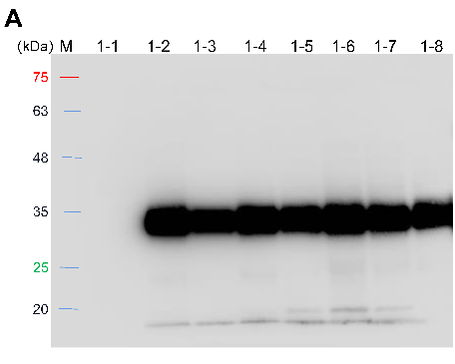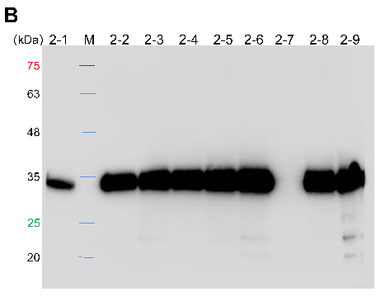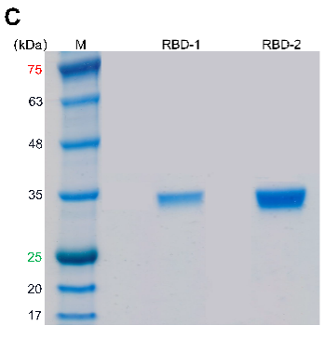
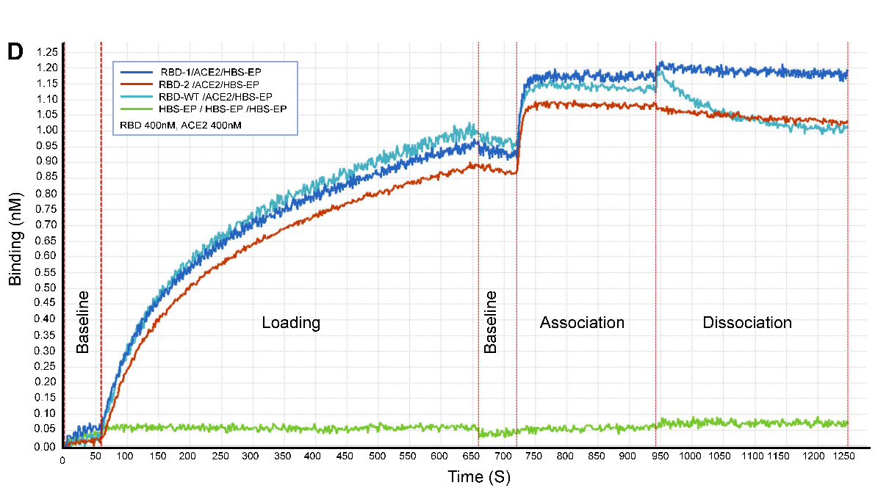
Supplementary Fig. 1. A. Western blot analysis of various glycoengineered clones of RBD-1. B. Western blot analysis of various glycoengineered clones of RBD-1. C. Sodium dodecyl sulfate–polyacrylamide gel electrophoresis (SDS-PAGE) analyses of RBD-1 and RBD-2 proteins. D. RBD-ACE2 binding kinetics of studied proteins of the receptor-binding domain (RBD). In the legend box, the samples separated by slash “/” represent stages of sample molecules: Loading, Association, and Dissociation, respectively.
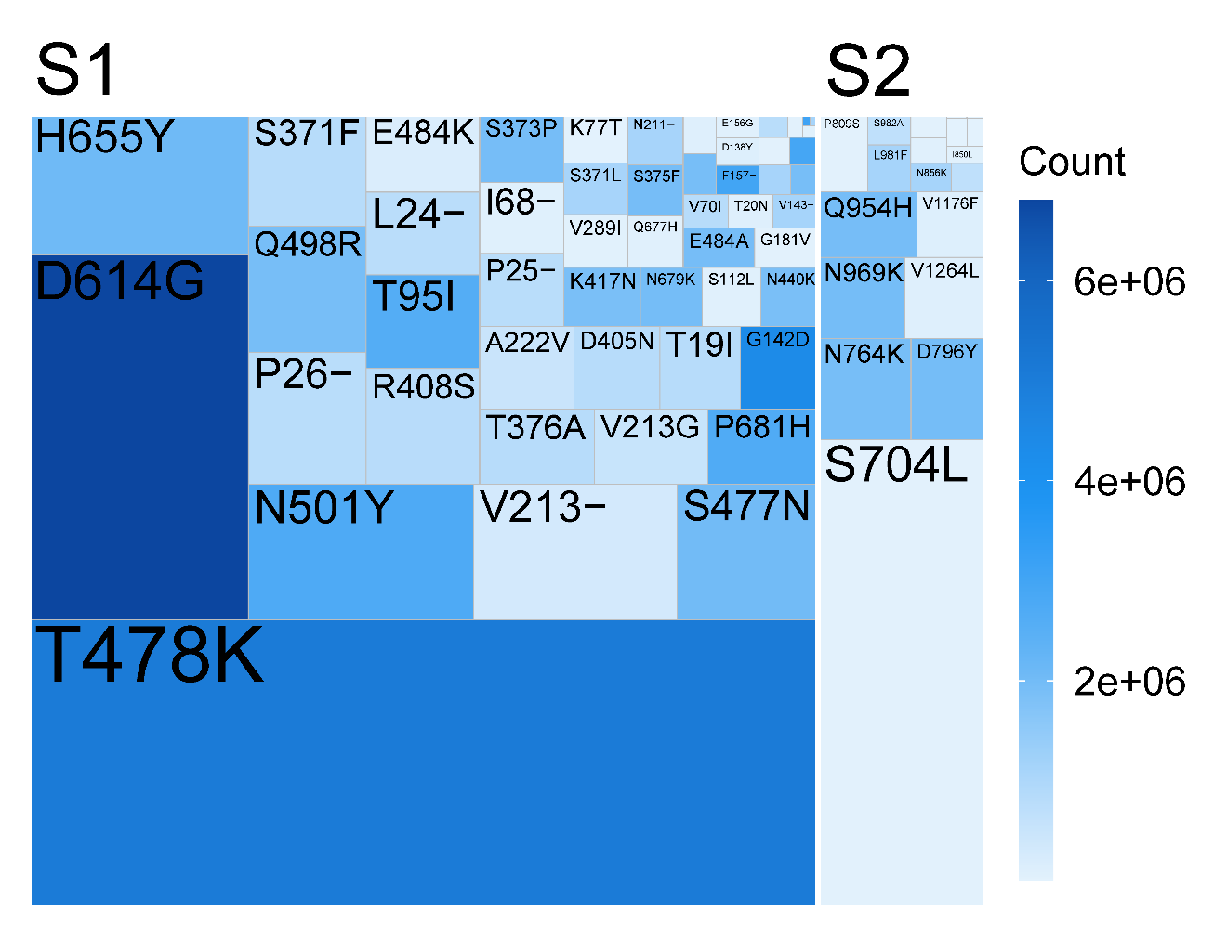 Supplementary Fig. 2. Treemap of Spike mutations. The size represents the effect score of mutations, and the color represents the count of mutational occurrences. Mutations of the S1 and S2 subunits are grouped respectively.

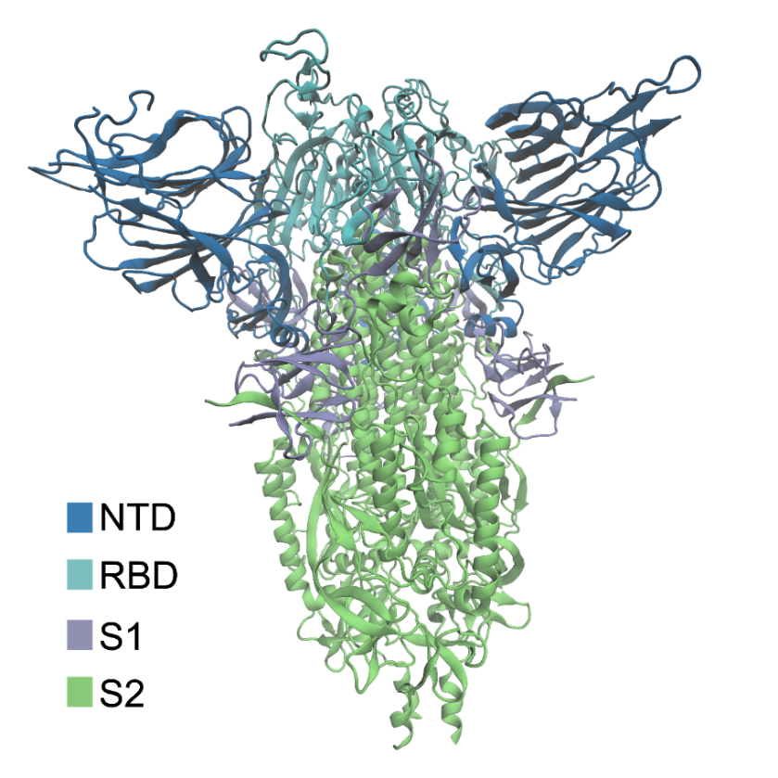
Supplementary Fig. 3. Structure of the Spike protein in closed conformation (PDB: 7DDD) (39), visualized by Visual Molecular Dynamics (VMD) (50, 51). Colors represent different domains and subunits: blue, the N-terminal domain (NTD); cyan, the receptor-binding domain (RBD); grey, the S1 subunit; green, the S2 subunit. Note that RBD and NTD are particularly distinguished from other parts of the S1 subunit by different colors.

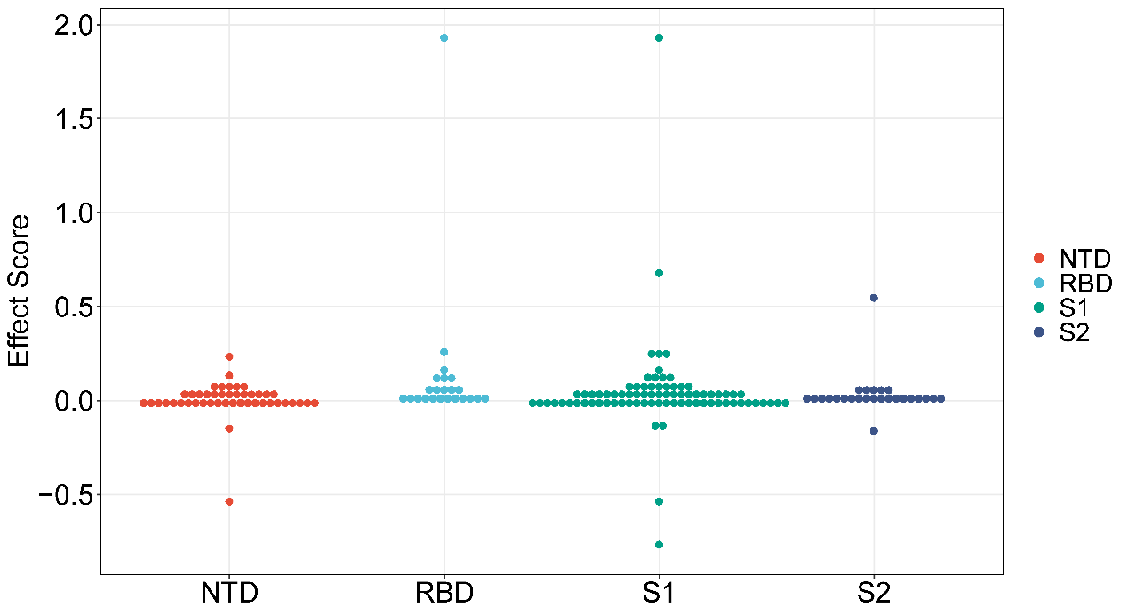Supplementary Fig. 4. Dot plot of effect scores of mutations, grouped by different subunits and domains: the N-terminal domain (NTD), the receptor-binding domain (RBD), the S1 subunit, and the S2 subunit. Dot-density binning is applied, with each dot representing one or two close observations. Note that mutations of RBD and NTD are also included in the S1 subunit.

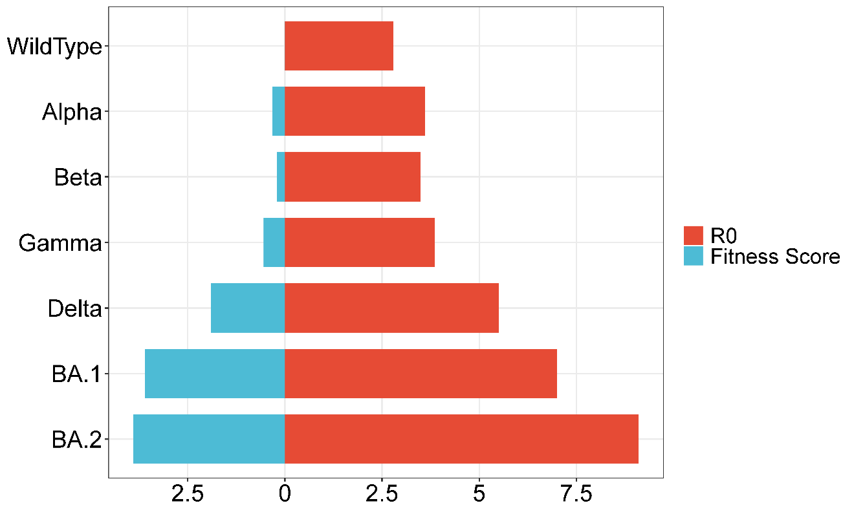
Supplementary Fig. 5. Fitness score and R0 of wildtype and VoC strains. For Omicron strains, BA.1 and BA.2 are investigated. The fitness score of the wildtype is zero.

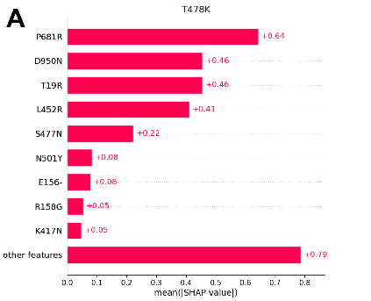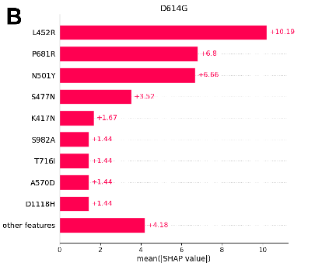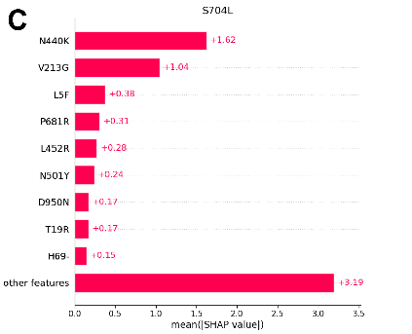
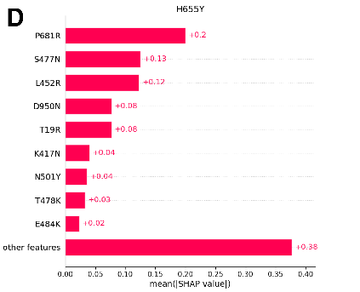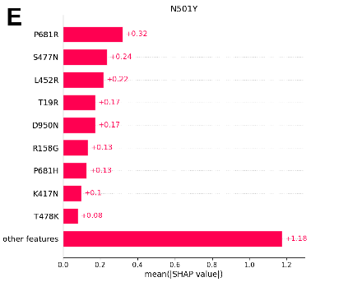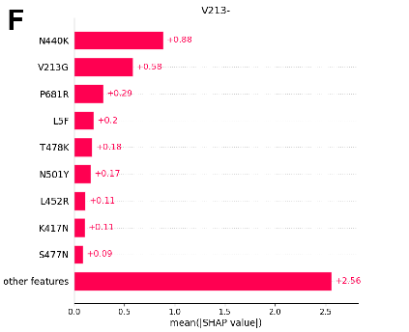
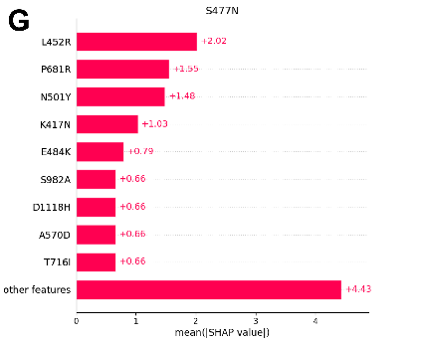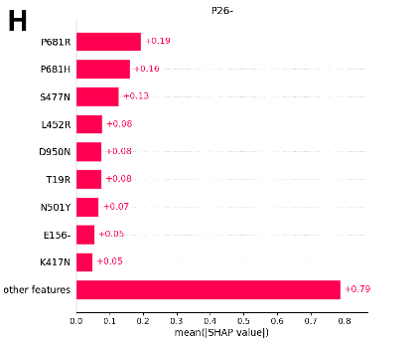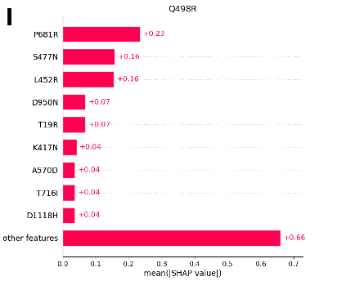
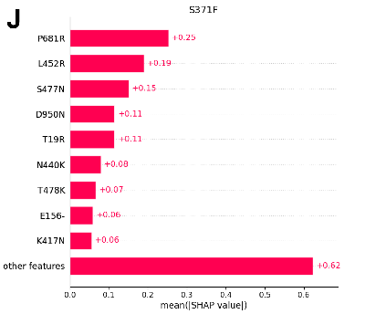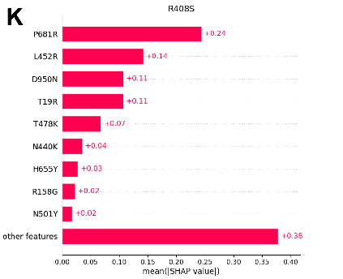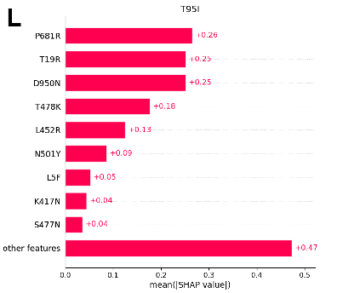
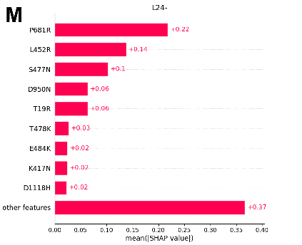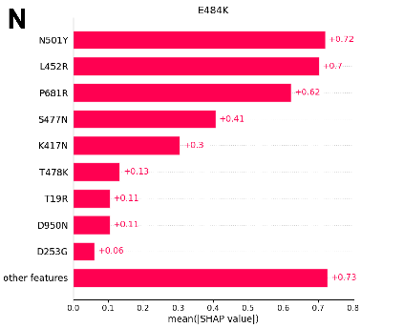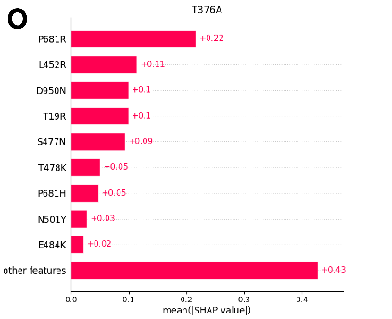
Supplementary Fig. 6. Mean absolute value of SHAP values in the causal inference model for top mutations. A. T478K. B. D614G. C. S704L. D. H655Y. E. N501Y. F. V213-. G. S477N. H. P26-. I. Q498R. J. S371F. K. R408S. L. T95I. M. L24-. N. E484K. O. T376A. Top features in the model are explicitly shown with values.
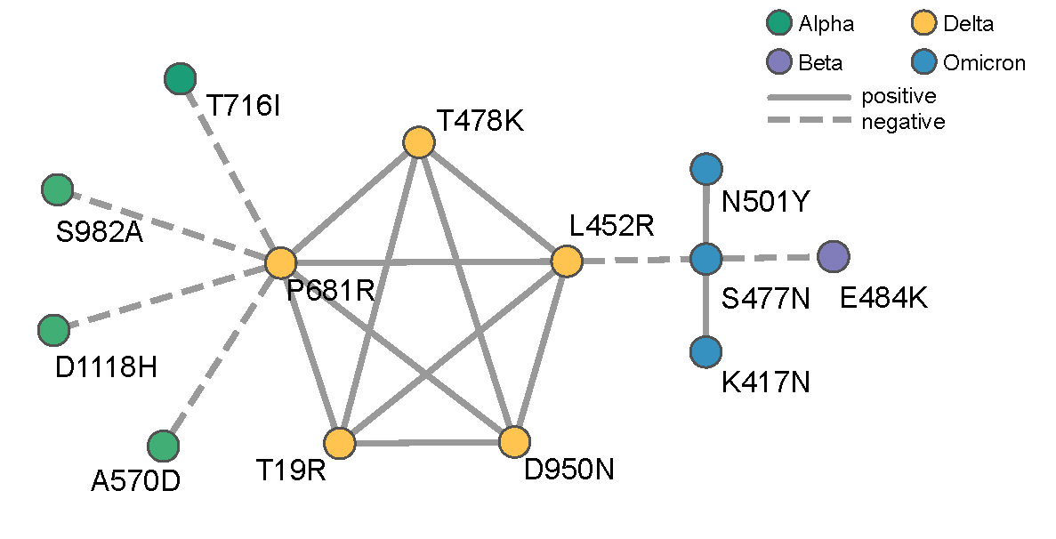
Supplementary Fig. 7. Possible interactions between mutations, colored by related VoC variants. Positive and negative interactions are represented by different line types.

