SUPPLEMENTARY

(A)

(B)
Figure S1: VIVACIOUS study design and CONSORT diagram
(A), Study design and analyses conducted; blood sampling timepoints at baseline (BASE, between 1st and 2nd dose (PRE2D), at 1 week (1W), 1 month (1M), 4-6 months (4-6M) and 10-12 months (10-12M) following the second vaccine dose (B), CONSORT diagram of patients received initial vaccination series and boosters, *patients who died of their malignant disease.

Table S1. List of antigens used to generate antigen microarrays

Antigen Name (Used in Assay) | Antigen full name | Company/source
A1AR | Alpha 1A adrenergic receptor (A1AR) fragment | GenScript
Actin (Bovine) | Actin | Sigma
Actin Rabbit | Actin (rabbit muscle) | Molecular Probes
Aggrecan | Aggrecan | Sigma
Aldolase, Type X | Aldolase, Type X | Sigma
Alpha elastin | Alpha-elastin | Dr Fred Keeley lab (University of Toronto)
alpha-Actinin | Alpha-actinin | Sigma
Alpha-KGDH | Alpha-ketoglutarate dehydrogenase | Sigma
Alpha B-crystallin | Alpha B-crystallin | Enzo (Stressgen)
Asparaginyl-tRNA Synthetase | Asparaginyl-tRNA Synthetase (KS) | Diarect
AT1 | angiotensin 2 receptor (AT1R) fragment | GenScript
B1AR | Beta 1 adrenergic receptor (B1AR) fragment | GenScript
B2AR | Beta 2 adrenergic receptor (B2AR) fragment | GenScript
BCOADC-E2 | branched chain 2-oxo-acid dehydrogenase complex | Diarect
Beta 2 Glyc (recombinant human) | Beta 2 Glycoprotein I | Diarect
Beta 2 GPI (non-recombinant) (Bovine) | Beta 2 Glycoprotein I | Diarect
Beta 2 GPI (non-recombinant) (Human) | Beta 2 Glycoprotein I | Diarect
Bovine Histone H4 and H2A | Bovine Histone H4 and H2A | Immunovision
Bovine Histone subclass F1 | Bovine Histone subclass F1 | Immunovision
Bovine Histone H2b (F2b) | Bovine Histone H2b (F2b) | Immunovision
Bovine Histone H3 | Bovine Histone H3 | Immunovision
BPI | Bactericidal/Permeability Increasing protein | Diarect
C1q (purified non-recombinant) | Complement component C1q | Sigma
Carbonic Anhydrase | Carbonic Anhydrase VI (CAG) | MyBiosource
Cardiolipin C1649 | Cardiolipin | Sigma
CENP-A | Centromere Protein A | Diarect
CENP-B | Centromere Protein B | Diarect
Collagen I | Collagen, I | Sigma
Collagen III | Collagen, III | Sigma
Antigen Name (Used in Assay) | Antigen full name | Company/source
Collagen IV | Collagen, IV | Sigma
Collagen V | Collagen, V | Sigma
Collagen VI | Collagen, VI | Sigma
Desmin | Desmin | GenWay
DNA Topoisomerase I (Scl-70; non recombinant; bovine) | DNA Topoisomerase I | Diarect
dsDNA (genomic) | Deoxyribonucleic acid, double stranded | Sigma
dsDNA (plasmid) | DNA circular plasmid, Double Stranded | Diarect
Ebna peptide | EBV nuclear antigen | Stanford
Enolase | Enolase | Sigma
Fib I | Fibrinogen, type I | Sigma
Fib I-S | Fibrinogen, type I-S | Sigma
Fib IV | Fibrinogen, type IV | Sigma
GBM, diss | Glomerular Basement Membrane (GBM; dissociated) | Diarect
Gliadin | Gliadin | Diarect
Glycyl-tRNA Synthetase (EJ) | Glycyl-tRNA synthetase (EJ) | Diarect
GP2 | Zymogen granule membrane glycoprotein 2 | Diarect
gp210 | glycoprotein 210 | Diarect
Grp78/BiP | GRP78 (HSPa5 or BiP) immunoglobulin heavy chain-binding protein | Enzo (Stressgen)
HCEC cytop | Human Cardiac Endothelial Cells Lysate | Dr Vivek Rao's lab (University Health Network)
HCEC memb | Human Cardiac Endothelial Cell Lysate | Dr Vivek Rao's lab (University Health Network)
HCEC total (SDS) | Human Cardiac Endothelial Cell Lysate | Dr Vivek Rao's lab (University Health Network)
HCEC total (Triton) | Human Cardiac Endothelial Cell Lysate | Dr Vivek Rao's lab (University Health Network)
Heparin | Heparin Sulfate | Sigma
Histone H2A-H2B dimers | Histone H2A-H2B dimers | EMDMillipore
Histone H2B | Histone H2B | Active Motif
Histone H3 (1-136 aa) | Histone H3 (1-136 aa) | RayBiotech
Histone H4 (1-103 aa) | Histone H4 (1-103 aa) | RayBiotech
HMG CoA | 3-hydroxy-3-methylglutaryl-Coenzyme A Reductase | Cayman
Antigen Name (Used in Assay) | Antigen full name | Company/source
HSP 27 | Heat shock protein 27 | Enzo (Stressgen)
HSP 40 | Heat shock protein 40 | Enzo (Stressgen)
HSP 47 | Heat shock protein 47 | Enzo (Stressgen)
HSP 60 | Heat shock protein 60 | Enzo (Stressgen)
HSP 70 | Heat shock protein 70 | Enzo (Stressgen)
HSP 90 | Heat shock protein 90 | Enzo (Stressgen)
human albumin | Human albumin | Sigma
human C1q (Abcam) | Native Human C1q protein | Abcam
Human core histones | Human core histones | RayBiotech
human fgl2 | fibrinogen-like 2 | Dr Gary Levy (University Health Network)
Human H1 Chromatin | Human H1 Chromatin | Dr Joan Wither (University Health Network)
Human IgA | Human IgA | Jackson Immunoresearch
Human IgE | Human IgE | Abcam
Human IgG | Human IgG | Jackson Immunoresearch
human IgG F(ab)2 | Human IgG F(ab)2 fragment | Jackson Immunoresearch
human IgG Fc | Human IgG Fc fragment | Jackson Immunoresearch
Human IgM | Human IgM | Jackson Immunoresearch
human intestinal smooth muscle cell | Human Intestinal Smooth Muscle Cell Lysate | ScienCell Research Laboratories
Human LEDGF | lens epithelium-derived growth factor) or dense fine speckles 70kD protein (DFS 70) | R&D Systems
Human LGALS3/Galectin 3 | Human LGALS3/Galectin 3 | LSBio
human nucleosome | Human nucleosome | EpiGex
ICAM-1 | Inter-Cellular Adhesion Molecule 1 | ProSci
Insulin | Insulin | Sigma
Intrinsic Factor | Intrinsic Factor | Diarect
Jo-1 | Histidyl-tRNA synthetase | Diarect
kidney endothelial cell lysate | Kidney Endothelial Cell Lysate | Dr. Anna Konvalinka (University Health Network)
Ku (p70/p80) | Ku (p70/p80) | Diarect
La (SS-B) antigens (Immunovision) | La (SS-B) antigens (47 kD ribonucleic protein) | Immunovision

Antigen Name (Used in Assay) | Antigen full name | Company/source
La/SS-B (Recombinant, human diarect) | La (SS-B) Antigens (47 kD ribonucleic protein) | Diarect
Laminin | Laminin | Sigma
LCI | liver cytosol type 1 antigen | Diarect
LG3 | immunogenic fragment of perlecan | Dr Marie-Josee Hebert (University of Montreal)
LKM 1 hp | Cytochrome p450 2D6 | Diarect
M2 | The branched-chain α-ketoacid dehydrogenase complex: BCKDC or BCKDH complex) | Diarect
M2AR | M2 Muscarinic Receptor | GenScript
MDA5 | melanoma differentiation-associated protein 5 | Diarect
Measles | Measles antigen | Meridian
Mi-2 | Subunit of the nucleosome remodelling deacetylase (NuRD) complex | Diarect
mouse fgl2 | Mouse fibrinogen-like 2 | Dr Gary Levy (University Health Network)
mouse IgG F(ab')2 | mouse IgG F(ab')2 | Jackson Immunoresearch
mouse IgG Fc | mouse IgG Fc | Jackson Immunoresearch
mouse IgM | mouse IgM | Biolegend
MPO | Myeloperoxidase (MPO) | Diarect
Muscarinic Receptor 3 | Muscarinic acetylcholine receptor 3, fragment | GenScript
MYH6 | alpha cardiac myosin heavy chain | CUSABIO
Myosin Bind Protein C | Myosin Binding Protein C | Dr. Sadayappan (Loyola University)
Myosin | Myosin, calcium activated | Sigma
Nucleolin | Nucleolin | Diarect
Nucleosome (non-recombinant; bovine) | Nucleosome | Diarect
Nup62 | nucleoporin Nup62 | Diarect
OGDC-E2 | 2-oxoglutarate dehydrogenase complex | Diarect
Ox LDL | Copper Oxidized human LDL | Academy Bio-Medical Company
PBS | phosphate buffered saline | Wisent Bioproducts
PCNA | Proliferating cell nuclear antigen | Diarect
PDC-E2 | E2 component of mitochondrial pyruvate dehydrogenase complex | Diarect
PDH | Pyruvate dehydrogenase | Sigma
PL-12 | Alanyl-tRNA Synthase (PL-12) | Diarect
PL-7 | Threonyl-tRNA Synthase (PL-7) | Diarect

Antigen Name (Used in Assay) | Antigen full name | Company/source
PM/Scl 100 | polymyositis/scleroderma (PM/Scl) complex 100 | Diarect
PM/Scl 75 | polymyositis/scleroderma (PM/Scl) complex 75 | Diarect
Porcine Myosin Heart | Myosin, calcium activated, porcine heart | Sigma
PR3 | Proteinase 3 | Diarect
Proteoglycan | Proteoglycan | Sigma
Recombinant Histone H2A (hu) | Recombinant Histone H2A (hu) | Active Motif
Ribo P0 | Ribosomal Phosphoprotein P0 | Diarect
Ribo P1 | Ribosomal Phosphoprotein P1 | Diarect
Ribo P2 | Ribosomal Phosphoprotein P2 | Diarect
RNP/Sm (non-recombinant; bovine) | RNP/Sm (non-recombinant; bovine) | Diarect
Ro/SS-A (52 kDa, human recombinant) | Ro/SS-A (52 kDa) | Diarect
Ro/SS-A (60 kD; non-recombinant; bovine) | Ro/SS-A (60 kDa) | Diarect
Ro/SS-A (60kD; recombinant) | Ro/SS-A (60 kDa) | Diarect
SCGB1A1 | Secretoglobin family 1A member 1 | Sigma
Scl-70 Full | DNA Topoisomerase I (Scl-70) full length | Diarect
Scl-70: trunc | DNA Topoisomerase I (Scl-70) truncated | Diarect
Sm (non-recombinant; bovine) | Sm | Diarect
Sm Antigens | Sm Antigens | Immunovision
SmD | SmD | Diarect
SmD1 | Human small nuclear ribonucleoprotein D1 polypeptide (SNRPD1; SmD1). | Diarect
SmD2 | Human small nuclear ribonucleoprotein D2 polypeptide (SNRPD2; SmD2). | Diarect
SmD3 | Human small nuclear ribonucleoprotein D3 polypeptide (SNRPD3; SmD3). | Diarect
snRNP 68 | U1-snRNP 68 Protein | Diarect
snRNP 68 B/B | U1-snRNP 68 Protein B/B | Diarect
snRNP A | U1-snRNP A Protein | Diarect
snRNP C | U1-snRNP C Protein | Diarect
SP-D | Surfactant protein D | Novusbio
Sp100 | Sp100 nuclear antigen (Speckled 100 kDa) | Diarect
SPLUNC2 | Human Parotid Secretory Protein (SPLUNC2: Recombinant Short Palate, Lung and Nasal Epithelium Carcinoma Associated Protein 2) | MyBiosource

Antigen Name (Used in Assay) | Antigen full name | Company/source
SRP54 | Signal recognition particle (SRP) 54 GTPase protein | Diarect
ssDNA | Deoxyribonucleic acid, single stranded | Sigma
thyroglobulin #2 | dimeric glycoprotein thyroglobulin | Diarect
Thyroglobulin | dimeric glycoprotein thyroglobulin | Diarect
TIF1 gamma | transcription intermediary factor 1-gamma | Diarect
TPO | Thyroid peroxidase (TPO) | Diarect
Tropoelastin | Tropoelastin | Fred Keeley lab (University of Toronto)
Tropomyosin | Tropomyosin | Sigma
Troponin C | Troponin C | CalBioreagents
Troponin I | Troponin I | Sigma
Troponin T | Troponin T | Sigma
tTG baculovirus | tTG (Tissue transglutaminase) baculovirus | Diarect
tTG E. coli | tTG (Tissue transglutaminase) E. coli | Diarect
TUBA1B protein | Tubulin alpha-1B chain | Abnova
Vimentin | Vimentin | Cedarlane
Whole histones | Whole Histones | Immunovision
Whole mouse IgG | mouse IgG | Jackson immunoresearch

Figure S2: Antibody level and neutralization at 1M and change after 1M.
(A), Anti-RBD antibody levels at 4-6M following completion of initial vaccination series between non-immunotherapy (non-IO, cyan) and immunotherapy groups (IO, magenta). (B), Neutralizing antibody levels at 1M following completion of initial vaccination series between non-immunotherapy (non-IO, cyan) and immunotherapy groups (IO, magenta). Mann-Whitney tests were used for comparison. (C), change in levels of anti-RBD antibody (left panel) and neutralizing antibody (right panel) in relation to time after completion of initial vaccination series in patients who had 2 vaccine doses only; colours indicate vaccine formulation for initial vaccination series (navy blue: AstraZeneca, red: AstraZeneca followed by Pfizer, green: Moderna, purple: Pfizer followed by Moderna and light green: Pfizer). Circled level belongs to patient who contracted SARS-CoV-2 at 228 days after receiving the second dose and has not received any booster vaccine doses.
Table S2: Univariate regression models of log-transformed antibody levels and neutralization levels by various predictors.
 | Antibody levels at 1M following 2 vaccination doses
 | Estimate (95%CI) | p-value | N
Age | -0.03 (-0.08, 0.01) | 0.93 | 48
Sex |  | 0.01 | 48
Female | Reference |  | 22
Male | -1.62 (-2.55, -0.69) |  | 26
Therapy |  | 1 | 48
IO | Reference |  | 33
Non-IO | -0.19 (-1.31, 0.93) |  | 15
Chemotherapy |  | 0.1 | 48
No | Reference |  | 42
Yes | -1.93 (-3.39, -0.46) |  | 6
time since first dose | -4.4e-06 (-0.02, 0.02) | 1 | 48
Vaccine Type |  |  | 48
P+P | Reference |  | 33
AZ+AZ | -1.83 (-3.96, 0.31) | 0.73 | 3
AZ+P | 0.13 (-3.46, 3.73) | 1 | 1
M+M | -0.18 (-1.65, 1.30) | 1 | 7
P+M | 1.07 (-0.81, 2.94) | 1 | 4
 | Neutralization levels at 1M following 2 vaccination doses
 | Estimate(95%CI) | p-value | N
Age | -0.26 (-0.75, 0.23) | 1 | 48
Sex |  | 0.03 | 48
Female | Reference |  | 22
Male | -16.38 (-26.56, -6.20) |  | 26
Therapy |  | 1 | 48
IO | Reference |  | 33
Non-IO | -1.41 (-13.53, 10.71) |  | 15
Chemotherapy |  | 1 | 48
No | Reference |  | 42
Yes | -13.18 (-29.72, 3.35) |  | 6
time since first dose | -0.23 (-0.48, 0.02) | 0.75 | 48
Vaccine Type |  |  | 48
P+P | Reference |  | 33
AZ+AZ | -21.42 (-44.55, 1.71) | 0.75 | 3
AZ+P | 9.25 (-29.68, 48.18) | 1 | 1
M+M | 2.34 (-13.62, 18.30) | 1 | 7
P+M | 6.42 (13.89, 26.73) | 1 | 4

Abbreviations: P+P: Pfizer followed by Pfizer; AZ+AZ: AstraZeneca followed by AstraZeneca; AZ+P: AstraZeneca followed by Pfizer; M+M: Moderna followed by Moderna, P+M: Pfizer followed by Moderna.

Figure S3: Prevalence of immune-related adverse events, relative to time of vaccination dose.

Table S3: Immune-related adverse events

Patient ID | AE severity | Vaccine (1st dose) | D1 to AE days | Adverse event
After 1st dose of vaccine
LIB-26-0013 | 3 | Moderna | 12 | Increased lipase
LIB-26-0043 | 2 | Pfizer | 21 | Hypothyroidism
After 2nd dose of vaccine
LIB-26-0009 | 2 | Pfizer | 64 | Skin hypopigmentation
LIB-26-0013 | 2 | Moderna | 1 | Neck lymphadenopathy
LIB-26-0013 | 2 | Moderna | 1 | Fatigue
LIB-26-0015 | 2 | Pfizer | 73 | Adrenal insufficiency
LIB-26-0020 | 2 | Moderna | 80 | Diarrhoea
LIB-26-0027 | 2 | Pfizer | 57 | Splenomegaly
LIB-26-0029 | 2 | Moderna | 39 | Adrenal insufficiency
LIB-26-0033 | 2 | Pfizer | 38 | Diarrhoea
LIB-26-0038 | 2 | Moderna | 8 | Rash
After 3rd dose of vaccine
LIB-26-0031 | 2 | Pfizer | 89 | Hypothyroidism
LIB-26-0040 | 2 | Pfizer | 29 | Transaminitis
After 4th dose of vaccine
LIB-26-0024 | 2 | Pfizer | 38 | Rash
LIB-26-0024 | 2 | Pfizer | 84 | Pruritus
LIB-26-0031 | 2 | Pfizer | 20 | Rash

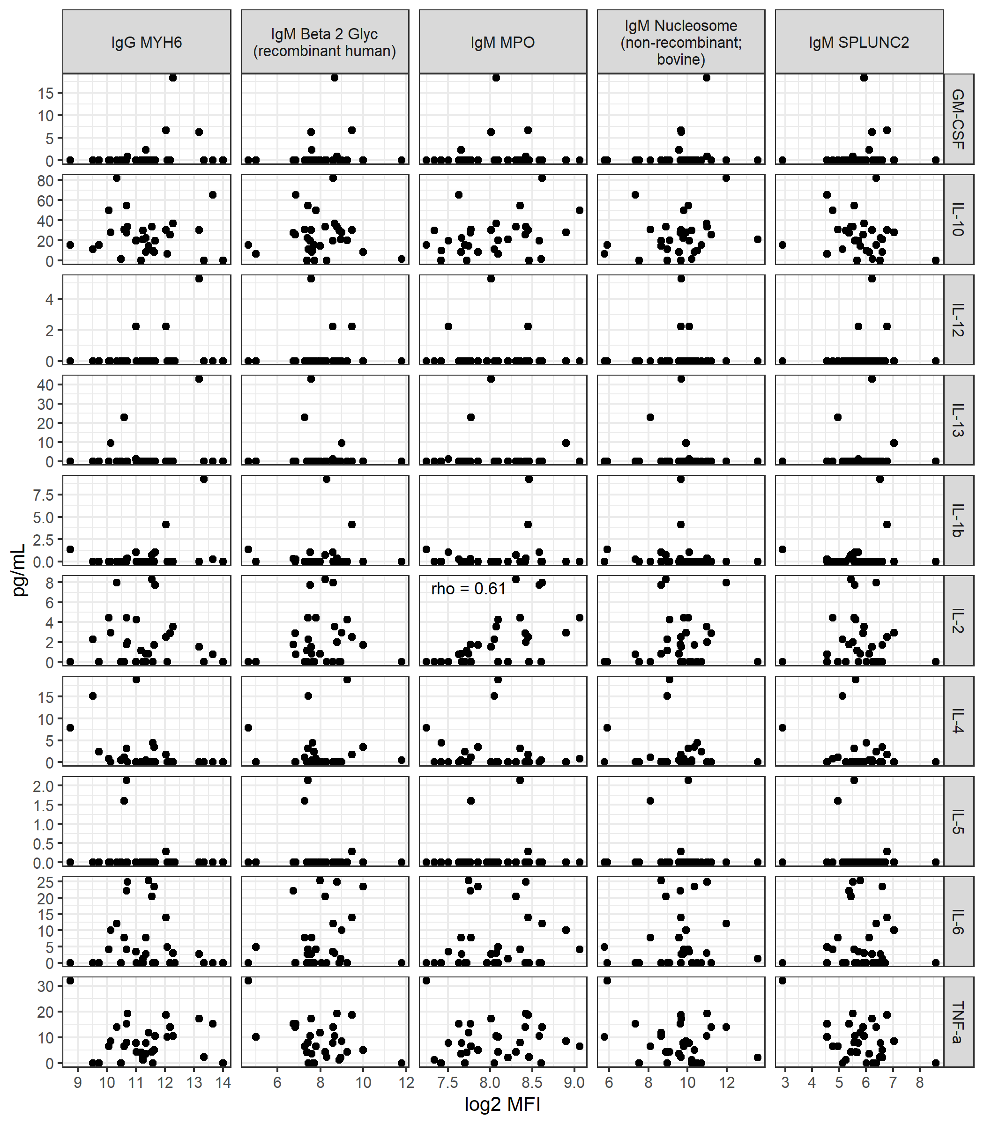

Figure S4: Correlation between cytokine levels and autoantibodies post 2nd vaccine dose.
Spearman’s correlation was used to test the association between cytokine levels and auto-antibody levels at 1 week post 2nd vaccination dose in a cohort of IO-treated patients (n=33) and non-IO treated patient samples (n=5).

