Supplementary Materials
1. Pourbaix diagram for chromium and copper
Pourbaix diagram was constructed based on the potentials (E in V) for cathodic reduction is a function of chromium ion concentration/activity ([Cr⁶⁺] in mM) and the pH of the system. In the present study, the chromium species considered for constructing the Pourbaix diagram are [Cr⁶⁺], [Cr³⁺] and Cr₂O₃. The initial total chromium [Cr^{T}] concentration and [Cr⁶⁺] concentrations are considered as equal, and 100 mg L⁻¹ of [Cr^{T}] or [Cr⁶⁺] was used throughout the experiment. Therefore, the adopted concentration/activity of [Cr⁶⁺] was 1.92 mM for constructing the Pourbaix diagram. In addition, the activity/concentration of [Cr³⁺] was considered as 2.88 mM as the removal efficiency of 99.85% (reduction of [Cr⁶⁺] to [Cr³⁺]) achieved in the experimental study.
Similarly, the copper species considered for constructing the Pourbaix diagram are [Cu²⁺], [Cu⁰], [CuO], and [Cu₂O]. According to the experimental condition, the total [Cu²⁺] concentration adopted was 1.57 mM (100 mg L⁻¹). Table S1 shows the free energy of formation (∆G⁰) of elements at the standard condition and expressed in kilojoules per mole.

Table S1 Free energy of formation of elements in a Cr-Cu-H₂O system at standard condition
Sl. No | Formula | ∆G⁰ kJ mol⁻¹
1 | HCrO₄⁻ | -761.4
2 | H⁺ | 0
3 | OH⁻ | -37,595
4 | Cr³⁺ | -198.3
5 | H₂O | -237.14
6 | Cr₂O₃ | -1059.3
7 | Cu⁺ | +12,000
8 | Cu²⁺ | +15,530
9 | Cu₂O | -34,980
10 | CuO | -30,400

1.1 Thermodynamic calculation
The half-cell reaction of an electrochemical reaction is represented as follows.
aA + mH⁺ + ne ↔ bB + cH₂O | 1

where a, m, b, and c are the stoichiometric coefficients for species A, H⁺, B, and H₂O in the electrochemical reaction, respectively; and n is the electron transfer number of the electrode reaction. The activity of water [H₂O] is considered to be 1 for a dilute solution, and the corresponding equilibrium potential was represented by Nernst isothermal equation (Eq. (1)).
$$\text{E =}$$ | $$\text{E}\text{0 }\text{– 2.303 }\left[\frac{m R T}{n F}\right] pH-2.303 \left[\frac{R T}{n F}\right]\log_{10}\left[\frac{a\text{B}\text{b}}{a\text{A}\text{a}}\right]$$ | Eq. (1)
where,
E = Electrochemical potential for a reaction at temperature, T.
E⁰ = Standard electrochemical potential for a reaction at standard temperature, (298.15 K).
F = Faraday’s constant (96.485 kJ V⁻¹ or 23061 cal V⁻¹).
R = Universal gas constant (8.314 J mol⁻¹ K⁻¹ or 1.98 cal K⁻¹).
aA and aB are the overall activity of species A and B, respectively.
The relationship between the potential, pH, and ∆G⁰ is represented in Eq. (2):
$$∆G\text{0}=$$ | $-RT lnK= -nFE\text{0}$ | (2)

where, ∆G⁰ = Standard Gibb’s free energy of reaction at temperature, T.
K = Equilibrium constant.
Table S2 listed the thermodynamic data of the elements considered in the Cr-H₂O system. To avoid the complexity in the Pourbaix diagram, the species considered in the aqueous state are [Cr⁶⁺] and [Cr³⁺], and the solid-state is Cr₂O₃. The acidic pH varied from 0 to 6 was adopted for the construction Pourbaix diagram.

Table S2 Thermodynamic data of the elements in the Cr-Cu-H₂O system
No | Reaction | E⁰ or  log K | E-pH system¹
1 | O_{2(g)} + 4H⁺ + 4e ̶ ↔ H₂O_{(l)} | 1.228 V | $$\text{E = E}\text{0 }\text{̶ 2.303 }\frac{\text{RT}}{\text{F}}\text{ pH + 2.303 }\frac{\text{RT}}{\text{4F}} \text{log}{\text{P}\text{O}\text{2}}\text{*}$$
2 | 2H⁺ + 2e ̶ ↔ H_{2(g)} | 0 V | $$\text{E =} \text{̶} \text{2.303 }\frac{\text{RT}}{\text{F}}\text{ pH + 2.303 }\frac{\text{RT}}{\text{2F}} \text{log}{\text{P}\text{H}\text{2}}\text{**}$$
3 | HCrO₄ ̶_{(l)} + 7H⁺ + 3e ̶ ↔ Cr³⁺_{(l)} + 4H₂O_{(l)} | 1.33 V | $\text{E = }\text{1.33 V} \text{̶} \text{0.020 log [Cr}\text{3+}\text{] }\text{+ }\text{0.020}\text{ log }\text{[}\text{HCrO}\text{4} \text{̶}$ ] ̶ 0.14 pH
4 | 2Cr³⁺_{(l)} + 3H₂O_{(l)} ↔ Cr₂O_{3(s)} + 6H⁺ | Log K =  ̶ 8.3426 | $$\text{pH} \text{=} \frac{\text{8.346 – 2 log [Cr}\text{3+}\text{]}}{\text{6}}$$
5 | Cu²⁺_{(l)} + 2e ̶ ↔ Cu⁰_{(s)} | 0.337 V | $$\text{E} \text{= } \text{0.337 V + 0.0605 log [Cu}\text{2+}\text{]}$$
6 | Cu²⁺_{(l)} + H₂O_{(l)} ↔ CuO_{(s)} + 2H⁺ | Log K =  ̶ 8. 062 | $$\text{pH} \text{= } \frac{\text{8.062 } \text{̶} \text{2 log [Cu}\text{2+}\text{]}}{\text{2}}$$
7 | 2Cu²⁺_{(l)} + H₂O_{(l)} + 2e ̶ ↔ Cu₂O_{(s)} + 2H⁺ | 0.2027 V | $$\text{E = }\text{0.2027 V} \text{+} \text{0.0605 pH }\text{+ }\text{0.0605 log [}\text{Cu}\text{2+}\text{]}$$
8 | 2CuO_{(s)} + 2e ̶ + 2H⁺ ↔ Cu₂O_{(s)} + H₂O_{(l)} | 0.669 V | $$\text{E = 0.669 V } \text{̶} \text{0.0605 pH}$$
9 | Cu₂O_{(s)} + 2H⁺ + 2e ̶ ↔ 2Cu⁰_{(s)} + H₂O_{(l)} | 0.470 V | $$\text{E = 0.}\text{470}\text{ V } \text{̶} \text{0.0605 pH}$$
¹Note that E⁰ and K values are adjusted according to the experimental temperature of 305 K (32 °C).
*Partial pressure of oxygen.
**Partial pressure of hydrogen.

2. The mineralization of organic matter at the anode chamber
The microbial fuel cell (MFC) was operated for 288 h by fed-batch mode and the degradation of acetate at the anode chamber was monitored. During the startup of MFC, the initial chemical oxygen demand (COD) concentration of 997 mg L⁻¹ (1 g L⁻¹ of acetate) was maintained in the system. After 48 h, MFC exhibits a reduction of 66.8% in the COD concentration and can be attributed to the immediate acclimatization of microbes in the anode chamber (Fig. S1). During the second cycle, the COD concentration was increased to 3511 mg L⁻¹ (2.5 g L⁻¹ of acetate), and COD degradation efficiency of 91.42% was achieved within 120 h of operation time. More or less similar trend was observed in the third cycle, where the COD concentration was increased to 5599 mg L⁻¹ (5 g L⁻¹ of acetate) and the degradation efficiency of COD was examined as 89.71%.
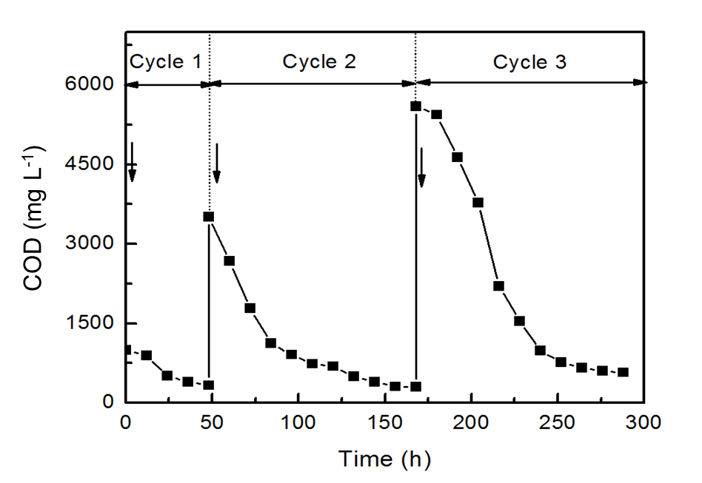
Fig. S1 Temporal changes in the substrate concentration operated under fed-batch mode (arrow mark indicates the addition of acetate)
References
- McCafferty E. Thermodynamics of corrosion: pourbaix diagrams. In: Introduction to Corrosion Science. New York: Springer; 2010. p. 95–117.
- Kotas J, Stasicka Z. Chromium occurrence in the environment and methods of its speciation. Environ Pollut. 2000;107:263–83.
- Beverskog B, Puigdomenech I. Revised Pourbaix diagrams for chromium at 25-300 °C. Corros Sci. 1997;39:43–57.
- Zhang LJ, Tao HC, Wei XY, Lei T, Li JB, Wang AJ, et al. Bioelectrochemical recovery of ammonia-copper(II) complexes from wastewater using a dual chamber microbial fuel cell. Chemosphere. 2012;89:1177–82.

