Supporting Information
Green Fabrication of Thermal-stable oxidized Cellulose Nanocrystals by Evolutive
Fenton Reaction and In-Situ Nanoreinforced Thermoplastic Starch
Bingbing Gao^{#1}, Jiahui Yang^{#1}, Shuidong Zhang^{1,2,3}*, and Xiangyu Li¹
¹ School of Mechanical and Automotive Engineering, South China University of Technology, Guangzhou 510640, China.
² State Key Laboratory of Bio-Fibers and Eco-Textiles, Qingdao University, Qingdao, 250101, China
³ SCNU Qingyuan Institute of Science and Technology Innovation Co., Ltd., Qingyuan 511517, China
Corresponding author, Email: starch@scut.edu.cn (S.-D. Zhang)

Table of Contents

Section 1. Results and Discussion
Determination of carboxyl content (CC)
The degree of polymerization in viscosity (DPv) of cellulose analysis
Table S1. The integration of the different peak areas when the integration of the peak for C1 is used as the control
Table S2. The T_{5%}, T_{max} and carbon residual under 600 ℃ of MCC and OCNCs
Table S3. Residual mass of samples after 30 minutes at different temperatures
Table S4. The T_{5%}, T_{max} and carbon residual under 600 ℃ of TPS and TPS/OCNC composites
Table S5. Activation energy (E) and correlation coefficient (r) of TPS, TPS/1 MCC and TPS/1 OCNC-17.1 according to the Ozawa method
Fig S1. (a) The FTIR spectra of the samples (b) solid ¹³C NMR spectroscopy of MCC and OCNC-17.1 (c) XRD spectra of the samples
Fig S2. (a) TG of TPS (b) TPS/1 MCC (c) TPS/1 OCNC-17.1 at different heating rates in nitrogen (d) Activation energy of three composites at the following fractional weight losses (α): 0.01, 0.02, 0.03
Fig S3. Ozawa plots of (a) TPS and (b) TPS/1 MCC and (c) TPS/1 OCNC-17.1 at the following fractional weight losses (α): 0.01, 0.02, 0.03
Fig. S4. (a) FTIR of the composites, (b) XRD of the composites
Fig S5. The fracture surfaces morphology of the (a) TPS (b) TPS/1 MCC (c) TPS/ 0.5 OCNC-17.1 (d) TPS/1 OCNC-17.1 (e) TPS/2 OCNC-17.1

Section 2. References

Section 1. Results and Discussion
Determination of carboxyl content (CC)
The quantification of the free CC in the sample was determined by a method from the United States Pharmacopoeia (USP, 1995) (Rinaudo 1968). Approximately 0.5 g of the sample was accurately weighed ($m_{cell}, g$) and suspended in 50 mL deionized water. 10.00 mL 0.2 M NaOH solution (accurately titrated by potassium hydrogen phthalate,$c_{NaOH}, mol/L$) was added to the suspension and stirred for 1 h. Adding 10.00 mL 0.1 M H₂SO₄ (accurately titrated by standard sodium carbonate,$c_{H_{2}SO_{4}}, mol/L$) and 3 drops of phenolphthalein indicator, the solution was then titrated by 0.2 M NaOH solution mentioned above. The carboxyl content in the sample was calculated by Eq. (S1) :(Kumar and Yang 2002)
$CC=\frac{(V_{NaOH}×c_{NaOH}-V_{H_{2}SO_{4}}×c_{H_{2}SO_{4}}×2)÷1000}{m_{cell}÷M_{cell}}×100\%$ (S1)
where $V_{NaOH}$ was the total volume of 10.00 mL and the titration volume of NaOH solution, and $V_{H_{2}SO_{4}}$ was 10.00 mL in this method. $M_{cell}$was the molar mass of the cellulose monomer, and the value of 161 was adopted for this paper.
The degree of polymerization in viscosity (DPv) of cellulose analysis
Intrinsic viscosity was measured with an Ubbelohde capillary viscometer with a capillary diameter of 0.58 mm at 25 ± 0.1℃. This method was referred to the ASTM D1795-13 Standard Test Method for Intrinsic Viscosity of Cellulose. An approximately 0.2 g sample was accurately weighted by analytical balance and then dissolved in 25.00 mL deionized water and 25.00 mL Bis (ethylenediamine) copper (II) hydroxide solution 1.0 M in H₂O. The time of the solvent solution (consisting of 25.00 mL deionized water and 25.00 mL Bis (ethylenediamine) copper(II) hydroxide solution 1.0 M in H₂O) passing through the Ubbelohde capillary viscometer was marked as t₀, and the time of a solution that dissolves a sample was marked as t. The Intrinsic viscosity was obtained by Eq. (S2), (S3) and (S4):
$η_{r}=\frac{t}{t_{0}}$ (S2)
$η_{sp}=η_{r}-1$ (S3)
$\left[η\right]=\frac{\sqrt{2(η_{sp}-\ln{η_{r}})}}{c}$ (S4)
Where the c was the concentration of the sample, the unit was g / mL.
The average degree of polymerization was obtained by Eq. (S5).(da Silva Perez et al. 2003; Kumar and Yang 2002)
$\left[η\right]=0.891×{DP}^{0.936}$ (S5)
Table S1. The integration of the different peak areas when the integration of the peak for C1 is used as the control
Sample | C1 | C4 | C4' | C2,3,5 |  | C6 | C6'
MCC | 1 | 0.5 | 0.37 | 1.35 | 1.47 | 0.51 | 0.35
OCNC-3 | 1 | 0.61 | 0.37 | 1.44 | 1.43 | 0.45 | 0.26

Table S2. The T_{5%}, T_{max} and carbon residual under 600 ℃ of MCC and OCNCs
Sample | T_{5%} (°C) | T_{max} (°C) | Carbon residual (600 °C) (%)
MCC | 300 | 335 | 11.7
OCNC-13.9 | 265 | 335 | 14.4
OCNC-17.1 | 247 | 323 | 18.7
OCNC-15.7 | 247 | 328 | 13.0

Table S3. Residual mass of samples after 30 minutes at different temperatures
Sample | 200 ℃ | 250 ℃ | 300 ℃
MCC | 96.0% | 94.3% | 47.5%
OCNC-17.1 | 93.0% | 86.1% | 50.6%
CNC commercial | 65.6% | 59.5% | 53.7%

Table S4. The T_{5%}, T_{max} and carbon residual under 600 ℃ of TPS and TPS/OCNC composites
Sample | T_{5%} (°C) | T_{max} (°C) | Carbon residual (600 °C) (%)
TPS | 202 | 311 | 8.4
TPS/1 MCC | 168 | 311 | 9.4
TPS/1 OCNC-17.1 | 212 | 310 | 10.5

Table S5. Activation energy (E) and correlation coefficient (r) of TPS, TPS/1 MCC and TPS/1 OCNC-17.1 according to the Ozawa method
 | TPS |  | TPS/1 MCC |  | TPS/1 OCNC-17.1
Conversion α/% | Activation energy E (kJ·mol⁻¹) | Correlation coefficient r | Activation energy E (kJ·mol⁻¹) | Correlation coefficient r | Activation energy E (kJ·mol⁻¹) | Correlation coefficient r
1 | 47.84163595 | 0.99453 | 21.930974 | 0.95616 | 64.924749 | 0.83443
2 | 90.14436751 | 0.99495 | 30.953129 | 0.96555 | 92.531889 | 0.99468
3 | 142.9472787 | 0.98233 | 103.12673 | 0.99882 | 159.03242 | 0.9862

Chemical structure analysis
The FTIR spectra of all samples are shown in Fig. S1a. Generally, for Curve 1, the absorption peaks at 2927 cm⁻¹ and 1465 cm⁻¹ are attributed to the characterized absorption of -CH₂-, while the absorption peaks at 3500 cm⁻¹ and 1640 cm⁻¹ are assigned to the characterized absorption of -OH. After oxidized by hydrogen peroxide, Curves 2-4 represents the OCNCs, a new character peak is presented on 1740 cm⁻¹, which corresponded to the stretching vibration of C=O bonds(D'Acierno et al. 2020). Compared with the data in Table S1, the comparatively absorbing strength on 1740 cm⁻¹ increased with the increase of carboxyl content of each sample. The results of FTIR demonstrate that MCC is oxidized to OCNC with different CC successfully via Fenton reaction.
Fig S1. (a) The FTIR spectra of the samples (b) solid ¹³C NMR spectroscopy of MCC and OCNC-17.1 (c) XRD spectra of the samples
Due to the solubility problem, MCC and OCNCs were characterized by solid ¹³C NMR spectroscopy, and the results were shown in Fig. S1b. For MCC, the curve shows the chemical shifts at 105 ppm, 89 ppm, 84 ppm, 72 and 75 ppm, 65 ppm and 63 ppm, respectively, which can be ascribed to C1, C4 crystalline section, C4 amorphous section, C2/C3/C5, C6 crystalline section and C6 amorphous section in glucose units, respectively. When the integration of the peak for C1 is used as the control, the ratio of the integration of the peak areas are listed in the Table S1. For OCNC-17.1, the curve features are similar to that of MCC with the peak intensity located at 65 ppm and 63 ppm reduce. Due to the low CC and Detection limit, the carboxyl group of OCNC-17.1 does not display its characters’ peak about at 174 ppm(Wen et al. 2019). Strikingly, its $\frac{I_{C6*}}{I_{C1}}$ reduced from 0.35 to 0.26, while other values have not changed, significantly. The result can prove that the oxidation mainly occurs in the C6-OH for C6 amorphous section because it will be great favorite for •OH to attack and form the carboxyl group(Carvalho do Lago et al. 2011).
XRD Studies
The measurement of X-ray diffraction patterns of MCC and OCNCs can be applied to elaborate how their crystalline integrity varies during the oxidation and their XRD curves are presented at Fig. S1c. The deconvolution process and related calculations refers to the publications of French et al(Ling et al. 2019). MCC appears the diffraction peaks of at 2θ = 14.2°, 16.4°, 22.6°, and 34.4°, respectively, which were assigned to the typical reflection planes of (1 -1 0), (1 1 0), (2 0 0), and (0 0 4), respectively and proved that MCC owns the cellulose Iβ(French 2014; French and Santiago Cintrón 2013; Ling et al. 2019; Nishiyama et al. 2012; Nishiyama et al. 2002). Moreover, for the curves of OCNCs, all their crystalline characteristic peaks are displayed clearly as compared with those of MCC. The phenomenon reveals that the OCNCs preserve the original crystalline structure of cellulose Iβ., furthermore, the crystallinity index (Ic) of MCC decreases from 74.4% to 72% with the increase of CC for OCNC. The reduction in the crystallinity of OCNCs is ascribed to the fact that the regular arrangement of cellulose molecular chains reduces when the cellulose Iβ suffer the oxidant.
Thermostability of the composites
The Flynn-Wall-Ozawa method is used to elucidate the thermal degradation behaviors of TPS, TPS/1 MCC and TPS/1 OCNC-17.1.(Flynn and Wall 1966; Takeo 1965)
$\log{F\left(α\right)}=log\frac{AE}{R}-log β-2.315-0.4567\frac{E}{RT}$ (S6)
where F(α) is the function of degree of conversion (weight loss) , A is the pre-exponential factor, E is the activation energy, R is the gas constant, T is the absolute temperature and β is the heating rate.
This method can be used to determine the activation energy from TGA results, which is only relevant to the temperatures at a constant degree of conversion from several integral thermograms at different heating rates. The activation energy for different conversion values can be calculated from the logβ versus 1/T plot. The TG curves of TPS, TPS/1 MCC and TPS/1 OCNC-17.1 at different heating rates under nitrogen are illustrated in Fig. S2 (a, b and c). Activation energies at 1, 2 and 3% conversion were calculated (Fig S2d). Fig. S3 shows the best-fit lines of the logβ versus 1/T plots, and activation energy as a function of conversion is displayed in Table S5.
Fig S2. (a) TG of TPS (b) TPS/1 MCC (c) TPS/1 OCNC-17.1 at different heating rates in nitrogen (d) Activation energy of three composites at the following fractional weight losses (α): 0.01, 0.02, 0.03
Fig S3. Ozawa plots of (a) TPS and (b) TPS/1 MCC and (c) TPS/1 OCNC-17.1 at the following fractional weight losses (α): 0.01, 0.02, 0.03
The FT-IR spectra of pure TPS, TPS/MCC, and TPS/OCNC-17.1 are shown in Fig. S4a, which revealed the interactions between the OCNCs fiber and starch. For Curve a, the characteristic bands of TPS can be found at 3300 cm⁻¹ (O–H), 2920, 1454 cm⁻¹ (C–H of –CH₂–), 1150, 1102, 1077, 1013 and 995 cm⁻¹ (–C–O–C– of the anhydroglucose). Meanwhile, the absorption peak around 1663 cm⁻¹ belongs to the H₂O bending vibration, which is attributed to the water absorption by hydroxyl groups in starch. When MCC or OCNC-17.1 is incorporated, the FT-IR features of the composites are similar with that of TPS due to the same chemical structure between starch and cellulose. Compared with the curve of pure TPS, TPS/2 OCNC-17.1 changed in the position of the characteristic absorption peak of -OH stretching vibration absorption peak: the shift of the same band to lower wavenumber (from 3290 cm⁻¹ to 3281 cm⁻¹), indicating the formation of hydrogen bonding between the TPS and OCNC-17.1, which will enhance the intermolecular hydrogen bonds of the composites. The degree of the enhancement rises with the increase of OCNC-17.1 contents, the reason may be attributed to the sizes of intermolecular hydrogen bonds (just like the cross-linking density) increase. The results of FT-IR are consistent with the DMA analysis.
Fig. S4. (a) FTIR of the composites, (b) XRD of the composites
Morphology of TPS/OCNCs Composites
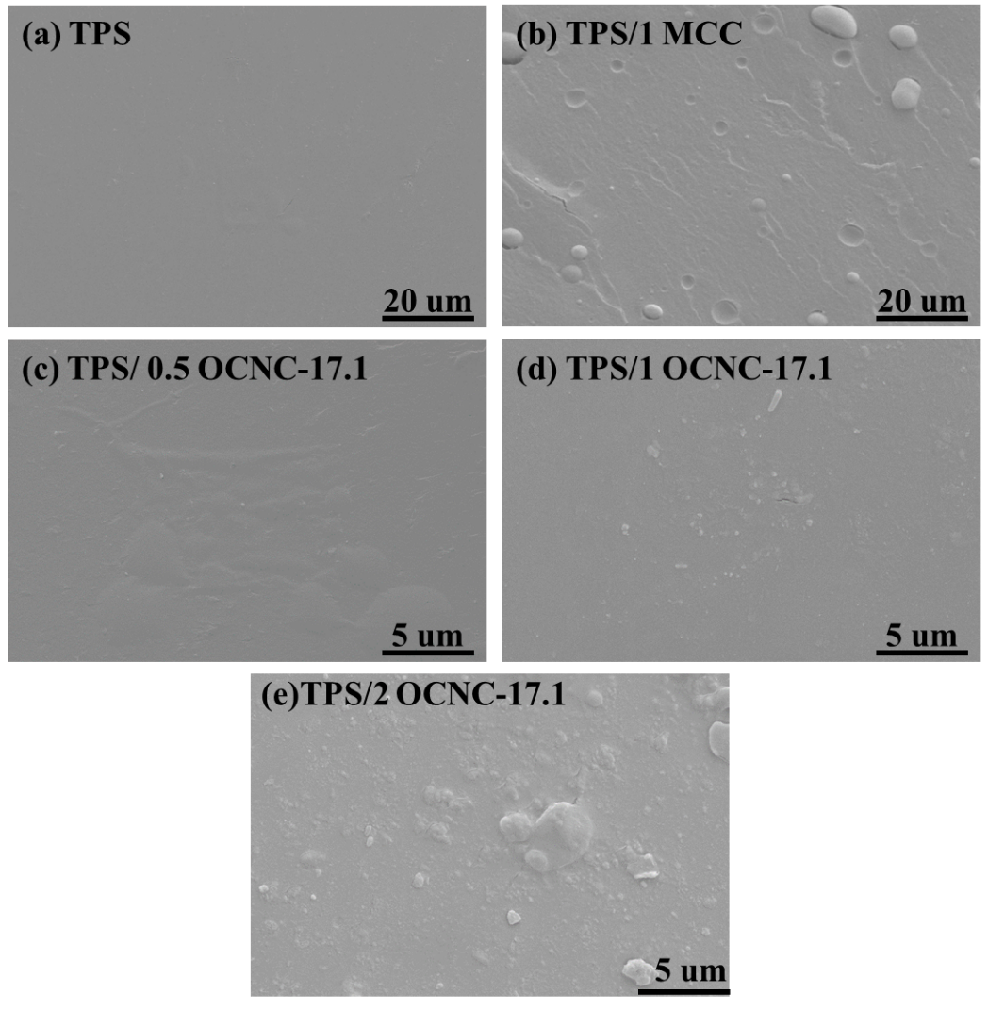
Fig S5. The fracture surfaces morphology of the (a) TPS (b) TPS/1 MCC (c) TPS/ 0.5 OCNC-17.1 (d) TPS/1 OCNC-17.1 (e) TPS/2 OCNC-17.1
The fracture surfaces morphology of the composites was evaluated by SEM images in Fig. S5. The cross-sectional morphology of TPS was flat and smooth, which shows the brittle fracture characteristics, proved by the tensile testing. After adding 1% MCC to TPS, vesicular agglomeration of MCC particles, which display a potato feature with the micron sizes, embed in the matrix are clearly observed. Furthermore, the interface between MCC and TPS is smooth, some MCC particles break away from TPS matrix reveals that the poor compatibility of TPS and MCC. For comparison, the micrographs of the fracture plane show some differences with the addition of 0.5% as well as 1% OCNC-17.1 to TPS, such as rough, uniform dispersion without the agglomeration of OCNC-17.1 fibers. The improved dispersion may be attributed to OCNC-17.1 shows a nano-size fiber and own a larger aspect ratio than MCC. Importantly, due to the formation of enhanced hydrogen bonds between OCNC-17.1 and starch, the interface between OCNC and TPS is roast and tightly integrated, which achieve good phase compatibility. Consequently, the mechanical performances of TPS/1 OCNC-17.1 achieve the highest values of all samples. However, with the addition of OCNC-17.1 up to 2%, the agglomeration of large concentrations of OCNC-17.1 occur in the fracture surface. As a result, it deteriorates the dispersion of OCNC-17.1 in TPS matrix and the mechanical performances of TPS/2 OCNC-17.1, just confirmed by mechanical measurement.

Section 2. References
Carvalho do Lago LC, Matias AC, Nomura CS, Cerchiaro G (2011) Radical production by hydrogen peroxide/bicarbonate and copper uptake in mammalian cells: Modulation by Cu(II) complexes Journal of Inorganic Biochemistry 105:189-194 doi:https://doi.org/10.1016/j.jinorgbio.2010.10.017
D'Acierno F, Hamad W, Michal C, MacLachlan M (2020) Thermal Degradation of Cellulose Filaments and Nanocrystals Biomacromolecules 21 doi:10.1021/acs.biomac.0c00805
da Silva Perez D, Montanari S, Vignon MR (2003) TEMPO-Mediated Oxidation of Cellulose III Biomacromolecules 4:1417-1425 doi:10.1021/bm034144s
Flynn JH, Wall LA (1966) A quick, direct method for the determination of activation energy from thermogravimetric data Journal of Polymer Science Part B: Polymer Letters 4:323-328 doi:https://doi.org/10.1002/pol.1966.110040504
French AD (2014) Idealized powder diffraction patterns for cellulose polymorphs Cellulose 21:885-896 doi:10.1007/s10570-013-0030-4
French AD, Santiago Cintrón M (2013) Cellulose polymorphy, crystallite size, and the Segal Crystallinity Index Cellulose 20:583-588 doi:10.1007/s10570-012-9833-y
Kumar V, Yang T (2002) HNO₃/H₃PO₄–NaNO₂ mediated oxidation of cellulose — preparation and characterization of bioabsorbable oxidized celluloses in high yields and with different levels of oxidation Carbohydrate Polymers 48:403-412 doi:https://doi.org/10.1016/S0144-8617(01)00290-9
Ling Z et al. (2019) Effects of ball milling on the structure of cotton cellulose Cellulose 26:305-328 doi:10.1007/s10570-018-02230-x
Nishiyama Y, Johnson GP, French AD (2012) Diffraction from nonperiodic models of cellulose crystals Cellulose 19:319-336 doi:10.1007/s10570-012-9652-1
Nishiyama Y, Langan P, Chanzy H (2002) Crystal Structure and Hydrogen-Bonding System in Cellulose Iβ from Synchrotron X-ray and Neutron Fiber Diffraction Journal of the American Chemical Society 124:9074-9082 doi:10.1021/ja0257319
Rinaudo M (1968) Etude physico-chimique des solutions de cellulose dans le FeTNa La Papeterie:479-487
Takeo O (1965) A New Method of Analyzing Thermogravimetric Data Bulletin of the Chemical Society of Japan 38:1881-1886 doi:10.1246/bcsj.38.1881
Wen J, Yin Y, Peng X, Zhang S (2019) Using H₂O₂ to selectively oxidize recyclable cellulose yarn with high carboxyl content Cellulose 26:2699-2713 doi:10.1007/s10570-018-2217-1

B.G and J.Y contributed equally to this article.

