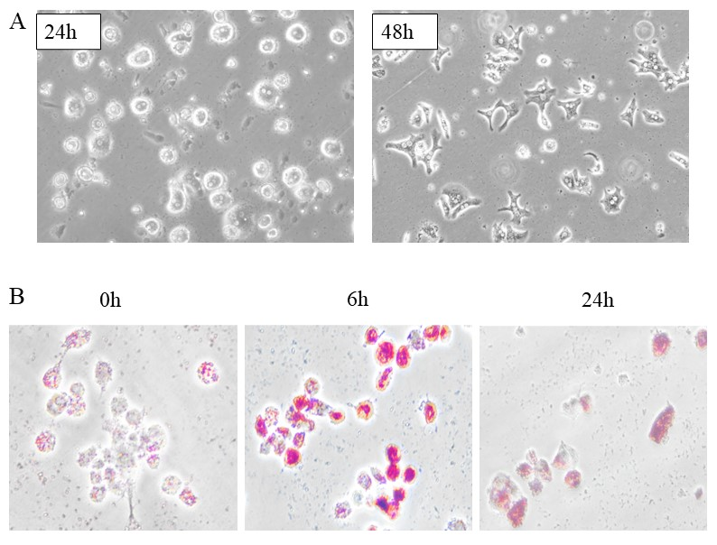
Figure S1 PHMs were cultured and ORO staining
(A) PHMs were isolated and cultured for 24 h and 48 h. The representative images were shown. (B) By ORO staining, cytosolic lipid droplets were increased markedly in lipotoxic PHMs (PA 400 µM treated with 0, 6, 24 hours).

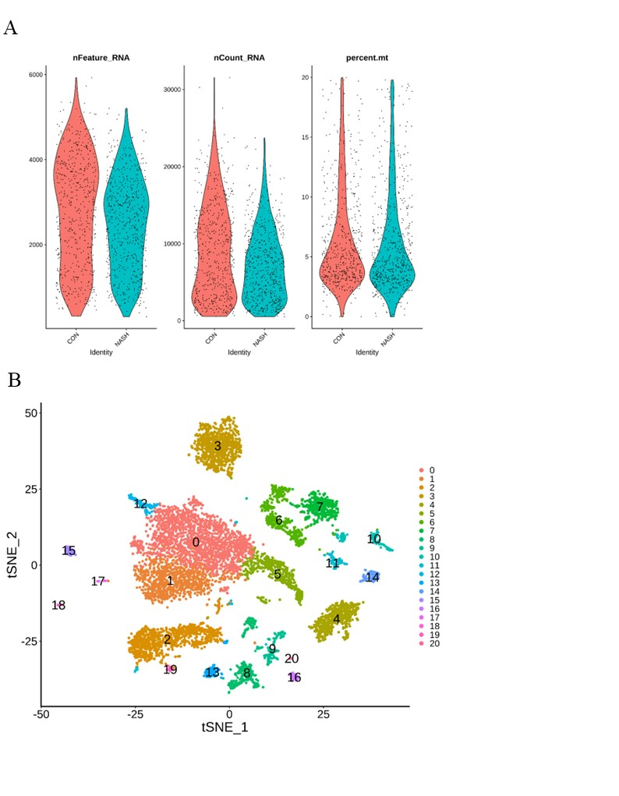
Figure S2 Quality control analyses and a landscape of scRNA-seq of control and NASH mice
(A) Quality control analyses was based on the unique feature counts, mRNA reads and the percentages of mitochondrial genes. (B) t-SNE plot showing NPC populations in all livers. The single NPCs were divided into 21 clusters. Each dot represents a single cell, and each color represents a different cluster.

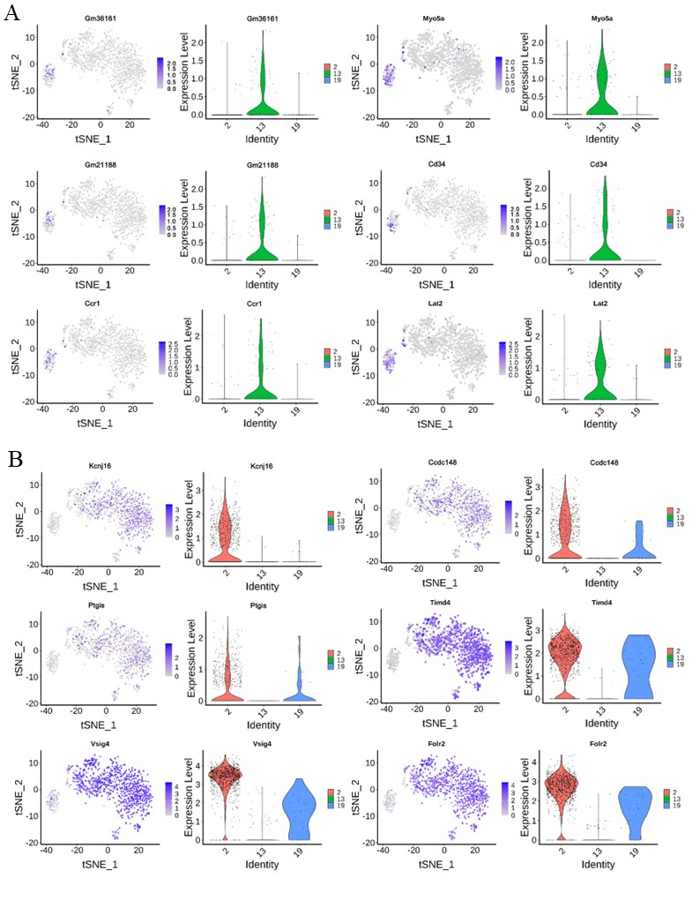
Figure S3 Top 10 DEGs of single-macrophage in Custer 13 and Cluster 2
Paired tSNE plots (left) and violin plots (right) showing expression levels of representative DEGs: (A) the top 10 specific DEGs of LAMs distributed in Cluster 13； (B) the top 10 specific DEGs of resident KCs distributed in Cluster 2.

