Table 4. Selected compounds to show the differences between the two hashed fingerprints (circular and path-based) and the CAScore. All coefficients represent compound dissimilarity. For a more thorough list of examples cf. Table ST2 in Supporting Information.

Ex. | Structure 1 | Structure2 | CAScore | MFP2 | RDK7
1 | 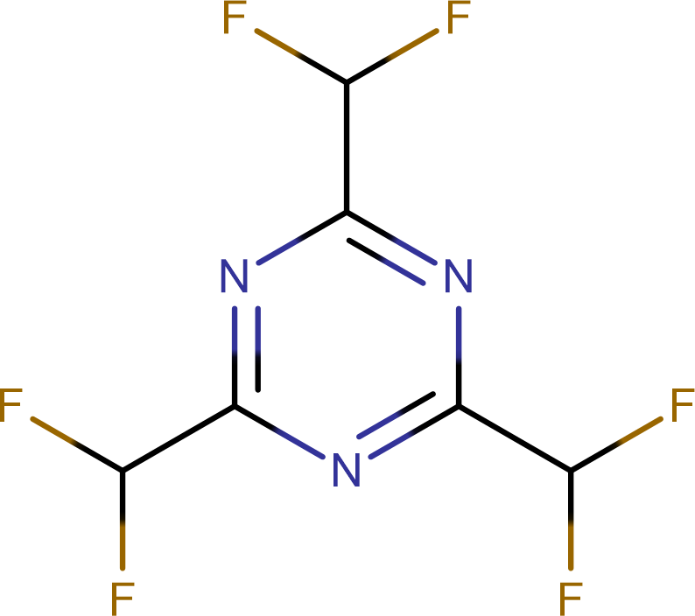  SCHEMBL4536844 | 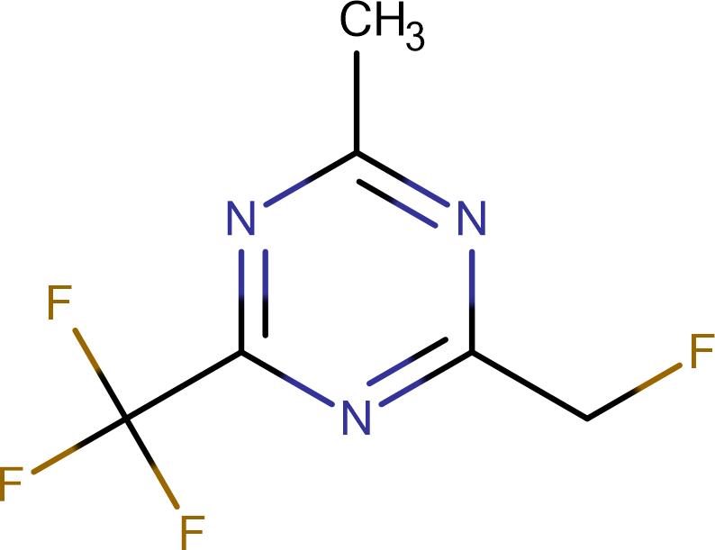  SCHEMBL18483369 | 0.12 | 0.86 | 0.00
2 | 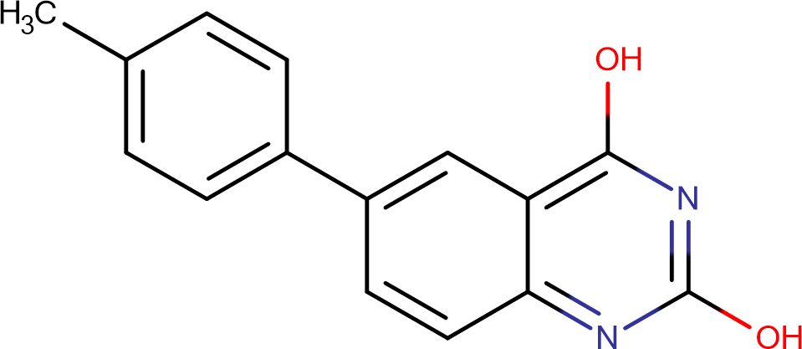  SCHEMBL19758793 | 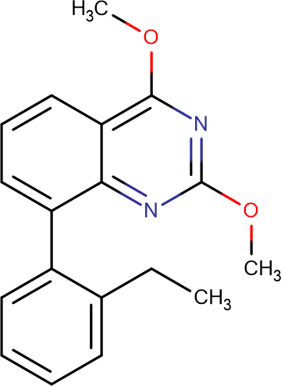  SCHEMBL8900146 | 0.27 | 0.88 | 0.38
3 | 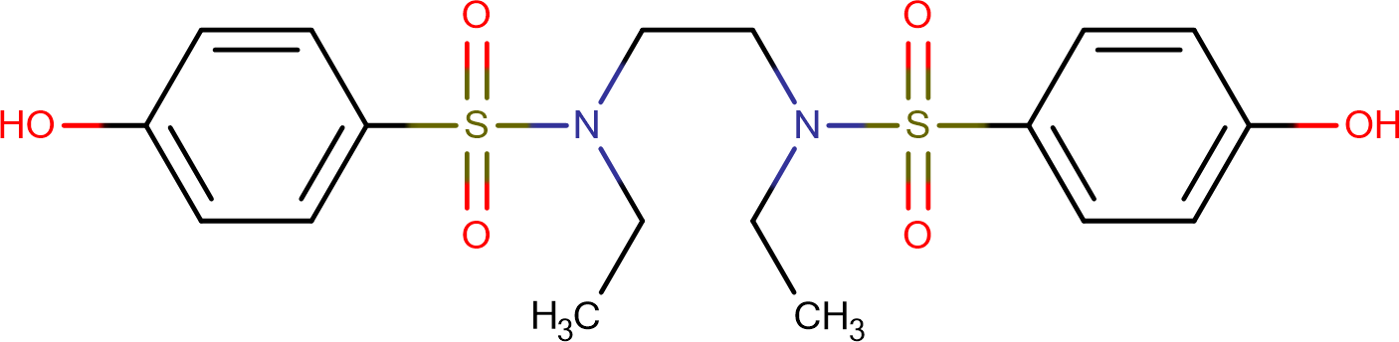  SCHEMBL13286927 | 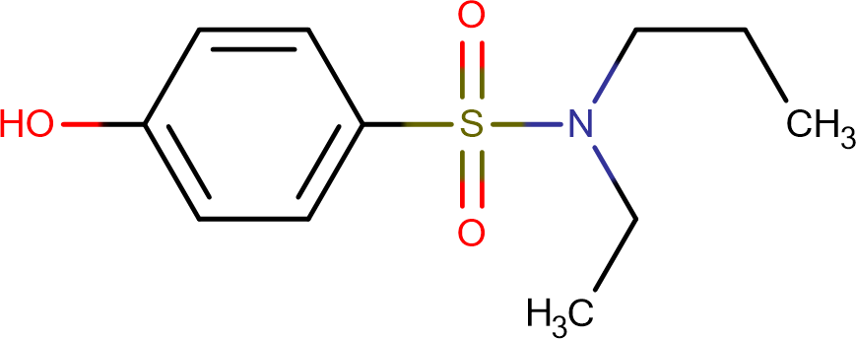  SCHEMBL2914696 | 0.54 | 0.11 | 0.30
4 | 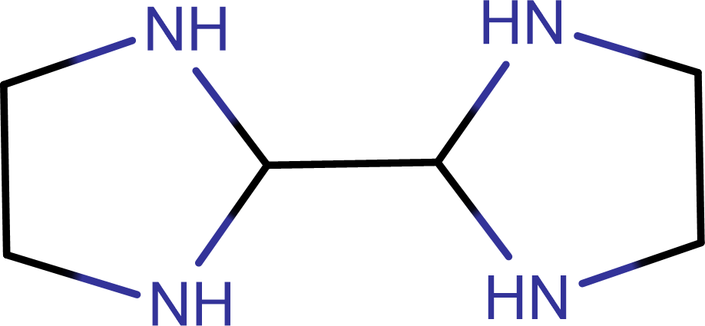  SCHEMBL660984 | 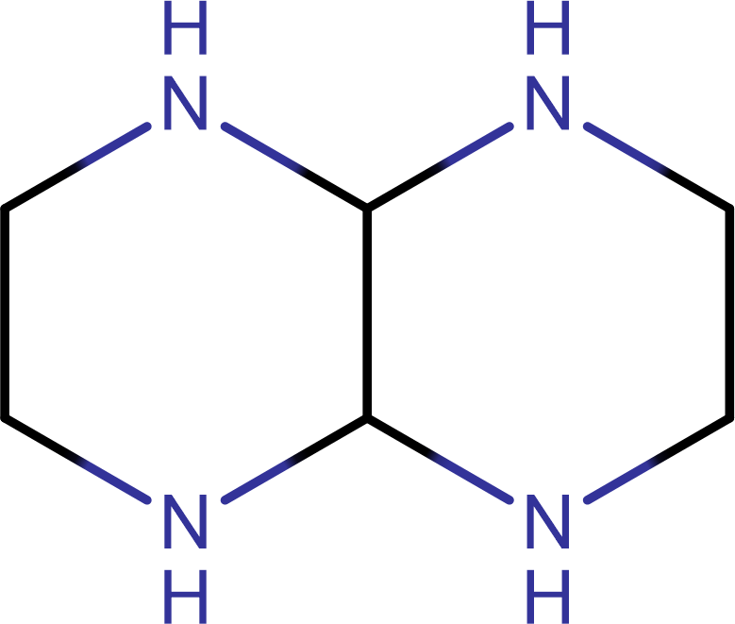  SCHEMBL7558516 | 0.33 | 0.00 | 0.33
5 | 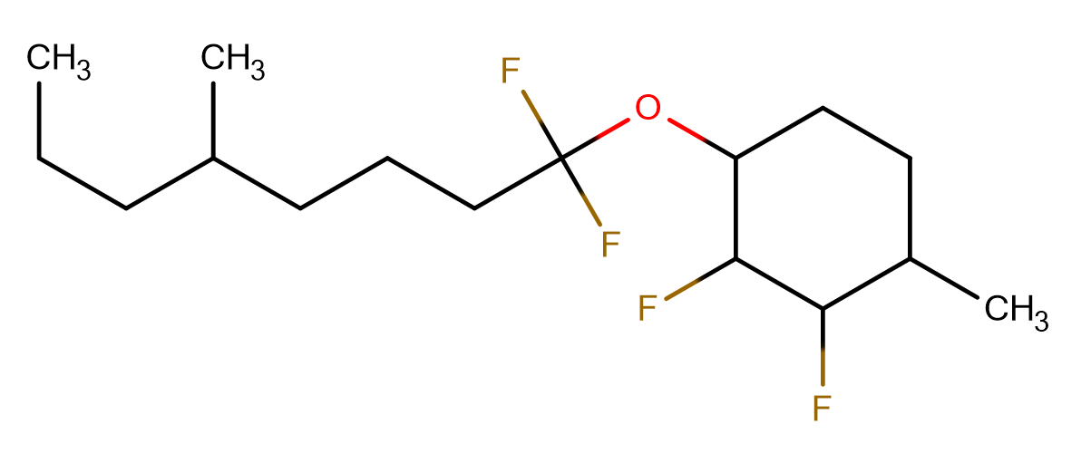  SCHEMBL15250408 | 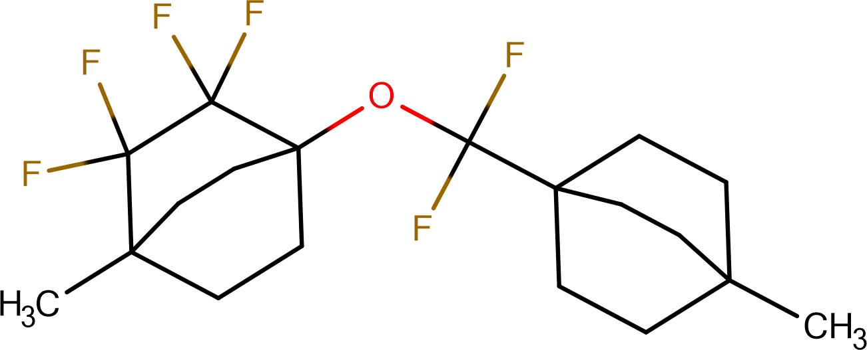  SCHEMBL10096885 | 0.71 | 0.86 | 0.00
6 | 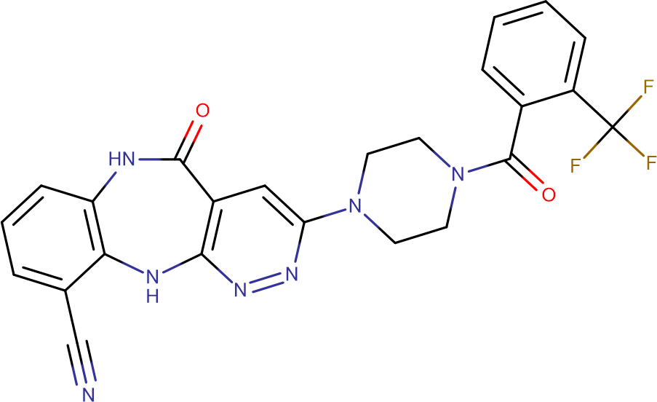  SCHEMBL6110649-taut1 | 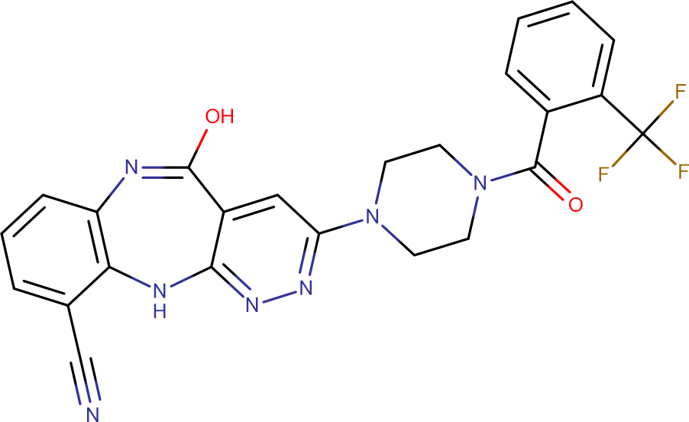  SCHEMBL6110649-taut2 | 0.24 | 0.24 | 0.31

