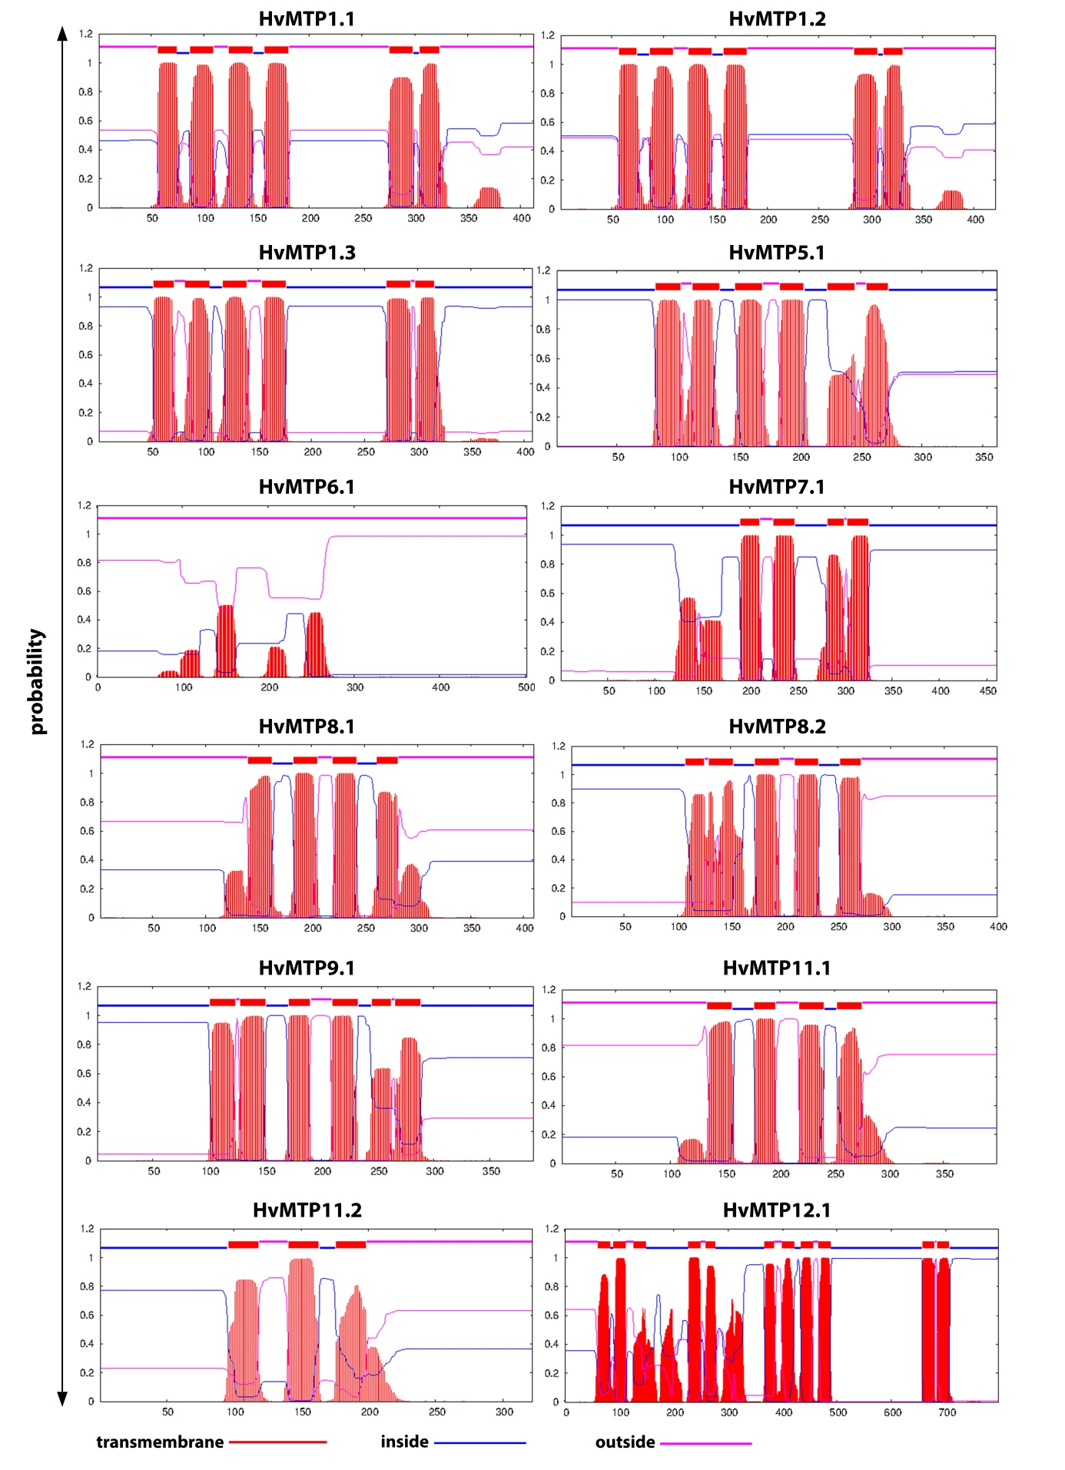
Supplementary figure S1. Prediction of transmembrane domains in HvMTP proteins.
Supplementary Figure S2. The consensus sequence HxxxD, His-rich region and CDF-signature in the HvMTP - Zn-CDFs (groups 1, 5 and 12) protein sequences.

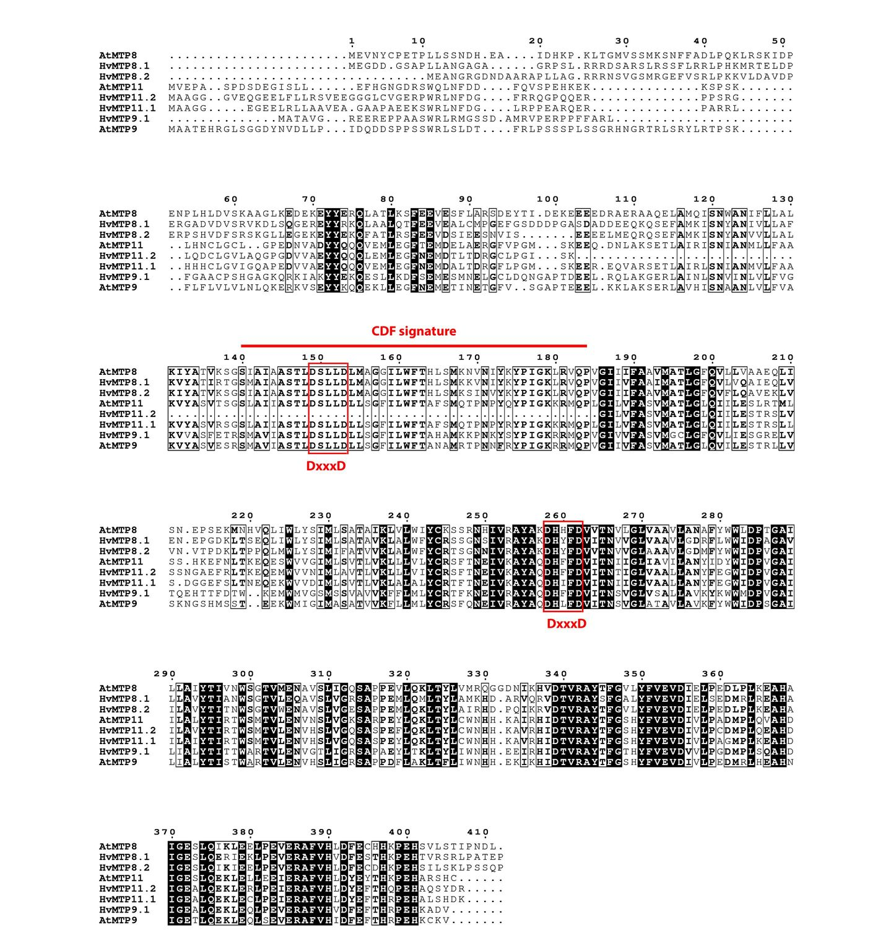

Supplementary Figure S3. The consensus sequence DxxxD, and CDF-signature in the HvMTP- Mn-CDFs (groups 8 and 9) protein sequences.

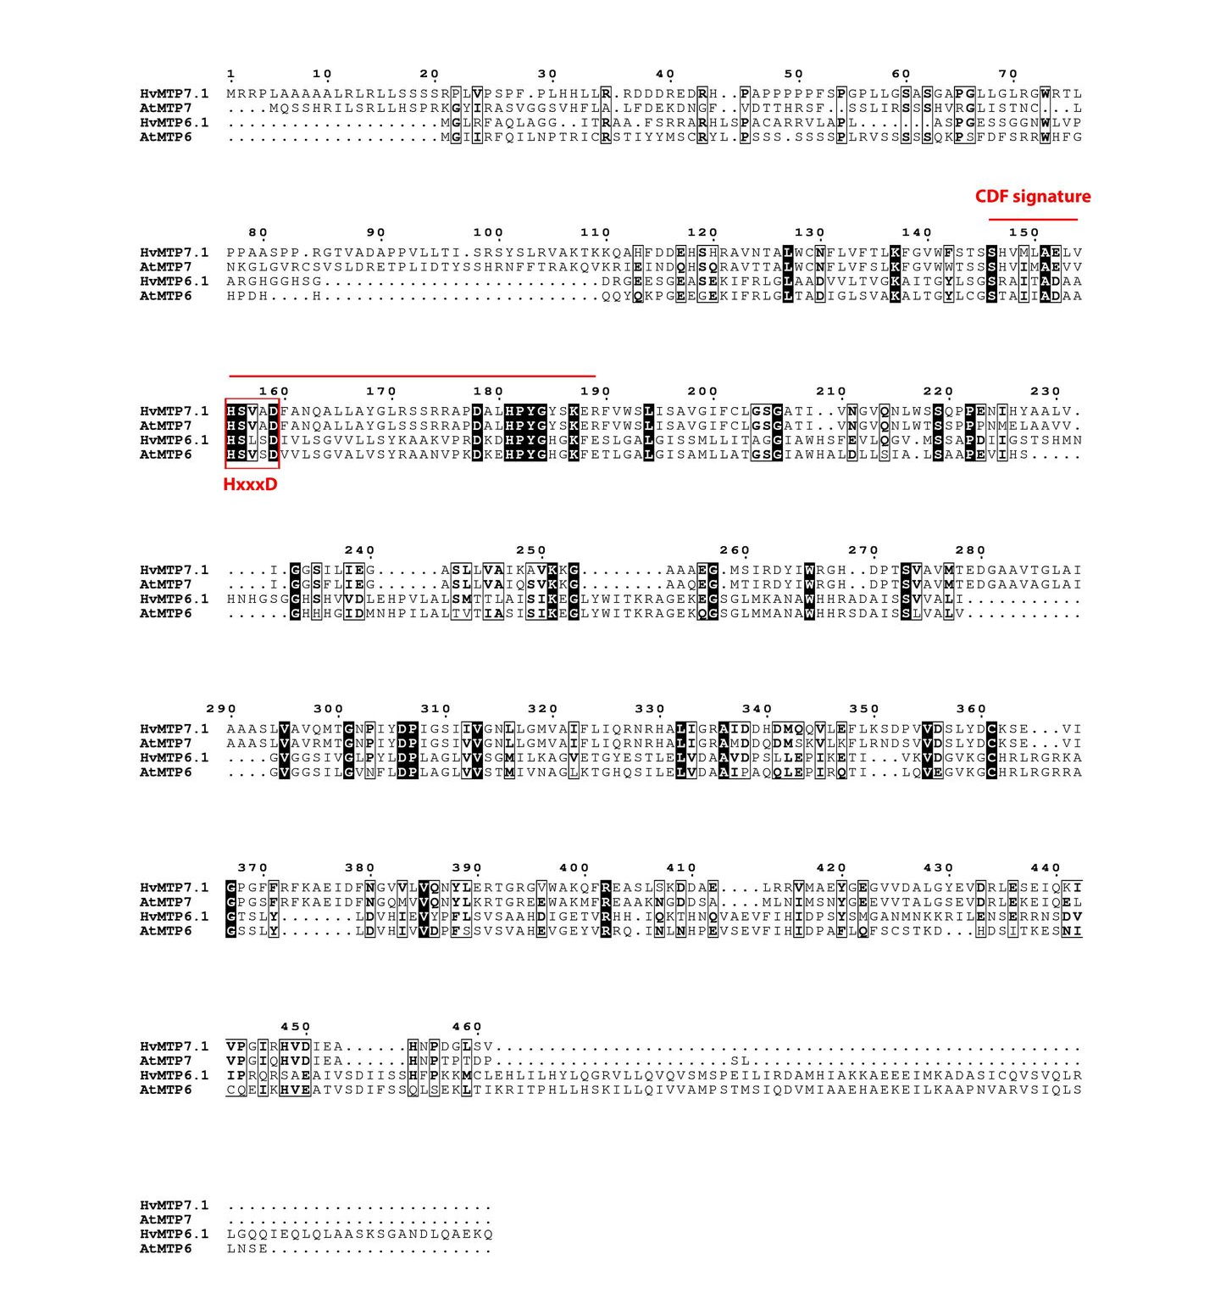
Supplementary Figure S4. The consensus sequence HxxxD, and CDF-signature in the HvMTP- Fe/Zn-CDFs (groups 6 and 7) protein sequences.

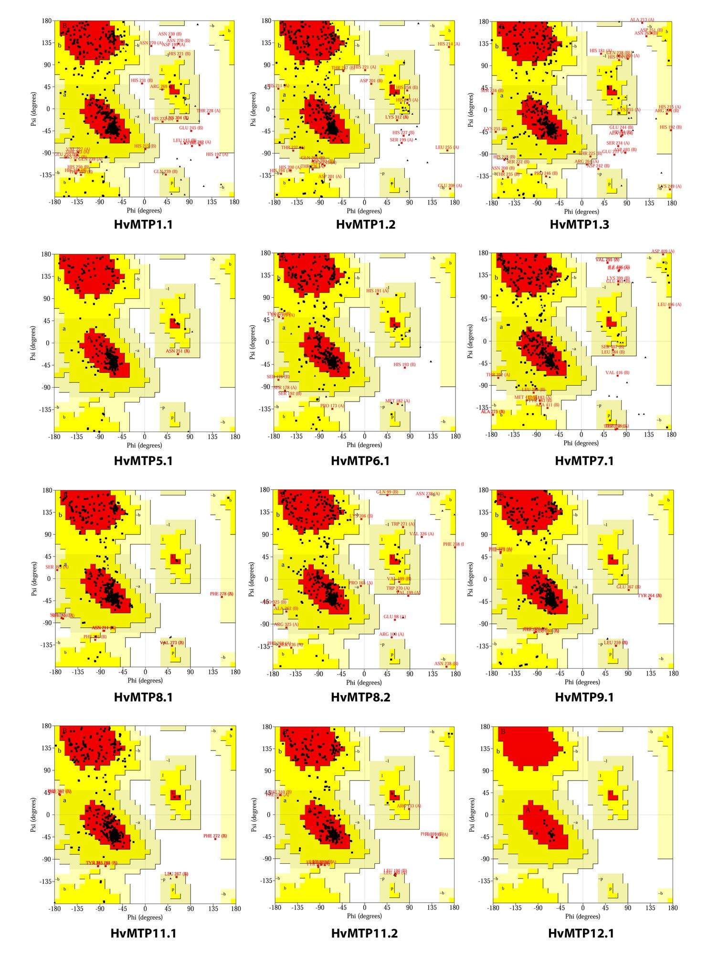
Supplementary Figure S5. Ramachandran plot analysis of homology models of HvMTP proteins.

