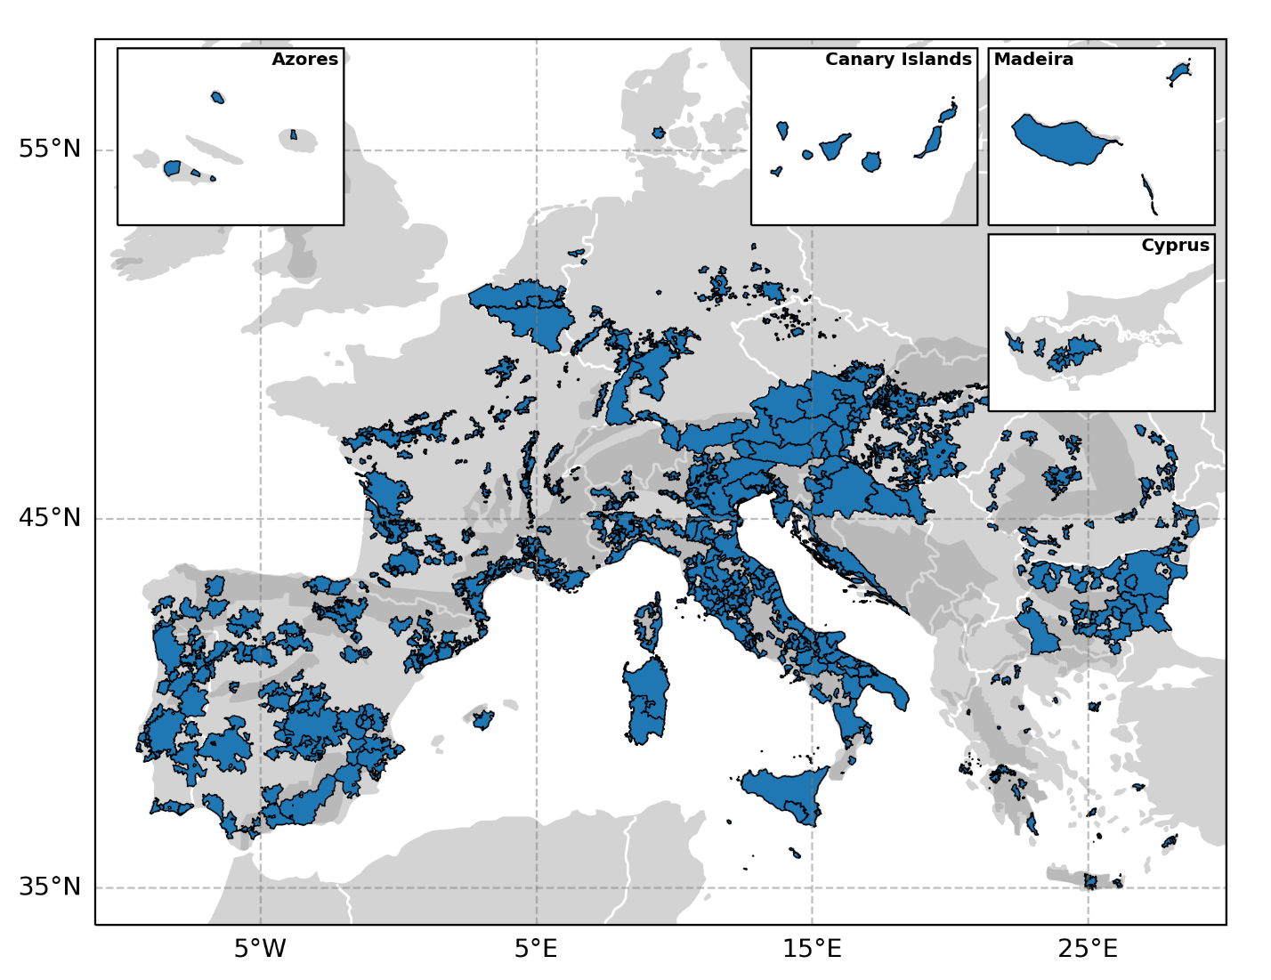
Supplementary Figure 1: European wine PDOs adapted from Candiago et al.¹ Dark grey areas refer to mountain regions.
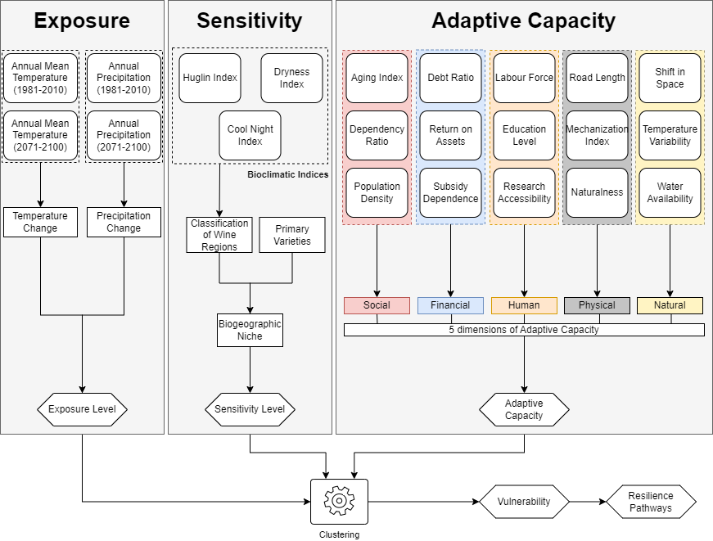
Supplementary Figure 2: Methodologial overview. The three grey boxes show the steps and the indicators used to calculate exposure, sensitivity and adaptive capacity.
Supplementary Table 3-1: Vulnerability levels of the clusters, their corresponding centroid values and the vulnerability index (VI).
Cluster | Exposure | Sensitivity | Adaptive Capacity | VI | Vulnerability Level
1 | 0.55 | 0.20 | 0.59 | 0.16 | Very low
3 | 0.79 | 0.43 | 0.77 | 0.45 | Low
2 | 0.33 | 0.69 | 0.41 | 0.60 | Low
5 | 0.74 | 0.54 | 0.41 | 0.88 | Moderate
4 | 0.75 | 0.85 | 0.60 | 0.99 | Moderate
6 | 0.67 | 0.80 | 0.26 | 1.21 | High

Supplementary Methods 1: Adaptive Capacity Indicators
Supplementary Table 1: Exposure, sensitivity and adaptive capacity indicators used to assess the vulnerability of winegrowing regions. All the indicators were standardized to the level of individual wine regions during the calculations.
Dimension | Dimension | Indicator
Exposure |  | Change in annual mean temperature
Exposure |  | Change in annual precipitation
Sensitivity |  | Huglin index
Sensitivity |  | Cool night index
Sensitivity |  | Dryness index
Adaptive capacity | Social | Aging index
Adaptive capacity | Social | Dependency ratio
Adaptive capacity | Social | Population density
Adaptive capacity | Physical | Road length
Adaptive capacity | Physical | Mechanization Index  Naturalness
Adaptive capacity | Natural | Shift in Space
Adaptive capacity | Natural | Water availability
Adaptive capacity | Natural | Temperature variability
Adaptive capacity | Human | Labour force
Adaptive capacity | Human | Education Level
Adaptive capacity | Human | Research accessibility
Adaptive capacity | Financial | Debt ratio
Adaptive capacity | Financial | Return on assets
Adaptive capacity | Financial | Subsidy dependence

Indicators: Exposure
Change in annual mean temperature
General description
The change in annual mean temperature under climate change, (C°).
Rationale
Air temperature is a key determinant of vine development. Several wine regions have already observed altered phenological development and grape composition caused by increased air temperature^{2,3}. Changes in air temperature are therefore strongly related to the climate change impacts that can be expected in a wine region.
Input data
Chelsa high resolution monthly temperature data (present time 1981-2010 and future projection 2071-2100) for the ssp858 scenario from a 5-model ensemble^{4,5}.
Calculation process
Annual mean temperature during 2071-2100 minus the annual mean temperature during 1981-2010
Standardization
0 = lower increase in temperature; 1 = higher increase in temperature.
Change in annual precipitation
General description
The change in annual precipitation under climate change, (mm).
Rationale
A decrease in precipitation can have negative consequences for wine regions by exposing vines to increased drought, which impacts vine growth and berry composition². In established wine regions, that traditionally optimized plant material and viticultural techniques to their local conditions, a change in the precipitation pattern may require specific adaptations³.
Input data
Chelsa high resolution monthly precipitation data (present time 1981-2010 and future projection 2071-2100) for the ssp858 scenario from a 5-model ensemble^{4,5}.
Calculation process
Annual precipitation during 2071-2100 minus annual precipitation during 1981-2010
Standardization
0 = lower decrease in precipitation; 1 = higher decrease in precipitation.
Indicators: Sensitivity
Huglin index
General description
The Huglin index describes the thermal conditions in a wine region during the vegetation period, which is related to the potential grape sugar content⁶, (C°).
Rationale
Thermal conditions during the vegetation period play a critical role for vine phenology and grape ripening⁷. They strongly determine viticultural suitability⁸ and have been used to forecast required adaptation efforts for several regions⁹. Changes in thermal conditions therefore have significant impacts on the wine style that can be produced in a region as well as which varieties can be cultivated and where they can be grown.
Input data
Chelsa high resolution monthly temperature data (1981-2010) ^{4,5}.
Calculation process
$$\sum_{April}^{Sept.}{\frac{\left(T-10\right)+(Tmax-10)}{2}}d$$
T=Mean air temperature (C°)
Tmax=Maximum air temperature (C°)
D=Length of day coefficient, from 1.02 to 1.06

Standardization
0 = lower Huglin index; 1 = higher Huglin index.
Cool night index
General description
The cool night index accounts for minimum temperatures during September, providing an estimate of temperature conditions during the ripening stage⁶, (C°).
Rationale
Minimum temperatures during grape ripening are critical for grape composition at harvest and influence wine style and quality. As a consequence, increased air temperature during this period can result in decreased wine quality². For instance, if minimum air temperatures during night become too high, sugar consumption in the berries increases which in turn affects the concentration of flavour compounds².
Input data
Chelsa high resolution monthly temperature data (1981- 2010)^{4,5}.
Calculation process
Average daily minimum temperature during September (C°).
Standardization
0 = lower cool night index; 1 = higher cool night index.
Dryness index
General description
The dryness index evaluates soil water availability for vine development, by estimating soil water reserves, precipitation, and potential evapotranspiration⁶, (mm).
Rationale
The available water is a critical factor that influences vine growth and berry ripening. For instance, a decrease in precipitation or an increase in temperature in areas with dry conditions (low dryness index) can put the vines under water stress and negatively impact vine vigor². In contrast, areas with moist conditions (high dryness index) might even experience positive consequences from a decrease in the dryness index, such as lower pathogen pressure¹².
Input data
Chelsa high resolution monthly temperature and precipitation data (1981- 2010) ^{4,5}.
Calculation process
$$\sum_{April}^{Sept.}{(Wo+P-Tv-Es)}$$
Wo=Initial available soil water reserve (mm) on the first month / DI on the following months
P=Precipitation (mm)
Tv=Potential vineyard transpiration (mm)
Es=Direct evaporation from the soil (mm)
Tv; Es are assessed using the Thornthwaite method

Standardization
0 = higher dryness index; 1 = lower dryness index.
Indicators: Adaptive capacity
Aging index
General description
The ratio between the old and the young population in a municipality, (n°).
Rationale
This indicator is a measure of aging population indicating how many persons at retirement age there are for every child. It shows the demographic trend that a municipality can expect. An unfavourable ratio (high indicator values) may indicate an exodus of young people and families, showing a negative outlook for the regional labour market which may also impact future agricultural activities in the area¹³.
Input data
Population number at the LAU2 (municipality) level¹⁴.
Calculation process
$$\frac{Residents age >65}{Residents age 0-15}$$

Standardization
0 = high aging index; 1 = low aging index.
Dependency ratio
General description
The ratio between the dependent population and the working population per municipality, (n°).
Rationale
This indicator shows the socioeconomic burden on the active population, which must support the non-active population through taxes. It gives insight into structural weaknesses of regions, such as emigration of the economically active population, or their economic attractiveness.
Input data
Population number at the LAU2 (municipality) level¹⁴.
Calculation process
$$\frac{Residents age<15 and >65}{Residents aged 15-65}$$

Standardization
0 = high dependency ratio; 1 = low dependency ratio.
Population density
General description
The population density per agricultural area and municipality, (n°/ha).
Rationale
This indicator gives insight into the rural-urban gradient of each municipality. Dense population clusters generally coincide with urban or metropolitan areas, while lowly populated areas are associated with the countryside. A high population density positively impacts the value of farmland and the availability of labour force, thereby facilitating the continuation of agricultural activity. Very low values on the other hand show a low attractiveness of the region with negative demographic and socioeconomic trends.
Input data
GISCO population dataset¹⁵, Corine Land Cover¹⁶, EUcropmap¹⁷.
Calculation process
Calculation of the ratio n° of people/total agricultural area. To calculate the agricultural area per municipality we used the Corine Land Cover classes related to agriculture as a primary source. We used the EUcropmap to obtain information in municipalities for which no agricultural areas were present in the Corine Land Cover.
Standardization
0 = lower population; 1 = higher population.
Road length
General description
The total length of the roads per municipality (m).
Rationale
The availability of transport infrastructure is critical for the adaptive capacity¹⁸. In the context of viticulture, the available road network is related to the capacity to effectively supply and manage vineyards, for instance when altering varieties or relocating plantations. An increased availability of roads is therefore related to increased adaptive capacity, as many structural changes in vineyards, which may be critical for climate change adaptation, can be performed more effectively.
Input data
Road shapefile from Open Street Map¹⁹.
Calculation process
Calculation of the total length of the roads classified as primary, secondary, tertiary, and tracks (up to the 5th grade) in the Open Street Map dataset within a municipality in areas below 1200m of elevation.
Standardization
0 = lower road length; 1 = higher road length.
Mechanization index
General description
The value of machinery & equipment per total utilised agricultural area.
Rationale
A low value indicates regions with low necessity for machinery or very extensive vineyards per farm in which case the depreciations should be easy to manage. High indicator values show machine intensive viticulture in small farm areas.
Input data
Statistical data about machinery and equipment and total utilised agricultural area for viticultural farms in Europe (codes in brackets in the calculation process description identify the statistics that have been used to calculate the indicator)²⁰.
Calculation process
$$\frac{Machinery and equipment (€)}{Total Utilised Agricultural Area (ha)}$$

Machinery and equipment (SE455) in € = Tractors, motor cultivators, lorries, vans, cars, major and minor farming equipment.
Total Utilised Agricultural Area (SE025) in ha = Total utilised agricultural area of holding. It consists of land in owner occupation, rented land, land in share-cropping (remuneration linked to output from land made available).
Standardization
0 = high mechanization index; 1 = low mechanization index.
Naturalness
General description
The natural and semi-natural areas in % of the total area of the municipality.
Rationale
Natural and seminatural areas play an important role for viticulture because they provide habitats for natural predators that can support pest and disease control²¹. Because a shift in climatic conditions can change patterns of crop pathogens and pests²², these areas are of critical importance for adaptation purposes, as they support the resilience of vineyards.
Input data
Corine Land Cover¹⁶, European DEM²³.
Calculation process
To calculate the percentage of natural and seminatural areas, we used the Corine Land Cover classes related to forest and seminatural areas, wetlands and water bodies, below 1200m of elevation.
Standardization
0 = low amount of natural and seminatural areas; 1 = high amount of natural and seminatural areas.
Shift in space
General description
The potential of a municipality to relocate vineyards to areas with cooler climatic conditions to adapt to increasing temperature, (km²).
Rationale
Relocating vineyards to areas with cooler climatic conditions can be an effective adaptation strategy in the context of climate change². For instance, a shift to higher elevations allows to maintain cool climatic conditions during grape ripening under climate change and can thus preserve varietal composition and traditional wine style in a region²⁴. The more potential new area is available within the boundaries of a region, the higher its adaptive capacity.
Input data
Chelsa high resolution monthly average temperature data (present time 1981-2010 and future projection 2071-2100 using the ssp858 scenario and a 5-model ensemble)^{4,5}, European DEM²³ , Corine Land Cover¹⁶, boundaries of wine regions in Europe¹.
Calculation process
Calculation of present and future Huglin index. All areas that are: too cool for viticulture in the present (Huglin<1200), suitable for viticulture in the future (Huglin>1200) and classified as agricultural or forest areas are considered as potential new areas for viticulture^{25–27}.
Standardization
0 = lower capacity to shift in space; 1 = higher capacity to shift in space.
Water availability
General description
The water available through precipitation in a municipality, (mm).
Rationale
Artificial irrigation might not be feasible in all areas and can pose significant challenges to the natural water reserves of a region. The available water from precipitation (after accounting for evapotranspiration) is therefore critical to the adaptive capacity of a region. A higher availability of water is related to lower risk for drought and lower dependence on irrigation and may therefore protect regions from negative impacts of climate change.
Input data
Climate moisture index over the period 1981-2010 from the CHELSA database^{4,5}, boundaries of wine regions in Europe²⁸.
Calculation process
The difference between evapotranspiration and total precipitation.
Standardization
0 = lower water availability; 1 = higher water availability.
Temperature variability
General description
The number of climatic niches present in each municipality based on the variability of temperature (°C).
Rationale
The availability of climatic niches plays an important role for viticulture, since varieties typically have a very narrow range of climatic conditions where they can produce optimum quality²⁹. A high variability of climatic conditions within a region thus allows the cultivation of a greater number of varieties and facilitates potential climate change adaptation through relocation of vineyards³⁰.
Input data
Chelsa high resolution monthly average temperature data (1981-2010) ^{4,5}, boundaries of wine regions in Europe²⁸.
Calculation process
Standard deviation of the mean temperature values.
Standardization
0 = lower temperature variability; 1 = higher temperature variability.
Labour force
General description
Farm labour force based on the ratio between regular and total labour force (%).
Rationale
Regular labour force usually lives in close proximity to the farm where it works. Areas with a higher share of regular labour force from total labour have potentially more access to workers that can be used for specific tasks, e.g., to carry out tailored adaptation strategies.
Input data
Statistics on labor force in Europe³¹, boundaries of wine regions in Europe²⁸.
Calculation process
$$\frac{Regular labour force}{Total labour force}$$

Regular labour force=Labour force that is regularly employed by the farm, and it’s not part of the holding family
Total labour force= Total labour force employed by the farm

Standardization
0 = lower ratio; 1 = higher ratio.
Education level
General description
The training level of farm managers based on their highest education level.
Rationale
A higher education can improve adaptive capacity and the identification of adaptation solutions amongst farmers³². Farmers with a higher education level are more likely to find innovative strategies to cope with and adapt to climate change and therefore have a higher adaptive capacity.
Input data
Statistics on training of farm managers in Europe³³, boundaries of wine regions in Europe²⁸.
Calculation process
$$\frac{\frac{Farmers with full education*2}{Number of total farmers}+\frac{Farmers with basic education}{Number of total farmers}}{2}$$
Farmers with full education = Farmers with full agricultural training
Farmers with basic education = Farmers with basic agricultural training
Number of total farmers = Total number of farmers in the region
Standardization
0 = lower level of training; 1 = higher level of training.
Research accessibility
General description
The distance of each LAU2 polygon included in a winegrowing region to the next major research centre on wine and vine in Europe, (m).
Rationale
Research and technology are important to find new solutions for climate change adaptation³⁴. A lower distance to major research centres facilitates the transmission of new knowledge and innovative solutions and therefore improves adaptive capacity.
Input data
Location of the research centers on wine and vine, boundaries of LAU2 polygons¹⁵, OSM European road network¹⁹, boundaries of wine regions in Europe²⁸.
Calculation process
Calculation of the linear distance along the roads from the centroid of each LAU2 polygon included in a winegrowing region to the nearest research centre on vine and wine. The research centres were selected based on a search in the Scopus database: we searched papers published in the last 5 years on the topic of viticulture and spatialized the affiliation of the first authors in the list.
Standardization
0 = low distance to research centres; 1 = high distance to research centres.
Debt ratio
General description
The liability percentage of the total assets of farms specialized in viticulture. This indicator shows how much of the farm capital is owned by the farmer and how much is borrowed capital (%).
Rationale
Financial readiness is important for farms in the context of climate change, as they might need to adopt new innovative solutions and technologies to cope with the negative impacts³². Lower values of this indicator show regions where farms are less indebted and therefore can acquire additional capital and pay back already borrowed capital more easily in case of needed investments, e.g., to develop strategies for climate change adaptation.
Input data
Statistical data about liabilities and total assets for viticultural farms in Europe (codes in brackets in the calculation process description identify the statistics that have been used to calculate the indicator)²⁰.
Calculation process
$$\frac{Total liabilities}{Total assets closing valuation}$$

Total liabilities (SE485) = Value at closing valuation of total of (long-, medium- or short-term) loans still to be repaid.
Total assets closing valuation (SE436) = Fixed assets + current assets.

Standardization
0 = higher ratio; 1 = lower ratio.
Return on assets
General description
The adjusted net income of farms specialized in viticulture compared to their total assets (%).
Rationale
This indicator is a measure of fiscal health of the farm by showing the real farm profitability. Farms specialised in viticulture are asset intensive so return on assets of more than 3% shows already success. A high value indicates farms that are economically successful and therefore have a higher adaptive capacity to climate change, as it is easier to write off investments or pay for additional labour and still be profitable.
Input data
Statistical data about the return on assets for viticultural farms in Europe (codes in brackets in the calculation process description identify the statistics that have been used to calculate the indicator)²⁰.
Calculation process

$$\frac{(Farm Net Income-(Unpaid labour input*(Wages paid/Paid labour input)))}{Total assets closing valuation}$$

Farm net income (SE420) in € = Remuneration to fixed factors of production of the family and remuneration to the entrepreneur's risks in the accounting year.
Unpaid labour input (SE015) = Refers to unpaid labour expressed in annual work units (AWU) labour input by the farmer or the farmers family.
Wages paid (SE370) in € = Wages and social security charges of wage earners.
Paid labour input (SE020) = Refers to paid labour expressed in AWU.
Total assets closing valuation (SE436) in € = Fixed assets plus current assets of the farm.

Standardization
0 = lower ratio; 1 = higher ratio.
Subsidy dependence
General description
Dependency of farms in the viticultural sector on subsidies (%).
Rationale
Farms with a low subsidy dependency are economically more viable on their own. The higher the ratio the less profitable are farms if subsidies are discontinued.
Input data
Statistical data about the return on percentage of subsidies and net income for viticultural farms in Europe (codes in brackets in the calculation process description identify the statistics that have been used to calculate the indicator)²⁰.
Calculation process

$$\frac{Total subsidies - excluding on investments }{Farm Net Value Added}$$

Total subsidies - excluding on investments (SE605) = Subsidies on current operations linked to production, in €.
Farm Net Value Added (SE415) = Remuneration to the fixed factors of production (work, land and capital), whether they be external or family factors.

Standardization
0 = higher ratio; 1 = lower ratio.

Supplementary Methods 2: Sensitivity Analysis
To identify the optimum number of groups k for the clustering, we carried out a sensitivity analysis. We tested the clustering using 4 to 8 groups and analysed the effect of the number of groups on the obtained clusters. Fig. SM2-1 shows the characteristics of the resulting clusters for different numbers of groups.
Below a total number of six groups, we only find clusters with very low, low and moderate vulnerability levels, whereby most of the wine regions are allocated to the moderate vulnerability level (57 and 65% when using 4 and 5 groups, respectively). When increasing the number of groups, new clusters appear to include wine regions with exposure, sensitivity, and adaptive capacity characteristics in the high vulnerability level, while reducing the number of wine regions with a moderate vulnerability level. For instance, when using 6 groups, 19% of the wine regions are allocated to the high vulnerability cluster, while the number of wine regions that are classified as moderate vulnerability is reduced to 42%. This new cluster with a high vulnerability is a key group because it is the one that has poor scores for all three components. Similar results were observed when using more than 6 groups: 18 and 19% of the wine regions are allocated to a high vulnerability cluster when using 7 or 8 groups, respectively. Working with less than 6 groups therefore would produce an underestimation of present vulnerability because regions with a high vulnerability are clustered together within groups of moderate vulnerability. Increasing the number of groups further leads to a more fine-tuned separation of the clusters, for instance a new cluster with a low vulnerability level appears when using 7 groups and a new cluster with a moderate vulnerability level when using 8 groups. However, the overall share of appellations in the different vulnerability levels remains very similar, for instance 21, 28 and 27% of the appellations fall into the low vulnerability level and 42, 38 and 40% into the moderate vulnerability level using 6, 7, and 8 groups, respectively.
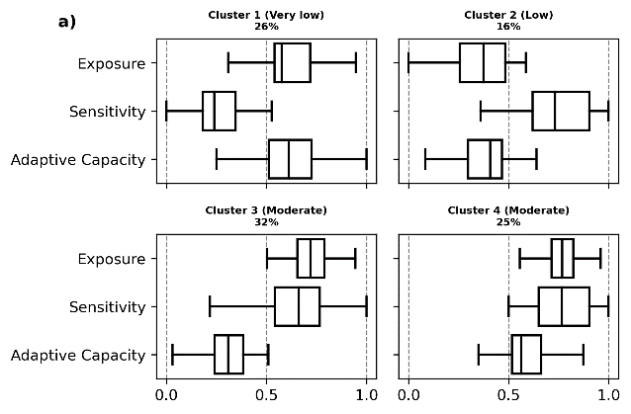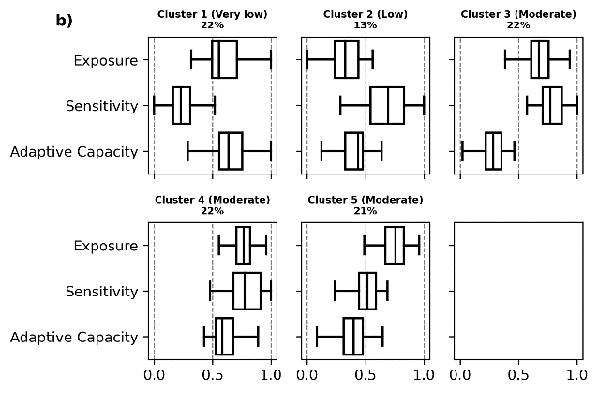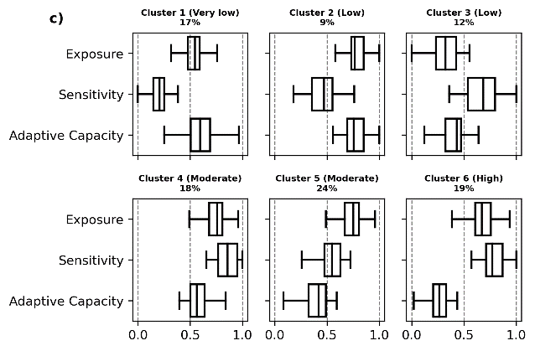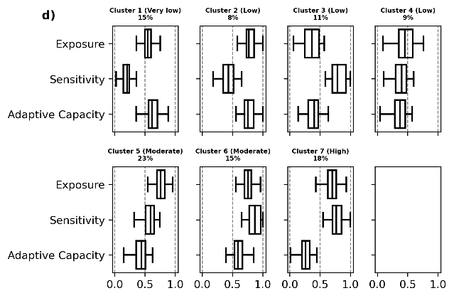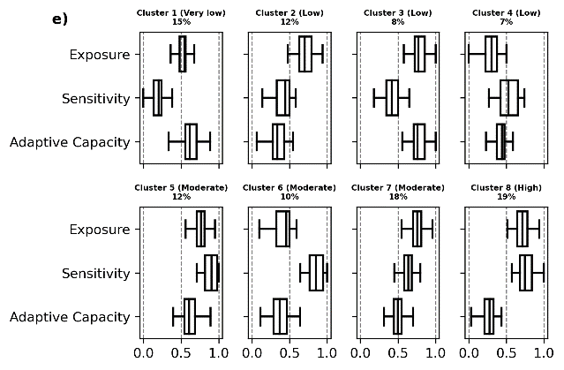
Supplementary Figure 2-1: Characteristics of the clusters using a) 4, b) 5, c) 6, d) 7 and e) 8 groups for clustering.
We also analysed the percentage of wine regions that are assigned to the same vulnerability level across different numbers of groups (Supplementary Table 2-1). Results with 6 or more groups are all very similar to each other, with at least 75% of the regions assigned to the same vulnerability level. In contrast, results with fewer than 6 groups are very different from those with 6 or more groups, which is mostly related to the fact that no regions are assigned a high vulnerability when using less than 6 groups.
Based on the sensitivity analysis presented here, we conclude that the best number of clusters for the study is 6. The use of 6 groups makes it possible to identify wine regions with a high vulnerability level but avoids an increased disaggregation with a large number of groups. Meanwhile, it assures that up to 87% and 75% of the regions obtain the same scoring as when using 7 or 8 groups, respectively.

Supplementary Table 2-1: Precentage of wine regions with an equal level of vulnerability for different number of clusters
Number of groups | 4 | 5 | 6 | 7 | 8
4 | - | 92 | 68 | 64 | 51
5 | 92 | - | 70 | 64 | 55
6 | 68 | 70 | - | 87 | 75
7 | 64 | 64 | 87 | - | 78
8 | 51 | 55 | 75 | 78 | -
Supplementary References

1. Candiago, S., Tscholl, S., Bassani, L., Fraga, H. & Vigl, L. E. A geospatial inventory of regulatory information for wine Protected Designations of Origin in Europe. Sci. Data (2022) doi:in review.
2. Santos, J. A. et al. A Review of the Potential Climate Change Impacts and Adaptation Options for European Viticulture. Appl Sci 10, 3092 (2020).
3. Leeuwen, C. van et al. An Update on the Impact of Climate Change in Viticulture and Potential Adaptations. Agronomy 9, 514 (2019).
4. Karger, D. N., Schmatz, D. R., Dettling, G. & Zimmermann, N. E. High-resolution monthly precipitation and temperature time series from 2006 to 2100. Sci Data 7, 248 (2020).
5. Karger, D. N. et al. Climatologies at high resolution for the earth’s land surface areas. Sci Data 4, 170122 (2017).
6. Fraga, H. et al. Very high resolution bioclimatic zoning of Portuguese wine regions: present and future scenarios. Reg Environ Change 14, 295–306 (2014).
7. Fraga, H., Malheiro, A. C., Moutinho-Pereira, J. & Santos, J. A. Future scenarios for viticultural zoning in Europe: Ensemble projections and uncertainties. Int J Biometeorol (2013) doi:10.1007/s00484-012-0617-8.
8. Fraga, H. et al. Climatic suitability of Portuguese grapevine varieties and climate change adaptation. Int J Climatol 36, 1–12 (2016).
9. Santillán, D., Iglesias, A., Jeunesse, I. L., Garrote, L. & Sotes, V. Vineyards in transition: A global assessment of the adaptation needs of grape producing regions under climate change. Sci Total Environ 657, 839–852 (2019).
10. Fraga, H., Malheiro, A. C., Moutinho-Pereira, J. & Santos, J. A. Future scenarios for viticultural zoning in Europe: Ensemble projections and uncertainties. Int J Biometeorol (2013) doi:10.1007/s00484-012-0617-8.
11. Jones, G. & Schultz, H. Climate change and emerging cool climate wine regions. Wine and Viticulture journal 51 (2016).
12. Bois, B., Zito, S. & Calonnec, A. Climate vs grapevine pests and diseases worldwide: the first results of a global survey. Oeno One 51, 133–139 (2017).
13. Borsdorf, A., Tasser, E. I. & Tappeiner, U. Alpenatlas: Society - economy - environment. (Spektrum Akademischer Verlag, 2008).
14. Eurostat Census Hub, Resident Population, 2022. https://ec.europa.eu/CensusHub2/query.do?step=selectHyperCube&qhc=false.
15. Eurostat, GISCO LAU2 dataset for the year 2020, 2022. https://ec.europa.eu/eurostat/web/gisco/geodata/reference-data/administrative-units-statistical-units/lau.
16. Union, E. Corine Land Cover. Preprint at (2022).
17. d’Andrimont, R. et al. From parcel to continental scale – A first European crop type map based on Sentinel-1 and LUCAS Copernicus in-situ observations. Remote Sens Environ 266, 112708 (2021).
18. IPCC. Impacts, Adaptation and Vulnerability. (2001).
19. OpenStreetMap contributors, 2022. https://download.geofabrik.de/.
20. European Commision, Farm Accountancy Data Network, 2022. https://agridata.ec.europa.eu/extensions/DashboardFarmEconomyFocus/DashboardFarmEconomyFocus.html.
21. Winkler, K. J., Viers, J. H. & Nicholas, K. A. Assessing Ecosystem Services and Multifunctionality for Vineyard Systems. Frontiers Environ Sci 5, 15 (2017).
22. Caffarra, A., Rinaldi, M., Eccel, E., Rossi, V. & Pertot, I. Modelling the impact of climate change on the interaction between grapevine and its pests and pathogens: European grapevine moth and powdery mildew. Agric Ecosyst Environ 148, 89–101 (2012).
23. EU-DEM v1.1, Copernicus Land Monitoring Service, 2022. https://land.copernicus.eu/imagery-in-situ/eu-dem/eu-dem-v1.1.
24. Egarter, L. V. et al. Upward shifts in elevation – a winning strategy for mountain viticulture in the context of climate change? in E3S Web of Conferences vol. 50 02006 (2018).
25. Santos, M., Fonseca, A., Fraga, H., Jones, G. V. & Santos, J. A. Bioclimatic conditions of the Portuguese wine denominations of origin under changing climates. Int J Climatol (2019) doi:10.1002/joc.6248.
26. Jones, G. V., Duff, A. A., Hall, A. & Myers, J. W. Spatial analysis of climate in winegrape growing regions in the western United States. American Journal of Enology and Viticulture 61, 313-- 326 (2010).
27. Hall, A. & Jones, G. V. Spatial analysis of climate in winegrape-growing regions in Australia. Aust J Grape Wine R (2010) doi:10.1111/j.1755-0238.2010.00100.x.
28. Candiago, S., Tscholl, S., Bassani, L., Fraga, H. & Vigl, L. E. A geospatial inventory of regulatory information for wine Protected Designations of Origin in Europe. Sci. Data (2022).
29. Parker, A. K. et al. Temperature-based grapevine sugar ripeness modelling for a wide range of Vitis vinifera L. cultivars. Agr Forest Meteorol 285–286, 107902 (2020).
30. Tscholl, S., Tasser, E., Ulrike, T. & Vigl, L. E. Coupling solar radiation and cloud cover data for enhanced temperature predictions over topographically complex mountain terrain. Int J Climatol (2021) doi:10.1002/joc.7497.
31. Eurostat data explorer, labour force main indicators, 2021. https://appsso.eurostat.ec.europa.eu/nui/show.do?dataset=ef_lf_main&lang=en.
32. Williges, K., Mechler, R., Bowyer, P. & Balkovic, J. Towards an assessment of adaptive capacity of the European agricultural sector to droughts. Clim Serv 7, 47–63 (2017).
33. Eurostat Data Browser, training of farm managers, 2022. https://ec.europa.eu/eurostat/databrowser/view/ef_mp_training/default/table?lang=en.
34. Greiving, S. et al. ESPON Climate: Climate Change and Territorial Effects on Regions and Local Economies. 72 https://www.espon.eu/sites/default/files/attachments/Final%20Report%20Main%20Report.pdf (2011).

