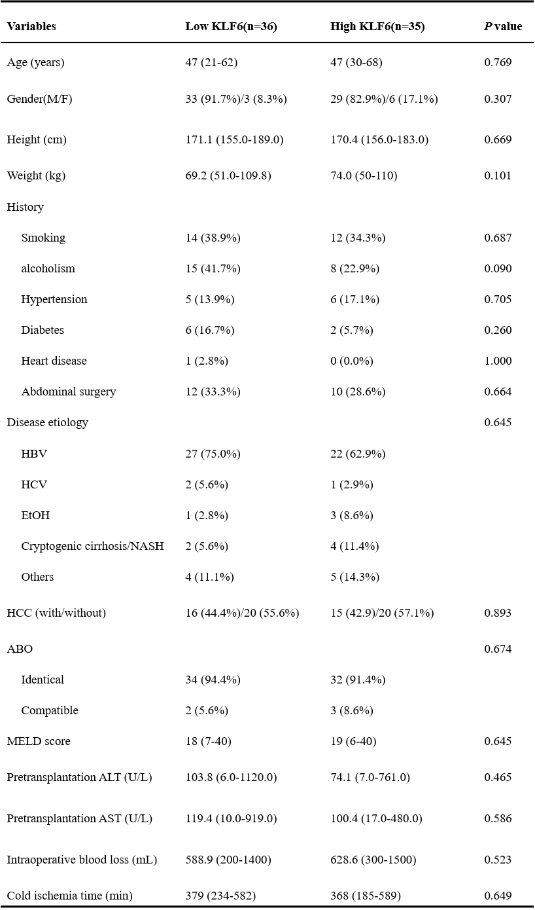
Table S2. Recipients’ perioperative variables

