Supplementary Information
Table S1: The amino acid profile of the culture systems
mz | rt | exact_mass | annotation | Oka | GLM7 | GLM14 | LBM7 | LBM14 | GLco7 | GLco14
122.0195 | 71.1 | 121.0197 | L-Cysteine | 1.20 ± 0.1 | 8.40 ± 0.5 | 3.30 ± 0.3 | 1.40 ± 0.1 | 1.30 ± 0.2 | 2.3 ± 0.2 | 3.1 ± 0.2
132.1421 | 217 | 131.0946 | L-Isoleucine | 1.50± 0.2 | 10.2± 0.5 | 1.45± 0.1 | 0.60 | 0.90± 0.1 | 8.60± 0.6 | 1.90± 0.2
147.0644 | 142 | 146.1055 | L-Lysine | 10.8± 0.4 | 1.20± 0.1 | 4.30± 0.2 | 8.50± 0.3 | 8.70± 0.2 | 33.60± 1.5 | 3.30± 0.2
182.081 | 104 | 181.0739 | L-Tyrosine | 28.8± 0.8 | 23.60± 0.9 | 29.50± 1.6 | 24.92± 1.2 | 32.71± 1.3 | 30.52± 1.3 | 27.14± 1.4
164.0726 | 290 | 165.079 | L-Phenylalanine | 63.6± 0.9 | 57.10± 2.1 | 36.90± 1.3 | 32.20± 0.8 | 42.4± 0.9 | 24.22± 0.5 | 60.10± 3.5
204.0875 | 94.8 | 204.0899 | Tryptophan | 90.1± 2.8 | 19.26± 0.6 | 33.72± 0.8 | 46.95± 1.1 | 100.4± 3.9 | 164.4± 4.5 | 50.27± 2.3
148.9767 | 139 | 149.051 | L-Methionine | 94.9± 2.6 | 65.14± 1.3 | 85.63± 2.2 | 97.56± 2.8 | 51.58± 2.1 | 110.6± 4.7 | 59.85± 1.8
104.0353 | 85.6 | 105.0426 | L-Serine | 140.6± 5.5 | 20.68± 0.4 | 7.38± 0.2 | 30.93± 0.7 | 6.47± 0.3 | 24.86± 0.4 | 4.83± 0.4
173.104 | 104 | 174.1117 | L-Arginine | 172.0± 4.4 | 40.95± 3.1 | 6.36± 0.4 | 74.35± 2.9 | 98.43± 5.2 | 54.75± 2.3 | 14.30± 0.8
116.0721 | 744 | 117.079 | L-Valine | 195.7± 3.8 | 242.16± 8.3 | 263.17± 7.5 | 172.23± 3.8 | 280.8± 4.9 | 177.8± 4.3 | 68.19± 2.6
130.0864 | 604 | 131.0946 | Leucine | 269.3± 4.6 | 239.52± 6.2 | 195.93± 2.4 | 306.72± 5.8 | 253.5± 6.2 | 240.1± 3.5 | 269.0± 5.7
114.0557 | 817 | 115.0633 | L-Proline | 361.4± 6.3 | 308.9± 4.8 | 582.3± 9.9 | 852.3± 9.5 | 234.0± 3.9 | 445.2± 6.1 | 356.8± 3.2
130.0489 | 167 | 147.0532 | L-Glutamic acid | 374.54± 4.2 | 555.60± 8.4 | 17.60± 0.8 | 96.25± 5.9 | 119.6± 8.5 | 595.4± 9.8 | 62.28± 2.6
154.0616 | 94.8 | 155.0695 | L-Histidine | 387.76± 4.8 | 114.61± 2.4 | 146.37± 3.8 | 168.94± 3.7 | 162.7± 3.2 | 98.69± 1.9 | 147.2± 2.2
The concentration of the amaino acid of the cultures (µg/mL);blue column= increased amino acid concentration compared to okara medium, yellow column= decreased amino acid concentration compared to the okara medium; white column= no significant difference in amino acid concentrationcompared to okara medium; Oka -okara medium; GLM7-G. lucidum culture on day 7 of the incubation; GLM14-G. lucidum culture on day 14 of the incubation; LBM7-Lactobacillus plantarum on day 7 of the incubation; LBM14-Lactobacillus plantarum on day 14 of the incubation; GLco7-G. lucidum/L. plantarum coculture on day 7 of the incubation; GLco14-G. lucidum/L. plantarum coculture on day 14 of the incubation

Table S2: Effect of TOR silencing of G. lucidum on sugar metabolism during the culture
Sugars | mz | rt | Oka | GLM7 | GLM14 | LBM7 | LBM14 | GLc7 | GLc14
Sucrose | 343.2948 | 710.8 | 0.07±0.003 | 0.05±0.002 | 0.03±0.001 | 0.05±0.003 | 0.03±0.001 | 0.07±0.002 | 0.06±0.004
D-Maltose | 342.1388 | 152.1 | 0.25±0.02 | 0.04±0.002 | 0.18±0.01 | 0.09±0.002 | 0.1 | 0.26±0.02 | 0.25±0.03
D-Psicose | 180.0859 | 201.2 | 0.54±0.04 | 2.58±0.5 | 3.24±0.6 | 1.46±0.3 | 1.7±0.1 | 2.66±0.3 | 2.77±0.2
D-Glucose | 179.0576 | 645.4 | 1.69±0.4 | 1.73±0.1 | 3.65±0.4 | 0.74±0.03 | 0.65±0.02 | 0.86±0.04 | 0.09±0.003
L-Fucose | 165.0755 | 92 | 1.82±0.5 | 0.88±0.02 | 2.1±0.2 | 1.38±0.4 | 1.82±0.2 | 1.24±0.2 | 0.64±0.04
Sorbitol | 181.0717 | 88.8 | 4.25±0.5 | 8.3±0.7 | 3.91±0.5 | 9.08±0.8 | 6.71±0.5 | 4.25±0.4 | 4.26±0.3
L-Gulose | 179.0576 | 284.9 | 4.39±0.4 | 0.61±0.06 | 1.99±0.07 | 1.25±0.1 | 0.81±0.04 | 4.39±0.5 | 4.38±0.3
D-Fructose | 179.0574 | 130.9 | 6.33±0.4 | 3.46±0.4 | 9.27±0.8 | 2.14±0.3 | 9.55±0.6 | 3.07±0.6 | 0.16±0.05
Concnetration of sugars in the culture samples (g/L); blue column= increased sugar concentration compared to okara medium, yellow column= decreased sugar concentration compared to the okara medium; white column= no significant difference in nsugar concentrationcompared to okara medium;Oka -okara medium; GLM7-G. lucidum culture on day 7 of the incubation; GLM14-G. lucidum culture on day 14 of the incubation; LBM7-Lactobacillus plantarum on day 7 of the incubation; LBM14-Lactobacillus plantarum on day 14 of the incubation; GLco7-G. lucidum/L. plantarum coculture on day 7 of the incubation; GLco14-G. lucidum/L. plantarum coculture on day 14 of the incubation

Table S3: Impact of TOR silencing of G. lucidum on amino acid metabolism during the culture
mz | rt | exact_mass | annotation | Oka | GLM7 | GLM14 | LBM7 | LBM14 | GLco7 | GLco14
122.0195 | 71.1 | 121.0197 | L-Cysteine | 1.2±0.1 | 1.22±0.3 | 1.2±0.2 | 1.4±0.3 | 1.3±0.1 | 27.9±1.2 | 8.1±0.6
132.1421 | 217 | 131.0946 | L-Isoleucine | 1.5±0.3 | 7.6±0.6 | 4.5±0.4 | 0.6±0.05 | 0.9±0.04 | 0.91±0.06 | 0.4±0.05
147.0644 | 142 | 146.1055 | L-Lysine | 10.8±0.9 | 10.31±0.8 | 10.22±0.7 | 8.5±0.9 | 8.7±0.7 | 5.9±0.6 | 2.43±0.4
182.081 | 104 | 181.0739 | L-Tyrosine | 28.8±1.6 | 28.6±1.3 | 28.5 | 24.92±0.9 | 32.71±2.3 | 32.8±2.1 | 29.9±2.0
164.0726 | 290 | 165.079 | L-Phenylalanine | 63.6±3.3 | 63.1±4.2 | 63.9±3.2 | 32.2±2.4 | 42.4±2.5 | 63.9±4.8 | 62.4±4.4
204.0875 | 94.8 | 204.0899 | Tryptophan | 90.1±5.3 | 90.26±4.3 | 90.72±3.3 | 46.95±2.6 | 100.44±6.8 | 91.1±7.3 | 90.4±6.8
148.9767 | 139 | 149.051 | L-Methionine | 94.9±6.5 | 95.14±8.5 | 95.63±7.6 | 97.56±8.2 | 51.58±4.2 | 34.8±2.3 | 94.3±8.2
104.0353 | 85.6 | 105.0426 | L-Serine | 140.6±10.3 | 140.68±9.9 | 140.8±9.3 | 30.93±2.4 | 6.47±0.9 | 140.2±8.6 | 141.1±6.9
173.104 | 104 | 174.1117 | L-Arginine | 172.2±7.8 | 170.95±8.7 | 172.6±9.2 | 74.35±6.6 | 98.43±8.9 | 173±6.8 | 172.1±7.3
116.0721 | 744 | 117.079 | L-Valine | 195.7±8.9 | 195.16±8.3 | 195.5±8.4 | 172.23±6.6 | 280.83±9.4 | 195.1±8.7 | 194.6±8.4
130.0864 | 604 | 131.0946 | Leucine | 269.3±7.7 | 145.52±4.1 | 92.03±3.1 | 306.72±4.4 | 253.35±3.3 | 268.4±4.2 | 269.8±5.2
114.0557 | 817 | 115.0633 | L-Proline | 361.4±5.2 | 218.9±4.3 | 19.3±0.9 | 852.3±30.7 | 234±9.3 | 104.2±5.5 | 56.8±3.3
130.0489 | 167 | 147.0532 | L-Glutamic acid | 374.54±9.6 | 225.6±6.1 | 115.6±5.1 | 96.25±4.6 | 119.86±8.3 | 63.41±5.2 | 42.58±4.4
154.0616 | 94.8 | 155.0695 | L-Histidine | 387.76±9.6 | 206.07±6.4 | 88.09±0.3 | 168.94±8.6 | 162.07±6.5 | 59.23±5.4 | 38.28±1.1
The concentration of the amaino acid of the cultures (µg/mL);blue column= increased amino acid concentration compared to okara medium, yellow column= decreased amino acid concentration compared to the okara medium; white column= no significant difference in amino acid concentrationcompared to okara medium; Oka -okara medium; GLM7-G. lucidum culture on day 7 of the incubation; GLM14-G. lucidum culture on day 14 of the incubation; LBM7-Lactobacillus plantarum on day 7 of the incubation; LBM14-Lactobacillus plantarum on day 14 of the incubation; GLco7-G. lucidum/L. plantarum coculture on day 7 of the incubation; GLco14-G. lucidum/L. plantarum coculture on day 14 of the incubation

Table S4: The concentration of extracellular vitamins and cofactors in the cultures
mz | RT | exact_mass | Annotation | Oka | GLM7 | GLM14 | LBM7 | LBM14 | GLco7 | GLco14
441.252 | 777.4 | 441.1397 | Folic acid | 0.84±0.06 | 11.76±0.9 | 4.43±0.3 | 1.36 ±0.1 | 2.77±0.1 | 1.36±0.4 | 0.07±0.003
220.1178 | 325.6 | 219.1107 | Pantothenic acid | 0.80±0.05 | 0.56±0.04 | 0.63±0.05 | 9.87±0.8 | 4.37±0.4 | 7.13±0.4 | 6.61±0.5
450.2085 | 287.3 | 450.3498 | Vitamin K1 | 7.80±0.6 | 0.72±0.05 | 0.21±0.03 | 0.68±0.04 | 0.49±0.02 | 0.64±0.03 | 0.34±0.04
376.2585 | 764.5 | 376.1383 | Riboflavin(Vit. B2) | 10.80±0.8 | 10.35±0.9 | 10.46±0.7 | 11.51±0.9 | 9.08±0.6 | 12.37±0.7 | 11.89±0.8
663.445 | 3.13 | 663.4254 | NAD | 2.04±0.5 | 1.86±0.2 | 3.02±0.2 | 2.33±0.1 | 1.19±0.1 | 0.35±0.02 | 3.54±0.7
646.1221 | 4.35 | 665.1248 | NADH | 1.11±0.7 | 0.53±0.06 | 1.45±0.7 | 1±0.2 | 1.54±0.3 | 0.59±0.04 | 0.31±0.02
456.1039 | 9.14 | 456.1046 | FMN | 2.58±0.7 | 4.8±0.4 | 0.42±0.04 | 1.03±0.3 | 0.45±0.04 | 8.76±0.9 | 4.71±0.6
459.1264 | 5.21 | 458.1203 | FMNH2 | 1.28±0.3 | 0.1±0.01 | 2±0.4 | 1.17±0.5 | 1.65±0.6 | 0.26±0.01 | 0.38±0.02
832.6139 | 8.26 | 745.0911 | NADPH | 2.12±0.6 | 3.91±0.5 | 2.14±0.4 | 9.73±0.9 | 5.73±0.4 | 7.58±0.6 | 6.83±0.5
The concentration of the extracellular vitamins and cofactors in the cultures (g/L);blue column= increased extracellular vitamins and cofactors concentration compared to okara medium, yellow column= decreased extracellular vitamins and cofactors concentration compared to the okara medium; white column= no significant difference in extracellular vitamins and cofactors concentrationcompared to okara mediumOka -okara medium; GLM7-G. lucidum culture on day 7 of the incubation; GLM14-G. lucidum culture on day 14 of the incubation; LBM7-Lactobacillus plantarum on day 7 of the incubation; LBM14-Lactobacillus plantarum on day 14 of the incubation; GLco7-G. lucidum/L. plantarum coculture on day 7 of the incubation; GLco14-G. lucidum/L. plantarum coculture on day 14 of the incubation

Table S5: HPLC-MS/MS metabolite identification and quantification in the culture systems
mz | RT (Min) | Metabolite | molecular formular | exact_mass | Concentration (mg/mL)
 |  |  |  |  | Oka | GLM7 | GLM14 | LBM7 | LBM1 | GLco7 | GLco14
433.1334 | 384.2 | Asperulosidic acid | C18H24O12 | 432.127 | 0.08 ± 0.004 | 0.09 ± 0.003 | 0.05 ± 0.006 | 0.03 ± 0.001 | 0.02 ± 0.001 | 0.79 ± 0.03 | 1.39 ± 0.4
339.048 | 218.8 | Salvianolic acid G | C18H12O7 | 340.058 | 0.02 ± 0.003 | 0.06 ± 0.002 | 0.2 ± 0.01 | 0.03 ± 0.002 | 0.05 ± 0.02 | 0.53 ± 0.04 | 1.02 ± 0.2
307.084 | 96 | Bilobalide | C15H18O8 | 326.100 | 0.24 ± 0.02 | 0.15 ± 0.04 | 0.24 ± 0.01 | 0.15 ± 0.03 | 0.40 ± 0.02 | 0.61 ± 0.01 | 1.01 ± 0.1
520.3433 | 443.8 | Cucurbitacin P | C30H48O7 | 520.340 | 0.16 ± 0.03 | 0.85 ± 0.02 | 0.25 ± 0.05 | 0.24 ± 0.01 | 0.51 ± 0.03 | 0.83 ± 0.04 | 0.9 ± 0.06
471.0746 | 91.1 | Maslinic acid | C15H10O6 | 472.355 | 0.05 ± 0.004 | 0.05 ± 0.005 | 0.65 ± 0.04 | 0.30 ± 0.02 | 0.79 ± 0.04 | 0.83± 0.03 | 0.93 ± 0.05
636.4151 | 525.4 | Fasciculic acid B | C36H60O9 | 636.424 | 0.24 ± 0.02 | 0.19 ± 0.04 | 0.21 ± 0.02 | 0.16 ± 0.05 | 0.24 ± 0.02 | 0.88 ± 0.04 | 0.94 ± 0.05
439.3562 | 569.5 | Ursolic acid, | C30H48O3 | 456.360 | 0.06 ± 0.02 | 0.70 ± 0.04 | 0.52 ± 0.05 | 0.05 ± 0.02 | 0.02 ± 0.01 | 0.77 ± 0.03 | 0.78 ± 0.04
312.2023 | 31.8 | Dienogest | C20H25NO2 | 311.418 | 0.07 ± 0.004 | 0.72 ± 0.03 | 0.59 ± 0.02 | 0.03 ± 0.001 | 0.04 ± 0.002 | 0.29 ± 0.03 | 1.13 ± 0.04
804.3619 | 410.9 | Stevioside | C38H60O18 | 804.378 | 0.04 ± 0.005 | 0.32 ± 0.05 | 0.17 ± 0.01 | 0.11 ± 0.04 | 0.16 ± 0.01 | 0.79 ± 0.05 | 0.97 ± 0.06
959.5277 | 689.7 | Asiaticoside | C48H78O19 | 958.514 | 0.50 ± 0.03 | 0.47 ± 0.04 | 0.86 ± 0.02 | 0.63 ± 0.04 | 0.30 ± 0.03 | 0.92 ± 0.05 | 1.11 ± 0.08
375.1289 | 434.9 | Geniposidic acid | C16H22O10 | 374.121 | 0.08 ± 0.004 | 0.03 ± 0.002 | 0.07 ± 0.003 | 0.44 ± 0.04 | 0.05 ± 0.003 | 0.21 ± 0.04 | 0.55 ± 0.06
516.309 | 7.25 | Ganoderic acid A | C30H44O7 | 516.308 | 0.21 ± 0.05 | 0.36 ± 0.06 | 0.51 ± 0.02 | 0.01 ± 0.003 | 0.01 ± 0.004 | 0.53 ± 0.06 | 0.92 ± 0.05
516.691 | 2.1 | Ganoderic acid B | C30H44O7 | 517.014 | 0.42 ± 0.02 | 0.43 ± 0.04 | 0.73 ± 0.05 | 0.04 ± 0.03 | 0.03 ± 0.002 | 1.07 ± 0.06 | 1.93 ± 0.07
491.2132 | 371 | Jasminoside H | C22H36O12 | 492.221 | 0.01 ± 0.001 | 0.23 ± 0.03 | 0.09 ± 0.005 | 0.04 ± 0.003 | 0.01 ± 0.002 | 0.29 ± 0.02 | 0.20 ± 0.03
389.1841 | 97 | Ilicicolinic acid A | C23H31ClO4 | 406.191 | 0.09 ± 0.005 | 0.78 ± 0.02 | 0.27 ± 0.03 | 0.69 ± 0.05 | 0.80 ± 0.07 | 0.51 ± 0.03 | 0.57 ± 0.04
289.0693 | 608.4 | Epicatechin | C15H14O6 | 290.079 | 0.19 ± 0.02 | 1.53 ± 0.2 | 2.39 ± 0.4 | 1.31 ± 0.3 | 1.11 ± 0.1 | 0.75 ± 0.3 | 1.48 ± 0.4
271.0614 | 494.7 | Catechin | C15H14O6 | 290.079 | 0.62 ± 0.05 | 1.47 ± 0.2 | 1.59 ± 0.5 | 2.39 ± 0.5 | 2.28 ± 0.4 | 0.97 ± 0.4 | 1.26 ± 0.5
287.0543 | 450.5 | Kaempferol | C15H10O6 | 286.048 | 0.45 ± 0.03 | 0.21 ± 0.03 | 0.01 ± 0.003 | 0.41 ± 0.02 | 0.47 ± 0.02 | 1.10 ± 0.3 | 1.13 ± 0.4
255.065 | 487.1 | Daidzein | C15H10O4 | 254.058 | 0.28 ± 0.03 | 1.72 ± 0.5 | 0.51 ± 0.04 | 1.85 ± 0.5 | 0.31 ± 0.03 | 1.35 ± 0.4 | 0.90 ± 0.03
269.1625 | 639.4 | Genistein | C15H10O5 | 270.053 | 0.11 ± 0.01 | 1.12 ± 0.3 | 1.06 ± 0.6 | 1.54 ± 0.4 | 1.62 ± 0.2 | 1.39 ± 0.4 | 2.04 ± 0.31
285.0399 | 738.8 | Luteolin | C15H10O6 | 286.048 | 0.02 ± 0.004 | 0.09 ± 0.003 | 1.10 ± 0.3 | 0.78 ± 0.02 | 0.17 ± 0.03 | 0.41 ± 0.02 | 1.59 ± 0.4
269.0452 | 526 | Apigenin | C15H10O5 | 270.053 | 0.00± 0.0 | 0.98± 0.06 | 1.07± 0.3 | 0.36± 0.05 | 0.63± 0.03 | 0.95± 0.04 | 1.08± 0.5
514.2268 | 300.2 | Nomilin | C28H34O9 | 514.220 | 0.01± 0.001 | 0.48± 0.03 | 0.82± 0.06 | 0.91± 0.05 | 1.68± 0.3 | 1.01± 0.5 | 2.09± 0.3
303.0439 | 79.1 | Quercetin | C15H10O7 | 302.043 | 0.04± 0.005 | 0.48± 0.06 | 0.82± 0.03 | 0.91± 0.04 | 0.68± 0.05 | 1.01± 0.4 | 1.49± 0.6
416.1218 | 269.3 | Puerarin | C21H20O9 | 416.111 | 0.02± 0.001 | 0.41± 0.02 | 0.82± 0.03 | 0.91± 0.06 | 1.08± 0.4 | 1.01± 0.3 | 1.73± 0.5
Oka -okara medium; GLM7-G. lucidum culture on day 7 of the incubation; GLM14-G. lucidum culture on day 14 of the incubation; LBM7-Lactobacillus plantarum on day 7 of the incubation; LBM14-Lactobacillus plantarum on day 14 of the incubation; GLco7-G. lucidum/L. plantarum coculture on day 7 of the incubation; GLco14-G. lucidum/L. plantarum coculture on day 14 of the incubation

Table S6: List of primers used in this study
Primer | Sequence (5′ to 3′) | Function
Tori-F | GTACggtaccAGGTATCAAGGGGAGCGA | Get the target of rapamycin gene fragment of Ganoderma lucidum
Tori-R | GTACactagtACAGCAAGCGAACGAGTG
RT-Tori-F | TCAACAACCTCCTTACCG | Detect the tor expression
RT-Tori-R | TGACCAGACTATGCTCCC | Detect the tor expression
RT-GS2-F | GCTGCTGTATGTGACGCTGAC | Detect the relative gene expression of putative glucan synthase 2
RT-GS2-R | TGGTGCGGGTTGAATAAGAA
HmgrRT-F | GTCATCCTCCTATGCCAAAC | Detects the Hmgr expression
HmgrRT-R | GGGCGTAGTCGTAGTCCTTC | Detects the Hmgr expression
OscRT-F | AGGGAGAACCCGAAGCATT | Detects the osc expression
OscRT-R | CGTCCACAGCGTCGCATAAC | Detects the osc expression
SqsRT-F | CTGCTTATTCTACCTGGTGCTACG | Detects the Sqs expression
SqsRT-R | GGCTTCACGGCGAGTTTGT | Detects the Sqs expression
GL26783-F | AACACCATCTACGACCAGCA | Detects putative glucokinase expression
GL26783-R | TCGACCAGACTCAACAAGCT | Detects putative glucokinase expression
GL24280-F | GGTCCGTTTGTATGTCGAGC | Detects putative α-phosphoglucomutase expression
GL24280-R | AAACGGTCATTTTCGCAGCT | Detects putative α-phosphoglucomutase expression
GL25739-F | CCCAATGATTATGCTGCCGT | Detects putative UDP-glucose-1-phosphate uridylyltransferase expression
GL25739-R | ATCGTCAGTCAATGCTTGCC
GL24465-F | CTTGAAAGGATGGCTCGACG | Detects putative 1,3-β-glucan synthase expression
GL24465-R | ACCGTCAATCAAGGCAGAGA | Detects putative 1,3-β-glucan synthase expression
18s-F | TATCGAGTTCTGACTGGGTTGT | Detects the 18s expression
18s-R | ATCCGTTGCTGAAAGTTGTAT | Detects the 18s expression

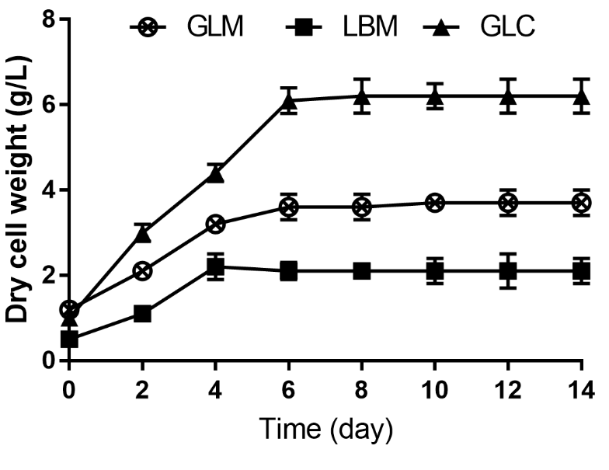
Fig S1: Impact of TOR silencing on the dry cell weight of the strains

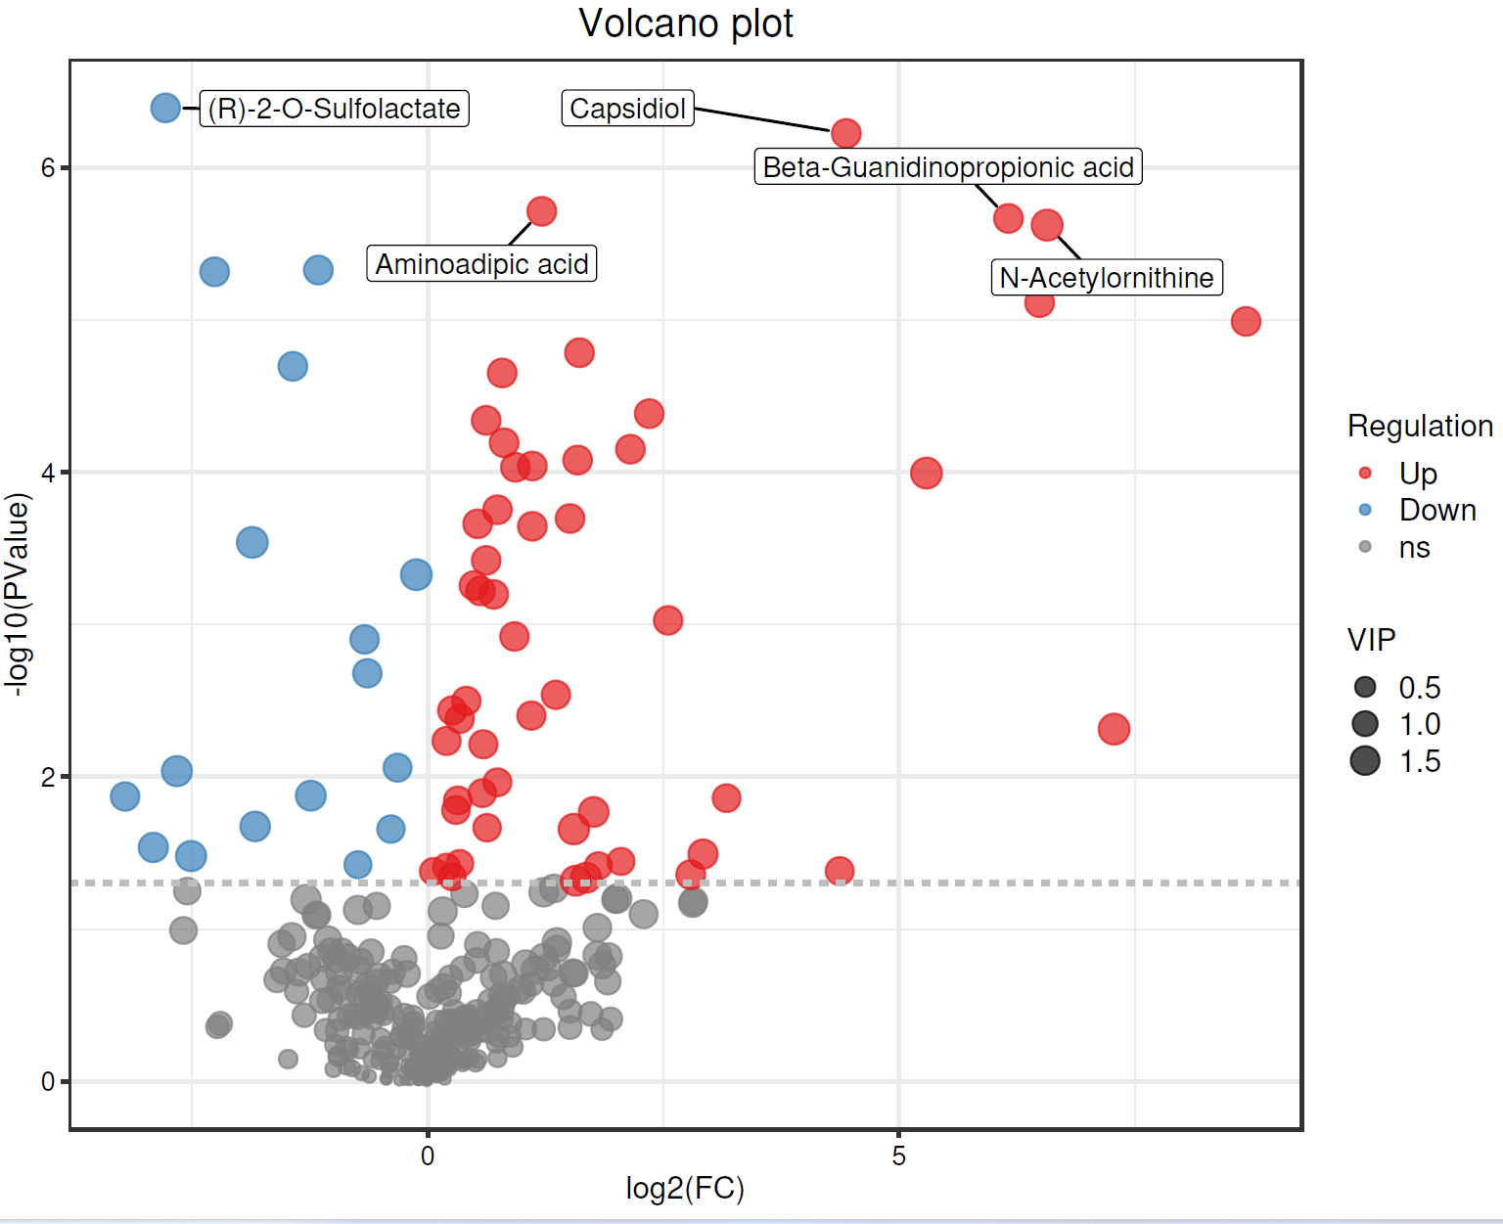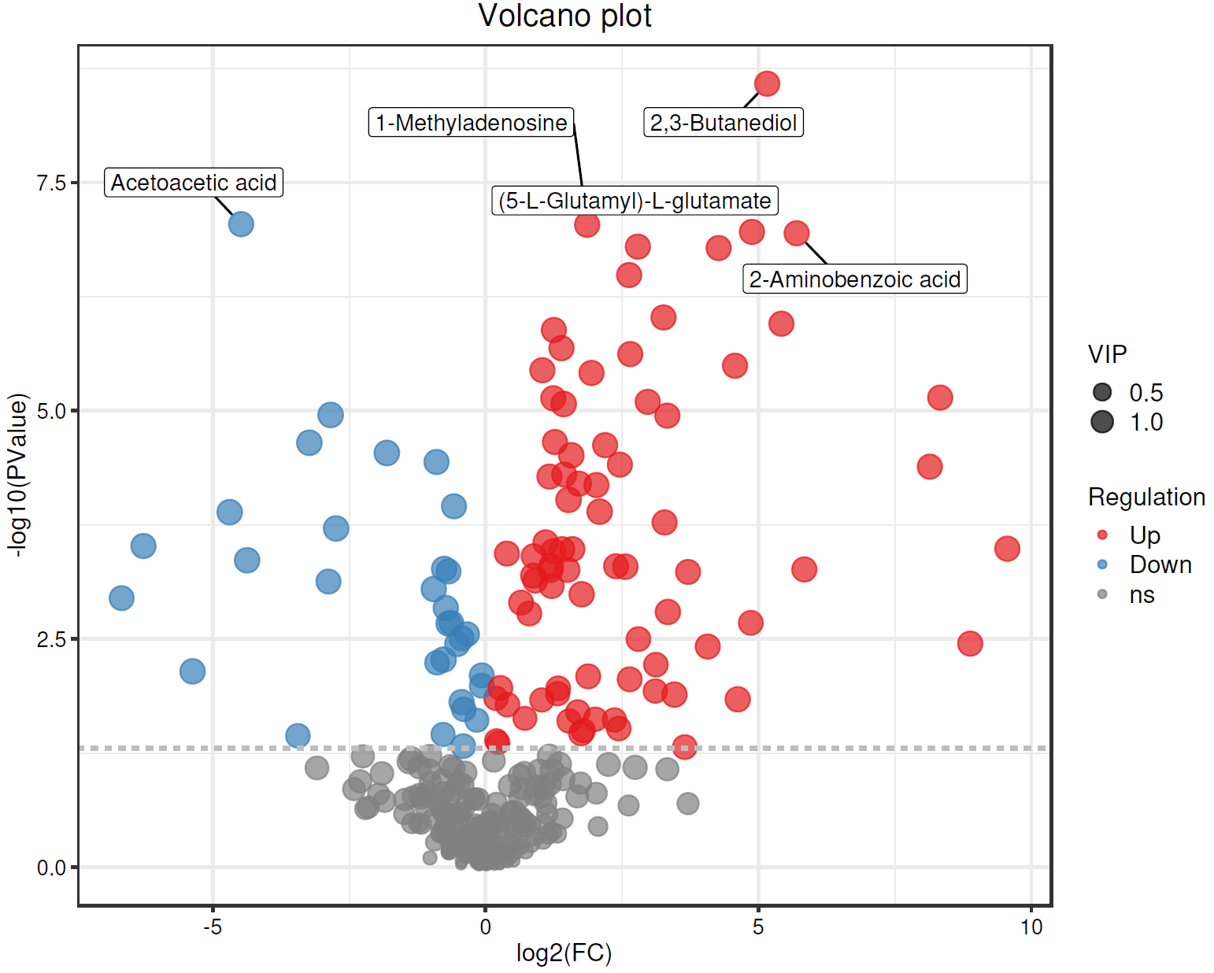
(b)

(a)

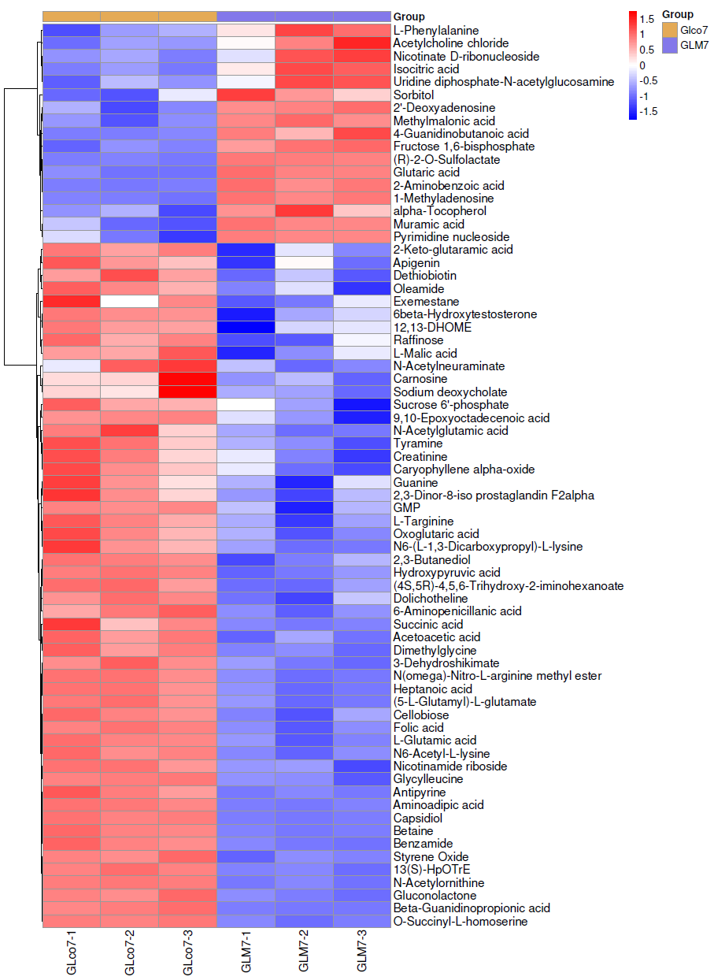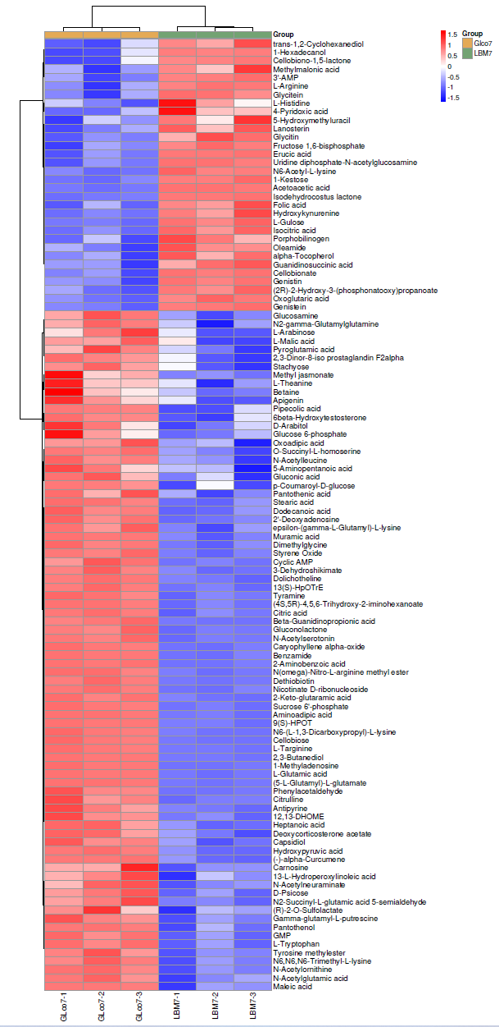
(e)

(d)

(c)

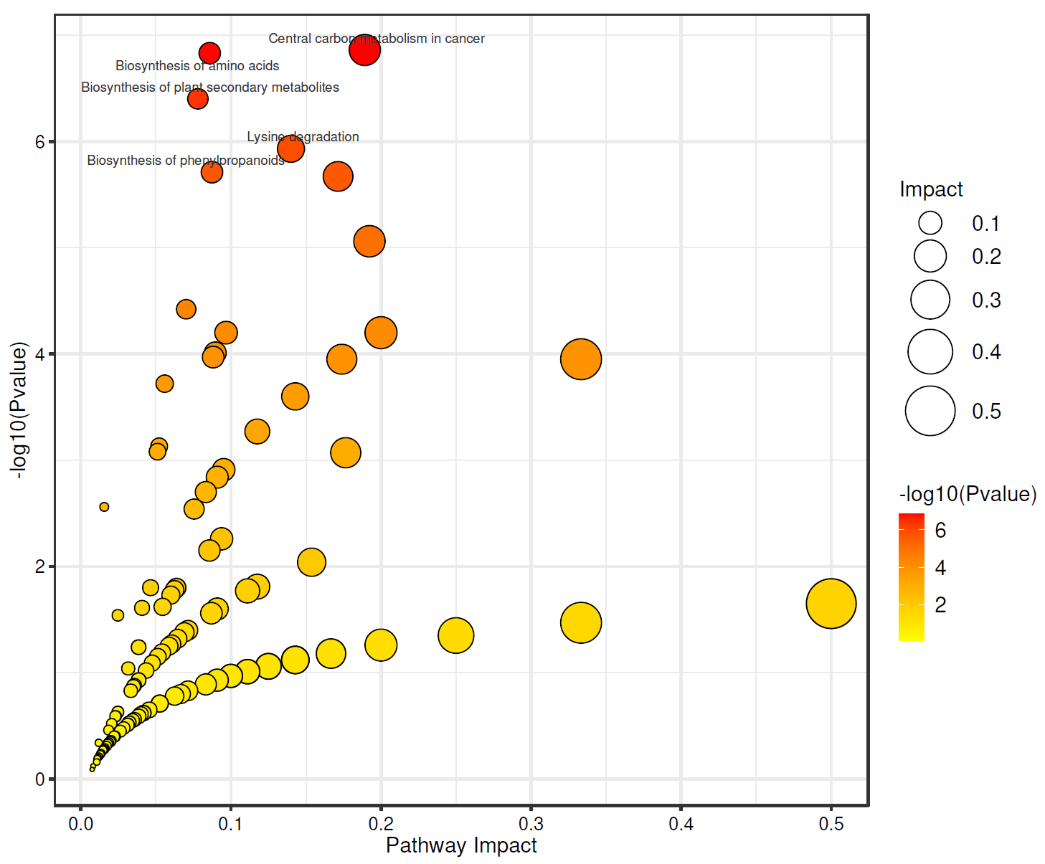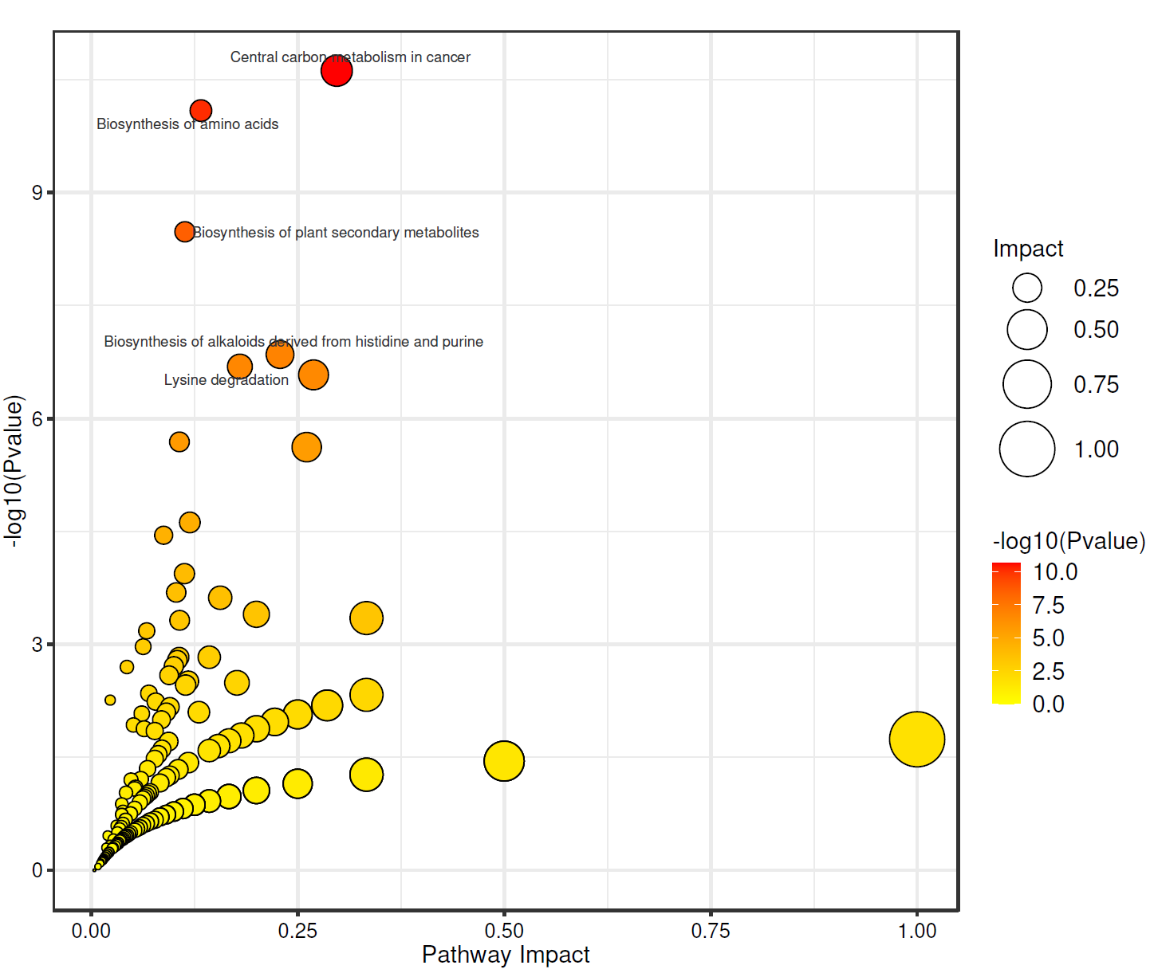
(f)

Fig.S2: The volcano plot of the metabolimc data of the G. lucidum/L. plantarum coculture (GLco7) and G. lucidum monoculture (GLM7) on day 7 of the incubation (a); The volcano plot of the metabolimc data of the G. lucidum/L. plantarum coculture (GLco7) and L. plantarum monoculture (LBM7) on day 7 of the incubation (b); The heatmap of the metabolimc data of the G. lucidum/L. plantarum coculture (GLco7) and G. lucidum monoculture (GLM7) on day 7 of the incubation (c); The heatmap of the metabolimc data of the G. lucidum/L. plantarum coculture (GLco7) and L. plantarum monoculture (LBM7) on day 7 of the incubation (d); The KEGG pathway impact map of the G. lucidum/L. plantarum coculture (GLco7) and G. lucidum monoculture (GLM7) on day 7 of the incubation (e); The KEGG pathway impact map of the metabolimc data of the G. lucidum/L. plantarum coculture (GLco7) and L. plantarum monoculture (LBM7) on day 7 of the incubation (f)
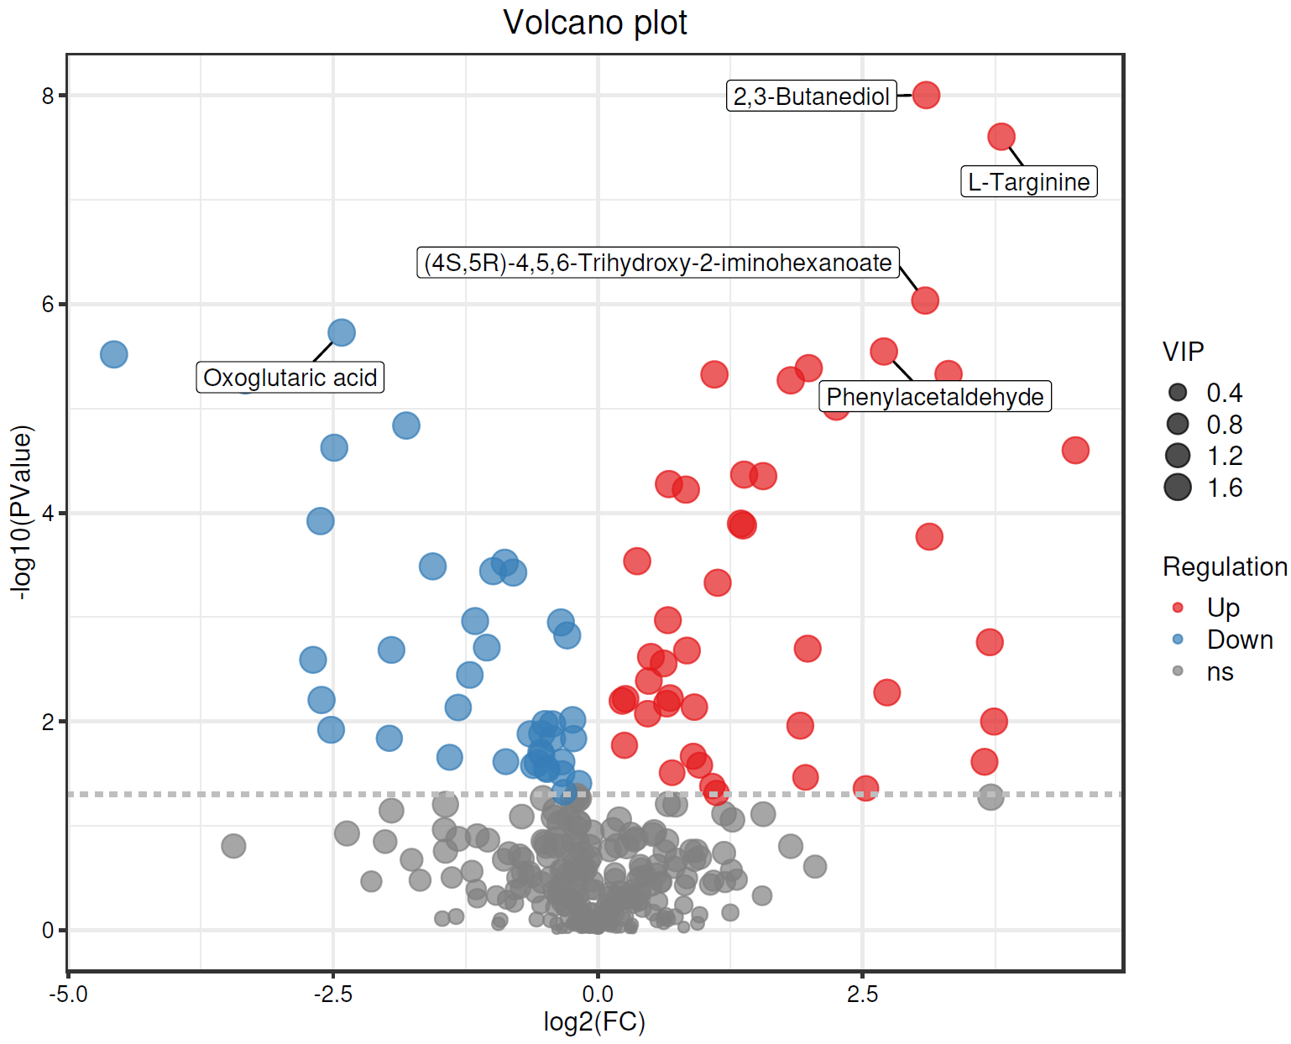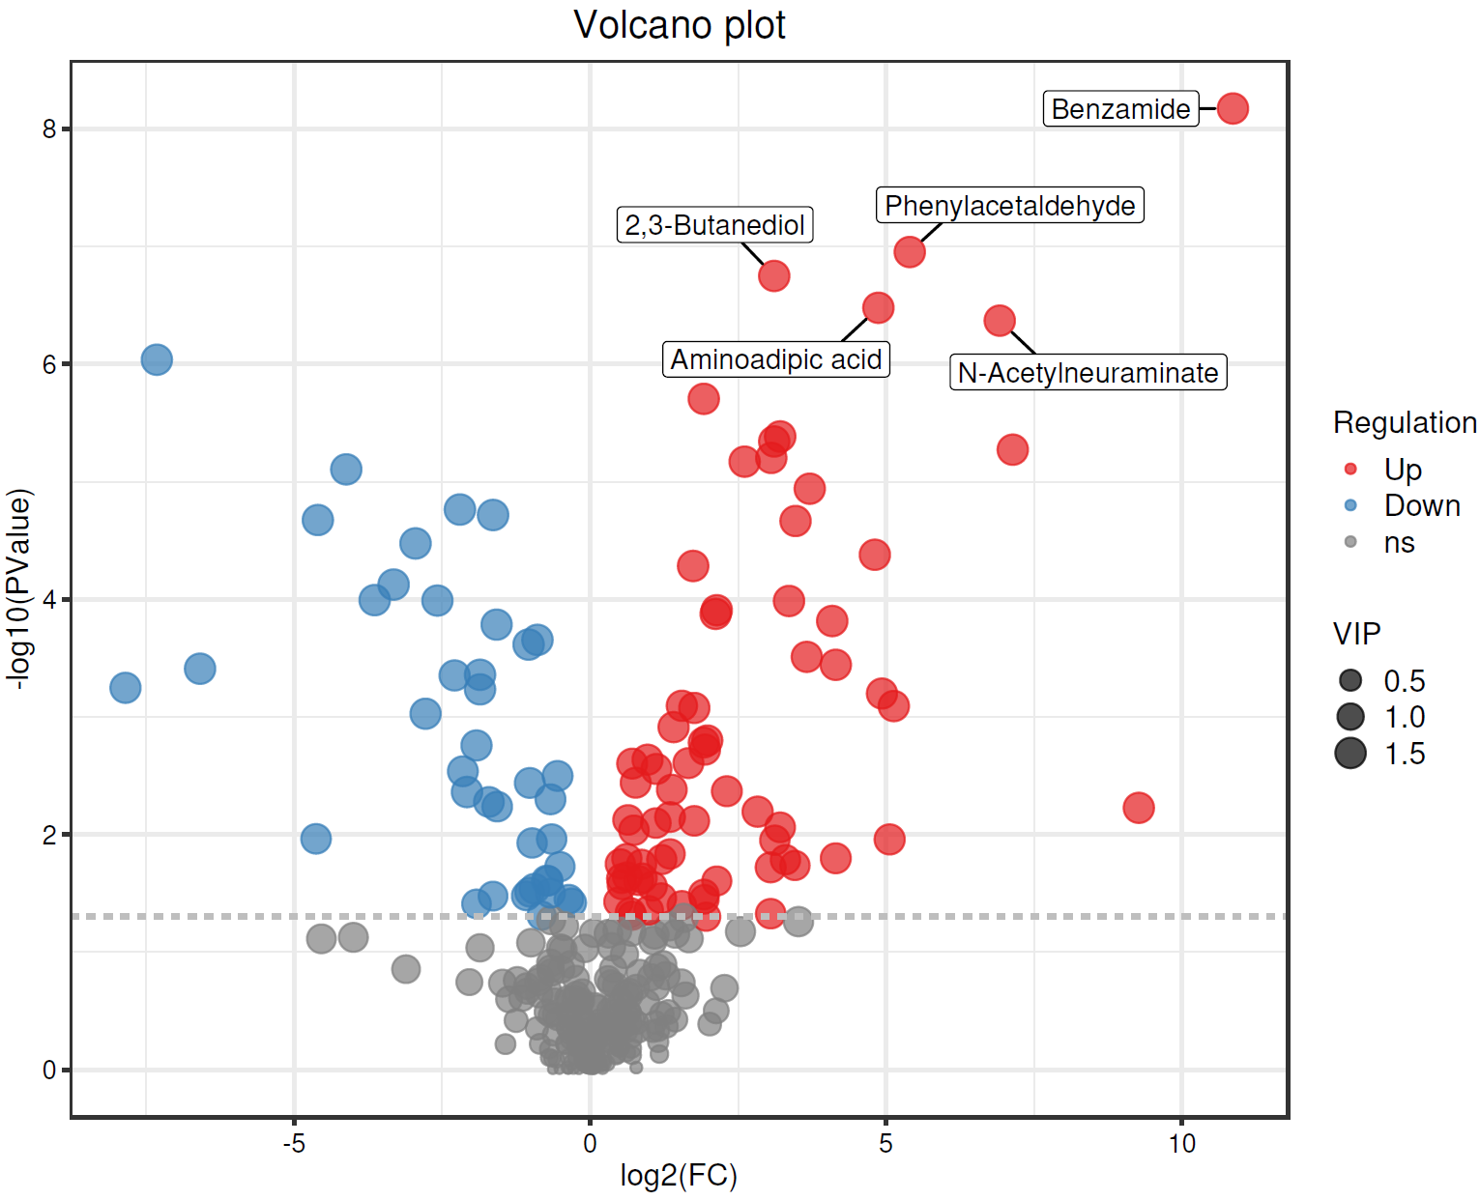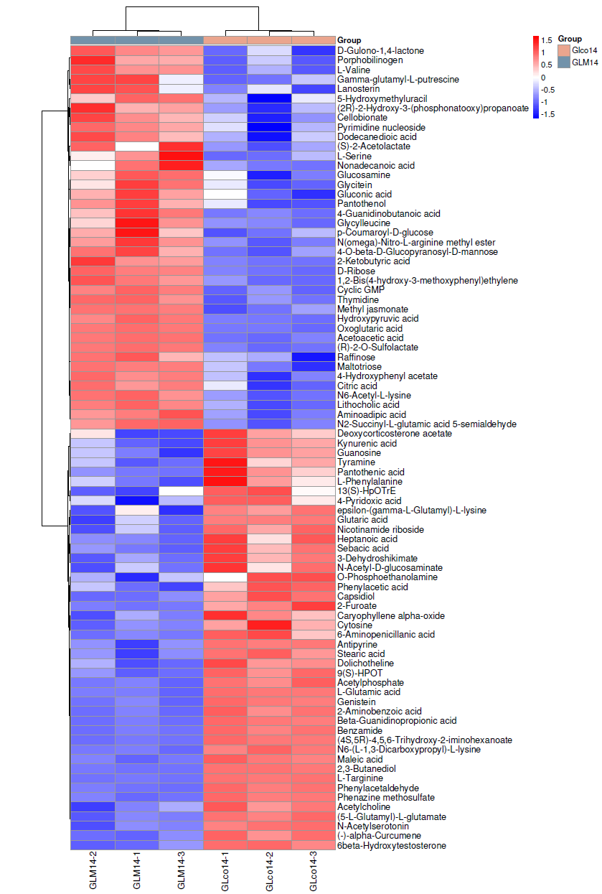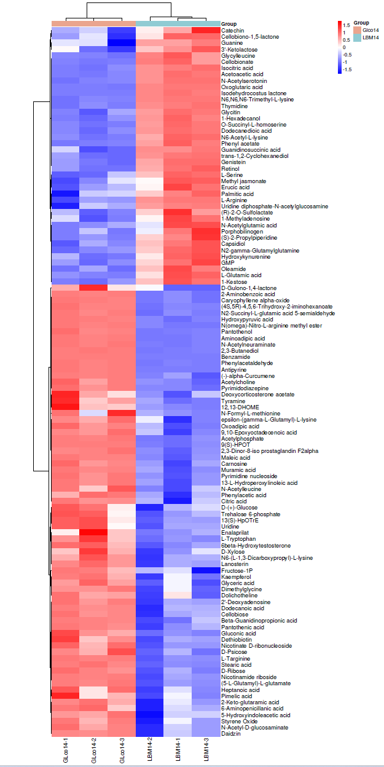
(f)

(d)

(c)

(b)

(a)

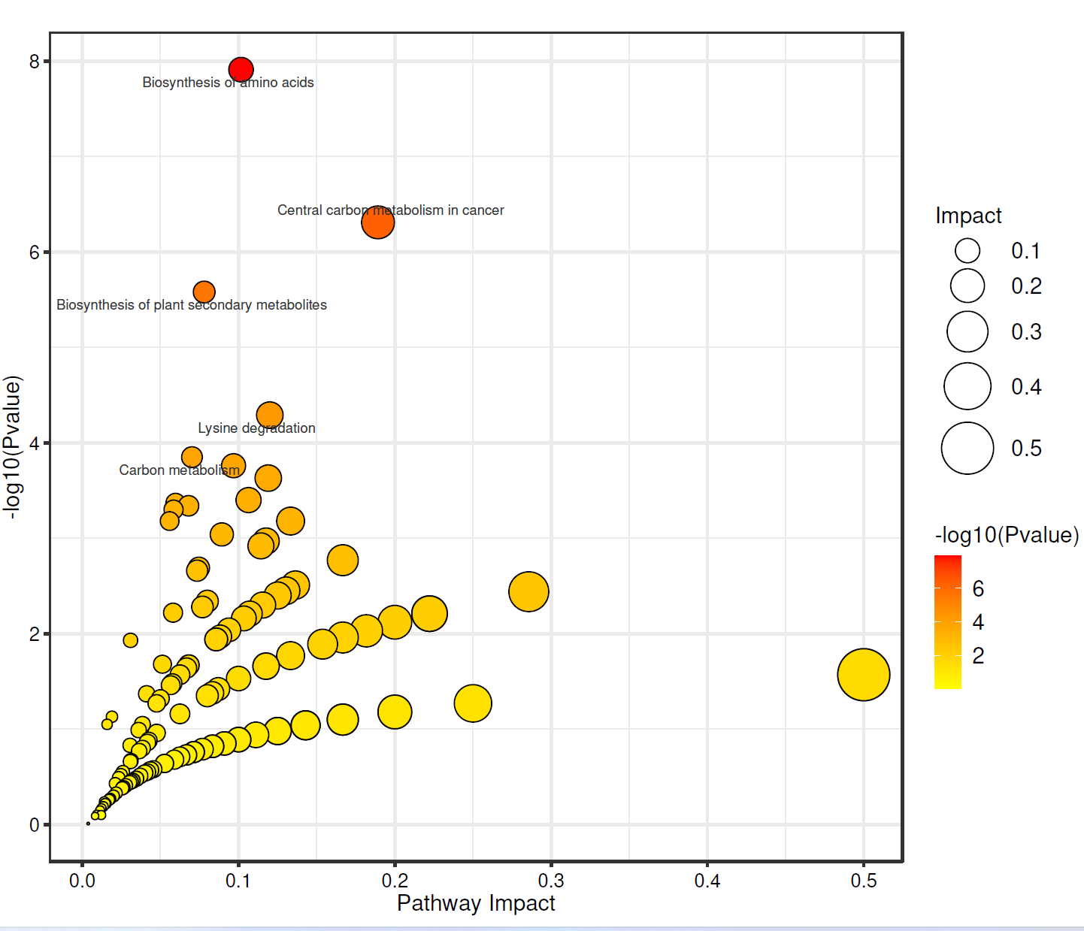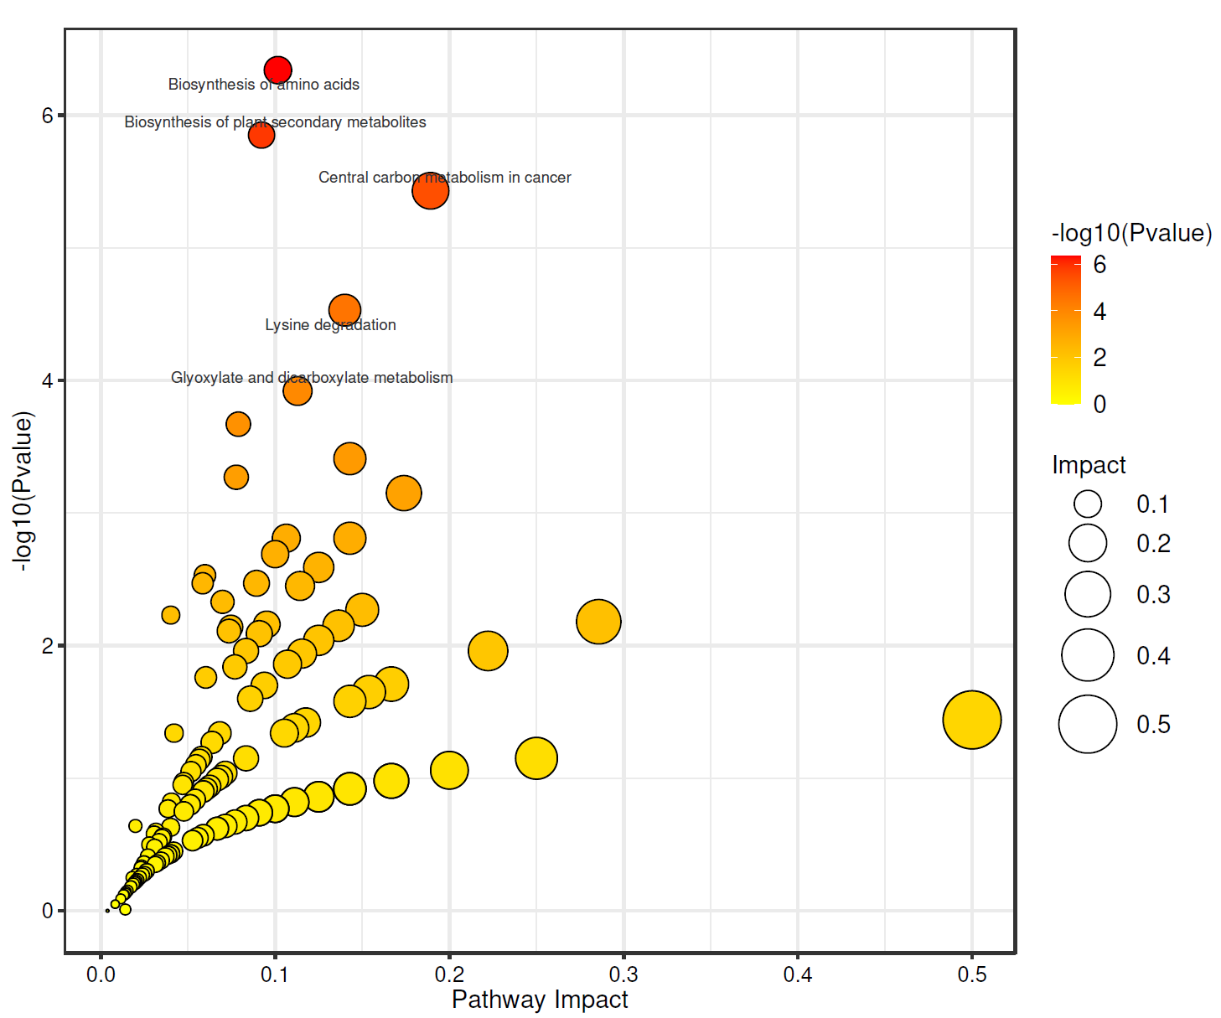
(e)

Fig.S3: The volcano plot of the metabolimc data of the G. lucidum/L. plantarum coculture (GLco14) and G. lucidum monoculture (GLM7) on day 14 of the incubation (a); The volcano plot of the metabolimc data of the G. lucidum/L. plantarum coculture (GLco14) and L. plantarum monoculture (LBM14) on day 14 of the incubation (b); The heatmap of the metabolimc data of the G. lucidum/L. plantarum coculture (GLco14) and G. lucidum monoculture (GLM14) on day 14 of the incubation (c); The heatmap of the metabolimc data of the G. lucidum/L. plantarum coculture (GLco14) and L. plantarum monoculture (LBM14) on day 14 of the incubation (d); The KEGG pathway impact map of the G. lucidum/L. plantarum coculture (GLco14) and G. lucidum monoculture (GLM14) on day 14 of the incubation (e); The KEGG pathway impact map of the metabolimc data of the G. lucidum/L. plantarum coculture (GLco14) and L. plantarum monoculture (LBM7) on day 14 of the incubation (f)

Supplementary methods
Liquid chromatography conditions: The LC analysis was performed on a Vanquish UHPLC System (Thermo Fisher Scientific, USA). Chromatography was carried out with an ACQUITY UPLC ® HSS T3 (150 × 2.1 mm, 1.8 μm) (Waters, Milford, MA, USA). The column was maintained at 40 ℃. The flow rate and injection volume were set at 0.25 mL/min and 2 μL, respectively. For LC-ESI (+)-MS analysis, the mobile phases consisted of (C) 0.1% formic acid in acetonitrile (v/v) and (D) 0.1% formic acid in water (v/v). Separation was conducted under the following gradient: 0~1 min, 2% C; 1~9 min, 2%~50% C; 9~12 min, 50%~98% C; 12~13.5 min, 98% C; 13.5~14 min, 98%~2% C; 14~20 min, 2% C. For LC-ESI (-)-MS analysis, the analytes were carried out with (A) acetonitrile and (B) ammonium formate (5mM). Separation was conducted under the following gradient: 0~1 min, 2%A; 1~9 min, 2%~50%A; 9~12 min, 50%~98%A; 12~13.5 min, 98%A; 13.5~14 min, 98%~2%A; 14~17 min, 2%A[1].
Mass spectrum conditions
Mass spectrometric detection of metabolites was performed on Q Exactive Focus (Thermo Fisher Scientific, USA) with ESI ion source. Simultaneous MS1 and MS/MS (Full MS-ddMS2 mode, data-dependent MS/MS) acquisition was used. The parameters were as follows: sheath gas pressure, 30 arb; aux gas flow, 10 arb; spray voltage, 3.50 kV and -2.50 kV for ESI(+) and ESI(-), respectively; capillary temperature, 325 ℃; MS1 range, m/z 100-1000; MS1 resolving power, 70000 FWHM; number of data dependant scans per cycle, 3; MS/MS resolving power, 17500 FWHM; normalized collision energy, 30 eV; dynamic exclusion time, automatic.
Metabolomic data processing and multivariate analysis
The raw data were firstly converted to mzXML format by MSConvert in ProteoWizard software package
(v3.0.8789)and processed using XCMS for feature detection, retention time correction and alignment. The metabolites were identified by accuracy mass (< 30 ppm) and MS/MS data which were matched with HMDB(http://www.hmdb.ca), massbank(http://www.massbank.jp/), LipidMaps(http://www.lipidmaps.org), mzcloud(https://www.mzcloud.org) and KEGG (http://www.genome.jp/kegg/). The robust LOESS signal correction (QC-RLSC)was applied for data normalization to correct for any systematic bias. After normalization, only ion peaks with relative standard deviations (RSDs) less than 30 % in QC were kept to ensure proper metabolite identification. The Roplssoftware was used for all multivariate data analyses and modelings. After scaling data, models were built on principal component analysis (PCA), orthogonal partial least-square discriminant analysis
(PLS-DA) and partial least-square discriminant analysis (OPLS-DA). The metabolic profiles could be visualized as score plot, where each point represents a sample. The corresponding loading plot and S-plot were generated to provide information on the metabolites that influence clustering of the samples. All the models evaluated were tested for over fitting with methods of permutation tests. The descriptive performance of the models was determined by R2X (cumulative) (perfect model: R2X (cum) = 1) and R2Y (cumulative) (perfect model: R2Y (cum) = 1) values while their prediction performance was measured by Q2 (cumulative) (perfect model: Q2 (cum) = 1) and a permutation test. The permuted model should not be able to predict classes: R2 and Q2 values at the Y-axis intercept must be lower than those of Q2 and the R2 of the non-permuted model. OPLS-DA allowed the determination of discriminating metabolites using the variable importance on projection (VIP). The P value, Variable importance projection (VIP) produced by OPLS-DA, fold change (FC) was applied to discover the contributable-variable for classification. Finally, P value < 0.05 and VIP values > 1 were considered to be statistically significant metabolites.
Pathway analysis
Differential metabolites were subjected to pathway analysis by MetaboAnalyst, which combines results from powerful pathway enrichment analysis with the pathway topology analysis. The identified metabolites in metabolomics were then mapped to the KEGG pathway for biological interpretation of higher-level systemic functions. The metabolites and corresponding pathways were visualized using KEGG Mapper tool. Gene silencing, over-expressing and triterpenoid and polysaccharides quantification

