Supplemental Materials and Methods
Study participants
This study was approved by the Joint Chinese University of Hong Kong–New Territories East Cluster Clinical Research Ethics Committee (CREC Ref. No. 2021.719). This retrospective study consisted of 101 patients with azoospermia (non-obstructive; absence of sperms) or severe oligozoospermia (<5 million sperm in 1 milliliter of semen) who had two semen tests and negative findings from G-banded chromosome analysis and Y microdeletion detection assays. All semen samples were obtained by masturbation after 3–7 days of sexual abstinence. Semen analysis was performed as described previously (Shi et al. 2021) according to World Health Organization guidelines (version V). Informed written consent was obtained from each participant at the time of semen analysis. The stored DNA samples used for Y microdeletion detection were used for this study. Microsurgical epididymal sperm aspiration (MESA) or testicular sperm extraction (TESE) following the standard protocol (Esteves et al. 2013) was performed if the patients opted for it after genetic counseling (with negative results from karyotyping analysis and Y microdeletion detection).

DNA preparation, library construction and genome sequencing
Genomic DNA from each sample was extracted from EDTA-anticoagulated peripheral blood using DNeasy Blood and Tissue Kit (Cat No./ID: 69506, Qiagen, Hilden, Germany) and were treated with RNase (Qiagen) for the Y microdeletion detection assay (Tse et al. 2000). The leftover DNA was quantified using a Qubit dsDNA HS Assay kit (Invitrogen, Carlsbad, CA, United States) and the DNA integrity was assessed by agarose gel electrophoresis.

The mate-pair library construction with low-pass GS was performed for each sample based on our published protocol (Dong et al. 2019): in brief, 1 µg DNA (measured by Qubit, London, England, UK) from each case was sheared with a E220e Focused-Ultrasonicator with miniTUBE Red (Covaris, Woburn, MA, USA) into 3~8 kb (a median size of 5 kb) fragments. DNA fragments were subsequently purified with Agencourt AmpureXP beads (Brea, CA, USA), end-repaired, A-tailed, and ligated with Ad1 adaptor. 320-ng of ligated DNA was then amplified with Pfu Turbo Cx (Agilent Technologies, Santa Clara, CA, USA) and additional dNTPs in a 200-µl of reaction volume (Pfu Turbo Cx, Agilent). After purification, a total of 20 µg amplified DNAs were pooled from 16 samples. The products were treated with Uracil Specific Excision Reagent (NEB, Ipswich, MA, USA) and T4 DNA ligase (Enzymatics, Beverly, MA, USA) to form double-stranded circular (dsCir) DNAs with one gap. A polymerization step nick translation (naCNT) controlling input nucleotide was performed with 1-pmol dsCir DNA, Bst DNA Polymerase, Full Length (NEB), Klenow fragment (Enzymatics), and limited dNTPs followed by 3’-branch ligations (3’end of Ad2 to the naCNT products). In addition, primer extension was accomplished by adjusting reaction temperature and duration time (ttCPE), and the reaction mixture incubated at 92℃ for 5-min, 56℃ for 60 sec, and 60℃ for 40 sec. The reaction mixture was further purified with Agencourt AmpureXP beads. ttCPE products were ligated to the 5’end of Ad2 and amplified with Pfu Turbo Cx. Single-stranded circular (ssCir) DNAs were processed for generating DNA nanoballs (DNBs) and sequenced on a MGISEQ-2000 platform (MGI Tech Co., Ltd., Shenzhen, China). A minimum of 60 million read-pairs (100 bp in length) were generated for each case, equating to an average 4 × read-depth and 60 × to 100 × physical coverage (Dong et al. 2021a).

High read-depth GS was performed for selected cases to identify or exclude additional clinically significant SNVs (single nucleotide variants) or small insertions/deletions (Indels) in cases for which mate-pair GS identified a pathogenic deletion in a gene implicated in an autosomal recessive (AR) etiology (n=2) or for multiple regions of AOHs (n=3). For high read-depth GS, 500-ng DNA (by Qubit) genomic DNA was sheared (300~500 bp) with an E220 Evolution Focused-Ultrasonicator (Covaris) and subjected to library construction using the MGIEasy FS DNA Library Prep kit according to the manufacturer’s protocol(Cao et al. 2022). Each library was sequenced (paired-end 150 bp) in an independent lane for a read-depth of ~40-fold on an MGISEQ-2000 platform (MGI).

Variant identification
With low-pass mate-pair GS, structural variants (SVs) and AOHs were identified using our reported in-house bioinformatics pipelines(Dong et al. 2021b; Dong et al. 2014; Dong et al. 2016). After data QC, read pairs were aligned to the human reference genome (GRCh37/hg19) using the Burrows–Wheeler aligner (BWA)(Li and Durbin 2009). Uniquely aligned reads were used for further analysis.

For copy-number variant (CNV) detection with read-depth difference algorithm (Wang et al. 2020), reads were classified into both adjustable sliding windows (50 kb with 5 kb increments) and nonoverlapping windows (5 kb), respectively. Subsequently, the copy ratios of all windows were normalized by the GC percentages and population-based data from our in-house dataset(Chau et al. 2020; Wang et al. 2020). CNVs were reported by the increment-rate-of-coverage module(Dong et al. 2016) at a resolution of 50 kb (homozygous or hemizygous deletion at 10 kb). For SV detection, chimeric read-pairs (aligned to different chromosomes or to the same chromosome with a genomic distance >10 kb) were selected for event clustering(Dong et al. 2018). Each potential event was then filtered against a dataset of systematic errors with optimized parameters (such as aligned strands). For AOH analysis(Dong et al. 2021b), after removal of reads resulting from PCR duplication, the coverage of each genomic location was summarized using the Mpileup module from SAMtools. A genomic locus with a read-depth of 5- to 20-fold with read(s) covered and with at least one read supporting a mutant base type was selected. Determination of heterozygous or homozygous SNV was based on the ratio of reads supporting a mutant base dividing the overall reads in this locus. The number of heterozygous SNVs and homozygous SNVs were calculated per window (with fixed size: 100-kb), respectively, and normalized by the average rate in that sample. Regions with AOH were indicated by a simultaneous decrease in the rate of heterozygous SNVs and increase in the rate of homozygous SNVs at a resolution of 5 Mb. Candidate CNVs, SVs, and AOHs were filtered against our in-house datasets, the 1,000 Genomes Project(Dong et al. 2018), the database of genomic variants (DGV), and SV curated in the Genome Aggregation Database (gnomAD) to filter out known common variants in the populations reported.

For cases sequenced with high read-depth GS(Cao et al. 2022) (40X), after quality control, paired-end reads were aligned to the human reference genome (GRCh37/hg19) by BWA and then reformatted by SAMtools. Detection of SNV/InDel was performed by HaplotypeCaller V.3.4 of the Genome Analysis Toolkit (Broad Institute), and annotation was conducted by ANNOVAR(Wang et al. 2010) with public databases and in-house datasets.

Annotation and variant interpretation
For SVs, the breakpoints/boundaries identified were used for analysis: (1) disruption or involvement of RefSeq gene(s) or (2) disruption of topologically associated domains (TAD) with ClinTAD(Spector and Wiita 2019) in which RefSeq gene(s) were involved. A SV was selected for further interpretation if it involved OMIM disease-causing gene(s), or disease-causing gene(s) due to haploinsufficiency/triplosensitivity in peer-reviewed publications, or curated by ClinGen Dosage Sensitivity Map, DECIPHER, GeneReviews or gnomAD. CNV interpretation followed the guidelines from the American College of Medical Genetics and Genomics (ACMG)(Riggs et al. 2019) for classification into pathogenic (P), likely pathogenic (LP), variant of uncertain significance (VUS), likely benign (LB) or benign (B). For copy-number neutral AOHs, parental consanguinity was suspected in cases with multiple regions with AOH (>5 Mb)(Rehder et al. 2013) on multiple chromosomes. In contrast, if there were one or more regions of AOH identified in one chromosome with an overall size of interstitial AOH exceeding 15 Mb, uniparental disomy (UPD) was suspected, or if the size of a terminal AOH exceeded 5 Mb, segmental UPD was suspected based on the ACMG recommendation (Del Gaudio et al. 2020).

In addition, potentially deleterious SNVs/Indels identified from high read-depth GS analysis were classified with the following criteria: (1) read-depth of ≥10, mutant allele fraction of ≥30% and ≤70% for heterozygous variants and >70% for homozygous variants; (2) affecting protein-coding regions and/or exon-intron junctions ± 200 bp; (3) with a minor allele frequency (MAF) of ≤1% indicated in gnomAD. Variants predicted as P/LP or VUS by InterVar, reported as P/LP in ClinVar or curated as ‘disease-causing mutation’ or ‘likely disease-causing mutation’ in the Human Gene Mutation Database (HGMD) were set as the highest priority. Variants (1) predicted as ‘deleterious’ by at least two in silico predictions such as SIFT, Polyphen2, HumVar, Mutation Taster and CADD (≥20); (2) likely resulting in alternative splicing sites predicted by Human Splicing Finder; or (3) as truncating mutations in genes with a pLI (the probability of being loss-of-function intolerant) score of ≥0.9 were also selected. Classification of SNVs/Indels also followed ACMG guidelines(Richards et al. 2015).

Variant verification
Firstly, CNVs identified in this study were verified by an orthogonal approach by either chromosomal microarray analysis (CMA) platform or quantitative PCR (qPCR). For each CNV queried, the 44K Fetal DNA Chip v1.0 (Agilent Technologies, Santa Clara, CA, USA) was assessed for sufficient probe coverage in the region of interest (at least five probes)(Wang et al. 2020). For those with insufficient probes from CMA in the candidate region, qPCR was used with primers targeting the candidate region as previously described(Wang et al. 2020). Primers were designed with Primer 3 Web, Primer-Blast (NCBI), and in silico PCR (UCSC) based on the human reference genome (GRCh37/hg19). The melting curve analysis was performed for each pair of primers to ensure specificity of PCR amplification, and the standard curve method was applied to determine PCR efficiency (within a range of 95 – 105%). Each reaction was performed in triplicate in 10 μL of reaction mixtures simultaneously in cases and controls (in-house normal male and female controls) using the SYBR Select Master Mix (Applied Biosystems, Waltham, MA, USA). Reactions were run in a 7900HT Real-Time PCR System (Applied Biosystems) using default reaction conditions. Copy numbers in each sample were determined by the ΔΔ Ct (cycle threshold) method, which compared the difference in Ct of the targeted region with a reference primer pair targeting a universally conserved element in a case against control.

For verification of structural rearrangements (Dong et al. 2021a) and SNVs/Indels(Cao et al. 2022), primers targeting rearrangement junctions or regions with SNVs/Indels were designed using Primer3, Primer-Blast (NCBI), and in silico PCR (UCSC). In addition, PCR was performed in case and negative controls simultaneously, and products were sequenced on an ABI 3730 DNA Analyzer (Applied Biosystems). Sanger sequencing results were aligned to the reference genome by BLAT (UCSC) for breakpoint verification and delineation or confirmation of genotype changes for SNVs/Indels. Lastly, for cases with parental consanguinity or suspected UPD, high read-depth GS was performed to confirm long contiguous stretches of homozygosity and investigate whether any variants resulted in diseases in an AR manner.
Supplemental Figures
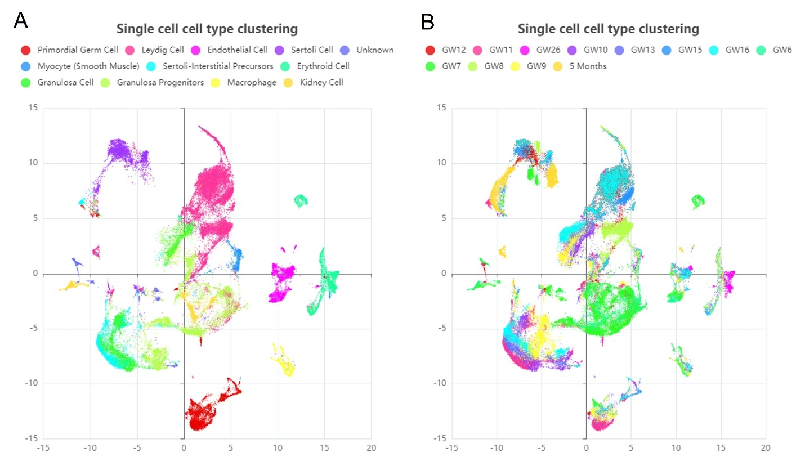
Supplementary Figure S1. UMAP results of the integrated dataset from human fetal testicular development. (A) Cells labelled by cell-type in the UMAP result; and (B) Cells labelled by the sample collection timepoints.

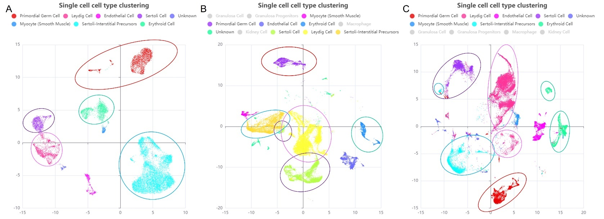
Supplementary Figure S2. Comparison of cell clustering results from the integrated dataset with the original studies. (A) UMAP results of the datasets generated by Han et al. (Han et al. 2020), (B) by Guo et al. (Guo et al. 2021), (C) by integration. In each figure, the clusters were circled based on the cell-types: primordial germ cells (by red circle), Leydig cells (by pink circle), Sertoli cells (by purple circle), Sertoli interstitial precursors (by blue circle) and erythroid cells (by green circle).

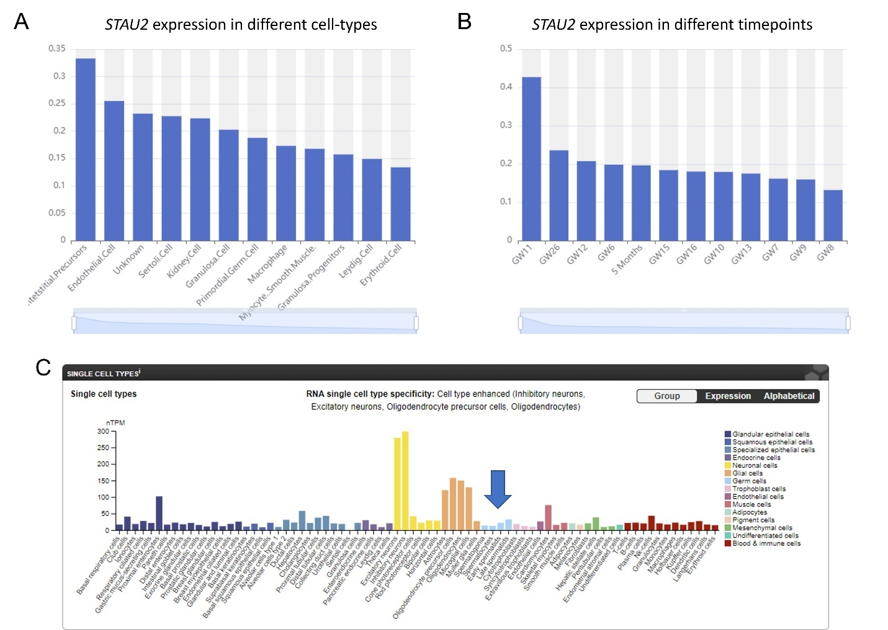
Supplementary Figure S3. Expression profiles of the gene STAU2. (A) and (B) indicate the abundance of STAU2 gene expression in different cell-types and timepoints during fetal and postnatal testicular development. (C) The expression profile of gene STAU2 in adult germ cells. The histogram was obtained from The Human Protein Atlas browser.

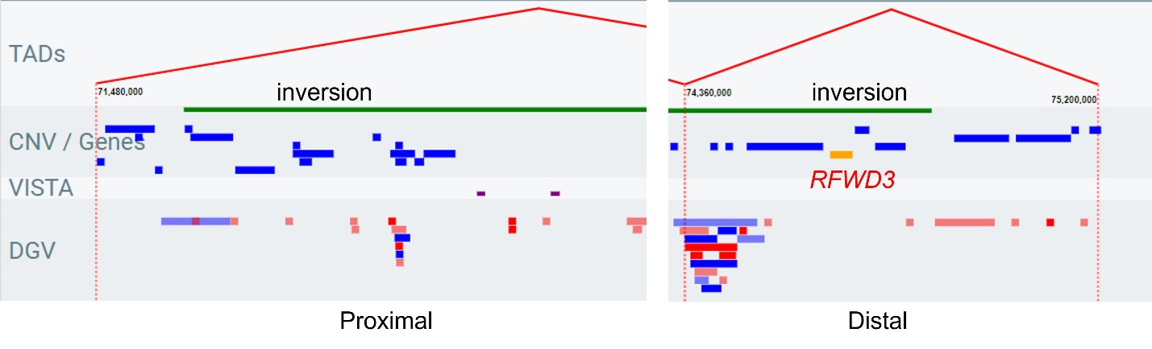
Supplemental Figure S4. Analysis of topologically associated domain in case 20C0011 by ClinTAD. Figures in left and right indicate the involvement of genes, enhancers (VISTA) and copy-number variants (DGV) in the topologically associated domains (TADs) in proximal and distal breakpoint junctions of the inversion, respectively. The dotted lines represent the putative boundaries of each TAD, and the green bar indicates the inversion identified in case 20C0011. RFWD3 indicated in yellow bar is known to cause Fanconi anemia with variable expressivity of azoospermia (GeneReviews# NBK1401). It is located in the TAD of distal breakpoint junction of the inversion (Figure S3), which is potentially disrupted. Whether a position effect was induced by the inversion is unknown.

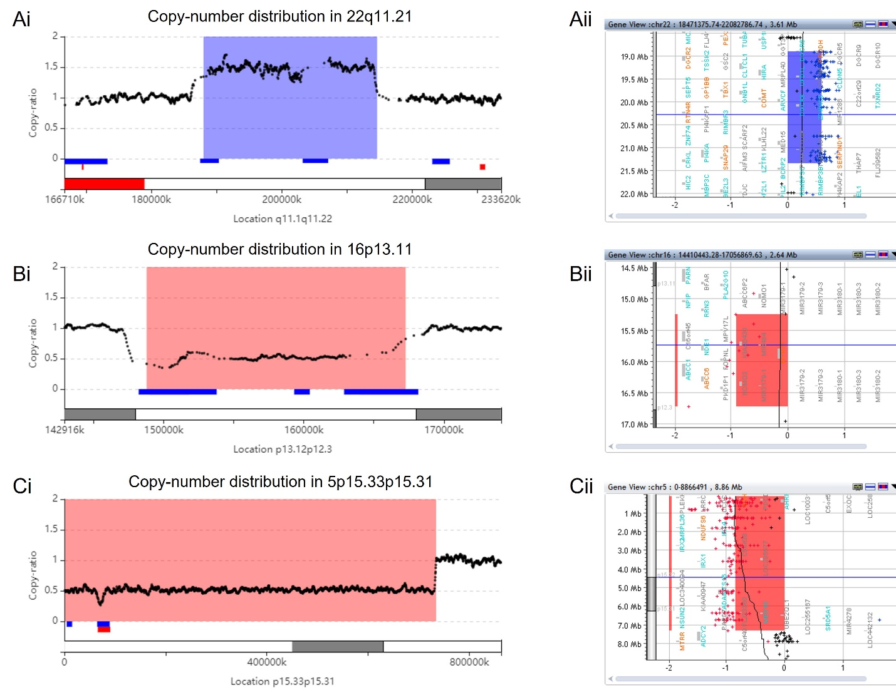
Supplemental Figure S5. Validation of pathogenic CNV syndrome by chromosomal microarray analysis. (A) Patient 21C1102: 2.6 Mb duplication seq[GRCh37] dup(22)(q11.21) chr22:g.18862504_21453290dup, (B) Patient 20C2873: 1.5 Mb microdeletion seq[GRCh37] del(16)(p13.11) chr16:g.14991714_16507667del, and (C) Patient 19C1235: 7.3 Mb deletion seq[GRCh37] del(5)(p15.33p15.31) chr5:g.10379_7361801del, were identified by low-pass mate-pair genome sequencing (figures i) and confirmed by chromosomal microarray analysis (CMA, figures ii). In figure (i), the X-axis indicates the genomic location of the human genome reference (GRCh37), while the Y-axis shows the copy number. Blue and red bars shown in the bottom refer to common duplications and deletions in our in-house database. In figure (ii), probe distribution on the CMA platform with the candidate region reported by low-pass mate-pair GS. In both low-pass mate-pair GS and CMA, the region with duplication is highlighted in blue while the two regions with deletions are highlighted in red.

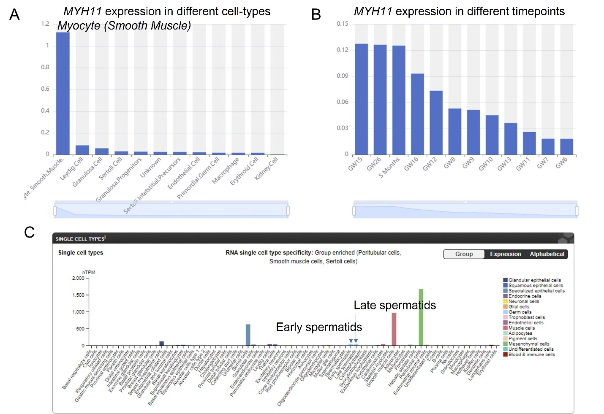
Supplementary Figure S6. Expression profiles of the gene MYH11. (A) and (B) indicate the abundance of MYH11 gene expression in different cell-types and timepoints during fetal and postnatal testicular development. (C) The expression profile of gene MYH11 in adult germ cells. The histogram was obtained from The Human Protein Atlas browser.

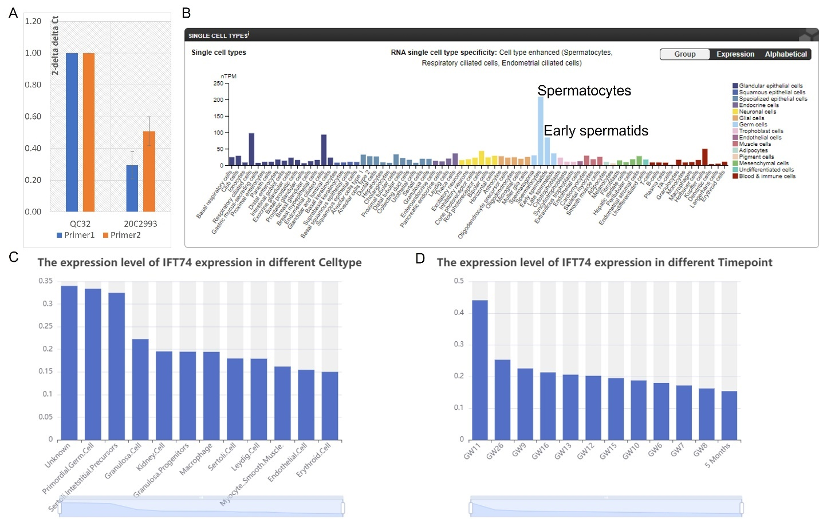
Supplementary Figure S7. Validation of intragenic deletion and the expression profiles of the gene IFT74. (A) Validation of cryptic CNVs by quantitative PCR. Quantitative PCR with two independent pairs of primers targeting intragenic deletions in IFT74 in patient 20C2993. Only one copy is observed in each DNA, confirming that the intragenic deletion. (B) and (C) indicate the abundance of IFT74 gene expression in different cell-types and timepoints during fetal and postnatal testicular development. (D) The expression profile of gene IFT74 in adult germ cells. The histogram was obtained from The Human Protein Atlas browser.

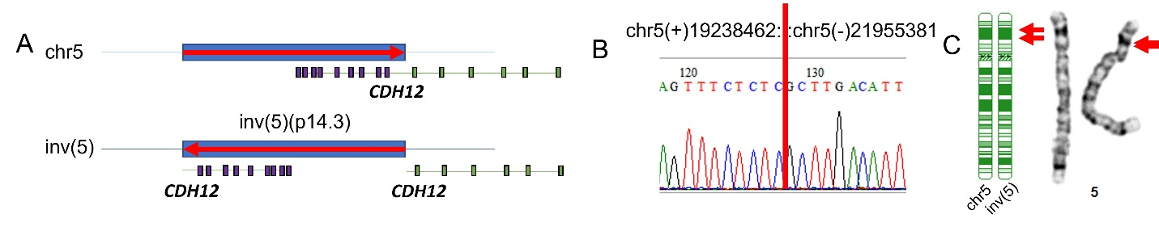
Supplemental Figure S8. Low-pass mate-pair GS revealed a 2.7 Mb inv(5)(p14.3) in case 19C3124 not detected by previous karyotyping analysis. (A) Diagram shown on the left side indicating direct disruption of CDH12 by the inversion confirmed by breakpoint junction-specific PCR and Sanger sequencing (B). (C) The ideograms show the banding patterns of the normal chromosome 5 (chr5) and the inv(5) and the potential location of the inversion (indicated by two red arrows). It is unlikely to have been identified by karyotyping analysis as both breakpoints are located in the same dark band 5p14.3.

Supplemental Table S1. Rare structural rearrangements with/with copy number variants less likely related to the male infertility
No. | Sample ID | Clinical indications* | SV identified in this study
1 | 19C0203 | Severe oligozoospermia | seq[GRCh37] ins(X;X)(p22.31;p22.31) (pter->p22.31(+)(7805528)::p22.31(-)(6462919)<-p22.31(-)(6290935)::p22.31 (+)(7571075)->qter)  dup(X)(p22.31) chrX:g.6290935_6462919dup  dup(X)(p22.31) chrX:g.7571075_7805528dup
2 | 19C0429 | Severe oligozoospermia | seq[GRCh37] ins(8;8)(q23.3;q23.3) (pter->q23.3(+)(117105918)::q23.3(-)(116926348)<-q23.3(-)(116913034):: q23.3(+)(116929711)->qter)  dup(8)(q23.3) chr8:g.116913034_116926348dup  dup(8)(q23.3) chr8:g.116929711_117105918dup
3 | 22C0195 | NOA | seq[GRCh37] ins(8;8)(p21.3;p21.3) (pter->p21.3(+)(19026618)::p21.3(+)(19036976)->p21.3(+)(19141154)::p21.3(+)(19010889)->qter)  dup(8)(p21.3) chr8:g.19010889_19026618dup  dup(8)(p21.3) chr8:g.19036976_19141154dup
4 | 21C1433 | Severe oligozoospermia | seq[GRCh37] ins(7;7)(q21.2;q21.2) (pter->q21.2(+)(91771281)::q21.2(+)(91209684)->q21.2(+)(91272882)::q21.2(+)(917870202)->qter)  dup(7)(q21.2) chr7:g.91209684_91272882dup  del(7)(q21.2) chr7:g.91771281_91787202del
5 | 21C0925 | Severe oligozoospermia | seq[GRCh37] ins(Y;Y)(p11.32;p11.2) (pter->p11.32(+)(2888522)::p11.2(+)(3216692)->p11.2(+)(3434226)::p11.32(+)(2841415)->qter)  dup(Y)(p11.32) chrY:g.2841415_2888522dup  dup(Y)(p11.2) chrY:g.3216692_3434226dup
6 | 18C0169 | NOA | seq[GRCh37] dup(4)(q12q13.1) (pter->q13.1(+)(62691666)::q12(+)(58183887)->qter)  chr4:g.58183887_62691666dup
7 | 19C3124 | NOA | seq[GRCh37] inv(5)(p14.3) (pter->p14.3(+)(19238462)::p14.3(-)(21955381)<-p14.3(-)(19239790)::p14.3(+)(21955889)->qter)
8 | 22C0195 | NOA | seq[GRCh37] ins(6;6)(q23.3;q23.3) (pter->q23.3(+)(137194819)::q23.3(-)(137269155)<-q23.3(-)(137201299)::q23.3(+)(137186526)->qter) dup(6)(q23.3) chr6:g.137186526_137194819dup dup(6)(q23.3) chr6:g.137201299_137269155dup
*NOA: non-obstructive azoospermia
References:
Cao Y, Chau MHK, Zheng Y, Zhao Y, Kwan AHW, Hui SYA, Lam YH, Tan TYT, Tse WT, Wong L, Leung TY, Dong Z, Choy KW (2022) Exploring the diagnostic utility of genome sequencing for fetal congenital heart defects. Prenat Diagn 42: 862-872. doi: 10.1002/pd.6151
Chau MHK, Wang H, Lai Y, Zhang Y, Xu F, Tang Y, Wang Y, Chen Z, Leung TY, Chung JPW, Kwok YK, Chong SC, Choy KW, Zhu Y, Xiong L, Wei W, Dong Z (2020) Low-pass genome sequencing: a validated method in clinical cytogenetics. Hum Genet 139: 1403-1415. doi: 10.1007/s00439-020-02185-9
Del Gaudio D, Shinawi M, Astbury C, Tayeh MK, Deak KL, Raca G, Committee ALQA (2020) Diagnostic testing for uniparental disomy: a points to consider statement from the American College of Medical Genetics and Genomics (ACMG). Genet Med 22: 1133-1141. doi: 10.1038/s41436-020-0782-9
Dong Z, Chau MHK, Zhang Y, Dai P, Zhu X, Leung TY, Kong X, Kwok YK, Stankiewicz P, Cheung SW, Choy KW (2021a) Deciphering the complexity of simple chromosomal insertions by genome sequencing. Hum Genet 140: 361-380. doi: 10.1007/s00439-020-02210-x
Dong Z, Chau MHK, Zhang Y, Yang Z, Shi M, Wah YM, Kwok YK, Leung TY, Morton CC, Choy KW (2021b) Low-pass genome sequencing-based detection of absence of heterozygosity: validation in clinical cytogenetics. Genet Med 23: 1225-1233. doi: 10.1038/s41436-021-01128-7
Dong Z, Jiang L, Yang C, Hu H, Wang X, Chen H, Choy KW, Hu H, Dong Y, Hu B, Xu J, Long Y, Cao S, Chen H, Wang WJ, Jiang H, Xu F, Yao H, Xu X, Liang Z (2014) A robust approach for blind detection of balanced chromosomal rearrangements with whole-genome low-coverage sequencing. Hum Mutat 35: 625-36. doi: 10.1002/humu.22541
Dong Z, Wang H, Chen H, Jiang H, Yuan J, Yang Z, Wang WJ, Xu F, Guo X, Cao Y, Zhu Z, Geng C, Cheung WC, Kwok YK, Yang H, Leung TY, Morton CC, Cheung SW, Choy KW (2018) Identification of balanced chromosomal rearrangements previously unknown among participants in the 1000 Genomes Project: implications for interpretation of structural variation in genomes and the future of clinical cytogenetics. Genet Med 20: 697-707. doi: 10.1038/gim.2017.170
Dong Z, Zhang J, Hu P, Chen H, Xu J, Tian Q, Meng L, Ye Y, Wang J, Zhang M, Li Y, Wang H, Yu S, Chen F, Xie J, Jiang H, Wang W, Choy KW, Xu Z (2016) Low-pass whole-genome sequencing in clinical cytogenetics: a validated approach. Genet Med 18: 940-8. doi: 10.1038/gim.2015.199
Dong Z, Zhao X, Li Q, Yang Z, Xi Y, Alexeev A, Shen H, Wang O, Ruan J, Ren H, Wei H, Qi X, Li J, Zhu X, Zhang Y, Dai P, Kong X, Kirkconnell K, Alferov O, Giles S, Yamtich J, Kermani BG, Dong C, Liu P, Mi Z, Zhang W, Xu X, Drmanac R, Choy KW, Jiang Y (2019) Development of coupling controlled polymerizations by adapter-ligation in mate-pair sequencing for detection of various genomic variants in one single assay. DNA Res 26: 313-325. doi: 10.1093/dnares/dsz011
Esteves SC, Miyaoka R, Orosz JE, Agarwal A (2013) An update on sperm retrieval techniques for azoospermic males. Clinics (Sao Paulo) 68 Suppl 1: 99-110. doi: 10.6061/clinics/2013(sup01)11
Guo J, Sosa E, Chitiashvili T, Nie X, Rojas EJ, Oliver E, DonorConnect, Plath K, Hotaling JM, Stukenborg JB, Clark AT, Cairns BR (2021) Single-cell analysis of the developing human testis reveals somatic niche cell specification and fetal germline stem cell establishment. Cell Stem Cell 28: 764-778 e4. doi: 10.1016/j.stem.2020.12.004
Han X, Zhou Z, Fei L, Sun H, Wang R, Chen Y, Chen H, Wang J, Tang H, Ge W, Zhou Y, Ye F, Jiang M, Wu J, Xiao Y, Jia X, Zhang T, Ma X, Zhang Q, Bai X, Lai S, Yu C, Zhu L, Lin R, Gao Y, Wang M, Wu Y, Zhang J, Zhan R, Zhu S, Hu H, Wang C, Chen M, Huang H, Liang T, Chen J, Wang W, Zhang D, Guo G (2020) Construction of a human cell landscape at single-cell level. Nature 581: 303-309. doi: 10.1038/s41586-020-2157-4
Li H, Durbin R (2009) Fast and accurate short read alignment with Burrows-Wheeler transform. Bioinformatics 25: 1754-60. doi: 10.1093/bioinformatics/btp324
Rehder CW, David KL, Hirsch B, Toriello HV, Wilson CM, Kearney HM (2013) American College of Medical Genetics and Genomics: standards and guidelines for documenting suspected consanguinity as an incidental finding of genomic testing. Genet Med 15: 150-2. doi: 10.1038/gim.2012.169
Richards S, Aziz N, Bale S, Bick D, Das S, Gastier-Foster J, Grody WW, Hegde M, Lyon E, Spector E, Voelkerding K, Rehm HL, Committee ALQA (2015) Standards and guidelines for the interpretation of sequence variants: a joint consensus recommendation of the American College of Medical Genetics and Genomics and the Association for Molecular Pathology. Genet Med 17: 405-24. doi: 10.1038/gim.2015.30
Riggs ER, Andersen EF, Cherry AM, Kantarci S, Kearney H, Patel A, Raca G, Ritter DI, South ST, Thorland EC, Pineda-Alvarez D, Aradhya S, Martin CL, Acmg (2019) Technical standards for the interpretation and reporting of constitutional copy-number variants: a joint consensus recommendation of the American College of Medical Genetics and Genomics (ACMG) and the Clinical Genome Resource (ClinGen). Genet Med. doi: 10.1038/s41436-019-0686-8
Shi X, Chan CPS, Man GKY, Chan DYL, Wong MH, Li TC (2021) Associations between blood metal/ metalloid concentration and human semen quality and sperm function: A cross-sectional study in Hong Kong. J Trace Elem Med Biol 65: 126735. doi: 10.1016/j.jtemb.2021.126735
Spector JD, Wiita AP (2019) ClinTAD: a tool for copy number variant interpretation in the context of topologically associated domains. J Hum Genet 64: 437-443. doi: 10.1038/s10038-019-0573-9
Tse JY, Yeung WS, Lau EY, Ng EH, So WW, Ho PC (2000) Deletions within the azoospermia factor subregions of the Y chromosome in Hong Kong Chinese men with severe male-factor infertility: controlled clinical study. Hong Kong Med J 6: 143-6.
Wang H, Dong Z, Zhang R, Chau MHK, Yang Z, Tsang KYC, Wong HK, Gui B, Meng Z, Xiao K, Zhu X, Wang Y, Chen S, Leung TY, Cheung SW, Kwok YK, Morton CC, Zhu Y, Choy KW (2020) Low-pass genome sequencing versus chromosomal microarray analysis: implementation in prenatal diagnosis. Genet Med 22: 500-510. doi: 10.1038/s41436-019-0634-7
Wang K, Li M, Hakonarson H (2010) ANNOVAR: functional annotation of genetic variants from high-throughput sequencing data. Nucleic Acids Res 38: e164. doi: 10.1093/nar/gkq603

