Supplementary Information

Figure 1. Names and structures of some commonly used ILs.

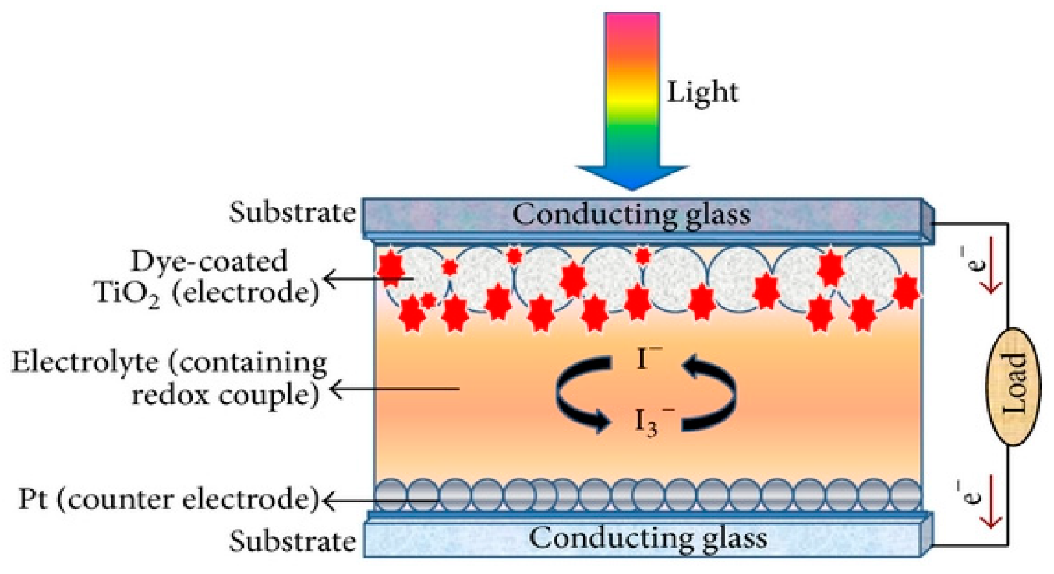
Fig. 2Basic components of DSSCs( Kushwaha et al. 2013).

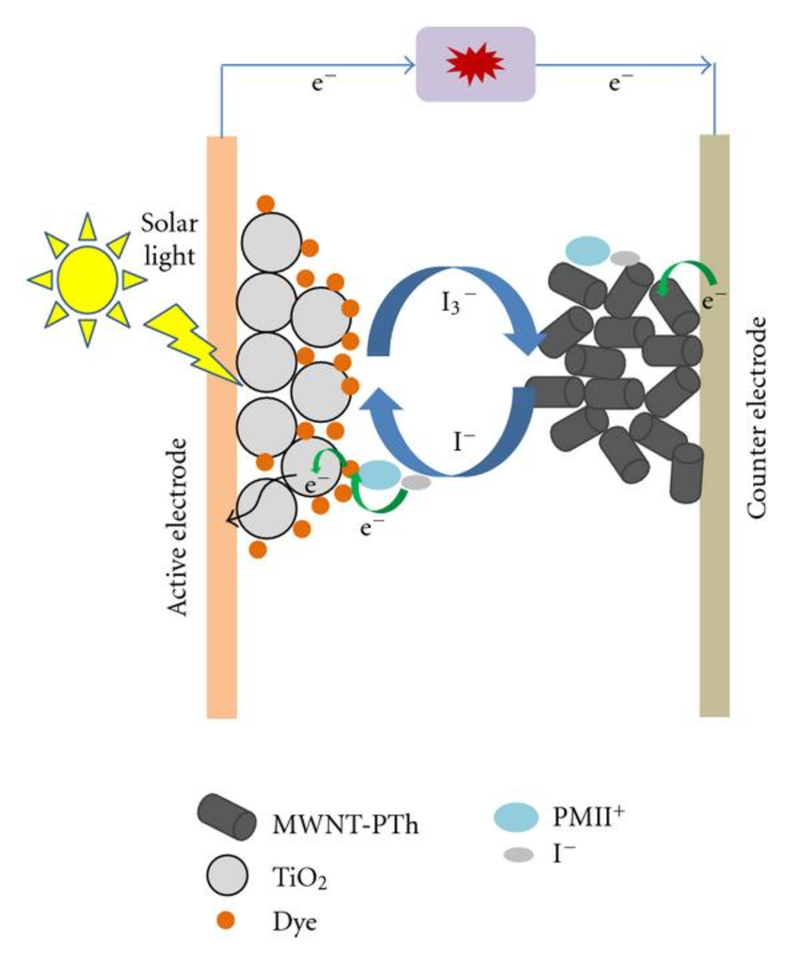
Fig. 3 Charge transport pathways in quasi solid-state DSSCs with MWNTPTh/PMII composites(Karim et al. 2011).

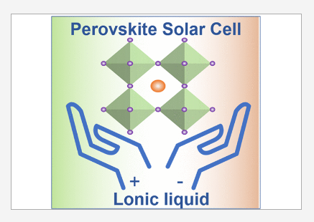
Figure 4: Diagrammatic representation of Perovskite solar cells with ionic liquid(Lingfeng Chao et al.2021).

Fig. 5 Classification of Supercapacitors

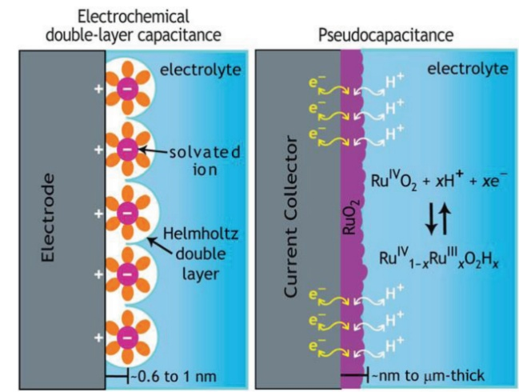
Fig. 6 Representation of charge storage mechanism by two different electrochemical capacitors(Shahzad et al. 2019).
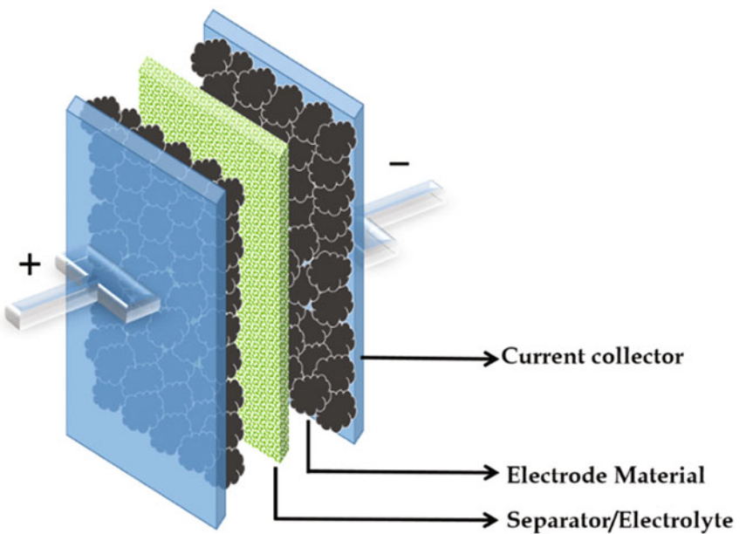
Fig. 7 Construction of Supercapacitors(Samantara et al. 2018).
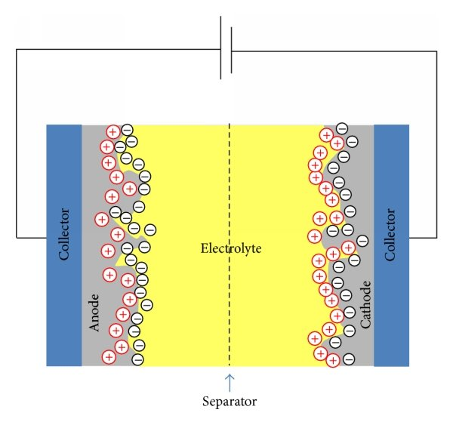
Fig. 8 Working mechanism of Supercapacitors( Saleem et al. 2016).
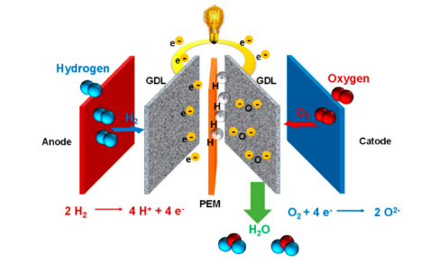
Figure 9: Systematic representation of polymer electrolyte membrane fuel cell flow diagram and chemical equation(Escorihuela et al. 2020).

Table 1: A few accounts of ionic liquid used.
Ionic Liquids | Application | References
1,1’-(5,14-dioxo-4,6,13,15- tetraazaoctadecane-1,18-diyl) bis(3-(sec-butyl)-1H-imidazol-3- ium) bis((trifluoromethyl)-sulfonyl) imide | Lithium-ion battery | (Rau et al. 2021)
[SO₃H-Pyrazine-SO₃H] Cl | Catalyst | (Chatterjee et al. 2020)
1-butyl-3-methylimidazolium chloride | Co-solvent used in the production of h-MoO₃ | ( Yao et al. 2015)
1-hexadecyl-3-vinylimidazolium bromide | Chemical for recovering oil | (Han et al. 2015)
1-methylimidazolium | Making collagen-alginate hydrogels using a biopolymer solvent | (Iqbal et al. 2017)
1-(4-sulfonate)-butyl-3- vinylimidazolium | Esterification pre-treatment catalyst | (Wang et al. 2019)
1-allyl-3-methylimidazolium chloride | Adsorbent for oxytetracycline detection in milk sample | (Ferreira et al. 2019)

