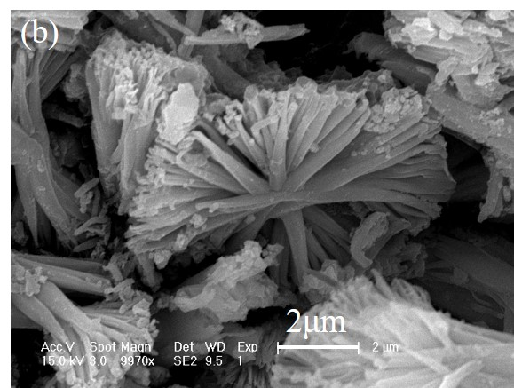
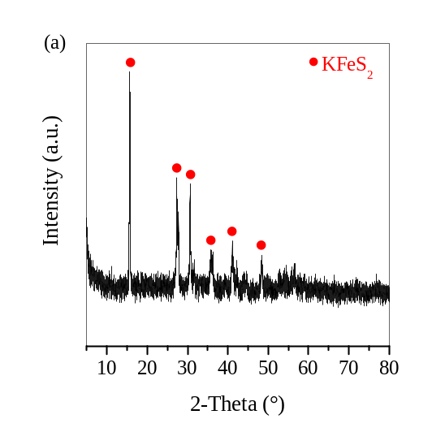
Fig. S1 (a) XRD pattern and (b) SEM image of wet P80-24 by freeze-dried after one week of storage.

