Appendices

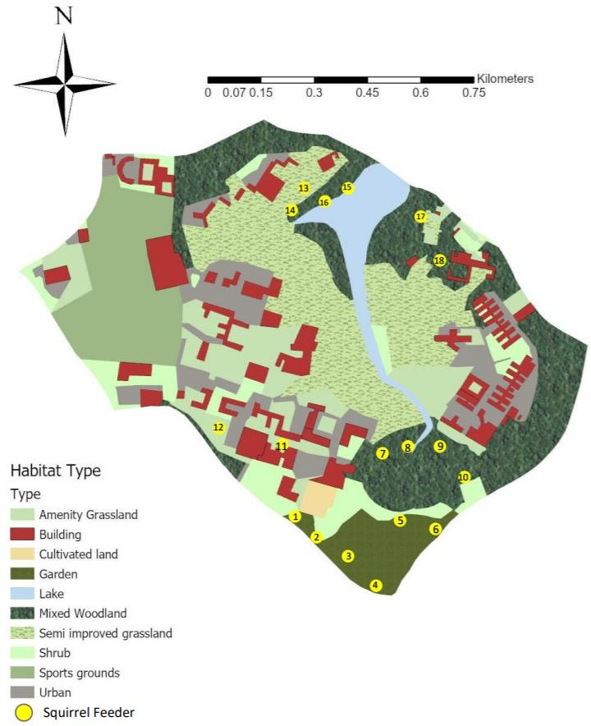
Feeder

Appendix 1. Map of the University of Reading’s Whiteknights Campus, with habitat type denoted by various colours and the location of squirrel feeders denoted by yellow circles

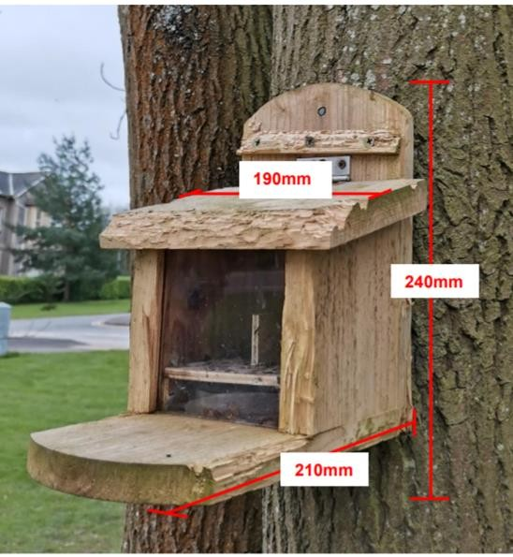
Appendix 2. Illustration of the squirrel feeder and experimental setup. Squirrel feeders consisted of a food reservoir behind a transparent plastic screen, a hinged wooden lid, and a perching platform in front. Dimensions are displayed in red. The custom-made platform, indicated by the blue arrow, was perforated, and prevented peanut samples contaminating the cue samples in the petri dish at the bottom of the food reservoir.

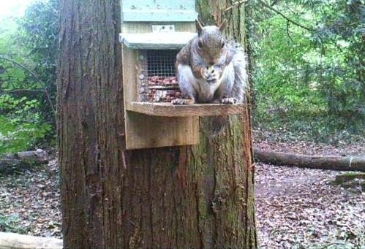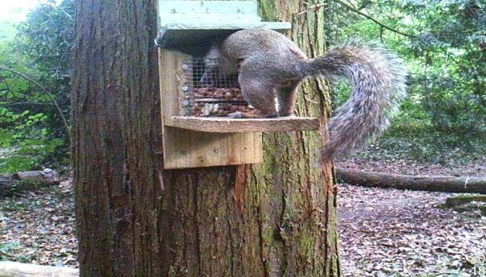
a)
b)

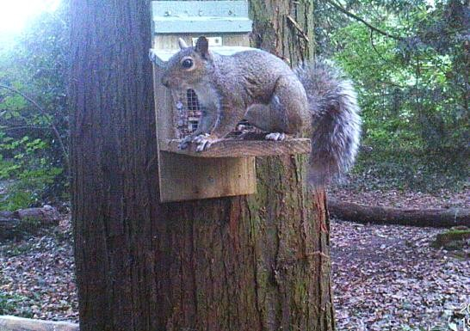
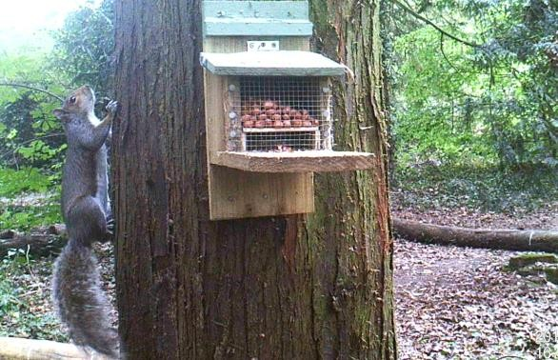
c) d)

Appendix 3 . Photographic stills obtained from trail camera footage, demonstrating the behaviours observed and analysed in video footage/
(Top, left). An individual consuming peanuts gathered from the feeder was deemed feeding behaviour, despite the individual facing outwards while feeding.
(Top, right). An individual feeding from a mounted feeder. Often an individual’s head or, rarely, their entire body would be inside the feeding reservoir to gather peanuts. This behaviour was also recorded as feeding.
(Bottom, left). Scanning behaviour, evident by an individual looking outwards into the environment while stationary and not engaging in feeding behaviours. Individuals scanning often stood or sat upon the perching platform, though scanning from the top of the feeder was not uncommon.
(Bottom, right). Proximity behaviour indicated by an individual, or sometimes individuals, stationary upon or below the tree where a feeder is mounted.

