Supplementary Material

Supplementary Figure 1. Representation of main aims of study
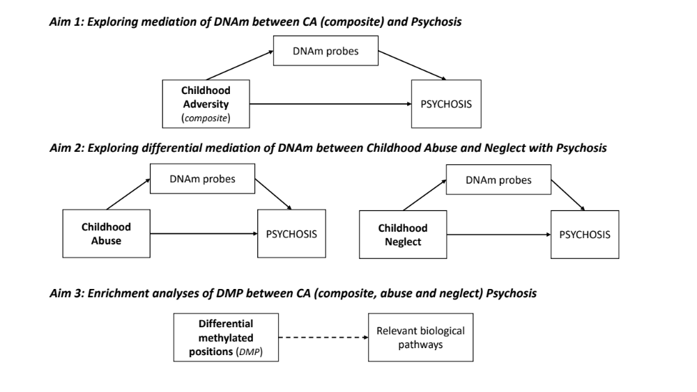

QQ plots

Supplementary Figure 2. Supplementary Figure 1: Pathway a. Composite
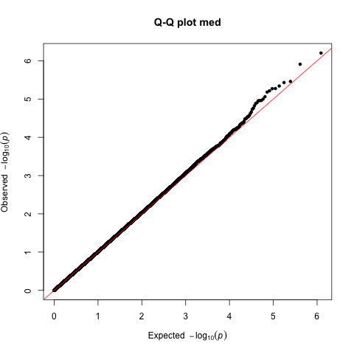

Lambda: 1.014 (SE: 6.395333e-06)

Supplementary Figure 3: Pathway b. Abuse
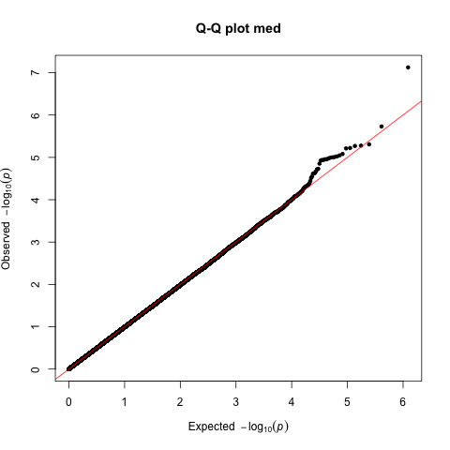
Lambda: 0.989 (SE: 8.436211e-06)

Supplementary Figure 4: Pathway a. Neglect
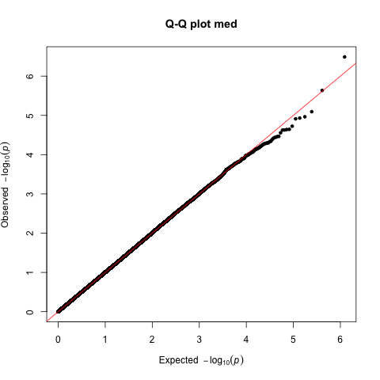
Lambda: 1.002 (SE: 5.70443e-06)

Supplementary Figure 5: Pathway b DNAm-Case control status
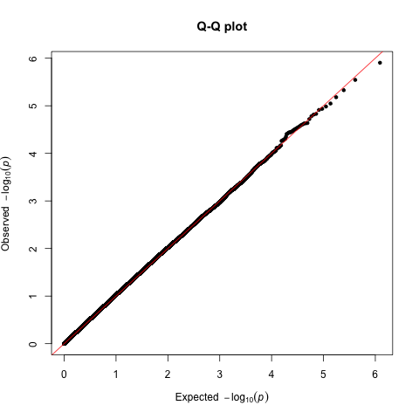

Lambda: 1.020 (SE: 1.67575e-05)

Supplementary Figure 6: Mediation composite
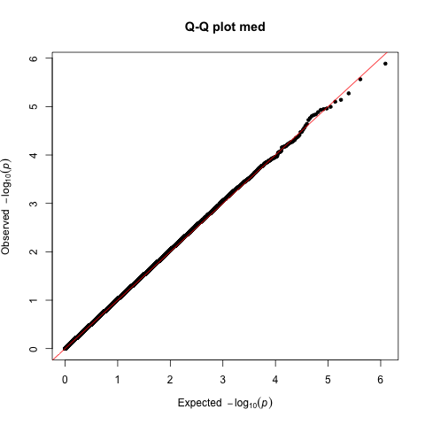
Lambda:1.022617 (SE: 6.505814e-06)

Supplementary Figure 7: Mediation abuse
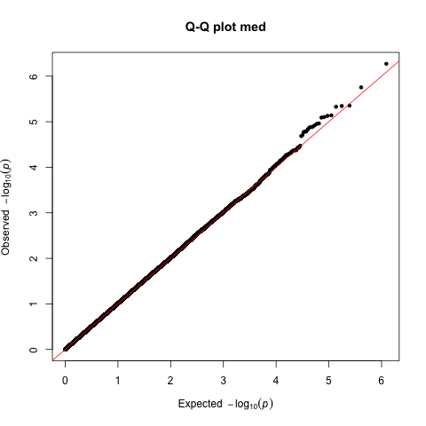

Lambda: 1.011843 (SE: 5.315356e-06)

Supplementary Figure 8: Mediation neglect
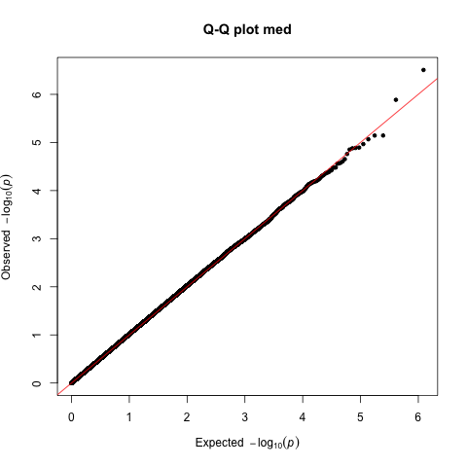
Lambda: 1.015875 SE: 8.53809e-06
Supplementary Table 1. Demographic and clinical characteristics of cases and controls
 | Total,  n = 883 | Controls,  n = 517 | Cases,  n = 366 | Controls  vs Cases | P value
Age in years, M (SD) | 35.33 (12.83) | 38.75 (13.42) | 30.5 (10.15) | t = 9.9195 | <0.001
Female, N (%) | 403 (45.64) | 274 (52.10) | 129 (35.25) | χ² = 27.2200 | <0.001
Country, N (%)  France  Netherlands  Italy  Spain  UK | 89 (10.08)  232 (26.27)  87 (9.85)  289 (32.73)  186 (21.07) | 62 (11.99)  131 (25.34)  56 (10.83)  159 (30.75)  109 (21.08) | 27 (7.38)  101 (27.60)  31 (8.47)  130 (35.52)  77 (21.04) | χ² = 7.6440 | 0.106
Composite trauma score, M (SD) | 0.69 (1.16) | 0.45 (0.93) | 1.03 (1.35) | t = -7.6100 | <0.001
Abuse score, M (SD) | 0.31 (0.61) | 0.21 (0.52) | 0.45 (0.71) | t = -5.9411 | <0.001
Neglect score, M (SD) | 0.35 (0.64) | 0.22 (0.52) | 0.53 (0.75) | t = -7.1358 | <0.001
Affective psychosis, N % |  |  | 87 (23.77)
Smoking score, M (SD) | 0.69 (4.65) | -0.25 (4.23) | 2.01 (4.91) | t = -7.3360 | <0.001
Current cannabis use, N (%) | 147 (16.65) | 67 (12.96) | 80 (21.86) | χ² = 20.1135 | <0.001
Antipsychotic medication, N (%) |  |  | 303 (82.79)
Batch effects, M (SD) | 6.25 (3.39) | 6.26 (3.44) | 6.23 (3.32) | t = 0.1567 | 0.875

Supplementary Table 2 demographic and baseline characteristics comparison between cases included in this study and the cases from the general EUGEI WP2 sample that were not included.

 | Total,  n = 1,134 | Epigenetic,  n = 366 | Other,  n = 768 | Epigenetic  vs Other | P value
Age in years, M (SD) | 31.24 (10.59) | 30.5 (10.15) | 31.59 (10.79) | t = 1.6265 | 0.052
Female, N (%) | 434 (38.27) | 128 (34.97) | 306 (39.84) | χ² = 2.4895 | 0.115
White ethnic backgorund, N (%) | 714 (63.19) | 269 (73.50) | 445 (58.25) | χ² = 24.7440 | <0.001
Years of education, M (SD) | 15.32 (14.54) | 15.06 (11.27) | 15.44 (15.87) | t = 0.4141 | 0.339
Composite trauma score, M (SD) | 42.35 (14.30) | 42.06 (14.41) | 42.51 (14.25) | t = 0.4736 | 0.317
Abuse score, M (SD) | 22.54 (9.00) | 22.26 (8.99) | 22.69 (9.02) | t = 0.7037 | 0.240
Neglect score, M (SD) | 19.81 (7.41) | 19.79 (7.47) | 19.83 (7.38) | t = 0.0793 | 0.468
Non-affective psychosis, N (%) | 738 (73.73) | 237 (74.29) | 501 (73.46) | χ² = 0.0781 | 0.780

Supplementary Table 3. Top DMPs (P < 5e-05) associated between composite cumulative measure of adversity and DNAm (path a)

Probe | Genomic location (hg19) | Illumina gene annotation | Relation to UCSC CpG Island | Effect  size | p value mediation
cg16347256 | 1: 57285160 | C1orf168 |  | -0.008 | 6.26E-07
cg00691266 | 17: 74015089 | EVPL | N_Shelf | -0.005 | 1.23E-06
cg16404074 | 15: 78934580 | CHRNB4 | S_Shore | 0.005 | 3.46E-06
cg11530213 | 8: 42037966 | PLAT |  | -0.012 | 3.70E-06
cg25318809 | 6: 29974863 | HLA-J; NCRNA00171 | Island | -0.005 | 4.56E-06
cg03809898 | 6: 100442553 | MCHR2 | S_Shore | -0.014 | 5.30E-06
cg01678176 | 20: 58088902 |  |  | -0.006 | 5.35E-06
cg06346838 | 19: 1466162 | APC2 | Island | 0.009 | 6.09E-06
cg13912639 | 5: 147603654 |  |  | -0.010 | 6.59E-06
cg07676349 | 19: 5242136 | PTPRS | N_Shore | -0.005 | 8.67E-06
cg10269671 | 5: 150683820 | SLC36A3 |  | 0.0047 | 1.00E-05
cg04876084 | 3: 56110939 | ERC2 |  | -0.006 | 1.09E-05
cg01457699 | 8: 100511131 | VPS13B |  | 0.008 | 1.10E-05
cg04439128 | 1: 226497537 | LIN9 | S_Shore | 0.004 | 1.11E-05
cg20691507 | 6: 28956683 |  | S_Shore | 0.004 | 1.24E-05
cg14319451 | 11: 63685777 | RCOR2 | Island | 0.005 | 1.31E-05
cg01245433 | 15: 42440011 | PLA2G4F |  | -0.005 | 1.50E-05
cg01472821 | 3: 42822769 |  |  | -0.003 | 1.73E-05
cg01217481 | 9: 74570344 | C9orf85 |  | 0.008 | 1.85E-05
cg20503109 | 17: 74565795 | ST6GALNAC2 |  | 0.002 | 2.16E-05
cg14588352 | 11: 67458806 |  |  | 0.004 | 2.38E-05
cg17795258 | 19: 12377690 |  | S_Shore | -0.004 | 2.66E-05
cg24999924 | 20: 61428215 | C20orf20 | S_Shore | 0.008 | 2.86E-05
cg24568311 | 3: 15519117 | COLQ |  | 0.007 | 2.87E-05
cg23709475 | 1: 214320064 |  |  | -0.007 | 3.04E-05
cg25869889 | 11: 6436464 | APBB1 | N_Shelf | -0.004 | 3.21E-05
cg09924353 | 10: 120155536 |  |  | -0.005 | 3.27E-05
cg08800869 | 10: 135204621 | PAOX | S_Shore | -0.007 | 3.36E-05
cg04170451 | 10: 28822079 | WAC;WAC-AS1; | Island | 0.003 | 3.86E-05
cg23740938 | 19: 2592227 | GNG7 | S_Shelf | -0.006 | 4.15E-05
cg23314241 | 15: 97029759 |  |  | -0.005 | 4.22E-05
cg27427514 | 3: 193922037 |  | Island | 0.017 | 4.22E-05
cg06218861 | 7: 35420759 |  |  | -0.008 | 4.35E-05
cg09744376 | 3: 53080176 | SFMBT1 | Island | 0.002 | 4.47E-05
cg18717600 | X: 46404986 | ZNF674;LOC401588 | Island | 0.005 | 4.58E-05
cg08882308 | 19: 29489929 |  |  | -0.007 | 4.77E-05

Supplementary Figure 9. Manhattan plot showing association between composite cumulative measure of adversity and DNAm. Red line: array-wide multiple testing threshold (p<5.8x10-8); blue line: “discovery” p-value threshold (P < 5e-5).

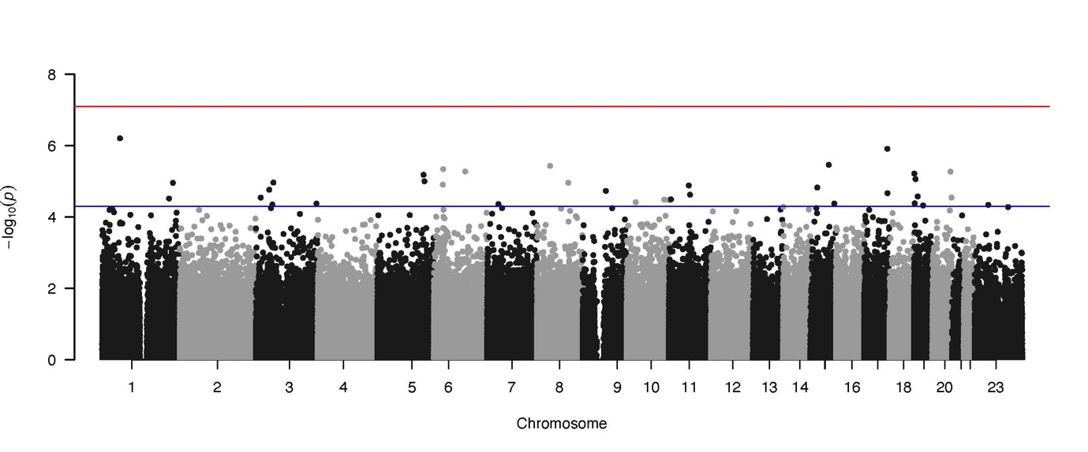

Suplementary Table 4. Top DMPs (P < 5e-05) associated between abuse and DNAm (path a)

Probe | Genomic location (hg19) | Illumina gene annotation | Relation to UCSC CpG Island | Effect size | p value mediation
cg00691266 | 17:74015089 | EVPL | N_Shelf | -0.011 | 7.50E-08
cg23314241 | 15:97029759 |  |  | -0.012 | 1.86E-06
cg07676349 | 19:5242136 | PTPRS | N_Shore | -0.011 | 4.92E-06
cg04170451 | 10:28822079 | WAC; WAC-AS1 | Island | 0.007 | 5.27E-06
cg16814066 | X:17483070 | NHS |  | 0.013 | 5.38E-06
cg05227288 | 16:32489822 |  | Island | -0.012 | 5.99E-06
cg17787809 | 9:3300190 | RFX3 |  | 0.014 | 6.13E-06
cg11504297 | 15:71902446 | THSD4 |  | -0.007 | 8.31E-06
cg20665338 | 8:71378068 |  |  | -0.012 | 8.98E-06
cg20360928 | 2:61191582 | PUS10 |  | 0.008 | 9.50E-06
cg17348714 | 14:102289979 | PPP2R5C |  | -0.010 | 9.81E-06
cg16404074 | 15:78934580 | CHRNB4 | S_Shore | 0.009 | 9.98E-06
cg21362986 | 1:38024945 | DNALI1 | S_Shelf | 0.008 | 1.02E-05
cg25496668 | 7:93144714 | CALCR |  | 0.0163 | 1.06E-05
cg12396344 | 12:69725444 |  |  | -0.013 | 1.11E-05
cg12485020 | X:110039269 | CHRDL1 | Island | 0.011 | 1.11E-05
cg03719539 | 8:145560549 | SCRT1 | Island | 0.007 | 1.15E-05
cg16882927 | 8:28246789 |  | S_Shelf | 0.009 | 1.15E-05
cg26444148 | 15:43716087 | RNU6-28P; TP53BP1 |  | 0.008 | 1.18E-05
cg09722259 | 2:167758744 | XIRP2 |  | -0.013 | 1.40E-05
cg01760103 | 7:151664041 | GALNTL5 |  | 0.009 | 1.86E-05
cg09299732 | 4:3807421 |  |  | -0.008 | 1.91E-05
cg19420645 | 4:55983534 | KDR |  | -0.017 | 2.13E-05
cg25318809 | 6:29974863 | HLA-J; NCRNA00171 | Island | -0.010 | 2.34E-05
cg01217481 | 9:74570344 | C9orf85 |  | 0.016 | 2.37E-05
cg16176398 | 11:5531941 | UBQLN3 |  | -0.012 | 2.43E-05
cg18717600 | X:46404986 | ZNF674; LOC401588; ZNF674 | Island | 0.009 | 2.81E-05
cg22120488 | 2:107199102 |  |  | 0.021 | 3.06E-05
cg06208834 | 1:243656201 | SDCCAG8; AKT3 | S_Shelf | -0.006 | 3.61E-05
cg19115490 | 6:37483925 |  |  | -0.004 | 4.10E-05
cg02520160 | 5:156589436 | FAM71B |  | 0.008 | 4.37E-05
cg09304014 | 6:35737336 |  | S_Shelf | -0.008 | 4.57E-05
cg14233855 | 8:106185570 |  |  | -0.013 | 4.62E-05
cg08311767 | X:37865052 | SYTL5 |  | 0.019 | 4.80E-05
cg02999418 | 5:141041669 | ARAP3 |  | 0.007 | 4.92E-05
cg01296504 | 10:60627901 |  |  | -0.011 | 4.98E-05

Supplementary Figure 10. Manhattan plot showing association between abuse and DNAm. Red line: array-wide multiple testing threshold (p<5.8x10-8); blue line: “discovery” p-value threshold
(P < 5e-5).

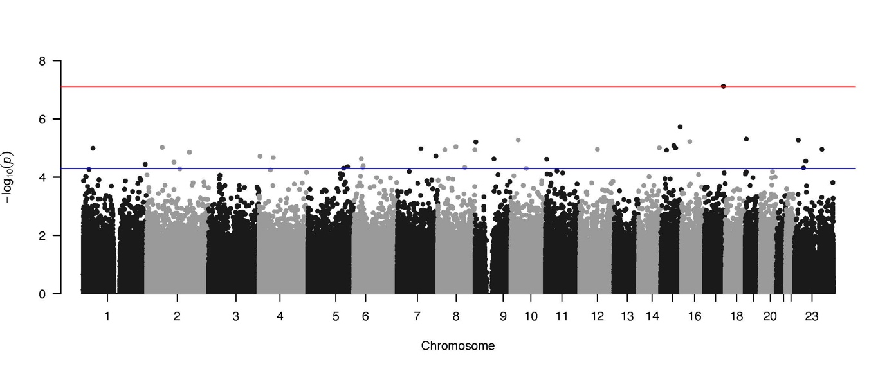

Suplementary Table 5. Top DMPs (P < 5e-05) associated between neglect and DNAm (pathway a)

Probe | Genomic location (hg19) | Illumina gene annotation | Relation to UCSC CpG Island | Effect size | p value mediation
cg10490670 | 19:3684882 | PIP5K1C | N_Shelf | -0.009 | 3.24E-07
cg07646999 | 19:36359211 | APLP1 | N_Shore | 0.016 | 2.31E-06
cg18182483 | 1:215697171 |  |  | 0.012 | 8.05E-06
cg13682028 | 18:20424908 |  |  | 0.011 | 1.08E-05
cg22002893 | 15:66220351 | MEGF11 |  | -0.010 | 1.17E-05
cg12849710 | 5:58952314 | PDE4D |  | -0.008 | 1.23E-05
cg16981685 | 11:123305126 |  | S_Shelf | 0.011 | 1.89E-05
cg17805223 | 15:74002276 | CD276 |  | 0.007 | 2.27E-05
cg04741336 | 6:136847372 | MAP7 |  | -0.012 | 2.29E-05
cg16347256 | 1:57285160 | C1orf168 |  | -0.012 | 2.35E-05
cg13912639 | 5:147603654 |  |  | -0.018 | 2.38E-05
cg09982504 | 8:143413495 | TSNARE1 |  | -0.006 | 2.78E-05
cg00883590 | 7:103076127 | SLC26A5 |  | 0.009 | 3.44E-05
cg03356331 | 10:3610737 | LOC105376360 |  | 0.012 | 3.45E-05
cg24568311 | 3:15519117 | COLQ |  | 0.013 | 3.61E-05
cg05995220 | 20:55964998 | RBM38 | Island | 0.006 | 3.66E-05
cg10699599 | 6:75855715 | COL12A1 |  | -0.006 | 3.87E-05
cg17983064 | 5:131396357 | IL3 |  | 0.016 | 4.17E-05
cg01591738 | 7:137040544 |  |  | -0.019 | 4.59E-05
cg14044522 | 2:64587789 |  |  | -0.007 | 4.62E-05
cg21606405 | 6:152795042 | SYNE1 |  | -0.013 | 4.93E-05

Supplementary Figure 11. Manhattan plot showing association between neglect and DNAm. Red line: array-wide multiple testing threshold (p<5.8x10-8); blue line: “discovery” p-value threshold
(P < 5e-5).

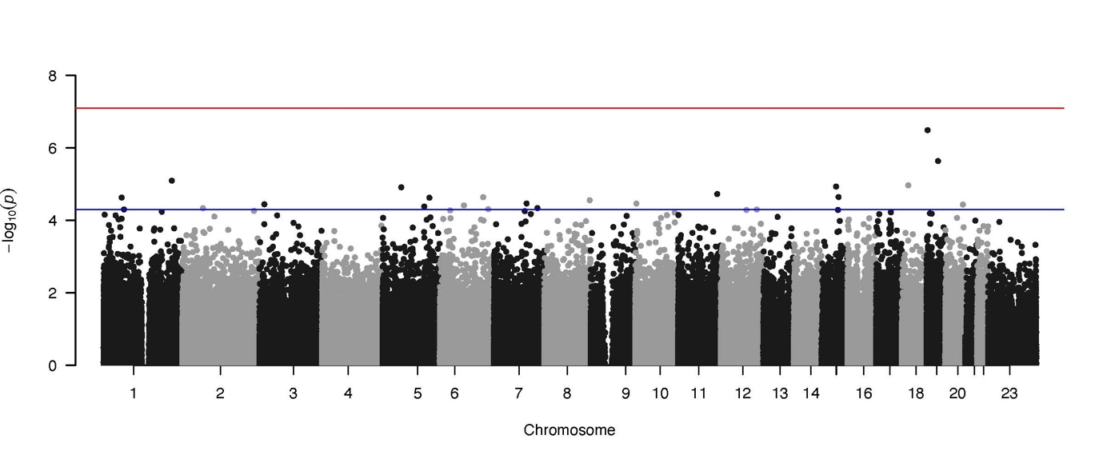

Suplementary Table 6. Top DMPs (P < 5e-05) associated between DNAm and psychosis (path b)

Probe | Genomic location (hg19) | Illumina gene annotation | Relation to UCSC CpG Island | Effect  size | p value mediation
cg00402173 | 5:81709024 |  |  | 30.177 | 1.25E-06
cg07650009 | 15:56112297 |  |  | 22.359 | 2.86E-06
cg22213006 | X:128789768 | APLN | S_Shore | -21.948 | 4.70E-06
cg13914094 | 5:77148665 |  | S_Shore | -28.315 | 6.60E-06
cg04623458 | 16:871165 |  | N_Shelf | 21.383 | 8.97E-06
cg06906230 | 15:48680848 |  |  | 23.900 | 1.04E-05
cg21233897 | 6:41657184 | TFEB |  | 13.462 | 1.16E-05
cg02595120 | 5:146832518 | DPYSL3 | N_Shore | 33.484 | 1.22E-05
cg24853340 | 13:113546294 |  | N_Shelf | 18.912 | 1.48E-05
cg19292908 | 22:22900159 | PRAME | N_Shore | -21.314 | 1.53E-05
cg25358133 | 11:1020251 | MUC6 | N_Shelf | -26.600 | 1.66E-05
cg11600511 | 22:44284127 | PNPLA5 | N_Shelf | 26.004 | 1.90E-05
cg18479241 | 3:177221418 | LINC00578 |  | 13.523 | 2.30E-05
cg09509179 | 10:91598023 |  | S_Shore | 18.489 | 2.34E-05
cg06209574 | 2:12918241 |  |  | 20.986 | 2.35E-05
cg12425670 | 2:62422030 | B3GNT2 | N_Shore | 27.258 | 2.46E-05
cg21299462 | 11:124953020 | SLC37A2 |  | -27.773 | 2.54E-05
cg16243247 | 4:3803686 |  |  | -17.506 | 2.67E-05
cg08507802 | 8:126912031 |  |  | -23.867 | 2.80E-05
cg09276913 | 10:129807938 | PTPRE |  | -25.019 | 2.87E-05
cg23640575 | 19:1571440 |  | S_Shelf | -26.133 | 3.01E-05
cg21776797 | X:100662746 | HNRNPH2; GLA; RPL36A-HNRNPH2 | N_Shore | -32.512 | 3.08E-05
cg03088599 | 8:70544397 | SULF1 |  | 18.832 | 3.19E-05
cg09277541 | 21:34677002 |  |  | 18.533 | 3.27E-05
cg05560118 | 2:101850632 |  |  | 14.172 | 3.43E-05
cg21127508 | 15:40749867 | BAHD1 |  | -21.288 | 3.52E-05
cg07112779 | X:48687187 | ERAS | S_Shore | -18.075 | 3.60E-05
cg20739360 | 7:91833683 | KRIT1 |  | 25.418 | 3.60E-05
cg20329861 | 10:111716018 | ADD3-AS1 |  | -19.135 | 3.65E-05
cg17274057 | 1:164599431 | PBX1 |  | 26.406 | 3.75E-05
cg25626273 | 12:111480104 | CUX2 |  | 26.221 | 3.86E-05
cg21123355 | 9:136844644 | VAV2 | Island | 8.612 | 3.93E-05
cg11228898 | 10:72301873 | PALD1 |  | -18.821 | 4.46E-05
cg14808739 | 17:17741098 | SREBF1 | S_Shore | -30.289 | 4.95E-05

Supplementary Figure 12. Manhattan plot showing the DNAm associated to psychosis. Red line: array-wide multiple testing threshold (p<5.8x10-8); blue line: “discovery” p-value threshold
(P < 5e-5).

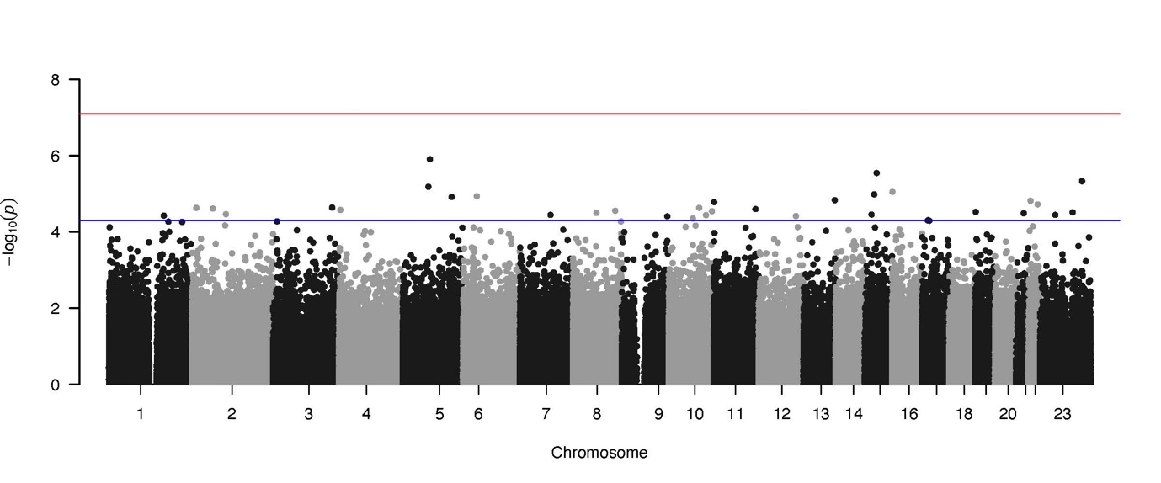

Supplementary Table 7 Top DMPs (P < 5e-05) associated with composite cumulative measure of neglect using the DACT test
Probe | Genomic location (hg19) | Illumina gene annotation | Relation to UCSC CpG Island | Effect size med | p value mediation
cg11476306 | 8: 122273909 |  |  | -0.142 | 3.11E-07
cg19456890 | 10: 91402272 | PANK1 | N_Shore | 0.134 | 1.30E-06
cg14074251 | 2: 220299116 | SPEG | N_Shore | 0.120 | 7.17E-06
cg16244155 | 18: 77905565 | LOC100130522 | Island | 0.129 | 7.17E-06
cg21978195 | 17: 77918905 | TBC1D16 | S_Shore | -0.146 | 8.58E-06
cg23315592 | 16: 57674745 | ADGRG1 |  | -0.100 | 1.08E-05
cg17606450 | 11: 60500636 |  |  | -0.109 | 1.28E-05
cg12028337 | 13: 107790939 |  |  | 0.140 | 1.30E-05
cg01490742 | 15: 77223149 | RCN2 | N_Shore | 0.096 | 1.32E-05
cg08324612 | 8: 1030521 |  |  | -0.100 | 1.40E-05
cg01464104 | 11: 56043040 | OR5T1 |  | -0.110 | 1.74E-05
cg19517291 | 15: 85201039 | NMB | N_Shore | -0.111 | 2.22E-05
cg23244948 | 14: 47096230 |  |  | 0.096 | 2.48E-05
cg01632958 | 12: 91619323 |  |  | -0.077 | 2.64E-05
cg16351998 | 6: 136873379 | MAP7 | S_Shore | -0.095 | 2.72E-05
cg09716762 | 16: 31383689 | ITGAX | S_Shore | -0.115 | 2.77E-05
cg14910138 | 1: 177178755 | BRINP2 |  | 0.090 | 3.31E-05
cg04345540 | 6: 35446409 | TEAD3 |  | -0.098 | 3.32E-05
cg17331920 | 17: 4081325 | ANKFY1 |  | -0.103 | 3.37E-05
cg11573143 | 2: 228192092 | MFF | S_Shore | -0.095 | 3.78E-05
cg20350203 | 20: 47957157 |  |  | 0.094 | 3.79E-05
cg00708080 | 9: 34382709 | C9orf24 | S_Shore | 0.100 | 4.09E-05
cg11495399 | 11: 62495898 | HNRNPUL2;TTC9C | S_Shore | -0.114 | 4.19E-05
cg17219331 | 3: 139025555 |  |  | -0.092 | 4.28E-05
cg12641286 | 8: 141537198 |  |  | -0.121 | 4.34E-05
cg17280975 | 8: 123875899 | ZHX2 |  | 0.1090 | 4.52E-05
cg05339605 | 14: 91269861 | TTC7B |  | -0.113 | 4.69E-05
cg10194002 | 1: 24878007 | LOC100506985 |  | 0.082 | 4.88E-05
cg05288426 | 11: 134469461 |  |  | 0.086 | 4.90E-05

Supplementary Figure 13. Manhattan plot showing the DNAm mediating DMP between cumulative measure of neglect and psychosis.
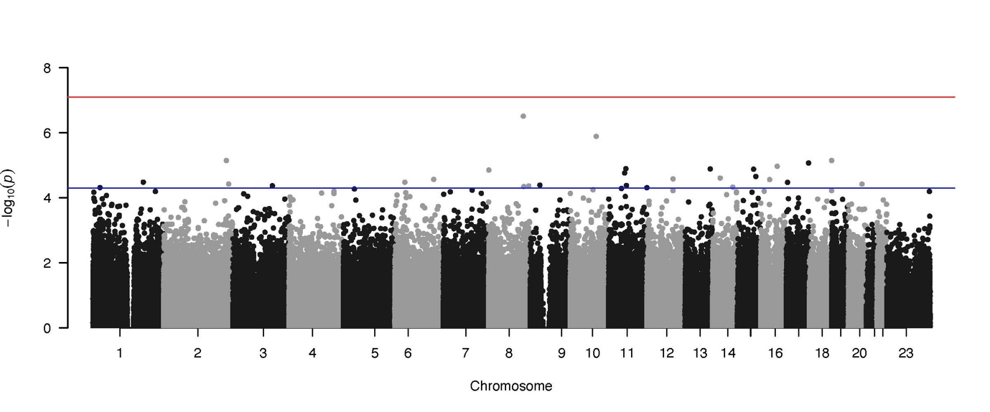Red line: array-wide multiple testing threshold (p<5.8x10-8); blue line: “discovery” p-value threshold
(P < 5e-5).

Supplementary Figure 14. The top 10 CpG sites for composite measure of adversity showing the most significant correlation with smoking score. Each circle represents a subject.

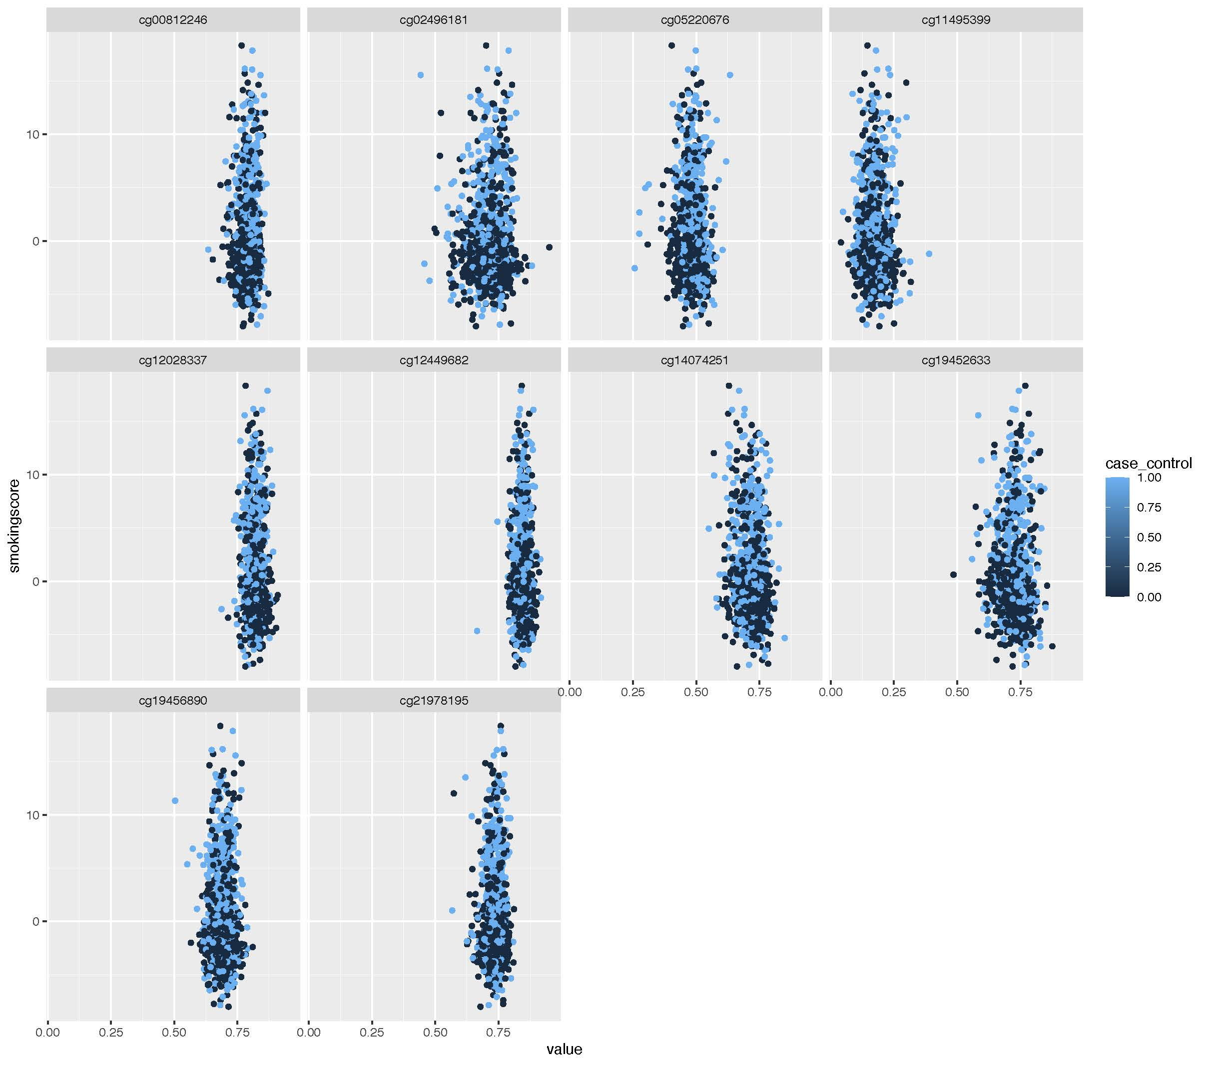

Supplementary Figure 15. The top 10 CpG sites for abuse measure showing the most significant correlation with smoking score. Each circle represents a sample.

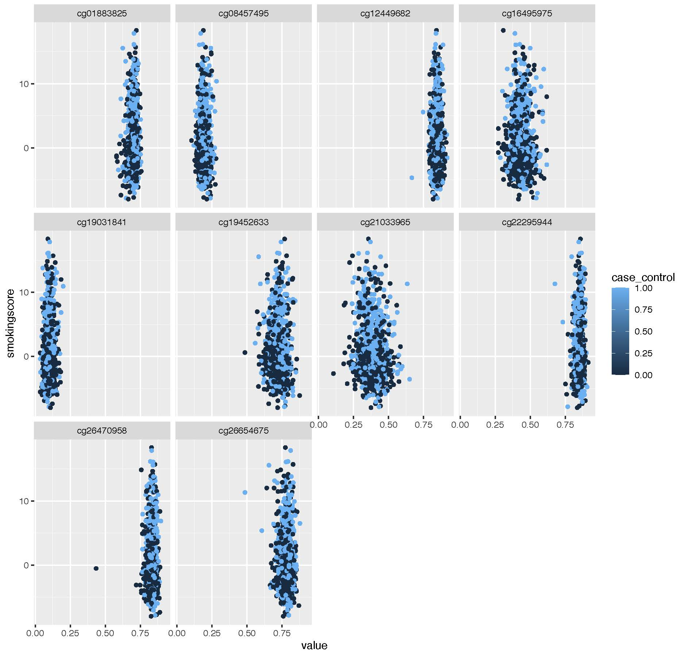

Supplementary Figure 16. The top 10 CpG sites for neglect measure showing the most significant correlation with smoking score. Each circle represents a sample.

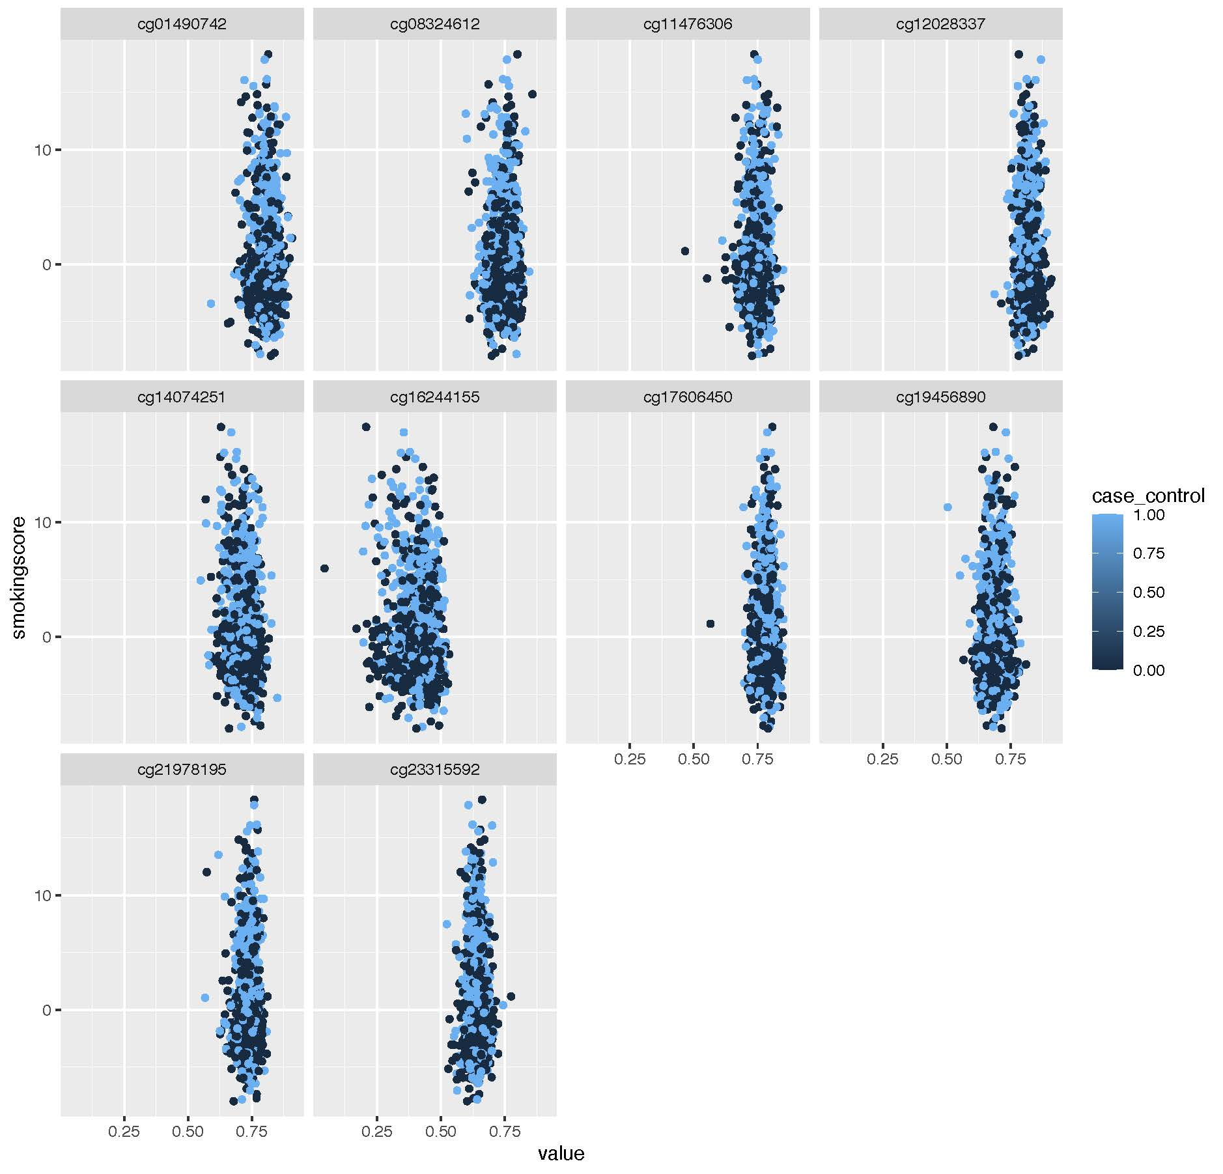

Supplementary Table 8. Top 10 biological KEGG pathway analysis of top-ranked differentially methylated positions (DMPs; P-value of P < 5e-5) mediating composite measure of adversity and psychosis.

ID | Ontology | Description | N of DMPs | DE | p-value | FDR | Genes
GO:0001697 | BP | histamine-induced gastric acid secretion | 1 | 1 | 0.002 | 1 | HRH2
GO:0015805 | BP | S-adenosyl-L-methionine transport | 1 | 1 | 0.002 | 1 | SLC25A26
GO:1901962 | BP | S-adenosyl-L-methionine transmembrane transport | 1 | 1 | 0.002 | 1 | SLC25A26
GO:0031641 | BP | regulation of myelination | 46 | 2 | 0.002 | 1 | ITGAX, TG
GO:0001698 | BP | gastrin-induced gastric acid secretion | 2 | 1 | 0.002 | 1 | HRH2
GO:1905956 | BP | positive regulation of endothelial tube morphogenesis | 2 | 1 | 0.002 | 1 | ITGAX
GO:0014809 | BP | regulation of skeletal muscle contraction by regulation of release of sequestered calcium ion | 4 | 1 | 0.005 | 1 | DMD
GO:1904340 | BP | positive regulation of dopaminergic neuron differentiation | 4 | 1 | 0.005 | 1 | FGF20
GO:0014722 | BP | regulation of skeletal muscle contraction by calcium ion signaling | 5 | 1 | 0.006 | 1 | DMD
GO:1905962 | BP | glutamatergic neuron differentiation | 5 | 1 | 0.007 | 1 | ZHX2
N, number of genes in the GO or KEGG term; DE, number of genes that are differentially methylated; P.DE, p-value for over-representation of the GO term; FDR, False discovery rate

Supplementary Table 9. Top 10 biological KEGG pathway analysis of top-ranked differentially methylated positions (DMPs; P-value of P < 5e-5) mediating abuse and psychosis
ID | Ontology | Description | N | DE | p-value | FDR | Genes
GO:0070782 | BP | phosphatidylserine exposure on apoptotic cell surface | 6 | 2 | <0.001 | 0.80412781 | XKR4, XKR5
GO:0017121 | BP | plasma membrane phospholipid scrambling | 18 | 2 | <0.001 | 1 | XKR4, XKR5
GO:0043652 | BP | engulfment of apoptotic cell | 18 | 2 | <0.001 | 1 | XKR4, XKR5
GO:0007009 | BP | plasma membrane organization | 113 | 3 | <0.001 | 1 | XKR4, XKR5, FAT4
GO:1902742 | BP | apoptotic process involved in development | 40 | 2 | 0.001 | 1 | XKR4, XKR5
GO:0001697 | BP | histamine-induced gastric acid secretion | 1 | 1 | 0.001 | 1 | HRH2
GO:0043277 | BP | apoptotic cell clearance | 50 | 2 | 0.002 | 1 | XKR4, XKR5
GO:0001698 | BP | gastrin-induced gastric acid secretion | 2 | 1 | 0.002 | 1 | HRH2
GO:0045332 | BP | phospholipid translocation | 44 | 2 | 0.003 | 1 | XKR4, XKR5
GO:0034204 | BP | lipid translocation | 47 | 2 | 0.003 | 1 | XKR4, XKR5

Supplementary Table 10. Top 10 biological KEGG pathway analysis of top-ranked differentially methylated positions (DMPs - discovery” P-value of P < 5e-5 threshold) mediating neglect and psychosis

ID | Ontology | Description | N | DE | p-value | FDR | Genes
GO:1900063 | BP | regulation of peroxisome organization | 3 | 1 | 0.001 | 1 | MFF
GO:1905956 | BP | positive regulation of endothelial tube morphogenesis | 2 | 1 | 0.002 | 1 | ITGAX
GO:0060040 | BP | retinal bipolar neuron differentiation | 5 | 1 | 0.005 | 1 | ZHX2
GO:1905962 | BP | glutamatergic neuron differentiation | 5 | 1 | 0.005 | 1 | ZHX2
GO:0016559 | BP | peroxisome fission | 9 | 1 | 0.005 | 1 | MFF
GO:0043653 | BP | mitochondrial fragmentation involved in apoptotic process | 9 | 1 | 0.006 | 1 | MFF
GO:0048284 | BP | organelle fusion | 138 | 2 | 0.006 | 1 | ANKFY1, MFF
GO:0021796 | BP | cerebral cortex regionalization | 7 | 1 | 0.007 | 1 | ADGRG1
GO:0055059 | BP | asymmetric neuroblast division | 6 | 1 | 0.007 | 1 | TEAD3
GO:0015937 | BP | coenzyme A biosynthetic process | 10 | 1 | 0.008 | 1 | PANK1

1. Li M, Li Y, Qin H, Tubbs JD, Li M, Qiao C, et al. Genome-wide DNA methylation analysis of peripheral blood cells derived from patients with first-episode schizophrenia in the Chinese Han population. Molecular psychiatry. 2020:1-11.
2. Hannon E, Dempster EL, Mansell G, Burrage J, Bass N, Bohlken MM, et al. DNA methylation meta-analysis reveals cellular alterations in psychosis and markers of treatment-resistant schizophrenia. eLife. 2021;10:e58430.
3. Zhang L, Silva TC, Young JI, Gomez L, Schmidt MA, Hamilton-Nelson KL, et al. Epigenome-wide meta-analysis of DNA methylation differences in prefrontal cortex implicates the immune processes in Alzheimer’s disease. Nature communications. 2020;11(1):1-13.
4. Marioni RE, McRae AF, Bressler J, Colicino E, Hannon E, Li S, et al. Meta-analysis of epigenome-wide association studies of cognitive abilities. Molecular psychiatry. 2018;23(11):2133-44.
5. Yang BZ, Zhang H, Ge W, Weder N, Douglas-Palumberi H, Perepletchikova F, et al. Child abuse and epigenetic mechanisms of disease risk. Am J Prev Med. 2013;44(2):101-7.
6. Dunn EC, Soare TW, Zhu Y, Simpkin AJ, Suderman MJ, Klengel T, et al. Sensitive Periods for the Effect of Childhood Adversity on DNA Methylation: Results From a Prospective, Longitudinal Study. Biol Psychiatry. 2019;85(10):838-49.
7. Rijlaarsdam J, Cecil CAM, Relton CL, Barker ED. Epigenetic profiling of social communication trajectories and co-occurring mental health problems: a prospective, methylome-wide association study. Development and psychopathology. 2021:1-10.
8. Gervin K, Nordeng H, Ystrom E, Reichborn-Kjennerud T, Lyle R. Long-term prenatal exposure to paracetamol is associated with DNA methylation differences in children diagnosed with ADHD. Clin Epigenetics. 2017;9:77.
9. Roberts S, Suderman M, Zammit S, Watkins SH, Hannon E, Mill J, et al. Longitudinal investigation of DNA methylation changes preceding adolescent psychotic experiences. Transl Psychiatry. 2019;9(1):69.
10. Kandaswamy R, Hannon E, Arseneault L, Mansell G, Sugden K, Williams B, et al. DNA methylation signatures of adolescent victimization: analysis of a longitudinal monozygotic twin sample. Epigenetics. 2020:1-18.
11. van Dongen J, Hagenbeek FA, Suderman M, Roetman PJ, Sugden K, Chiocchetti AG, et al. DNA methylation signatures of aggression and closely related constructs: A meta-analysis of epigenome-wide studies across the lifespan. Mol Psychiatry. 2021;26(6):2148-62.
12. Lunnon K, Smith R, Hannon E, De Jager PL, Srivastava G, Volta M, et al. Methylomic profiling implicates cortical deregulation of ANK1 in Alzheimer's disease. Nat Neurosci. 2014;17(9):1164-70.
13. Karlsson Linnér R, Marioni RE, Rietveld CA, Simpkin AJ, Davies NM, Watanabe K, et al. An epigenome-wide association study meta-analysis of educational attainment. Mol Psychiatry. 2017;22(12):1680-90.
14. Smith AK, Ratanatharathorn A, Maihofer AX, Naviaux RK, Aiello AE, Amstadter AB, et al. Epigenome-wide meta-analysis of PTSD across 10 military and civilian cohorts identifies methylation changes in AHRR. Nat Commun. 2020;11(1):5965.
15. Ju C, Fiori LM, Belzeaux R, Theroux JF, Chen GG, Aouabed Z, et al. Integrated genome-wide methylation and expression analyses reveal functional predictors of response to antidepressants. Transl Psychiatry. 2019;9(1):254.
16. Jeremian R, Chen YA, De Luca V, Vincent JB, Kennedy JL, Zai CC, et al. Investigation of correlations between DNA methylation, suicidal behavior and aging. Bipolar Disord. 2017;19(1):32-40.
17. Starnawska A, Tan Q, McGue M, Mors O, Børglum AD, Christensen K, et al. Epigenome-Wide Association Study of Cognitive Functioning in Middle-Aged Monozygotic Twins. Front Aging Neurosci. 2017;9:413.

