External globus pallidus input to the dorsal striatum regulates habitual reward-seeking behavior

Matthew Baker^{1,#}, Seungwoo Kang^{1,2,#}, Sa-Ik Hong¹, Minryung Song³, Minsu Abel Yang³, Lee Peyton¹, Hesham Essa¹, Sang Wan Lee^{3,4,5,6}, and Doo-Sup Choi^{1,2,*}
¹Department of Molecular Pharmacology and Experimental Therapeutics, Mayo Clinic, Rochester, Minnesota 55905. ²Department of Pharmacology and Toxicology, Medical College of Georgia, Augusta University, Augusta, Georgia, 30912 ³Department of Bio and Brain Engineering, ⁴Program of Brain and Cognitive Engineering, ⁵Korea Advanced Institute of Science and Technology (KAIST) for Health Science Technology, ⁶KAIST for Artificial Intelligence, KAIST, Daejeon, 34141, Republic of Korea. ⁷Department of Psychiatry and Psychology, ⁸Neuroscience Program, Mayo Clinic College of Medicine and Science, Rochester, Minnesota.
#These authors contributed to this article equally.
*Corresponding author: choids@mayo.edu

Keywords: external globus pallidus, arkypallidal neuron, goal-directed behavior, habit, reward-seeking behavior
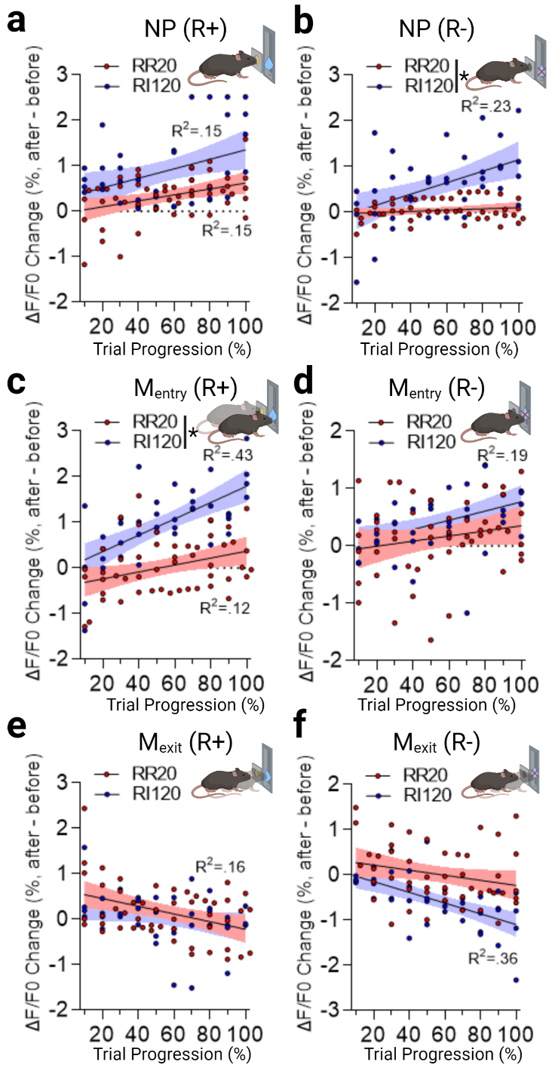

Supplementary Figure 1. GPe arkypallidal neuron Ca²⁺ signal changes across an operant session. Simple linear regression models for the association between a change in GPe arkypallidal neuron Ca²⁺ signal (2 sec after – 2 sec before) and operant trial duration averaged into 10 blocks for rewarded nose poke (a), unrewarded nose poke (b), rewarded magazine entry (c), unrewarded magazine entry (d), rewarded magazine exit (e), and unrewarded magazine exit (f). Lines indicate regression line ± 95% CI. R² value indicates a significant association between the change in Ca²⁺ signal and behavioral event progression across a trial. *p < 0.05 for between-group slope comparisons. See Supplementary Table 2 for full statistical information.

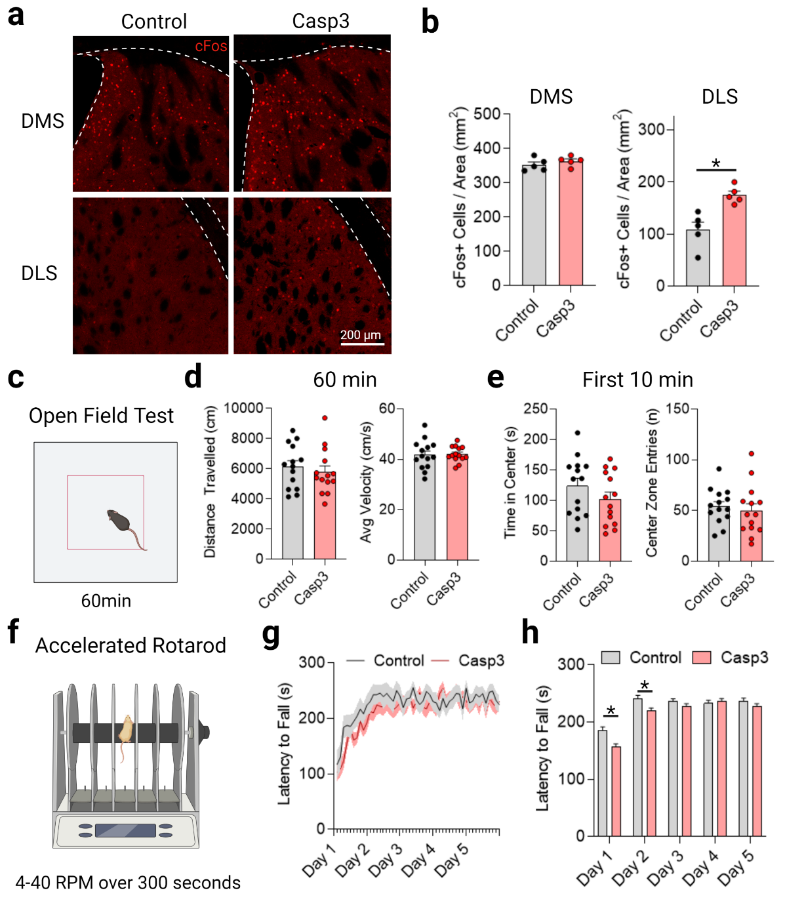
Supplementary Figure 2. Effects of caspase-3 (casp3) ablation of GPe arkypallidal neurons on cFos expression in the dorsal striatum and spontaneous locomotion and motor skill acquisition. (a) representative IHC images of Cfos expression in the dorsomedial (DMS) and dorsolateral (DLS) striatum for sham and casp3 mice. Scale: 200 µm. (b) GPe arkypallidal neuron ablation increased the number of cFos positive cells in the DLS, but not DMS. Unpaired t-test. n = 5/group (c) Schematic for open field test. (d) GPe arkypallidal neuron ablation did not alter distance travelled or average velocity in the open field test, nor did it alter anxiety-like behaviors during the first 10 minutes. Mann-Whitney test. (e) (f) schematic for accelerating rotarrod test for motor skill acquisition. (g) Latency to fall increased across days and sessions. Two-way RM ANOVA. (h) casp3 mice had shorter latency to fall compared to control mice for days 1 and 2. Post-hoc Sidak test. n = 14/group. Data represent mean ± s.e.m. *p < 0.05. Full statistical results are in Supplementary Table 2.
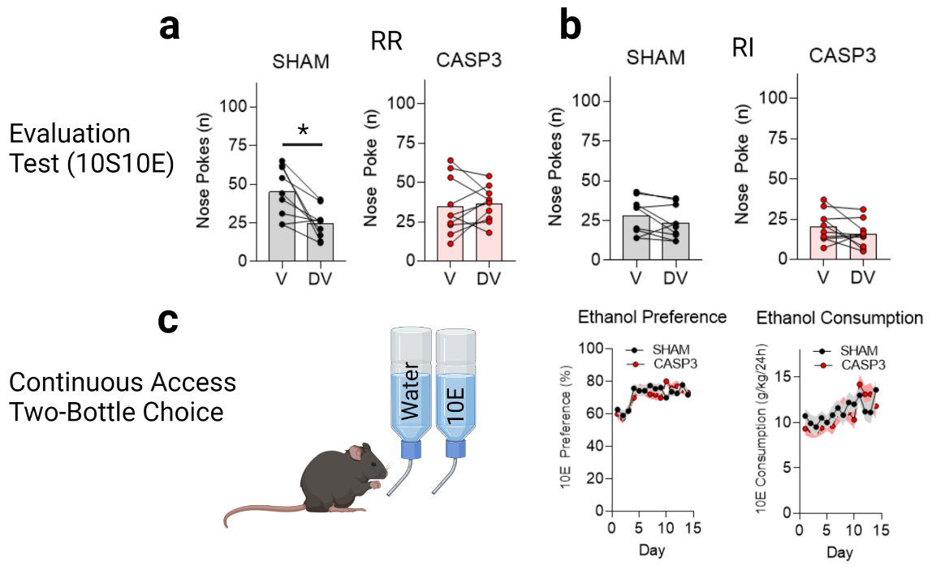
Supplementary Figure 3. Effect of GPe arkypallidal neuron ablation (casp3) on goal-directed and habitual sweetened ethanol-seeking and baseline ethanol preference and consumption. (a) RR-trained (Goal-directed) sham mice reduced nose poke responses in the devalued state, confirming goal directed behavior. However, casp3 mice showed no changes in nose poke responses between valued and devalued states, typical of habitual behavior. (b) RI-trained mice showed no differences between valued and devalued states, suggestive of habitual behavior. Wilcoxon test. (c) 10% Ethanol preference and consumption during a continuous access two-bottle choice test. Two-way RM ANOVA. n = 8/group. Data represent mean ± s.e.m. *p < 0.05. Full statistical results are in Supplementary Table 2.

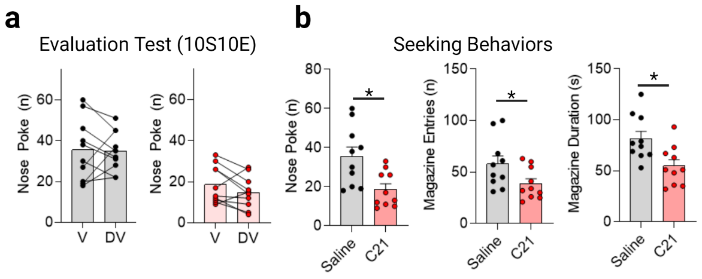

Supplementary Figure 4. Effect of chemogenetic activation of GPe arkypallidal neurons on habitual sweetened ethanol-seeking. (a) there were no differences in nose poke rates between the valued and devalued state for RI-trained mice with saline or C21 groups, indicating habitual reward-seeking. Wilcoxon test. (b) Chemogenetic activation of GPe arkypallidal neurons decreased nose poke, magazine entry, and magazine duration seeking behaviors during extinction testing. Mann-Whitney test. n = 10/group. Data represent mean ± s.e.m. *p < 0.05. Full statistical results are in Supplementary Table 2.

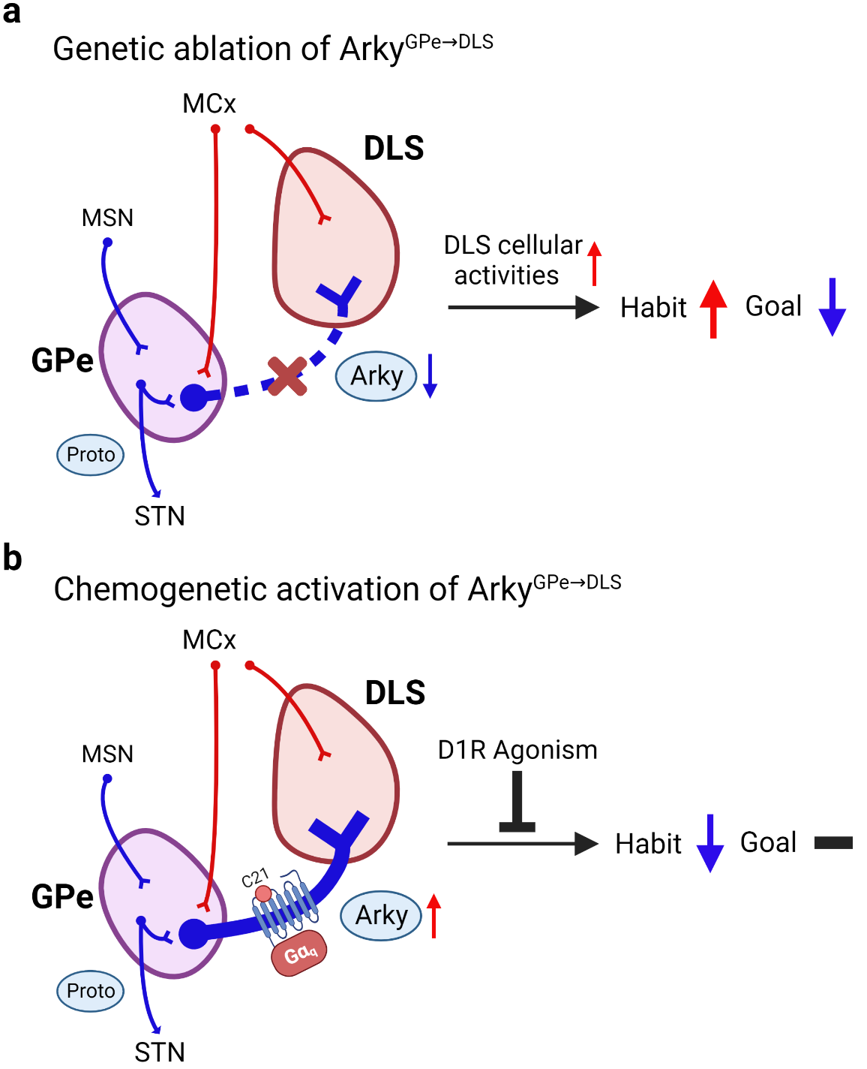
Supplementary Figure 5. Possible circuit mechanisms of GPe arkypallidal neurons on habitual behaviors. Circuit overview involving the external globus pallidus (GPe) and dorsolateral striatum (DLS) including excitatory glutamatergic (red) and inhibitory GABAergic (blue) projections. (a) Caspase 3-induced ablation of the arky^{GPeDLS} circuit caused an increase in cFos expression in the DLS and resulted in a shift from goal-directed to habitual reward-seeking. (b) In contrast, chemogenetic activation (hM3Dq) of arky^{GPeDLS} caused a reduction in habitual seeking-behaviors, which was blocked by D1R agonism. Possible afferent innervation of arkypallidal (arky) neurons from dorsal striatal medium spiny neurons (MSN), motor cortex (MCx), and neighboring prototypic (proto) neurons, which also project to the subthalamic nucleus (STN).

Supplementary Table 1. SVM AUC results to classify behavioral task types for all time windows of analysis using fiber photometry data.
Event | SVM Data input |  |  |  | AUC
Event | Before |  | After |  | AUC
Event | Start (s) | End (s) | Start (s) | End (s) | AUC
Nose-poke | -2 | 0 | 0 | 2 | 0.70 ± 0.001
Nose-poke | -1.5 | 0 | 0 | 1.5 | 0.68 ± 0.001
Nose-poke | -1 | 0 | 0 | 1 | 0.65 ± 0.001
Nose-poke | -0.5 | 0 | 0 | 0.5 | 0.65 ± 0.001
Magazine entry | -2 | 0 | 0 | 2 | 0.66 ± 0.001
Magazine entry | -1.5 | 0 | 0 | 1.5 | 0.67 ± 0.001
Magazine entry | -1 | 0 | 0 | 1 | 0.67 ± 0.001
Magazine entry | -0.5 | 0 | 0 | 0.5 | 0.68 ± 0.001
Magazine exit | -2 | 0 | 0 | 2 | 0.65 ± 0.001
Magazine exit | -1.5 | 0 | 0 | 1.5 | 0.68 ± 0.001
Magazine exit | -1 | 0 | 0 | 1 | 0.70 ± 0.001
Magazine exit | -0.5 | 0 | 0 | 0.5 | 0.71 ± 0.001

Supplementary Table 2. Summary of statistical analyses and results.
Figure | Statistical Tests | Comparison | Value | p value
Figure 3d | Two-way RM ANOVA | MT: Time | F_{1,16} = 142.9 | p<0.0001
Figure 3d | Two-way RM ANOVA | MT: Group | F_{1,16} = 5.34 | p= 0.040
Figure 3d | Two-way RM ANOVA | MT: Interaction | F_{1,16} = 1.14 | p= 0.30
Figure 3d | Two-way RM ANOVA | RR: NP | F_{1,80} = 127.3 | p< 0.0001
Figure 3d | Two-way RM ANOVA | RR: Time | F_{9,80} = 127.3 | p< 0.0001
Figure 3d | Two-way RM ANOVA | RR: Interaction | F_{9,80} = 4.93 | p< 0.0001
Figure 3d | Two-way RM ANOVA | RI: NP | F_{1,80} = 142.1 | p< 0.0001
Figure 3d | Two-way RM ANOVA | RI: Time | F_{9,80} = 1.85 | p= 0.070
Figure 3d | Two-way RM ANOVA | RI: Interaction | F_{9,80} = 1.77 | p= 0.090
Figure 3e | Wilcoxon test | RR: V vs DV | W= -21.00 | p= 0.030
Figure 3e | Wilcoxon test | RI: V vs DV | W= -5.00 | p= 0.62
Figure 4a | Two-way RM ANOVA | NP+: RR vs RI | F_{1,7} = 5.73 | p= 0.048
Figure 4a | Two-way RM ANOVA | NP+: Time | F_{120,840} = 11.40 | p< 0.0001
Figure 4a | Two-way RM ANOVA | NP+: Interaction | F_{120,840} = 1.62 | p= 0.0001
Figure 4a | Two-way RM ANOVA | NP-: RR vs RI | F_{1,7} = 12.34 | p= 0.0098
Figure 4a | Two-way RM ANOVA | NP-: Time | F_{120,840} = 12.52 | p< 0.0001
Figure 4a | Two-way RM ANOVA | NP-: Interaction | F_{120,840} = 5.52 | p< 0.0001
Figure 4b | Paired T-test | NP+ RR: Before vs. After | t(4) = 5.16 | p= 0.0067
Figure 4b | Paired T-test | NP+ RI: Before vs. After | t(3) = 8.49 | p= 0.0034
Figure 4b | Paired T-test | NP- RR: Before vs. After | t(4) = 0.52 | p= 0.63
Figure 4b | Paired T-test | NP- RI: Before vs. After | t(3) = 2.68 | p= 0.075
Figure 4c | Unpaired T-test | NP+: RR vs RI | t(7) = 4.02 | p= 0.0051
Figure 4c | Unpaired T-test | NP-: RR vs RI | t(7) = 2.62 | p= 0.034
Figure 4d | Two-way RM ANOVA | ME+: RR vs RI | F_{1,7} = 25.84 | p= 0.0014
Figure 4d | Two-way RM ANOVA | ME+: Time | F_{120,840} = 14.48 | p< 0.0001
Figure 4d | Two-way RM ANOVA | ME+: Interaction | F_{120,840} = 5.73 | p< 0.0001
Figure 4d | Two-way RM ANOVA | ME -: RR vs RI | F_{1,7} = 0.05 | p= 0.83
Figure 4d | Two-way RM ANOVA | ME -: Time | F_{120,840} = 5.60 | p< 0.0001
Figure 4d | Two-way RM ANOVA | ME -: Interaction | F_{120,840} = 1.74 | p< 0.0001
Figure 4e | Paired T-test | ME + RR: Before vs. After | t(4) = 0.13 | p= 0.91
Figure 4e | Paired T-test | ME + RI: Before vs. After | t(3) = 7.63 | p= 0.0047
Figure 4e | Paired T-test | ME - RR: Before vs. After | t(4) = 0.21 | p= 0.85
Figure 4e | Paired T-test | ME - RI: Before vs. After | t(3) = 3.94 | p= 0.029
Figure 4f | Unpaired T-test | ME +: RR vs RI | t(7) = 3.28 | p= 0.034
Figure 4f | Unpaired T-test | ME -: RR vs RI | t(7) = 1.67 | p= 0.14
Figure 4g | Two-way RM ANOVA | MX +: RR vs RI | F_{1,7} = 6.66 | p= 0.036
Figure 4g | Two-way RM ANOVA | MX +: Time | F_{120,840} = 0.85 | p= 0.87
Figure 4g | Two-way RM ANOVA | MX +: Interaction | F_{120,840} = 1.26 | p= 0.039
Figure 4g | Two-way RM ANOVA | MX -: RR vs RI | F_{1,7} = 0.20 | p= 0.67
Figure 4g | Two-way RM ANOVA | MX -: Time | F_{120,840} = 8.65 | p< 0.0001
Figure 4g | Two-way RM ANOVA | MX -: Interaction | F_{120,840} = 5.51 | p< 0.0001
Figure 4h | Paired T-test | MX + RR: Before vs. After | t(4) = 0.73 | p= 0.51
Figure 4h | Paired T-test | MX + RI: Before vs. After | t(3) = 0.77 | p= 0.50
Figure 4h | Paired T-test | MX - RR: Before vs. After | t(4) = 1.11 | p= 0.33
Figure 4h | Paired T-test | MX - RI: Before vs. After | t(3) = 8.06 | p= 0.0040
Figure 4i | Unpaired T-test | MX +: RR vs RI | t(7) = 0.37 | p= 0.72
Figure 4i | Unpaired T-test | MX -: RR vs RI | t(7) = 2.37 | p= 0.050
Figure 5b | Kruskal-Wallis test | Accuracy |  | p < 0.001
Figure 5b | Posthoc Dunn’s test | Accuracy; NP vs. ME | Z = 12.71 | p < 0.001
Figure 5b | Posthoc Dunn’s test | Accuracy; NP vs. MX | Z = 33.28 | p < 0.001
Figure 5b | Posthoc Dunn’s test | Accuracy; ME vs. MX | Z = 20.57 | p < 0.001
Figure 5b | Kruskal-Wallis test | Sensitivity |  | p < 0.001
Figure 5b | Posthoc Dunn’s test | Sensitivity; NP vs. ME | Z = 9.09 | p < 0.001
Figure 5b | Posthoc Dunn’s test | Sensitivity; NP vs. MX | Z = 24.40 | p < 0.001
Figure 5b | Posthoc Dunn’s test | Sensitivity; ME vs. MX | Z = 33.49 | p < 0.001
Figure 5b | Kruskal-Wallis test | Specificity |  | p < 0.001
Figure 5b | Posthoc Dunn’s test | Specificity; NP vs. ME | Z = 13.17 | p < 0.001
Figure 5b | Posthoc Dunn’s test | Specificity; NP vs. MX | Z = 52.07 | p < 0.001
Figure 5b | Posthoc Dunn’s test | Specificity; ME vs. MX | Z = 38.89 | p < 0.001
Figure 6c | Unpaired t-test | Control vs Casp3 | t(8) = 6.90 | p = 0.001
Figure 6e | Two-way RM ANOVA | RR MT: Time | F_{2,36} = 29.91 | p< 0.0001
Figure 6e | Two-way RM ANOVA | RR MT: Group | F_{1,18} = 0.00 | p= 0.99
Figure 6e | Two-way RM ANOVA | RR MT: Interaction | F_{2,36} = 2.36 | p= 0.11
Figure 6e | Two-way RM ANOVA | RI MT: Time | F_{2,36} = 30.55 | p< 0.0001
Figure 6e | Two-way RM ANOVA | RI MT: Group | F_{1,18} = 0.13 | p= 0.73
Figure 6e | Two-way RM ANOVA | RI MT: Interaction | F_{2,36} = 0.01 | p= 0.98
Figure 6f | Two-way RM ANOVA | RR: Time | F_{9,161} = 13.38 | p< 0.0001
Figure 6f | Two-way RM ANOVA | RR: Group | F_{1,18} = 0.21 | p= 0.65
Figure 6f | Two-way RM ANOVA | RR: Interaction | F_{9,161} = 0.66 | p= 0.74
Figure 6f | Two-way RM ANOVA | RI: Time | F_{9,161} = 20.64 | p< 0.0001
Figure 6f | Two-way RM ANOVA | RI: Group | F_{1,18} = 0.28 | p= 0.61
Figure 6f | Two-way RM ANOVA | RI: Interaction | F_{9,161} = 0.52 | p= 0.86
Figure 6g | Wilcoxon test | RR Control: V vs DV | W= -45.00 | p= 0.0039
Figure 6g | Wilcoxon test | RR Casp3: V vs DV | W= -7.00 | p= 0.73
Figure 6h | Wilcoxon test | RI Control: V vs DV | W= -16.00 | p= 0.38
Figure 6h | Wilcoxon test | RI Casp3: V vs DV | W= 5.00 | p= 0.83
Figure 7d | One-way RM ANOVA | MT Time | F_{1,49}= 17.29 | p= 0.0001
Figure 7d | One-way RM ANOVA | RI Time | F_{1,168}= 91.68 | p< 0.0001
Figure 7e | Wilcoxon test | Saline: V vs DV | W= -58.00 | p= 0.14
Figure 7e | Wilcoxon test | C21: V vs DV | W= -21.00 | p= 0.57
Figure 7e | Wilcoxon test | C21+ Raclopride: V vs DV | W= -2.00 | p= 0.91
Figure 7e | Wilcoxon test | C21+ SKF38393: V vs DV | W= 0.00 | p= 0.99
Figure 7f | Kruskal-Wallis test | Nose Poke: Drug |  | p= 0.0004
Figure 7f | Posthoc Dunn’s test | Saline vs C21 | Z = 2.71 | p= 0.04
Figure 7f | Posthoc Dunn’s test | Saline vs C21 + Raclopride | Z = 3.96 | p= 0.0005
Figure 7f | Posthoc Dunn’s test | Saline vs C21 + SKF38393 | Z = 0.83 | p= 0.99
Figure 7g | Kruskal-Wallis test | Magazine Entry: Drug |  | p= 0.99
Figure 7g | Posthoc Dunn’s test | Saline vs C21 | Z = 3.59 | p< 0.0001
Figure 7g | Posthoc Dunn’s test | Saline vs C21 + Raclopride | Z = 4.13 | p= 0.002
Figure 7g | Posthoc Dunn’s test | Saline vs C21 + SKF38393 | Z = 0.69 | p= 0.0002
Figure 7h | Kruskal-Wallis test | Magazine Duration: Drug |  | p= 0.99
Figure 7h | Posthoc Dunn’s test | Saline vs C21 | Z = 2.52 | p= 0.07
Figure 7h | Posthoc Dunn’s test | Saline vs C21+ Raclopride | Z = 3.56 | p= 0.002
Figure 7h | Posthoc Dunn’s test | Saline vs C21 + SKF38393 | Z = 2.39 | p= 0.10
Figure S1a | Linear Regression | NP+: RR | b= 0.065; R²= .15; F_{1,48}= 8.26 | p= 0.006
Figure S1a | Linear Regression | NP+: RI | b= 0.10; R²= .15; F_{1,38}= 6.78 | p= 0.013
Figure S1a | Linear Regression | NP+: RR vs RI | F_{1,86}= 0.79 | p= 0.38
Figure S1b | Linear Regression | NP-: RR | b= 0.011; R²= .03; F_{1,48}= 1.48 | p= 0.23
Figure S1b | Linear Regression | NP-: RI | b= 0.037; R²= .23; F_{1,38}= 11.66 | p= 0.002
Figure S1b | Linear Regression | NP-: RR vs RI | F_{1,86}= 10.08 | p= 0.002
Figure S1c | Linear Regression | ME+: RR | b= 0.076; R²= .12; F_{1,48}= 6.62 | p= 0.013
Figure S1c | Linear Regression | ME+: RI | b= 0.18; R²= .43; F_{1,38}= 28.86 | p< 0.0001
Figure S1c | Linear Regression | ME+: RR vs RI | F_{1,86}= 5.34 | p= 0.023
Figure S1d | Linear Regression | ME-: RR | b= 0.044; R²= .04; F_{1,48}= 1.96 | p= 0.17
Figure S1d | Linear Regression | ME-: RI | b= 0.080; R²= .19; F_{1,38}= 9.08 | p= 0.005
Figure S1d | Linear Regression | ME-: RR vs RI | F_{1,86}= 0.69 | p= 0.41
Figure S1e | Linear Regression | MX+: RR | b= -0.08; R²= .16; F_{1,48}= 9.08 | p= 0.004
Figure S1e | Linear Regression | MX+: RI | b= -0.05; R²= .08; F_{1,38}= 3.12 | p= 0.09
Figure S1e | Linear Regression | MX+: RR vs RI | F_{1,86}= 0.60 | p= 0.44
Figure S1f | Linear Regression | MX-: RR | b= -0.06; R²= .06; F_{1,48}= 3.30 | p= 0.075
Figure S1f | Linear Regression | MX-: RI | b= -0.12; R²= .36; F_{1,38}= 21.77 | p< 0.0001
Figure S1f | Linear Regression | MX-: RR vs RI | F_{1,86}= 2.29 | p= 0.13
Figure S2b | Unpaired t-test | DMS: Control vs Casp3 | t(8) = 1.02 | p= 0.34
Figure S2b | Unpaired t-test | DLS: Control vs Casp3 | t(8) = 3.99 | p= 0.004
Figure S2d | Mann-Whitney test | Distance: Control vs Casp3 | U = 81 | p= 0.45
Figure S2d | Mann-Whitney test | Velocity:Control vs Casp3 | U = 91 | p= 0.76
Figure S2e | Mann-Whitney test | Time: Control vs Casp3 | U = 70 | p= 0.21
Figure S2e | Mann-Whitney test | Entries: Control vs Casp3 | U = 80 | p= 0.42
Figure S2g | Two-Way RM ANOVA | Time | F_{49,1274}= 8.68 | p< 0.0001
Figure S2g | Two-Way RM ANOVA | Control vs Casp | F_{1,26}= 1.28 | p= 0.27
Figure S2g | Two-Way RM ANOVA | Interaction | F_{49,1274}= 0.76 | p= 0.89
Figure S2h | Two-Way RM ANOVA | Time | F_{4,1390}= 58.82 | p< 0.0001
Figure S2h | Two-Way RM ANOVA | Control vs Casp | F_{1,1390}= 14.89 | p= 0.0001
Figure S2h | Two-Way RM ANOVA | Interaction | F_{4,1390}= 2.99 | p= 0.018
Figure S2h | Posthoc Sidak test | Day 1 | t(1390) = 3.90 | p= 0.0005
Figure S2h | Posthoc Sidak test | Day 2 | t(1390) = 2.92 | p= 0.018
Figure S2h | Posthoc Sidak test | Day 3 | t(1390) = 1.11 | p= 0.79
Figure S2h | Posthoc Sidak test | Day 4 | t(1390) = 0.56 | p= 0.98
Figure S2h | Posthoc Sidak test | Day 5 | t(1390) = 1.25 | p= 0.69
Figure S3a | Wilcoxon test | RR Control: V vs DV | W= -43.00 | p= 0.0078
Figure S3a | Wilcoxon test | RR Casp3: V vs DV | W= 8.00 | p= 0.72
Figure S3b | Wilcoxon test | RI Control: V vs DV | W= -28.00 | p= 0.11
Figure S3b | Wilcoxon test | RI Casp3: V vs DV | W= -29.00 | p= 0.15
Figure S3c | Two-Way RM ANOVA (preference) | Time | F_{13,234}= 9.09 | p< 0.0001
Figure S3c | Two-Way RM ANOVA (preference) | Control vs Casp3 | F_{1,18}= 0.33 | p= 0.57
Figure S3c | Two-Way RM ANOVA (preference) | Interaction | F_{13,234}= 1.29 | p= 0.22
Figure S3c | Two-Way RM ANOVA (consumption) | Time | F_{13,234}= 3.54 | p< 0.0001
Figure S3c | Two-Way RM ANOVA (consumption) | Control vs Casp3 | F_{1,18}= 0.39 | p= 0.54
Figure S3c | Two-Way RM ANOVA (consumption) | Interaction | F_{13,234}= 0.87 | p= 0.58
Figure S4a | Wilcoxon test | Saline: V vs DV | W= -3.00 | p= 0.90
Figure S4a | Wilcoxon test | C21: V vs DV | W= -31.00 | p= 0.13
Figure S4b | Mann-Whitney test | NP: Saline vs C21 | U = 15.5 | p= 0.0073
Figure S4b | Mann-Whitney test | Entries: Saline vs C21 | U = 23.5 | p= 0.046
Figure S4b | Mann-Whitney test | Duration: Saline vs C21 | U = 15 | p= 0.0065

Supplementary Table 3. Time range for significant (p < 0.05) individual comparisons between fiber photometry groups.
Figure | Comparison | Time range
Fig. 4a | NP+; RR vs. RI | NS
Fig. 4a | NP-; RR vs. RI | 0.73 – 1.7 s
Fig. 4d | M_{entry} +; RR vs. RI | 0.00 – 2 s
Fig. 4d | M_{entry} -; RR vs. RI | NS
Fig. 4g | M_{exit} +; RR vs. RI | NS
Fig. 4g | M_{exit} -; RR vs. RI | 0.03 – 0.27 s

