Supporting Information
Kinetically Facilitating Two-electron Oxygen Reduction by the Synergy of Multiple Pyrrolic Nitrogen Sites for Ultra-high-yield Electrochemical Hydrogen Peroxide Production
Wei Peng¹, Jiaxin Liu¹, Xiaoqing Liu¹, Liqun Wang²*, Lichang Yin³*, Haotian Tan¹, Feng Hou¹*, Ji Liang¹*
1 Key Laboratory of Advanced Ceramics and Machining Technology of Ministry of Education School of Materials Science and Engineering, Tianjin University, Tianjin 300072, China.
E-mail: houf@tju.edu.cn (F. Hou) and liangji@tju.edu.cn (J. Liang)
2 Applied Physics Department, College of Physics and Materials Science, Tianjin Normal University, Tianjin 300387, China.
Email: wlxywlq@mail.tjnu.edu.cn (L. Wang)
3 Shenyang National Laboratory for Materials Science, Institute of Metal Research, Chinese Academy of Sciences, Shenyang, Liaoning 110016, China.
E-mail: lcyin@imr.ac.cn (L. Yin)

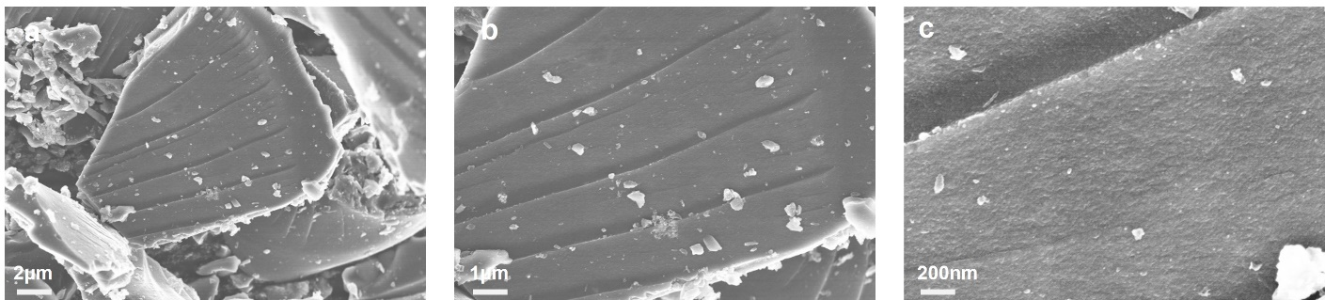
Figure S1. a), b), and c) SEM images of P-NMG-0

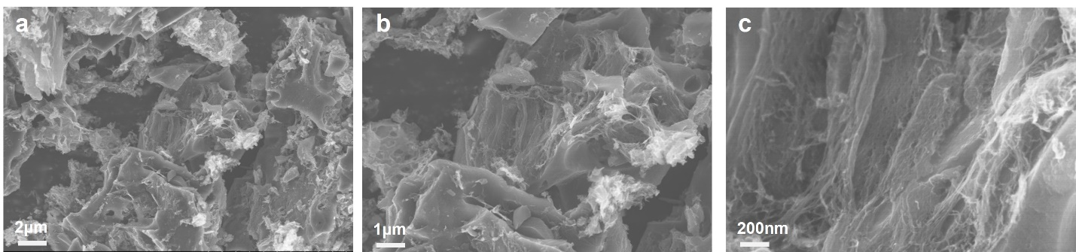
Figure S2. a), b), and c) SEM images of P-NMG-5

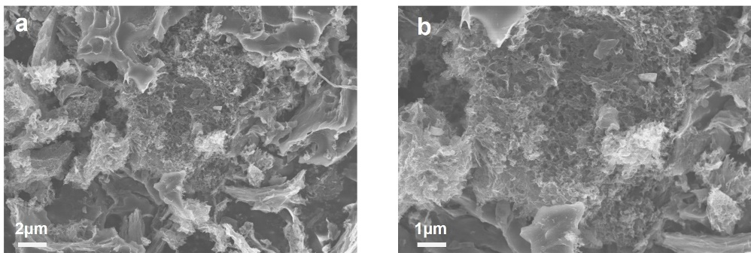
Figure S3. a) and b) SEM images of P-NMG-10

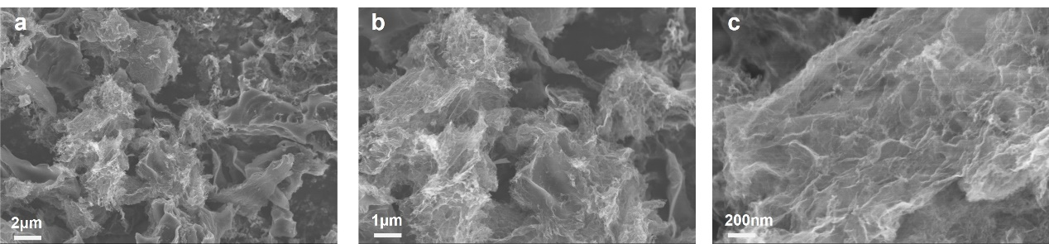
Figure S4. a), b), and c) SEM images of P-NMG-15

Figure S5. XRD patterns of P-NMG-0, P-NMG-5, P-NMG-10 and P-NMG-15.

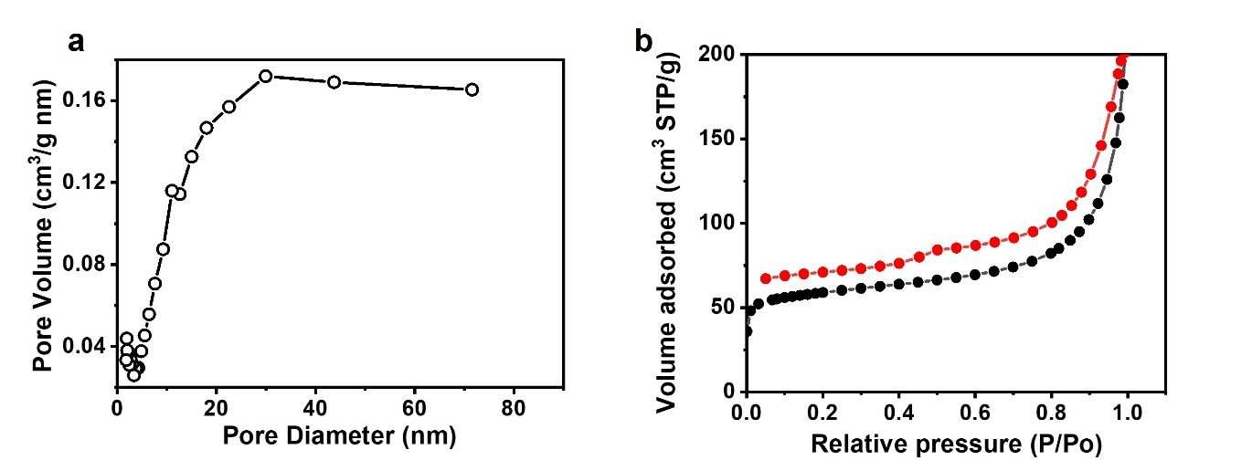
Figure S6. a) Nitrogen adsorption-desorption isotherm, and b) its corresponding pore distribution pattern of P-NMG-5.

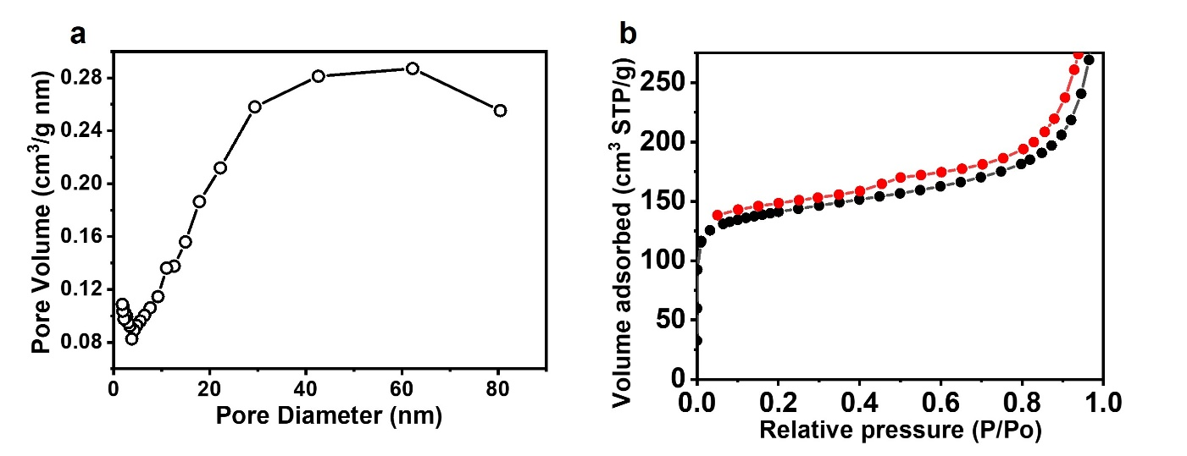
Figure S7. a) Nitrogen adsorption-desorption isotherm, and b) its corresponding pore distribution pattern of P-NMG-15.

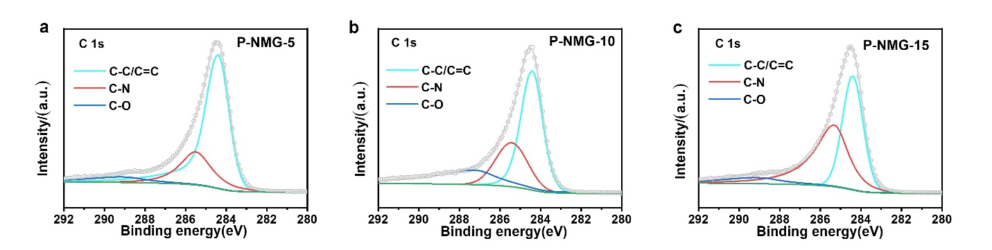
Figure S8. High-resolution C 1s XPS spectra of a) P-NMG-5, b) P-NMG-10, and c) P-NMG-15.

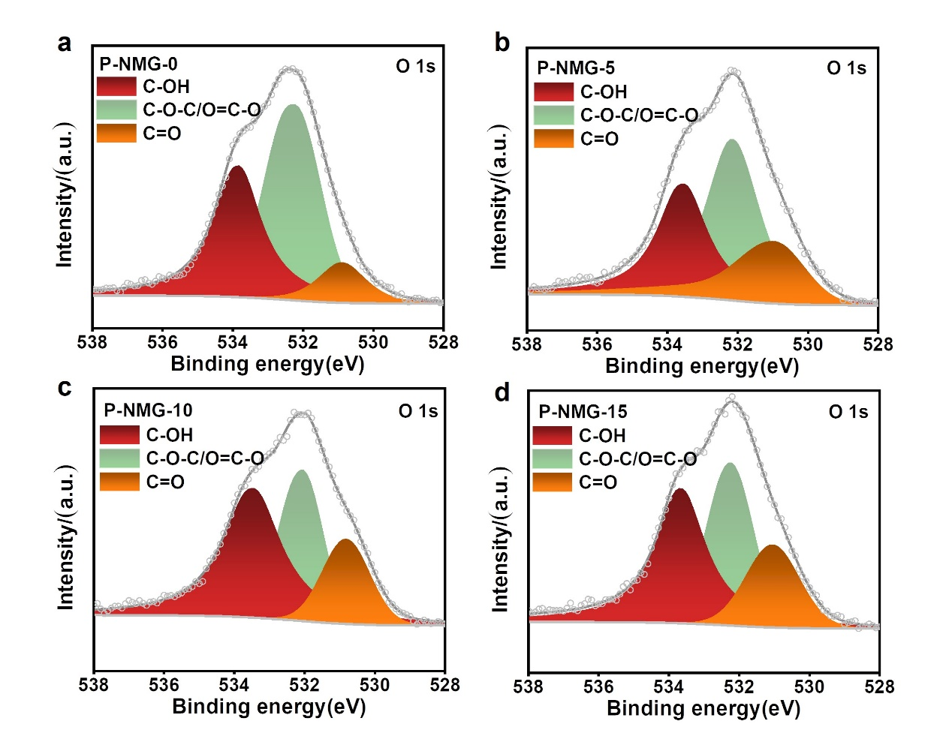
Figure S9. High-resolution O 1s XPS spectra of a) P-NMG-0, b) P-NMG-5, c) P-NMG-10, and d) P-NMG-15.
Figure S10. The collection efficiency (N) immersed in Ar-saturated 0.1 M PBS with 5mM of potassium ferricyanide (K₃Fe(CN)₆).

Figure S11. LSV curves of P-NMG-5, P-NMG-10 and P-NMG-15 in 0.10 M KOH containing 50 mM H₂O₂.

Figure S12. Corresponding standard curve.

Figure S13. The blank control group.

Figure S14. H₂O₂ yield of the samples obtained from different temperature treatments.
The samples obtained from different temperature treatments were tested (Figure S14,15), and it can be observed that the highest yield and Faraday efficiency (FE) were obtained (0 V vs. RHE) from the samples treated at 900 °C. It proved that 900 °C is the optimum annealing temperature for P-NMG-X.

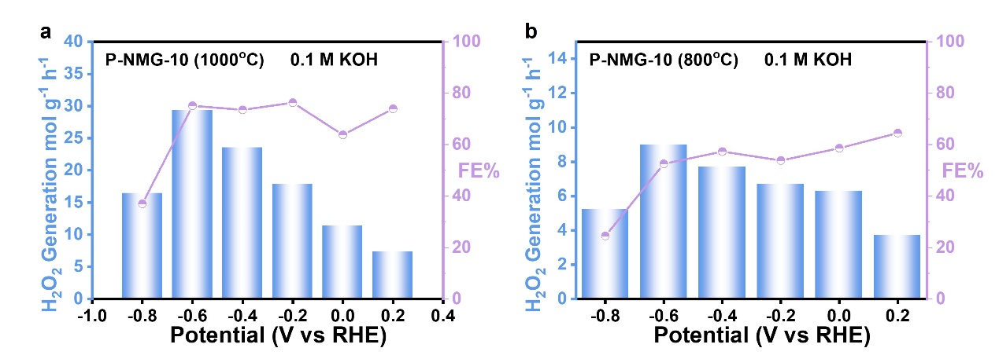
Figure S15. a) The yield and FE of H₂O₂ for the samples obtained from 1000 °C. b) The yield and FE of H₂O₂ for the samples obtained from 800 °C.

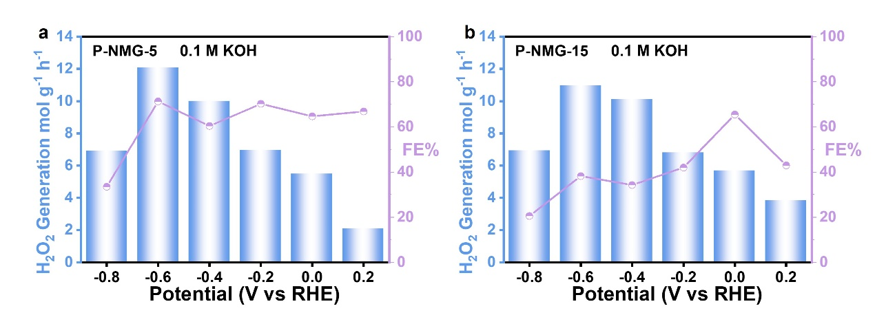
Figure S16. a) The yield and FE of H₂O₂ for the P-NMG-5. b) The yield and FE of H₂O₂ for the P-NMG-15.
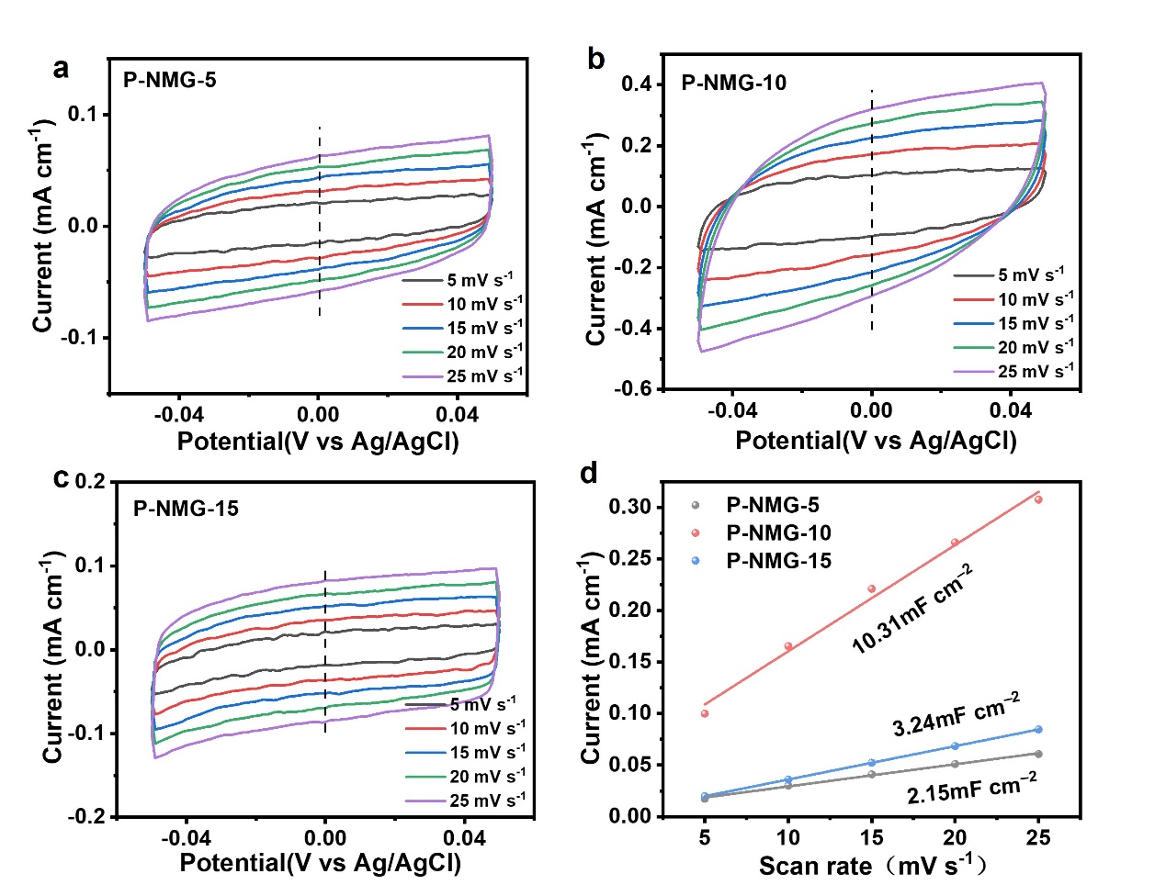
Figure S17. Determination of electrochemically active surface area. (a-c) CV curves of P-NMG-5, P-NMG-10 and P-NMG-15. d) The C_{dl} for P-NMG-5, P-NMG-10 and P-NMG-15 are calculated to be 2.15, 3.24 and 10.31 mF cm^{–2}, respectively.
Figure S18. UV-vis spectra of electrolyte every hour.

Figure S19. The yield and FE of H₂O₂ for the P-NMG-10 in 0.9 wt.% NaCl.

Figure S20. The current density for 24h in 0.9 wt.% NaCl and linear fitted lines for the change in H₂O₂ concentration.

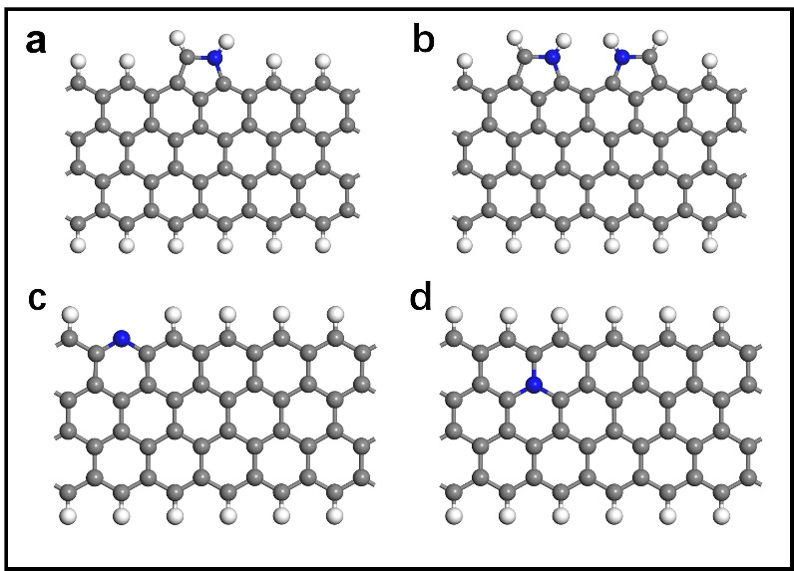
Figure S21. Schematic diagram of N-doped graphene with pyrrolic nitrogen (a/b), pyridinic nitrogen (c), and quaternary nitrogen in the bulk phase (d), respectively.

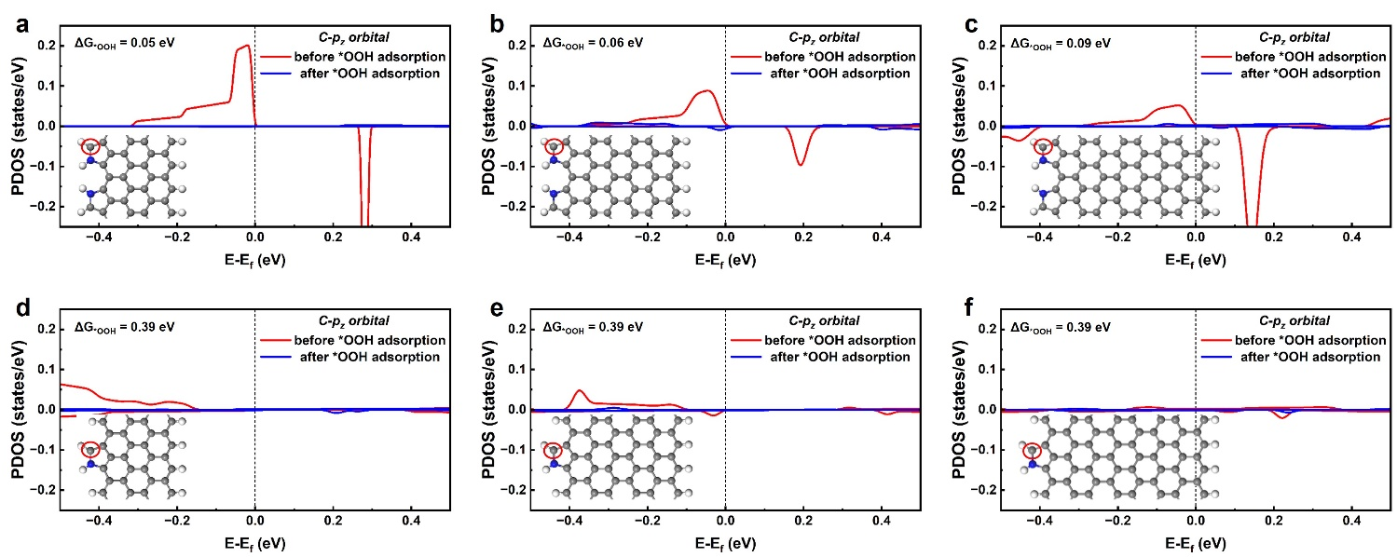
Fig S22 (a-c) PDOS of p_{z} orbital of C atom on dual-spyrrolic nitrogen carbon with different nanoribbon widths before and after *OOH adsorption. (d-f) PDOS of p_{z} orbital of C atom on pyrrole with different nanoribbon widths before and after *OOH adsorption.

Table S1. Atomic content of C, N and O for P-NMG-0, P-NMG-5, P-NMG-10 and P-NMG-15 according to XPS survey spectra.

Sample | O (at. %) | N (at. %) | C (at. %)
P-NMG-0 | 13.01 | 0 | 86.99
P-NMG-5 | 4.91 | 8.69 | 86.4
P-NMG-10 | 3.71 | 9.38 | 86.91
P-NMG-15 | 4.53 | 9.47 | 86

Table S2. Atomic content of C−OH, C−O−C/O=C−O and C=O for P-NMG-0, P-NMG-5, P-NMG-10 and P-NMG-15 according to XPS survey spectra.
Sample | C−OH | C−O−C/O=C−O | C=O
P-NMG-0 | 9.4 | 50.1 | 40.5
P-NMG-5 | 23.3 | 41.3 | 35.4
P-NMG-10 | 18.9 | 32.2 | 48.9
P-NMG-15 | 19.8 | 37.9 | 42.3

Table S3. The electrochemical performance comparison with electrocatalysts recently reported.
Catalysts | Potential (V vs. RHE) | FE | H₂O₂ yield  (mol g⁻¹ h⁻¹) | Ref.
P-NMG-10 | 0 | 90 | 12 | This work
P-NMG-10 | -0.6 | 80 | 30 | This work
G-COF-950 | 0.1 | 69.8 | 1.29 | 1
N-doped porous carbon | 0.1 | 55 | 0.46 | 1
N-doped porous carbon | 0.2 | 58 | 0.35 | 1
N-doped mesoporous carbon | 0.1 | 70 | 0.56 | 2
Biomass derived N/C | −0.67 | 51 | 0.05 | 3
a-NiO NSs | 0.45 | 85 | 0.23 | 4
Co₁-NG(O) | 0.6 | 95.6 | 0.42 | 5
Oxo-G/NH₃·H₂O | 0.2 | 43.6 | 0.22 | 6
rGO-PEI | 0.74 | 90.7 | 0.11 | 7
Ni-N₂O₂ | ~0.4 | 90 | 5.9 | 8
N‐FLG‐8 | 1.8 (cell voltage) | 90 | 9.66 | 9
Single site Co-NC | 0.1 | 52 | 0.19 | 10
N-O-P-C-800 | 0.25 | 65 | 1.47 | 11

References:
1. Zhang, Junyu, et al. Graphitic N in Nitrogen-Doped Carbon Promotes Hydrogen Peroxide Synthesis from Electrocatalytic Oxygen Reduction. Carbon. 163, 154-161 (2020).
2. Sun, Yanyan, et al. Structure, Activity, and Faradaic Efficiency of Nitrogen‐Doped Porous Carbon Catalysts for Direct Electrochemical Hydrogen Peroxide Production. ChemSusChem. 11, 3388-3395 (2018).
3. Sun, Yanyan, et al. Efficient Electrochemical Hydrogen Peroxide Production from Molecular Oxygen on Nitrogen-Doped Mesoporous Carbon Catalysts. Acs Catal. 8, 2844-2856 (2018).
4. Yang, Yiran, et al. A Biomass Derived N/C-Catalyst for the Electrochemical Production of Hydrogen Peroxide. Chem Commun. 53, 9994-9997 (2017).
5. Li, Ruilong, et al. Short-range Order in Amorphous Nickel Oxide Nanosheets Enables Selective and Efficient Electrochemical Hydrogen Peroxide Production. Cell Rep Phys Sci. 3, 100788 (2022).
6. Jung, Euiyeon, et al. Atomic-Level Tuning of Co-N-C Catalyst for High-Performance Electrochemical H₂O₂ Production. Nat. Mater. 19, 436-442 (2020).
7. Han, Lei, et al. In-Plane Carbon Lattice-Defect Regulating Electrochemical Oxygen Reduction to Hydrogen Peroxide Production over Nitrogen-Doped Graphene. ACS Catal. 9, 1283-1288 (2019).
8. Xiao, Xue, et al. Enhancing the Selectivity of H₂O₂ Electrogeneration by Steric Hindrance Effect. ACS Appl Mater Inter. 10, 42534-42541 (2018).
9. Wang, Yulin, et al. High‐Efficiency Oxygen Reduction to Hydrogen Peroxide Catalyzed by Nickel Single‐Atom Catalysts with Tetradentate N₂O₂ Coordination in A Three‐phase Flow Cell. Angew. Chem. Int. Ed. 59, 13057-13062 (2020).
10. Li, Laiquan, et al. Tailoring selectivity of electrochemical hydrogen peroxide generation by tunable pyrrolic‐nitrogen‐carbon. Adv. Energy Mater. 10, 2000789 (2020).
11. Sun, Yanyan, et al. Activity-Selectivity Trends in The Electrochemical Production of Hydrogen Peroxide over Single-Site Metal-Nitrogen-Carbon Catalysts. J. Am. Chem. Soc. 141, 12372-12381 (2019).

