Supplementary Fig. 1: Cell morphology, cell phenotype, osteogenic differentiation and cell proliferation in HD-MSCs/AML-MSCs
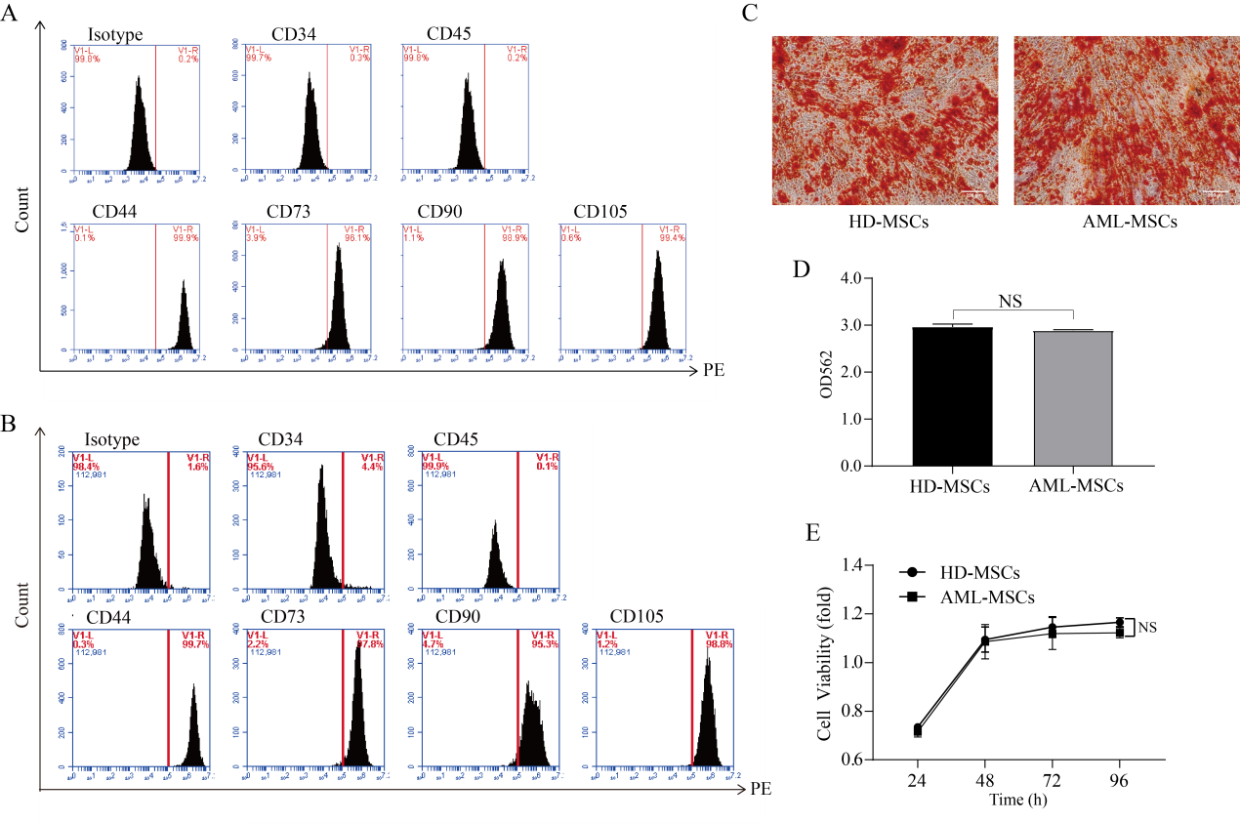
A. Flow cytometry used to detect the HD-MSCs surface markers; B. Flow cytometry used to detect the AML-MSCs surface markers; C. Osteogenic differentiation medium used to induce the HD-MSCs and AML-MSCs to differentiate into osteoblasts, after which an alizarin red staining method was adopted. D. Then, a 10% cetylpyridinium chloride solution was utilized to dissolve the stained mineralized nodules. Detections of the formations of osteoblasts at 562 nm were completed，and their differentiation ability was found to not be significantly different; E. Results of the CCK8 showing there was no related proliferation between the HD-MSCs and AML-MSCs. Isotype: homotype control;

Note: In the figure, it can be seen that the HD-MSCs had similar morphology when compared with the AML-MSCs, and usually those cells grew as vortices. The expressions of the surface antigens were detected using the flow cytometry in the HD-MSCs. The results showed that the positive rates of the CD34 and CD45 were less than 5%, and the positive rates of the CD44, CD73, CD90, and CD105 were more than 95%. In the expressions of the surface antigens in the HD-MSCs, there were no significant differences observed in the percentages of MSCs markers between the AML-MSCs and HD-MSCs. This study used osteoblast differentiation medium to induce the HD-MSCs and AML-MSCs to differentiate into osteoblasts. In addition, and ARS and 10% cetylpyridinium chloride solution was used to dissolve the stained mineralized nodules. Then, detections were completed regarding the formations of osteoblasts at 562 nm. The differentiation abilities were not found to be significantly different.

