Supplementary Figure S1：2D or 3D diagrams show the compounds interacting with the IGF1R. (A) Daptomycin; (B) Tannic acid; (C) Anemoside B4; (D) Neuromedin B.
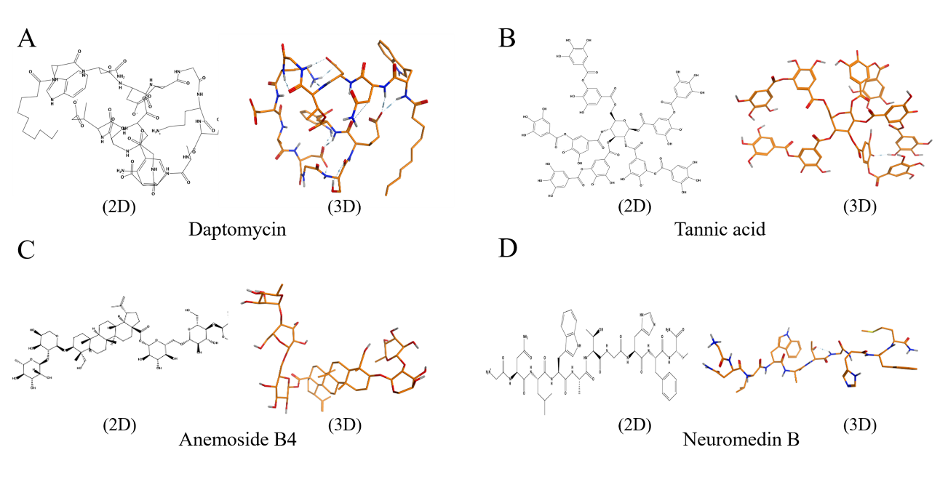

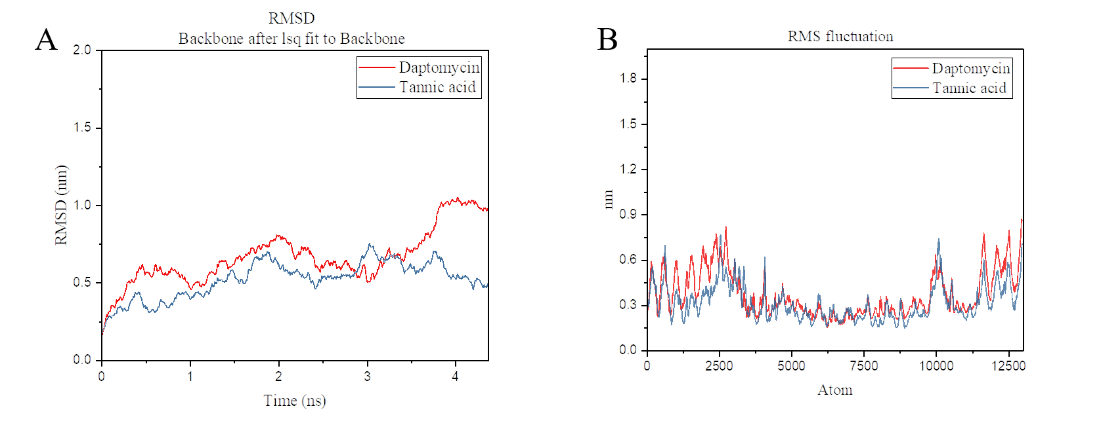
Supplementary Figure S2：RMSD (A) and RMSF (B) analysis of molecular dynamics simulations.

