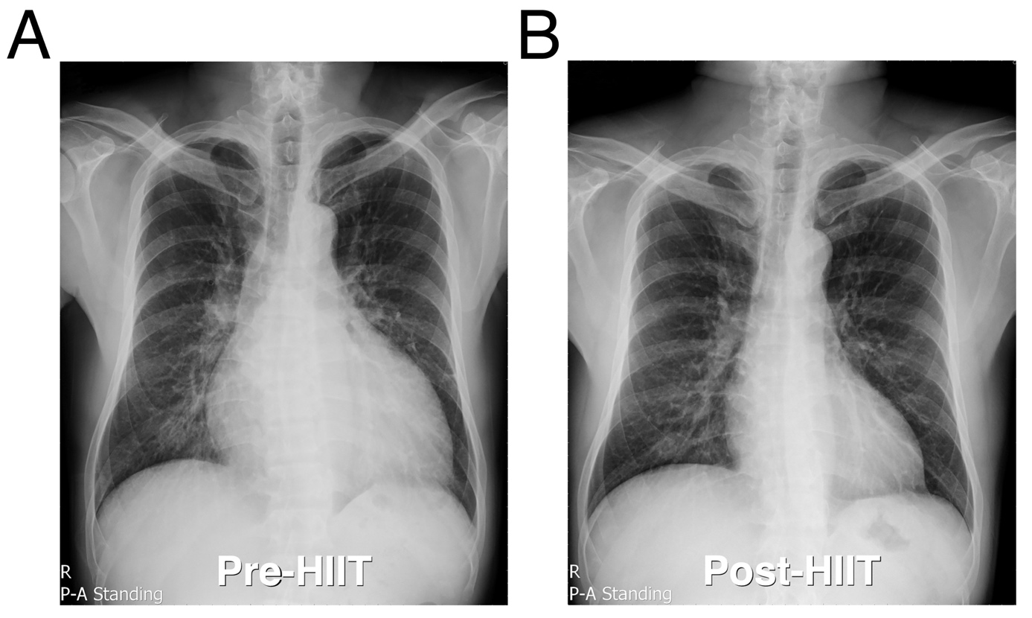
Supplementary Material S5: Typical posterior-anterior (P-A) standing views of chest roentgenograms before and after high-intensity interval training (HIIT). (A) Enlarged heart of a heart failure patient was noticed before HIIT. (B) Decreased cardiac size was observed after HIIT.

