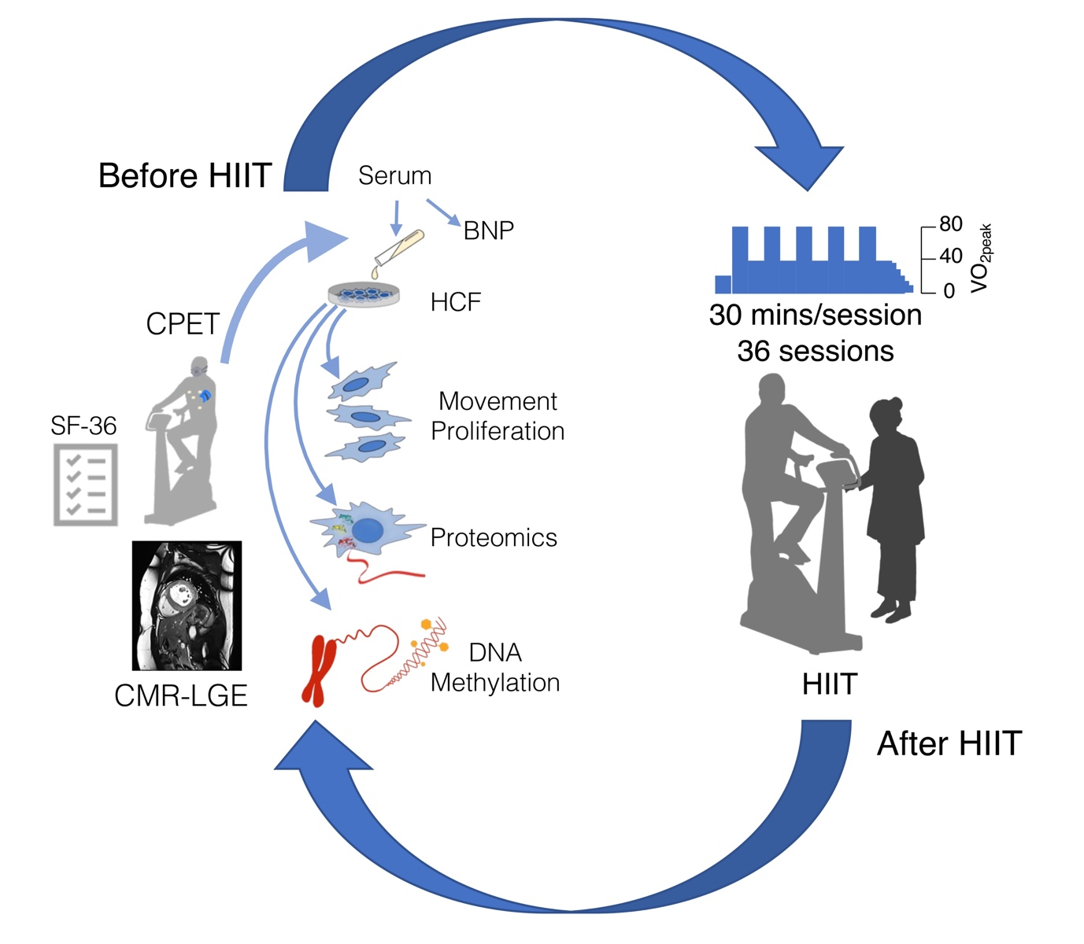
Supplementary Material S1: Experimental designs. Participants underwent cardiovascular magnetic resonance image with late gadolinium enhancement (CMR-LGE), cardiopulmonary exercise test (CPET), the Medical Outcomes Study Short Form 36 (SF-36) questionnaire before high-intensity interval training (Pre-HIIT). Blood was sampled before CMR-LGE study and was used for cell culture and serum b-type brain natriuretic peptide (BNP) measurement. Cell behaviors (movement and proliferation), proteomics, and DNA methylation profiling (yellow spots) in primary human cardiac fibroblasts (HCFs) were assessed. Participants exercised at 3-min of 80% peak oxygen consumption ($\dot{V}$O_{2peak}) and separated exercise at 3-min of 40% $\dot{V}$O_{2peak} for 30-min per session. The serial studies were performed again within 1 week after completing 36 sessions of HIIT (Post-HIIT).

