Supplementary Information

Co-aggregation with Apolipoprotein E modulates the function of Amyloid-β in Alzheimer's disease
Zengjie Xia^{1,2,7}, Emily E. Prescott^{3,7}, Hollie E, Wareing³, Martyna M Matuszyk³, Helen Dakin^{1,2,4}, Eleni Dimou^{1,2}, Eric Zuo^{1,2}, Yu P. Zhang^{1,2}, Jeff Y.L. Lam^{1,2}, John S. H. Danial^{1,2}, Tom Leah³, Katy A. Barnes³, Michael Strickland⁵, Hong Jiang⁵, Peter Thornton⁶, Damian C. Crowther⁶, David M. Holtzman⁵, Simon M. Bell³, Adrian Higginbottom³, Laura Ferraiuolo³, Heather Mortiboys³, Stephen B. Wharton³, Rohan T. Ranasinghe^{1,2,*}, David Klenerman^{1,2,*}, Suman De^{3*}
¹Yusuf Hamied Department of Chemistry, University of Cambridge, Cambridge, UK
²UK Dementia Research Institute at University of Cambridge, Cambridge, UK
³Sheffield Institute for Translational Neuroscience, University of Sheffield, Sheffield, UK
⁴Clinical Neurosciences, University of Cambridge, Cambridge CB2 0QQ, UK.
⁵Department of Neurology, Hope Center for Neurological Disorders, Knight ADRC, Washington University School of Medicine, St. Louis, MO, USA
⁶Neuroscience, BioPharmaceuticals R&D, AstraZeneca, Cambridge, UK.
⁷These authors contributed equally
*Corresponding author. Email: rr360@cam.ac.uk (R.T.R), dk10012@cam.ac.uk (D.K.); S.De@sheffield.ac.uk (S.D.)

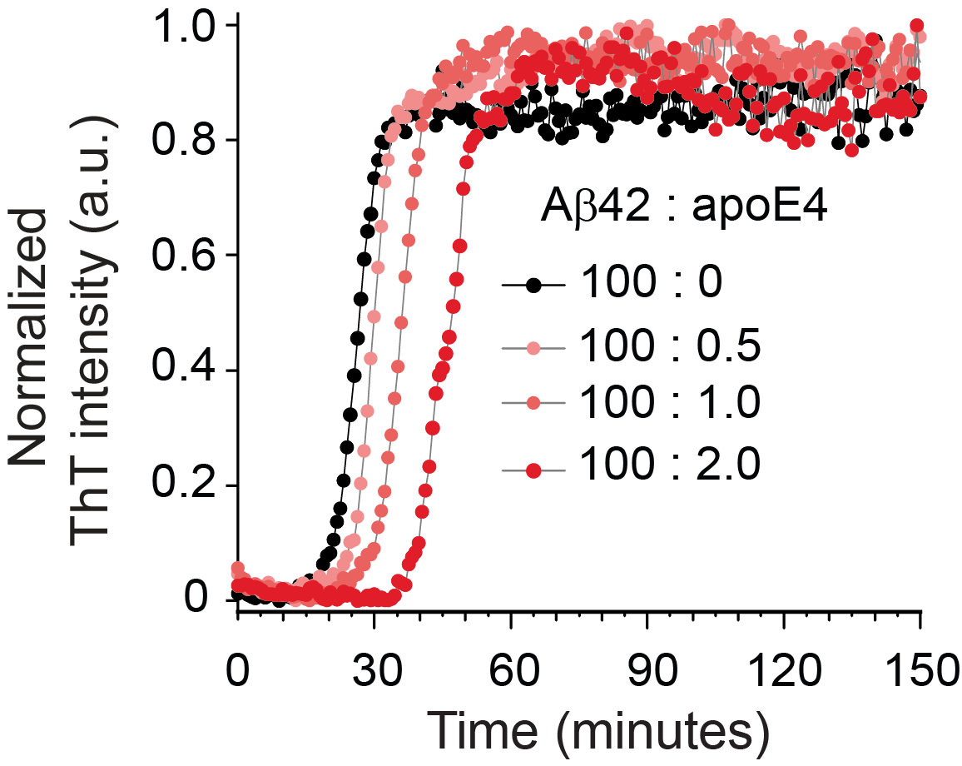
Supplementary Figure 1. Dependence of Aβ42 aggregation (4 µM) on the concentration of non-lipidated ApoE4 (0, 20, 40 and 80 nM), monitored by ThT fluorescence.

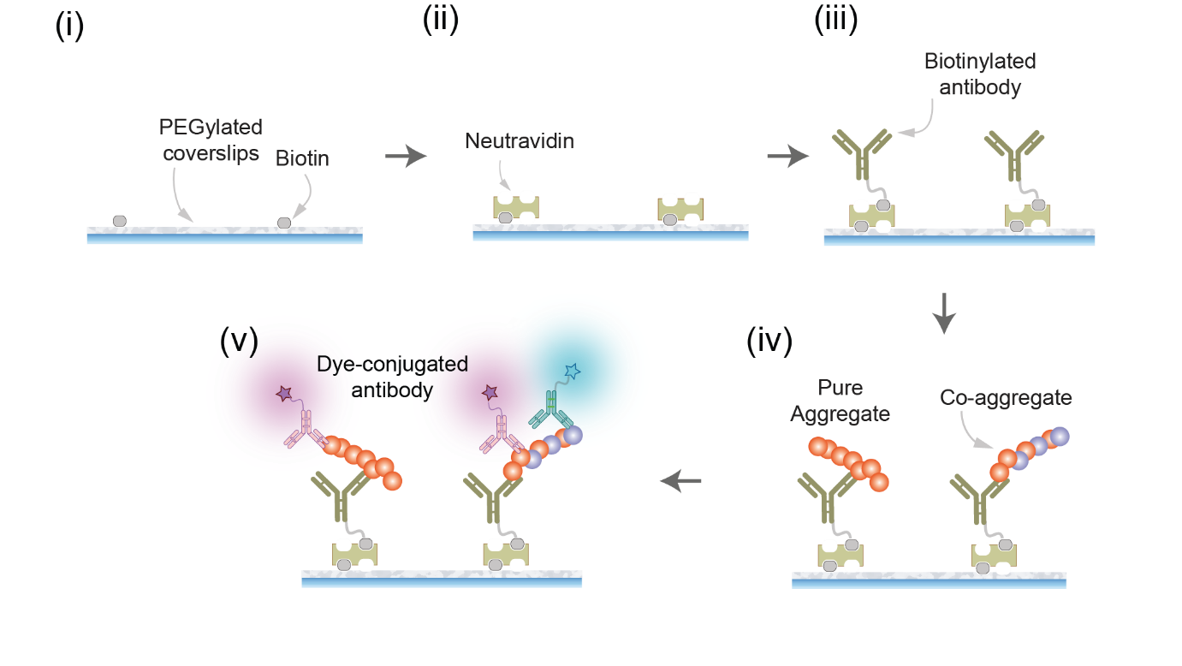
Supplementary Figure 2. Schematic of SiMPull assay.
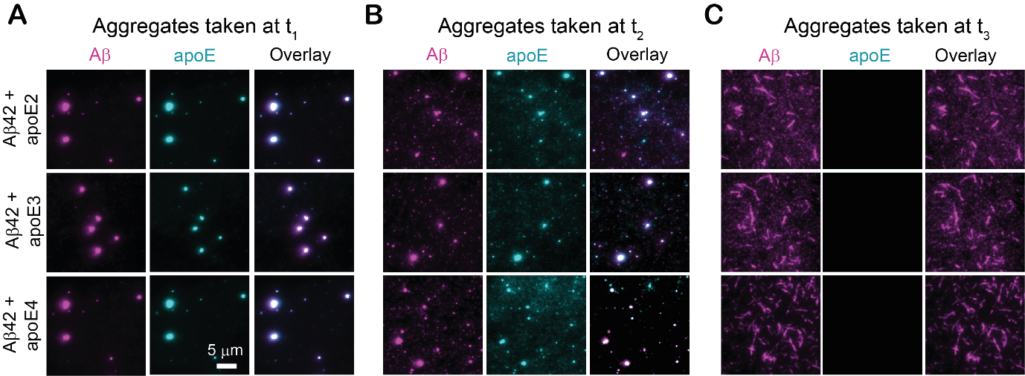
Supplementary Figure 3. Colocalization of apoE with Aβ42 aggregates does not depend on the anti-apoE antibody used. Aliquots of non-lipidated apoE-Aβ42 co-aggregation mixtures (aggregated at 4 µM Aβ42 and 80 nM apoE, then diluted 4-fold prior to pulldown) at t₁, t₂ and t₃ timepoints (as defined in Figure 1B) imaged using SiMPull with biotinylated 6E10 antibody for capture, and Aβ-specific Alexa-Fluor-647-labeled 6E10 (500 pM) and apoE-specific Alexa-Fluor-488-labeled F-9 (1 nM) as imaging antibodies. As in Figure 1 - where a different apoE antibody is used - apoE colocalizes with soluble Aβ42 aggregates, but not fibrillar aggregates.

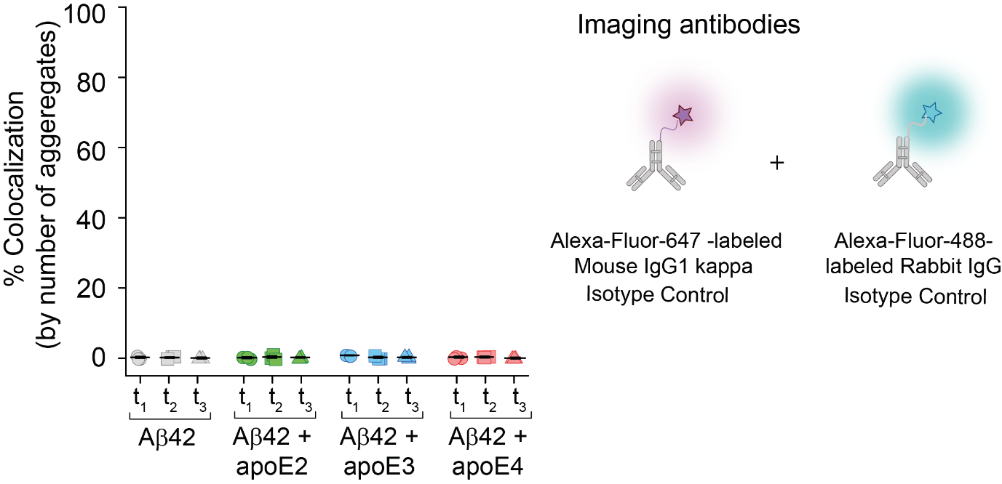
Supplementary Figure 4. Isotype control antibodies generate no colocalization in two-color SiMPull imaging. Aβ42 aggregates and non-lipidated apoE-Aβ42 co-aggregates formed at different stages of aggregation (defined in Figure 1B) and imaged with SiMPull using two isotype control antibodies. For all samples, no significant colocalization is observed.
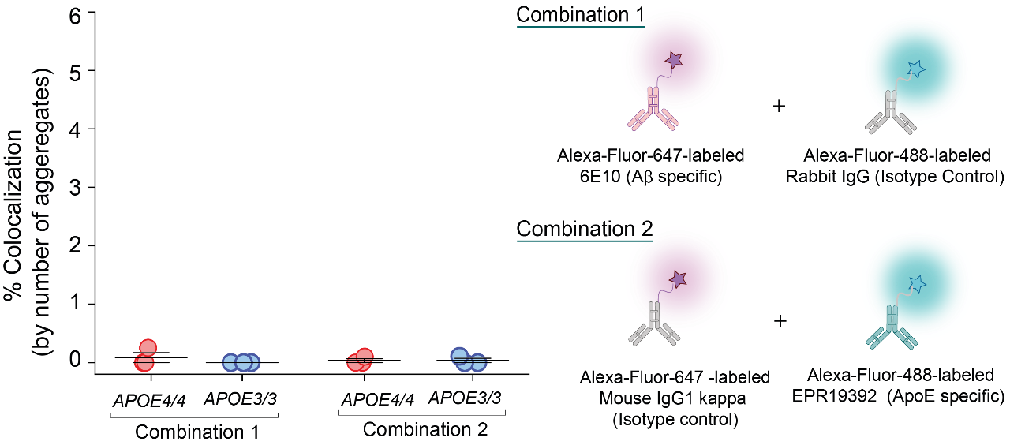
Supplementary Figure 5. Aβ and apoE antibodies bind co-aggregates via their specific paratopes. Aβ-containing aggregates captured from frontal cortex extracts of homozygous APOE4 and APOE3 AD patients imaged using two different combinations of imaging antibodies (n=3). In each experiment, one isotype control antibody is combined with an Aβ- or apoE-specific antibody respectively. No significant colocalization is observed, indicating that antibody binding is paratope mediated.

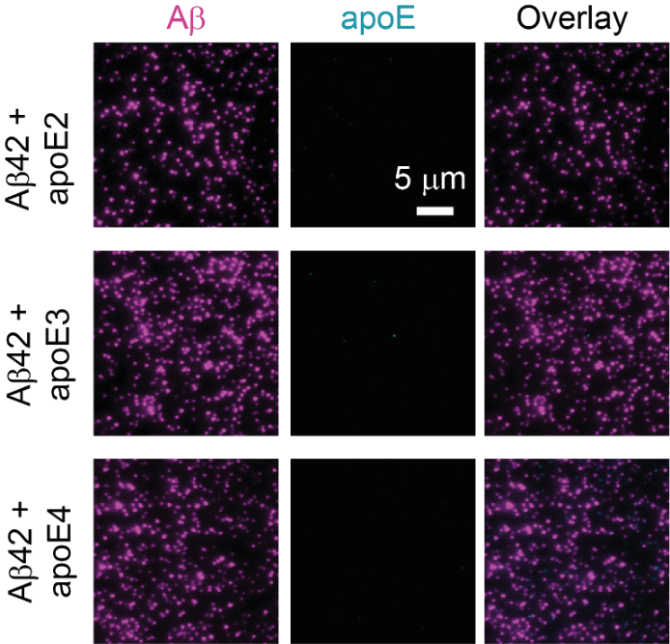
Supplementary Figure 6. ApoE does not colocalize with pre-formed Aβ42 aggregates. Aβ42 aggregates (4 µM monomer equivalents) taken at the end of the lag phase (t₁, as defined in Figure 1B), incubated in an ice bath with non-lipidated apoE (80 nM), diluted 4-fold in PBS then imaged using SiMPull.
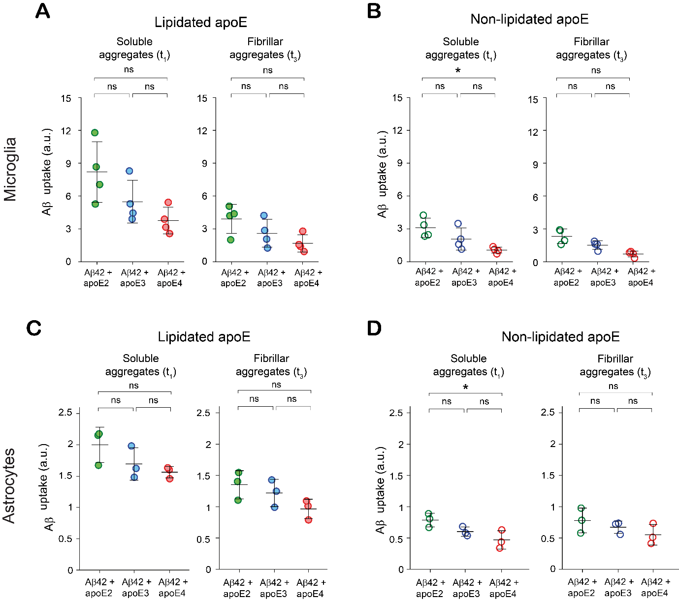
Supplementary Figure 7. Uptake of apoE-Aβ co-aggregates by BV2 microglial cells and human astrocytes depends on apoE isoform. Uptake of soluble (t₁) and fibrillar (t₃) Aβ aggregates by BV-2 microglia (A, B) and human astrocytes (C, D) formed in the presence of lipidated (A) and non-lipidated apoE (B). Units of uptake = integrated fluorescence of sample divided by the integrated fluorescence of internalized soluble Aβ42 aggregates at t₁ for each replicate (as in Figure 3). Data were averaged over four and three biological replicates for BV-2 microglia and astrocytes respectively; data are shown as individual data points and error bars represent standard deviation. Statistical significance was calculated using a one-way ANOVA with post-hoc Tukey. *P < 0.05, **P < 0.01, ***P < 0.001, ns, non-significant (P > 0.05).

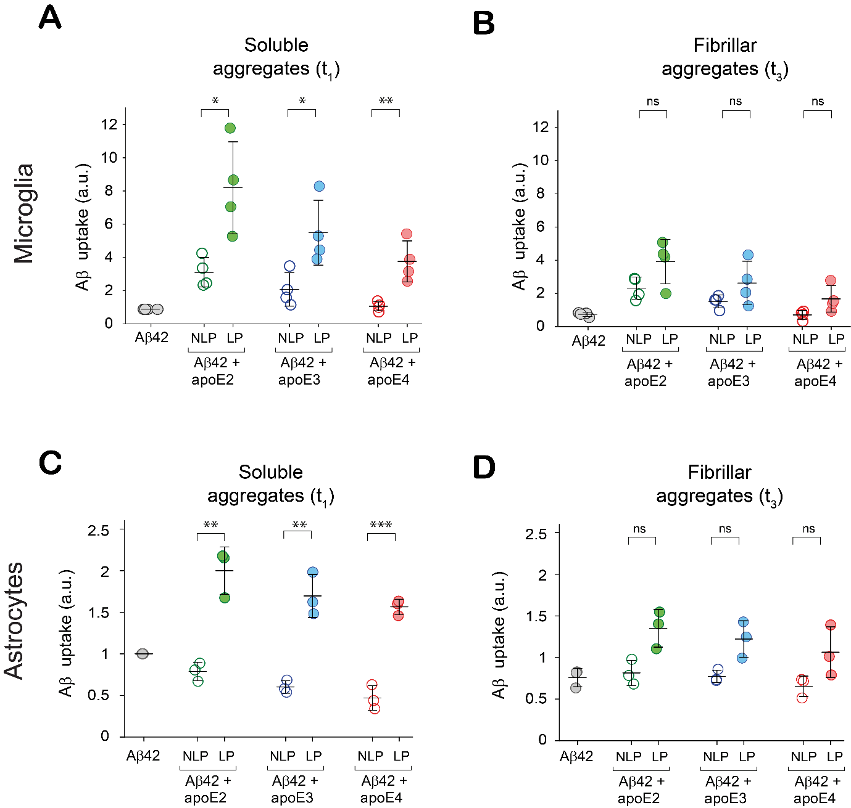
Supplementary Figure 8. Association with lipidated apoE enhances uptake of Aβ aggregates by BV2 microglial cells and human astrocytes. Uptake of Aβ aggregates by BV-2 microglia (A,B) and human astrocytes (C,D) formed in the presence of lipidated and non-lipidated apoE. Units of uptake = integrated fluorescence of sample divided by the integrated fluorescence of internalized soluble Aβ42 aggregates at t₁ for each replicate (as in Figure 3). Data points represent one of four (microglia) or three (astrocytes) biological replicates; error bars represent standard deviation. Statistical significance was calculated using an unpaired two sample T-test. *P < 0.05, **P < 0.01, ***P < 0.001, ns, non-significant (P > 0.05).

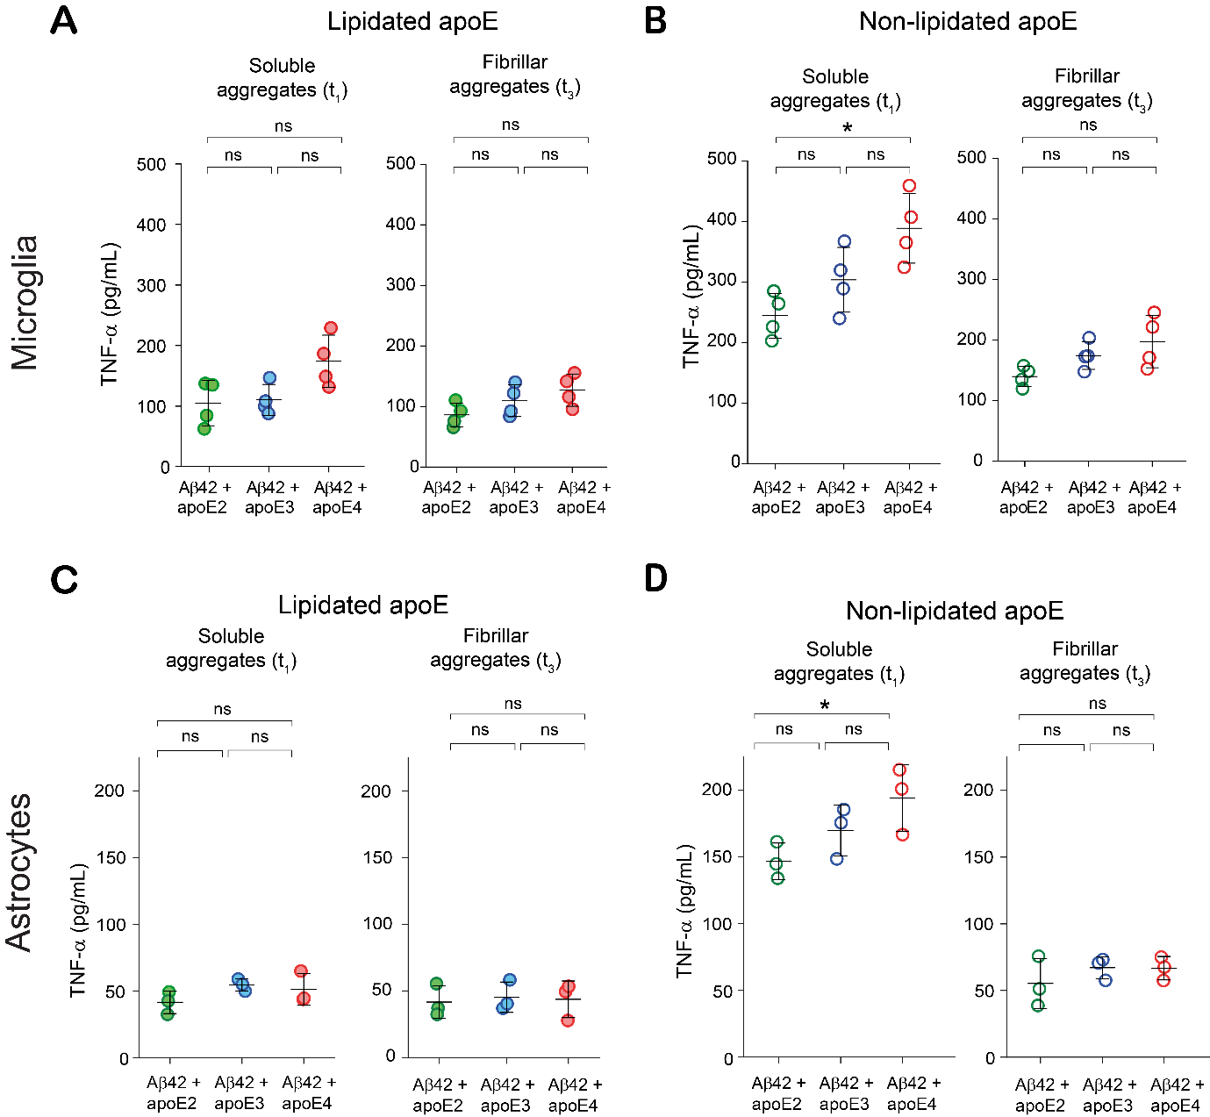
Supplementary Figure 9. ApoE-Aβ co-aggregates inflame microglia and astrocytes in an isoform-dependent way. TNF-α release by BV-2 microglia (A-B) and astrocytes (C, D) induced by soluble (t₁) and fibrillar (t₃) aggregates. Each data point represents one of four (for BV-2 cells) or three (for astrocytes) biological replicates; error bars represent standard deviation. Statistical significance was calculated using one-way ANOVA with post-hoc Tukey. *P < 0.05, **P < 0.01, ***P < 0.001, ns, non-significant (P > 0.05).

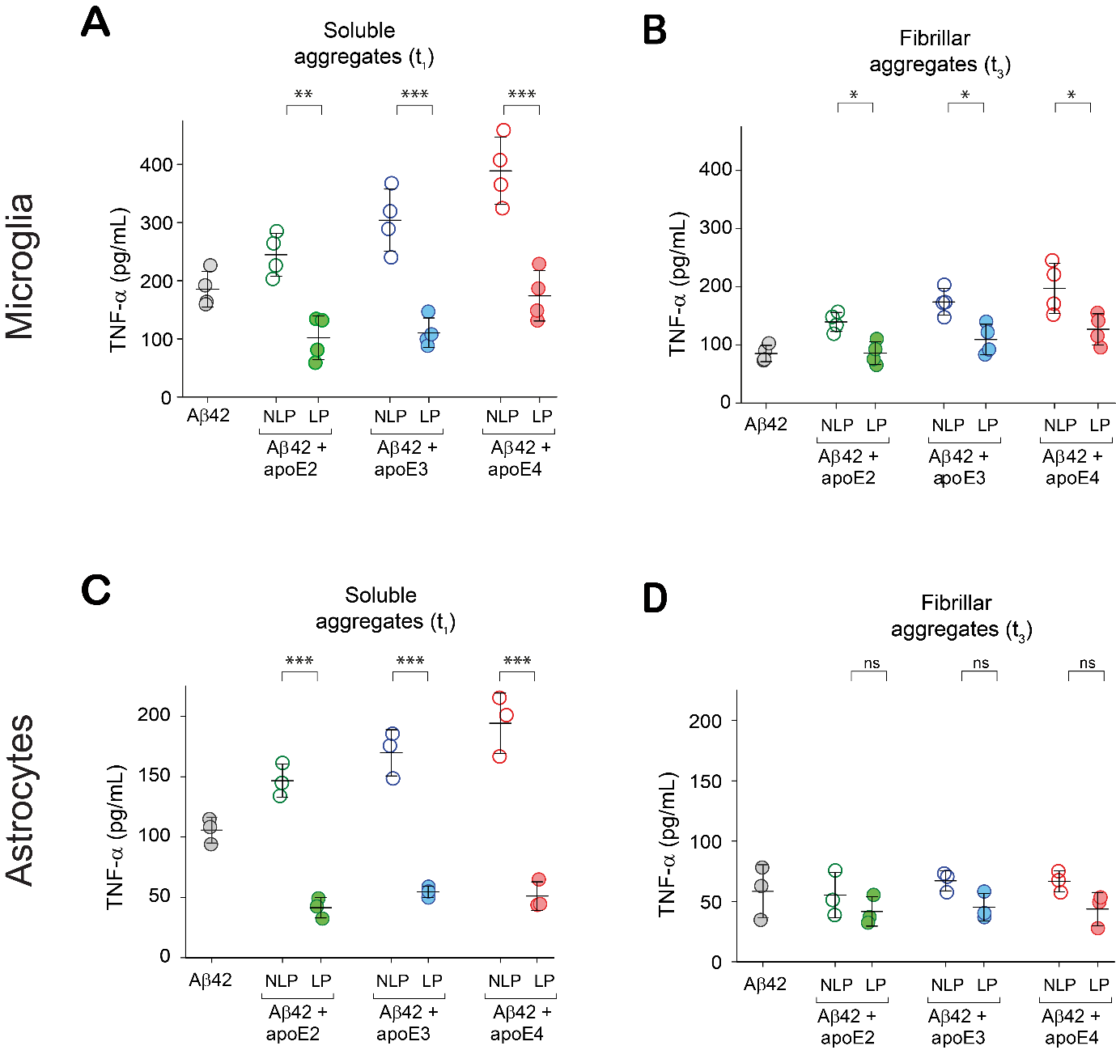
Supplementary Figure 10. ApoE-Aβ co-aggregates inflame microglia and astrocytes in an apoE-lipidation-dependent manner. TNF-α release by BV-2 microglia (A-B) and astrocytes (C, D) induced by soluble (t₁) and fibrillar (t₃) aggregates. Each data point represents one of four (for BV-2 cells) or three (for astrocytes) biological replicates; error bars represent standard deviation. Statistical significance was calculated using a two-sample t-test. *P < 0.05, **P < 0.01, ***P < 0.001, ns, non-significant (P > 0.05).

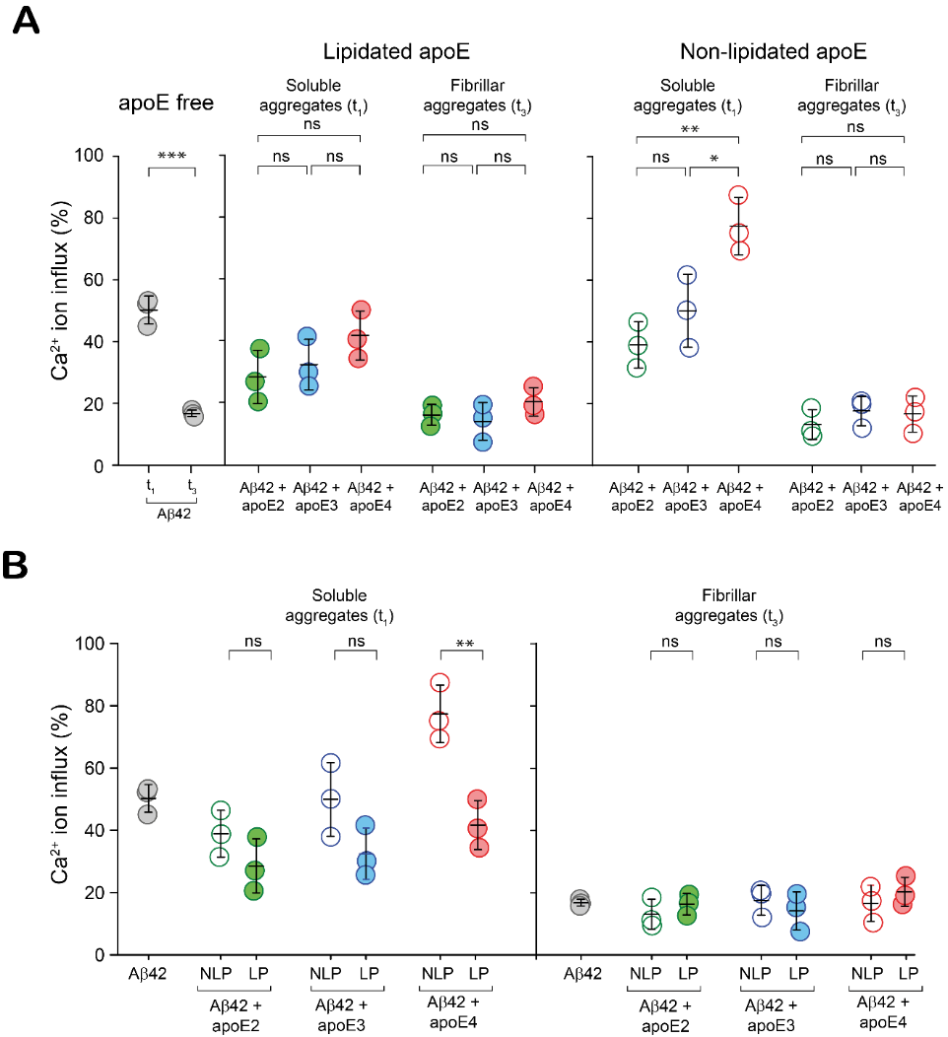
Supplementary Figure 11. Isoforms and lipidation of apoE modulate the lipid membrane permeabilization ability of Aβ aggregates differently. Comparison of lipid bilayer permeabilization by (A) apoE-Aβ co-aggregates containing different apoE isoforms and (B) lipidated and non-lipidated apoE-Aβ co-aggregates formed at t₁ (end of lag phase, where aggregates are mostly soluble co-aggregates) and t₃ (plateau phase, where aggregates are mostly Aβ-only fibrils) ([Aβ42] = 4 µM in monomer equivalents; [apoE] = 0 or 80 nM). Ca²⁺ influx is referenced to the influx caused by the ionophore, ionomycin. Data points represent one of three technical replicates; error bars represent standard deviation and statistical significance was calculated using One-way ANOVA with post-hoc Tukey (A) and an unpaired two-sample t-test (B). *P < 0.05, **P < 0.01, ***P < 0.001, NS, non-significant (P > 0.05).
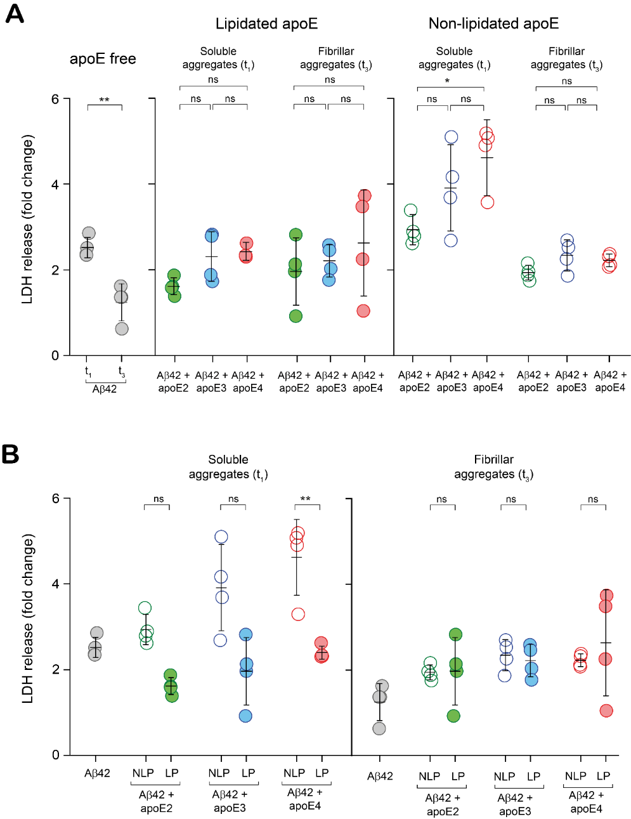
Supplementary Figure 12. Isoforms and lipidation of apoE modulate the Aβ-aggregate-induced LDH release differently. Comparison of LDH release elicited by (A) apoE-Aβ co-aggregates containing different apoE isoforms and (B) lipidated and non-lipidated apoE-Aβ co-aggregates formed at t₁ (end of lag phase, where aggregates are mostly soluble co-aggregates) and t₃ (plateau phase, where aggregates are mostly Aβ-only fibrils) ([Aβ42] = 4 µM in monomer equivalents; [apoE] = 0 or 80 nM). Units of LDH release = LDH release elicited by sample divided by LDH release elicited by buffe for each replicate. Data points represent one of four biological replicates; error bars represent standard deviation and statistical significance was calculated using One-way ANOVA with post-hoc Tukey (A) and an unpaired two-sample t-test (B). *P < 0.05, **P < 0.01, ***P < 0.001, NS, non-significant (P > 0.05).

