Supplementary Information
Real-time finger motion recognition in free space via skin-compatible electronics

Haein Cho^{1,†}, Inho Lee^{2,†}, Jingon Jang^{1,†}, Jae-hyun Kim², Hanbee Lee², Sungjun Park^{2,}*and Gunuk Wang^{1,3,4,}**

¹KU-KIST Graduate School of Converging Science and Technology, Korea University, Seoul 02841, Republic of Korea
²Department of Electrical and Computer Engineering, Ajou University, Suwon 16499, Republic of Korea
³Department of Integrative Energy Engineering, Korea University, Seoul 02841, Republic of Korea
⁴Center for Neuromorphic Engineering, Korea Institute of Science and Technology, Seoul 02792, Republic of Korea

†These authors contributed equally to this work.
*Correspondence: sj0223park@ajou.ac.kr
**Correspondence: gunukwang@korea.ac.kr

Keywords: ultra-flexible devices, gesture-recognition sensor, neuromorphic, organic-photodiode, device-integration

Supplementary Notes
Note S1. Nonlinearity (NL) calculation
NL can be defined as follows^{1–3}:

$NL=\frac{max|G_{P}\left(n\right)- G_{D}\left(n\right)|}{G_{max}-G_{min}}, n=1,⋯, 32$ (1)

, where G_{P}(n) and G_{D}(n) represent the conductance values after n-th potentiating and depressing pulses, respectively. The maximum difference between G_{P}(n) and G_{D}(n) is then divided by the difference of G_{max} and G_{min} for normalization. The NL is ranged from 0 to 1. The NL = 0 implies the perfect linearity in the weight update for LTP/LTD function.

Note S2. Calculation of ε in the flexible multi-stack layered device
Assuming a two-layered sheet consisting of a film on a substrate bent to a cylinder of radius R, the thickness of film and substrate corresponds to f and s, respectively (Fig. S3a). When the sheet is bent, the outer surface gets extended while the inner surface gets compressed. Inside the sheet, there lies a neutral plane where no strain is applied. The strain on the top surface is the same as the distance from the neutral plane divided by R. Considering Young's modulus (Y_{f} for film, Y_{s} for substrate) which determines the allowable radius of curvature without mechanical failure, the strain on top can be defined as follows⁴:

$ε=\left(\frac{f+s}{2R}\right)\frac{\left(1+2η+χη^{2}\right)}{\left(1+η\right)\left(1+χη\right)}$ (2)

, where η indicates the f / s and χ represents the Y_{f} / Y_{s}. When the s is sufficiently thicker than f, the equation (2) can be approximated as $ε≈s/2R$. Therefore, the thinner substrate can further reduce the applied ε. The TOAS device is composed of multiple layers with a junction structure of Al/TiO2/Al/parylene, and each layer can be numbered from 1st (Parylene) to 4th (top Al). Here, the neutral plane exists at distance b from the bottom end of the first layer, as described by the following equation⁵,

$b=\frac{\sum_{i=1}^{n}{{Y_{i}h}_{i}\left[\left(\sum_{j=1}^{i}{h_{j}}\right)-\frac{h_{i}}{2}\right]}}{\sum_{i=1}^{n}{Y_{i}h_{i}}}$ (3)

, where h_{i} represents the thickness of the i-th layer and the Y_{i} the Young's modulus value of the i-th layer. Each h_{i} and Y_{i} corresponding to the layers of the TOAS device are represented in the Fig. S3b^{6–10}. Based on this result, the b is estimated to be ~1173 nm. By the as-obtained values, ε can be obtained as following equation:

$ε=\frac{r-b}{R+b}$ (4)

, where r represents the distance from bottom surface to the surface for which estimate the strain.

Note S3. The light-electrical signal transformation of the OPS for image reshaping process
The fabricated OPS device attached to the finger can generate the light-responsive V_{out} proportional to the D_{L} between the OPS and light source. The change of V_{out} under the light sources (i.e., green (horizontal, x-axis) and red LED (vertical, y-axis)) over the time represents the real-time movement of OPS device itself. Here, two OPS devices generate each V_{out} at x- and y-axis respectively, and the normal vector direction of each device surface was aligned to confront each green and red light source squarely (Fig. 3g). For example, if the OPS device closely moves to the green light source at x-direction over time, the relative change in the V_{out} (ΔV_{X}) can be increased at that time domain, and if the OPS device moves far away from green light source, ΔV_{X} can be decreased. Similarly, the same goes for the red light at y-direction and its relevant OPS device. The obtained green and red OPS signals (ΔV_{X} and ΔV_{Y}) were reshaped into 16×16 2D image using direct point transformation with following equation for all digit classes^{11–15}.

$x_{i}=x_{0}-αΔV_{X}$ (5)
$y_{i}=y_{0}-αΔV_{Y}$ (6)

Here, α is magnification constant to determine the image size in 16×16 space considering the scale of voltage amplitude ΔV_{X} and ΔV_{Y}, and initial location as x₀ and y₀ which were set to be different according to digit classes (Fig. 3j). The trajectory of gesture motion in image space was cumulatively recorded during 8,000 ms (1≤i≤8,000). After the point transformation, we reflected the trajectory boundary at the neighbourhood pixel around the black pixel, resulting in reshaped ternary image for each output signal of OPS device.

Note S4. Learning and recognition process
We evaluated the learning capability of a neuromorphic system based on the developed OPS–TOAS array and its applicability to finger-writing motion recognition in 3D free space. Because there are 10 output classes (0,1,2…9) for the 16 × 16 ternary digit image set from OPS signal data (Fig. S7, S14, S17, and S21), total synaptic weight components of 10 × 16 × 16 (Fig. 4c) were individually updated according to the conventional batch-mode backpropagation principle^{16,17}. Here, we utilized the noise-reflected reshaped images with particular signal amplitude (σ_{amp}) and point elimination (σ_{eli}) deviation to avoid the overfitting problem in neural network training^{18–22}. As shown in Fig. S9-S13, the randomly applied signal variation can result in variation of reshaped image of ‘8’ to extend the coverage of synaptic weight to recognize the differently deviated input images and to increase the inference accuracy (Fig. S15, S16, S18-S20, and S22-S24).
Initially, all memristor cells were maintained in the minimum conductance state and could be evolved in the batch unit where the conductance update was implemented at one time for each training epoch using randomly selected 100 training images. For the different OPS device measurement condition (Fig. 4f and g, Fig. S18-S20) or different persons (Fig. 4h and i, Fig. S21-S24), the even epoch training was performed using image set #1 (finger-writing digit patterns by person #1) and the odd epoch training was performed using image set #2 (finger-writing digit patterns by stick-bar or person #2), respectively. The weight increment at each training epoch was transferred to the number of potentiation processes for each memristor cell. Here, the individual synaptic weight is composed by pair-device structure using conductance difference between two devices to extend the range of effective weight until negative value^{23–25}. If the weight increment is positive, positive memristor device was updated to increase the effective synaptic weight, and if it is negative, negative memristor device was updated to decrease the effective synaptic weight. In addition, the potentiation number was divided into three cases (1, 2, and 3) according to the magnitude of the weight increment, thus indicating that the individual effective synaptic weight could evolve between 7 selections (+3, +2, +1, 0, –1, –2, –3) at each training epoch until it reached conductance saturation. The recognition accuracy was evaluated by comparing the actual and recognition classes for 100 test images for each training condition. The contour plot of synaptic weight and each potentiation number are presented in Fig. 4c in main text.

Supplementary Figures

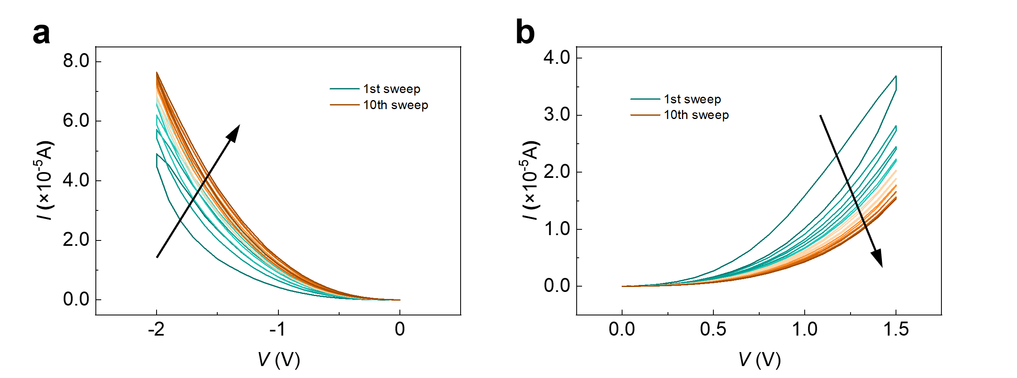
Figure S1. Analog I–V switching characteristics of TOAS device before peeling off under repetitive voltage sweeps. (a) I−V plots in negative voltage regime ranging from 0 to -2 V. (b) I−V plots in positive voltage regime ranging from 0 to 1.5 V.

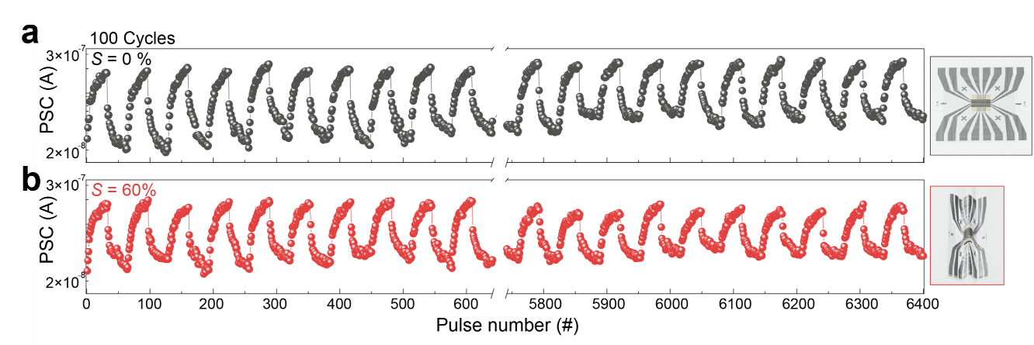
Figure S2. The PSCs responses for LTP/LTD of the TOAS device under 6,400 repeated input pulses (100 cycles) at S of 0% and 60%. The first and last ten cycles out of 100 cycles of LTP/LTD transitions at S of (a) 10% and (b) 60%.

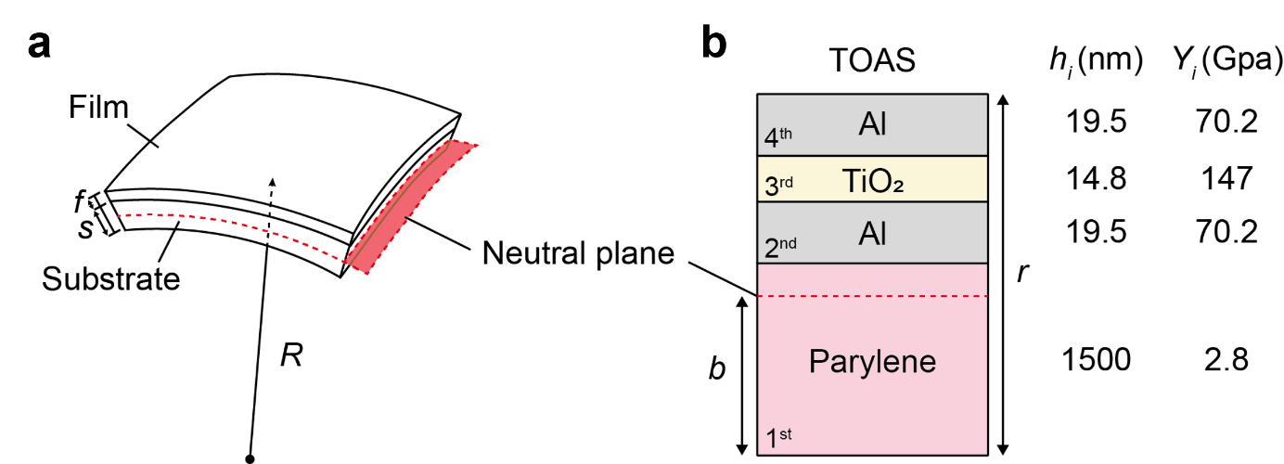
Figure S3. Device schematics and thickness information for ε calculation. (a) Schematic image for a film on the bending surface with neutral plane, where R represents the bending radius and f and s represent the thickness of the film and the substrate, respectively. (b) Schematic image of the Al/TiO₂/Al/Parylene junction structure with the information of thickness (h_{i}) and Young’s modulus (Y_{i}) of each layer. The total thickness is r. Neutral plane exists within the 1st Parylene layer and positions at b from its end. The ε calculation is detailed in Supplementary Note S2.

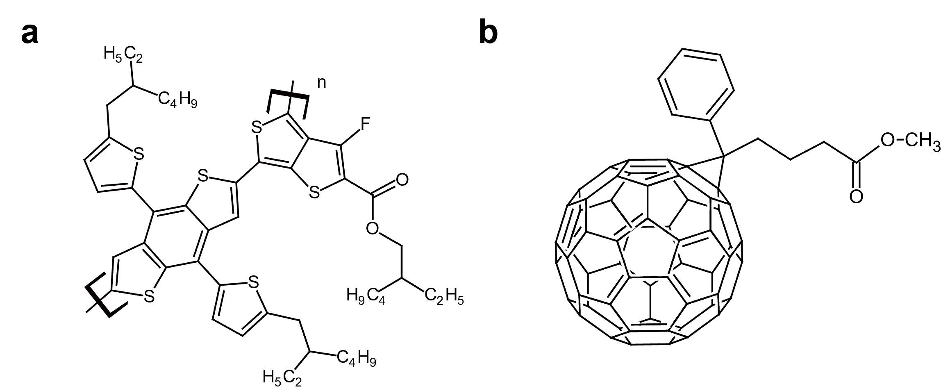
Figure S4. Chemical structure of the donor and acceptor material in the active layer. (a) Chemical structure of Poly([2,6′-4,8-di(5ethylhexylthienyl) benzo[1,2-b;3,3-b]dithiophene]{3-fluoro-2[(2-ethylhexyl)carbonyl]thieno[3,4-b]thiophenediyl}), and (b) [6,6]-phenyl-C₇₁-butyric acid methyl ester (PC₇₁BM).

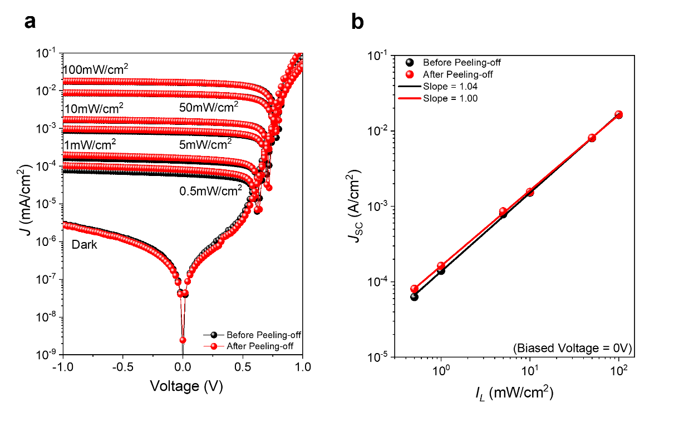
Figure S5. The electrical characteristics of OPS as a function of I_{L} before and after peeling off. (a) J–V characteristics of OPS under different incident I_{L} (from dark to 100 mW/cm²) before and after peeling off. (b) J_{SC}−I_{L} characteristics of OPS before and after peeling off.

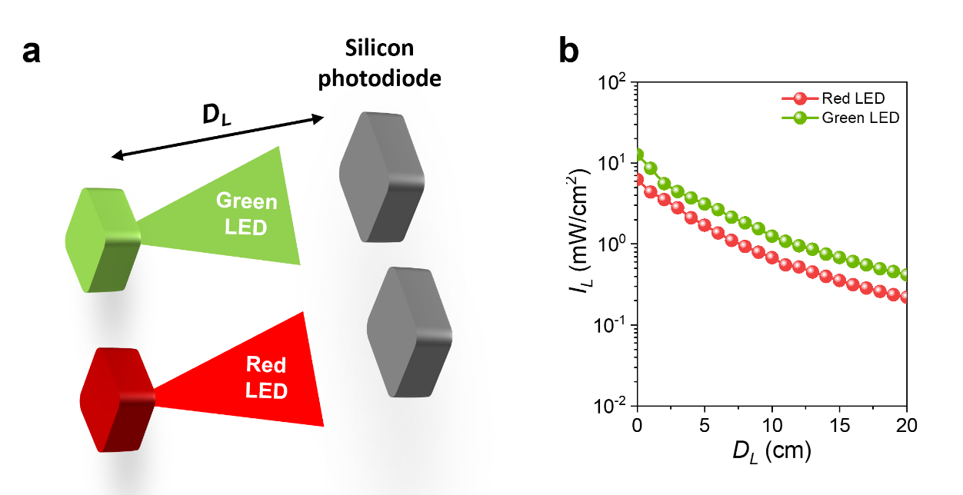
Figure S6. I_{L} measurement as a function of D_{L} from the green and red LED sources using Si photodiode (PM100D). (a) Schematic of the experimental setup. (b) I_{L}−D_{L} plots as a function of the green and red LED sources.

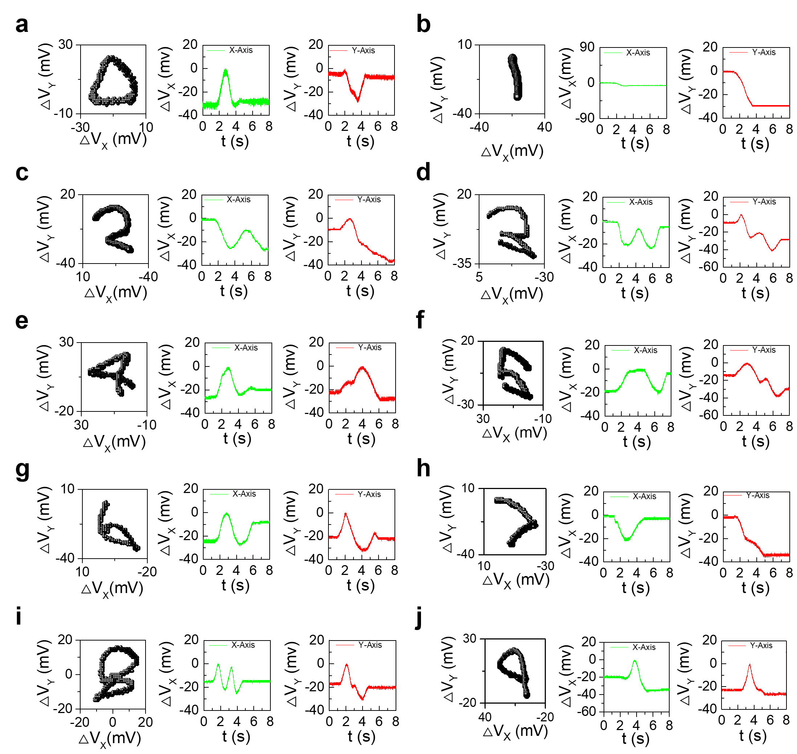
Figure S7. Time-resolved ΔV_{X} and ΔV_{Y} in the x- and y-direction for the OPS-attached finger-writing digit patterns under the green (x-direction) and red (y-direction) LED illuminations. The projected digits data on the x-y plane after drawing numbers from (a), “0” to (j), “9” by the OPS-attached finger (left figure). The ΔV_{X}−t and ΔV_{Y}−t plots when writing digit patterns from “0” to “9” (right figures).

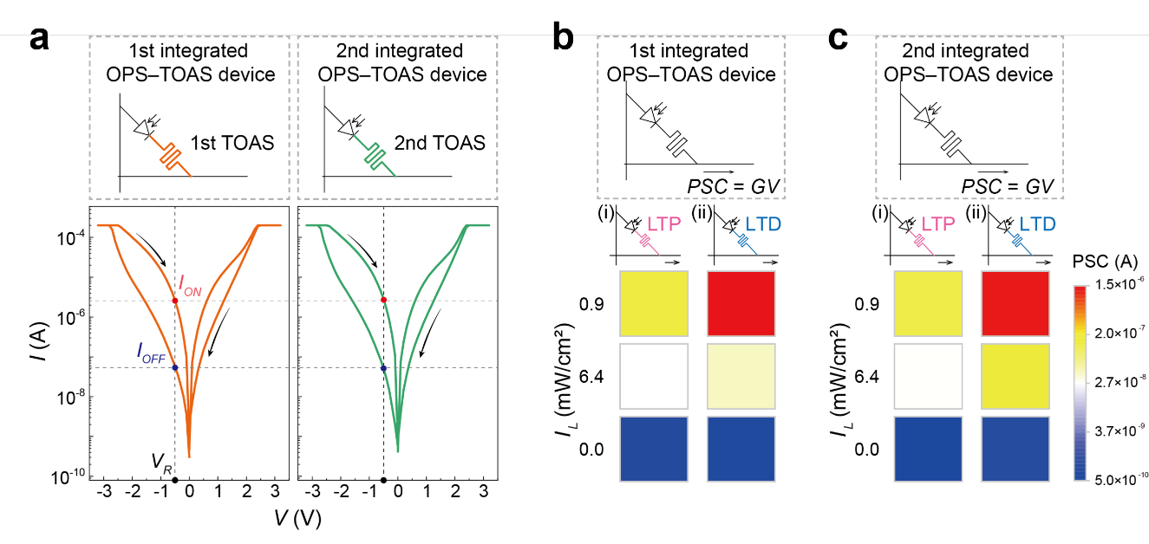
Figure S8. Electrical characteristics of integrated OPS–TOAS device. (a) Representative I−V switching curves of 1st and 2nd TOAS devices in each integrated OPS–TOAS device. (b), (c) PSC responses from 1st and 2nd integrated OPS–TOAS device depending on I_{L} for the LTP (i) and LTD (ii) of the TOAS device.

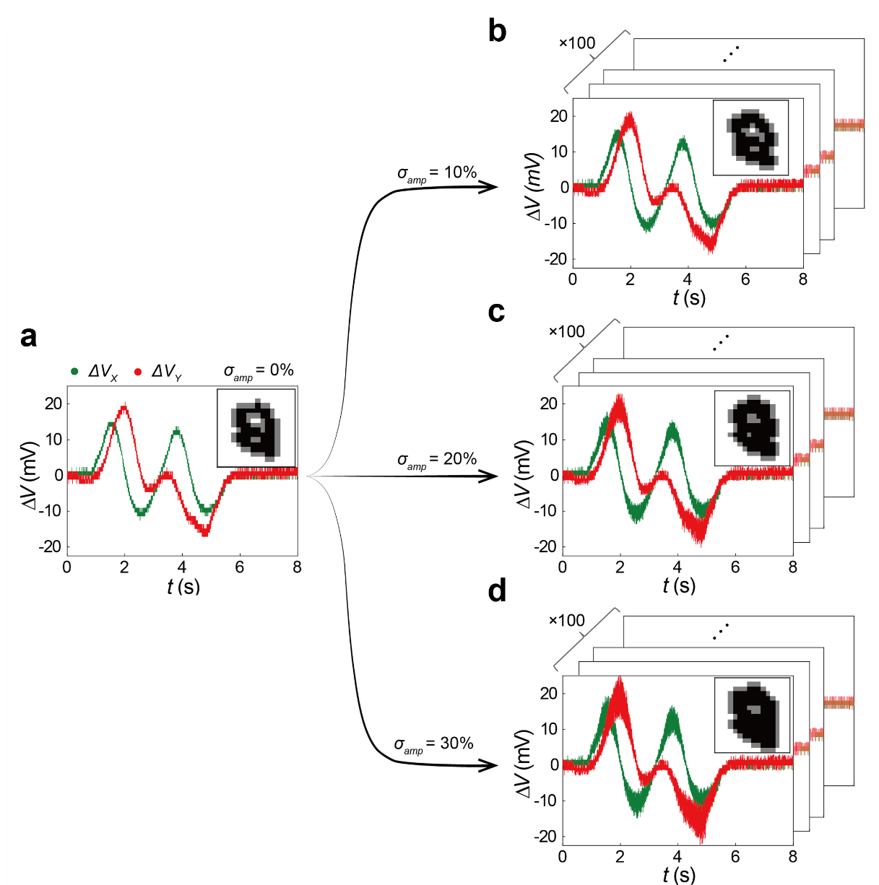
Figure S9. Examples of digit 8 datasets with different signal amplitude deviation (σ_{amp}). Regenerated time-resolved ΔV_{X} (green) and ΔV_{Y} (red) data and the reshaped image of ‘8’ (right upper image) when σ_{amp} is (a) 0%, (b) 10%, (c) 20%, and (d) 30%. For example, if σ_{amp} is 20 %, all 8,000 ΔV_{X} and ΔV_{Y} data points are multiplied by a factor of random number between 0.8 and 1.2. Here, 100 datasets were regenerated at each σ_{amp} condition (b,c, and d).

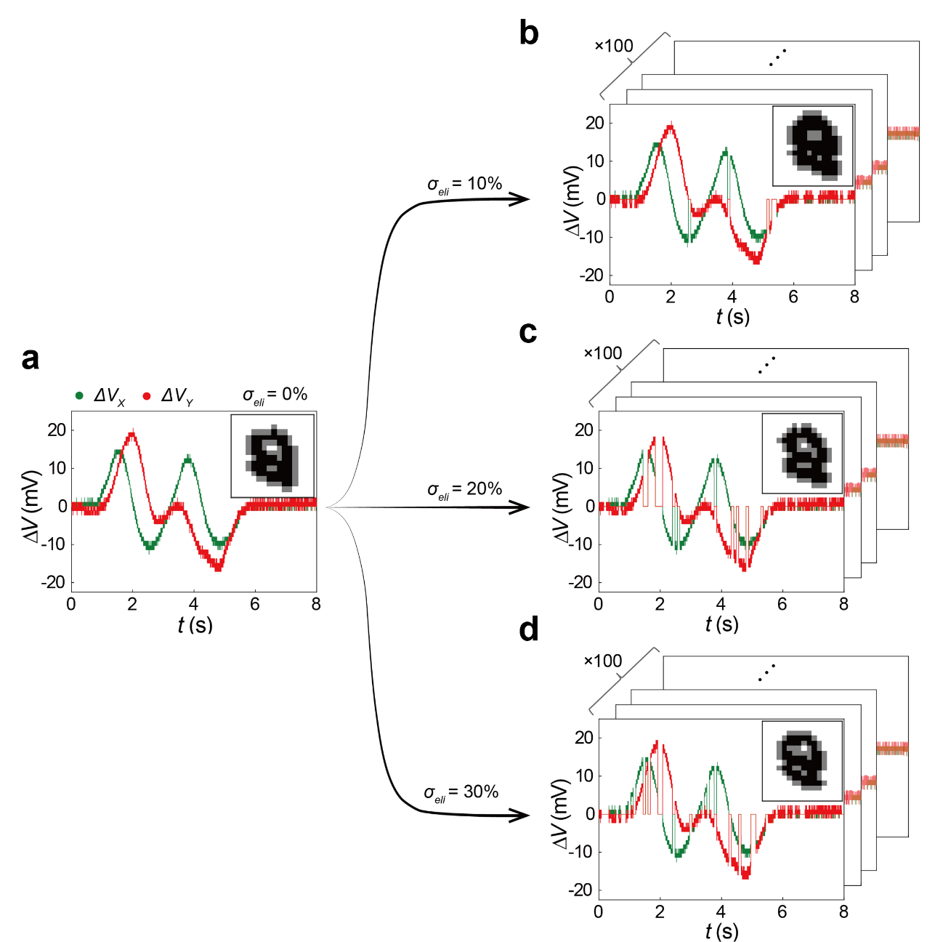
Figure S10. Examples of digit 8 datasets with different point elimination deviations (σ_{eli}). Regenerated time-resolved ΔV_{X} (green) and ΔV_{Y} (red) data and the reshaped image of ‘8’ (right upper image) when σ_{eli} is (a) 0%, (b) 10%, (c) 20%, and (d) 30%. For example, if σ_{eli} is 20 %, ΔV_{X} and ΔV_{Y} data points in each time sequence can be stochastically removed at 20 % of probability. In this case, entire signal data amounts are remained at about 80 % of original value. Here, 100 datasets were regenerated at each σ_{eli} condition (b,c, and d).

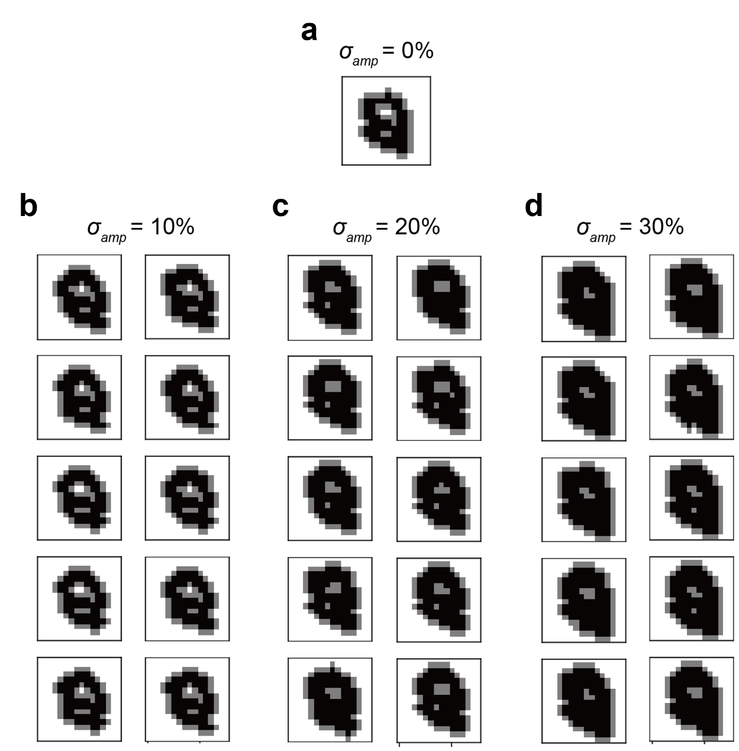
Figure S11. Examples of variation of reshaped image of ‘8’ with randomly applied σ_{amp}. (a) Reshaped image of ‘8’ when is σ_{amp} is 0%. Ten different examples of variation of reshaped images of ‘8’ when σ_{amp} is (b) 10%, (c) 20%, and (d) 30%.

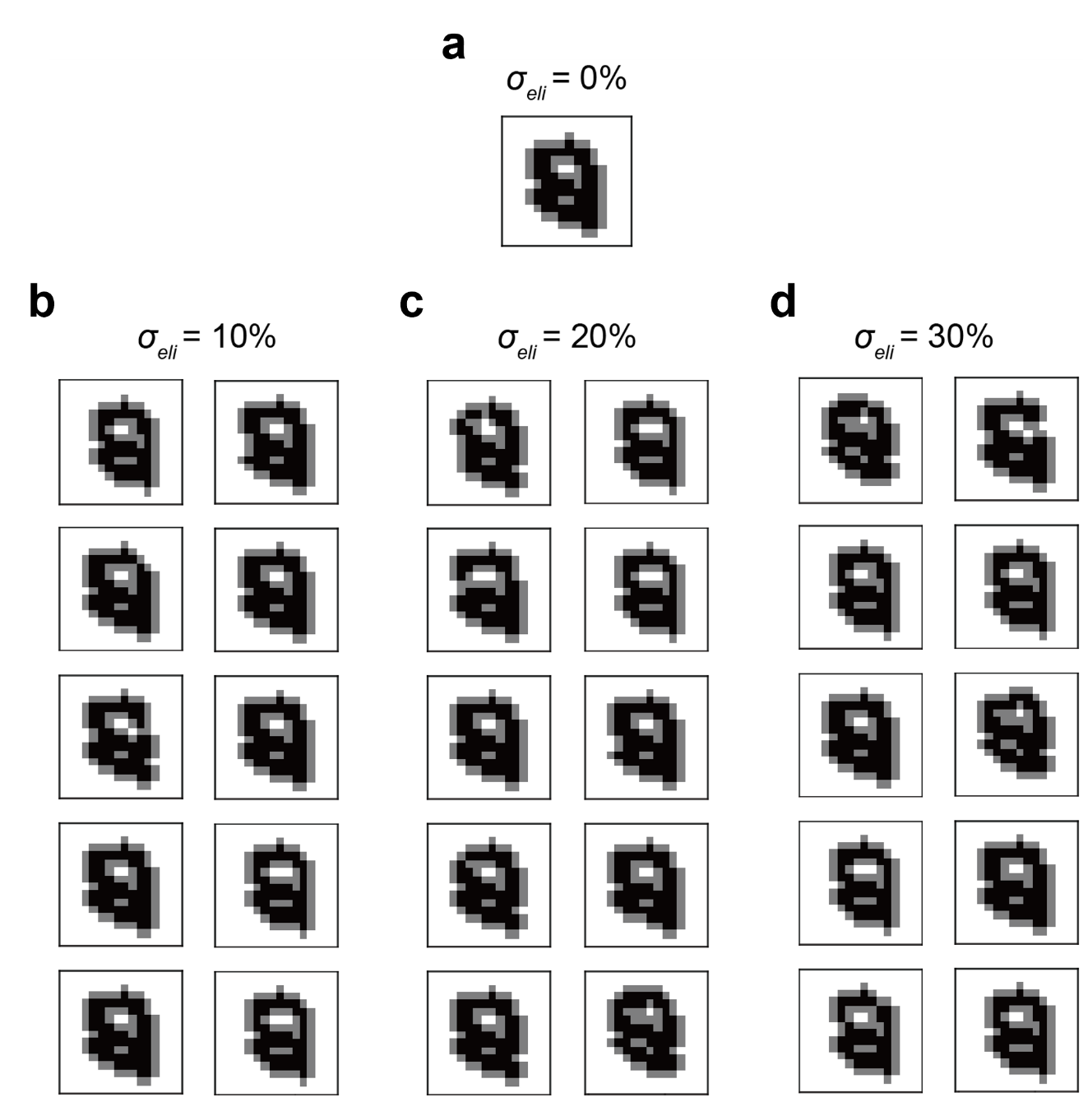
Figure S12. Examples of variation of reshaped image of ‘8’ with randomly applied σ_{eli}. (a) Reshaped image of ‘8’ when is σ_{eli} is 0%. Ten different examples of variation of reshaped images of ‘8’ when σ_{eli} is (b) 10%, (c) 20%, and (d) 30%.

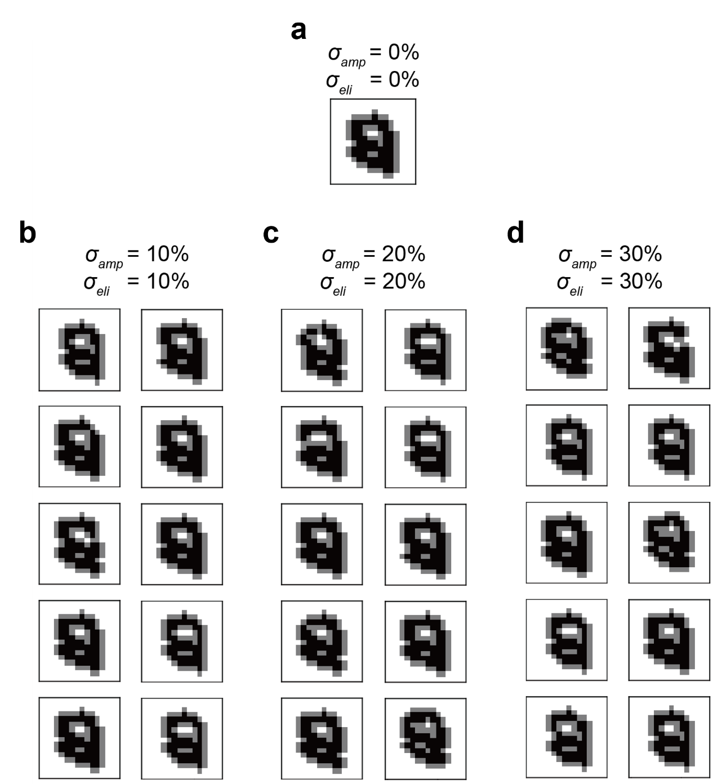
Figure S13. Examples of variation of reshaped image of ‘8’ with randomly applied σ_{amp} and σ_{eli}. (a) Reshaped image of ‘8’ when both σ_{amp} and σ_{eli} are 0%. Ten different examples of variation of reshaped images of ‘8’ when σ_{amp}/σ_{eli} is (b) 10%/10%, (c) 20%/20%, and (d) 30%/30%.

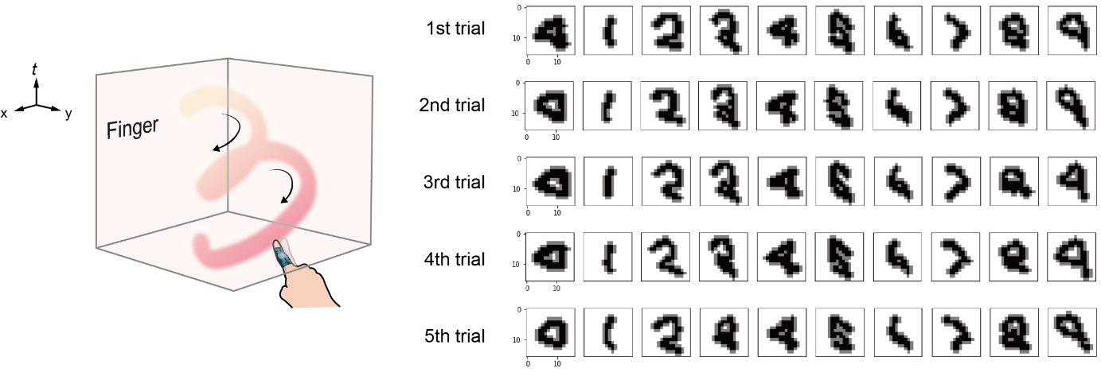
Figure S14. Training image sets for each 10-digit class (0–9) for 1st−5th trials acquired from the OPS-attached finger of one person.

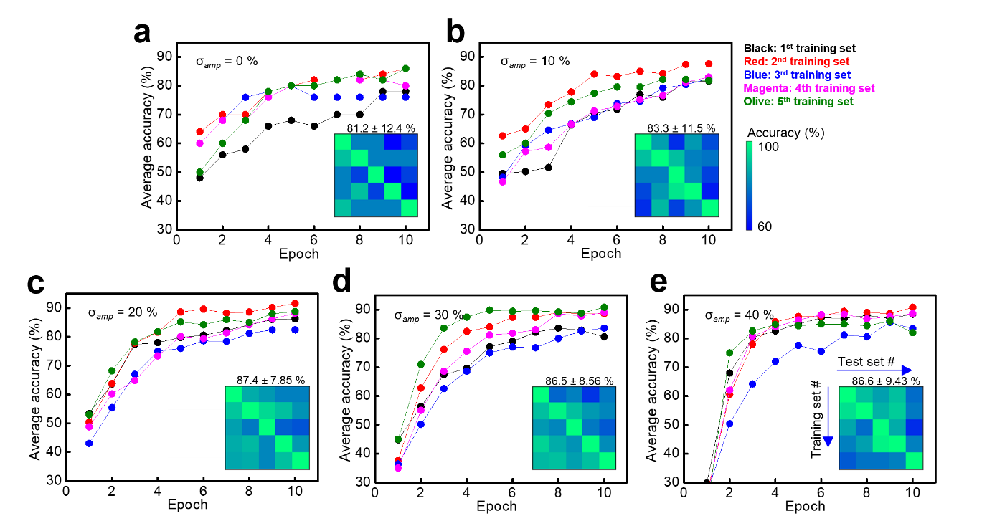
Figure S15. The average recognition accuracy as a result of training epochs based on five training image sets for 10-digit classes from the OPS-attached finger of one person at different σ_{amp}. The average recognition accuracy change to training epochs at σ_{amp} of (a) 0 %, (b) 10 %, (c) 20 %, (d) 30 %, and (e) 40 %. The row of inset confusion matrix indicates the number of training set and the column of it indicates the number of test sets.

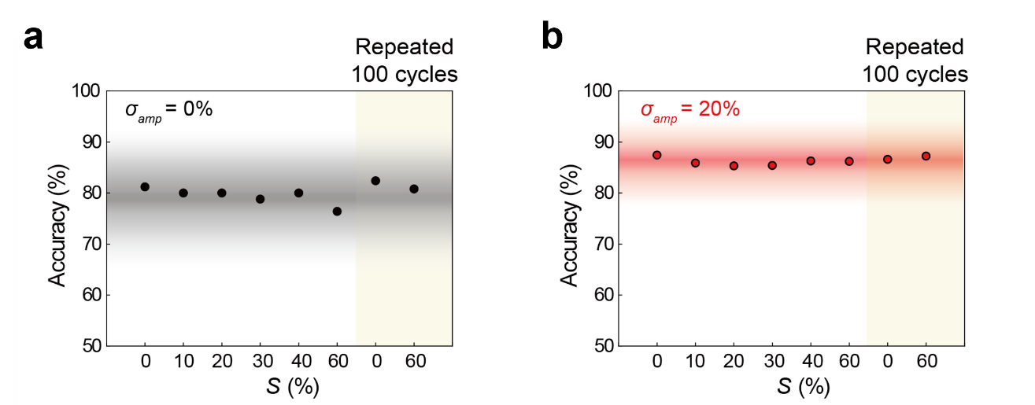
Figure S16. Variations in accuracy according to S, repeated cycles, and σ_{amp} based on five training image sets from the OPS-attached finger of one person. The average accuracy with the change of S from 0 to 60 % and up to 100 cycles at σ_{amp} of (a) 0% (black dots) and (b) 20% (red dots). The gradation regions indicate the standard deviations. The standard deviation is more concentrated for σ_{amp} = 20% than for σ_{amp} = 0%.

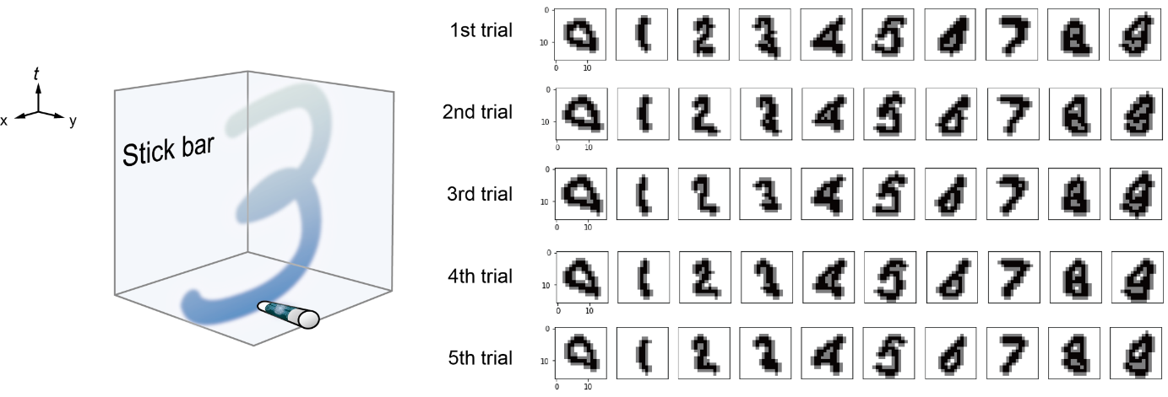
Figure 17. Training image sets for each 10-digit class (0–9) for 1st−5th trials acquired from the OPS attached on a stick bar.

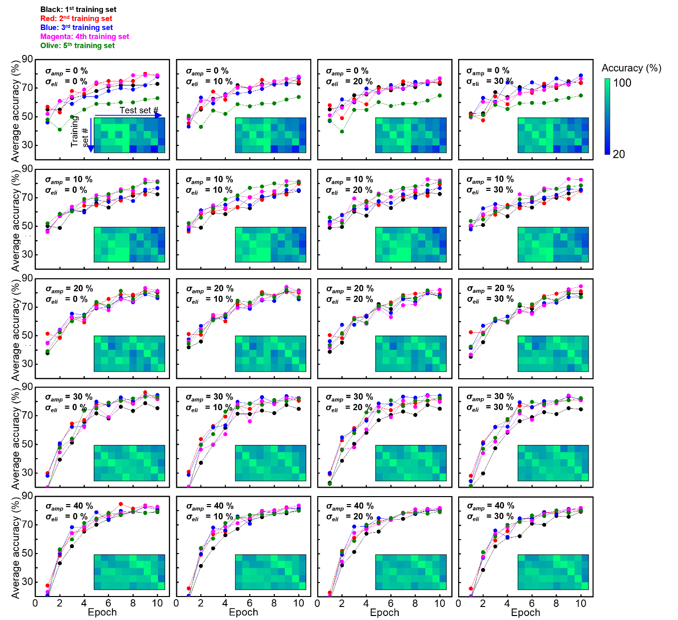
Figure S18. The average recognition accuracy as a result of training epochs based on 10 training image sets for 10-digit classes from the OPS-attached finger and stick-bar with varying σ_{amp} and σ_{eli}. The magnitude of σ_{amp} increases from the top to bottom plots (from 0 to 40%), while the σ_{eli} increases from the left to right plots (from 0 to 30%). The row of inset confusion matrix indicates the number of cross training set and the column of it indicates the number of test set (1st~5th for finger and 6th~10th for stick bar).

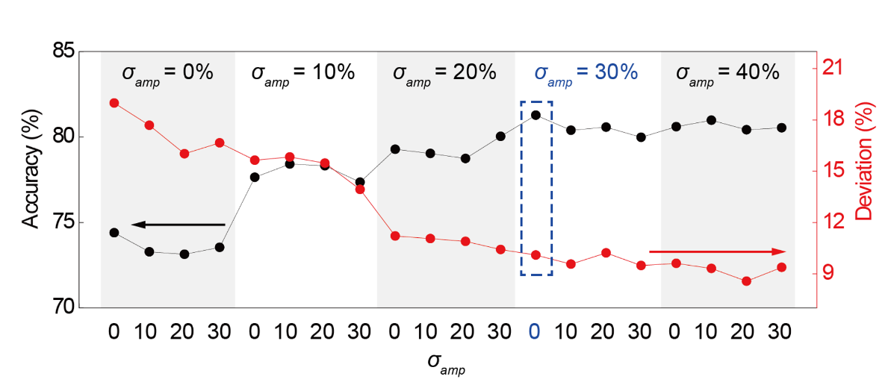
Figure S19. The average accuracy (left black line) and the standard deviation (right red line) with different σ_{amp} and σ_{eli} based on training image sets from a finger and a stick-bar. The magnitude of σ_{amp} ranges from 0 % to 40 %, and that of σ_{eli} from 0 % to 30 %. A blue dotted rectangle at σ_{amp} of 30% and σ_{eli} of 0% indicates the condition for maximum accuracy (~81.3 % in Fig. 4g).

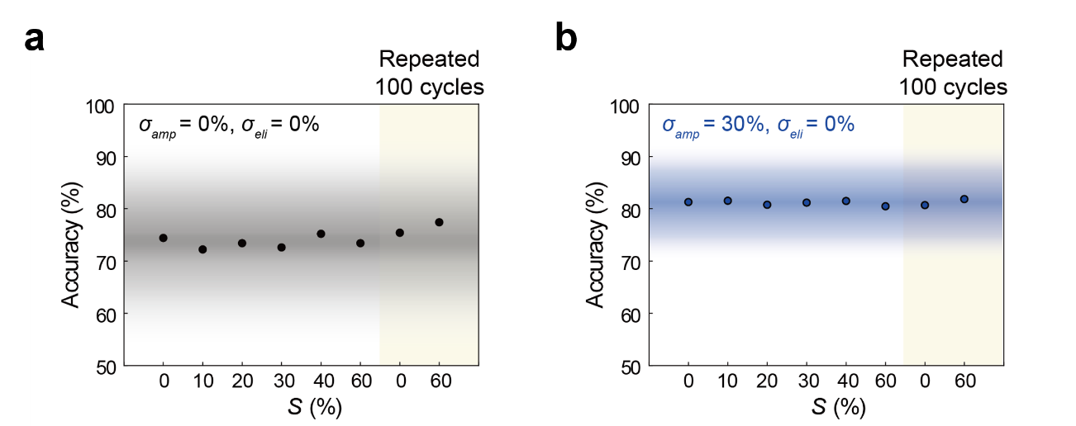
Figure S20. Variations in accuracy according to S, repeated cycles, and σ_{amp} based on 10 training image sets from the OPS-attached finger and stick-bar at σ_{eli} = 0%. The average accuracy with the change of S from 0 to 60 % and up to 100 cycles at (a) σ_{amp} of 0%, σ_{eli} of 0% (black dots), and (b) σ_{amp} of 30%, σ_{eli} of 0% (blue dots). The gradation regions indicate the standard deviations. The standard deviation is more concentrated for σ_{amp} = 30% than for σ_{amp} = 0%.

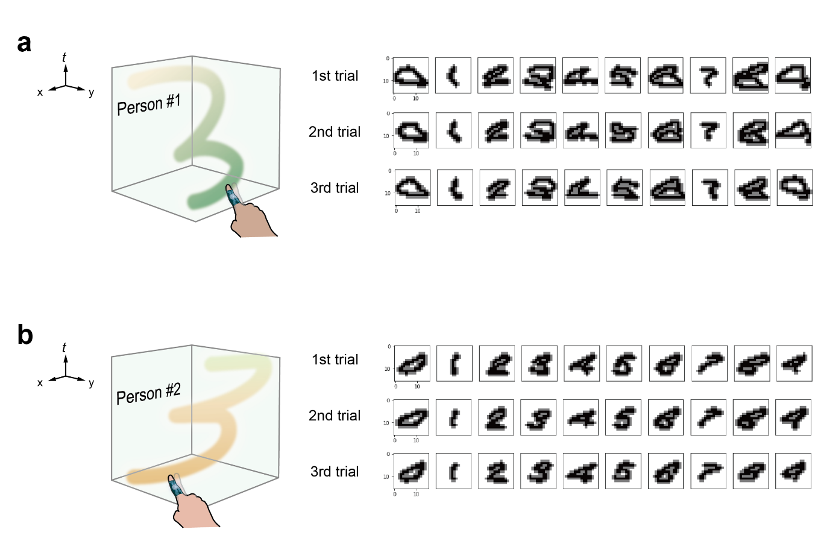
Figure S21. Training image sets for each 10-digit class (0–9) for 1st−3rd trials acquired from the OPS attached fingers of two different persons (three trials per person). Six training image sets based on three trials from each OPS-attached finger of (a) person #1 and (b) person #2.

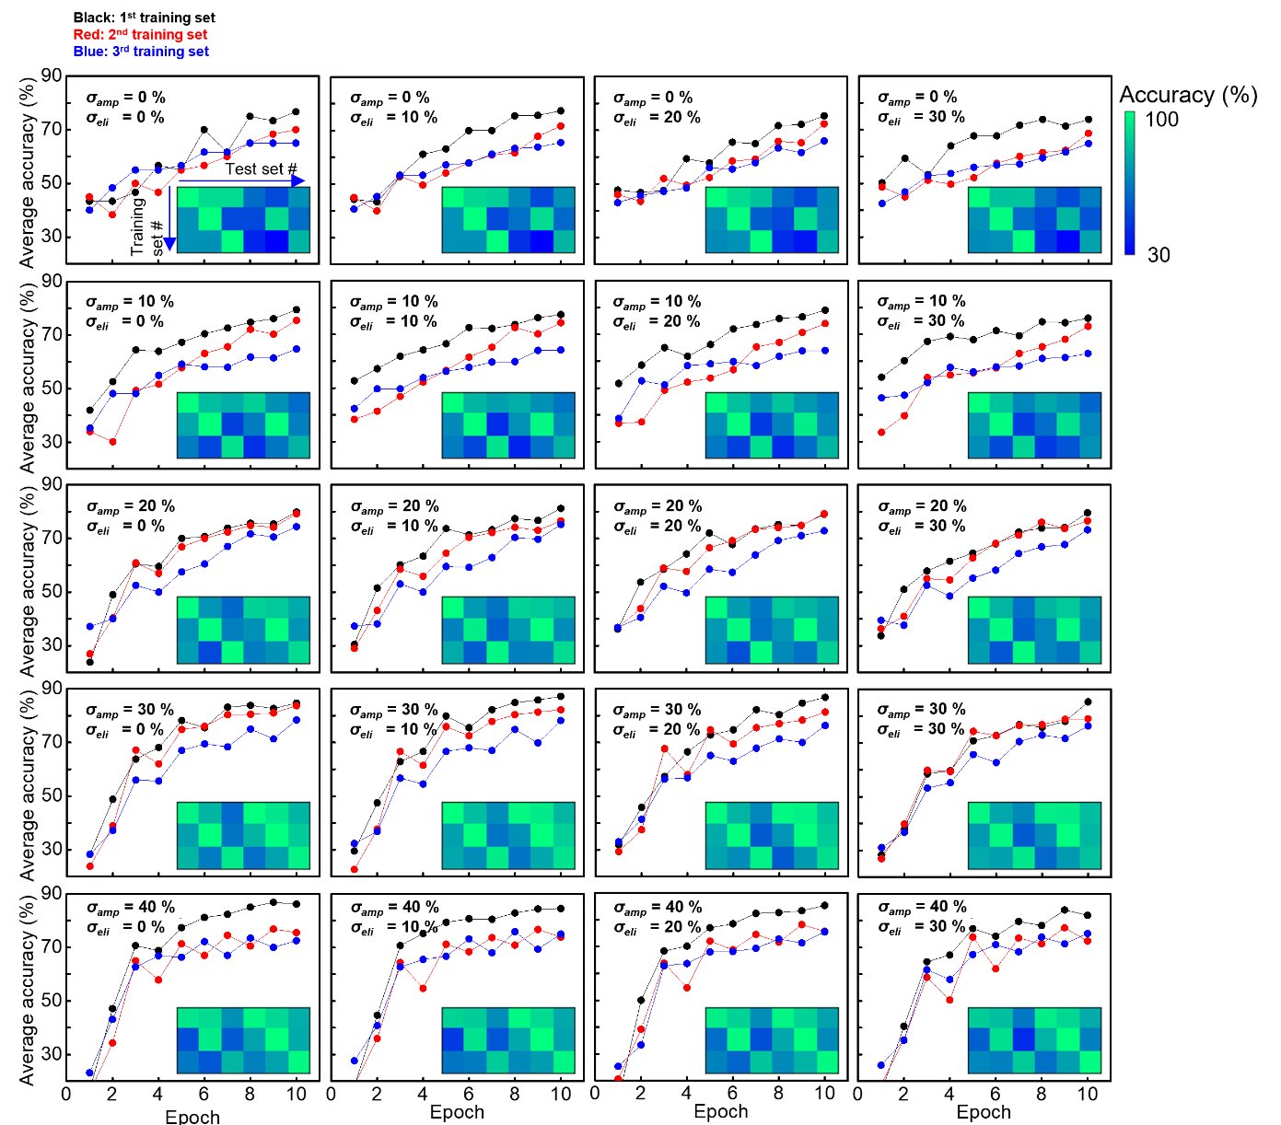
Figure S22. The average recognition accuracy as a result of training epochs based on six training image sets for 10-digit classes from the OPS on fingers of two persons with varying σ_{amp} and σ_{eli}. The magnitude of σ_{amp} increases from the top to bottom plots (from 0 to 40%), while the σ_{eli} increases from the left to right plots (from 0 to 30%). The row of inset confusion matrix indicates the number of cross training set and the column of it indicates the number of test set (1st~3rd for person #1 and 4th~6th for person #2).

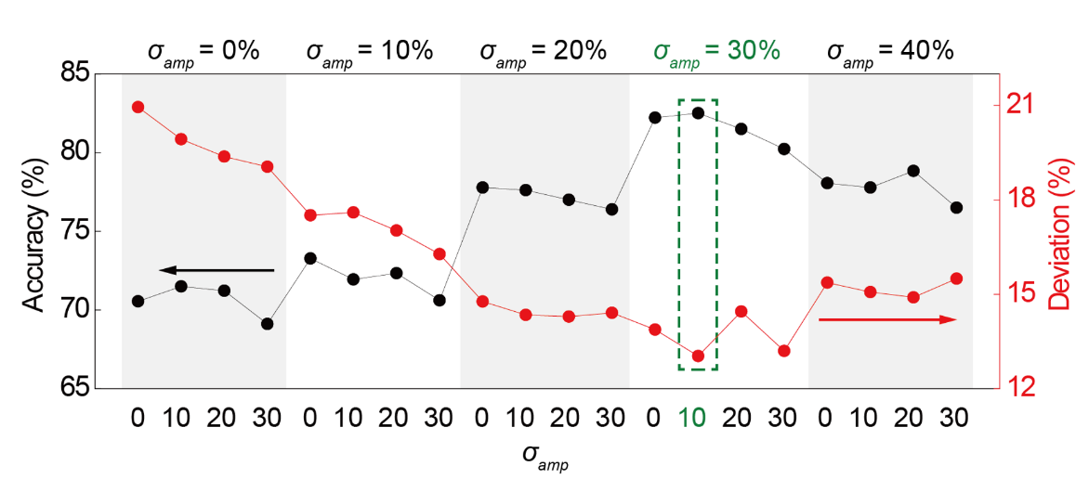
Figure S23. The average accuracy (left black line) and the standard deviation (right red line) with different σ_{amp} and σ_{eli} based on training image sets from fingers on two persons. The magnitude of σ_{amp} ranges from 0 % to 40 %, and that of σ_{eli} from 0 % to 30 %. A green dotted rectangle at σ_{amp} of 30% and σ_{eli} of 10% indicates the condition for maximum accuracy (~82.5 % in Fig. 4i).

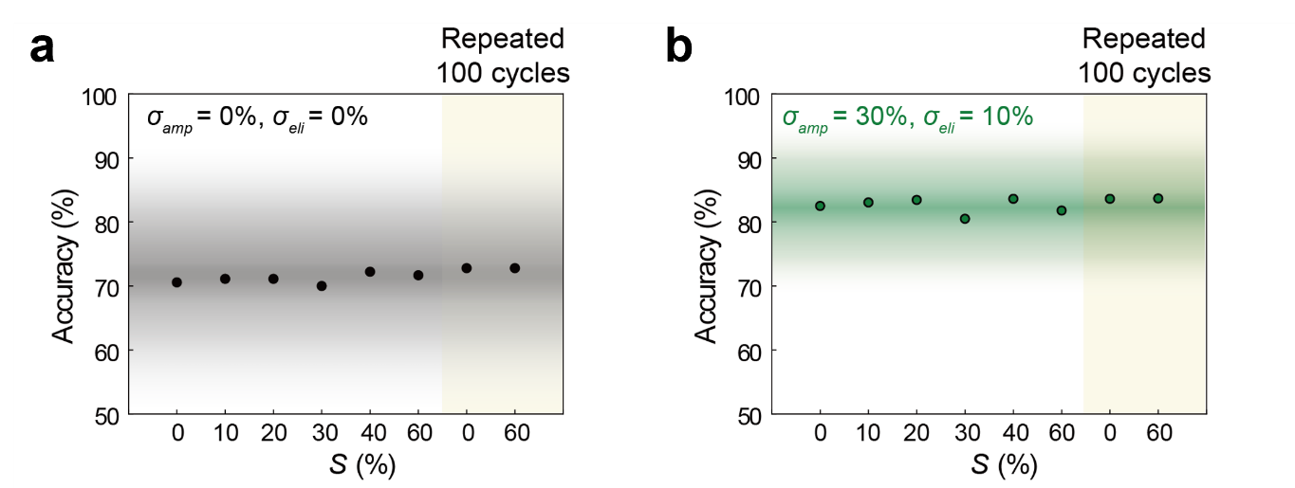
Figure S24. Variations in accuracy according to S, repeated cycles, σ_{amp}, and σ_{eli} based on six training image sets from the OPS on fingers of two persons. The average accuracy with the change of S from 0 to 60 % and up to 100 cycles at (a) σ_{amp} of 0%, σ_{eli} of 0% (black dots), and (b) σ_{amp} of 30%, σ_{eli} of 10% (green dots). The gradation regions indicate the standard deviations. The standard deviation is more concentrated for σ_{amp} = 30% and σ_{eli} = 10% than for σ_{amp} = 0% and σ_{eli} = 0%.

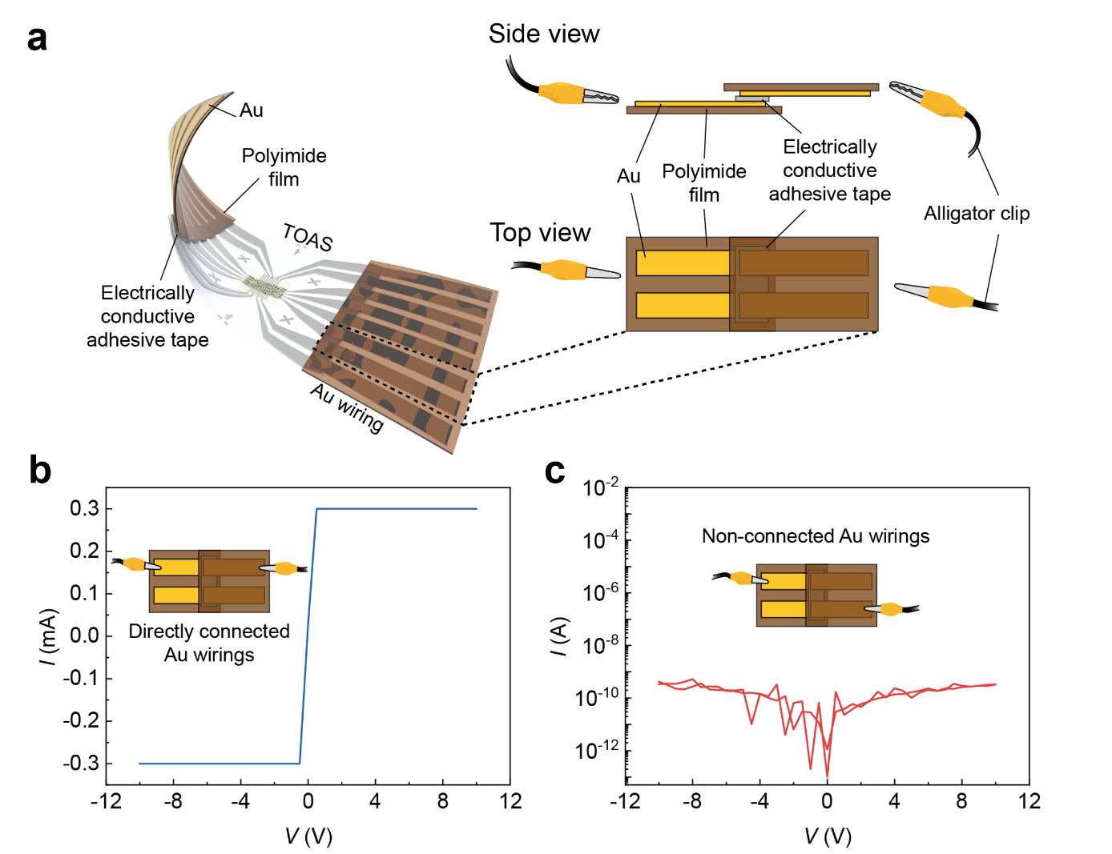
Figure S25. Experimental setup diagram for electrical connections of TOAS device after peeling off. (a) Schematic image of experimental setup for Au wirings. (b), (c) Electrical connection tests for two cases of Au wirings.

References
1. Choi, Y., Oh, S., Qian, C., Park, J.-H. & Cho, J. H. Vertical organic synapse expandable to 3D crossbar array. Nat. Commun. 11, 4595 (2020).
2. Kim, S.-M. et al. Linear and Symmetric Li-Based Composite Memristors for Efficient Supervised Learning. ACS Appl. Mater. Interfaces 14, 5673–5681 (2022).
3. Kim, S., Lim, M., Kim, Y., Kim, H.-D. & Choi, S.-J. Impact of Synaptic Device Variations on Pattern Recognition Accuracy in a Hardware Neural Network. Sci. Rep. 8, 2638 (2018).
4. Suo, Z., Ma, E. Y., Gleskova, H. & Wagner, S. Mechanics of rollable and foldable film-on-foil electronics. Appl. Phys. Lett. 74, 1177–1179 (1999).
5. Kim, D.-H. et al. Stretchable and Foldable Silicon Integrated Circuits. Science 320, 507–511 (2008).
6. Cardarelli, F. Materials Handbook: a Concise Desktop Reference. (Springer-Verlag Springer e-books, 2008).
7. Home - Parylene. Specialty Coating Systems https://scscoatings.com/.
8. Soares, P. et al. Hardness and elastic modulus of TiO2 anodic films measured by instrumented indentation. J. Biomed. Mater. Res. Part B: Appl. Biomater. 84B, 524–530 (2008).
9. Bendavid, A., Martin, P. J. & Takikawa, H. Deposition and modification of titanium dioxide thin films by filtered arc deposition. Thin Solid Films 360, 241–249 (2000).
10. Borgese, L. et al. Young modulus and Poisson ratio measurements of TiO2 thin films deposited with Atomic Layer Deposition. Surf. Coat. Technol. 206, 2459–2463 (2012).
11. Yin, K., Huang, H., Cohen-Or, D. & Zhang, H. P2P-NET: Bidirectional Point Displacement Net for Shape Transform. ACM Trans. Graph. 37, 1–13 (2018).
12. Sherlock, B. G. & Monro, D. M. Moving discrete fourier transform. IEE Proceedings F (Radar and Signal Processing) 139, 279–282 (1992).
13. Sandryhaila, A. & Moura, J. M. F. Discrete Signal Processing on Graphs. IEEE Trans. on Signal Process. 61, 1644–1656 (2013).
14. Zhao, J. et al. A new bearing fault diagnosis method based on signal-to-image mapping and convolutional neural network. Measurement 176, 109088 (2021).
15. Miyashita, Y., Tanaka, Y., Hasegawa, M. & Kato, S. Adaptive color-to-gray image mapping using directional transform. in 2012 19th IEEE International Conference on Image Processing 809–812 (2012). doi:10.1109/ICIP.2012.6466983.
16. Hecht-Nielsen. Theory of the backpropagation neural network. in International 1989 Joint Conference on Neural Networks 593–605 vol.1 (1989). doi:10.1109/IJCNN.1989.118638.
17. Zamanidoost, E., Bayat, F. M., Strukov, D. & Kataeva, I. Manhattan rule training for memristive crossbar circuit pattern classifiers. in 2015 IEEE 9th International Symposium on Intelligent Signal Processing (WISP) Proceedings 1–6 (2015). doi:10.1109/WISP.2015.7139171.
18. Karystinos, G. N. & Pados, D. A. On overfitting, generalization, and randomly expanded training sets. IEEE Trans. Neural Netw. 11, 1050–1057 (2000).
19. Lotfi, A. & Benyettou, A. Over-fitting avoidance in probabilistic neural networks. in 2015 World Congress on Information Technology and Computer Applications (WCITCA) 1–6 (2015). doi:10.1109/WCITCA.2015.7367037.
20. Srivastava, N., Hinton, G., Krizhevsky, A., Sutskever, I. & Salakhutdinov, R. Dropout: A Simple Way to Prevent Neural Networks from Overfitting. J. of Mach. Learn. Res. 15, 1929–1958 (2014).
21. Vincent, P., Larochelle, H., Bengio, Y. & Manzagol, P.-A. Extracting and composing robust features with denoising autoencoders. in Proceedings of the 25th international conference on Machine learning 1096–1103 (Association for Computing Machinery, 2008). doi:10.1145/1390156.1390294.
22. Wu, H. & Gu, X. Towards Dropout Training for Convolutional Neural Networks. Neural Netw. 71, 1–10 (2015).
23. Li, C. et al. Efficient and self-adaptive in-situ learning in multilayer memristor neural networks. Nat. Commun. 9, 2385 (2018).
24. Prezioso, M. et al. Training and operation of an integrated neuromorphic network based on metal-oxide memristors. Nature 521, 61–64 (2015).
25. Wang, Z. et al. In situ training of feed-forward and recurrent convolutional memristor networks. Nat. Mach. Intell. 1, 434–442 (2019).

