Supplementary Information
for
Long-wave infrared photothermoelectric detectors with ultrahigh polarization sensitivity

Mingjin Dai^{1†}, Chongwu Wang^{1†}, Bo Qiang¹, Yuhao Jin¹, Ming Ye¹, Fakun Wang¹, Fangyuan Sun¹, Xuran Zhang¹, Yu Luo¹, and Qi Jie Wang^{1,2}
¹School of Electrical and Electronic Engineering, Nanyang Technological University, Singapore 639798, Singapore.
²Centre for Disruptive Photonic Technologies, School of Physical and Mathematical Sciences, Nanyang Technological University, Singapore 637371, Singapore.
†These authors contributed equally to this work.
Corresponding Author: qjwang@ntu.edu.sg; luoyu@ntu.edu.sg

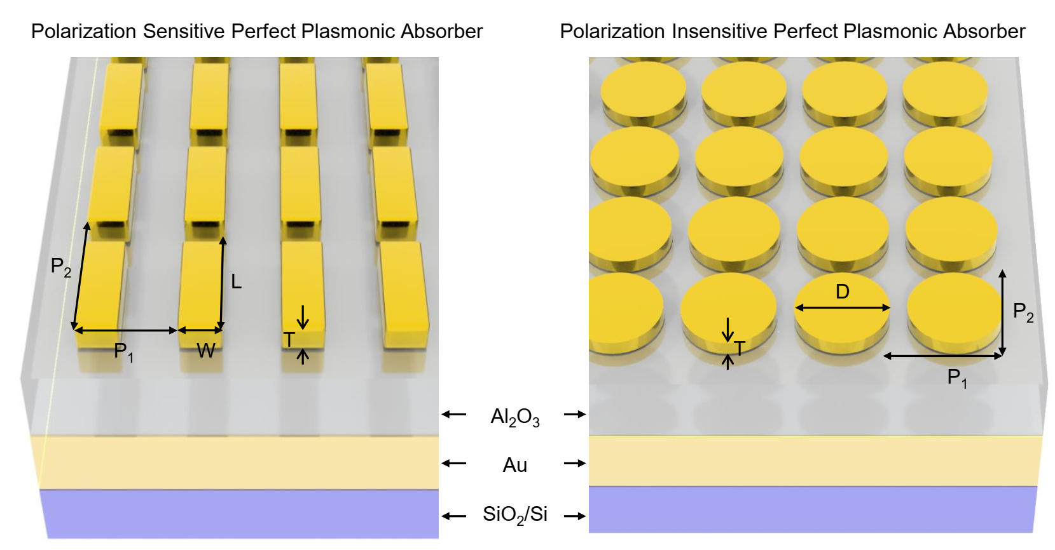
Supplementary Figure 1: Structure diagram of the polarization sensitive/insensitive perfect plasmonic absorber with structure parameters. P₁ and P₂ indicate the period length along x and y direction. W and L indicate the width and length of the rectangle microstructure. D indicates the diameter of the micro-disk. T indicates the thickness of microstructures.

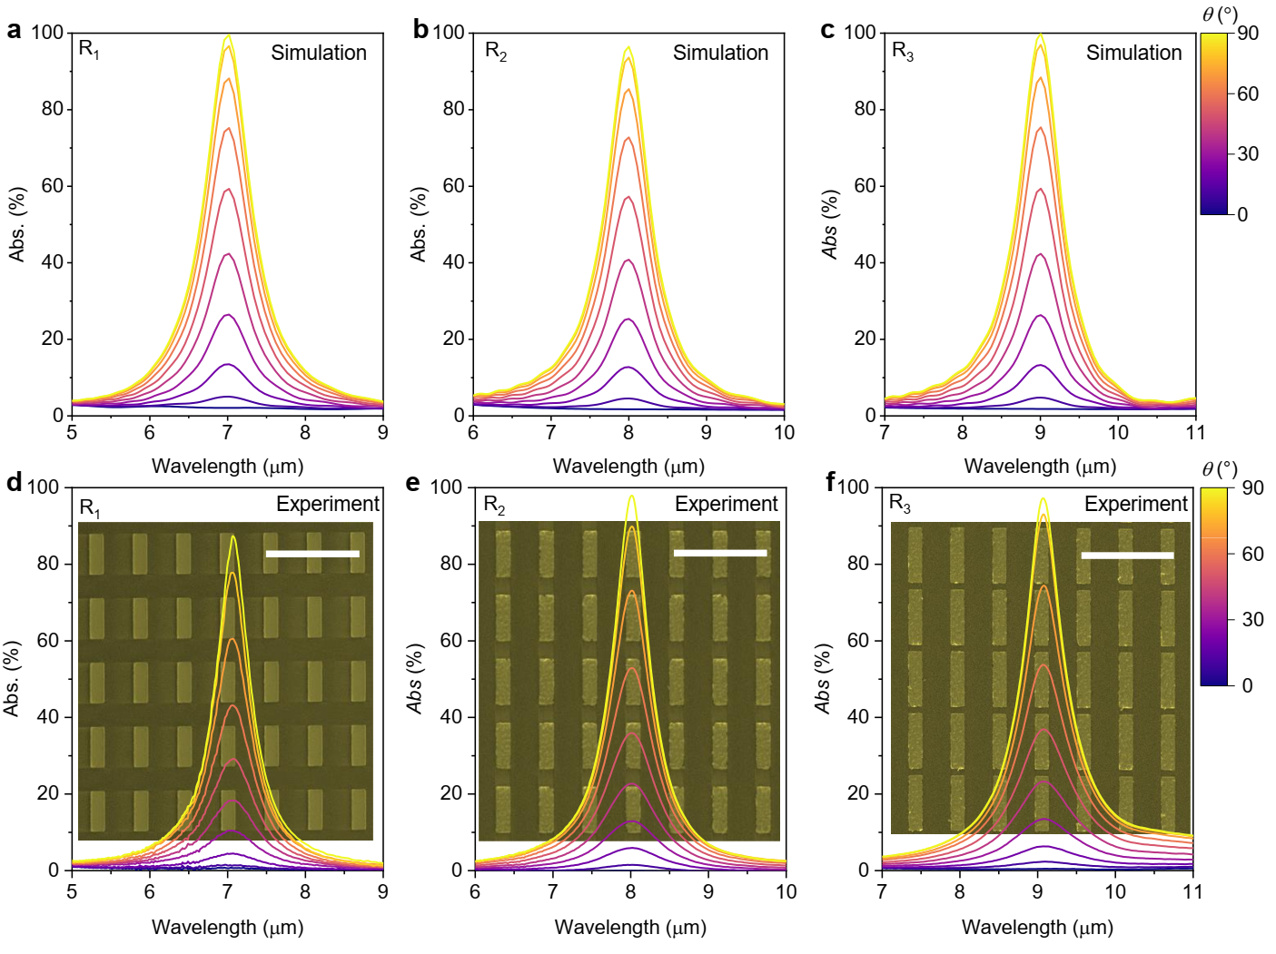
Supplementary Figure 2: Simulated and experimental measured linear polarization dependent optical absorption spectra of perfect plasmonic absorbers. a-c, Simulated linear polarization dependent optical absorption spectra of perfect plasmonic absorber R₁ (a) R₂ (b), and R₃ (c). d-f, Experimental measured optical linear polarization dependent optical absorption spectra of perfect plasmonic absorber R₁ (d), R₂ (e) R₃ (f). Insets: SEM images of corresponding perfect plasmonic absorbers. Scale bars: 5 μm.

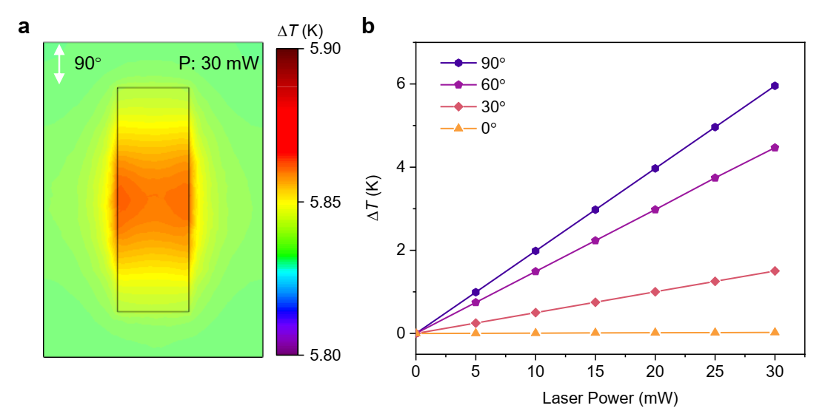
Supplementary Figure 3: Simulation of the photothermal effect of the perfect plasmonic absorber. a, Simulated temperature distribution in the Au microstructure under illumination with a laser power of 30 mW. b, Laser power dependent temperature increase (∆T) for different polarization states.

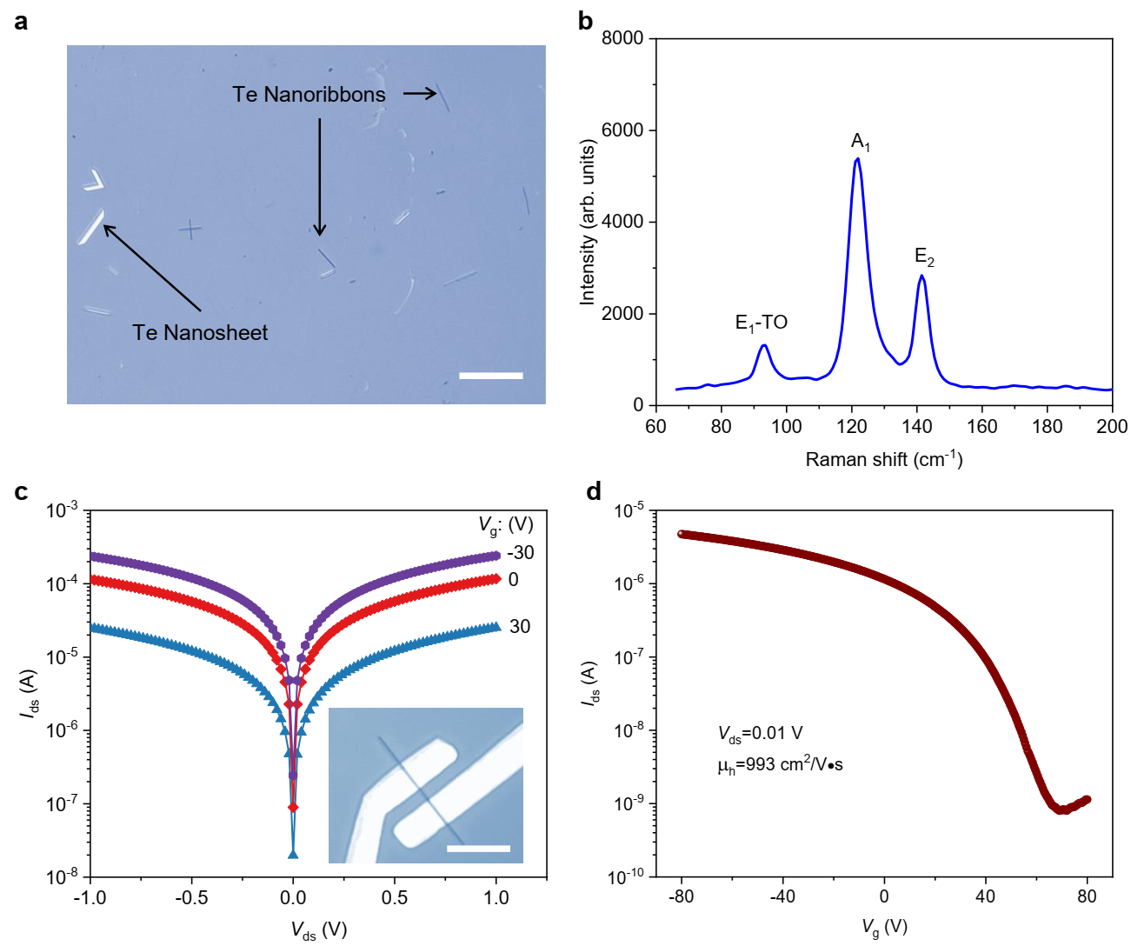
Supplementary Figure 4: Characterization of as-synthesized Te nanoribbons. a, A typical image of synthesized Te products transferred onto a SiO₂/Si substrate with nanoribbon and nanosheets. Scale bar: 20 μm. b, Raman spectrum of Te nanoribbon shows three modes localized at 93, 121, and 141 cm⁻¹, respectively. c, Output curves under different gate biases V_{g}. Inset shows the optical image of the Te nanoribbon-based device. d, Transfer curve measured under a source-drain bias V_{ds}=0.01 V showing a p-type transport behavior with a hole mobility of 993 cm²/V•s.

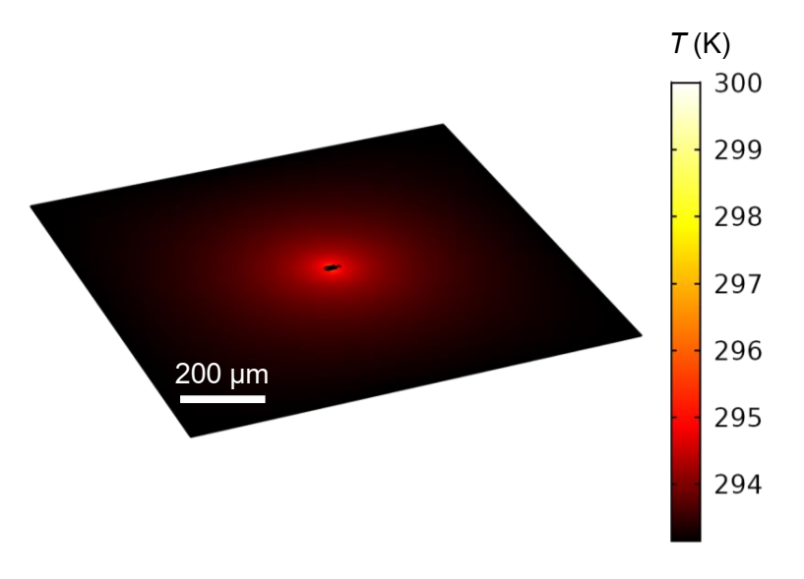
Supplementary Figure 5: Simulation of the temperature distribution of the device in a large scale.

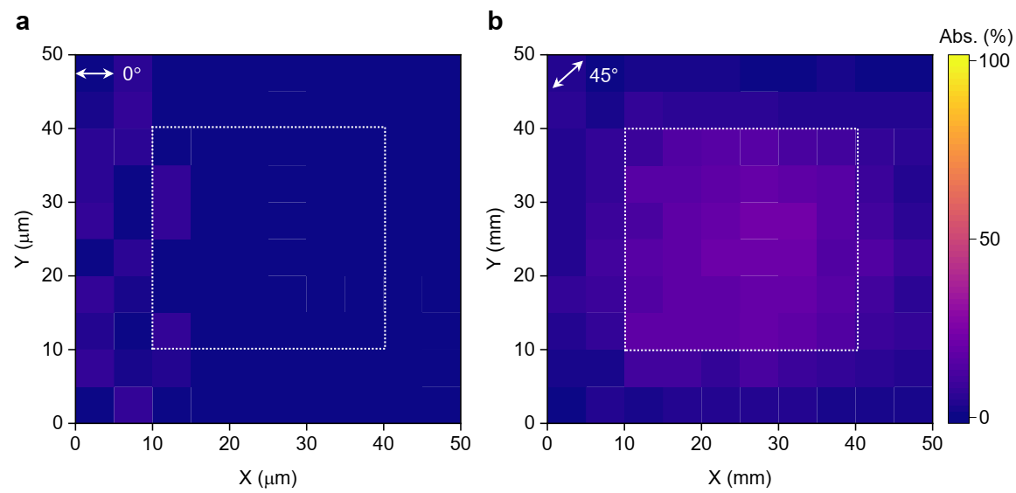
Supplementary Figure 6: Polarization dependent absorption mapping of the perfect plasmonic absorber array with a finite-size of 30×30 µm². a,b, The absorption mappings of the metamaterial for linear polarized light at wavelength of 8 µm with the polarization angle 0° (a) and 45° (b), respectively.

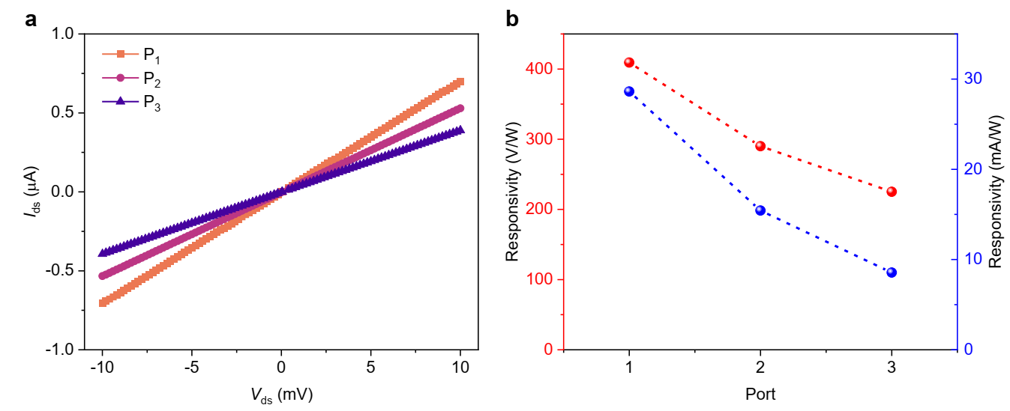
Supplementary Figure 7: High responsivity of the devices with different channel lengths. a, I_{ds}-V_{ds} curves for different channel length in the device with three ports. b, The photovoltage and photocurrent responsivities for different ports.

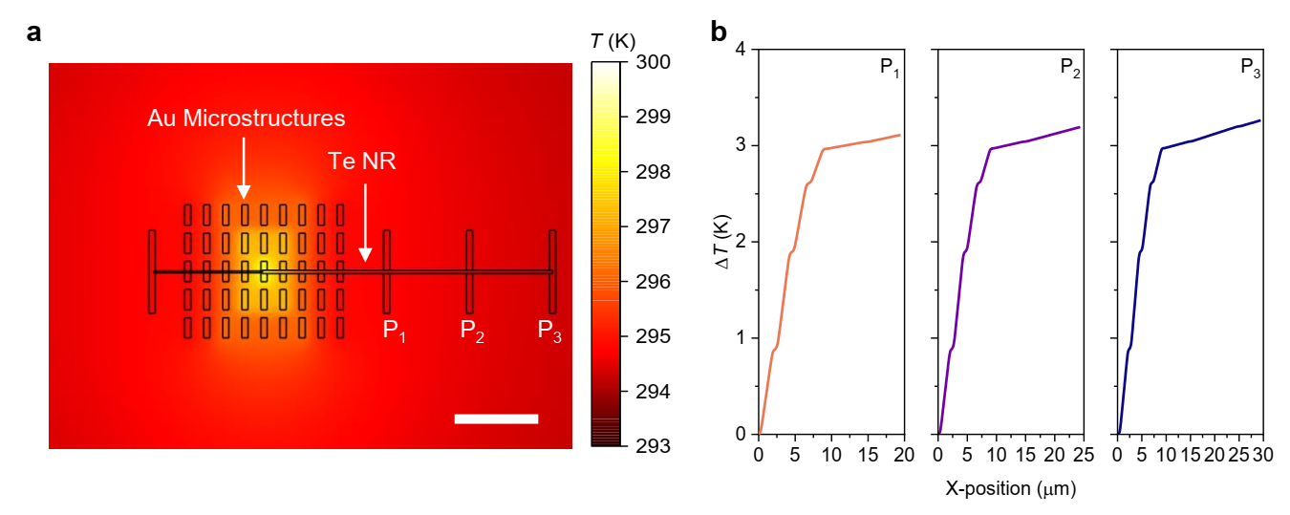
Supplementary Figure 8: Simulation of the temperature distribution of the device with three ports. a, Temperature distribution in the device with three ports. b, The temperature increasing profiles along the Te NW for different ports with a fixed incident laser power.

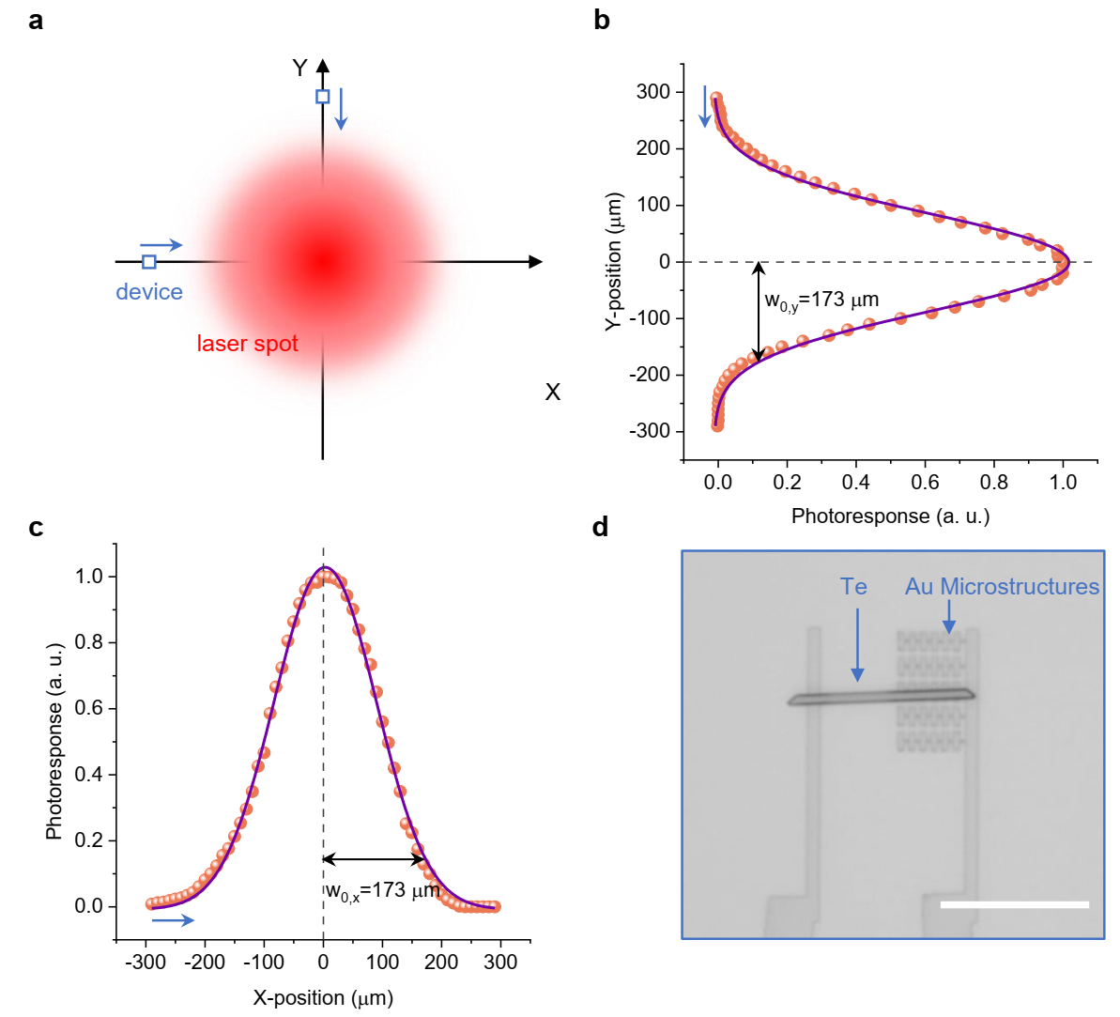
Supplementary Figure 9: Measurement of the laser spot size. a, Schematic diagram of the laser spot size measurement by scanning our device along X and Y axis, respectively. The blue arrows indicate the device moving directions. b,c,The experimental photoresponse distributions along Y (b) and X (c) axis, showing two axis radii (1/e² intensity) as 173 and 173 µm. d, The optical image of the device used for laser spot size measurement. Scale bar: 20 µm.

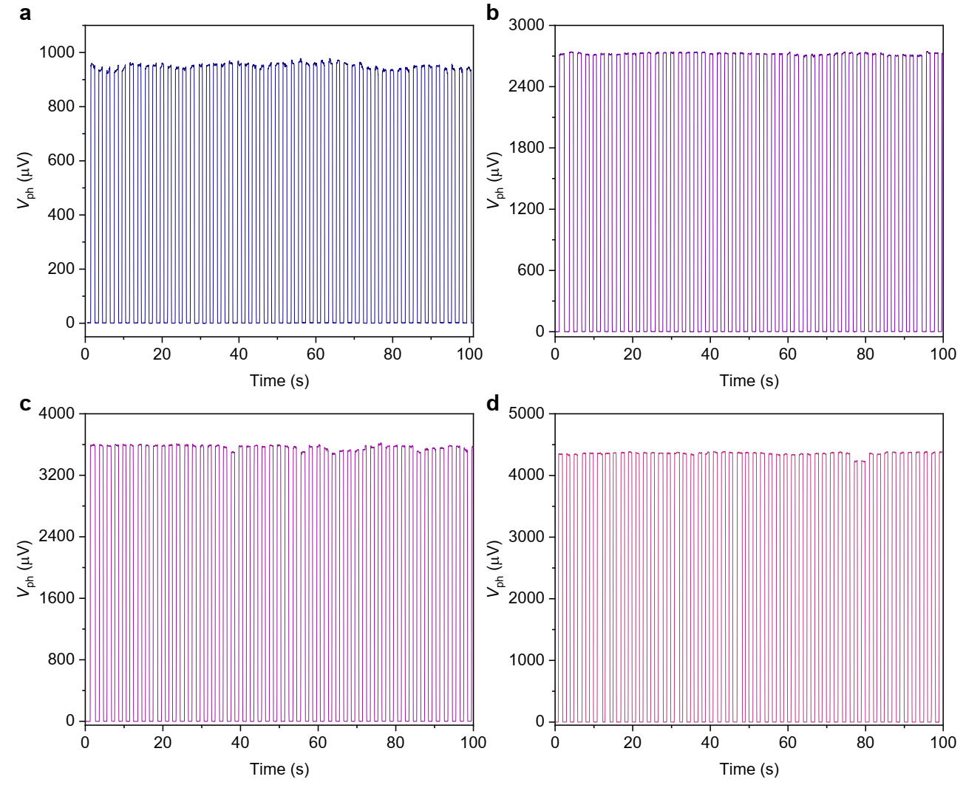
Supplementary Figure 10: Measured time-resolved photoresponse response of our device with different incident light powers at device. a-d, 2.3 μW (a), 6.5 μW (b), 8.8 μW (c), and 10.6 μW (d).

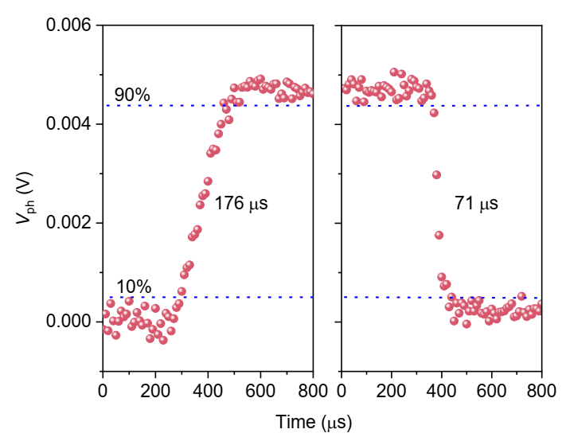
Supplementary Figure 11: Transient photonresponse of the device. The transient photoresponse shows a rise time of 176 μs and a decay time of 71 μs, indicating a -3dB bandwidth of 5.7 kHz.

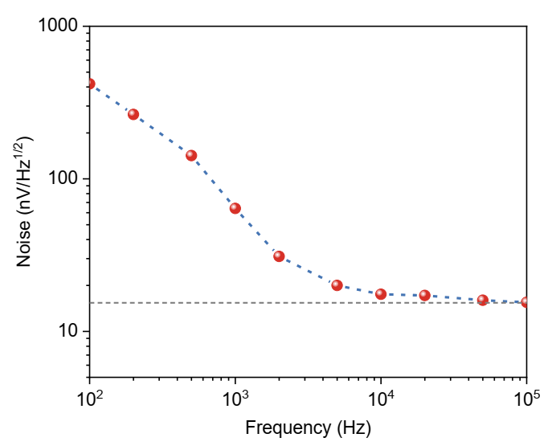
Supplementary Figure 12: The spectral voltage noise density of the device. It shows a dramatically decrease with frequency at low frequency range and then keeping a constant when the frequency is over around 5 kHz. The dash line indicates the white noise of the device.

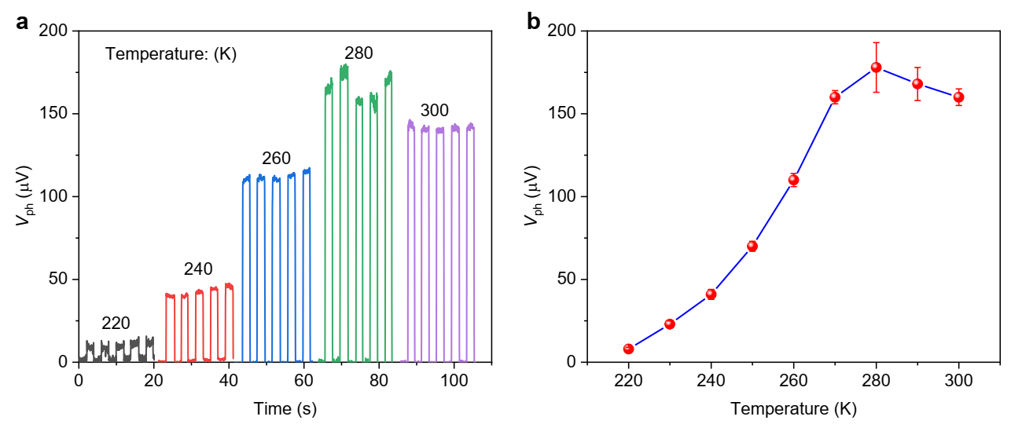
Supplementary Figure 13: The temperature dependent photovoltage response of a typical device. a, The photovoltage responses at different temperature. b, Temperature dependent photovoltage responses showing that, at a lower temperature, the device exhibits a lower photovoltage response.

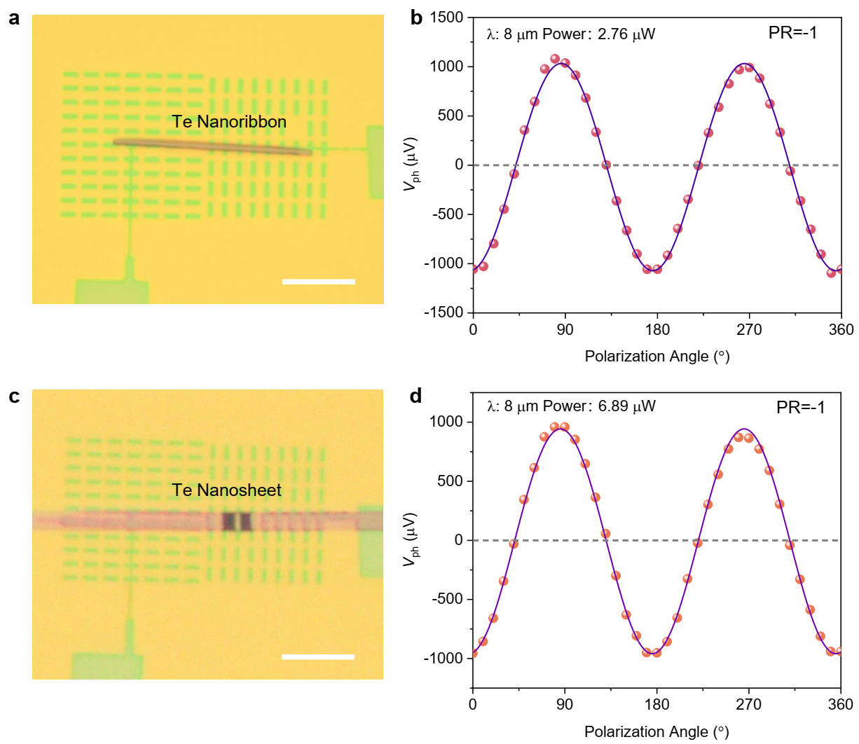
Supplementary Figure 14: Photoresponses of designed devices with polarization ratio of -1. a, An optical image of the device based on Te nanoribbon and perfect plasmonic absorber array. Scale bar: 10 μm. b, The corresponding experimental polarization angle dependent photoresponses showing a bipolar response with a PR=-1. c, An optical image of the device based on Te nanosheet and metamaterials. Scale bar: 10 μm. d, The corresponding experimental polarization angle dependent photoresponses showing a bipolar response with a PR=-1.

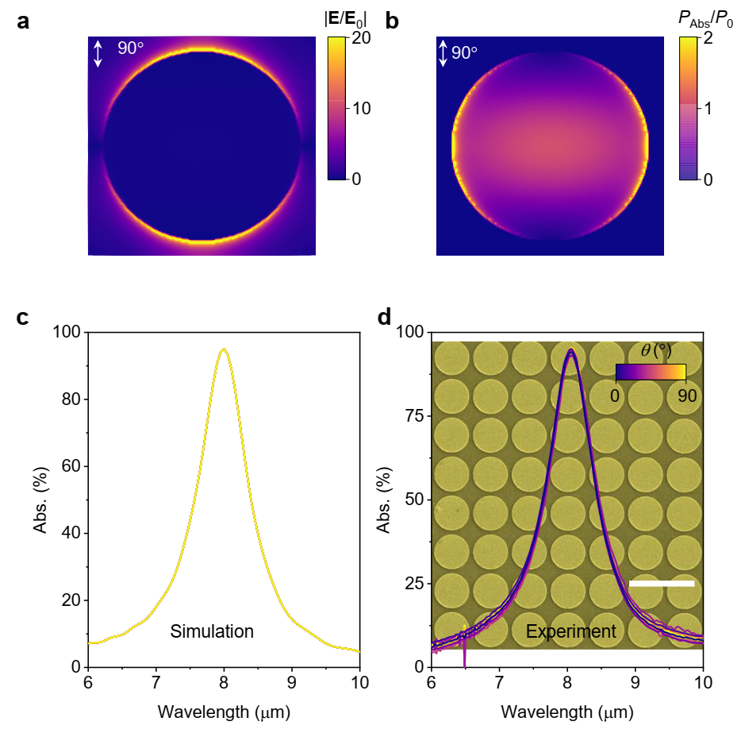
Supplementary Figure 15: Simulated and experimental measured optical absorption of polarization-insensitive perfect plasmonic absorber D₁. a, Full wave simulations of electric field distributions normalized to incident electric field. The period of the gold disk with a radius of 1.3 μm is 3 μm. b, Full wave simulations of power absorption density calculated by P_{abs}= 1/2ωε′′|E|², and normalized by the incident power density P₀. c, Simulated linear polarization angle dependent absorption spectra. d, Experimental measured linear polarization dependent absorption spectra. Inset: SEM image of as-fabricated perfect plasmonic absorber D₁. Scale bar 5 μm.

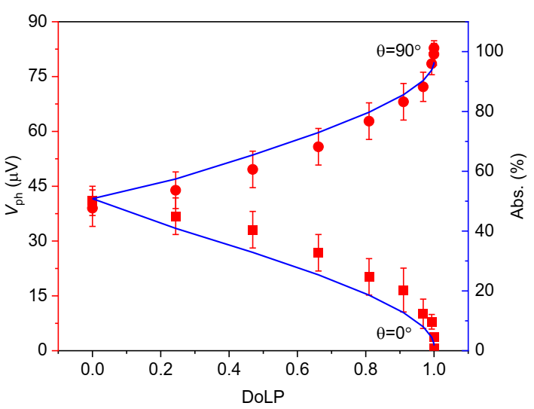
Supplementary Figure 16: Experimental measured photoresponses and simulated absorption as a function of DoLP of the incident light. The photoresponses are monotonically increasing (decreasing) with the DoLP increases from 0 to 1 for θ=90° (θ=0°), indicating the ability to detect the DoLP of the incident light.

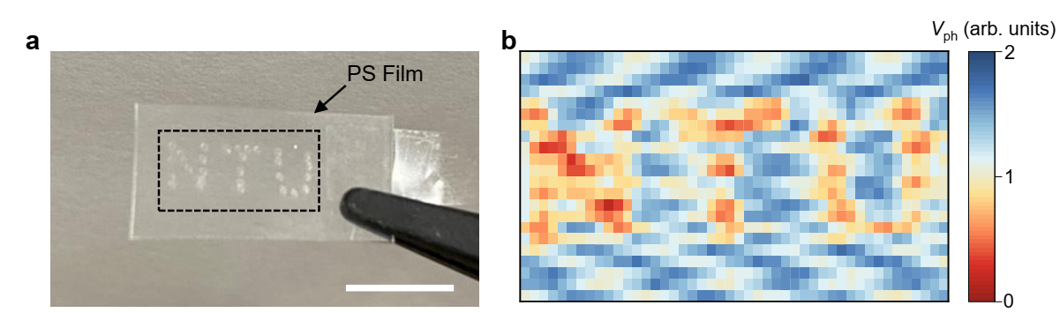
Supplementary Figure 17: Optical strain measurement for a PS film with local strain. a, A typical image of the PS film with local positive strain along with the letter of NTU. Scale bar 0.5 cm. b, Experimental measurements of photovoltage response distribution for polarized infrared light transmitted the PS film with local positive strain.

Supplementary Table 1: Structure parameters of perfect plasmonic absorbers with different resonance wavelengths.
 | Resoance Wavelength (μm) | P₁ (μm) | P₁ (μm) | T (μm) | W (μm) | L (μm)
R₁ | 7.0 | 2.3 | 3.4 | 0.05 | 0.75 | 2.15
R₂ | 8.0 | 2.3 | 3.4 | 0.05 | 0.75 | 2.45
R₃ | 9.0 | 2.3 | 3.4 | 0.05 | 0.75 | 2.95
D₁ | 8.0 | 3.0 | 3.0 | 0.05 | D=2.6

Supplementary Table 2. Performance comparison of linear polarization sensitive photodetectors operating in mid-/long-wave infrared region
Materials | Mechanism | Wavelength (μm) | PR | Responsivity  (V/W) | Detectivity  (Jones) | PAS  (V/W•degree) | PAD  (Jones/degree) | Ref.
Gr/Au antenna | PTE | 6.6 | 1.5 | 92 | / | 0.53 | / | 33
Gr/Au antenna | PTE | 4.0 | ∞ | 15.6 | 1.56×10⁶ | 0.27 | 2.7×10⁴ | 8
Gr/Au antenna | BPVE | 4.0 | -1 | 27 | 5×10⁶ | 0.94 | 1.7×10⁵ | 31
Twist Gr | BPVE | 7.7 | -2 | 3.7 | / | 0.09 | / | 32
PdSe₂/Au metamaterials | PTE | 5.3 | ∞ | 3.6 | 2.5×10⁵ | 0.06 | 4.1×10³ | 7
PdSe₂ | PTE | 4.6  10.5 | 2.03  1.21 | 21.6  14.3 | 6.7×10⁶  4.5×10⁶ | 0.19  0.04 | 5.9×10⁴  1.2×10⁴ | 16
TaIrTe₄ | Shift Current | 4.0 | 8.5 | 53.3 | / | 0.82 | / | 34
Te/Au metamaterials | PTE | 8.0 | ∞  -1 | 410  380 | 1.2×10⁷  1.1×10⁷ | 7.1  13.2 | 2.1×10⁵  3.8×10⁵ | This work
PTE: photothermoelectric, BPVE: bulk photovoltaic effect.
Ref. is cited in the main article.

