3D Printed Boron Nitride Polyurethane Composites Electroosmotic Pump
Liang Wu^{a,b*} Hadis Khakbaz ^{a,c} Stephen Beirne^{a,d}, Gordon G. Wallace^{a,d} and Peter C. Innis^{a,d*}
- ARC Centre of Excellence for Electromaterials Science (ACES), Intelligent Polymer Research Institute, University of Wollongong, Australia 2522
- School of Chemical and Biomolecular Engineering, The University of Sydney, Australia 2006
- School of Mechanical and Mining Engineering, The University of Queensland, Australia 4072
- Australian National Fabrication Facility - Materials Node, University of Wollongong, Australia 2522
* Corresponding author email: liang.wu@sydney.edu.au; innis@uow.edu.au

Electronic Supplementary Information
Material-structure | BNPU-BCC |  |  |  |  |  | Theoretic-BCC
The number of capillaries | 4 | 4 | 4 | 4 | 1 | 1 | 4
Mass Weigh of BN in PU | 0 | 1 | 3 | 5 | 10 | 20 | -
BCC overall area (${10}^{5}$µm²) | 5.3$±$0.2 | 7.6$±$0.4 | 6.7$±$1.3 | 6.5$±$0.3 | 8.3$±$1.3 | 10.1$±$0.4 | 8.24
Capillary overall area (${10}^{3}$µm²) | 6.9$±$2.23 | 6.0$±$0.78 | 6.6$±$1.04 | 6.5$±$0.67 | 7.8$±$0.35 | 9.6$±$0.7 | 17.2
A _{capillaries}/ A _{structures} ratio | 1.30% | 0.97% | 1.01% | 1.01% | 1.07% | 0.94% | 2.09%
Capillary width (µm) | 166$±$17 | 141$±$10 | 133$±$16 | 132$±$10 | 174$±$20 | 196$±$16 | 200
Capillary height (µm) | 115$±$6 | 84$±$8 | 96$±$13 | 102$±$9 | 112$±$12 | 100$±$5 | 146
Table S1 The dimensions of 0-20BNPU-BCC capillary structures (See Figure S1 for the measurement of the capillary structures)

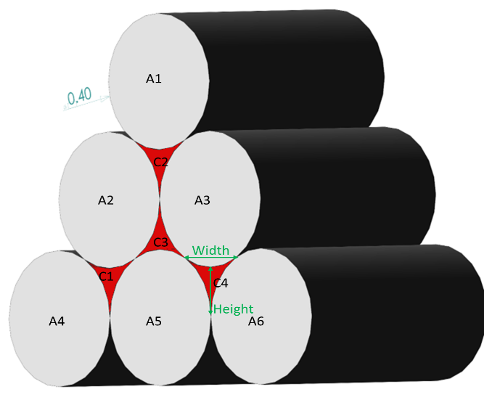
Figure S1A

Figure S1 the measurement of the BCC capillary structures
An optical microscope (Leica M205A) associated with Image J software was employed to measure the cross-sectional and dimensions of capillary structures.
In Figure S1A, A1~A6 represent the extruded filaments. C1~C4 represent the capillaries (microchannels) based on the BCC configuration. The BCC capillary structure is composed of 6 extruded PLA filaments (A1~A6) and 4 capillaries (C1~C4). During the dimensional measurement of BCC capillary structures, BCC overall area (Table S1) means the area of BCC capillary structure, while capillary overall area means the area of all capillaries. A _{capillaries}/ A _{structure} ratio means that the ratio of the area of capillary (capillaries) to the area of BCC capillary structure. Capillary average area means the average area of the formed BCC capillaries. In Table S1, the number of the tested single-capillary samples was 5. The error bars are one standard deviation. Image J was used to measure the dimensions and areas of the printed capillary samples including the capillaries formed by the filaments and the extruded filaments.

Figure S2 The thermal images of 0-20BNPU-BCC single capillary EOPs before and after applying voltage (200V-1500V) in 60s.(A)0BNPU-BCC EOPs; (B)1BNPU-BCC EOPs; (C)3BNPU-BCC EOPs; (D)5BNPU-BCC EOPs; (E)10BNPU-BCC EOPs; (F)20BNPU-BCC EOPs

Table S2 Thermal conductivity of BNPU composites
Composites | Average _{thermal conductivity} (W/m·K) | Standard deviation
Neat PU | 0.13103 | 0.00741
1% BNPU | 0.14782 | 0.01137
3% BNPU | 0.15004 | 0.00847
5% BNPU | 0.17308 | 0.02660
10% BNPU | 0.21206 | 0.01527
20% BNPU | 0.22790 | 0.00263

