SUPPLEMENTARY MATERIAL
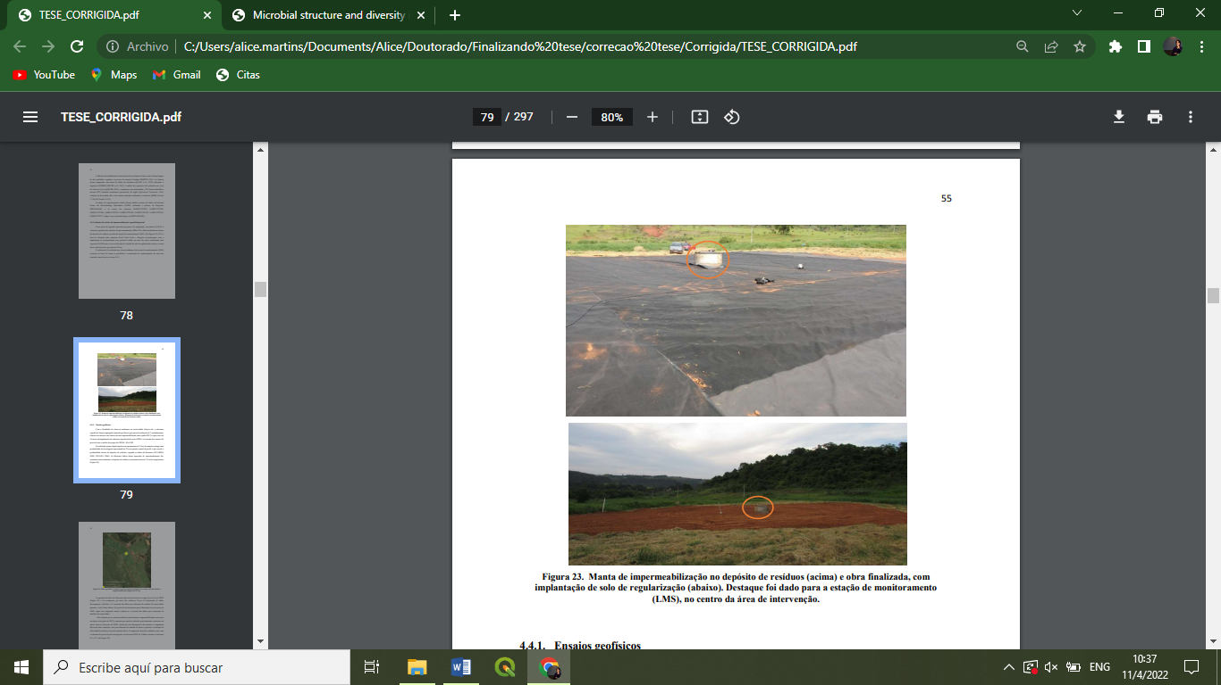
Fig. 1_{SM}. Detail of capping layers constructed in the study area.

Fig. 2_{SM}. Physicochemical results of solubilized samples.

Fig. 3_{SM}. Physicochemical results of solubilized samples.

Fig. 4_{SM}. Ecological indices for the collected samples.

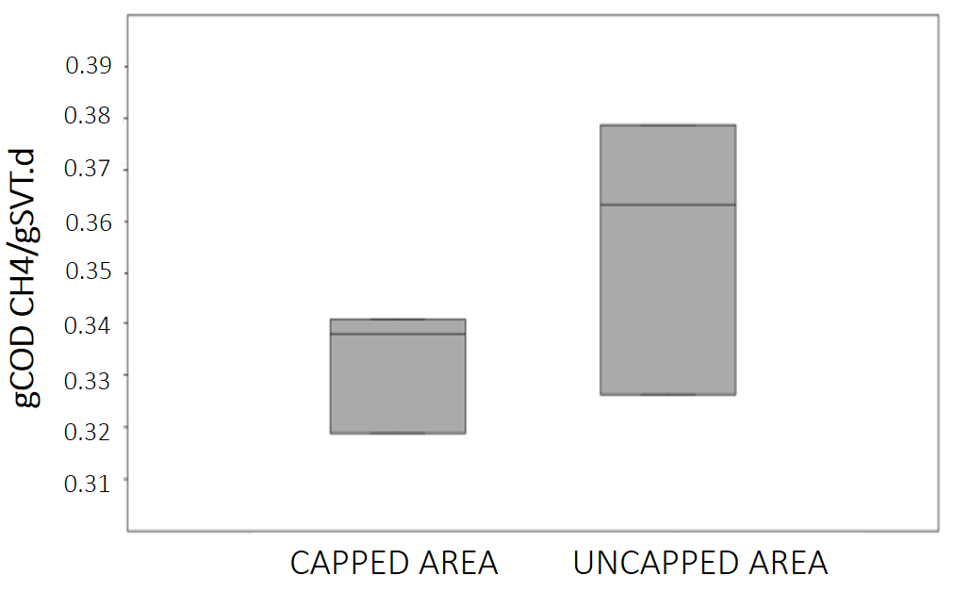
Fig. 5_{SM}. Boxplots of the SMA anaylisis.

