Ester-Functionalised Ferrocene based Polyvinylbenzyl Chloride Nanofibre as a Decyanidating Agent
A.O. Adesoji^{1,2,3} , I.O. Shotonwa¹, Z.R. Tshentu³ and S. Adewuyi¹*

¹Department of Chemistry, Federal University of Agriculture Abeokuta, PMB 2240, Abeokuta, Ogun State, 110001, Nigeria
²Education Science Department, Distance Learning Institute, University of Lagos, Lagos State, Nigeria
³Department of Chemistry, Nelson Mandela University, Summerstrand, Port Elizabeth, South Africa

*corresponding author: adewuyis@funaab.edu.ng +234-8038833122

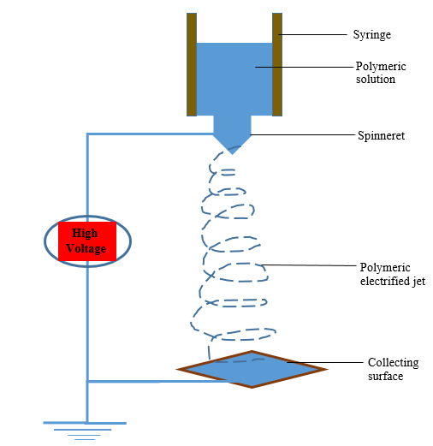
SI. 1: Schematic illustration of an electrospinning set-up

SI. 2: FTIR Spectrum of FePNCp
FcCOOH

PN

m/z
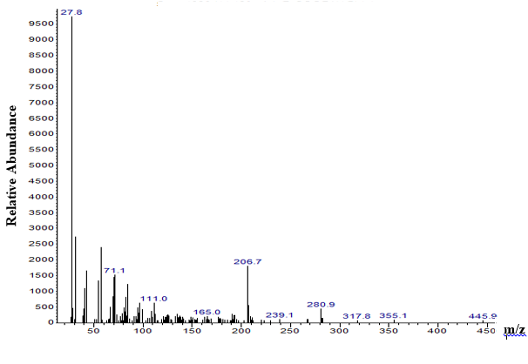
SI. 3: GC/MS of FePNCp

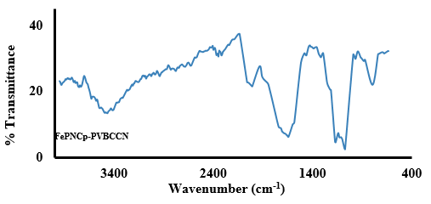
Wavenumber (cm⁻¹)

SI. 4: FTIR Spectrum of FePNCp-PVBCCN

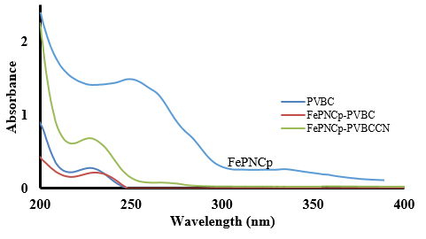
SI. 5: UV/Vis Spectra of PVBC, FePNCp, FePNCp-PVBC and FePNCp-PVBCCN

