Supplementary information for

Environmental predictors of SARS-CoV-2 infection incidence in Catalonia (northwestern Mediterranean)
Jesús Planella-Morató^{1,2,3}, Josep L. Pelegrí¹, Marta Martín-Rey^{4,5}, Anna Olivé-Abelló¹, Xavier Vallès ^{6,7}, Josep Roca⁸, Carlos Rodrigo Gonzalo de Liria⁹, Oriol Estrada¹⁰, Ignasi Vallès-Casanova^{1,11}
- Departament d’Oceanografia Física i Tecnològica, Institut de Ciències del Mar, CSIC, Barcelona, Spain
- Department of Physics, University of Girona, Girona, Spain
- University School of Health and Sport (EUSES), University of Girona, Girona, Spain
- Instituto de Geociencias, UCM-CSIC, Madrid, Spain
- Departamento de Física de la Tierra y Atrofísica, Universidad Complutense de Madrid, Madrid, Spain
- Fight AIDS and Infectious Diseases Foundation, Badalona, Spain
- Fundació Institut per la Recerca Germans Trias i Pujol, Badalona, Spain
- Epidemiology Unit, Hospital Universitari Germans Trias i Pujol, Institut Català de la Salut, Badalona, Spain
- Department of Pediatrics, University Hospital Germans Trias i Pujol, Northern Metropolitan Region from Barcelona, Institut Català de la Salut, Barcelona, Spain
- Directorate for Innovation and Interdisciplinary Cooperation, Northern Metropolitan Region from Barcelona, Institut Català de la Salut, Barcelona, Spain
- Institute of Earth Sciences, Hebrew University of Jerusalem, Jerusalem, Israel

Weather characterisation and main events during the COVID-19 second wave
In the first half of September, 2020, the highest precipitation event for the entire second wave (September 1 to November 15, 2020) was recorded in most of the basic health areas (BHAs) considered. On September 6, a humid and cold front entered Catalonia from the northwest, following east with 100% relative humidity, low temperatures and leaving high rainfall in the province of Girona and in the coast and pre-coastal of Barcelona province. On September 7, the front crossed south the region, causing all BHAs to record high precipitation values, between 67-80% relative humidity, low solar radiation of between 38 - 56 MJ m⁻² and a pressure of 1019 hPa. On September 8, the front moved east into the Mediterranean leaving no precipitation, a drop in relative humidity to less than 60%, an increase in surface atmospheric pressure, and a daily thermal amplitude of about 10 ºC in all coastal BHAs. Finally, on September 9, the front moved along the Catalan coast with very high relative humidity (78-83%), lowering the daily thermal amplitude to 3 ºC and the solar radiation to 18 MJ m⁻² in those BHAs near Barcelona (Figures S1and S2).
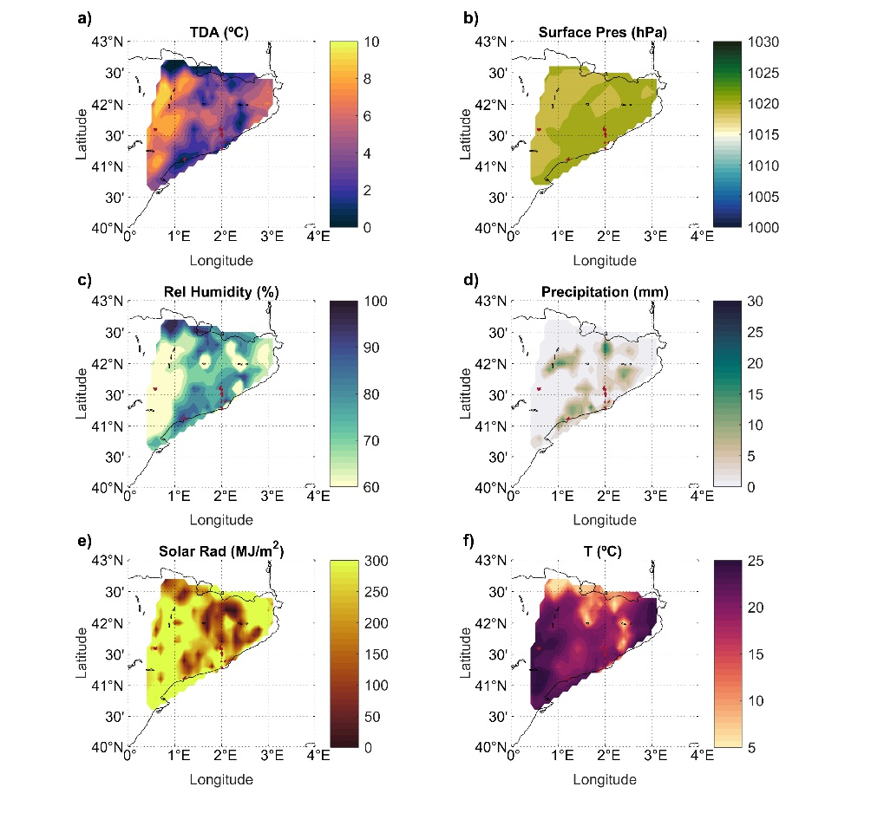
Figure S1. (a-f) Climate variables distribution along the Catalan region in September 9, 2020, as obtained from the 187 automatic weather stations (AWS). The BHAs selected for our study are represented in red, with a population density higher than 500 inhabitants per squared kilometre.
On September 18 and 19, 2020, another front entered from the east, leaving notable precipitations in all BHAs up to 20 mm, mostly those in the region's interior. The relative humidity was 80% near Barcelona, daily thermal amplitudes of 4 ºC on the coast and around 9.7 ºC in Lleida, and fairly homogeneous surface pressure near 1014 hPa. On October 2 and 10, precipitation appeared again. On October 2, minimum radiation, temperature variation, surface pressure and relative humidity recorded maximum values in most BHAs. Surface pressure and relative humidity experienced a gradual increase in the next days until reaching a maximum on October 10, with the heaviest precipitation and highest relative humidity for the entire month. On October 14, there was again an event of low temperature, significant precipitation, low solar irradiation, humidity above 60% and daily thermal amplitudes of 7ºC near Barcelona. Finally, by the end of the second wave, from November 3 to 7, a precipitation front entered from the north, generating widespread intermittent precipitation throughout Catalonia, coinciding with a remarkable minimum of solar radiation down to 100 MJ m⁻² and surface pressure around 1024 and 1025 hPa, low thermal amplitude around 2 ºC and relative humidity between 70 and 96%.
Figure S2 shows, for each BHA, the time series of all eight climatic variables considered in our study together with the normalized number of positive cases of COVID-19, ${\hat{\text{N}}}_{\text{PCR,+}}^{}$, and the infection index I_{c}. Details of the evolution of I_{c} and ${\hat{\text{N}}}_{\text{PCR,+}}^{}$ during the second wave in all the BHAs has been included in the main text. For the BHA BCN-10A, this information has been complemented with a brief weather description according to the information provided in this section.
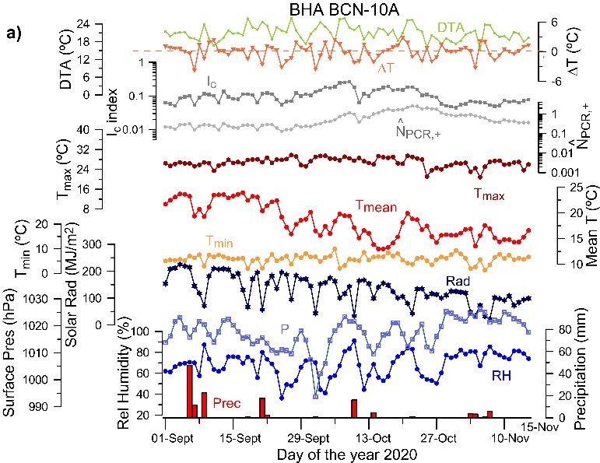 | 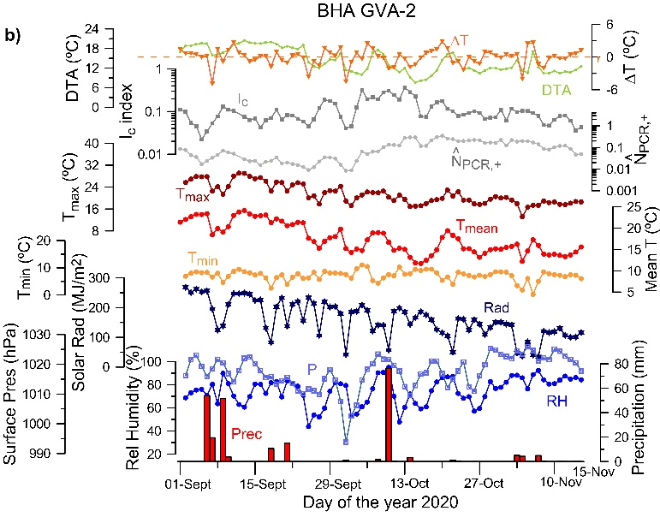
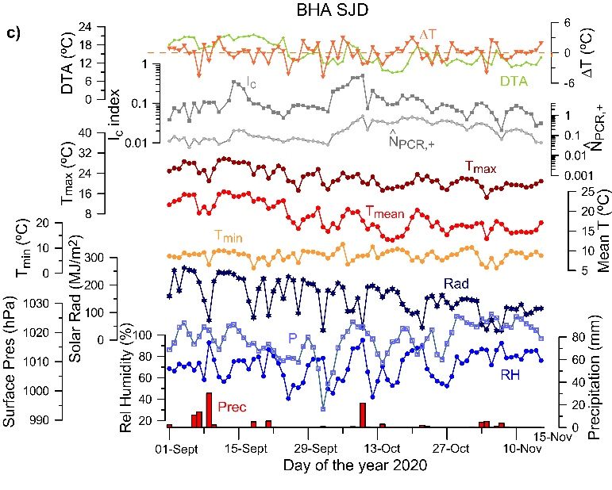 | 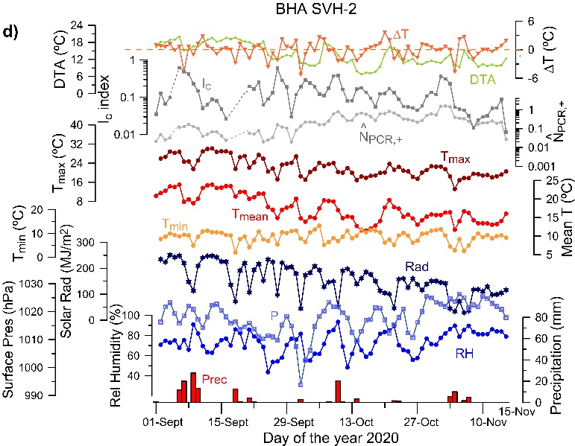
Figure S2. Time series of climate variables registered during the COVID-19 second wave (September 1 to November 15) together with the normalised number of cases (N_{PCR}) and the infection rate (I_{c}) in all the BHAs, as indicated. The climate variables analysed in the study are mean temperature (T_{mean}), relative humidity (RH), solar radiation(Rad), precipitation (Prec), surface pressure (P), minimum and maximum temperature (T_{min},T_{max}),daily thermal amplitude (DTA) as well as mean temperature difference between consecutive days (ΔT). The units for these variables are indicated in their corresponding axes.

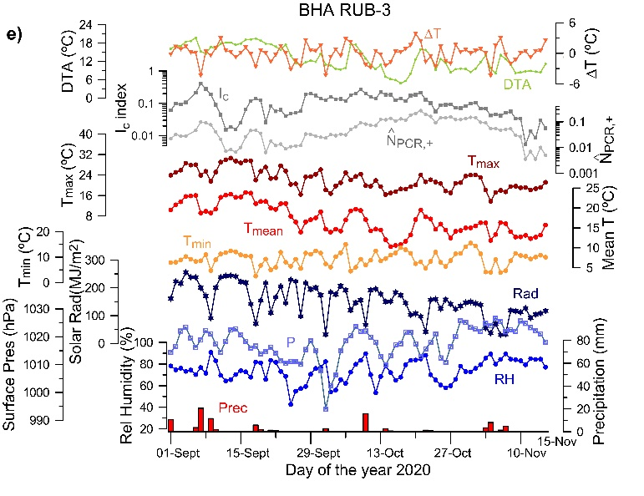 | 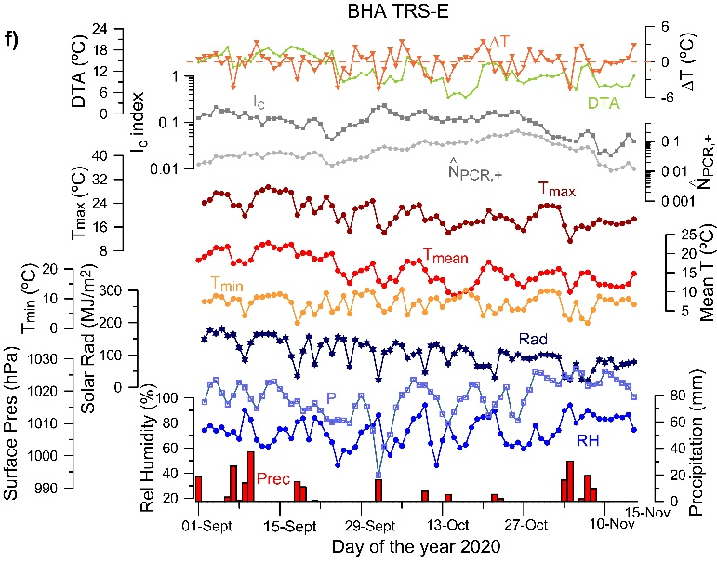
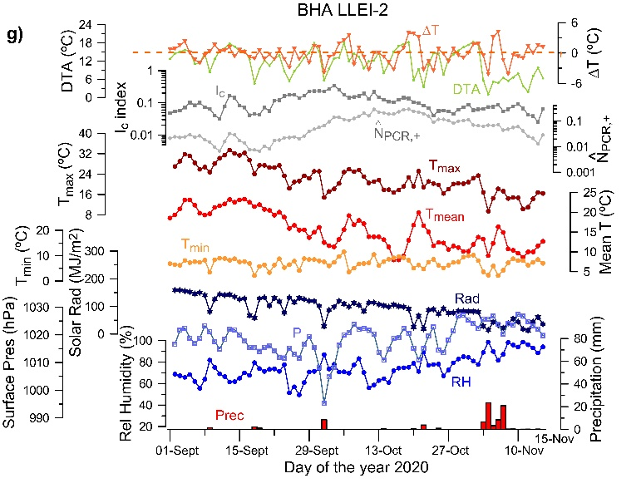 | 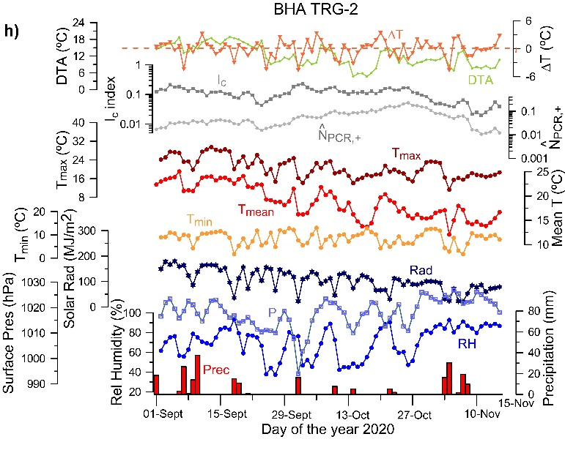

Figure S2 (continued)

Time lags between infection index and weather variables
Figure S3 shows the dependence of the cross-correlation coefficients between the infection index and the climatic variables as a function of time lag, in days, for all eight BHAs (BCN-10A, GVA-2, SJD, SVH-2, RUB-3, TRS-E, LLEI-2 and TRG-2).

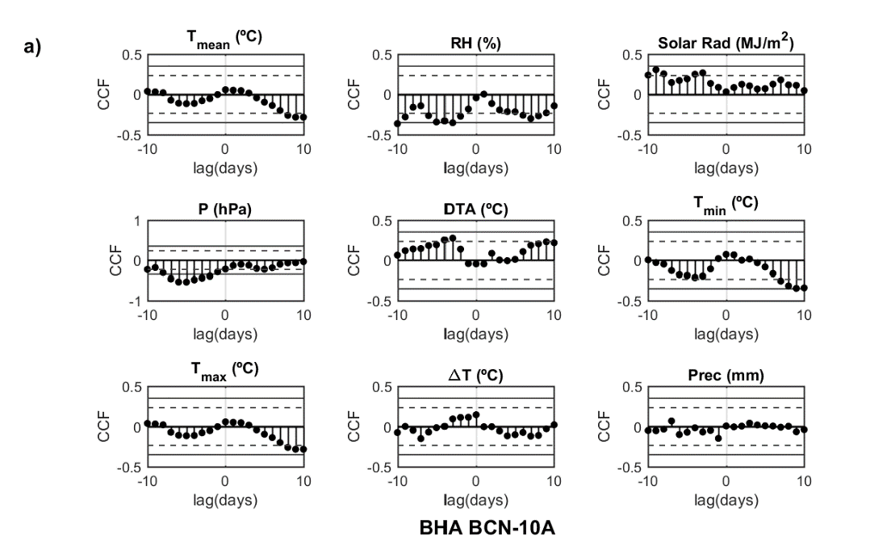
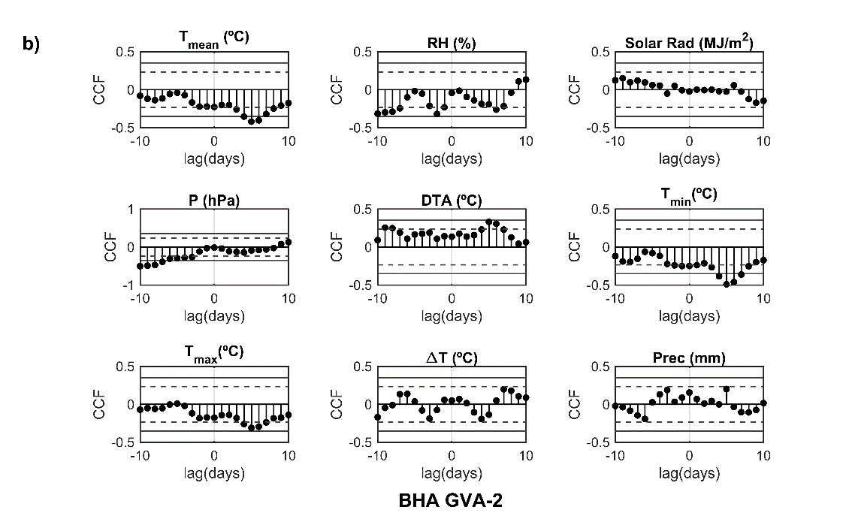
Figure S3. Plots of the cross-correlation coefficient functions of the infection index with the climatic variables as a function of time lag, in days, for the eight BHAs: (a) BCN-10A, (b) GVA-2, (c) SJD, (d) SVH-2, (e) RUB-3, (f) TRS-E, (g) LLEI-2, and (h) TRG-2. The horizontal dashed and solid lines indicate the statistical significance at 95% and 99% confidence levels.
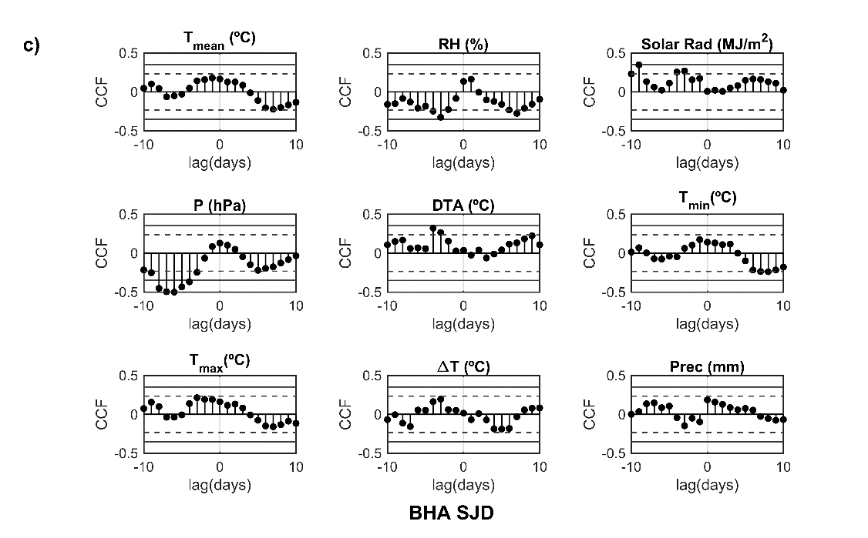
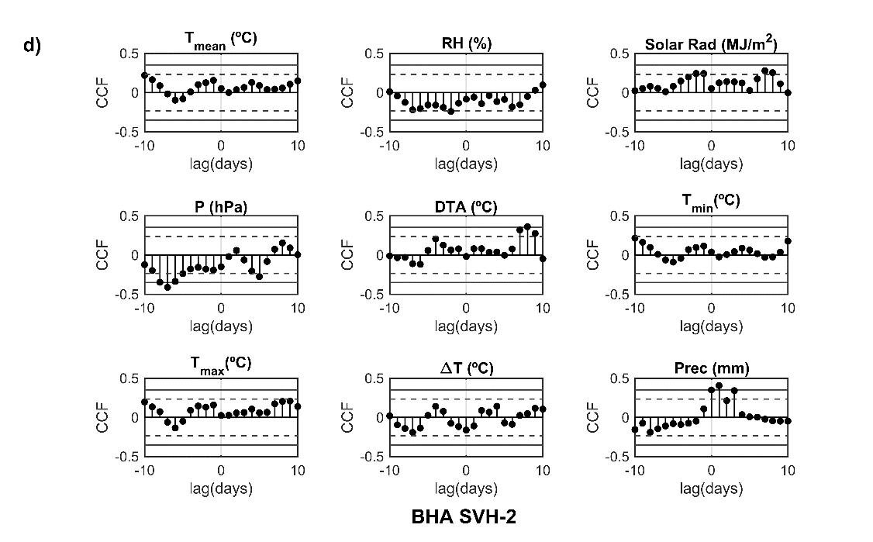
Figure S3 (continued)
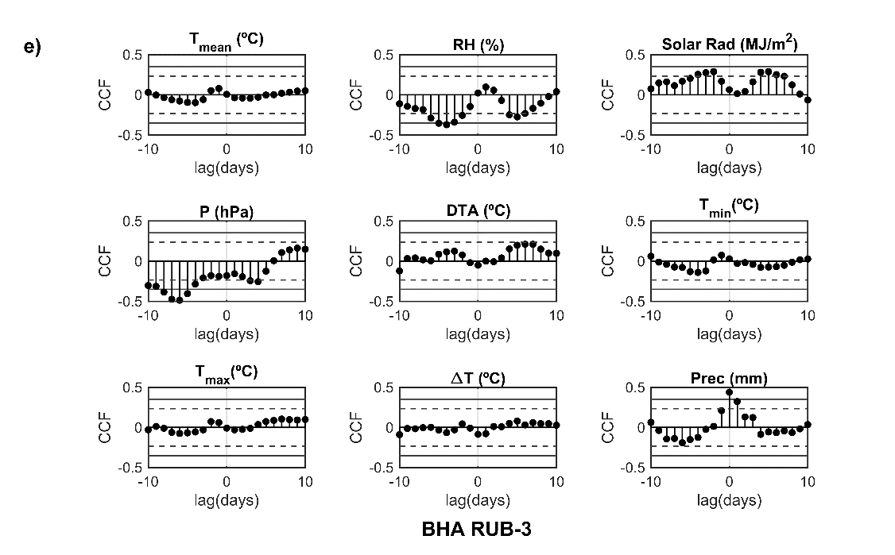
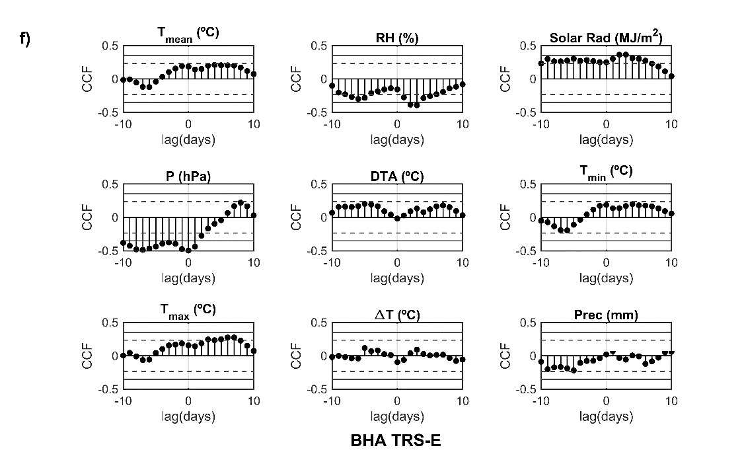
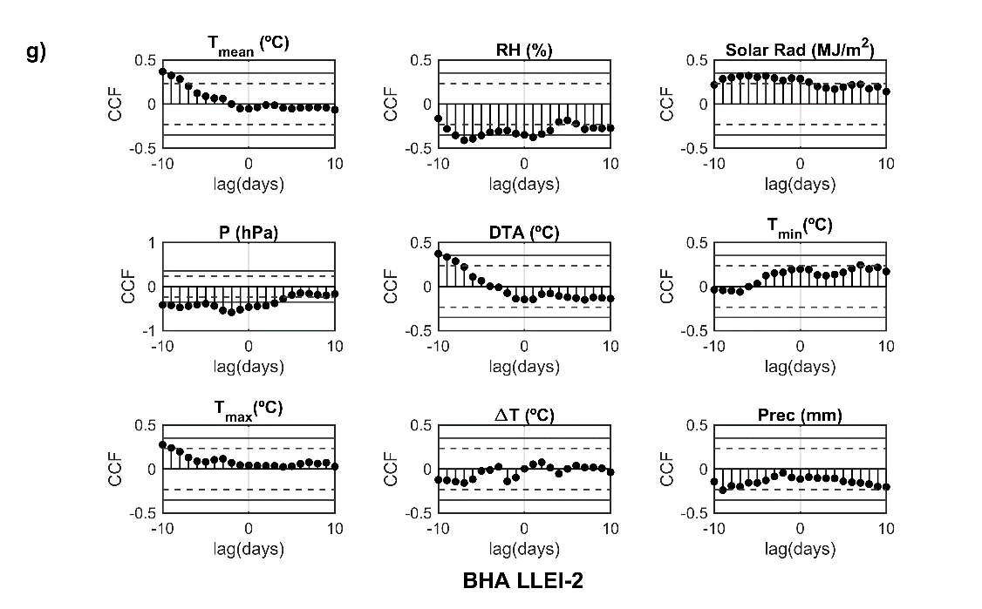
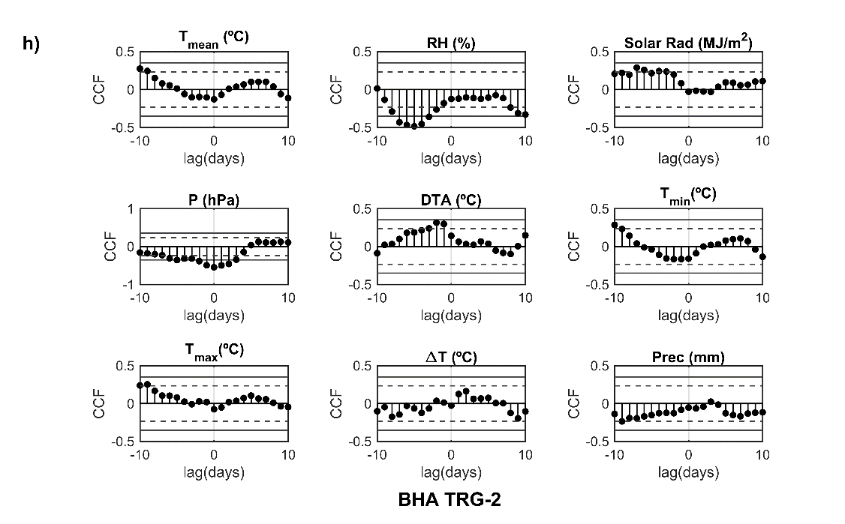
Figure S3 (continued)
Model parameters and statistics
Based on the cross-correlation analysis (see details in Methods) only the surface pressure P and the relative humidity RH, have been considered as potential predictors to build the model. The propagation of the virus on the predictors is modelled using a multiple linear regression as it has been described in Eq. (3) (Methods). The collinearity between the two predictors has been inspected and the results of the collinearity tests are shown in the Table S1. The variables have positive but weak correlation (r_{P,RH}) with values that range between 0.2 and 0.4. However, in all BHAs, this correlation is significant at 90% confidence level (critical p-value, p_{TS,crit} = 0.1). It indicates that the association between surface pressure and relative humidity could be important and collinearity effects may not be disregarded at this significance level. Hence, the relationship between the two predictors has been also analysed through the variance inflation index of the two predictors used in the model (VIF). It is found that the values of the VIF are smaller than 2.5 for all areas, which is the more conservative threshold suggested in literature. We conclude that, although collinearity between the surface pressure and the relative humidity could exist, the effects on the model parameters are not severe and they can be considered independent.
After the inspection of the collinearity between candidate predictors, hypothesis tests have been applied to the coefficients of the model, in a joint and a separate way. If we test the model as a whole, the joint test inspects whether the multiple regression model provides a better fit to the observations than a model that contains no predictors. The results of the joint F-test are shown in Table S2. Based on these results, we can conclude that there is a strong evidence that at least one of the two climatic variables is linearly related to the observations in all BHAs (p-value < 0.01). However, it does not mean that the two predictors must be included in the model to explain this relationship.

 | r_{P,RH} | t_{TS} | p_{TS} | VIF
BCN-10A | 0.24** | 2.06 | 0.042 | 1.06
GVA-2 | 0.21* | 1.84 | 0.069 | 1.05
SJD | 0.22* | 1.92 | 0.059 | 1.05
SVH-2 | 0.30** | 2.63 | 0.011 | 1.10
RUB-3 | 0.31*** | 2.77 | 0.007 | 1.11
TRS-E | 0.26** | 2.32 | 0.023 | 1.07
LLEI-2 | 0.36*** | 3.29 | 0.002 | 1.15
TRG-2 | 0.30*** | 2.66 | 0.005 | 1.10

Table S1. Statistical descriptors used to analyse the collinearity effects in the model: 1) r_{P,RH}, the correlation coefficient between surface pressure and relative humidity; 2) t_{TS}, the t-statistic of the significance correlation test; 3) p_{TS}, the p-value associated to the test statistic, t_{TS} ;4) VIPthe variance inflation factor for the surface pressure. The asterisks indicate that the correlation is significant at ‘*’ 90 %; ‘**’ 95%; ‘***’ 99% confidence level or ‘⁺’ not statistically significant at 90% confidence level.

 | RMSE | r² | r²_{adj} | F-statistic | p-value
BCN-10A | 0.0445 | 0.31 | 0.29 | 15.7 | < 0.01
GVA-2 | 0.0676 | 0.18 | 0.16 | 7.56 | < 0.01
SJD | 0.0827 | 0.31 | 0.29 | 15.3 | < 0.01
SVH-2 | 0.0996 | 0.26 | 0.24 | 12.1 | < 0.01
RUB-3 | 0.0505 | 0.45 | 0.43 | 28.0 | < 0.01
TRS-E | 0.0410 | 0.29 | 0.27 | 14.3 | < 0.01
LLEI-2 | 0.0580 | 0.27 | 0.25 | 12.7 | < 0.01
TRG-2 | 0.1830 | 0.17 | 0.14 | 6.82 | < 0.01

Table S2. Goodness-of-fit parameters of the model built with the two candidate predictors, the surface pressure and the relative humidity. Abbreviations: RMSE, root-mean-square error; r², the coefficient of determination; r²_{adj}, the adjusted coefficient of determination; F, the joint F-statistic, and p-value is its corresponding p-value.

The addition of predictors has been tested using the stepwise estimation method and it has been applied forwards. The results for each BHA are shown in Table S3. In all stations except TRG-2, the process starts with the surface pressure, which is the predictor with the highest correlation coefficient with the infection index. The critical value of the partial F-statistic, F*_{par} at 90% confidence level is 2.78. The values of the F_{par} reveal that the addition of the relative humidity is not significant in GVA-2, SVH-2 and TRS-E, and it should be removed from the final model. On the other hand, in TRG-2, the model does not improve when the surface pressure is added and it is hence removed from the final model. To summarize, we can conclude that the final model includes two predictors that are significant at least with a 90 % confidence level in four of the eight health areas. In the other four areas, only one predictor would have a significant contribution to the final model (three areas for the surface pressure and one for the relative humidity).
The inspection of the individual t-tests (Tables S4, S5 and S6) corroborates the results obtained from the stepwise estimation method. For the surface pressure, the tests indicate that the regression coefficients significantly differ from zero with 99% confidence level in all BHAs except TRG-2. However, if the test is performed for the relative humidity, the regression coefficients are significant in five of the BHAs but at lower confidence level (90%); in this case, GVA-2, SVH-2 and TRS-E exhibit non-significance at a minimum confidence level of 90 %, which is in agreement with the results presented in the Table S3.

 | c₀ | SE | t-statistic | p-value
BCN-10A | 4.18*** | 0.94 | 4.44 | <0.01
GVA-2 | 4.98*** | 1.44 | 3.47 | <0.01
SJD | 8.06*** | 1.74 | 4.62 | <0.01
SVH-2 | 9.83*** | 2.14 | 4.60 | <0.01
RUB-3 | 6.64*** | 1.08 | 6.14 | <0.01
TRS-E | 4.42*** | 0.86 | 5.13 | <0.01
LLEI-2 | 5.22 *** | 1.31 | -3.80 | <0.01
TRG-2 | 5.83⁺ | 4.05 | 1.44 | 0.15

Table S3. Statistical descriptors for the intercept c₀ of the relative humidity, in the model built with the two candidate predictors: surface pressure and relative humidity. Abbreviations: SE, the standard error of c₀; t-statistic, the t-statistic of the hypothesis test; p-val, the p-value of the hypothesis test. The asterisks indicates that the regression coefficient is significant at ‘*’ 90 %; ‘**’ 95%; ‘***’ 99% confidence level or ‘⁺’ not statistically significant at 90% confidence level.

 | c₁ (10⁻³ hPa⁻¹) | SE (10⁻³ hPa⁻¹) | t-statistic | p-value
BCN-10A | -3.92 *** | 0.93 | -4.21 | < 0.01
GVA-2 | -4.71*** | 1.42 | -3.32 | < 0.01
SJD | -7.69*** | 1.72 | -4.46 | < 0.01
SVH-2 | -9.49 *** | 2.12 | -4.47 | < 0.01
RUB-3 | -6.31*** | 1.07 | -5.87 | < 0.01
TRS-E | -4.22*** | 0.85 | -4.94 | < 0.01
LLEI-2 | -4.94*** | 1.30 | -3.80 | < 0.01
TRG-2 | -5.30⁺ | 1.42 | -2.88 | 0.19

Table S4. Statistical descriptors for the regression coefficient c₁ of the surface pressure, in the model built with the two candidate predictors: surface pressure and relative humidity. Abbreviations: SE, the standard error of c₁; t-stat, the t-statistic of the hypothesis test; p-val, the p-value of the hypothesis test. The asterisks indicates that the regression coefficient is significant at ‘*’ 90 %; ‘**’ 95%; ‘***’ 99% confidence level or ‘⁺’ not statistically significant at 90% confidence level.

 | c₂ (10⁻³) | SE (10⁻³) | t-statistic | p-value
BCN-10A | -1.15** | 0.44 | -2.57 | 0.012
GVA-2 | -0.87⁺ | 0.69 | -1.26 | 0.211
SJD | -1.64** | 0.75 | -2.19 | 0.032
SVH-2 | -0.70⁺ | 1.10 | -0.63 | 0.529
RUB-3 | -1.57** | 0.61 | -2.58 | 0.012
TRS-E | -0.31⁺ | 0.85 | -4.94 | 0.497
LLEI-2 | -1.07* | 0.63 | -1.68 | 0.097
TRG-2 | -4.11*** | 1.42 | -2.88 | 0.005

Table S5. Statistical descriptors for the regression coefficient c₂ of the relative humidity, in the model built with the two candidate predictors: surface pressure and relative humidity. Abbreviations: SE, the standard error of c₂; t-stat, the t-statistic of the hypothesis test; p-val, the p-value of the hypothesis test. The asterisks indicates that the regression coefficient is significant at ‘*’ 90 %; ‘**’ 95%; ‘***’ 99% confidence level or ‘⁺’ not statistically significant at 90% confidence level.

 | SSR₁ | SSR₂ | SSE₂ | $${\text{r}}_{\text{1}}^{\text{2}}$$ | $${\text{r}}_{\text{2}}^{\text{2}}$$ | Δr | F_{par} | p-value
BCN-10A | 0.0489 | 0.0620 | 0.1363 | 0.2464 | 0.3125 | 0.0661** | 6.60 | 0.012
GVA-2 | 0.0617 | 0.0690 | 0.3149 | 0.1608 | 0.1797 | 0.0189⁺ | 1.58 | 0.213
SJD | 0.2368 | 0.2027 | 0.4719 | 0.3067 | 0.2586 | 0.0481** | 4.79 | 0.032
SVH-2 | 0.2368 | 0.2407 | 0.6845 | 0.2559 | 0.2602 | 0.0043⁺ | 0.40 | 0.529
RUB-3 | 0.1259 | 0.1428 | 0.1757 | 0.3953 | 0.4484 | 0.0531** | 6.65 | 0.012
TRS-E | 0.0474 | 0.0482 | 0.1159 | 0.2887 | 0.2935 | 0.0048⁺ | 0.47 | 0.495
LLEI-2 | 0.0758 | 0.0853 | 0.2320 | 0.2388 | 0.2687 | 0.0299* | 2.82 | 0.098
TRG-2 | 0.3977 | 0.4562 | 2.3075 | 0.1439 | 0.1651 | 0.0212⁺ | 1.75 | 0.190
Table S6. Statistical parameters for the partial F-test. The subindex 1 and 2 indicates the model with the remaining predictor removed (1) or added (2). Abbreviations: SSR, the sum of the squares of the regression for the corresponding model; SSE, the sum of the squares of the error for the corresponding model; r², R-squared for the corresponding model; Δr², difference between ${\text{r}}_{\text{1}}^{\text{ 2}}$ and ${\text{r}}_{\text{2}}^{\text{ 2}}$; F_{par}, partial F-statistic of the test; p-val, the p-value associated with the test statistic. At 90 % of confidence level, the critical value of the partial F-statistic is ${\text{F}}_{\text{par}}^{\text{*}}$ = 2.78. The asterisks denotes that the differences in the determination coefficients are significant at ‘*’ 90 %; ‘**’ 95%; ‘***’ 99% confidence level or ‘⁺’ not statistically significant at 90% confidence level.

The infection index has been used to fit the data to the model and obtain the estimates of the parameters c_{i} ∀ [1,3] of Eq. 3 (Methods). Following the results of the partial F-test, some of the regression coefficients, c₁ or c₂ are set to 0 in several health areas. Table S7 summarizes the regression coefficients and several goodness-of-fit parameters used to describe how well the linear regression fits the corresponding model in each BHA. In this case, the standard R-squared (r²) and its adjusted coefficient (r²_{adj}) are displayed in Table S7. The analysis of the coefficients listed in this table shows that the values of the coefficient c₁ are significant at 95 % confidence level. The values of c₁ vary within [-10, -3]×10⁻³ hPa⁻¹ (mean(c₁) = -5.90×10⁻³ hPa⁻¹; std(c₁) = 1.90×10⁻³ hPa⁻¹). On the other hand, the values of c₂ significant at a lower confidence level (95%) and they range between -4×10⁻³ and -1×10⁻³ ( mean(c₂) =-1.91×10⁻³ ; std(c₂) =1.12·×10⁻³). The intercept c₀ is found to be significant at 95% confidence level in all BHAs except TRG-2 (c₀ ∈ (0.4, 10); mean(c₀ ) = 6.15; std(c₀) = 1.82).
The analysis of the residuals of the regression fit has also been performed in order to investigate other relevant assumptions in the linear models. For example, the assumption of normality has been inspected first from the probability plots of the standardized residuals, which have been compared to the normal distribution (Figure S4). In some BHAs, the visual inspection of the plots reveals the presence of long upper tails in the empirical distributions, which substantially deviate from the expected normal distributions. These tails are easily identified in the probability plots for the residuals obtained in SJD, SVH-2 or TRG-2. The Kolmogorov-Smirnov (K-S) test has been performed to investigate whether the deviations from normality observed in the probability plots are significant or not. The results of the K-S test (Table S8) show that the normality of the residuals is satisfied at 95% confidence level in all the BHAs except in TRG-2. On the other hand, the White test for heteroscedasticity (conducted at 99 % confidence level) indicate that variance of the errors is constant (null hypothesis is not rejected) in all the areas. The deviations observed in the tails and the use of low significance levels in the heteroscedasticity tests (α = 0.01) could suggest some problems in the collection of the samples in some of the BHAs. In fact, it is known that data reporting was a relevant issue that affected the positive cases reported during the early waves of the pandemic.

 | c₀ | c₁ (10⁻³ hPa⁻¹) | c₂ (10⁻³) | RMSE | r² | r²_{adj} | F | p-value
BCN-10A | 4.18*** | -3.92*** | -1.15** | 0.045 | 0.31 | 0.29 | 15.7 | < 0.01
GVA-2 | 5.30*** | -5.106*** | 0 | 0.068 | 0.16 | 0.15 | 13.4 | < 0.01
SJD | 8.06*** | -7.69*** | -1.64** | 0.083 | 0.31 | 0.29 | 15.3 | < 0.01
SVH-2 | 10.20*** | -9.89*** | 0 | 0.099 | 0.26 | 0.25 | 24.1 | < 0.01
RUB-3 | 6.64*** | -6.31*** | -1.57** | 0.051 | 0.45 | 0.43 | 28.0 | < 0.01
TRS-E | 4.56*** | -4.38*** | 0 | 0.041 | 0.29 | 0.28 | 28.4 | < 0.01
LLEI-2 | 5.22*** | -4.94*** | -1.07** | 0.058 | 0.27 | 0.25 | 12.7 | < 0.01
TRG-2 | 0.47*** | 0 | -4.67** | 0.184 | 0.14 | 0.13 | 11.8 | < 0.01
Table S7. Final model parameters for the propagation of the virus in each BHA, as constructed by forward stepwise regression. The intercept and the regression coefficients are expressed as c₀ and c₁ and c₂ respectively. The asterisks indicate that the coefficients are significant at ‘*’ 90 %; ‘**’ 95%; ‘***’ 99% confidence level or ‘⁺’ not statistically significant at 90% confidence level. Other relevant statistical parameters: Root-mean-square error (RMSE) of the linear fit, the R-squared (r²), its adjusted version r²_{adj} and the joint F-statistic (F) along with its corresponding p-value.
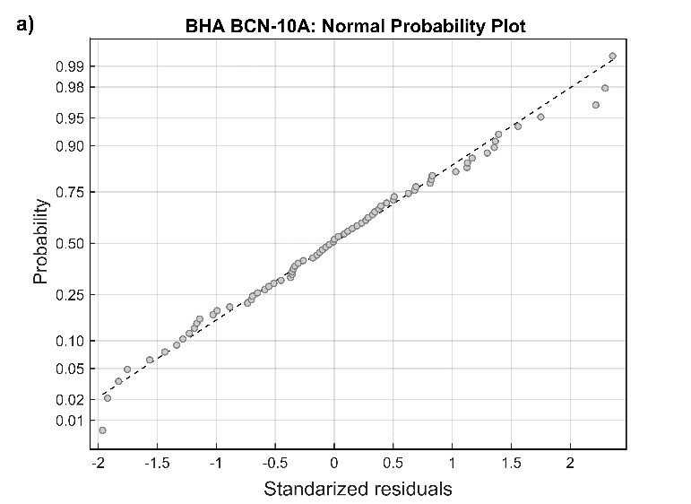 | 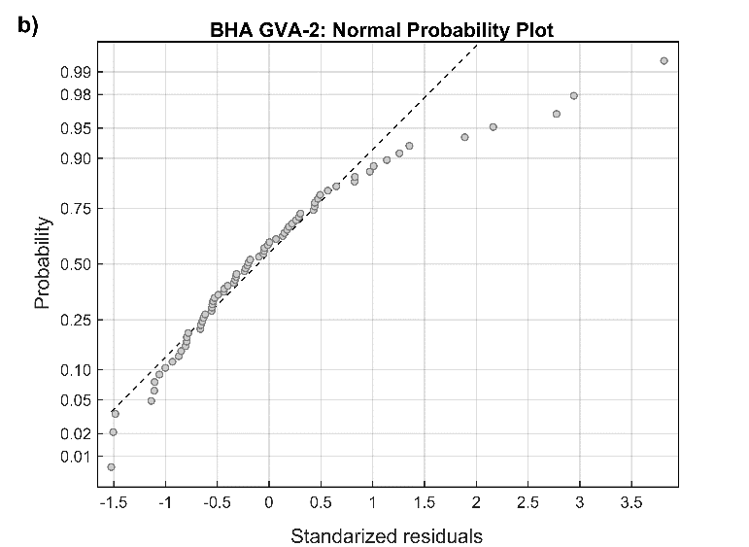
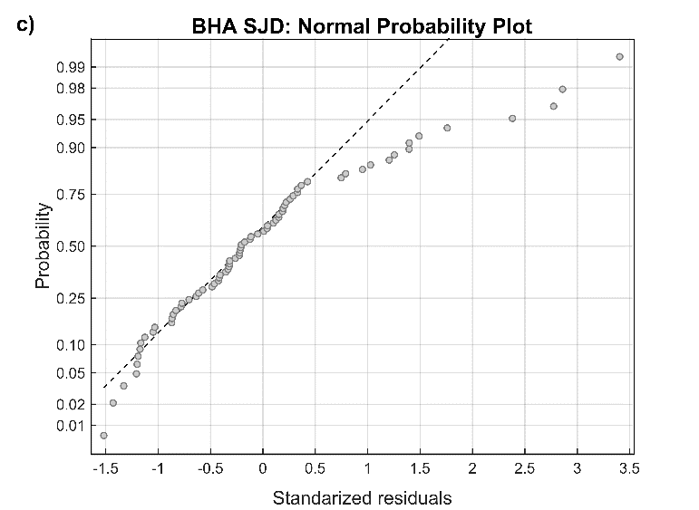 | 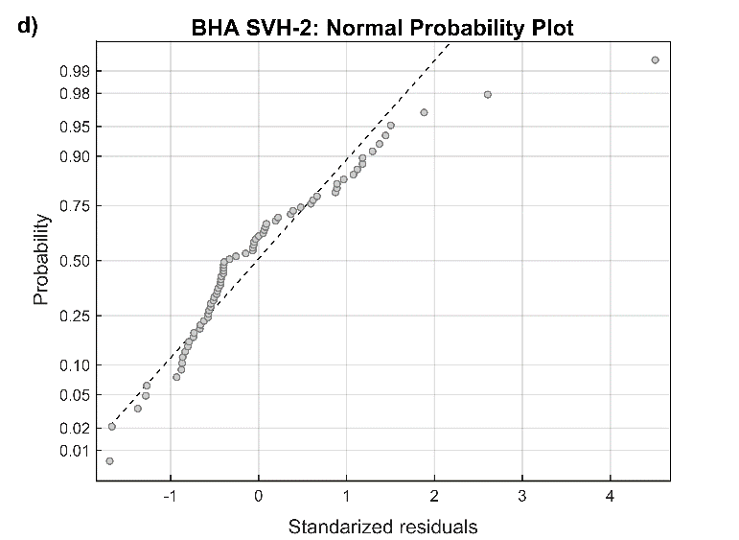
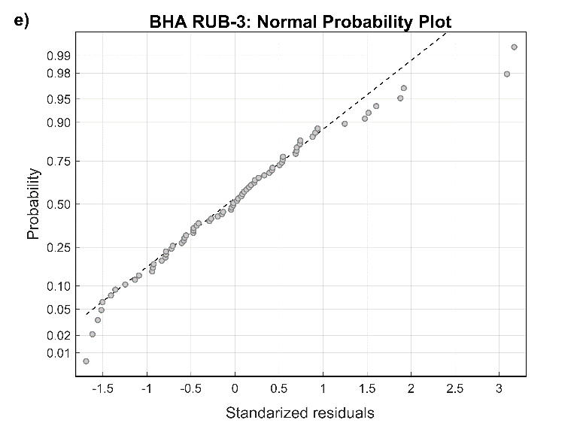 | 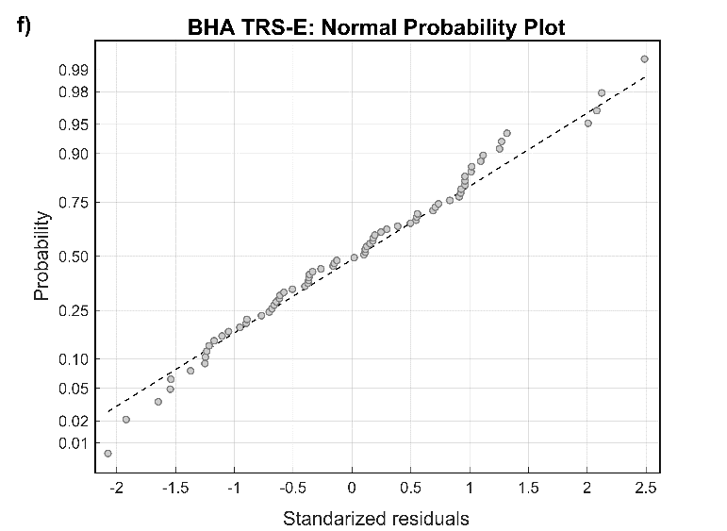
Figure S4. Probability plots of the standardized residuals fitted to a normal distribution.

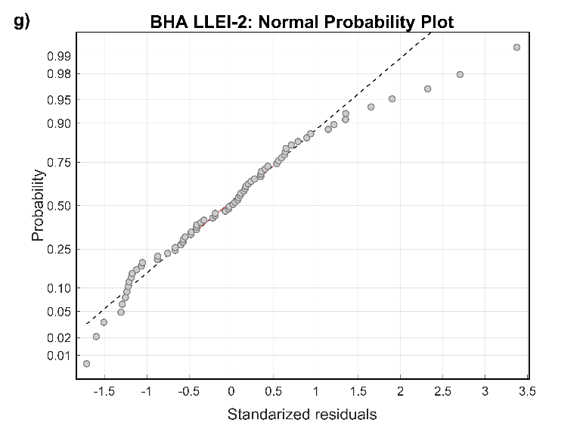 | 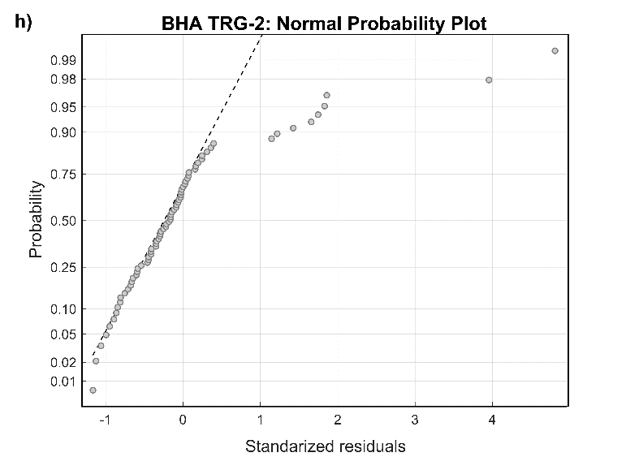
Figure S4 (continued)

 | KS-statistic | q-val_{KS} | χ ² | p-val_{HT}
BCN-10A | 0.042 | 0.999 | 14.35 | 0.013
GVA-2 | 0.117 | 0.253 | 1.22 | 0.543
SJD | 0.152 | 0.064 | 17.09 | 0.004
SVH-2 | 0.155 | 0.056 | 2.68 | 0.262
RUB-3 | 0.076 | 0.769 | 4.52 | 0.477
TRS-E | 0.062 | 0.931 | 0.99 | 0.610
LLEI-2 | 0.078 | 0.739 | 0.05 | 0.022
TRG-2 | 0.236 | < 0.001 | 2.21 | 0.331

Table S8. Results of the hypothesis tests conducted to inspect the assumptions of normality (Kolmogorov-Smirnov test) and heteroscedasticity (White test) of the residuals. The table includes the statistics (KS stat and χ² – stat) and the $p$-values of each test.

Internal validation of the model setup during the pandemics second wave
The predictions for the infection index in each BHA have been estimated using the linear model described in Eq. (8) (see in Methods), with the coefficients c₀, c₁ and c₂ in this equation replaced with the corresponding values listed in Table S7. The results obtained in each BHA (n = 72) are shown in Figure S5, where the grey circles indicate the observed values I_{c} represented against the predictions I_{c,pred}. The dashed line corresponds to the regression line between the two variables, I_{c} and I_{c,pred}. As it is expected from the model, the slope and the $y$-intercept of the linear regressions are equal to 1 and 0 respectively, and both are statistically significant (the t-statistic for these parameters is close to 0).
Figure S5 also includes data of the validation performed internally using the leave-one-out cross validation (LOOCV) method. In most of the BHAs, the results of the LOOCV method show that the cross-validated I_{c,[i]} values fall close to the predictions I_{c,pred} obtained from the model. Concretely, these values are very similar for small and moderate values of the infection index I_{c} (I_{c} ≅ [0.05, 0.15]). However, if very small and large values of I_{c} are considered, the cross-validated I_{c,[i]} indexes deviate substantially from their corresponding predictions I_{c,pred} . In general, if the value of I_{c} is large, the model underestimates the real value and the cross-validated value is lower than prediction. On the other hand, the model has the opposite behaviour for very small values of I_{c}, indicating possible model overestimation. This is in accordance with the deviations from normality observed in the upper tails of the probability distribution plots of the residuals, especially in SJD, GVA-2 and TRG-2 (Figure S4). For SVH-2, the differences between I_{c,pred} and I_{c,[i]} are in the range of observations. This is also in agreement with the probability plot of the residuals obtained in this area. Thus, Figure S5 suggests that the model have some limitations to predict adequately the highest and lowest values of the infection index. This could be related to the absence of relevant variables in the model, such as mobility factors, which can impact in the predictions particularly in these extreme situations, when these factors can play an important role. On the other hand, the internal dynamics of each BHA could also affect the report of positive cases in time. Finally, if sudden changes are detected in the observations, then the linear model can experience some difficulties to properly capture these variations.

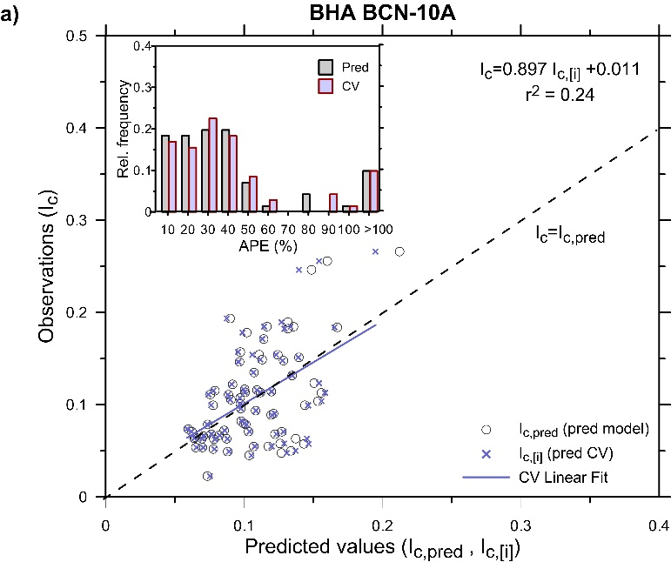 | 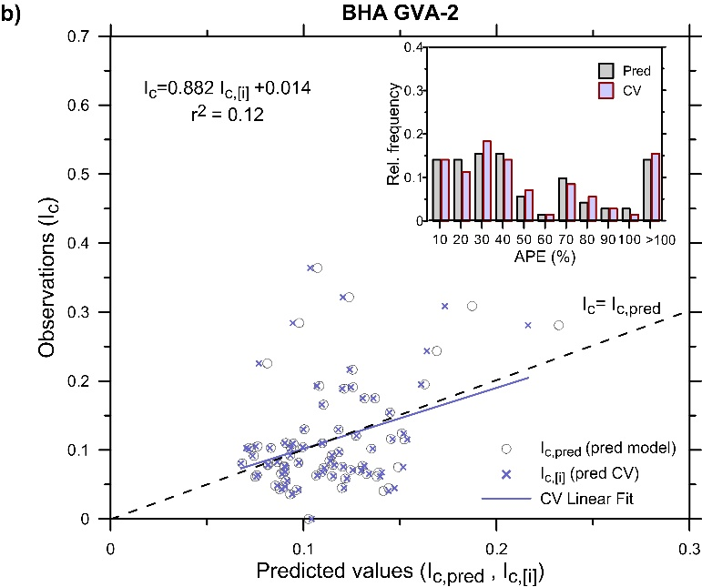
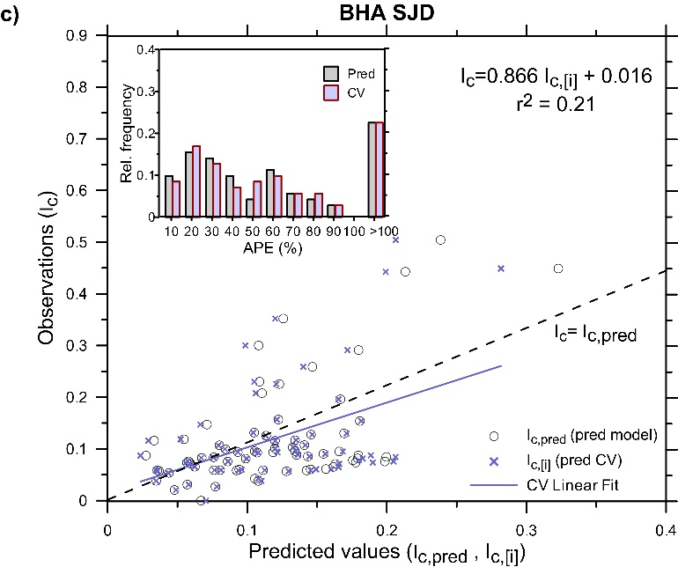 | 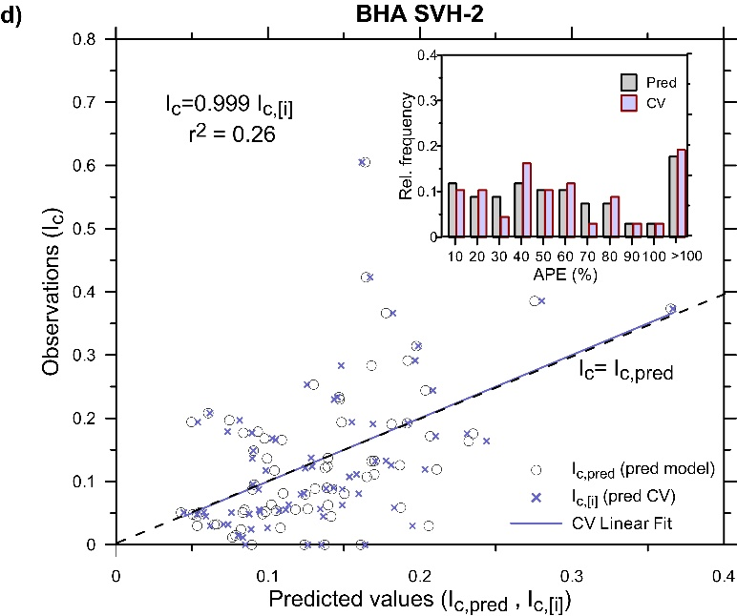
Figure S5. (a-h) Plots for the eight BHAs showing the actual infection index I_{c} plotted as a function of the corresponding model predictions I_{c,pred} (grey circles) and as a function of the cross-validated $I_{c, [i]}$ values obtained using the LOOCV method (blue crosses). The lines in the graphs indicate the regression fits for the observations and the model predictions (dashed black lines) or the cross-validated data (blue solid lines). The linear equations that correspond to the cross-validation dataset (blue crosses) are displayed in each graph along with their R-squared. Each graph also includes a multiple bar chart of the absolute percentage errors (APE) of the measurements, which have been grouped into intervals of 10%, using the model (grey bars) and the cross-validation method (blue bars).

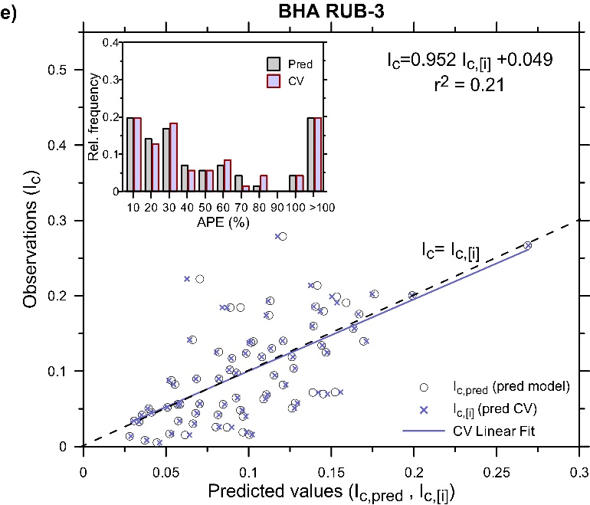 | 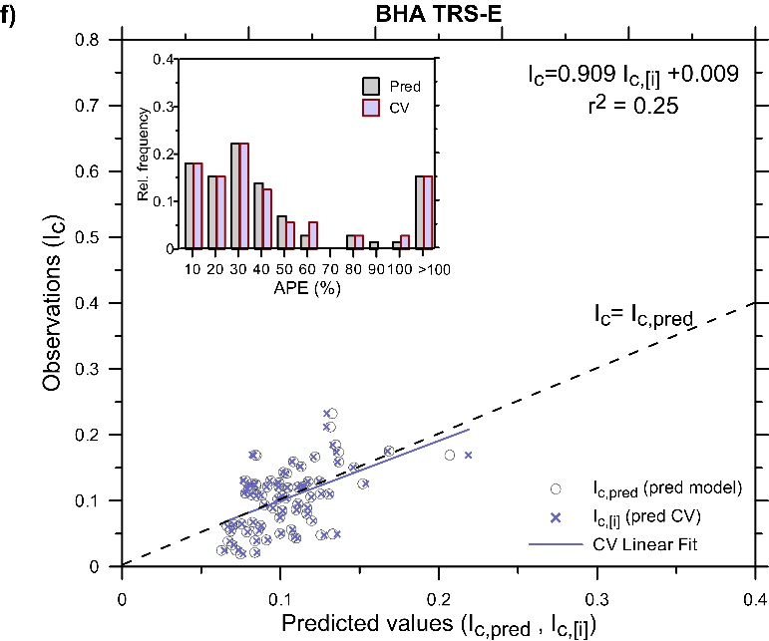
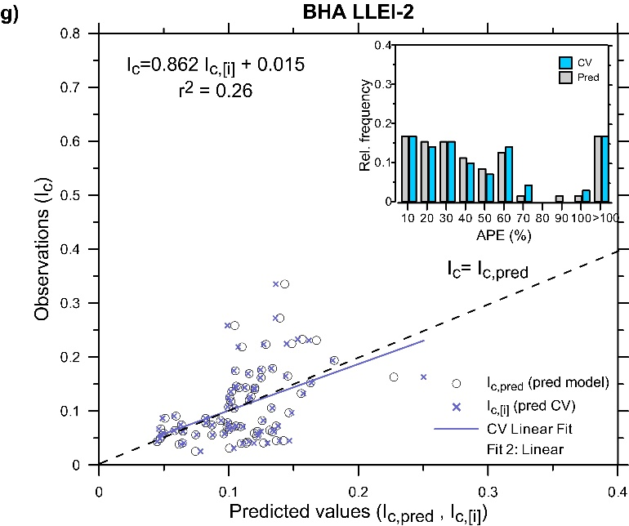 | 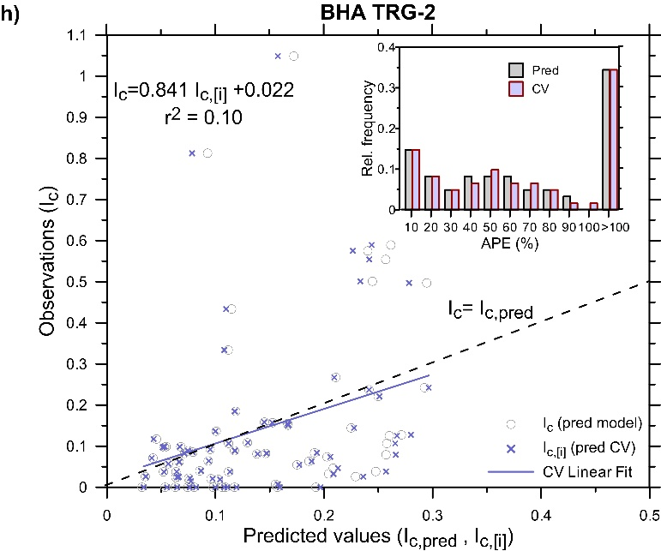
Figure S5 (continued)
The differences between the observed and the predicted values found in each BHA have been evaluated by the absolute percentage error APE_{i} of each measurement. These errors have been grouped into intervals of 10 % in the range from 0 to 100 % and the values of APE_{i} ≥ 100 % have been included into a single interval. To validate the model, the same procedure has been applied to the errors made when cross-validation was used (APE_{[i]}). The results obtained in each of the BHAs are displayed in the multiple charts inserted in the upper part of Figure S5, showing the prediction errors of the measurements using the model and the cross-validation.
The relationship between the observed and the predicted values has been assessed by the regression analyses. Table S9 includes the estimation of several statistical parameters for the model and the cross-validation, such as R-squared, MAPE and RMSE. The two values are compared in order to test the overall performance of the model. These results are complemented with the analysis of the $y$-intercept (${\text{β}}_{\text{0}}^{\text{ CV}}$) and the slope (${\text{β}}_{\text{1}}^{\text{ CV}}$) of the linear regression between the observed and the cross-validated values (Table S10) in order to check whether they differ significantly from the expected values, which are β₀ = 0 for the y-intercept and β₁ = 1 for the slope. The sources of the prediction errors can be associated with the mean differences between observed and predicted values (bias), the deviations from the 1:1 line (slope) and the unexplained variance. The significance tests for ${\text{β}}_{\text{0}}^{\text{ CV}}$ = 0 (bias) and ${\text{β}}_{\text{1}}^{\text{ CV}}$ = 1 (dispersion around the 1:1 line) allows assessing the predictive ability of the model based on the results of the cross-validation, that is, if the model is consistent (unbiased and with small differences between observations and predictions).
Table S9 shows that, for all the BHAs analysed, the linear fits of the observations and the predictions (Figure S5) have low R-squared coefficients, with values between about 0.15 and 0.45. The corresponding adjusted coefficients vary in a similar range, indicating that the predictions are able to explain at least about 15% of the variance observed in the observations, e.g. in TRG-2. However, these values increase up to about 30 % in other BHAs (BCN-10A or LLEI-2) and reach their maximum value (about 45%) for RUB-3. Although the low values can be related to the high variability of the data (Figure S5), the F-test of overall significance for the linear regressions indicates that there is statistical evidence (p-val< 0.01, not shown) of the existence of a linear dependence of the observed I_{c} index on the predictors (pressure and/or relative humidity). As mentioned previously, the linear regression intercepts the y-axis atβ₀ = 0 with slope β₁ = 1, indicating that most of the errors in the predictions are associated with unexplained variance. As the model aims to describe only the effect of weather on the propagation of the virus in the all Catalonia, this type of error could be attributed not only to the lack of other relevant variables in the model, such as mobility factors, but also to specific conditions of each BHA (e.g. population density, urban pattern, neighbouring areas) and possible local effects of the climatic predictors.

 | r² | r²_{adj} | MAPE (%) | MAPE | q²_{CV} | q²_{CV,adj} | MAPE_{CV} (%) | RMSE_{CV}
BCN-10A | 0.31*** | 0.29 | 40.02 | 0.044 | 0.24*** | 0.23 | 41.76 | 0.045
GVA-2 | 0.16*** | 0.15 | 50.50 | 0.067 | 0.12*** | 0.11 | 51.79 | 0.069
SJD | 0.31*** | 0.29 | 59.24 | 0.082 | 0.21*** | 0.19 | 61.92 | 0.085
SVH-2 | 0.26*** | 0.25 | 79.76 | 0.098 | 0.26*** | 0.25 | 82.13 | 0.099
RUB-3 | 0.45*** | 0.43 | 75.85 | 0.050 | 0.41*** | 0.40 | 78.57 | 0.051
TRS-E | 0.29*** | 0.28 | 48.90 | 0.040 | 0.25*** | 0.24 | 50.16 | 0.041
LLEI-2 | 0.27*** | 0.25 | 52.98 | 0.057 | 0.21*** | 0.20 | 55.19 | 0.058
TRG-2 | 0.14*** | 0.13 | 146.85 | 0.180 | 0.10*** | 0.09 | 150.73 | 0.185
Table S9. Summary of the statistics obtained from the datasets used for model construction and for cross-validation (CV). For the two datasets, the table includes the mean absolute prediction error (MAPE), the root-mean-square error (RMSE), the R-squared and its adjusted version. The asterisks indicate that the coefficients are significant at ‘*’ 90 %; ‘**’ 95%; ‘***’ 99% confidence level or ‘⁺’ not statistically significant at 90% confidence level.
The model has been validated for all BHAs through calculating the relevant statistical parameters in Table S10. For example, the R-squared q²_{CV} of the cross-validation was obtained by linear fitting between the observations validated predictions I_{c,[i]}. The q²_{CV} values are statistically significant (p-val < 0.01) for all BHAs, ranging between about 0.10 and 0.40. In general, the values of q²_{CV} are similar to the values of R-squared (r²) obtained by fitting the observations to the model predictions, with differences in the two coefficients of about 10-15 %. These results support that a weak but significant linear relationship exists between the observations and the predictions, i.e., the climatic variables. Table S10 also includes the values of the y-intercept ${\text{β}}_{\text{0}}^{\text{ CV}}$ and the slope ${\text{β}}_{\text{1}}^{\text{ CV}}$ of the cross-validations for each BHA, and the $p$-values of their corresponding significance tests, for ${\text{β}}_{\text{0}}^{\text{ CV}}$ = 0 and ${\text{β}}_{\text{1}}^{\text{ CV}}$ = 1, respectively. For all BHAs, the slopes are slightly below the 1:1 line with values oscillating between 0.84 and 1. However, the significance of the tests for ${\text{β}}_{\text{1}}^{\text{ CV}}$ indicates that the slope is not significantly different from 1 (p-val > 0.01, i.e. the null hypothesis H₀: β₁ = 1 cannot be rejected at 99 % significance level). On the other hand, for the all BHAs the y-intercept is found to be positive and around zero, with values between about 0.01 and 0.04 for all the areas except SVH-2, where the value is 0. Also, the p-values associated with the t-statistic of the significance tests for ${\text{β}}_{\text{0}}^{\text{ CV}}$ show that the y-intercept found in the linear regressions of the BHAs does not differ significantly from 0 (p-val > 0.01, then H₀: β₀ = 0 is not rejected). The results of the cross-validation also suggest that most of the errors made in the model predictions are related to the unexplained variance, hence not caused by any bias trend or misleading slope. Hence, the model is consistent and unbiased but not accurate because the errors in the predictions due to the unexplained variance can be relevant.
The errors in the predictions have been investigated in more detail based on other statistical parameters, such as the mean absolute percentage error (MAPE) and the root-mean-square (RMSE) and validated by the application of the LOOCV method (Table S10). The MAPE and the RSME model prediction errors agree with those obtained using cross-validation (MAPE_{CV} and RMSE_{CV}). The MAPE values exceed 50% in five of the eight BHAs, reaching over 100% for TRG-2; this is also observed from the cross-validated results (Table S10). However, for all BHAs the mean prediction errors (MAPE_{CV}) of the cross-validation do not deviate more than 5% with respect to the corresponding model values (MAPE). These results are consistent with the RMSE estimates in all BHAs, also validated using the LOOCV method (differences between RMSE and RMSE_{CV} are also ≤ 5%). The BHA with the highest RMSE value is TRG-2, which also exhibits the highest MAPE. This trend is observed in most of the BHAs analysed in this study and is corroborated from the visual inspection of the graphs in Figure S5. For example, the TRG-2 data have the largest dispersion around the best-fit line, supporting that both MAPE and RMSE values are highest for this health area.

 | q²_{CV} | p-value (linear model) | $${\text{β}}_{\text{1}}^{\text{ CV}}$$ | p-value (${\text{β}}_{\text{1}}^{\text{ CV}}$=1) | ${\text{β}}_{\text{0}}^{\text{ CV}}$ | p-value (${\text{β}}_{\text{0}}^{\text{ CV}}$=0)
BCN-10A | 0.24*** | < 0.0001 | 0.897 | 0.59 | 0.011 | 0.53
GVA-2 | 0.12*** | 0.0035 | 0.883 | 0.69 | 0.014 | 0.69
SJD | 0.21*** | < 0.0001 | 0.866 | 0.51 | 0.016 | 0.52
SVH-2 | 0.26*** | < 0.0001 | 0.999 | 0.78 | 0 | 0.76
RUB-3 | 0.41*** | < 0.0001 | 0.953 | 0.73 | 0.005 | 0.75
TRS-E | 0.25*** | < 0.0001 | 0.909 | 0.63 | 0.009 | 0.64
LLEI-2 | 0.21*** | < 0.0001 | 0.862 | 0.49 | 0.015 | 0.52
TRG-2 | 0.15*** | 0.0009 | 0.844 | 0.52 | 0.022 | 0.56
Table S10. Summary of the results from the cross-validation (CV) linear fits, as done with the LOOCV method in each of the selected BHAs. The table includes the R-squared (q²_{CV}) of the cross-validation and the coefficients of the linear regression fit, ${\text{β}}_{\text{1}}^{\text{ CV}}$ (slope) and ${\text{β}}_{\text{0}}^{\text{ CV}}$ (y-intercept). The asterisks indicate that the overall significance test for the linear regression is significant at ‘*’ 90%; ‘**’ 95%; ‘***’ 99% confidence level or ‘⁺’ not statistically significant at 90% confidence level. The $p$-values corresponding to the statistic of the significance tests for ${\text{β}}_{\text{1}}^{\text{ CV}}$=1 and ${\text{β}}_{\text{0}}^{\text{ CV}}$=0 are also shown.
These results are consistent with the RMSE estimates in all BHAs, also validated using the LOOCV method (differences between RMSE and RMSE_{CV} are also ≤ 5%). The BHA with the highest RMSE value is TRG-2, which also exhibits the highest MAPE. This trend is observed in most of the BHAs analysed in this study and is corroborated from the visual inspection of the graphs in Figure S5. For example, the TRG-2 data have the largest dispersion around the best-fit line, supporting that both MAPE and RMSE values are highest for this health area.
For each BHA, the variability observed in the predictions with respect to the observations is discussed in more detail based on the percentages of the absolute prediction errors (APE) for each measurement and assessed via cross-validation. This procedure also allows investigating the possible error sources in the model predictions. In all BHAs – except for SJD, TRG-2 and SVH-2 – an important fraction of the data (≥ 45% of the data) have relatively small APEs in the predictions (APE < 30 %) (Figure S5). The highest percentage (about 60% of the data) is found in BCN-10A and TRS-E. Note that BCN-10A, LLEI-2, RUB-3 and TRS-E exhibit relevant percentages of data (about 35 %) with APE < 20%. On the other hand, SJD, SVH-2 and TRG-2 have smaller amount of data (≤ 40% of the data) with small errors (APE < 30%). The lowest percentage of data (about 25% of the data) is found in TRG-2. Focusing on the large percentage errors, these three last BHAs show values of APE > 60% in over 30% percentage of data and, once again, the worst percentage is obtained for TRG-2, where about 35% of the data concentrate the largest errors (APE > 100%). For the other five BHAs, the amount of data with large errors (APE > 60%) are smaller (< 30%), decreasing further for GVA-2 and LLEI-2 (about 20%). The minimum percentage of data with large errors is reached in BCN-10A, with only about 12%. The results are validated computing the absolute percentage errors (APE_{CV}) of the cross-validation (Figure S5). It is found that the APE_{CV} values have distribution similar to those obtained from the model, and the differences between the relative frequencies of APE and APE_{CV} is less than 5%. The slope and y-intercept of the fittings explain the differences observed in the model and the cross-validated values of both MAPE and RMSE in all BHAs (Table S9).

External validation of the model forecast during the pandemic’s third wave
The meteorological and health data for the period from November 19, 2020, to February 28, 2021, have been inspected to validate the model externally. Figure S6 shows the time evolution of the normalized cases ${\hat{N}}_{PCR,+}^{}$ in this time period for all BHAs.
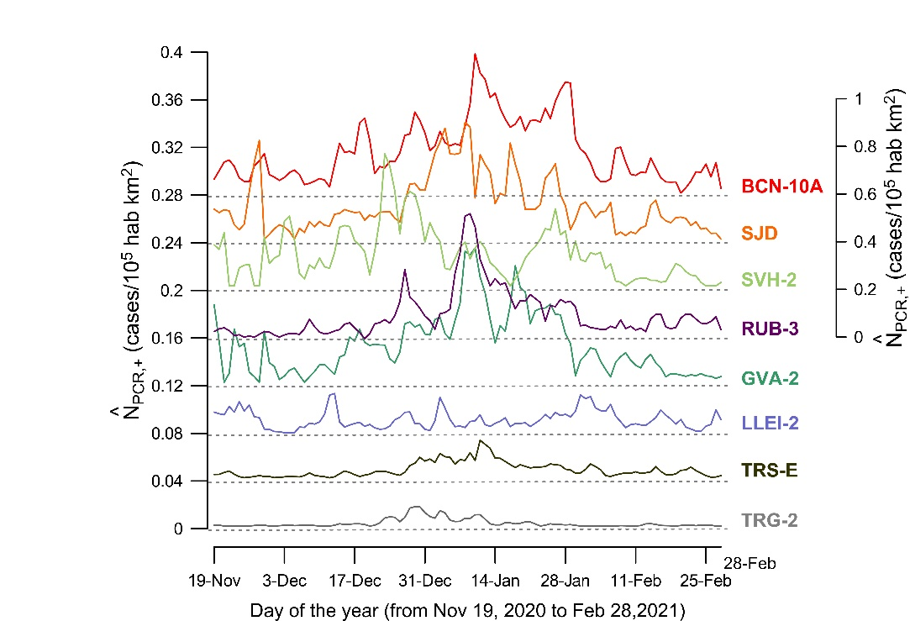
Figure S6. Temporal evolution of the number of COVID-19 cases in all BHAs from November 19, 2020, to February 28, 2021. The lower five time series (from TRG-2 to RUB-3) are represented against the left axis and the remaining BHAs (SVH-2, SJD and BCN-10A) against the right axis. The series are shifted to facilitate identifying the main features.
The pandemics third wave is clearly visible in most of the BHAs (Figure S6). In general, the plots reflect a rapid growth in COVID-19 cases during December, reaching their highest peak in January, followed by a substantial reduction of infections that return to low levels at the beginning of February. Note that SVH-2 has a more irregular behaviour, with two narrow peaks, one located around mid-December and another at the end of January. Also, LLEI-2 displays a different pattern, with no clear wide peaks. Although a period of time up to February appears to be appropriate to validate the model externally, some of these BHAs show normalized number of cases (${\hat{\text{N}}}_{\text{PCR}\text{,+}}^{}$) close to 0, which may lead to spurious predictions of the daily infectious index. Then, for some BHAs, such as TRG-2, TRS-E or RUB-3, the model has been only validated using the subsets of data that include representative ${\hat{N}}_{PCR,+}^{}$ values; in TRS-E and TRG-2 this period of time is short (Table S11). Finally, we have computed the correlation between the predicted and observed values of the infection index, and the external validation of the model has been performed for the data subsets that exhibit the highest correlation.
 | N | r²_{ext} | p-value (linear model) | $${\text{β}}_{\text{1}}^{\text{ *}}$$ | p-value (${\text{β}}_{\text{1}}^{\text{*}}$=1) | ${\text{β}}_{\text{0}}^{\text{ *}}$ | p-value (${\text{β}}_{\text{0}}^{\text{*}}$=0)
BCN-10A | 72ª | 0.11*** | 0.0045 | 0.538 | 0.020 | 0.047 | 0.04
GVA-2 | 72ª | 0.17*** | 0.0003 | 0.635 | 0.012 | 0.014 | 0.15
SJD | 56^{b} | 0.18*** | 0.0012 | 0.365 | < 0.01 | 0.056 | < 0.01
SVH-2 | 72ª | 0.02 | > 0.1 | -0.120 | n.a. | 0.128 | n.a.
RUB-3 | 30^{c} | 0.16*** | 0.0284 | 0.605 | 0.14 | 0.029 | 0.16
TRS-E | 24^{d} | 0.20** | 0.0288 | 0.540 | 0.05 | 0.042 | 0.15
LLEI-2 | 77e | 0.11*** | 0.0032 | 0.796 | 0.42 | 0.041 | 0.16
TRG-2 | 29^{f} | 0.17** | 0.0280 | 0.506 | 0.09 | 0.009 | 0.81
Table S11. Summary of the statistical parameters obtained for the external validation. N is the sample size and the superscript indicates the selected time intervals for the external validation: a, 19.11.2020 to 29.01.2021; b, 29.11.2020 to 23.01.2021; c, 31.12.2020 to 29.01.2021; d, 01.01.2021 – 24.01.2021; e, 19.11.2020 to 02.02.2021; f, 28.12.2020 to 25.01.2021. The statistical parameters are the predicted R-squared (${\text{r}}_{\text{ext}}^{\text{ 2}}$), the mean absolute prediction error (MAPE) and the root-mean-square error (RMSE). The asterisks indicate that the overall significance test for the linear regression is significant at ‘*’ 90 %; ‘**’ 95%; ‘***’ 99% confidence level or ‘⁺’ not statistically significant at 90% confidence level.
The external validation of the model follows the same method implemented for the internal validation and described previously (see Methods). For each BHA, the infection index I_{c} was computed based on the normalized number of positive cases,${\hat{\text{N}}}_{\text{PCR}\text{,+}}^{}$. Also, the Eq. (8) (see Methods) was applied in order to obtain the predicted values for the new observations I_{c.} Finally, the predicted values (I_{c,pred}) were used to validate the model externally during the pandemics third wave.
Figure S7 shows a scattered plot of observations against the corresponding predictions. The inset bar charts represent the relative frequency of the absolute prediction errors (APE’) which are expressed in percentage and grouped in 10-percent intervals. The plots exhibit a positive correlation between the observed I_{c} and predicted I_{c,pred} values in all the BHAs except SVH-2. In this latter area, the data points appear to be randomly scattered, indicating that, in this case, there is no correlation between I_{c.} and I_{c,pred} .This is corroborated by the values of the predicted R-squared (${\text{r}}_{\text{ext}}^{ \text{2}}$) obtained from the regression fits, which are represented as solid lines and displayed along with their corresponding linear equation in each panel of the Figure S7 (see also Table S11). Although the data are uncorrelated (${\text{r}}_{\text{ext}}^{ \text{2}}$ 0) for this BHA, a weak positive relationship between observations and predictions is found in the other BHAs, with ${\text{r}}_{\text{ext}}^{ \text{2}}$ between 0.1 and 0.2. Additionally, the F-test of the linear-prediction overall significance has been conducted to assess the strength of this relationship.
Table S12 evidences a linear relationship between the observations and the model predictions (p-val < 0.01) in four of the BHAs (BCN-10A, GVA-2, SJD and LLEI-2), which are those with the largest amount of data. If the size of the sample decreases, the evidence weakens but it is still moderately significant (0.01 ≤ p-val < 0.05), suggesting that the results obtained in small size datasets should be considered with caution. On the other hand, the amount of data for SVH-2 is large but the result of the test indicates that there is no significant linear relationship between observations and predictions (p-val > 0.1). In this case, the normalized number of cases behaves more irregularly as compared with other BHAs (Figure S7). This may explain the lack of skill of the model to capture the main features of the propagation of the virus in this area, suggesting that the variability of the observations is largely attributed to factors other than the weather conditions.

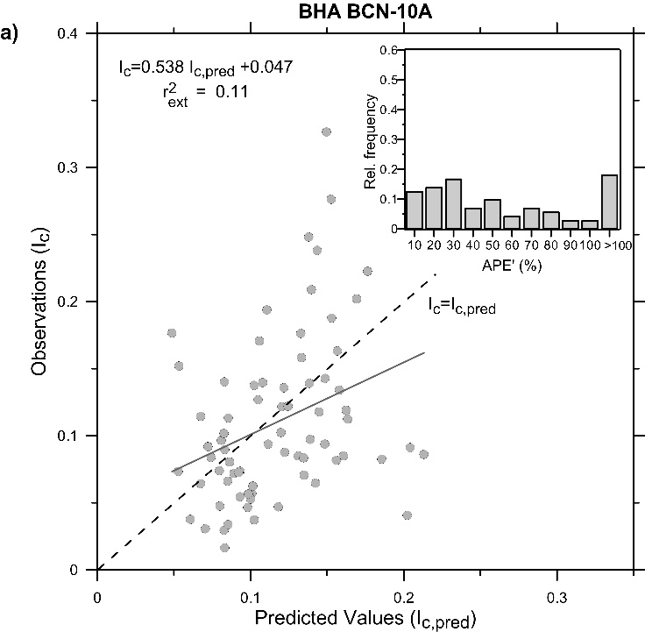 | 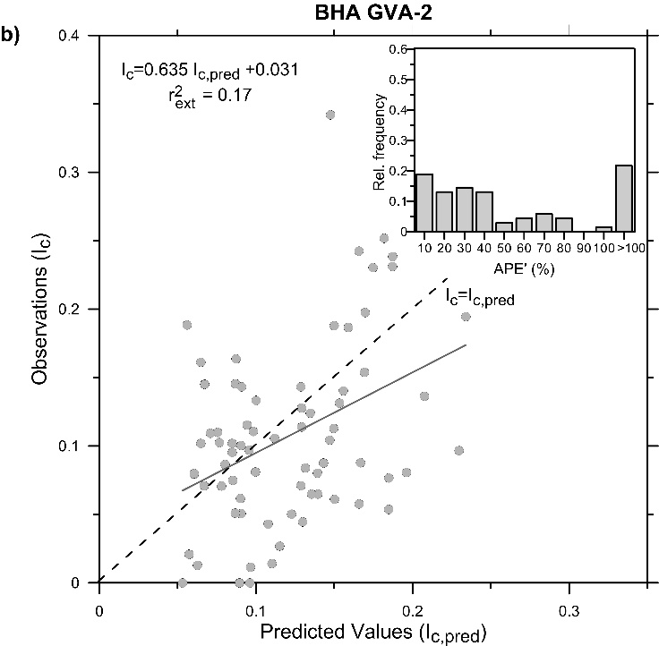
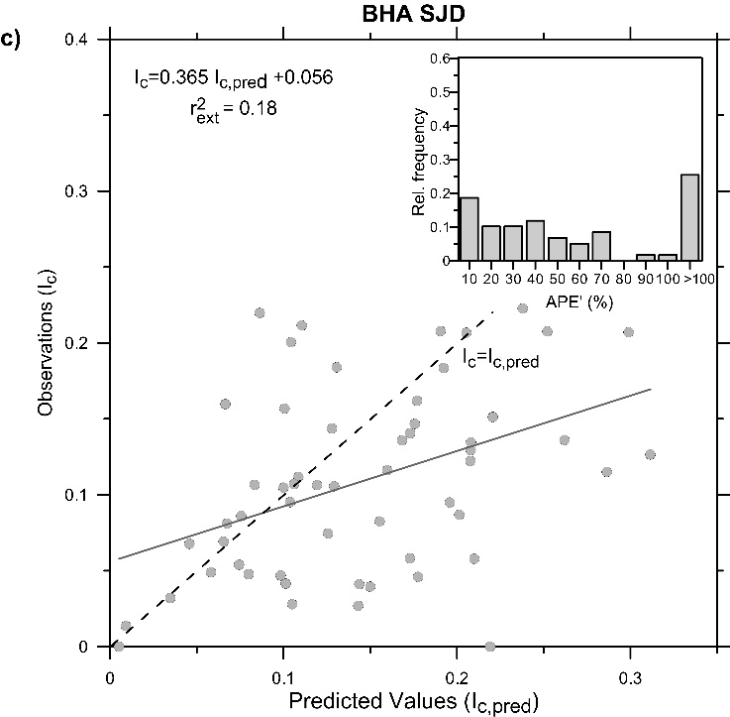 | 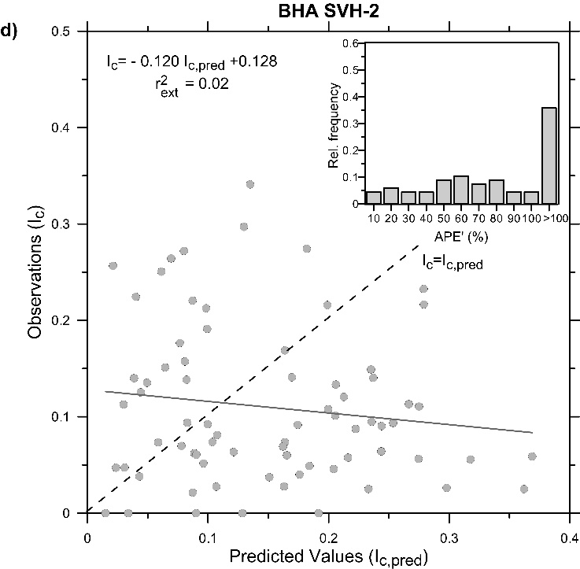
Figure S7. (a-h) Scattered plots of the infection index I_{c} as a function of the corresponding predictions I_{c,pred} over the forecast period for each BHA. The dashed lines indicate the 1:1 fit and the solid lines represent the best-fit line between them. The linear equations of the regression fit are displayed in each graph along with their predicted R-squared, ${\text{r}}_{\text{ext}}^{\text{ 2}}$. The bar charts for the absolute prediction errors (APE’) of the measurements, which have been grouped in intervals of 10%, are inserted in the upper part of each panel.

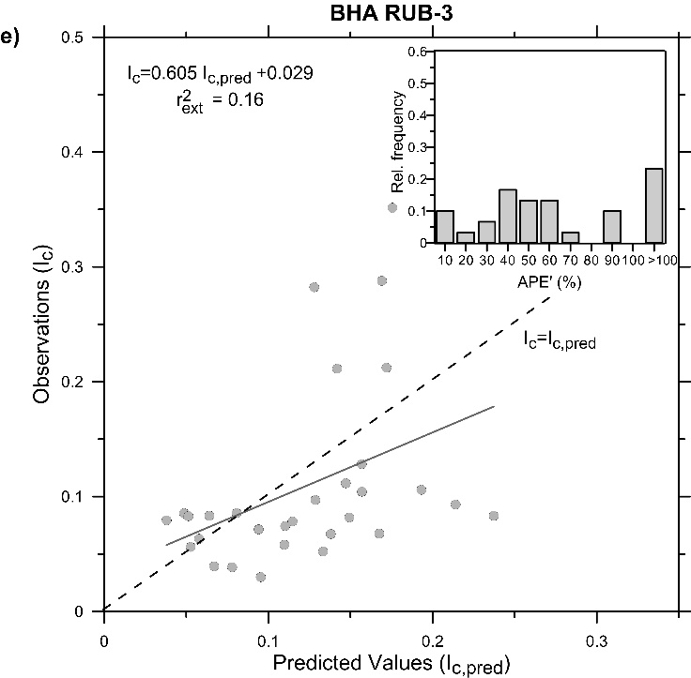 | 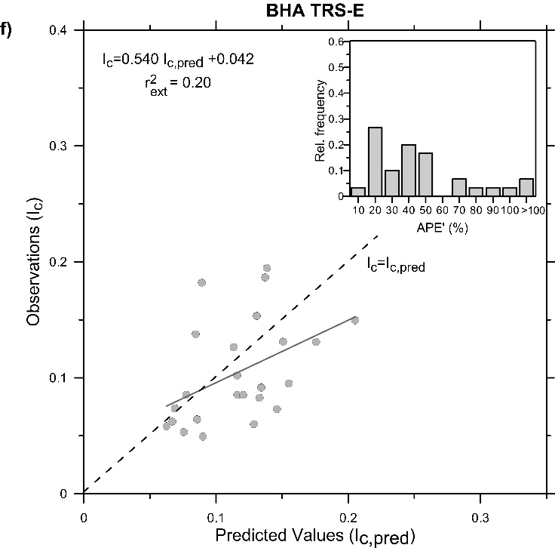
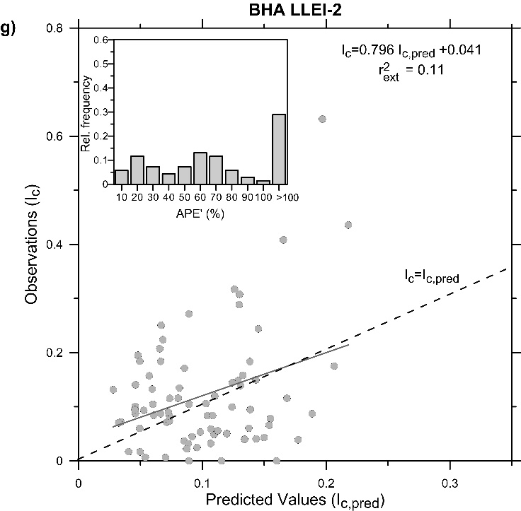 | 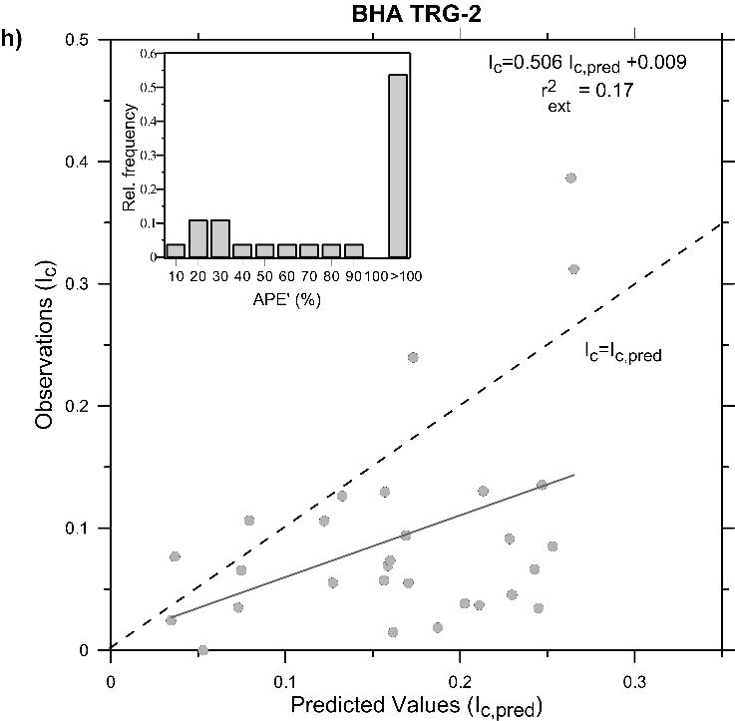
Figure S7 (continued)
For the BHAs with a significant linear relationship – all but SVH-2 – the parameters of the linear equations are analysed in more detail (equations displayed in Figure S7). The linear regressions lie below the 1:1 line and the y-intercept is a positive value close to zero. There appears to be a tendency of the model to overestimate the predictions of the infection index, in particular for GVA-2, RUB-3 and TRS-E. In these cases, the errors in the predictions associated with bias or lack of model consistency could be significant. In order to evaluate this possibility, the values of the slope (${\text{β}}_{\text{1}}^{\text{ *}}$) and the y-intercept (${\text{β}}_{\text{0}}^{\text{ *}}$) of the linear fits have been checked by performing their corresponding tests of significance. The results of the tests (Table S12) show that, in all BHAs except SJD, the values of both parameters do not differ significantly from their expected values, ${\text{β}}_{\text{1}}^{\text{ *}}$=1 and ${\text{β}}_{\text{0}}^{\text{ *}}$=0 respectively (p-val > 0.01, i.e. the null hypotheses H₀ of each test is not rejected at 99 % significance level). As a result, we can conclude that, for six of the seven health areas analysed, there is not enough statistical evidence to infer that the model is biased (${\text{β}}_{\text{0}}^{\text{ *}}$≠ 0) or inconsistent (${\text{β}}_{\text{1}}^{\text{ *}}$≠1). This is in agreement with the results obtained from the internal validation and suggests that the unexplained variance may be caused by factors other than weather. Only for SJD the results of the significance tests show that the values of the slope and the y-intercept are significantly different from the expected values, suggesting that the model tends to overestimate the predictions in this health area. The weaker consistency of the model predictions in SJD, and the observation that the upper 20% of these data in the residuals probability plots deviate from normality (Fig S4), suggest that there may be some issues related to the reporting system in this area.
Finally, the prediction error statistics have also been computed for each BHA. It includes the calculation of $MAPE$ and $RMSE$ for external validation along with the predicted R-squared (${\text{r}}_{\text{ext}}^{\text{ 2}}$) of the regression and its adjusted version (${\text{r}}_{\text{ext,adj}}^{\text{ 2}}$) (Table S12). The MAPE value is higher than 50% in six out of the seven analyzed BHAs and exceeds the 100% error in LLEI-2 and TRG-2. In general, the values found for the external validation are about 40% to 60% higher than the corresponding values used to build the model (Table S9). This can be explained by the presence of a higher percentage of data with large errors in the predictions when the model is validated externally. The bar charts inserted in the Figure S6 show that, in most of the areas, about 30 to 40% of the data have percentage absolute errors (APE’) higher than 60% with the largest errors (APE’ > 100%) observed in 20 to 30 % of the dataset. The worst results are found in LLEI-2 and TRG-2, where about 60% of the data have APE’ > 60%. In general, the data percentages differ by 10 to 15 % from those obtained when the model was built (see in Table S9). An exception is found in TRS-E, where the large-error percentages remain almost the same in both situations. The analysis for the small errors reports similar results. If the external validation is applied, the percentage of data with APE’ < 30% decreases down to around 30% in most of the BHAs except for BCN-10A, GVA-2 and TRS-E, where the data percentage remains at about 45%. In these areas, about one third of the data still concentrate the lowest errors (APE’ < 20%). Although the percentages of data with small errors are relevant, they are 10 to 15% lower than those obtained in the model setup period (Table S9). The changes in the distribution of the large and small errors in the predictions explain the differences in the averages of the absolute prediction errors between the setup and forecast periods. Notice that the health areas with the lowest averaged prediction errors are the same, independently of the time period analysed (see BCN-10A or TRS-E, for example). This is also observed for the health area with the highest averaged prediction error (TRG-2), although the error substantially increases for LLEI-2 when the external validation is applied.
 | r²_{ext} | r²_{ext,adj} | MAPE (%) | RMSE
BCN-10A | 0.11*** | 0.09 | 60.50 | 0.061
GVA-2 | 0.17*** | 0.15 | 82.20 | 0.065
SJD | 0.18*** | 0.16 | 74.82 | 0.080
SVH-2 | 0.02⁺ | n.a | n.a | n.a.
RUB-3 | 0.16** | 0.14 | 69.43 | 0.075
TRS-E | 0.20** | 0.16 | 38.32 | 0.044
LLEI-2 | 0.11*** | 0.09 | 101.84 | 0.102
TRG-2 | 0.17* | 0.12 | 205.86 | 0.111

Table S12. Summary of the results of the regression fits for the external validation in each BHA. The table includes the predicted R-squared (${\text{r}}_{\text{ext}}^{\text{ 2}}$), its adjusted version (${\text{r}}_{\text{ext,adj}}^{\text{ 2}}$), and the ${\text{β}}_{\text{1}}^{\text{ *}}$ (slope) and ${\text{β}}_{\text{0}}^{\text{ *}}$ (y-intercept). The asterisks indicate that the overall significance test for the linear regression is significant at ‘*’ 90%; ‘**’ 95%; ‘***’ 99% confidence level or ‘⁺’ not statistically significant at 90% confidence level. The p-values for the statistics of the significance tests with ${\text{β}}_{\text{1}}^{\text{ *}}$= 1 and ${\text{β}}_{\text{0}}^{\text{ *}}$= 0 are also displayed (n.a.: not applicable).
A similar behaviour is found in the model RMSE. This statistic is calculated for each health area and in two different situations, i.e. from the data of the setup or forecast periods. In general, the RMSE differences in these situations are considerably lower than those obtained when MAPE was analyzed. In four out of the six BHAs, the values obtained from the external validation increase by 5 to 10% with respect to those values obtained when the model was built. This percentage is larger in BCN-10A (about 35%) and reaches its maximum value for LLEI-2 (80%). In TRG-2, the RMSE value is the highest but decreases as compared to the model setup period (Table S9). For external validation, the coefficients vary ${\text{r}}_{\text{ext}}^{\text{ 2}}$ between 0.1 and 0.2 and decrease further when the modified coefficient ${\text{r}}_{\text{ext,adj}}^{\text{ 2}}$ is considered. These values are generally lower than those obtained from the dataset used to build the model (Table S9). Although the data are significantly correlated in both the setup and forecast scenarios, the linear relationship weakens when the external dataset is used. However, a percentage of the variance observed in the infection index during the pandemic’s third wave can be still explained by the predictors used in the model (pressure and/or relative humidity).

