Supplementary Material

Tumor Area Positivity (TAP) score of programmed death-ligand 1 (PD-L1): a novel visual estimation method for combined tumor cell and immune cell scoring

Chunyan Liu, MD, PhD¹, Fang Fang, PhD¹, Ying Kong, MD, PhD¹, Ehab ElGabry, MD¹
¹Roche Tissue Diagnostics, Tucson, AZ, USA
Supplementary Fig. 1 10x field rule: if tumor nests are separated by non-neoplastic tissue, they are included as part of the tumor area as long as the tumor nests are bordered on both sides of a 10x field; the intervening non-neoplastic tissue is also included in the tumor area.
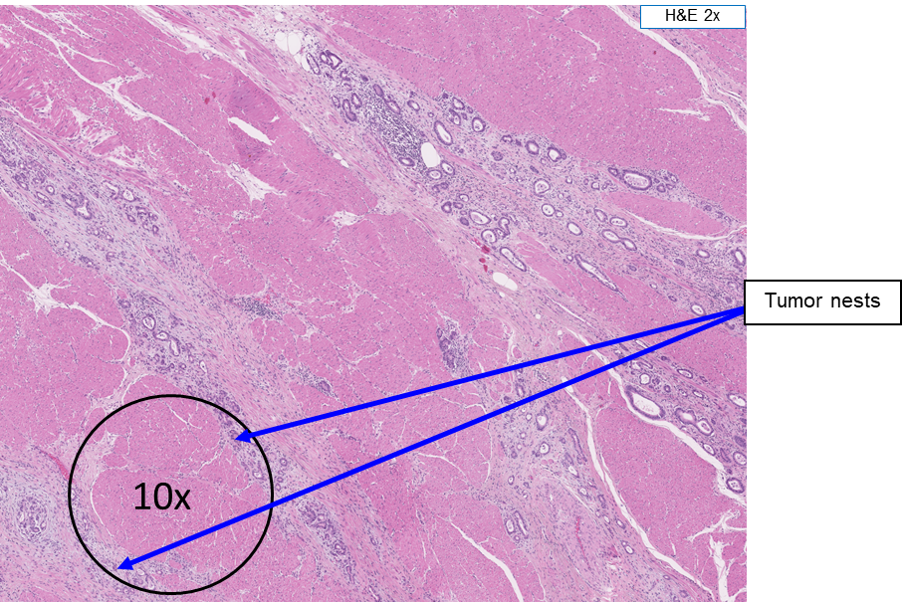
H&E hematoxylin and eosin
Supplementary Fig. 2 Neutrophils with weak cytoplasmic staining.
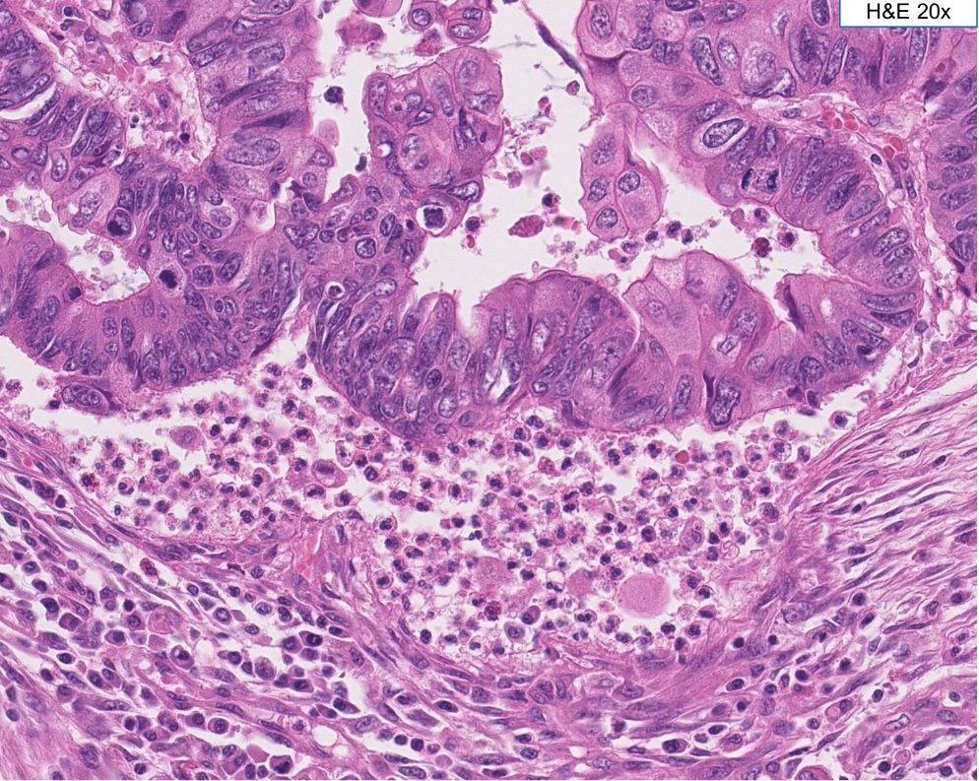
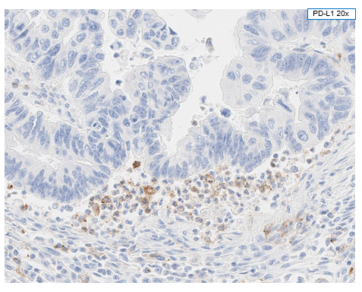
H&E hematoxylin and eosin, PD-L1 programmed death-ligand 1

