Reliability and validity of the parental monitoring of children’s digital activity (PARMON-CDA) scale: An exploratory factor analysis

Supplementary Materials

Supplementary Table 1
A committee of 5 assessors for contents of the validity test
Time Stamp* | Val. | Name | Institution | Scientific and research fields
Oct 4, 2021, 8:01 AM | 1 | Dr. Rahkman Ardi, M.Psych.  (Orcid ID) https://orcid.org/  0000-0002-2261-2417 | Faculty of Psychology, Universitas Airlangga, Indonesia | Social Cognition and Cyberpsychology
Oct 4, 2021, 11:12 PM | 2 | Siti Maimunah, S.Psi., M.M., M.A.  (Google Scholar: https://scholar.google.co.id/citations?user=s0t_q0MAAAAJ&hl=id) | Universitas Muhammadiyah Malang, Indonesia | Developmental Psychology and Family Psychology
Oct 7, 2021, 8:22 PM | 3 | Dian N. Marissa, Ph.D  (Google Scholar: https://scholar.google.co.id/citations?user=WGqVIygAAAAJ&hl=en) | Yanbu University College, Saudi Arabia | Educational Psychology/Second Language Acquisition and Education
Oct 7, 2021, 8:37 PM | 4 | Muchlisah, S.Psi., M.A.  (Google Scholar: https://scholar.google.co.id/citations?user=bDqqQv0AAAAJ&hl=id) | UIN Alauddin Makassar, Indonesia | Developmental Psychology and Family Psychology
Oct 7, 2021, 9:26 PM | 5 | Restu Tri Handoyo, M.Psi., Ph.D (Orcid ID : https://orcid.org/  0000-0002-3933-8653 | Faculty of Psychology, Universitas Gadjah Mada, Indonesia. | Clinical Psychology
Note. Val =Validator ; * Timestamp the validators return the content validity document to the researcher
Supplementary Table 2
Sub-scale, Indicator, and Number 75 initial item Indonesian PARMON-CDA Scale
Sub-scale | Indicators | Items number
1. Regulation: Adopting the categorization provisions of Van Kruistum anf Van Steensel (2017). “we chose the term ‘regulation’ rather than the commonly used label ‘restriction’ because the practices parents reported were not always aimed at restricting media use. Regulation (rule-making, pedagogical action, and technical restriction). The most commonly adopted rules pertained to when and how long a child was permitted to use a device although such rules were regularly implicit or vague: some parents docked the time whereas others relied on gut feeling. Besides rule-making, technical restrictions were also subsumed under the category of regulatory practices, but the parents in our sample scarcely made use of them. For other parental practices aimed at regulation, we distinguished a third category of “pedagogical actions”. In most of these cases, parents made an on-the-spot decision to restrict media use by telling a child to stop using a digital medium, instructing a child to do something else, or saying no to a request to use a device. In other cases, parents kept a device out of the child’s reach.” Regulations and restrictions on the duration and frequency of children's internet use are regulated so that children are able to balance online and offline activities. | 1.1. The balance between online and offline activities: reducing the time, duration, frequency, and access of children's internet usage is managed so that children can balance online and offline activities. | 1-6
 | 1.2. Agreement on rules: Parents and children agree on rules that are made together, meaning that parents give time and opportunities for children to access the internet via cellphones or computers according to agreed rules. These rules include schedules, space and platform limitations, as well as content that is appropriate to the age and needs of the child, the willingness of parents to accompany the child. | 7-12
 | 1.3. Technical Content Screening: The ability of parents to screen their children's activities focused on efforts to technically regulate hardware and software to limit negative content. Such as the use of timers, applications, multiscreen, filter applications, limiting modes (non-wifi mode/data plan, airplane mode), downloading online materials, blocking certain accounts, and including notifications via email. | 13-21
 | 1.4. Limit internet data quota: Limit money to buy internet data packages | 22-23
2. Guidance  Adopting the categorization term from Van Kruistum and Van Steensel (2017) for the term “guidance”:  “Guidance refers to a practice in which parents supported children’s media use and, contrary to regulation, did not exert control or did so to a lesser degree. We distinguished four roles a parent could adopt: they could act as an ‘enabler’ of media use (e.g., by buying a device or handing one down), a ‘buddy’ (i.e., by using a device together with the child), a ‘helper’ (e.g., by helping in case of technical difficulties), and a ‘teacher’ (e.g., by adopting active mediation). In previous studies, the focus has been mostly on the first three roles of the parent and one specific interpretation of parent-as-teacher, namely to talk about media content. By approximately half of the families participating in the present study other teaching practices were mentioned, namely to encourage the use of educational apps, to teach the child search strategies, and to provide guidance while using digital media for informational purposes such as learning a foreign language. However, such practices occurred only occasionally according to the parents.” | 2.1. Content of the discussion: a combination of egalitarian (equal discussion between child and parent) and hierarchical (e.g., advising, one-way, parental authority as the primary provider of reference to children's behavior based on moral values)  Such as: providing insight, advice, explanations, directions, lessons, reprimands, warnings, and prohibitions if children are too busy with cellphones, building communication, opening discussions, sharing information, exchanging ideas and opinions, telling stories, introducing positive content, doing reflection together, ask questions, facilitate, and provide logical reasons. | 24-33
 | 2.2. Participation: Parents play games, follow children's social media accounts, engage in online activities with children. | 34-40
 | 2.3. Parents are role models: The cooperation and solidarity of parents and other adults, including those from large families, to become role models for children in using the internet and devices appropriately | 41-48
3. Space  Adopting the term “Space” from Van Kruistumdan and van Steensel (2017):  “We use the label 'space' to denote the practice of doing nothing as long as the child is not negatively affected. These parents allow their child to use at least one device independently, to select and install apps, and/or to regulate their behavior. The majority of parents do monitor the use of media by monitoring what their children do. Some parents also check afterwards what information the child is looking for, who the child is calling, or which apps have been installed. Jan and Marlies (Family 11) recounted when their son Rik acted discreetly while using a tablet, prompting them to check what he had been up to. They found she had been looking for a 'naked' girl band and viewed pornographic pictures. Then they confronted Rik, talked to him about their findings, and explained why they found this content inappropriate." | 3.1. Trust-space: Parents choose to believe in their children's digital skills. They can already sort out what is good and what is bad; Parents provide opportunities for children to choose content independently because children have been able to behave according to their parents' advice. | 49-54
 | 3.2. Internet solicitation: Parents try to find out about their child's activities from other sources of information other than the child's (checking cell phones or other digital devices without the child's knowledge); These terms are adopted from the concept of parental supervision (Kerr et al., 2010; Stattin & Kerr, 2000). | 55-62
 | 3.3. Co-view and supervision: we adopted the term Supervision as the activities of parents and children are allowed to go online individually but with the assurance that children are under direct supervision and are in the same room with parents (Nikken & Jansz, 2014). This includes intentional sharing (i.e., intentional sharing of the internet by parent and child together and sharing experiences with each other). Being next to the child when doing activities with digital devices without any discussion. Such as: guiding, accompanying, monitoring, supervising, beside children who are playing the internet. | 63-67
4. Direct intervention  Direct intervention by parents (reactive parenting) in the real world; the goal is to charge the child's compliance that the child has agreed to comply with the rules made together. Such as, limiting, reprimanding properly (if found to be excessive use or violation of the agreement), looking directly at a friend's house, monitoring sleep hours, confiscation, calling or picking up children. Supervise children's social interactions, supervise directly, encourage children to interact in the real world. | Sanctions, confiscation of devices, surprise inspections, habituation for direct social interaction (outside the network), and direct reprimands | 68-75

Supplementary Table 3
Aiken's V Index for 75 items on the Indonesian PARMON-CDA Scale
Items |  | Validator |  |  |  |  | Analysis process
 |  | 1 | 2 | 3 | 4 | 5 | $s$1 | s2 | s3 | s4 | s5 | 𝛴s | n(c - 1) | V | Interpretation
1 | I remind children to regularly do other activities outside the internet network (favourable) | 5 | 3 | 4 | 2 | 5 | 4 | 2 | 3 | 1 | 4 | 14 | 20 | 0.70 | Moderate
2 | I limit the time, duration, and frequency of my child's internet access to maintain a balance in their daily activities (favourable) | 5 | 4 | 4 | 4 | 4 | 4 | 3 | 3 | 3 | 3 | 16 | 20 | 0.80 | High
3 | I encourage children to balance online activities with regular exercise (favourable) | 3 | 5 | 4 | 4 | 4 | 2 | 4 | 3 | 3 | 3 | 15 | 20 | 0.75 | Moderate
4 | Most of my child's activities are on the internet (unfavourable) | 5 | 4 | 4 | 3 | 4 | 4 | 3 | 3 | 2 | 3 | 15 | 20 | 0.75 | Moderate
5 | Most of my child's time is spent on the internet (unfavourable) | 5 | 4 | 4 | 3 | 4 | 4 | 3 | 3 | 2 | 3 | 15 | 20 | 0.75 | Moderate
6 | My child accesses the internet so he/she doesn't exercise regularly (unfavourable) | 3 | 5 | 4 | 4 | 4 | 2 | 4 | 3 | 3 | 3 | 15 | 20 | 0.75 | Moderate
7 | My children and I have an agreement regarding a certain schedule to access the internet (favourable) | 5 | 5 | 4 | 5 | 5 | 4 | 4 | 3 | 4 | 4 | 19 | 20 | 0.95 | High
8 | My children and I made an agreement about internet content that can be accessed according to their age (favourable) | 5 | 5 | 4 | 5 | 5 | 4 | 4 | 3 | 4 | 4 | 19 | 20 | 0.95 | High
9 | My partner and I agreed to regularly monitor our child's internet usage (favourable) | 5 | 5 | 2 | 5 | 4 | 4 | 4 | 1 | 4 | 3 | 16 | 20 | 0.80 | High
10 | My children and I do not have a specific agreement regarding the schedule for accessing the internet (unfavourable) | 3 | 5 | 4 | 5 | 3 | 2 | 4 | 3 | 4 | 2 | 15 | 20 | 0.75 | Moderate
11 | My children and I don't have a specific agreement about the content that can be accessed (unfavourable) | 3 | 5 | 4 | 4 | 3 | 2 | 4 | 3 | 3 | 2 | 14 | 20 | 0.70 | Moderate
12 | My partner and I don't have a specific agreement on how we monitor children's internet usage (unfavourable) | 3 | 5 | 2 | 4 | 3 | 2 | 4 | 1 | 3 | 2 | 12 | 20 | 0.60 | Moderate
13 | I filter internet consumption content for my child taking into account age restrictions on social media accounts (favourable) | 5 | 5 | 4 | 4 | 5 | 4 | 4 | 3 | 3 | 4 | 18 | 20 | 0.90 | High
14 | I installed certain apps on my digital device to monitor my child's internet activity (favourable) | 5 | 5 | 4 | 3 | 5 | 4 | 4 | 3 | 2 | 4 | 17 | 20 | 0.85 | High
15 | I use YouTube Kids when my child wants to access watching videos (favourable) | 3 | 5 | 4 | 3 | 5 | 2 | 4 | 3 | 2 | 4 | 15 | 20 | 0.75 | Moderate
16 | I read the terms and conditions on social media before creating an account for my child to access (favourable) | 5 | 5 | 4 | 3 | 5 | 4 | 4 | 3 | 2 | 4 | 17 | 20 | 0.85 | High
17 | I use the help center options on Facebook and/or Instagram to protect children from harm (favourable) | 3 | 5 | 4 | 3 | 4 | 2 | 4 | 3 | 2 | 3 | 14 | 20 | 0.70 | Moderate
18 | I'm not too involved in choosing what content my child can access (unfavourable) | 3 | 5 | 4 | 4 | 4 | 2 | 4 | 3 | 3 | 3 | 15 | 20 | 0.75 | Moderate
19 | Digital devices accessed by children are not equipped with special applications to monitor their activities (unfavourable) | 3 | 3 | 4 | 3 | 5 | 2 | 2 | 3 | 2 | 4 | 13 | 20 | 0.65 | Moderate
20 | I tend to skip the terms and conditions before creating a social media account for my child to access (unfavourable) | 3 | 5 | 4 | 3 | 3 | 2 | 4 | 3 | 2 | 2 | 13 | 20 | 0.65 | Moderate
21 | I tend to miss the help center function on Facebook and/or Instagram to monitor kids activity on the internet (favourable) | 3 | 5 | 4 | 3 | 3 | 2 | 4 | 3 | 2 | 2 | 13 | 20 | 0.65 | Moderate
22 | I limit internet payments for my child (favourable) | 5 | 5 | 4 | 4 | 4 | 4 | 4 | 3 | 3 | 3 | 17 | 20 | 0.85 | High
23 | I fulfill internet purchases for my child even though it has exceeded the allotment (unfavourable) | 5 | 3 | 4 | 4 | 4 | 4 | 2 | 3 | 3 | 3 | 15 | 20 | 0.75 | Moderate
24 | I advise my children to use the internet for things that are beneficial for themselves and for other people (favourable) | 5 | 5 | 4 | 3 | 4 | 4 | 4 | 3 | 2 | 3 | 16 | 20 | 0.80 | High
25 | I remind the children that there is a God who sees all our activities on the internet (favourable) | 2 | 5 | 4 | 4 | 3 | 1 | 4 | 3 | 3 | 2 | 13 | 20 | 0.65 | Moderate
26 | I discuss with my children about the experiences they feel when they are using the internet (favourable) | 5 | 5 | 4 | 4 | 5 | 4 | 4 | 3 | 3 | 4 | 18 | 20 | 0.90 | High
27 | I talk with my children about the dangers of excessive use of the internet (favourable) | 5 | 5 | 4 | 3 | 5 | 4 | 4 | 3 | 2 | 4 | 17 | 20 | 0.85 | High
28 | I talk about the benefits of using the internet for example searching for information about health and general knowledge (favourable) | 5 | 5 | 4 | 3 | 5 | 4 | 4 | 3 | 2 | 4 | 17 | 20 | 0.85 | High
29 | I rarely advise children about using the internet (unfavourable) | 4 | 5 | 4 | 4 | 3 | 3 | 4 | 3 | 3 | 2 | 15 | 20 | 0.75 | Moderate
30 | I haven't reminded my children so often about the power of God in seeing our actions on the internet (unfavourable) | 2 | 3 | 4 | 3 | 3 | 1 | 2 | 3 | 2 | 2 | 10 | 20 | 0.50 | Moderate
31 | I rarely open a discussion about the experience of children surfing the internet these days (unfavourable) | 3 | 5 | 4 | 4 | 3 | 2 | 4 | 3 | 3 | 2 | 14 | 20 | 0.70 | Moderate
32 | I rarely talk about the dangers that threaten children on the internet (unfavourable) | 3 | 5 | 4 | 4 | 3 | 2 | 4 | 3 | 3 | 2 | 14 | 20 | 0.70 | Moderate
33 | I rarely talk about the benefits that children can get from internet access (unfavourable) | 3 | 5 | 4 | 4 | 3 | 2 | 4 | 3 | 3 | 2 | 14 | 20 | 0.70 | Moderate
34 | I play online games with children (favourable) | 5 | 5 | 4 | 4 | 5 | 4 | 4 | 3 | 3 | 4 | 18 | 20 | 0.90 | High
35 | I share a fun experience when playing online games with my children (favourable) | 5 | 5 | 4 | 4 | 5 | 4 | 4 | 3 | 3 | 4 | 18 | 20 | 0.90 | High
36 | I follow children's online activities with my personal social media accounts (favourable) | 5 | 5 | 2 | 4 | 3 | 4 | 4 | 1 | 3 | 2 | 14 | 20 | 0.70 | Moderate
37 | I help my children look for clues on the internet while he is doing homework from school (favourable) | 5 | 5 | 3 | 4 | 4 | 4 | 4 | 2 | 3 | 3 | 16 | 20 | 0.80 | High
38 | I don't understand about how to play online games (unfavourable) | 4 | 3 | 4 | 4 | 4 | 3 | 2 | 3 | 3 | 3 | 14 | 20 | 0.70 | Moderate
39 | I don't know anything about my child's social media activities (unfavourable) | 4 | 5 | 2 | 3 | 3 | 3 | 4 | 1 | 2 | 2 | 12 | 20 | 0.60 | Moderate
40 | I tend to be passive when children do homework from school with the help of the internet (unfavourable) | 4 | 5 | 4 | 3 | 3 | 3 | 4 | 3 | 2 | 2 | 14 | 20 | 0.70 | Moderate
41 | My partner and I agreed to be role models for children about using the internet (favourable) | 5 | 4 | 4 | 3 | 4 | 4 | 3 | 3 | 2 | 3 | 15 | 20 | 0.75 | Moderate
42 | I try to show rejection of negative internet content in front of children (favourable) | 2 | 3 | 4 | 4 | 5 | 1 | 2 | 3 | 3 | 4 | 13 | 20 | 0.65 | Moderate
43 | I try to be in harmony with my partner to obey the internet rules that we agree on with the child (favourable) | 3 | 5 | 4 | 5 | 4 | 2 | 4 | 3 | 4 | 3 | 16 | 20 | 0.80 | High
44 | I consistently obey the rules of safe internet at home (favourable) | 3 | 5 | 4 | 5 | 4 | 2 | 4 | 3 | 4 | 3 | 16 | 20 | 0.80 | High
45 | I feel that I am not yet capable of being a good role model for children in using the internet (unfavourable) | 3 | 5 | 4 | 5 | 3 | 2 | 4 | 3 | 4 | 2 | 15 | 20 | 0.75 | Moderate
46 | I have not been able to show a firm stance against negative content on the internet to my child (unfavourable) | 3 | 3 | 4 | 4 | 3 | 2 | 2 | 3 | 3 | 2 | 12 | 20 | 0.60 | Moderate
47 | I don't feel like I'm able to follow the internet rules that we have agreed upon together at home (unfavourable) | 3 | 5 | 4 | 4 | 3 | 2 | 4 | 3 | 3 | 2 | 14 | 20 | 0.70 | Moderate
48 | I feel that I am not fully able to take advantage of internet access (unfavorable) | 1 | 3 | 3 | 4 | 2 | 0 | 2 | 2 | 3 | 1 | 8 | 20 | 0.40 | Moderate
49 | I believe my child can choose useful content on the internet (favourable) | 3 | 5 | 4 | 4 | 4 | 2 | 4 | 3 | 3 | 3 | 15 | 20 | 0.75 | Moderate
50 | I believe that my child can be trusted to avoid online dangers with his digital skills (favourable) | 3 | 5 | 4 | 3 | 4 | 2 | 4 | 3 | 2 | 3 | 14 | 20 | 0.70 | Moderate
51 | I believe my children can make the right decision to protect themself from the dangers of negative content on the internet (favourable) | 3 | 5 | 4 | 3 | 4 | 2 | 4 | 3 | 2 | 3 | 14 | 20 | 0.70 | Moderate
52 | I have not been able to trust my children in terms of choosing useful content on the internet (unfavourable) | 3 | 5 | 4 | 4 | 3 | 2 | 4 | 3 | 3 | 2 | 14 | 20 | 0.70 | Moderate
53 | I'm not entirely sure my child is ready to avoid the dangers of negative content on the internet (unfavourable) | 3 | 5 | 4 | 3 | 3 | 2 | 4 | 3 | 2 | 2 | 13 | 20 | 0.65 | Moderate
54 | I'm not sure if my child can make the right decision to protect him/herself from negative content on the internet (unfavourable) | 3 | 5 | 4 | 3 | 3 | 2 | 4 | 3 | 2 | 2 | 13 | 20 | 0.65 | Moderate
55 | I follow children's social media with an anonymous account or second account (favourable) | 5 | 5 | 3 | 5 | 3 | 4 | 4 | 2 | 4 | 2 | 16 | 20 | 0.80 | High
56 | I use an anonymous or second account to follow my child's friends' social media accounts (favourable) | 5 | 3 | 3 | 2 | 3 | 4 | 2 | 2 | 1 | 2 | 11 | 20 | 0.55 | Moderate
57 | I checked the search history on digital devices that children can access without their knowledge (favourable) | 5 | 5 | 3 | 5 | 4 | 4 | 4 | 2 | 4 | 3 | 17 | 20 | 0.85 | High
58 | I checked the apps downloaded on my phone that my children can access without them knowing (favourable) | 4 | 5 | 3 | 4 | 4 | 3 | 4 | 2 | 3 | 3 | 15 | 20 | 0.75 | Moderate
59 | I'm not that curious about what kids do on the internet/social media (unfavourable) | 3 | 3 | 3 | 3 | 4 | 2 | 2 | 2 | 2 | 3 | 11 | 20 | 0.55 | Moderate
60 | I didn't find out more about who my child is following on social media/internet accounts (unfavourable) | 3 | 5 | 3 | 3 | 3 | 2 | 4 | 2 | 2 | 2 | 12 | 20 | 0.60 | Moderate
61 | I'm not that curious about the search history on my child's digital device (unfavourable) | 3 | 3 | 3 | 3 | 3 | 2 | 2 | 2 | 2 | 2 | 10 | 20 | 0.50 | Moderate
62 | I didn't find out more about what apps children download and use (unfavourable) | 3 | 5 | 3 | 5 | 3 | 2 | 4 | 2 | 4 | 2 | 14 | 20 | 0.70 | Moderate
63 | I manage social media accounts on behalf of my child (favourable) | 4 | 3 | 3 | 2 | 4 | 3 | 2 | 2 | 1 | 3 | 11 | 20 | 0.55 | Moderate
64 | The screen of the child's digital device is within my sight when my child is accessing the internet (favourable) | 4 | 5 | 3 | 4 | 5 | 3 | 4 | 2 | 3 | 4 | 16 | 20 | 0.80 | High
65 | The digital devices in our home are accessed in the living room (favourable) | 4 | 5 | 3 | 2 | 5 | 3 | 4 | 2 | 1 | 4 | 14 | 20 | 0.70 | Moderate
66 | I give my child a personal digital device (unfavourable) | 4 | 3 | 3 | 2 | 5 | 3 | 2 | 2 | 1 | 4 | 12 | 20 | 0.60 | Moderate
67 | Children can access computers and smartphones privately in their rooms (unfavourable) | 4 | 5 | 3 | 5 | 5 | 3 | 4 | 2 | 4 | 4 | 17 | 20 | 0.85 | High
68 | I reprimand children when they overuse their digital devices (favourable) | 5 | 5 | 4 | 5 | 5 | 4 | 4 | 3 | 4 | 4 | 19 | 20 | 0.95 | High
69 | When a child violates the rules of the internet, I confiscate the digital equipment (favourable) | 5 | 5 | 4 | 5 | 5 | 4 | 4 | 3 | 4 | 4 | 19 | 20 | 0.95 | High
70 | I did a surprise check to monitor my child's activity on the internet (favourable) | 5 | 5 | 4 | 3 | 5 | 4 | 4 | 3 | 2 | 4 | 17 | 20 | 0.85 | High
71 | When the child has passed the internet access time limit, I will give sanctions according to the consequences that we have agreed upon (favourable) | 5 | 5 | 4 | 4 | 4 | 4 | 4 | 3 | 3 | 3 | 17 | 20 | 0.85 | High
72 | I don't reprimand the child even though he overuses the digital device (unfavourable) | 3 | 5 | 4 | 5 | 3 | 2 | 4 | 3 | 4 | 2 | 15 | 20 | 0.75 | Moderate
73 | I do not apply the penalty by confiscation of children's digital devices (unfavourable) | 3 | 5 | 4 | 3 | 3 | 2 | 4 | 3 | 2 | 2 | 13 | 20 | 0.65 | Moderate
74 | I don't apply surprise checks as a way of monitoring my child's activity on the internet (unfavourable) | 3 | 5 | 4 | 4 | 3 | 2 | 4 | 3 | 3 | 2 | 14 | 20 | 0.70 | Moderate
75 | When the child has passed the internet access time limit, I rarely give sanctions (unfavourable) | 3 | 5 | 4 | 3 | 3 | 2 | 4 | 3 | 2 | 2 | 13 | 20 | 0.65 | Moderate
 |  |  |  |  |  |  |  |  |  |  |  |  | Mean= | 0.73

Supplementary Table 4
Aiken's V index for the initial 75 items resulting in the final 36 items of the PARMON-CDA Scale

Subscale | Number of 75 item verson scale | Early Item | Aiken’s V |  | Short version scale Item | Number of 36 item version scale
Subscale | Number of 75 item verson scale | Early Item | V | Interpre-tation | Short version scale Item | Number of 36 item version scale
Regulation | 2 | I limit the time, duration, and frequency of my child's internet access to maintain a balance in their daily activities (favourable) | 0.80 | High | I limit the time, duration and frequency when my children use the internet so that their activities are balanced between activities of using the internet and not using the internet (fav) | 1
Regulation | 4 | Most of my child's activities are on the internet (unfavourable) | 0.75 | Moderate | Most of the activities and time my child spends is on the internet (unfav) | 2
Regulation | 7 | My children and I have an agreement regarding a certain schedule to access the internet (favourable) | 0.95 | High | My children and I have an agreement about the time schedule for when they may use the internet (fav) | 3
Regulation | 8 | My children and I made an agreement about internet content that can be accessed according to their age (favourable) | 0.95 | High | My children and I have made an agreement in regards to the internet content (subject material) which they may access in accordance with their age (fav) | 4
Regulation | 14 | I installed certain apps on my digital device to monitor my child's internet activity (favourable) | 0.85 | High | I apply application download limits for Google play in accordance with my children’s age (fav) | 5
Regulation | 15 | I use YouTube Kids when my child wants to access watching videos (favourable) | 0.75 | Moderate | I permit my children to watch videos through YouTube Kids at the times when the children want to watch videos (fav) | 6
Regulation | 16 | I read the terms and conditions on social media before creating an account for my child to access (favourable) | 0.85 | High | I read the terms and conditions for specific internet applications (for example YouTube Kids) before allowing the children to use them (fav) | 7
Regulation | 22 | I limit internet payments for my child (favourable) | 0.85 | High | I limit how much internet quota that is bought or Wi-Fi access for the children (fav) | 8
Regulation | 23 | I fulfill internet purchases for my child even though it has exceeded the allotment (unfavourable) | 0.75 | Moderate | I fulfill my child's purchase of internet quota (and/or wifi usage) even though it has exceeded his allotted needs (unfav) | 9
Guidance | 24 | I advise my children to use the internet for things that are beneficial for themselves and for other people (favourable) | 0.80 | High | I advise my children to use the internet for things that are beneficial for themselves and for other people (fav) | 10
Guidance | 26 | I discuss with my children about the experiences they feel when they are using the internet (favourable) | 0.90 | High | I discuss with my children about the experiences they feel when they are using the internet (fav) | 11
Guidance | 27 | I talk with my children about the dangers of excessive use of the internet (favourable) | 0.85 | High | I talk with my children about the dangers of excessive use of the internet (fav) | 12
Guidance | 28 | I talk about the benefits of using the internet for example searching for information about health and general knowledge (favourable) | 0.85 | High | I talk about the benefits of using the internet for example searching for information about health and general knowledge (fav) | 13
Guidance | 29 | I rarely advise children about using the internet (unfavourable) | 0.75 | Moderate | I free children to find their own benefits of the internet (unfav) | 14
Guidance | 34 | I play online games with children (favourable) | 0.90 | High | I play online games with children (fav) | 15
Guidance | 35 | I share a fun experience when playing online games with my children (favourable) | 0.90 | High | I share a fun experience when playing online games with my children (fav) | 16
Guidance | 37 | I help my children look for clues on the internet while he is doing homework from school (favourable) | 0.80 | High | I help my children look for clues on the internet while he is doing homework from school (fav) | 17
Guidance | 40 | I tend to be passive when children do homework from school with the help of the internet (unfavourable) | 0.70 | Moderate | I ignore the children's invitation to look for instructions on the internet in completing homework / school assignments (unfav) | 18
Guidance | 43 | I try to be in harmony with my partner to obey the internet rules that we agree on with the child (favourable) | 0.80 | High | I and other family members are consistent in adhering to the internet rules that we have agreed together with the children (favourable) | 19
Guidance | 47 | I don't feel like I'm able to follow the internet rules that we have agreed upon together at home (unfavourable) | 0.70 | Moderate | Obeying the rules of the internet at home that I have agreed with my child, is something that is difficult for me to apply (unfav) | 20
Trust-Space | 50 | I believe that my child can be trusted to avoid online dangers with his digital skills (favourable) | 0.70 | Moderate | I believe my children can avoid harm from negative content because I have advised them about this (fav) | 21
Trust-Space | 51 | I believe my children can make the right decision to protect themself from the dangers of negative content on the internet (favourable) | 0.70 | Moderate | I give space for children to access the internet to support their learning and creativity process (fav) | 22
Trust-Space | 52 | I have not been able to trust my children in terms of choosing useful content on the internet (unfavourable) | 0.70 | Moderate | Trusting my children still worries me, even though I have advised to be careful when accessing the internet (unfav) | 23
Trust-Space | 55 | I follow children's social media with an anonymous account or second account (favourable) | 0.80 | High | I follow children's social media with an anonymous account or second account (fav) | 24
Trust-Space | 57 | I checked the search history on digital devices that children can access without their knowledge (favourable) | 0.85 | High | I check the search history (search history) on the digital devices which can be accessed by the children without their knowledge of this (fav) | 25
Trust-Space | 58 | I checked the apps downloaded on my phone that my children can access without them knowing (favourable) | 0.75 | Moderate | I check any apps that have been downloaded to the mobile phone which can be accessed by my children with the children being unaware of this (fav) | 26
Trust-Space | 62 | I didn't find out more about what apps children download and use (unfavourable) | 0.70 | Moderate | I ignore the child's opinion about the content/application of his choice even though the child has followed my advice on internet access behavior (unfav) | 27
Trust-Space | 64 | The screen of the child's digital device is within my sight when my child is accessing the internet (favourable) | 0.80 | High | When my children access the internet, I have full view of the screens of their devices (fav) | 28
Trust-Space | 65 | The digital devices in our home are accessed in the living room (favourable) | 0.70 | Moderate | Digital devices in our house are accessed in the family room at the time when the children access the internet (fav) | 29
Trust-Space | 67 | Children can access computers and smartphones privately in their rooms (unfavourable) | 0.85 | High | I allow children to access computers and smartphones privately in their rooms (unfav) | 30
Direct intervention | 68 | I reprimand children when they overuse their digital devices (favourable) | 0.95 | High | I reprimand my children when they use their digital devices excessively (fav) | 31
Direct intervention | 69 | When a child violates the rules of the internet, I confiscate the digital equipment (favourable) | 0.95 | High | When the children break the rules of internet usage, I confiscate the device (fav) | 32
Direct intervention | 70 | I did a surprise check to monitor my child's activity on the internet (favourable) | 0.85 | High | I unexpectedly check the children’s devices to observe my children’s internet activities (fav) | 33
Direct intervention | 71 | When the child has passed the internet access time limit, I will give sanctions according to the consequences that we have agreed upon (favourable) | 0.85 | High | I give punishments in accordance with the consequences that we have agreed upon when my children go beyond the time limits of internet access (fav) | 34
Direct intervention | 72 | I don't reprimand the child even though he overuses the digital device (unfavourable) | 0.75 | Moderate | I tolerate the child even though my child overuses the digital devices (unfav) | 35
Direct intervention | 73 | I do not apply the penalty by confiscation of children's digital devices (unfavourable) | 0.65 | Moderate | Implementing penalties by confiscating children's digital devices is an act of excessive monitoring (unfav) | 36
Note. Aiken's V validity is high when V > 0.8; Aiken's V validity is moderate when 0.40 ≤ V < 0.80

Supplementary Table 5
Face Validity Analysis (Readability Test)
 | Frequency | Percent (%)
Parents
Father | 3 | 15
Mother | 17 | 85
total | 20 | 100
Graduate
Senior High School | 6 | 30
Associate degree (D3) | 4 | 20
Undergraduate (S1) | 4 | 20
Graduate (S2) | 5 | 25
Postgraduate (S3) | 1 | 5
Total | 20 | 100
Employment
Government Employees | 12 | 60
State-owned company employee | 1 | 5
Entrepreneur | 1 | 5
Lecturer/Researcher | 2 | 10
Homemaker | 3 | 15
Local government employee | 1 | 5
Total | 20 | 100
Level of respondent's comprehension on items statement
Quite easy | 5 | 25
Easy | 11 | 55
Very Easy | 3 | 15
Total | 19 | 95
Missing | 1 | 5
Estimated time spent filling out the scale
Between 16-20 minutes | 9 | 45
Between 11-15 minutes | 9 | 45
Between 6-10 minutes | 1 | 5
Total | 19 | 95
Missing | 1 | 5

Supplementary Figure 1
Readability test chart

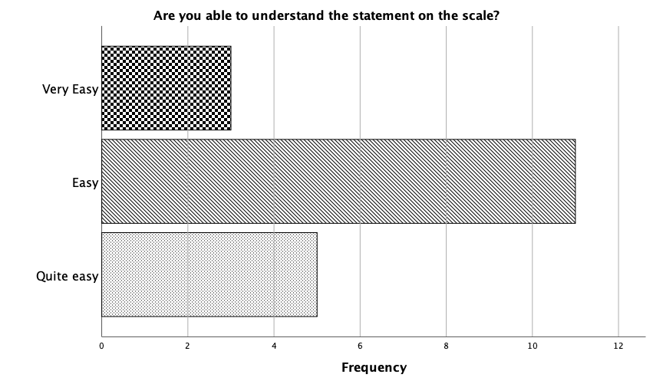

(a)
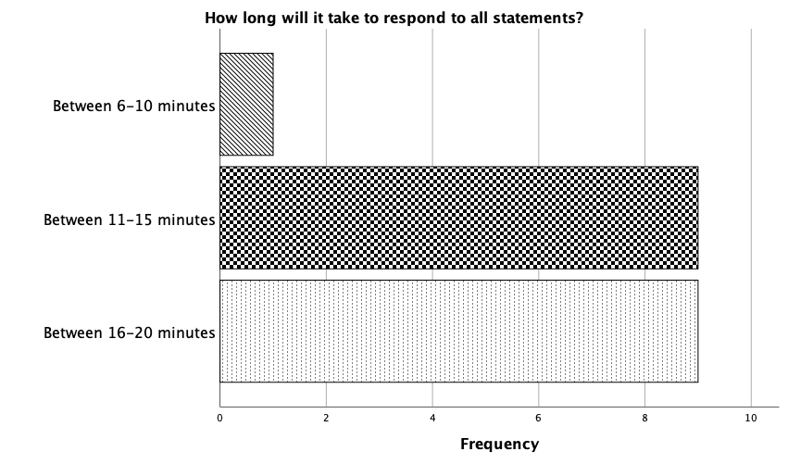
(b)

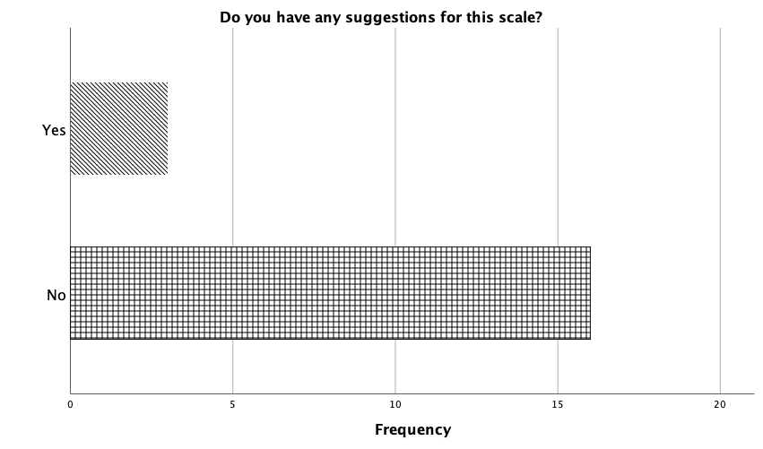
(c)

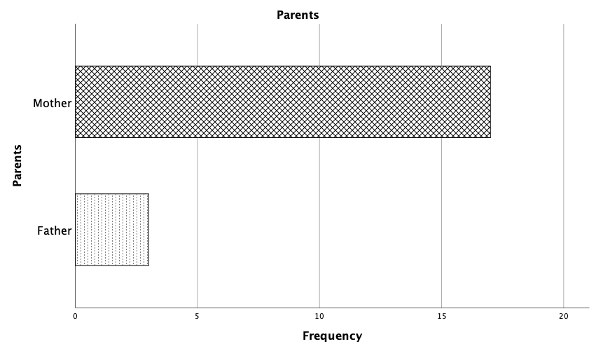
(d)

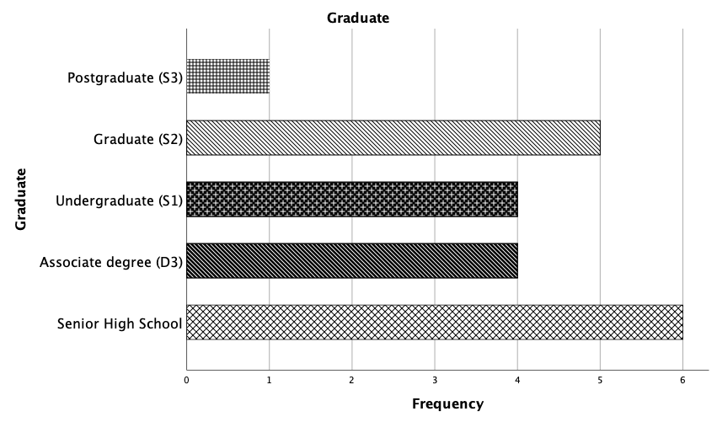
(e)

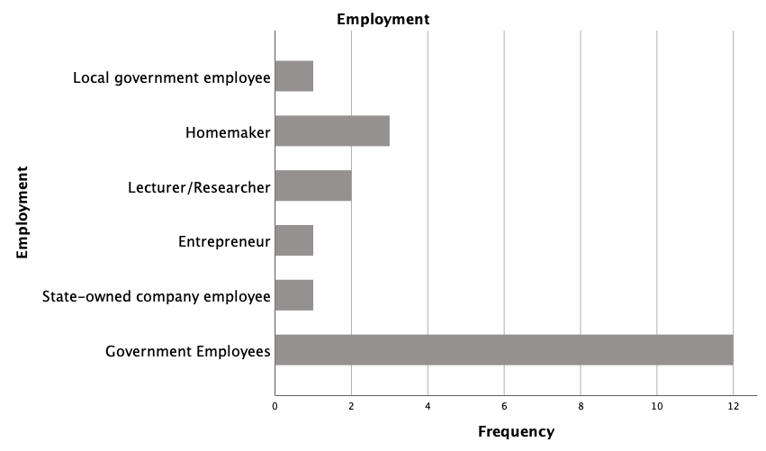
(f)

Supplementary Table 6
PARMON-CDA Scale Reliability 36 items

Reliability Statistics
Cronbach's Alpha | Cronbach's Alpha Based on Standardized Items | N of Items
.787 | .820 | 36

Supplementary Table 7
PARMON-CDA Scale Reliability 20 items
Reliability Statistics
Cronbach's Alpha | Cronbach's Alpha Based on Standardized Items | N of Items
.868 | .874 | 20

Supplementary Table 8
Additional information about the demographic characteristics of the sample respondents
Statistics
 |  | Parents' Age | Child's Age
N | Valid | 429 | 433
 | Missing | 4 | 0
Mean |  | 36.55 | 8.85
Std. Deviation |  | 5.07 | 1.89
Minimum |  | 20 | 1
Maximum |  | 45 | 15

Parents' Age
 |  | Frequency | Percent | Valid Percent | Cumulative Percent
Valid | 20 | 2 | 0.5 | 0.5 | 0.5
 | 22 | 2 | 0.5 | 0.5 | 0.9
 | 23 | 2 | 0.5 | 0.5 | 1.4
 | 24 | 2 | 0.5 | 0.5 | 1.9
 | 25 | 3 | 0.7 | 0.7 | 2.6
 | 26 | 5 | 1.2 | 1.2 | 3.7
 | 27 | 3 | 0.7 | 0.7 | 4.4
 | 28 | 7 | 1.6 | 1.6 | 6.1
 | 29 | 10 | 2.3 | 2.3 | 8.4
 | 30 | 19 | 4.4 | 4.4 | 12.8
 | 31 | 14 | 3.2 | 3.3 | 16.1
 | 32 | 19 | 4.4 | 4.4 | 20.5
 | 33 | 20 | 4.6 | 4.7 | 25.2
 | 34 | 32 | 7.4 | 7.5 | 32.6
 | 35 | 33 | 7.6 | 7.7 | 40.3
 | 36 | 35 | 8.1 | 8.2 | 48.5
 | 37 | 30 | 6.9 | 7 | 55.5
 | 38 | 32 | 7.4 | 7.5 | 62.9
 | 39 | 28 | 6.5 | 6.5 | 69.5
 | 40 | 23 | 5.3 | 5.4 | 74.8
 | 41 | 25 | 5.8 | 5.8 | 80.7
 | 42 | 29 | 6.7 | 6.8 | 87.4
 | 43 | 20 | 4.6 | 4.7 | 92.1
 | 44 | 18 | 4.2 | 4.2 | 96.3
 | 45 | 16 | 3.7 | 3.7 | 100
 | Total | 429 | 99.1 | 100
Missing | System | 4 | 0.9
Total |  | 433 | 100

Child's Age
 |  | Frequency | Percent | Valid Percent | Cumulative Percent
Valid | 1 | 1 | 0.2 | 0.2 | 0.2
 | 2 | 1 | 0.2 | 0.2 | 0.5
 | 3 | 1 | 0.2 | 0.2 | 0.7
 | 4 | 1 | 0.2 | 0.2 | 0.9
 | 5 | 2 | 0.5 | 0.5 | 1.4
 | 6 | 38 | 8.8 | 8.8 | 10.2
 | 7 | 69 | 15.9 | 15.9 | 26.1
 | 8 | 77 | 17.8 | 17.8 | 43.9
 | 9 | 77 | 17.8 | 17.8 | 61.7
 | 10 | 61 | 14.1 | 14.1 | 75.8
 | 11 | 90 | 20.8 | 20.8 | 96.5
 | 12 | 8 | 1.8 | 1.8 | 98.4
 | 13 | 4 | 0.9 | 0.9 | 99.3
 | 14 | 1 | 0.2 | 0.2 | 99.5
 | 15 | 2 | 0.5 | 0.5 | 100
 | Total | 433 | 100 | 100

Parents' Gender
 |  | Frequency | Percent | Valid Percent | Cumulative Percent
Valid | Male | 88 | 20.3 | 20.3 | 20.3
 | Female | 345 | 79.7 | 79.7 | 100
 | Total | 433 | 100 | 100

Child's Gender
 |  | Frequency | Percent | Valid Percent | Cumulative Percent
Valid | Male | 222 | 51.3 | 51.3 | 51.3
 | Female | 211 | 48.7 | 48.7 | 100
 | Total | 433 | 100 | 100

Statistics
 |  | Parents' Employment | Parent's Education
N | Valid | 433 | 433
 | Missing | 0 | 0
Mean |  | 3.06 | 4.19
Std. Deviation |  | 2.55 | 1.21
Minimum |  | 1 | 1
Maximum |  | 15 | 7

Parent's Education
 |  | Frequency | Percent | Valid Percent | Cumulative Percent
Valid | Elementary School | 7 | 1.6 | 1.6 | 1.6
 | Junior High School | 17 | 3.9 | 3.9 | 5.5
 | Senior High School | 134 | 30.9 | 30.9 | 36.5
 | Associate degree | 55 | 12.7 | 12.7 | 49.2
 | Undergraduate | 175 | 40.4 | 40.4 | 89.6
 | Graduate | 39 | 9 | 9 | 98.6
 | Postgraduate | 6 | 1.4 | 1.4 | 100
 | Total | 433 | 100 | 100

Parents' Employment
 |  | Frequency | Percent | Valid Percent | Cumulative Percent
Valid | Homemaker | 148 | 34.2 | 34.2 | 34.2
 | Government Employees | 91 | 21 | 21 | 55.2
 | Teacher | 57 | 13.2 | 13.2 | 68.4
 | Private Employees | 57 | 13.2 | 13.2 | 81.5
 | Lecturer | 11 | 2.5 | 2.5 | 84.1
 | Entrepreneur | 35 | 8.1 | 8.1 | 92.1
 | State-owned Company Employees | 4 | 0.9 | 0.9 | 93.1
 | College Student | 8 | 1.8 | 1.8 | 94.9
 | Midwife | 2 | 0.5 | 0.5 | 95.4
 | Laborer | 12 | 2.8 | 2.8 | 98.20
 | Journalist | 2 | 0.5 | 0.5 | 98.6
 | Nurse | 2 | 0.5 | 0.5 | 99.1
 | Dancer | 1 | 0.2 | 0.2 | 99.3
 | Unemployment | 2 | 0.5 | 0.5 | 99.8
 | Researcher | 1 | 0.2 | 0.2 | 100
 | Total | 433 | 100 | 100

Statistics
 |  | Area of residence
N | Valid | 430
 | Missing | 3
Mean |  | 2.83
Std. Deviation |  | 2.34
Minimum |  | 1
Maximum |  | 17

Area of residence
 |  | Frequency | Percent | Valid Percent | Cumulative Percent
Valid | Special Region of Yogyakarta Province | 169 | 39 | 39.30 | 39.3
 | Jakarta Capital Special Region Province | 4 | 0.9 | 0.90 | 40.2
 | Riau Province | 170 | 39.3 | 39.50 | 79.8
 | Jambi Province | 44 | 10.2 | 10.20 | 90
 | Central Java Province | 8 | 1.8 | 1.90 | 91.9
 | West Java province | 6 | 1.4 | 1.40 | 93.3
 | East Java Province | 11 | 2.5 | 2.60 | 95.8
 | Banten Province | 5 | 1.2 | 1.20 | 97
 | Riau Islands Province | 1 | 0.2 | 0.20 | 97.2
 | East Kalimantan Province | 4 | 0.9 | 0.90 | 98.1
 | West Kalimantan Province | 1 | 0.2 | 0.20 | 98.4
 | South Kalimantan Province | 1 | 0.2 | 0.20 | 98.6
 | South Sumatera Province | 1 | 0.2 | 0.20 | 98.8
 | North Sumatra Province | 1 | 0.2 | 0.20 | 99.1
 | Maluku Province | 2 | 0.5 | 0.50 | 99.5
 | Bali Province | 1 | 0.2 | 0.20 | 99.8
 | North Sulawesi Province | 1 | 0.2 | 0.20 | 100
 | Total | 430 | 99.3 | 100
Missing | System | 3 | 0.7
Total |  | 433 | 100

Income per month
N | Valid | 430
 | Missing | 3
Mean |  | 3.39
Std. Deviation |  | 1.18
Minimum |  | 1
Maximum |  | 6

Income per month
 |  | Frequency | Percent | Valid Percent | Cumulative Percent
Valid | Less than IDR500,000 ($33.95 in U.S. dollars) | 22 | 5.1 | 5.1 | 5.1
 | Around IDR550,000 ($37.35 in U.S. dollars) to IDR1,000,000 ($67.91 in U.S. dollars) | 74 | 17.1 | 17.2 | 22.3
 | Around IDR1,500,000 ($101.86 in U.S. dollars) to IDR3,000,000 ($203.72 in U.S. dollars) | 147 | 33.9 | 34.2 | 56.5
 | Around IDR3,500,000 ($237.67 in U.S. dollars) to IDR 5,000,000 ($339.54 in U.S. dollars) | 102 | 23.6 | 23.7 | 80.2
 | Above IDR5.000.000 ($339.54 in U.S. dollars) | 73 | 16.9 | 17 | 97.2
 | Others (have no income, uncertain income, income is shared with husband) | 12 | 2.8 | 2.8 | 100
 | Total | 430 | 99.3 | 100
Missing | System | 3 | 0.7
Total |  | 433 | 100

Supplementary Table 9
KMO and Bartlett’s Test
Kaiser-Meyer-Olkin Measure of Sampling Adequacy. |  | 0.865
Bartlett's Test of Sphericity
Approx. Chi-Square |  | 2902.25
df |  | 190
Sig. |  | 0.000

Supplementary Table 10
Correlation Matrix
Correlation Matrixª
 |  | 1 | 3 | 4 | 5 | 6 | 7 | 8 | 10 | 11 | 12 | 13 | 19 | 25 | 26 | 28 | 29 | 31 | 32 | 33 | 34
Correlation | 1. I limit the time, duration and frequency when my children use the internet so that their activities are balanced between activities of using the internet and not using the internet (REG1) | 1.000 | .499 | .320 | .213 | .148 | .260 | .256 | .258 | .239 | .263 | .253 | .380 | .110 | .051 | .181 | .126 | .203 | .107 | .085 | .159
Correlation | 3. My children and I have an agreement about the time schedule for when they may use the internet (REG3) | .499 | 1.000 | .469 | .345 | .242 | .386 | .377 | .271 | .374 | .277 | .319 | .451 | .163 | .141 | .280 | .256 | .195 | .100 | .105 | .287
Correlation | 4. My children and I have made an agreement in regards to the internet content (subject material) which they may access in accordance with their age (REG4) | .320 | .469 | 1.000 | .434 | .311 | .374 | .314 | .317 | .314 | .339 | .313 | .361 | .176 | .104 | .210 | .291 | .222 | .225 | .206 | .267
Correlation | 5. I apply application download limits for Google play in accordance with my children’s age (REG5) | .213 | .345 | .434 | 1.000 | .375 | .502 | .386 | .209 | .313 | .242 | .345 | .302 | .261 | .214 | .211 | .236 | .140 | .181 | .258 | .271
Correlation | 6. I permit my children to watch videos through YouTube Kids at the times when the children want to watch videos (REG6) | .148 | .242 | .311 | .375 | 1.000 | .504 | .302 | .182 | .179 | .188 | .192 | .186 | .136 | .105 | .126 | .157 | .098 | .108 | .110 | .176
Correlation | 7. I read the terms and conditions for specific internet applications (for example YouTube Kids) before allowing the children to use them (REG7) | .260 | .386 | .374 | .502 | .504 | 1.000 | .492 | .343 | .343 | .206 | .287 | .355 | .194 | .174 | .277 | .277 | .255 | .159 | .206 | .294
Correlation | 8. I limit how much internet quota that is bought or Wi-Fi access for the children (REG8) | .256 | .377 | .314 | .386 | .302 | .492 | 1.000 | .251 | .257 | .112 | .167 | .305 | .195 | .141 | .203 | .171 | .212 | .108 | .136 | .255
Correlation | 10. I advise my children to use the internet for things that are beneficial for themselves and for other people (PAND10) | .258 | .271 | .317 | .209 | .182 | .343 | .251 | 1.000 | .434 | .433 | .448 | .350 | .108 | .187 | .158 | .103 | .311 | .200 | .124 | .267
Correlation | 11. I discuss with my children about the experiences they feel when they are using the internet (PAND11) | .239 | .374 | .314 | .313 | .179 | .343 | .257 | .434 | 1.000 | .448 | .522 | .441 | .175 | .153 | .273 | .216 | .259 | .179 | .229 | .415
Correlation | 12. I talk with my children about the dangers of excessive use of the internet (PAND12) | .263 | .277 | .339 | .242 | .188 | .206 | .112 | .433 | .448 | 1.000 | .590 | .311 | .116 | .150 | .204 | .136 | .278 | .332 | .212 | .276
Correlation | 13. I talk about the benefits of using the internet for example searching for information about health and general knowledge (PAND13) | .253 | .319 | .313 | .345 | .192 | .287 | .167 | .448 | .522 | .590 | 1.000 | .382 | .115 | .141 | .191 | .177 | .300 | .257 | .221 | .322
Correlation | 19. I and other family members are consistent in adhering to the internet rules that we have agreed together with the children (PAND19) | .380 | .451 | .361 | .302 | .186 | .355 | .305 | .350 | .441 | .311 | .382 | 1.000 | .212 | .209 | .284 | .286 | .274 | .185 | .201 | .279
Correlation | 25. I check the search history (search history) on the digital devices which can be accessed by the children without their knowledge of this (RKEP25) | .110 | .163 | .176 | .261 | .136 | .194 | .195 | .108 | .175 | .116 | .115 | .212 | 1.000 | .692 | .358 | .311 | .171 | .284 | .374 | .159
Correlation | 26. I check any apps that have been downloaded to the mobile phone which can be accessed by my children with the children being unaware of this (RKEP26) | .051 | .141 | .104 | .214 | .105 | .174 | .141 | .187 | .153 | .150 | .141 | .209 | .692 | 1.000 | .402 | .252 | .211 | .320 | .450 | .209
Correlation | 28. When my children access the internet, I have full view of the screens of their devices (RKEP28) | .181 | .280 | .210 | .211 | .126 | .277 | .203 | .158 | .273 | .204 | .191 | .284 | .358 | .402 | 1.000 | .468 | .190 | .203 | .224 | .150
Correlation | 29. Digital devices in our house are accessed in the family room at the time when the children access the internet (RKEP29) | .126 | .256 | .291 | .236 | .157 | .277 | .171 | .103 | .216 | .136 | .177 | .286 | .311 | .252 | .468 | 1.000 | .122 | .151 | .181 | .171
Correlation | 31. I reprimand my children when they use their digital devices excessively (INTV31) | .203 | .195 | .222 | .140 | .098 | .255 | .212 | .311 | .259 | .278 | .300 | .274 | .171 | .211 | .190 | .122 | 1.000 | .401 | .259 | .320
Correlation | 32. When the children break the rules of internet usage, I confiscate the device (INTV32) | .107 | .100 | .225 | .181 | .108 | .159 | .108 | .200 | .179 | .332 | .257 | .185 | .284 | .320 | .203 | .151 | .401 | 1.000 | .517 | .431
Correlation | 33. I unexpectedly check the children’s devices to observe my children’s internet activities (INTEV33) | .085 | .105 | .206 | .258 | .110 | .206 | .136 | .124 | .229 | .212 | .221 | .201 | .374 | .450 | .224 | .181 | .259 | .517 | 1.000 | .408
Correlation | 34. I give punishments in accordance with the consequences that we have agreed upon when my children go beyond the time limits of internet access (INTV34) | .159 | .287 | .267 | .271 | .176 | .294 | .255 | .267 | .415 | .276 | .322 | .279 | .159 | .209 | .150 | .171 | .320 | .431 | .408 | 1.000
Sig.  (1-tailed) | 1. I limit the time, duration and frequency when my children use the internet so that their activities are balanced between activities of using the internet and not using the internet (REG1) |  | .000 | .000 | .000 | .001 | .000 | .000 | .000 | .000 | .000 | .000 | .000 | .011 | .147 | .000 | .004 | .000 | .013 | .039 | .000
Sig.  (1-tailed) | 3. My children and I have an agreement about the time schedule for when they may use the internet (REG3) | .000 |  | .000 | .000 | .000 | .000 | .000 | .000 | .000 | .000 | .000 | .000 | .000 | .002 | .000 | .000 | .000 | .019 | .014 | .000
Sig.  (1-tailed) | 4. My children and I have made an agreement in regards to the internet content (subject material) which they may access in accordance with their age (REG4) | .000 | .000 |  | .000 | .000 | .000 | .000 | .000 | .000 | .000 | .000 | .000 | .000 | .016 | .000 | .000 | .000 | .000 | .000 | .000
Sig.  (1-tailed) | 5. I apply application download limits for Google play in accordance with my children’s age (REG5) | .000 | .000 | .000 |  | .000 | .000 | .000 | .000 | .000 | .000 | .000 | .000 | .000 | .000 | .000 | .000 | .002 | .000 | .000 | .000
Sig.  (1-tailed) | 6. I permit my children to watch videos through YouTube Kids at the times when the children want to watch videos (REG6) | .001 | .000 | .000 | .000 |  | .000 | .000 | .000 | .000 | .000 | .000 | .000 | .002 | .014 | .004 | .001 | .021 | .012 | .011 | .000
Sig.  (1-tailed) | 7. I read the terms and conditions for specific internet applications (for example YouTube Kids) before allowing the children to use them (REG7) | .000 | .000 | .000 | .000 | .000 |  | .000 | .000 | .000 | .000 | .000 | .000 | .000 | .000 | .000 | .000 | .000 | .000 | .000 | .000
Sig.  (1-tailed) | 8. I limit how much internet quota that is bought or Wi-Fi access for the children (REG8) | .000 | .000 | .000 | .000 | .000 | .000 |  | .000 | .000 | .010 | .000 | .000 | .000 | .002 | .000 | .000 | .000 | .012 | .002 | .000
Sig.  (1-tailed) | 10. I advise my children to use the internet for things that are beneficial for themselves and for other people (PAND10) | .000 | .000 | .000 | .000 | .000 | .000 | .000 |  | .000 | .000 | .000 | .000 | .012 | .000 | .000 | .016 | .000 | .000 | .005 | .000
Sig.  (1-tailed) | 11. I discuss with my children about the experiences they feel when they are using the internet (PAND11) | .000 | .000 | .000 | .000 | .000 | .000 | .000 | .000 |  | .000 | .000 | .000 | .000 | .001 | .000 | .000 | .000 | .000 | .000 | .000
Sig.  (1-tailed) | 12. I talk with my children about the dangers of excessive use of the internet (PAND12) | .000 | .000 | .000 | .000 | .000 | .000 | .010 | .000 | .000 |  | .000 | .000 | .008 | .001 | .000 | .002 | .000 | .000 | .000 | .000
Sig.  (1-tailed) | 13. I talk about the benefits of using the internet for example searching for information about health and general knowledge (PAND13) | .000 | .000 | .000 | .000 | .000 | .000 | .000 | .000 | .000 | .000 |  | .000 | .009 | .002 | .000 | .000 | .000 | .000 | .000 | .000
Sig.  (1-tailed) | 19. I and other family members are consistent in adhering to the internet rules that we have agreed together with the children (PAND19) | .000 | .000 | .000 | .000 | .000 | .000 | .000 | .000 | .000 | .000 | .000 |  | .000 | .000 | .000 | .000 | .000 | .000 | .000 | .000
Sig.  (1-tailed) | 25. I check the search history (search history) on the digital devices which can be accessed by the children without their knowledge of this (RKEP25) | .011 | .000 | .000 | .000 | .002 | .000 | .000 | .012 | .000 | .008 | .009 | .000 |  | .000 | .000 | .000 | .000 | .000 | .000 | .000
Sig.  (1-tailed) | 26. I check any apps that have been downloaded to the mobile phone which can be accessed by my children with the children being unaware of this (RKEP26) | .147 | .002 | .016 | .000 | .014 | .000 | .002 | .000 | .001 | .001 | .002 | .000 | .000 |  | .000 | .000 | .000 | .000 | .000 | .000
Sig.  (1-tailed) | 28. When my children access the internet, I have full view of the screens of their devices (RKEP28) | .000 | .000 | .000 | .000 | .004 | .000 | .000 | .000 | .000 | .000 | .000 | .000 | .000 | .000 |  | .000 | .000 | .000 | .000 | .001
Sig.  (1-tailed) | 29. Digital devices in our house are accessed in the family room at the time when the children access the internet (RKEP29) | .004 | .000 | .000 | .000 | .001 | .000 | .000 | .016 | .000 | .002 | .000 | .000 | .000 | .000 | .000 |  | .005 | .001 | .000 | .000
Sig.  (1-tailed) | 31. I reprimand my children when they use their digital devices excessively (INTV31) | .000 | .000 | .000 | .002 | .021 | .000 | .000 | .000 | .000 | .000 | .000 | .000 | .000 | .000 | .000 | .005 |  | .000 | .000 | .000
Sig.  (1-tailed) | 32. When the children break the rules of internet usage, I confiscate the device (INTV32) | .013 | .019 | .000 | .000 | .012 | .000 | .012 | .000 | .000 | .000 | .000 | .000 | .000 | .000 | .000 | .001 | .000 |  | .000 | .000
Sig.  (1-tailed) | 33. I unexpectedly check the children’s devices to observe my children’s internet activities (INTEV33) | .039 | .014 | .000 | .000 | .011 | .000 | .002 | .005 | .000 | .000 | .000 | .000 | .000 | .000 | .000 | .000 | .000 | .000 |  | .000
Sig.  (1-tailed) | 34. I give punishments in accordance with the consequences that we have agreed upon when my children go beyond the time limits of internet access (INTV34) | .000 | .000 | .000 | .000 | .000 | .000 | .000 | .000 | .000 | .000 | .000 | .000 | .000 | .000 | .001 | .000 | .000 | .000 | .000
a. Determinant = .001

Supplementary Table 11
Information on SPSS Output Results Exploratory Factor Analysis Test
Communalities
 | Initial | Extraction
1. I limit the time, duration and frequency when my children use the internet so that their activities are balanced between activities of using the internet and not using the internet (REG1) | .310 | .380
3. My children and I have an agreement about the time schedule for when they may use the internet (REG3) | .457 | .628
4. My children and I have made an agreement in regards to the internet content (subject material) which they may access in accordance with their age (REG4) | .392 | .390
5. I apply application download limits for Google play in accordance with my children’s age (REG5) | .402 | .413
6. I permit my children to watch videos through YouTube Kids at the times when the children want to watch videos (REG6) | .295 | .355
7. I read the terms and conditions for specific internet applications (for example YouTube Kids) before allowing the children to use them (REG7) | .501 | .686
8. I limit how much internet quota that is bought or Wi-Fi access for the children (REG8) | .331 | .379
10. I advise my children to use the internet for things that are beneficial for themselves and for other people (PAND10) | .370 | .369
11. I discuss with my children about the experiences they feel when they are using the internet (PAND11) | .454 | .469
12. I talk with my children about the dangers of excessive use of the internet (PAND12) | .451 | .539
13. I talk about the benefits of using the internet for example searching for information about health and general knowledge (PAND13) | .485 | .635
19. I and other family members are consistent in adhering to the internet rules that we have agreed together with the children (PAND19) | .375 | .413
25. I check the search history (search history) on the digital devices which can be accessed by the children without their knowledge of this (RKEP25) | .526 | .634
26. I check any apps that have been downloaded to the mobile phone which can be accessed by my children with the children being unaware of this (RKEP26) | .570 | .759
28. When my children access the internet, I have full view of the screens of their devices (RKEP28) | .355 | .302
29. Digital devices in our house are accessed in the family room at the time when the children access the internet (RKEP29) | .301 | .215
31. I reprimand my children when they use their digital devices excessively (INTV31) | .272 | .273
32. When the children break the rules of internet usage, I confiscate the device (INTV32) | .424 | .686
33. I unexpectedly check the children’s devices to observe my children’s internet activities (INTEV33) | .414 | .468
34. I give punishments in accordance with the consequences that we have agreed upon when my children go beyond the time limits of internet access (INTV34) | .373 | .376
Extraction Method: Maximum Likelihood.

Supplementary Figure 2

The Scree Plot of Exploratory Factor Analysis Test
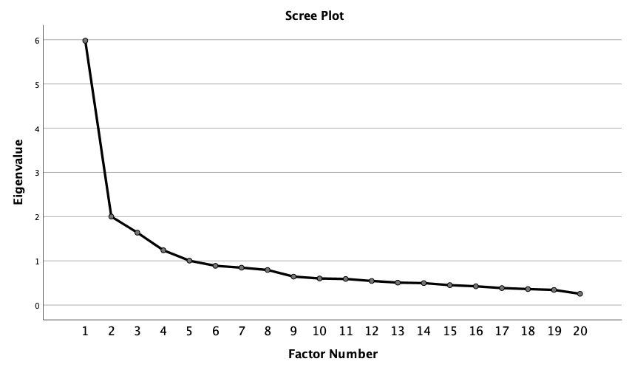
Supplementary Table 12
Total Variance Explained
Factor | Initial Eigenvalues |  |  | Extraction Sums of Squared Loadings |  |  | Rotation Sums of Squared Loadings
Factor | Total | % of Variance | Cumulative % | Total | % of Variance | Cumulative % | Total | % of Variance | Cumulative %
1 | 5.98 | 29.90 | 29.90 | 5.41 | 27.04 | 27.04 | 2.17 | 10.84 | 10.84
2 | 2.00 | 10.01 | 39.90 | 1.63 | 8.14 | 35.18 | 1.98 | 9.90 | 20.74
3 | 1.64 | 8.19 | 48.10 | 1.13 | 5.64 | 40.82 | 1.92 | 9.58 | 30.31
4 | 1.24 | 6.20 | 54.30 | 0.696 | 3.48 | 44.30 | 1.68 | 8.39 | 38.71
5 | 1.01 | 5.02 | 59.32 | 0.508 | 2.54 | 46.84 | 1.63 | 8.14 | 46.84
6 | 0.888 | 4.44 | 63.76
7 | 0.847 | 4.23 | 67.99
8 | 0.794 | 3.97 | 71.96
9 | 0.644 | 3.22 | 75.18
10 | 0.602 | 3.01 | 78.19
11 | 0.591 | 2.95 | 81.15
12 | 0.545 | 2.73 | 83.87
13 | 0.508 | 2.54 | 86.41
14 | 0.497 | 2.48 | 88.90
15 | 0.451 | 2.25 | 91.15
16 | 0.425 | 2.13 | 93.28
17 | 0.384 | 1.92 | 95.20
18 | 0.362 | 1.81 | 97.01
19 | 0.343 | 1.71 | 98.72
20 | 0.255 | 1.28 | 100.00
Extraction Method: Maximum Likelihood.

Supplementary Table 13
Factor Matrix
Factor Matrixª
 | Factor
 | 1 | 2 | 3 | 4 | 5
7. I read the terms and conditions for specific internet applications (for example YouTube Kids) before allowing the children to use them (REG7) | .612
13. I talk about the benefits of using the internet for example searching for information about health and general knowledge (PAND13) | .588
11. I discuss with my children about the experiences they feel when they are using the internet (PAND11) | .586
19. I and other family members are consistent in adhering to the internet rules that we have agreed together with the children (PAND19) | .577
3. My children and I have an agreement about the time schedule for when they may use the internet (REG3) | .568
5. I apply application download limits for Google play in accordance with my children’s age (REG5) | .562
4. My children and I have made an agreement in regards to the internet content (subject material) which they may access in accordance with their age (REG4) | .548
12. I talk with my children about the dangers of excessive use of the internet (PAND12) | .540
34. I give punishments in accordance with the consequences that we have agreed upon when my children go beyond the time limits of internet access (INTV34) | .529
10. I advise my children to use the internet for things that are beneficial for themselves and for other people (PAND10) | .511
32. When the children break the rules of internet usage, I confiscate the device (INTV32) | .509 |  | -.447
33. I unexpectedly check the children’s devices to observe my children’s internet activities (INTEV33) | .508
28. When my children access the internet, I have full view of the screens of their devices (RKEP28) | .479
8. I limit how much internet quota that is bought or Wi-Fi access for the children (REG8) | .469
31. I reprimand my children when they use their digital devices excessively (INTV31) | .457
29. Digital devices in our house are accessed in the family room at the time when the children access the internet (RKEP29) | .415
1. I limit the time, duration and frequency when my children use the internet so that their activities are balanced between activities of using the internet and not using the internet (REG1) | .413
6. I permit my children to watch videos through YouTube Kids at the times when the children want to watch videos (REG6)
26. I check any apps that have been downloaded to the mobile phone which can be accessed by my children with the children being unaware of this (RKEP26) | .541 | -.647
25. I check the search history (search history) on the digital devices which can be accessed by the children without their knowledge of this (RKEP25) | .518 | -.551
Extraction Method: Maximum Likelihood.
a. 5 factors extracted. 7 iterations required.

Supplementary Table 14

Goodness-of-fit test

Goodness-of-fit Test
Chi-Square | df | Sig.
226.797 | 100 | .000

Supplementary Table 15

Rotated Factor Matrix, Factor loading > 0.3

 | Factor
 | 1 | 2 | 3 | 4 | 5
13. I talk about the benefits of using the internet for example searching for information about health and general knowledge (PAND13) | .750
12. I talk with my children about the dangers of excessive use of the internet (PAND12) | .671
11. I discuss with my children about the experiences they feel when they are using the internet (PAND11) | .573
10. I advise my children to use the internet for things that are beneficial for themselves and for other people (PAND10) | .524
7. I read the terms and conditions for specific internet applications (for example YouTube Kids) before allowing the children to use them (REG7) |  | .770
6. I permit my children to watch videos through YouTube Kids at the times when the children want to watch videos (REG6) |  | .574
5. I apply application download limits for Google play in accordance with my children’s age (REG5) |  | .529
8. I limit how much internet quota that is bought or Wi-Fi access for the children (REG8) |  | .514 |  | .301
26. I check any apps that have been downloaded to the mobile phone which can be accessed by my children with the children being unaware of this (RKEP26) |  |  | .839
25. I check the search history (search history) on the digital devices which can be accessed by the children without their knowledge of this (RKEP25) |  |  | .768
28. When my children access the internet, I have full view of the screens of their devices (RKEP28) |  |  | .439
29. Digital devices in our house are accessed in the family room at the time when the children access the internet (RKEP29) |  |  | .318
3. My children and I have an agreement about the time schedule for when they may use the internet (REG3) |  |  |  | .709
1. I limit the time, duration and frequency when my children use the internet so that their activities are balanced between activities of using the internet and not using the internet (REG1) |  |  |  | .570
19. I and other family members are consistent in adhering to the internet rules that we have agreed together with the children (PAND19) | .347 |  |  | .445
4. My children and I have made an agreement in regards to the internet content (subject material) which they may access in accordance with their age (REG4) |  | .338 |  | .420
32. When the children break the rules of internet usage, I confiscate the device (INTV32) |  |  |  |  | .795
33. I unexpectedly check the children’s devices to observe my children’s internet activities (INTEV33) |  |  | .363 |  | .558
34. I give punishments in accordance with the consequences that we have agreed upon when my children go beyond the time limits of internet access (INTV34) |  |  |  |  | .478
31. I reprimand my children when they use their digital devices excessively (INTV31) |  |  |  |  | .400
Extraction Method: Maximum Likelihood.
Rotation Method: Varimax with Kaiser Normalization.ª
a. Rotation converged in 7 iterations.

