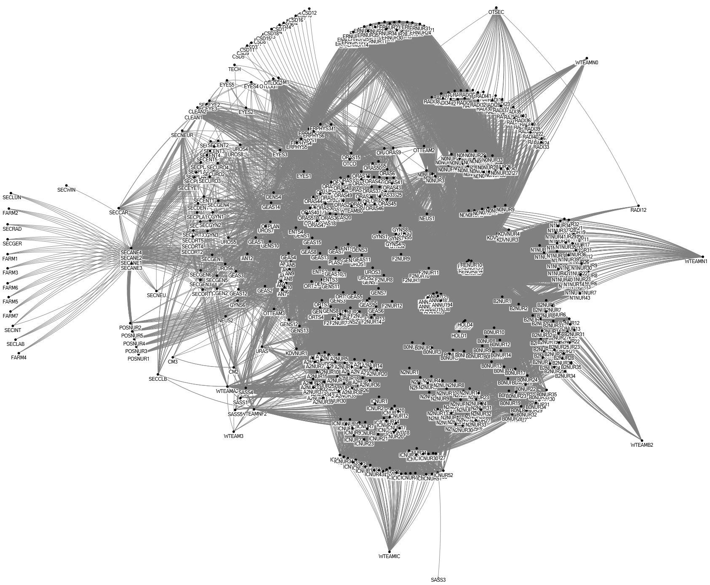
Additional file 1: Data collected and used for social network analysis per task

