Supplementary Information
A Local Water Molecular-heating Strategy for NIR Long-lifetime Imaging-guided Photothermal Therapy of Deep-tissue-bearing Tumor
Dongkyu Kang¹*, Hyung Shik Kim²*, Soohyun Han³, Yeonju Lee⁴, Young-Pil Kim^{,3,4,5,6}, Dong Yun Lee^{2,5,7,8}**, Joonseok Lee^{1,6}**

¹Department of chemistry, Hanyang University, Seoul 04763, Republic of Korea
²Department of Bioengineering, College of Engineering, and BK FOUR Biopharmaceutical Innovation Leader for Education and Research Group, Hanyang University, Seoul 04763, Republic of Korea
³Department of HY-KIST Bio-Convergence, Hanyang University, Seoul 04763, Republic of Korea
⁴Department of Life Science, Hanyang University, Seoul 04763, Republic of Korea
⁵Institute of Nano Science and Technology (INST), Hanyang University, Seoul 04763, Republic of Korea
⁶Research Institute for Convergence of Basic Sciences, Hanyang University, Seoul 04763, Republic of Korea
⁷Institute for Bioengineering and Biopharmaceutical Research (IBBR), Hanyang University, Seoul 04763, Republic of Korea
⁸Elixir Pharmatech Inc., Seoul 07463, Republic of Korea

*Equally contributed in this study
**Corresponding author
E-mail address: joonseoklee@hanyang.ac.kr, dongyunlee@hanyang.ac.kr

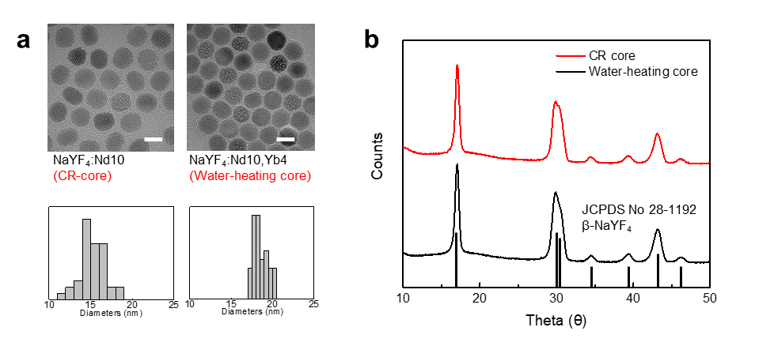
Supplementary Figure S1. Characterizations of water-heating core. a) TEM images and size distributions of CR-core and water-heating core, Scale bar : 20 nm. b) XRD patterns of core nanoparticles.
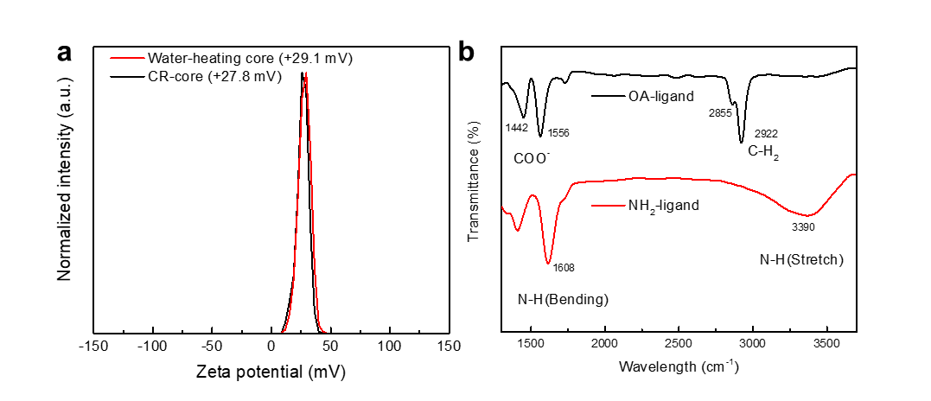
Supplementary Figure S2. a) Zetapotential profiles of dopamine-ligand exchanged water-heating core (+29.1 mV) and CR-core (+27.8 mV). Observed charge for each ligand were demonstrated the homogeneously exchanged ligand of nanoparticle. b) Fourier transform infrared spectroscopic (FT-IR) spectrum of oleic acid-ligand (black) and dopamine-ligand (red). The surface modification was confirmed by the appearance of two new bands at 1608 nm and 3390 nm, attributed to N-H bending and stretching of amine groups.

Fig. S3. Optimizations of core nanoparticle a) TEM images of core nanoparticles. 27.2 ± 4.7, 31.2 ± 2.0, 36.4 ± 1.4, and 43.5 nm ± 4.0 nm, respectively. b) TEM images of core@shell nanoparticle. 28.7 nm ± 5.5, 43.2 ± 2.0, 45.2 ± 2.3, and 48.9 ± 3.1 nm, respectively. Scale bar: 20 nm.

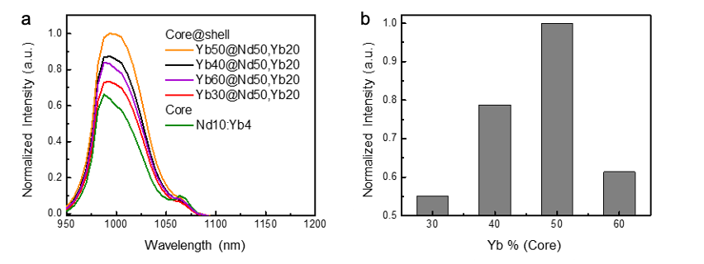
Fig. S4. Optimizations of Yb concentrations of core. a) 1.0 µm emission spectrum of core@shell nanoparticle (NaYF4:x%Yb@NaYF4:20%Yb,50%Nd) with various doping concentration of Yb in core and b) corresponding emission intensities

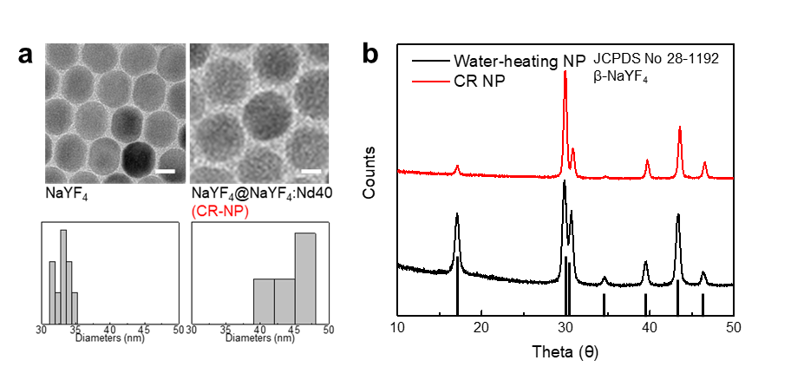
Supplementary Figure S5. a) TEM images of CR NP. Their size distributions were calculated to be 33.2 ± 1.8 nm and 44.9 ± 2.2 nm, respectively. Scale bar: 20 nm b) XRD patterns of core@shell nanoparticles

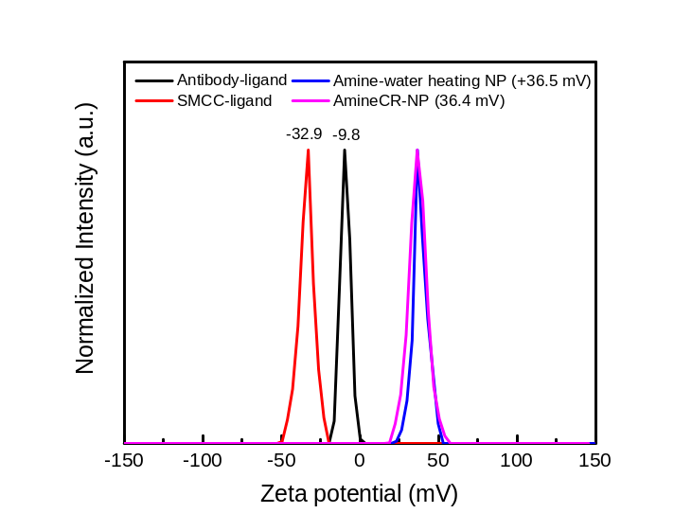
Supplementary Figure S6. Zetapotential profiles of water-heating NIR NP dopamine-ligand (+ 36.5 mV and 36.4 mV, water-heating NP and CR NP, respectively), SMCC-ligand (-32.9 mV) and antibody-ligand (-9.8 mV) of conjugated each nanoparticle.

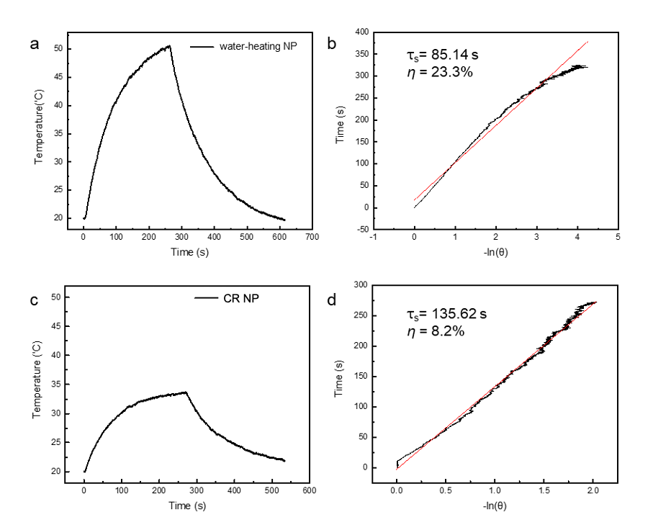Supplementary Figure S7. a) Temperature profiles of water-heating NP (NaYF₄:50%Yb@NaYF₄:40%Nd,20%Yb) (5 mg/mL) in aqueous solution with an irradiation of continuous NIR laser (808 nm, 2 W/cm²). b) Linear time data versus -ln(θ) obtained from the cooling period. c) temperature profiles of CR NP (NaYF4@NaYF₄40%Nd) (5 mg/mL) in aqueous solution with an irradiation of continuous NIR laser (808 nm, 2 W/cm²). d) Linear time data versus -ln(θ) obtained from the cooling period. Detailed calculation is described in method.

Supplementary Figure S8. Characterizations of optical properties of water-heating NIR NP. a) EDS mapping images of water-heating NIR NP. b) TEM images of NaYF₄:50%Yb,2%Tm and NaYF₄:50%Yb,2%Tm@NaYF₄:40%Nd,20%Yb (water-heating NIR NP), Scale bar: 20 nm. c) NIR emission spectrum for 800 nm emission under 980 nm laser excitation. 800 nm emission shape is slightly absorbed by the outer shell doped the Nd³⁺ ion d) NIR absorption spectrum of Nd³⁺ ion e) 1.0 μm emission spectrum of water-heating NIR NP and water-heating NP in cyclohexane under 808 nm laser excitation.

Supplementary Figure S9. Biodistribution of bare-NP and Ab-NP that administered by tail vein. a) In vivo luminescence image of dissected organs of GBM-bearing mice sacrificed at 1, 5, and 60 min after tail vein injection of bare-NP and Ab-NP (20 mg/kg dose of total drug, respectively). b) Mean intensity of luminescence detected in organs 1, 5, and 60 min after tail vein injection of bare-NP and Ab-NP, respectively.

Supplementary Figure S10. Histopathological analysis of heart, lung, liver, kidney, spleen, and intestine after repeated doses. The tissues were histologically analyzed after intravenous administration of 3-repeated doses at a concentration of 5 mg/kg to GBM-modeled mice. Scale bar: 100 μm.

Supplementary Figure S11. Relative body weight of each groups, that monitored for 25 days. Data were expressed as mean ± S.E.M (n=4).

Fig. S12. Investigation of spleen enlargement occurred due to unwanted immune stimulation after repeated drug administration. a) Images of spleen of PBS-vehicle- (Control), bare-NP-, and Ab-NP- treated group after repeated treatments. b) Spleen weight (mg) / body weight (g) of each group. Data are expressed as mean ± S.E.M (n=3).

