Dual-band metamaterial-based energy harvesting application for WLAN communication frequency bands
Author's Picture & Biography
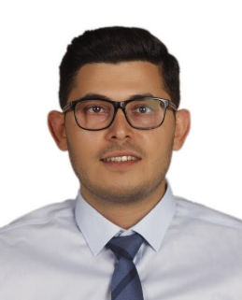
Murat Ercan was born in Turkey, in 1993. He received his BSc and MSc degrees in Materials Science and Nanotechnology Engineering from the Uşak University, Turkey, in 2018 and 2022. He has been working as a quality control engineer since 2018. His main interests are metamaterials, electronics, and activated carbon.

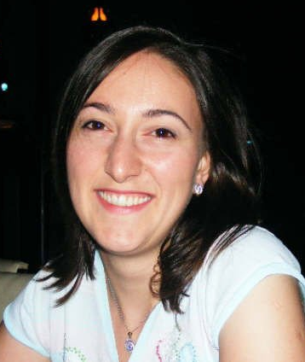
Gamze D. Tetik was born in Turkey, in 1982. She received her BSc (in 2004), MSc (in 2007), and PhD (in 2012) in Textile Engineering from Uludağ, Afyon Kocatepe, and Ege Universities, respectively. She has been working at Usak University since 2013 as an assistant professor at the Department of Materials Science and Nanotechology Engineering. Her research interests are nanofibers, electrospinning, and wearable electronics.

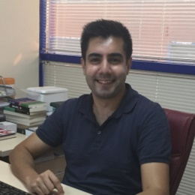
Olcay Altıntaş received a Ph.D. degree in Electrical and Electronics Engineering at Cukurova University in 2020. He has been working at Iskenderun Technical University as an assistant professor. He is the author of over 40 scientific papers published in SCI/ SCI Expanded journals. His main research interests include metamaterial-based sensors, absorbers, energy harvesters, and polarization converters in the microwave regime.

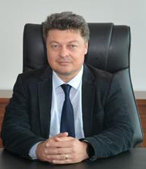
Erkan Tetik received the PhD. degree in Physics Department from the University of Cukurova, Adana, Turkey, in 2012. He has been working at Usak University since 2012 as an associate professor. His research interest are applications of the wearable electronics, metamaterials, antennas, and waveguides.

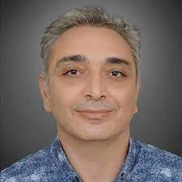
Muharrem Karaaslan received the Ph.D. degree in Physics Department from the University of Cukurova, Adana, Turkey, in 2009. He is the co-author of about 110 scientific contributions published in journals and conference proceedings. His research interest are applications of metamaterials, analysis and synthesis of antennas, and waveguides.

