Supplementary Material:
Methods
Selection of Streamflow Data
Long-term streamflow data were downloaded from two sources: 1) the Global Runoff Data Centre (GRDC, https://www.bafg.de/GRDC; last accessed on: 27 May 2022), and 2) the United States Geological Survey (USGS) Water Data for the USA (https://waterdata.usgs.gov/nwis; last accessed on: 27 May 2022). The datasets were requested from 1850 to 2019 to capture the entirety of the streamflow records. Stations were selected for bulk download by region, based on proximity to alpine glaciers. The regions with glaciated catchments include Upper Rocky Mountains in the USA and Canada, Cascadia in the USA and Canada, Andes Mountains in South America, Pacific Coast of Alaska, European Alps, and Himalayan Mountains. In total, mean daily streamflow data were downloaded from 800 stations. The dataset was then filtered according to the flowchart in Fig. S1.
1) The locations of the individual stations were filtered by selecting only gages that are draining alpine glaciers and have little to no anthropogenic infrastructure (e.g., hydropower, dams, diversions, etc.).
2) The remaining dataset was filtered such that only stations with more than 50 years of data spanning from 1900 to 2019 were included. This resulted in 45 stations that met the above prerequisites.
3) The remaining stations were filtered by assessing the quality of the timeseries data. All except 7 of the 45 stations were missing more than 5% of annual data. Infilling methods can improve the usability of timeseries data, but it is not possible to always calculate realistic flow for long sequences of missing data²⁷. For daily mean flow data, it is not uncommon for a record to be discarded if more than 20% of the values are missing. In fact, thresholds of 5%, or 18 missing days, are commonly used in timeseries studies²⁷.
4) Finally, we attempted to retain glaciated catchments having similar geographic location, geological setting, and climatology. This limited the dataset to 3 within the Swiss Alps and 1 in Austria (Fig. S1). Table S1 contains information about the three stations in the Swiss Alps. The three stations/catchments are referred to by the names of the largest glacier in each watershed: Rottengletscher (Rhone Glacier), Roseggletscher, and Glatt Firn.
Selection of Meteorological Data
This study is being performed on a catchment scale; therefore, finding a climate dataset with the highest resolution possible is the best approach. However, downscaling is problematic at small catchment scales. The first high resolution temperature and precipitation data utilized in this study was the climate reanalysis product, ERA5 (European Center for Medium-Range Weather Forecasts Re-Analysis 5) from the Copernicus Climate Change Service^{28,29}. ERA5 monthly averaged data on single levels from 1950 to 1978 (preliminary) and ERA5 monthly averaged data on single levels from 1979 to present were combined to create a continuous timeseries from 1950 to present. The spatial resolution of 0.25 degree grids (~27 km) initially seemed sufficient. Upon further inspection and use in this study, the resolution was deemed to be too coarse. The largest catchment in this study is 10x smaller than each cell, and there were no distinctions between lowland and high alpine areas in temperature, or more importantly, precipitation. Therefore, another gridded climate dataset was chosen, the EURO4M-APGD (European Re-analysis and Observations for Monitoring - Alpine Precipitation Grid Dataset). This is a daily precipitation dataset and has a resolution of 5 km encompassing the European Alps from 1971 to 2008. The grid analysis is based on the combination of more than 8500 rain gauges across Europe with model based regional reanalysis, but it does not differentiate the precipitation type (snow versus rain). For this study, the EURO4M grid cells overlapping each watershed boundary were used to create an area-weighted average daily precipitation unique to each catchment. This precipitation record was roughly 150 mm per month less than the estimation from the ERA5 model, yielding a more accurate estimation. Because temperature was not included as a metric given in the high-resolution dataset, the estimation provided by the ERA5 model was used.
Identifying Peak-water Year and the Pre-peak Water and Post-peak Water Boundary
There is pronounced seasonality in the sources of water that support annual streamflow from glaciated alpine catchments. Isotopic mixing model studies show that streamflow is composed primarily of seasonal snowmelt at the beginning of the melt season^{30,31,32}. As the summer progresses, the primary component of streamflow transitions to glacial melt. Glacial meltwater sustains the stream into the winter months. In addition, there can be substantial variability in meltwater discharge between years. However, the peak-water year can be identified from a discharge time series by using an 11-year moving average of annual discharge thus minimizing the effect of long-term atmospheric oscillations in the time series⁸. The peak-water year was then used to divide the timeseries datasets into pre- and post-peak water periods.
Spatial Datasets
Geologic maps (Fig. S2) were created from geologic datasets that were obtained from the GeoCover 500 V2 dataset (1:25000, Geological Vector Datasets, SwissTopo, https://www.swisstopo.admin.ch/en/geodata/geology/maps/geocover.html, last accessed on 01 June 2022). Glacier outlines were downloaded from GLIMS (Global Land Ice Measurements from Space; http://dx.doi.org/10.7265/N5V98602, last accessed on 01 June 2022). This series was used to create a rate of retreat timeseries for the glaciers in the catchments (Fig. S3). SwissTopo lidar data (the swissALTI3D model) was downloaded to create vector datasets of streams in the catchments. The lidar data has a horizontal resolution of 0.3 m. Stream delineation was done following the steps provided in the QGIS training manual (https://docs.qgis.org/3.22/en/docs/training_manual/index.html, last accessed on 01 June 2022). The geologic maps and maps of glacial change were then used to assess 1) the proportion of lithologies present in each catchment, and 2) the proportion of streams that cross unconsolidated rock versus bedrock (Fig. S4).
Delayed Flow Index (DFI) and Characteristic Delay Curves (CDCs)
Time series of discharge were first divided into non-overlapping adjacent blocks of length 1 to N days²³. This is equivalent to creating a moving filter, which outputs a new timeseries for each block length from 1 to N (we use the term BLEN). Each block is compared to the two adjacent blocks and if a factor, f (f = 0.9 * the minimum value), is less than or equal to these adjacent minimum values, a turning point is established. Turning points are therefore separated by a varying number of days due to this algorithm²³. Linear interpolation is performed between turning points, resulting in the creation of a delayed flow hydrograph. The delayed flow index (DFI) for each value of BLEN is then calculated as the sum of delayed flow divided by the sum of total streamflow. This is similar to the calculation of BFI, or baseflow index, which is simply baseflow divided by total flow.
Next, the DFI was plotted against the block length to create a characteristic delay curve (CDC). Because the units of block length are days, when the DFI is close to 1 the delayed flow timeseries is nearly equivalent to the total flow timeseries (i.e., the delayed flow time series is approximately equal to the original hydrograph). DFI values decrease with increasing BLEN, but the rate of decrease is not consistent throughout and instead shows distinct linear breaks in the curve. These changes in slope are assumed to represent a transition from faster to slower (or slower to faster) contributing stores/sources in the watershed²³. The natural breakpoints (BPs) in the CDC can be used to split the CDC into piecewise linear segments²³. A line is used to best fit as many points on the CDC curve as possible (least squares), and when the line no longer approximates the data, a BP is identified. Each BP is used to establish different classifications of flow. The R packages “lfstat” and “segmented” were used to accomplish the above steps^{33,34}. For this study a BLEN of 100 was sufficiently long enough to capture all BPs and allow the curve to level out. The leveling out represents a convergence within the catchment for larger values of N²³. At the largest value of N, the delayed flow time series is approximately equal to standard straight-line techniques used to partition between quick flow and baseflow. This entire process was completed for the full timeseries and then repeated again for both the pre- and post-peak water time series.
Once the DFI values for each BLEN are known, they can be applied to the total hydrograph to separate the total discharge into the different components of delayed flow that contribute to the stream. Four delay classes were retained during this study because the time series showed 3 natural breakpoints. To illustrate the differences between a given DFI at a given BLEN pre-peak water and post-peak water, pre-peak water DFI was subtracted from post-peak water DFI for each BLEN.
Statistical Significance of Trends
None of the analyzed timeseries followed a normal distribution and this was verified using Shapiro tests. Therefore, temporal trend tests were calculated by applying the non-parametric modified Mann-Kendall significance test on the pre- and post-peak water discharge and precipitation time series. The original Mann Kendall test is particularly useful in hydrologic studies because non-parametric trend-detection methods are less sensitive to extreme values than parametric methods and a priori knowledge of whether the trend is linear or not is not needed³⁵. We chose the modified version of this test due to possible positive serial correlation and false trend detection³⁶. The modified Mann Kendall test evaluates serial correlation within the time series and autocorrelation coefficients are then used to modify the variance. Magnitudes of the trends are calculated as well using Theil-Sen’s slope estimation³⁷. The temperature timeseries was not included in these significance tests because it was visually evident that there was a significant increase in trend with time. The tests were completed using the “modifiedmk” R package, specifically the “mmkh” function which is a modified Mann-Kendall test for serially correlated data using the Hamed and Rao Variance Correction Approach³⁶. The non-parametric Wilcoxon test was used to compare the pre and post summed monthly precipitation timeseries. This was computed with the R function “wilcox.test” included in base R.
Statistical analyses were performed on the hydrologic and atmospheric variables from approximately 1950 to 2015 using the non-parametric modified Mann Kendall test³⁶. The test was run at the 95% confidence interval and performed to evaluate the trend and their significance in the various timeseries. The Z-statistic after variance correction is presented: if Z is positive the trend is increasing, and if Z is negative, the trend is decreasing. The p-value reported aids in the determination of whether there is a significant trend in the data. If the p-value is less than 0.05, the timeseries is considered to have a significant trend. If the p-value is greater than 0.05 the timeseries does not have a significant trend and the null hypothesis, H₀, is accepted. The absolute value of the Z-statistic can also show significance by whether or not it is greater than 1.96. If it is, the null hypothesis is rejected and there is not a significant trend present. The Mann-Kendall test statistic, tau, was reported and can be used to compare variables that experience differences in their magnitude: if tau has a positive slope, then there is an upward trend. The Sen’s slope estimate is reported where appropriate.
The results of the tests are provided below. Please note that the results of each catchment’s delay classes were not separated into pre- and post-peak water, but rather as a continuous time series. Rottengletscher has a statistically significant increasing monotonic trend in delay classes 5 (Zc = 2.2486, p = 0.0245), 29 (Zc = 2.2579, p = 0.0240), and 43 (Zc = 2.4990, p = 0.0125). Delay class 18 shows a slightly increasing trend through time, but it was not deemed significant (Zc = 0.9962, p = 0.3191). Glatt Firn catchment shows a significantly increasing trend in all delay classes. Roseggletscher shows no significant trend in any delay class.
The monthly precipitation time series was tested for significance (Tables S2, S3, S4). It was confirmed that there is no statistically significant increasing or decreasing trend in total precipitation on a monthly timescale in any catchment with the exception of September in Glatt Firn catchment (Table S3). Recall that MeteoSwiss only commented on the full precipitation timeseries and in doing so, may have overlooked seasonality. Thus, it’s not plausible to infer that increases in discharge and baseflow from the catchments can be attributed solely to increases in precipitation.
The delay class flow for each catchment was also tested at a monthly level. Again, this was done because there may be underlying seasonality that an annual trend test may miss. In the following assessment, we describe the months and delay classes that show a significant trend. If a month is not mentioned, then it is because it was not deemed significant. The results for Rottengletscher (Table S5) show that at the shortest delay class, 5, there is an increasing significant trend in flow for months February through May and also a decreasing trend in October. There is a positive significant trend in delay class 18 for months February, March, April, and decreasing trend for September, and October. In delay class 29 there is a significant increasing trend for all months except August and December. Delay class 43 has a significant increasing trend for all months.
The Glatt Firn analyses again resembled those from Rottengletscher (Table S6). All months except July through October had an increasing significant trend at delay class 5. Delay class 18 also had increasing significance every month except June through November. The remaining delay classes (32 and 44) had an increasing significant trend for every month.
Roseggletscher has very different results from the modified Mann-Kendall test (Table S7). An increasing significant trend was found for delay class 4 in months May, June, July, November, and December. There was a significant decreasing for September. Delay class 18 had an increasing significant trend for May and November and decreasing significant trend for September. There was no significant trend detected for any month in delay class 29 or 41.

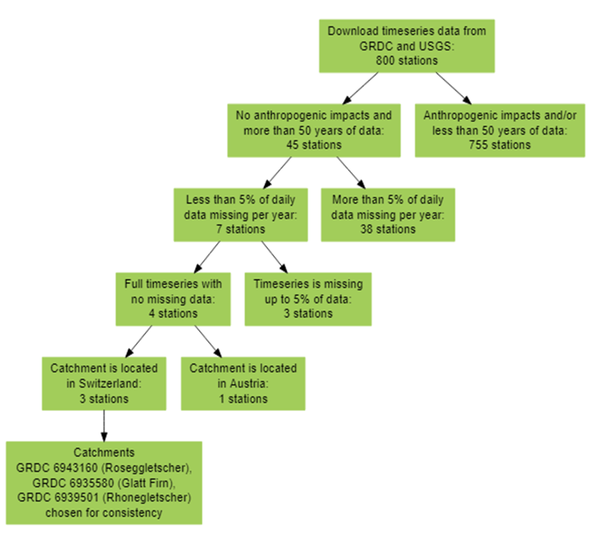

Fig. S1: Flowchart showing the process for identifying the best time series data (and eliminating poor study sites) for this study.

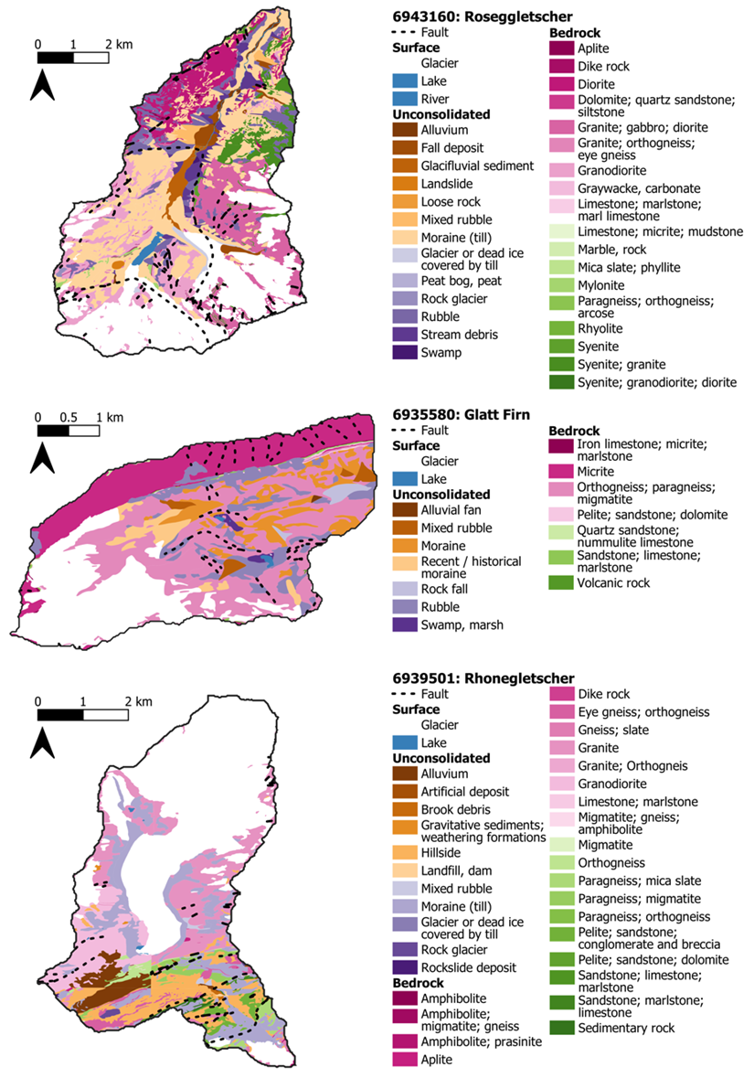

Fig. S2: Geologic maps for each catchment. Surface features like glaciers and/or lakes and rivers are colored in white and blue, respectively. Geodata was downloaded from SwissTopo.

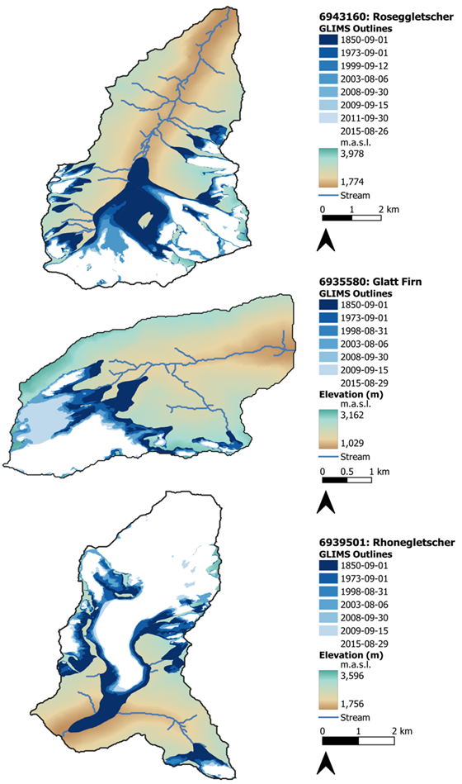

Fig. S3: The outline of each glacier in each catchment is plotted spatially through time. Stream channel locations and catchment elevation are shown.

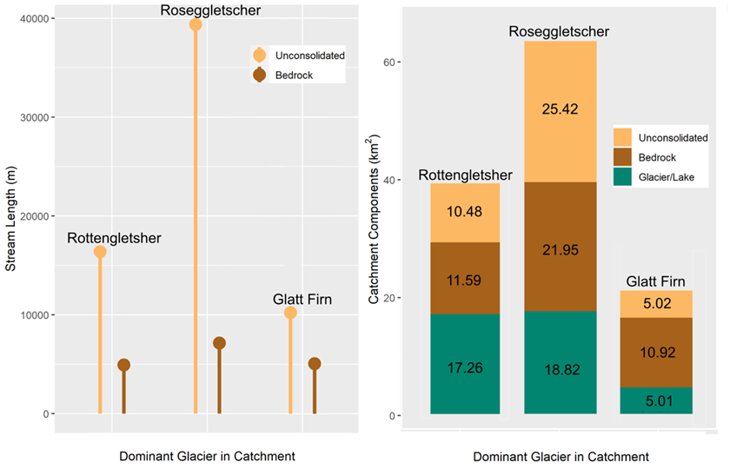

Fig. S4: The channel length and type of geology (unconsolidated versus bedrock) that streams flow through in each catchment (left) and the proportions of unconsolidated rock, bedrock, and glacier or lake composing each catchment’s total surface area (right). Colors denote the type of surface feature on both subplots. The area of each surface feature (right) is shown on each segment of the bar chart. Total catchment area is represented by the sum of all three surface features (right).

Table S1.
Station  Name | Catchment  Name | Latitude  (dec deg) | Longitude  (dec deg) | Catchment  Area (km²) | Altitude  (m.a.s.l.) | Start  Year | End Year | Total Years
GRDC6935580 | Glatt Firn | 46.8113 | 8.5990 | 20.6 | 1070.9 | 1960 | 2016 | 57
GRDC6939501 | Rottengletscher | 46.5623 | 8.3621 | 38.9 | 1810.7 | 1956 | 2016 | 61
GRDC6943160 | Roseggletscher | 46.4899 | 9.8982 | 66.5 | 1814.2 | 1954 | 2016 | 63

Station information for each stream gage used in this study.

Table S2.
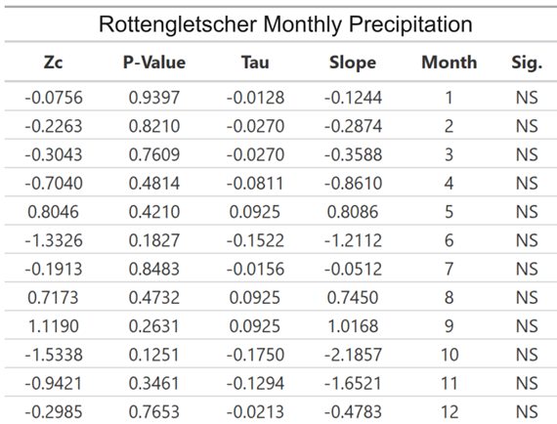

Results from the modified Mann-Kendall statistical analysis for the Rottengletscher precipitation time series at the monthly timescale. No differentiation between pre- and post-peak water is made, as the significance was tested for the full duration of the series.

Table S3.
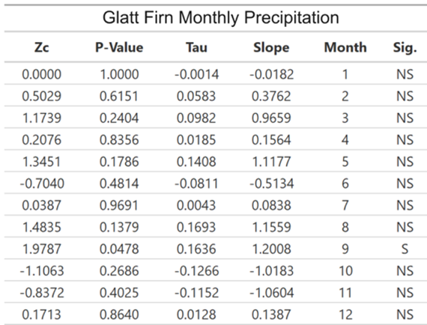

Results from the modified Mann-Kendall statistical analysis for the Glatt Firn precipitation time series at the monthly timescale. No differentiation between pre- and post-peak water is made, as the significance was tested for the full duration of the series. There is a significant positive trend in monthly precipitation for September.

Table S4.
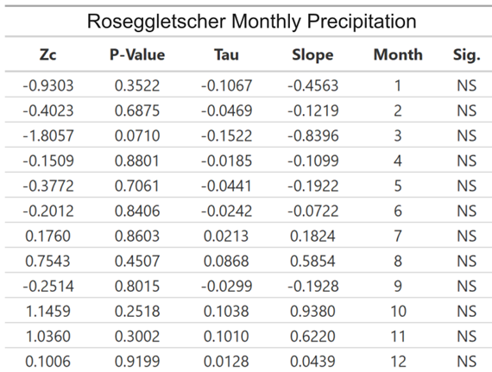

Results from the modified Mann-Kendall statistical analysis for the Roseggletacher precipitation time series at the monthly timescale. No differentiation between pre- and post-peak water is made, as the significance was tested for the full duration of the series.

Table S5.
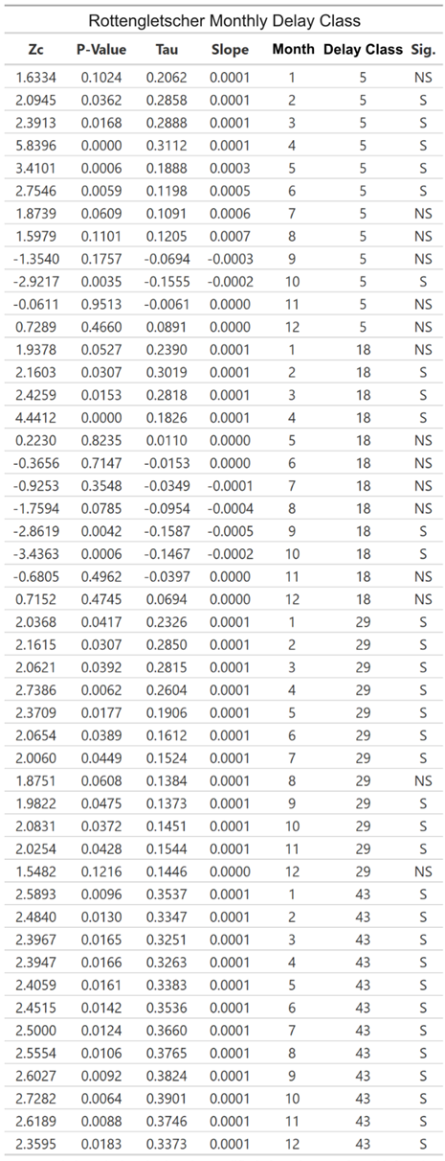

Results from the modified Mann-Kendall statistical analysis of the Rottengletscher delayed flow data separated by month and delay class. No differentiation between pre- and post-peak water is made, as the significance was tested for the full duration of the series.

Table S6.
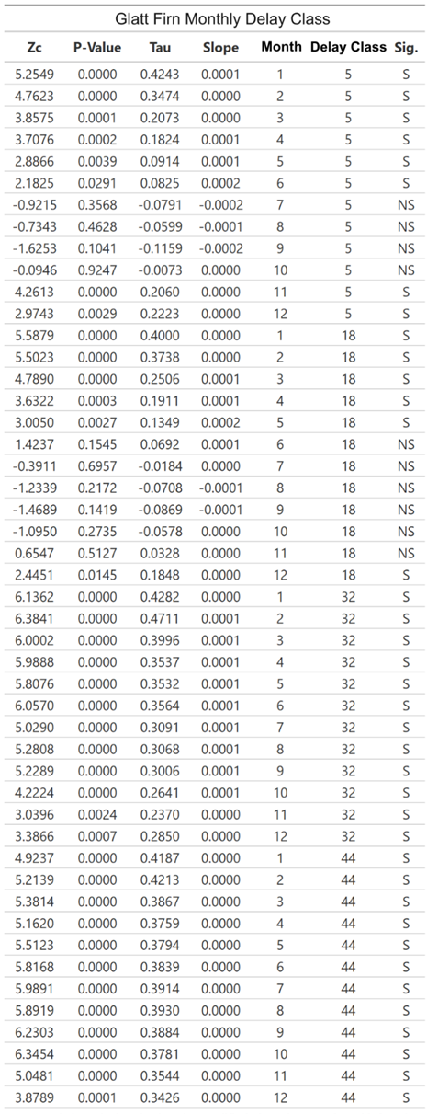

Results from the modified Mann-Kendall statistical analysis for the Glatt Firn delayed flow data separated by month and delay class. No differentiation between pre- and post-peak water is made, as the significance was tested for the full duration of the series.

Table S7.
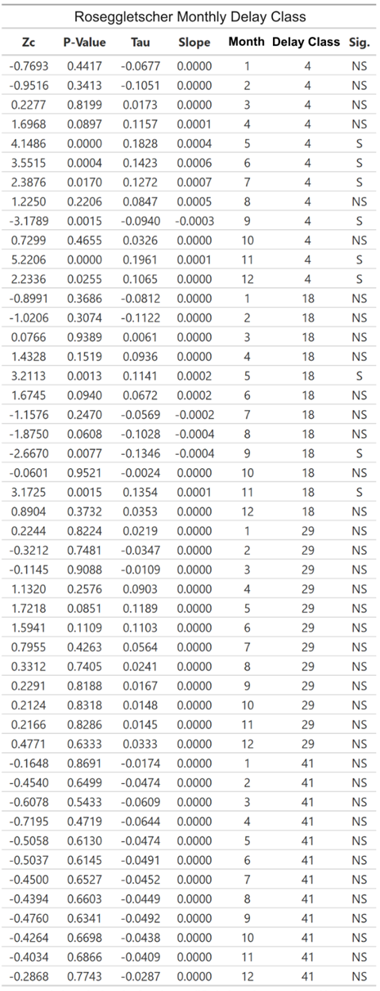

Results from the modified Mann-Kendall statistical analysis of the Roseggletscher delayed flow data separated by month and delay class. No differentiation between pre- and post-peak water is made, as the significance was tested for the full duration of the series.
References
27. A. Gustard, S. Demuth, Manual on low-flow estimation and prediction (No. 50, p. 136). Operational hydrology report, World Meteorological Organization, (2009).
28. H. Hersbach, B. Bell, P. Berrisford, G. Biavati, A. Horányi, J. Muñoz Sabater, J. Nicolas, C. Peubey, R. Radu, I. Rozum, D. Schepers, A. Simmons, C. Soci, D. Dee, J.-N. Thépaut, ERA5 monthly averaged data on single levels from 1979 to present. Copernicus Climate Change Service (C3S) Climate Data Store (CDS), doi:10.24381/cds.f17050d7, https://cds.climate.copernicus.eu/cdsapp#!/dataset/reanalysis-era5-single-levels-monthly-means?tab=overview, last accesses on 02 June 2022, (2019).
29. B. Bell, H. Hersbach, P. Berrisford, P. Dahlgren, A. Horányi, J. Muñoz Sabater, J. Nicolas, R. Radu, D. Schepers, A. Simmons, C. Soci, J.-N. Thépaut, ERA5 monthly averaged data on single levels from 1950 to 1978 (preliminary version). Copernicus Climate Change Service (C3S) Climate Data Store (CDS), https://cds.climate.copernicus.eu/cdsapp#!/dataset/reanalysis-era5-pressure-levels-monthly-means-preliminary-back-extension?tab=overview, last accessed on 02 June 2022, (2020).
30. C. A. Arendt, S. M. Aciego, E. A. Hetland, An open source Bayesian Monte Carlo isotope mixing model with applications in Earth surface processes. Geochemistry, Geophysics, Geosystems, 16(5), 1274–1292, doi:10.1002/2014GC005683, (2015).
31. O. S. Savoskul, V. Smakhtin, Glacier systems and seasonal snow cover in six major Asian river basins: hydrological role under changing climate (Vol. 150), IWMI, (2013).
32. J. Cable, K. Ogle, D. Williams, Contribution of glacier meltwater to streamflow in the Wind River Range, Wyoming, inferred via a Bayesian mixing model applied to isotopic measurements, Hydrological Processes, 25(14), 2228–2236, doi:10.1002/hyp.7982, (2011).
33. D. Koffler, T. Gauster, G. Laaha, lfstat: Calculation of Low Flow Statistics for Daily Stream Flow Data, available at: https://CRAN.R-project.org/package=lfstat, last accessed on 02 June 2022, (2016).
34. V. M. Muggeo, Segmented: an R package to fit regression models with broken-line relationships, R News, 8, 20–25, (2008).
35. Z. W. Kundzewicz, A. Robson, Detecting trend and other changes in hydrological data. World Climate Programme - Water, May, 158, doi:WMO/TD‐No.1013, (2000).
36. K. H. Hamed, A. R. Rao, A modified Mann-Kendall trend test for autocorrelated data. Journal of Hydrology, 204(1–4), 182–196, doi:10.1016/S0022-1694(97)00125-X, (1998).
37. P. K. Sen, Estimates of the regression coefficient based on Kendall's Tau, Journal of the American Statistical Association, 63(324), 1379–1389, doi:10.1080/01621459.1968.10480934, (1968).

