Supplementary Information

A) 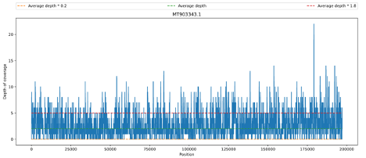 B)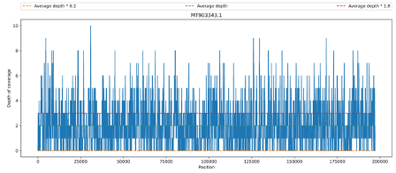
C) 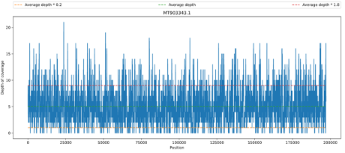 D)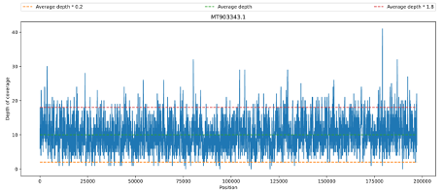
Figure S1. Coverage depth plots of reads aligned to the reference sequence MT903343.1. From samples (A) MPOX22-0034CH, (B) MPOX22-0034DSA, (C) MPOX22-0034DSE. and (D) pooled_MPOX22-0034. Figures 4a to 4c show wide coverage breadth over the whole MPXV genome but low coverage depth in all three separate samples between 2x to 5x. Coverage depth increased to an average of 10x in the pooled_MPOX22-0034 sample.

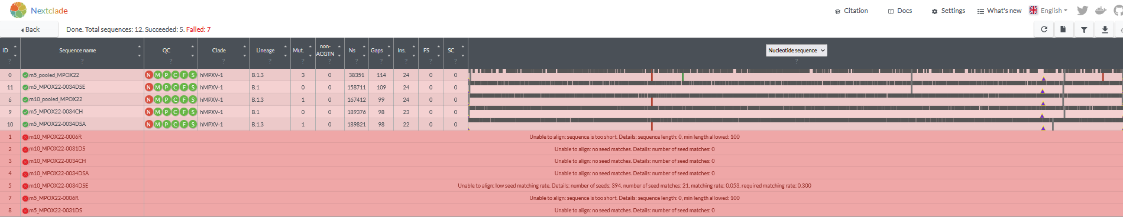
Figure S2. Nextclade Analysis of Consensus Sequences. From all three separate MPOX22-0034 samples, the pooled MPOX22-0034 sample, and using 10× and 5× depth thresholds with a reference sequence from the hMPXV outbreak clade

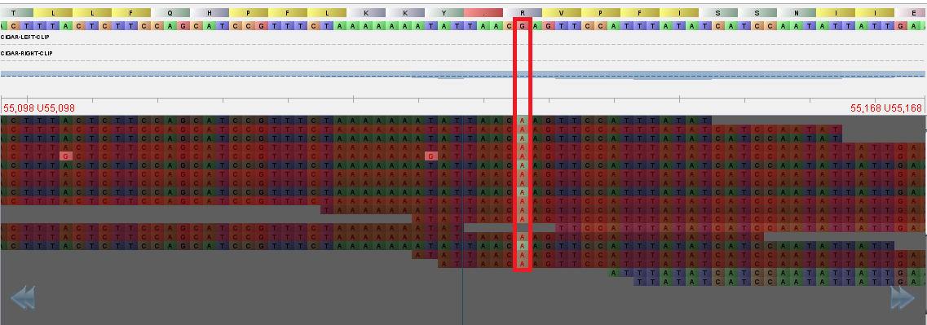
A
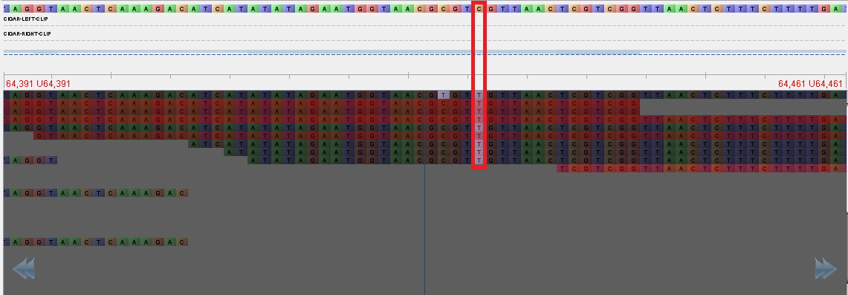
B
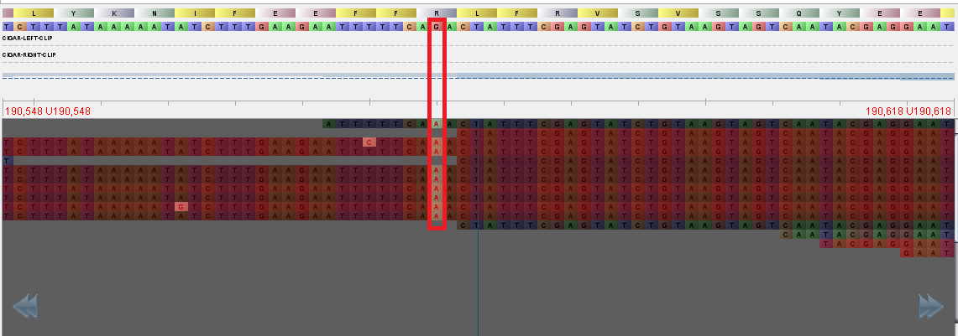
C
Figure S3. The three detected SNV mutations from the pooled_MPOX22-0034 consensus. Coordinates (A) 55133, (B) 64426, and (C) 190660 in the pseudo_ON563414 reference sequence.

