1. Cervical spine lateral glide applied to the C5/6 segment
Subject is in supine lying with the head in a neutral position. The Physiotherapist holds the patient’s head with the mobilizer hand at the C5-C6 level, while the other hand is placed on the contralateral side of the patient’s neck. in this position, the therapist applies lateral cervical glides at C5/C6 toward the contra-lateral side of symptoms (Maitland grade III)for 5 minutes in 2 sets of 2 minutes each, with 1 minute of rest between sets.
2. posteroanterior nonthrust mobilization of the mid cervical spine  The subject lies face downwards, The therapist stands at the head of the patient, the pads of the physiotherapist’s thumbs over the zygapophyses of targeted segment with medially-directed (30°), Central PA mobilization will be apply to C4-C6, 30 secend in each segment(Maitland grade III or IV) for an overall time of approximately 3 minutes. | 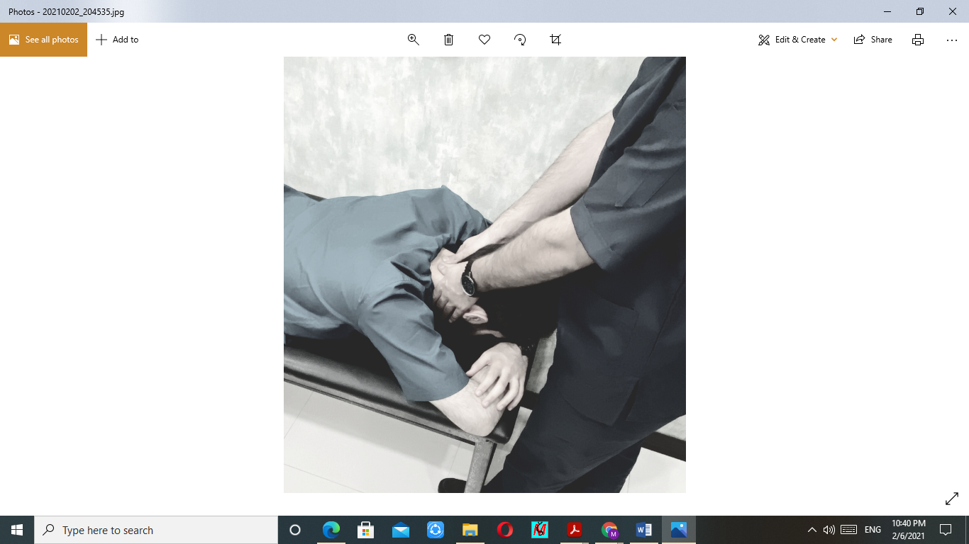
3. Manual Cervical Distraction:  Subject is in supine position so that his/her head and neck beyond the end of table.The physiotherapis stands at the head of the table and will place the patient's neck at 25-30 degrees. Manual traction will be apply to C4-C6 segments with 10 second pull and 5 second rest for 10 times. | 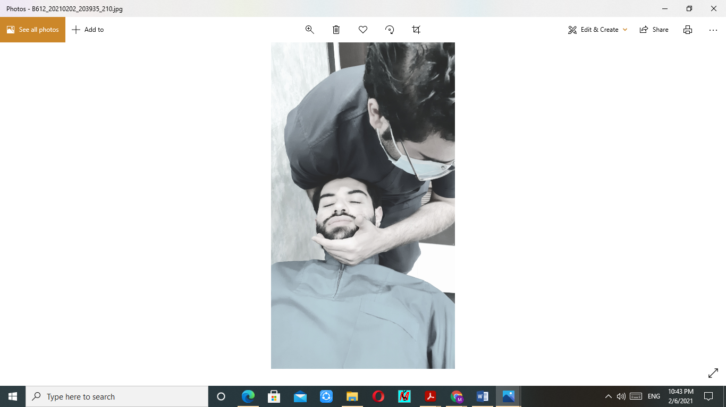
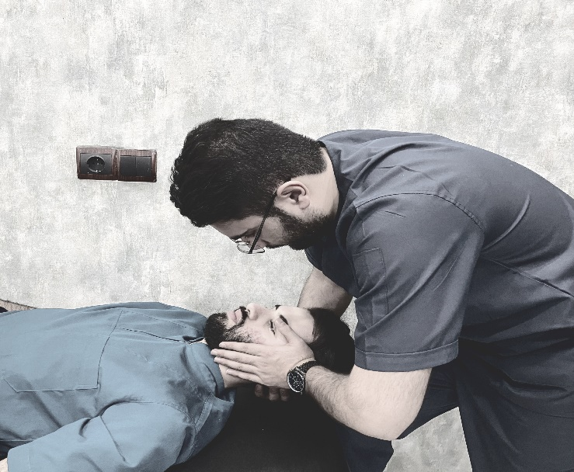
Appendix1: Cervical Manual therapy
CERVICAL SPINE EXERCISES
1. self-stretching of the trapezius muscle:  the patient is sitting upright on a table grasping the edge with epsilateral hand to avoid shoulder elevation and with the contralateral hand grasps her/his head then asked the patient to perform cervical flexion, contralateral lateral flexion, and epsilateral rotation.This stretching position will be held for 45 seconds 2 times | 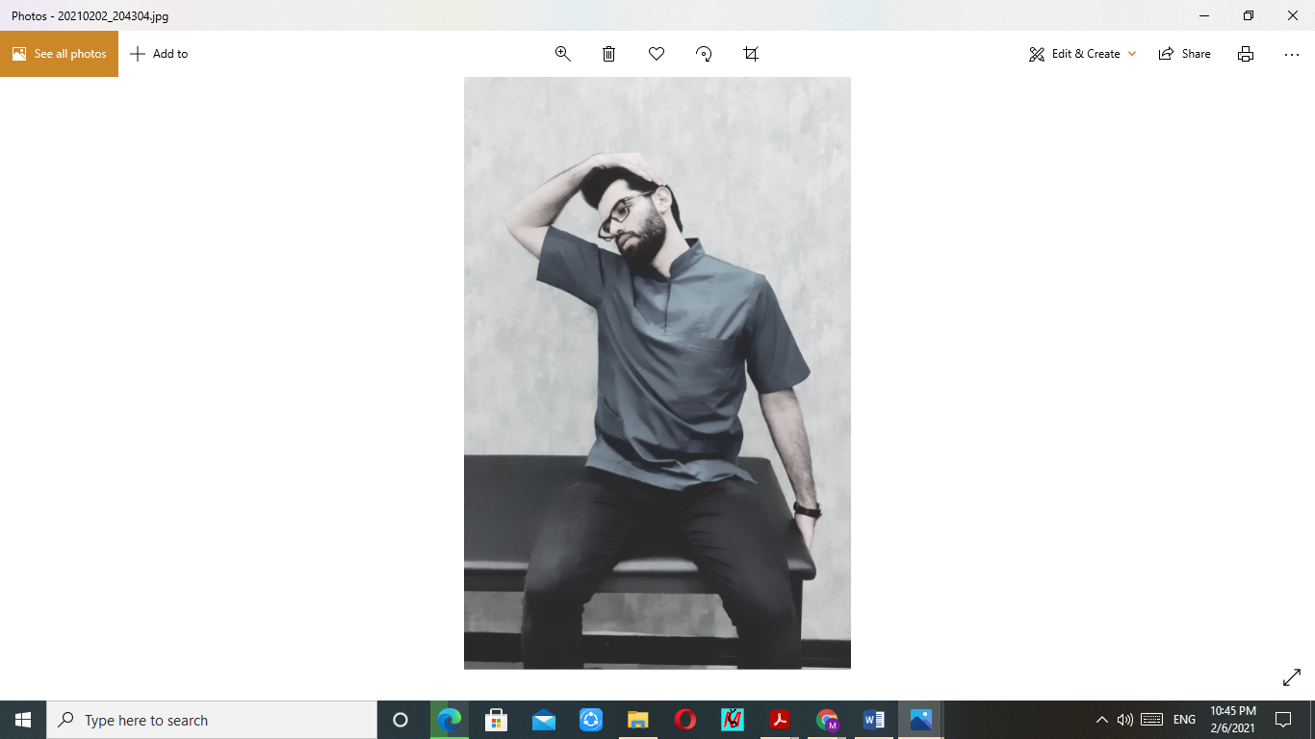
2. self-stretching of the levator scapulae muscle  the position is the same as for upper trapezius muscle stretching, then asked the patient to perform cervical flexion, contralateral lateral flexion, and contralateral rotation. This stretching position will be held for 45 seconds 2 times | 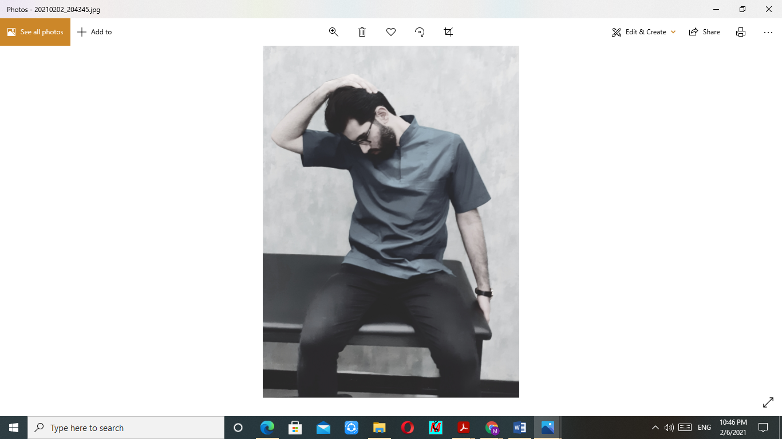
3. self-stretching of the upper fibers of the scalene muscles  the position is the same as for the other stretching exercises, then asked the patient to perform  slight cervical extension, contralateral lateral flexion, and contralateral rotation. This stretching position will be held for 45 seconds 2 times | 