Supporting Information
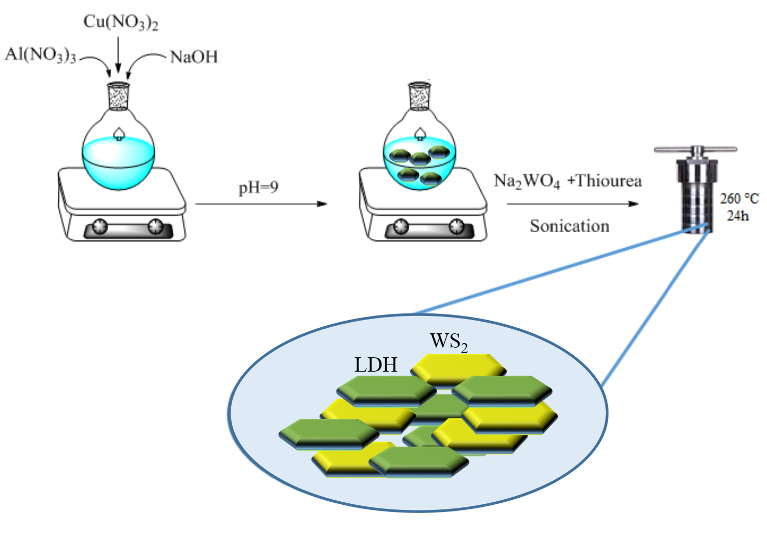
Fig. S1. Synthetic steps of the WS₂/CuAl LDH nanocomposite.

Table S1. The TFC, CuAl LDH TFN and WS₂/CuAl LDH TFN membranes prepared at different fillers concentrations.
Membranes | MPD in water phase (wt%) | TMC in n-hexane phase (wt%) | CuAl LDH in water phase (wt%) | WS₂/CuAl LDH in water phase (wt%)
TFC | 2 | 0.15 | 0.000 |  | 0.000
TFN-L₁ | 2 | 0.15 | 0.010 |  | 0.000
TFN-L₂ | 2 | 0.15 | 0.025 |  | 0.000
TFN-L₃ | 2 | 0.15 | 0.050 |  | 0.000
TFN-WL₁ | 2 | 0.15 | 0.000 |  | 0.010
TFN-WL₂ | 2 | 0.15 | 0.000 |  | 0.025
TFN-WL₃ | 2 | 0.15 | 0.000 |  | 0.050

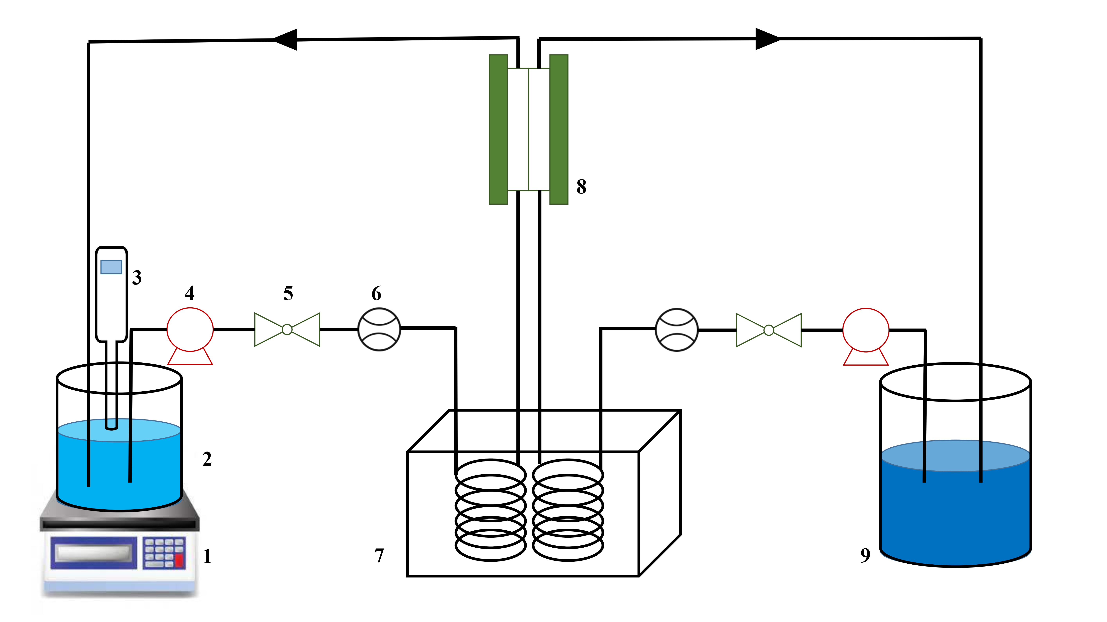
Fig S2. Schematic diagram of the laboratory-scale FO set-up, 1) digital weight balance, 2) feed solution, 3) conductometer, 4) pump, 5) controlling valve, 6) flow meter, 7) heat controller, 8) membrane cell and 9) draw solution.

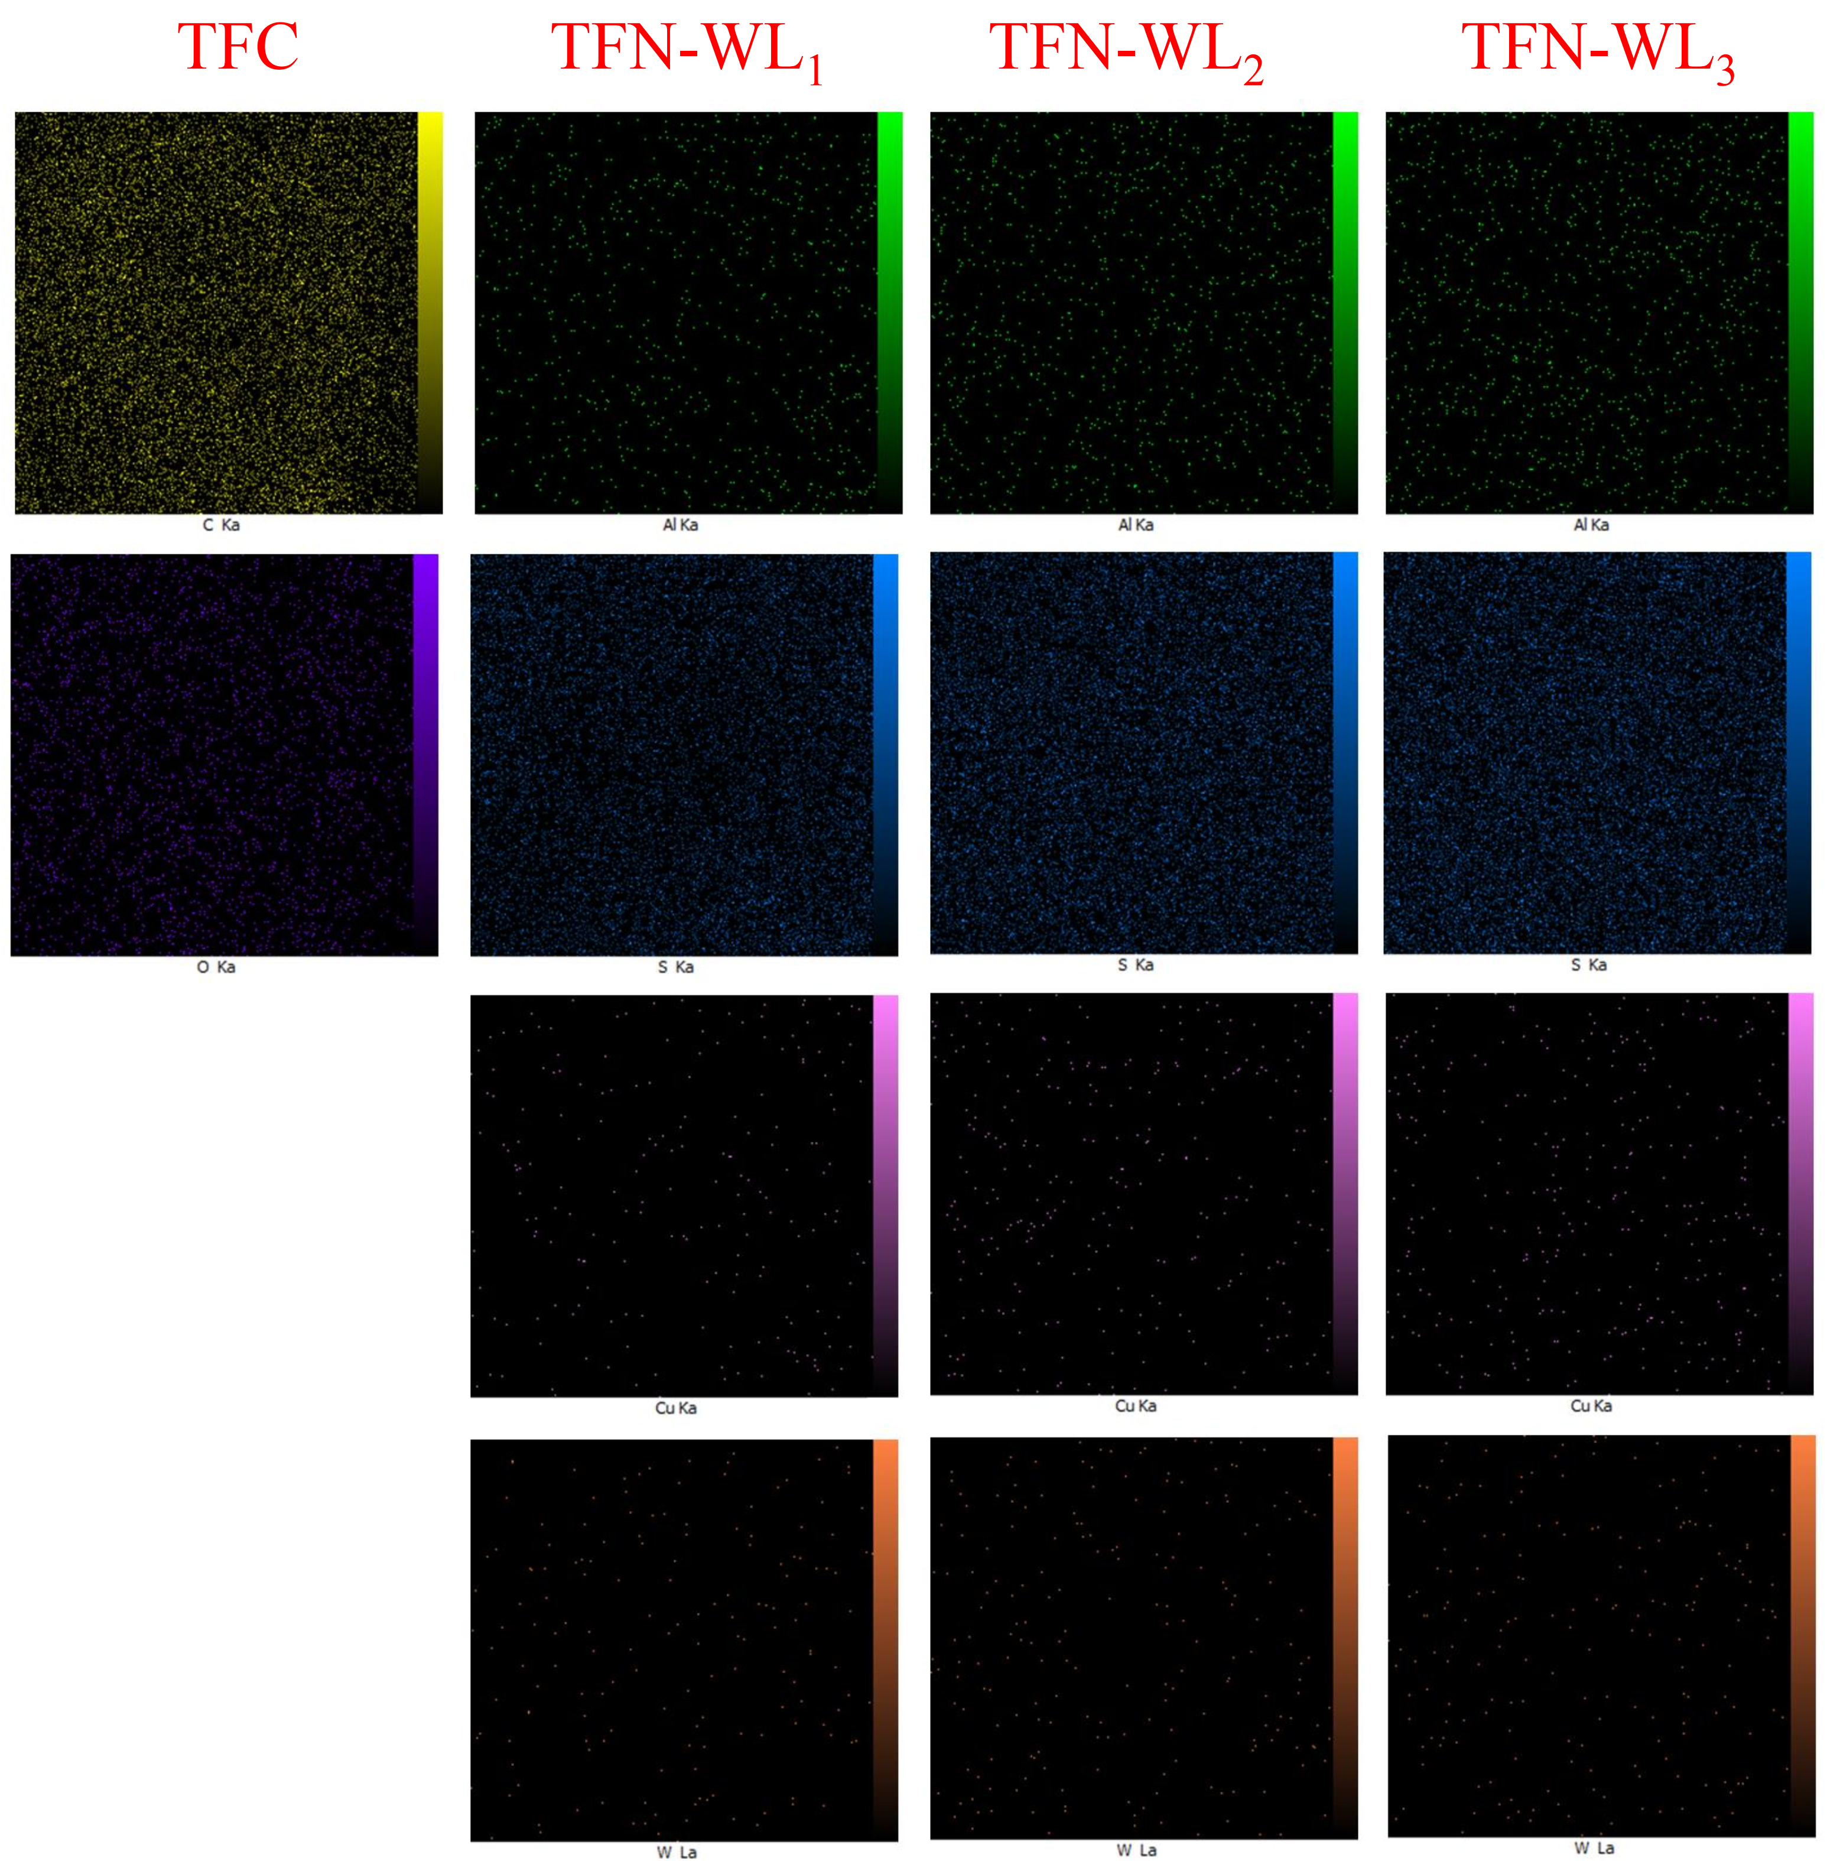
Fig. S3. Top surface EDX elemental mapping of the TFC and TFN-WL membranes.
Table S2. Calculated amplitude parameters for synthesized membranes by AFM.
Membrane | Amplitude parameters
Membrane | R_{a} (nm) | R_{q} (nm) | R_{10z} (nm)
TFC | 72.01 | 92.05 | 867.0
TFN-WL₁ | 55.81 | 69.33 | 552.8
TFN-WL₂ | 48.3 | 60.95 | 480.9
TFN-WL₃ | 43.56 | 55.83 | 423.0

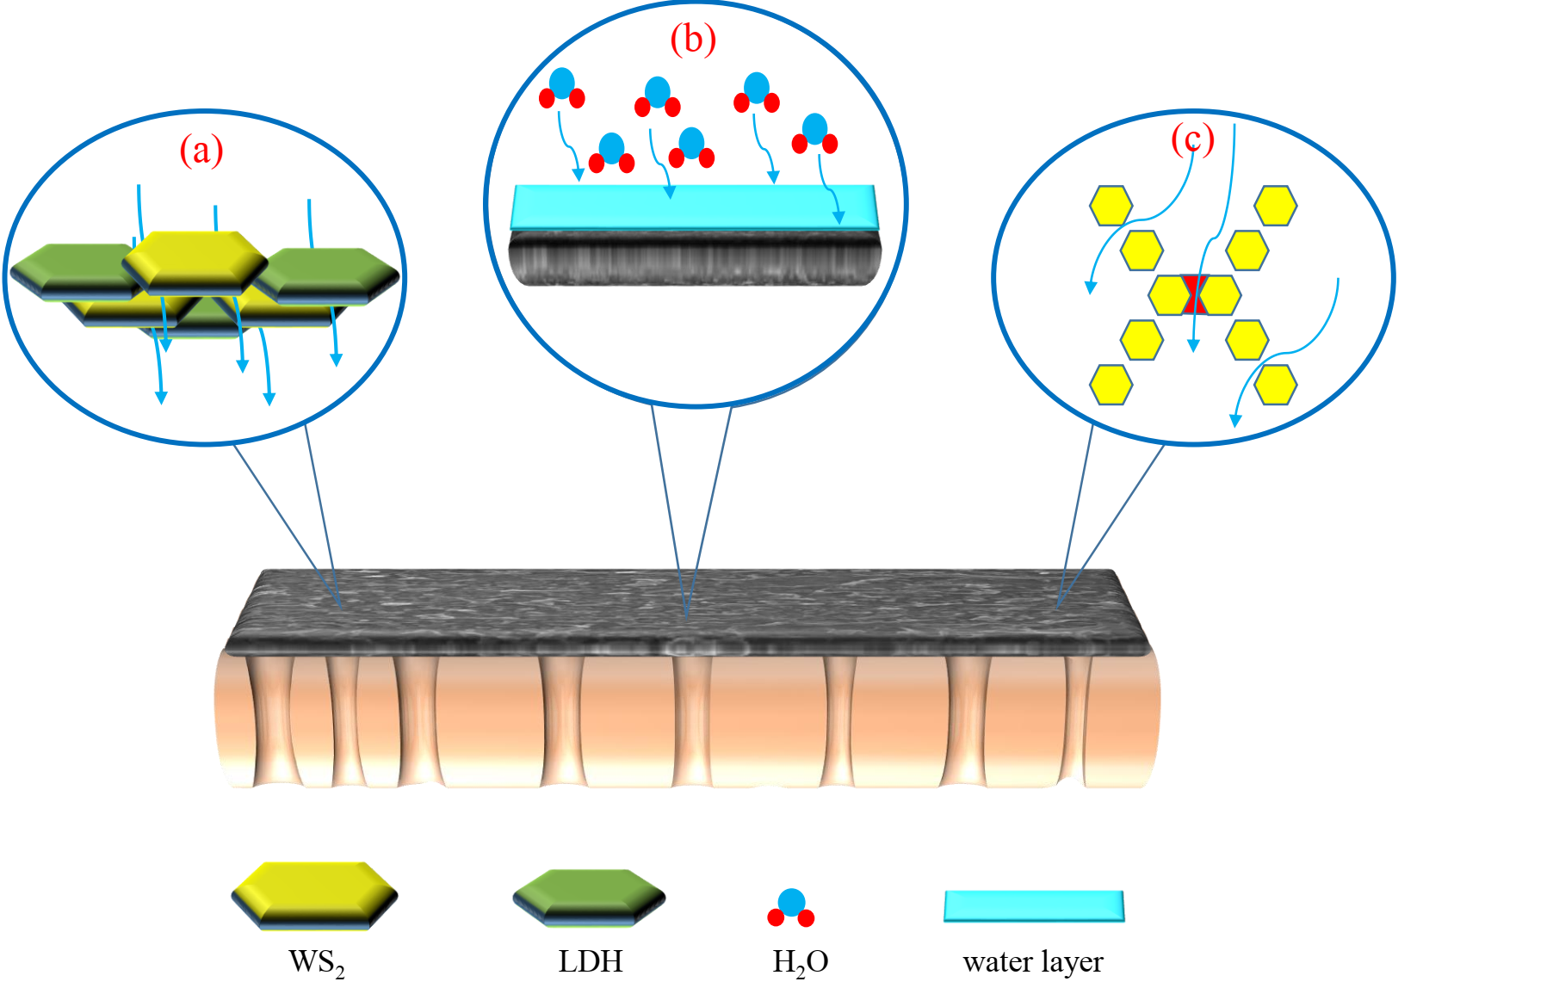
Fig. S4. The schematic diagram of membrane function mechanisms (a) overlapping of nanosheets and creating nanochannels, (b) formation of water layer and absorbing water molecules, (c) formation of hourglass-shaped nanopores.
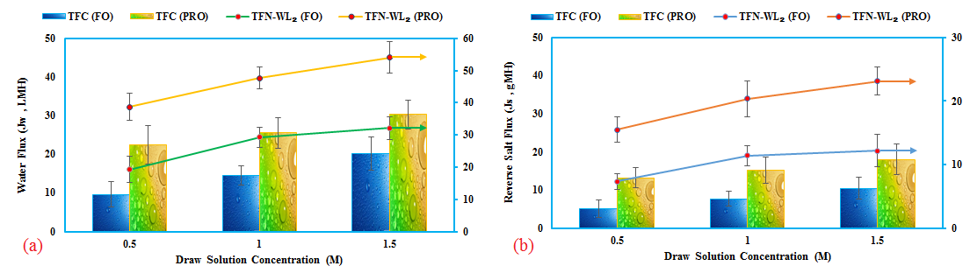
Fig. S5. (a) Water flux and (b) reverse salt flux of the TFC and TFN-WL₂ membranes against different DS concentrations (0.5 M–1.5 M) under FO and PRO mode.

Table S3. Comparison of the FO performances of the TFN-WL₂ membrane with previously reported ones in the literature.
Membranes with filler wt.% | Feed and draw solution | J_{w}  (LMH) | J_{s}  (gMH) | J_{s}/J_{w}  (g/L) | Membrane orientation | References
TFN-WL₂ | NaCl 1 M and DI water | 47.7  29.3 | 20.35  11.42 | 0.42  0.38 | PRO  FO | Present work
TFC |  | 25.55  14.45 | 15.14  7.63 | 0.59  0.52 | PRO  FO
TFN-2 | NaCl 1 M and DI water | 23.6  13.4 | 6.9  6.2 | 0.29  0.46 | PRO  FO | [1]
TFC |  | 15.3  8.6 | 7.2  6.8 | 0.47  0.79 | PRO  FO
TFN-U2 | NaCl 1 M and DI water | 36.7  20.7 | 7.1  4.3 | 0.20  0.21 | PRO  FO | [2]
TFC |  | 26.2  16.5 | 4.21  2.6 | 0.16  0.16 | PRO  FO
TFN-QMo-2 | NaCl 1 M and DI water | 55.0  40.1 | 17.0  14.4 | 0.31  0.36 | PRO  FO | [3]
TFC |  | 24.7  15.3 | 11.1  7 | 0.45  0.46 | PRO  FO
TFN-0.1 | NaCl 1 M and DI water | 38.7  17.5 | 15  7.5 | 0.39  0.43 | PRO  FO | [4]
TFC |  | 25.7  11.5 | 9.7  5.1 | 0.37  0.44 | PRO  FO
LDH@TFC-LDH | NaCl 1 M and DI water | 21.4  12.5 | 9.9  4.3 | 0.46  0.34 | PRO  FO | [5]
TFC |  | 21.5  12.6 | 9.2  5.6 | 0.43  0.45 | PRO  FO
TFN-0.25 | NaCl 1 M and DI water | 85.3  59.3 | 36.8  19.1 | 0.42  0.32 | PRO  FO | [6]
TFC |  | 50.7  29.3 | 27.2  14.0 | 0.53  0.47 | PRO  FO

References
1. P. Lu, S. Liang, T. Zhou, X. Mei, Y. Zhang, C. Zhang, A. Umar, and Q. Wang, RSC Adv. 6, 56599 (2016).
2. D. Ma, S. B. Peh, G. Han, and S. B. Chen, ACS Appl. Mater. Interfaces 9, 7523 (2017).
3. M. Amini, H. Naslhajian, A. Akbari, S. M. F. Farnia, E. Jabbari, S. Gautam, and K. H. Chae, Polyhedron 168, 138 (2019).
4. N. Ma, J. Wei, R. Liao, and C. Y. Tang, J. Memb. Sci. 405, 149 (2012).
5. P. Lu, W. Li, S. Yang, Y. Liu, Q. Wang, and Y. Li, Sep. Purif. Technol. 220, 231 (2019).
6. M. Bagherzadeh, A. Bayrami, and M. Amini, J. Water Process Eng. 33, 101107 (2020).

