Lost to follow-up, not willing to participate (n=5)

Enrolment
3 months follow-up

Screening
Severe COVID pneumonia survivors (n=72)

Excluded (n=30)
♦ Prolonged hospitalization (n=2)
♦ limited mobility (n=1)
♦ not willing to participate (n=27)

Severe COVID pneumonia survivors (n=42)
6 months follow-up

Baseline visit
Excluded
♦ Known diabetes (n=5)

Hyperglycemic group (n=22)
Normoglycemic group (n=15)
Lost to follow-up, not willing to participate (n=1)

Hyperglycemic group (n=19)
Normoglycemic group (n=13)
Normoglycemic group (n=13)
Hyperglycemic group (n=18)
STROBE Flow Diagram

Supplement Figure 1: STROBE flow diagram. From 37 subjects enrolled and examined at the T0 5 patients were considered as outliers in the major outcome variables and were not included in the final analysis.

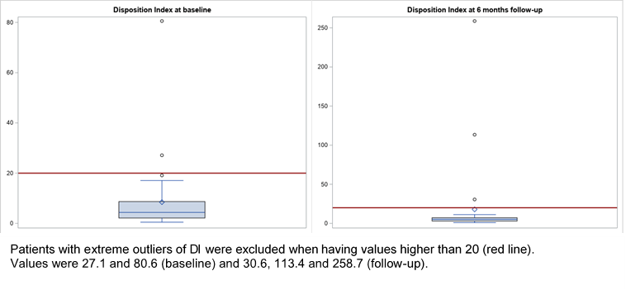
Excluded extreme outliers were: patients with a disposition index of 27.1 and 80.6 at baseline and with values of 30.6, 113.4 and 258.7 at follow-up after 6 months

Supplement Figure 2: Distribution of the disposition index (DI) at baseline and after 6 months follow-up: boxplots are showing extreme outliers that were excluded from the main analysis.

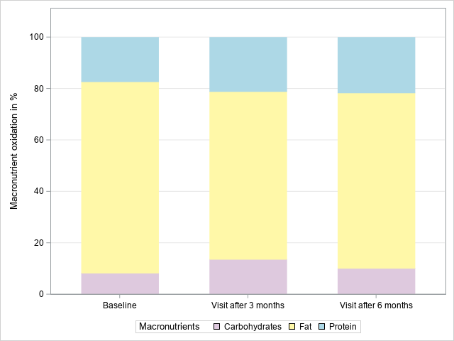
17.2 %
74.4%
21.0 %
68.2%
10.2 %
13.7 %
21.6%
8.4%
65.3 %
*
ANOVA
Protein: p=0.04
Fat: p=0.14
Carbohydrates: p=0.31
Differences between macronutrient oxidation at baseline and follow-up after 3 and 6 months were tested via repeated measures ANOVA including p-values for differences between two or all three time points;
*p-values <0.05 indicating differences in time for macronutrient oxidation between two time points for protein between baseline and visit after 6 months (p= 0.01)

Supplement Figure 3: Oxidation of carbohydrates, fat and protein at baseline (n=37) and follow-up after 3 months (n=32) and 6 months (n=31) in the full data-set

