Weihs et al. Lack of structural brain alteration associated with insomnia: Findings from the ENIGMA-Sleep working group

Supplementary Material

Supplementary Figures
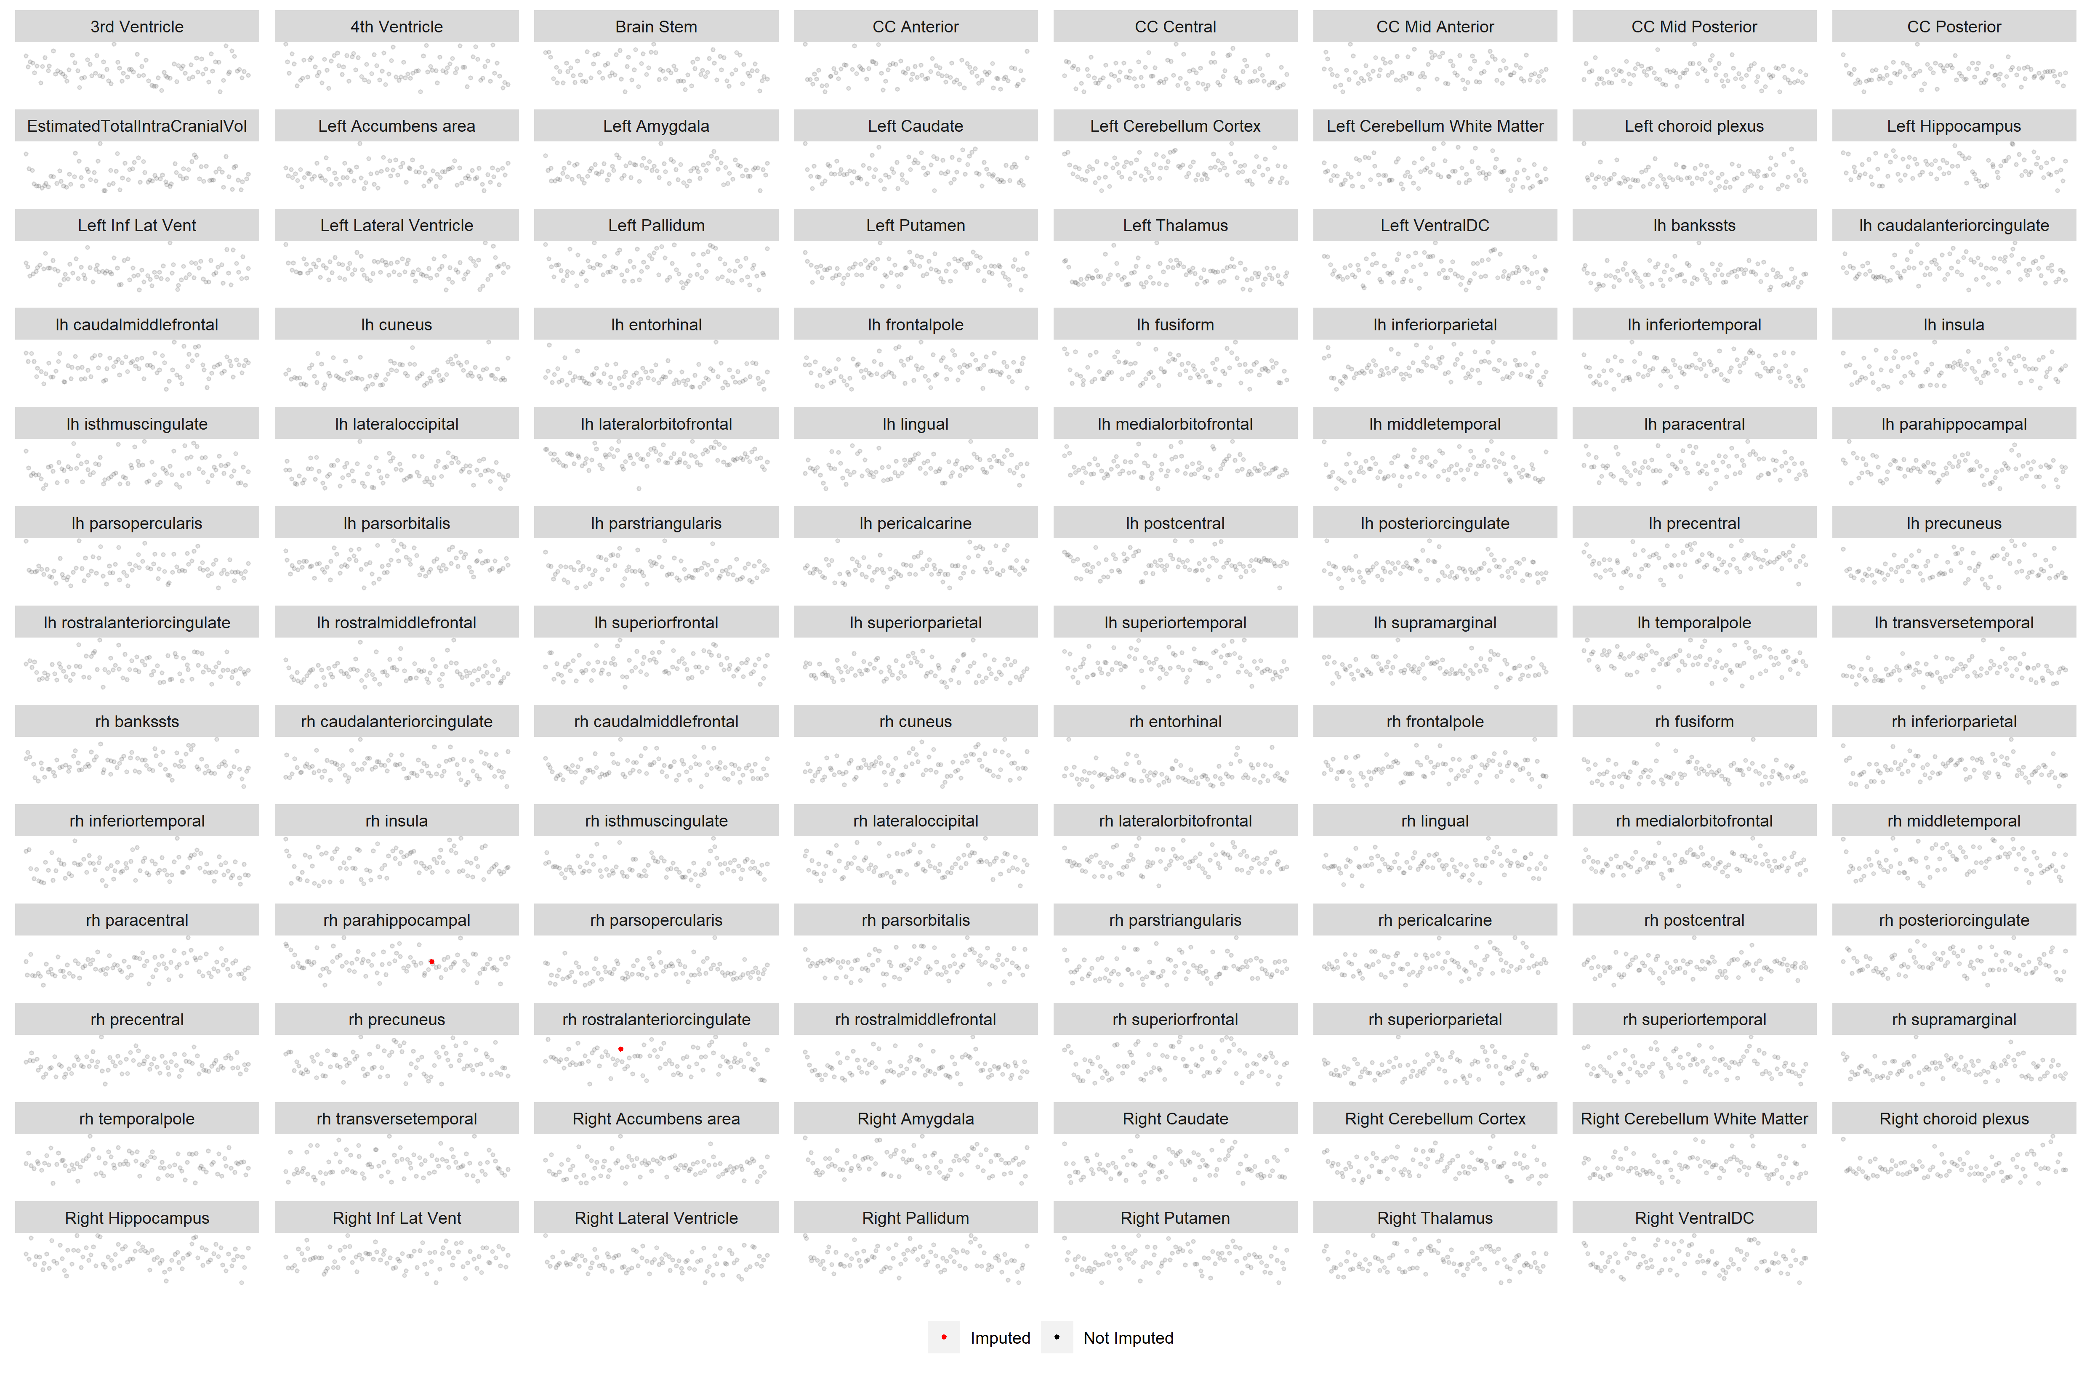
Supplementary Figure 1. Distribution of the imputed values (red) compared to the non-imputed values (grey) in the KUMS sample.
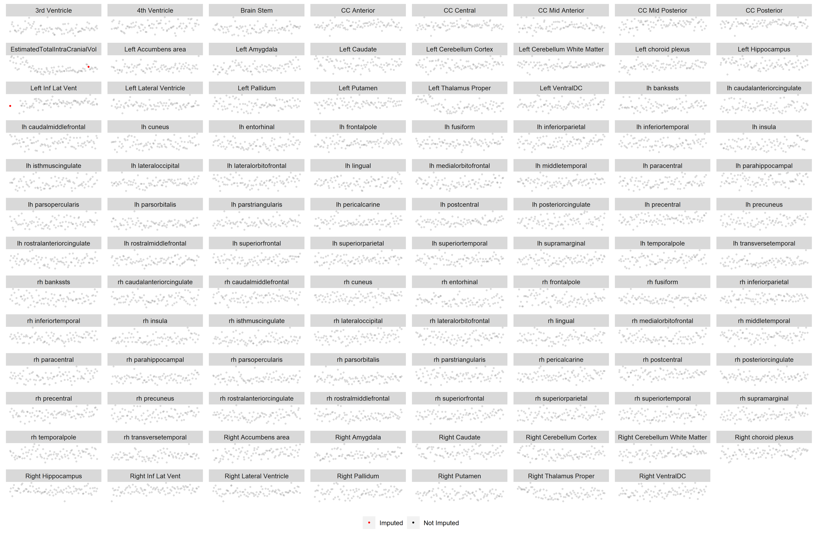
Supplementary Figure 2. Distribution of the imputed values (red) compared to the non-imputed values (grey) in the Freiburg sample.
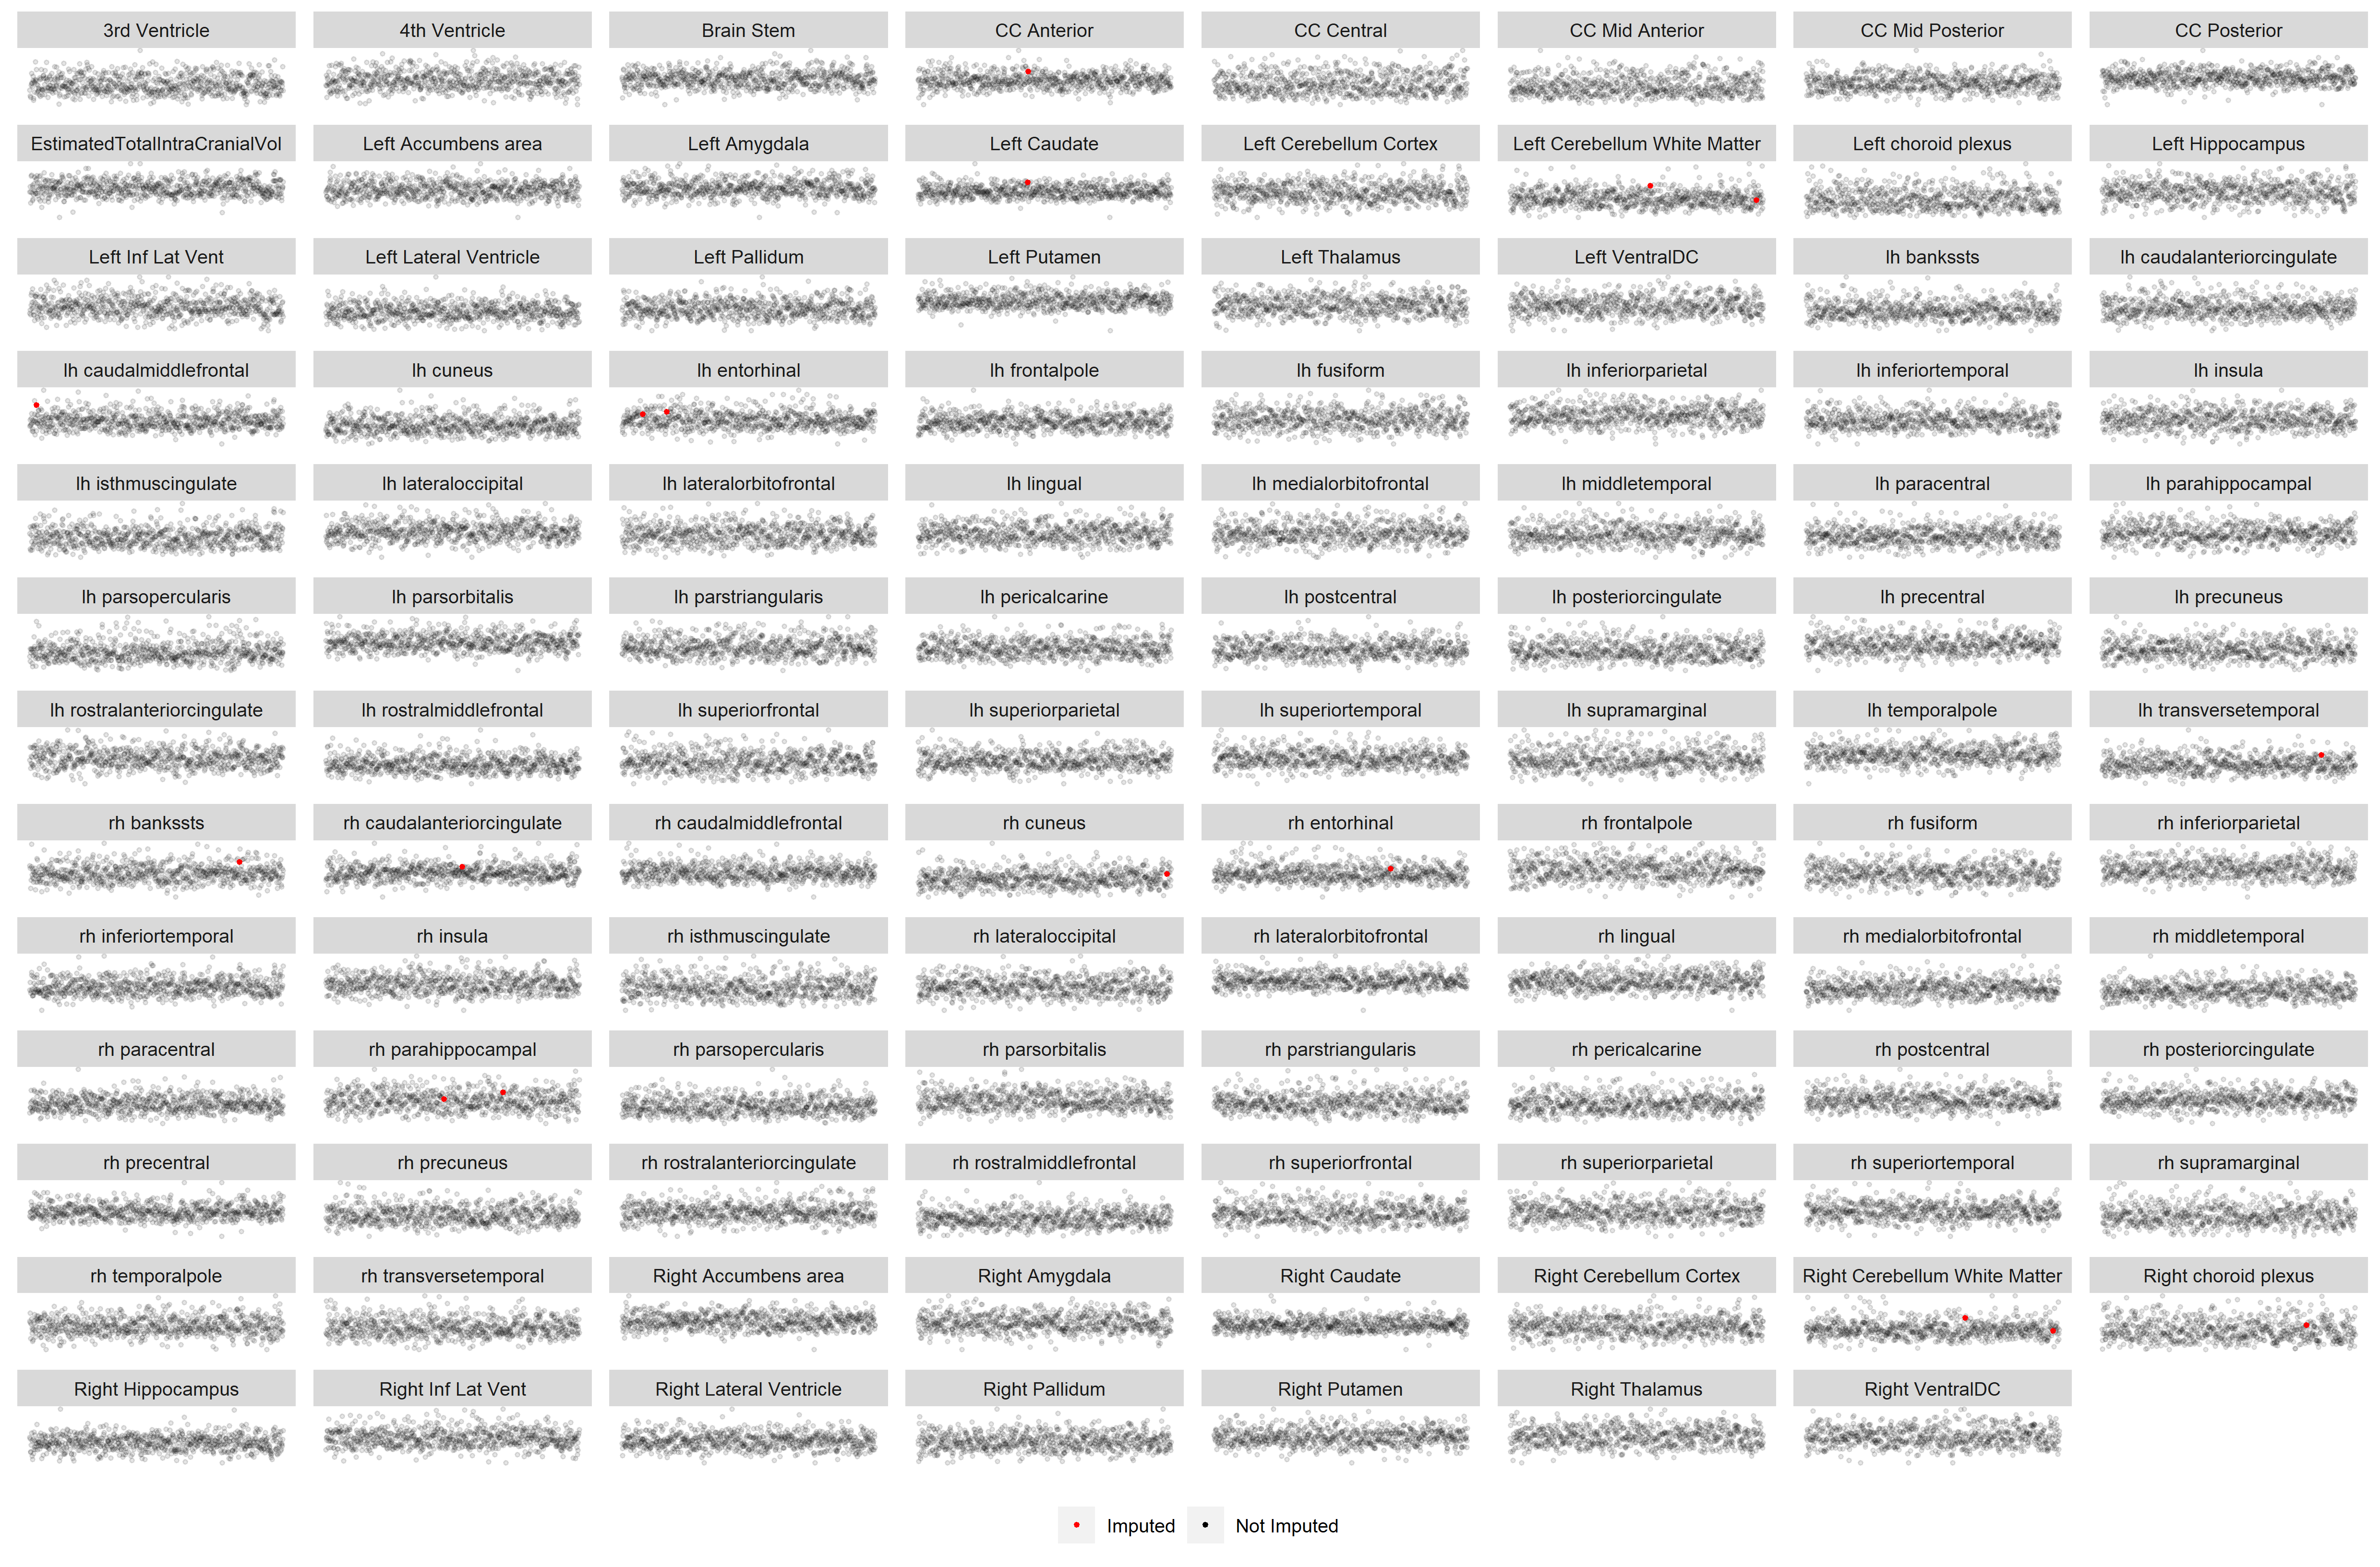
Supplementary Figure 3. Distribution of the imputed values (red) compared to the non-imputed values (grey) in the SHIP-Trend sample.
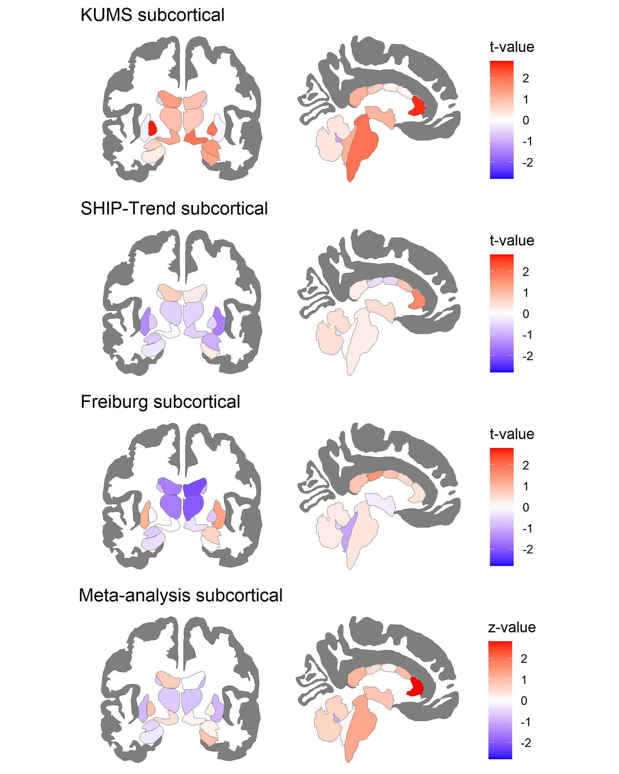
Supplementary Figure 4. Subcortical meta-analysis results
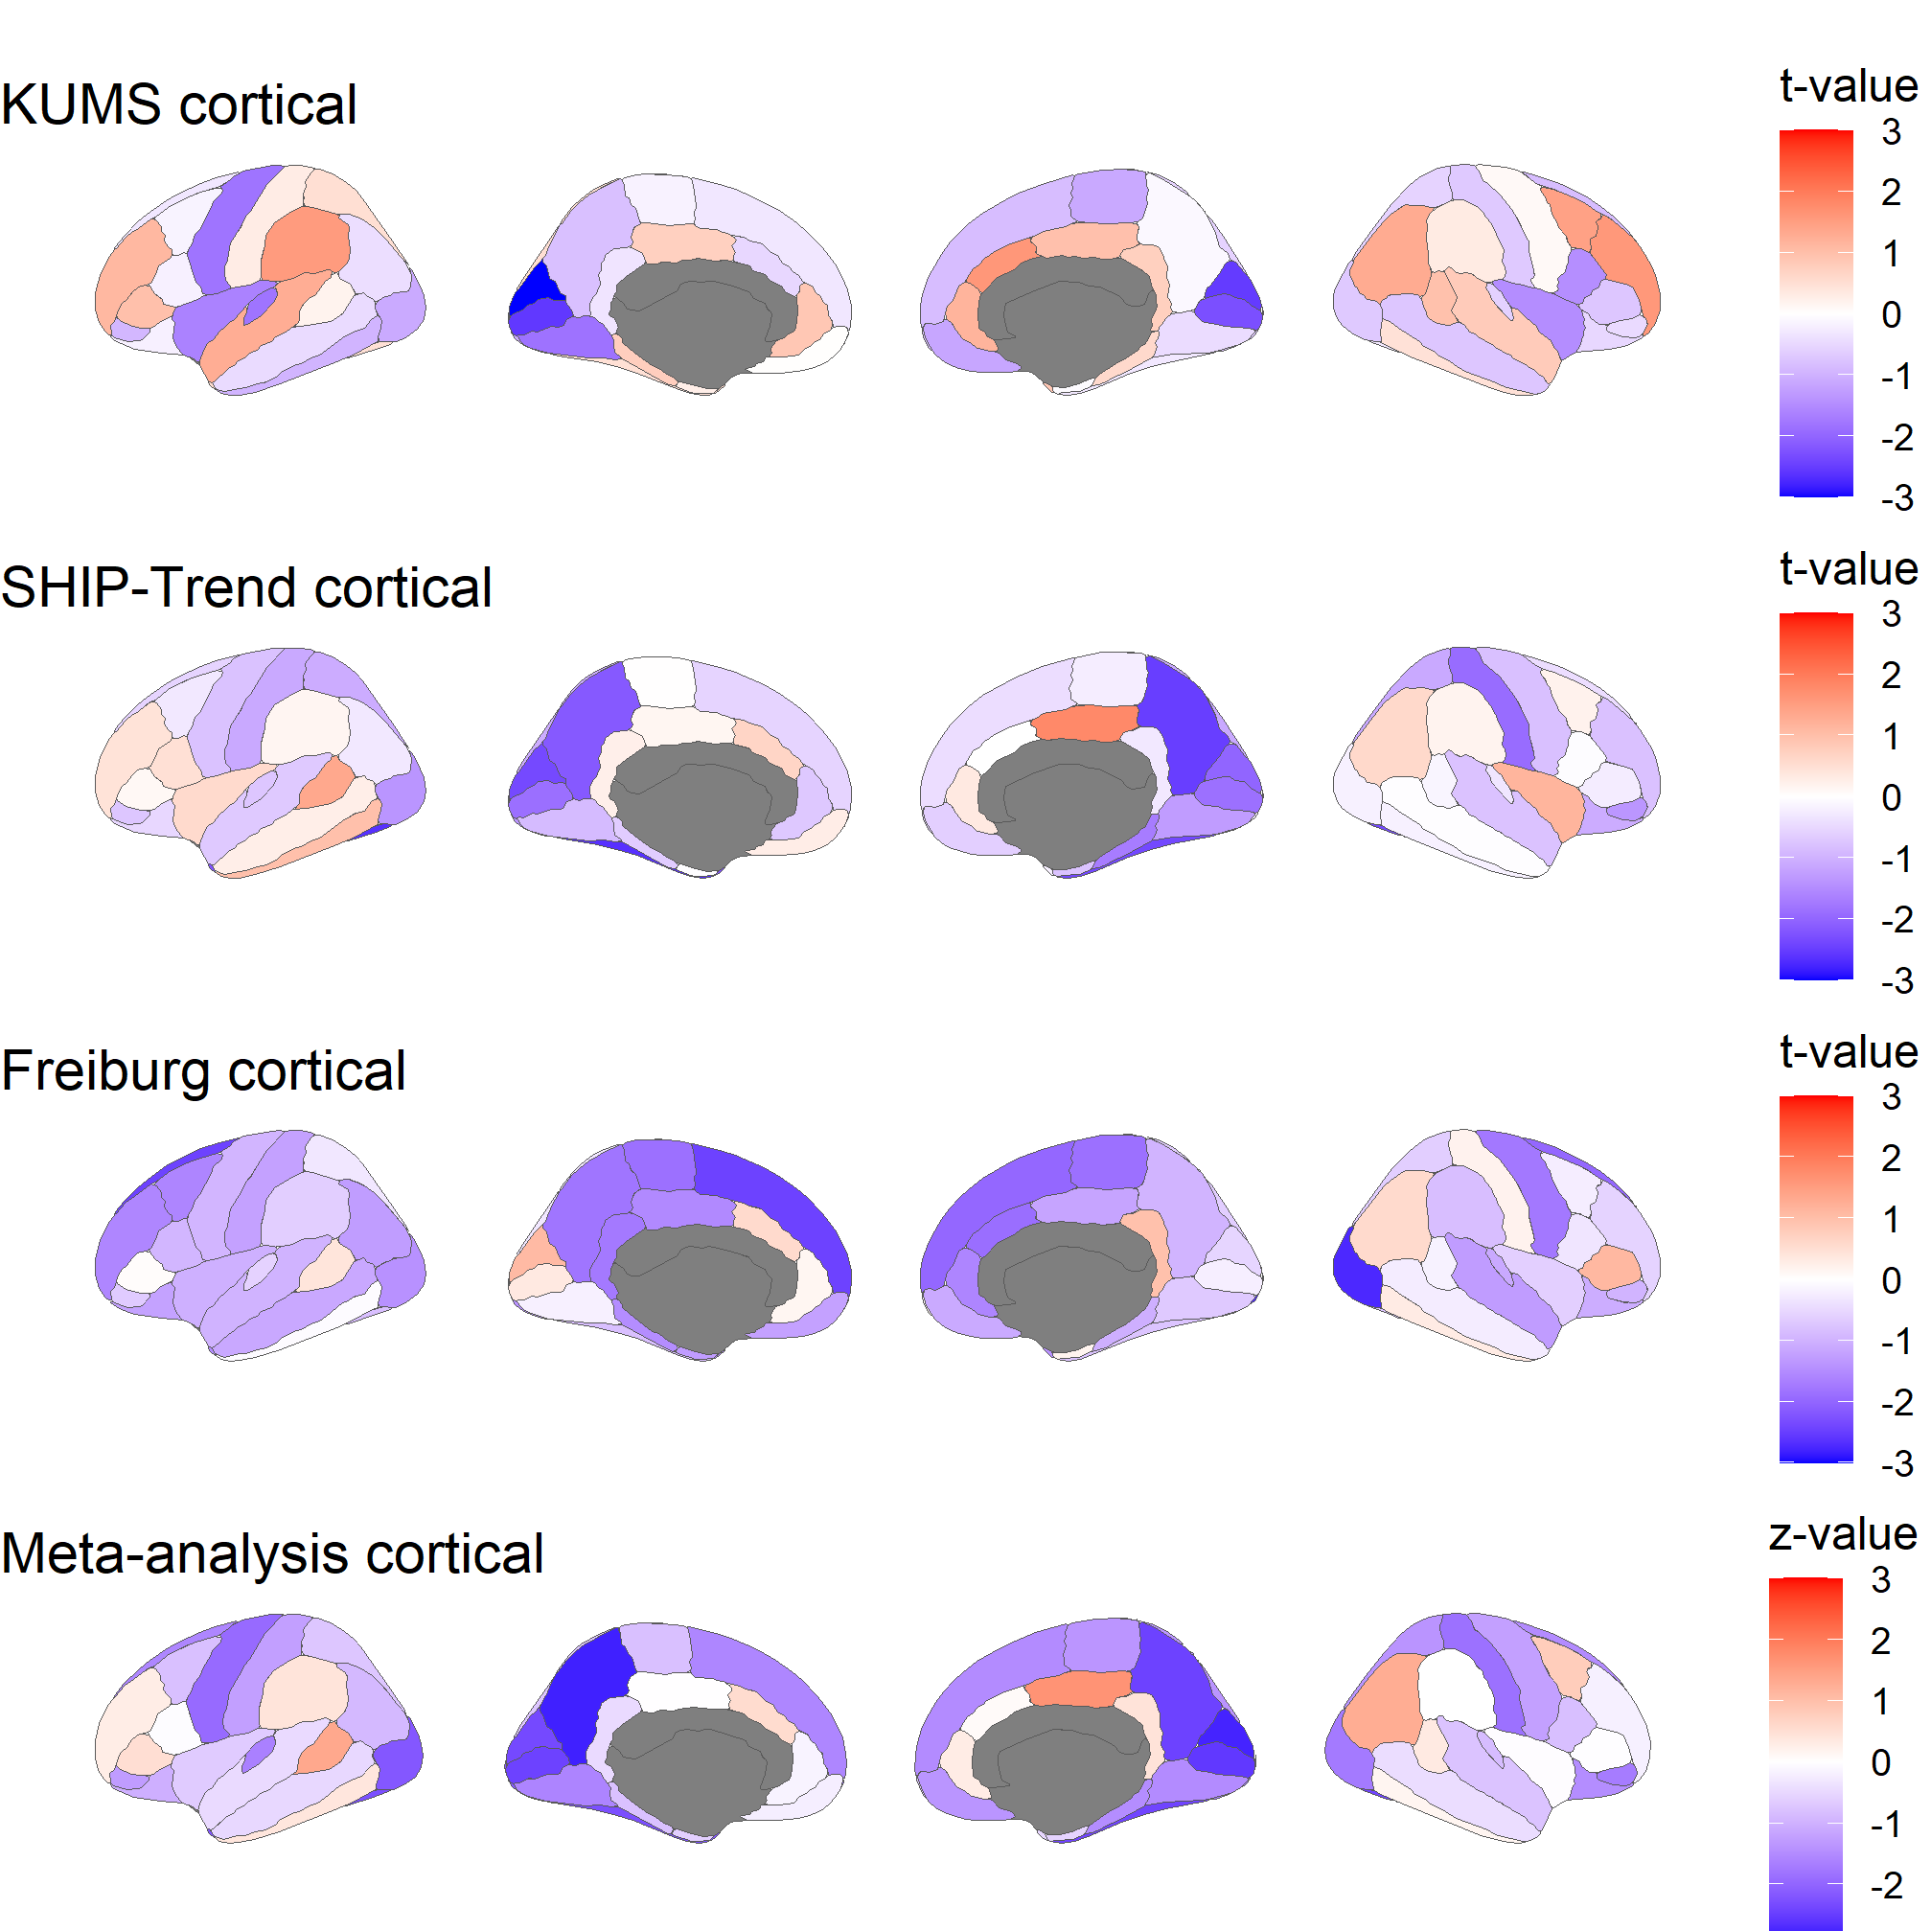
Supplementary Figure 5. Cortical meta-analysis results
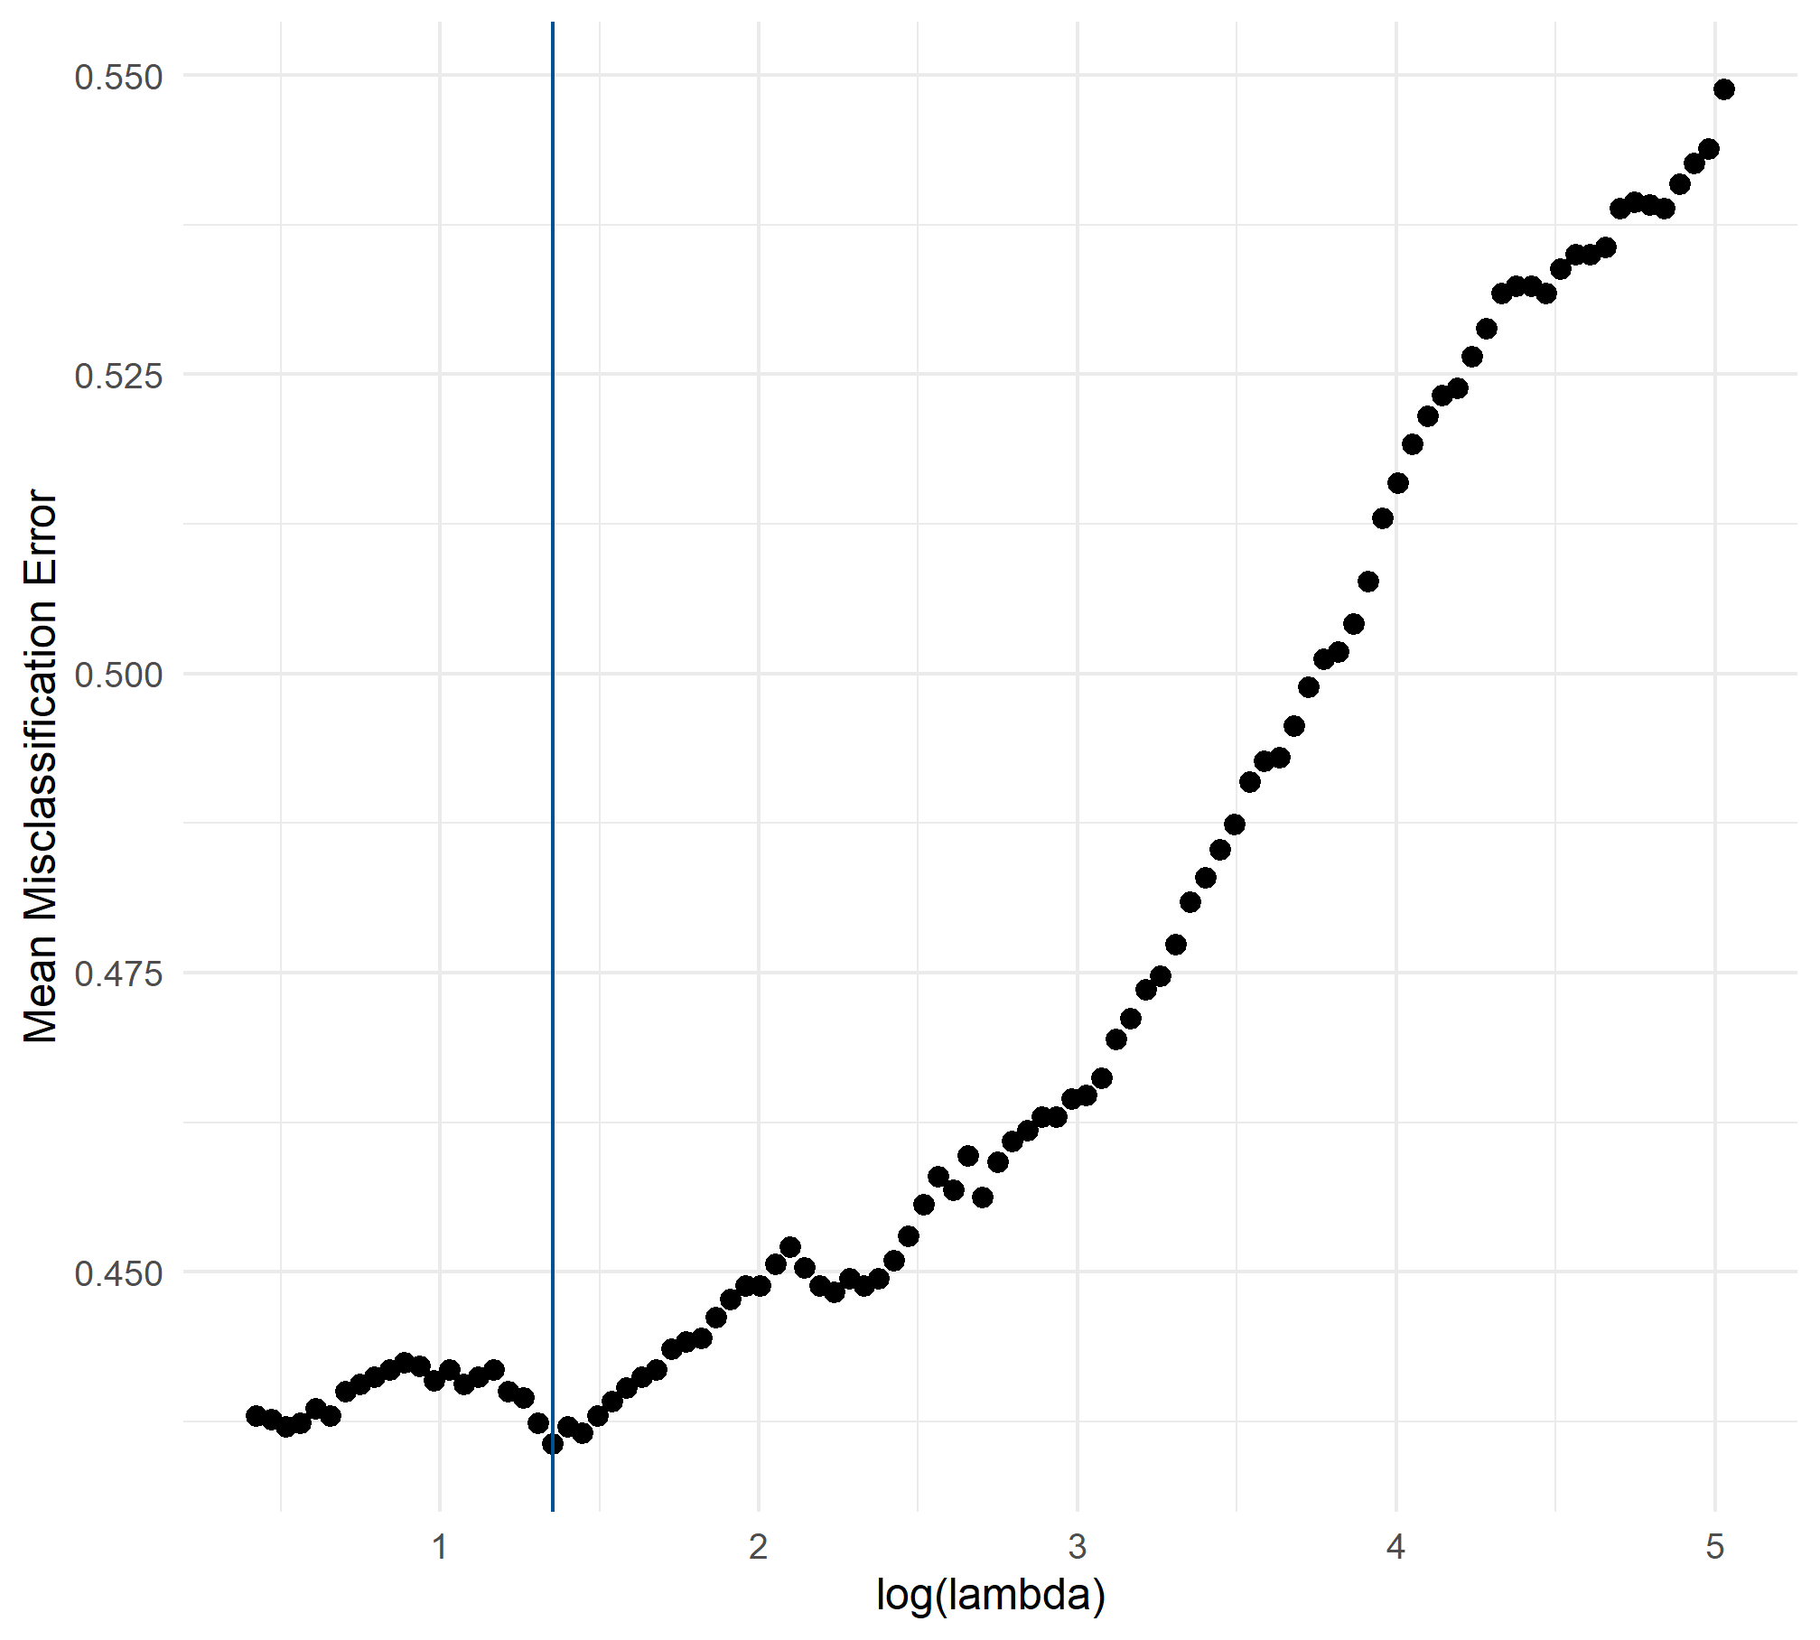
Supplementary Figure 6. Tuning curve for the optimal penalization parameter (λ = 3.88) using 5-fold cross validation with 40 repetitions. The blue line represents the optimal λ with the smallest mean misclassification error.

Supplementary Tables
Supplementary Table 1. Subcortical models
 | KUMS |  |  | SHIP-Trend |  |  | Freiburg |  |  | Meta-analysis
outcome | Estimate (95% CI) | FDR  (p-value) | N | Estimate (95% CI) | FDR  (p-value) | N | Estimate (95% CI) | FDR  (p-value) | N | Estimate (95% CI) | FDR  (p-value) | Effect Dir.
Brain Stem | 709.19 (-13.13; 1431.52) | 0.43 (0.054) | 91 | 56.33 (-353.97; 466.62) | 0.87 (0.79) | 737 | 192.46 (-852.39; 1237.32) | 0.95 (0.71) | 85 | 216.10 (-119.39; 551.60) | 0.92 (0.21) | +++
CC Anterior | 84.02 (20.86; 147.17) | 0.17 (0.0098) | 91 | 34.72 (-5.52; 74.96) | 0.87 (0.091) | 737 | 17.04 (-62.35; 96.44) | 0.95 (0.67) | 85 | 44.17 (13.19; 75.14) | 0.18 (0.0052) | +++
CC Central | 5.31 (-53.63; 64.25) | 0.91 (0.86) | 91 | -8.87 (-44.69; 26.95) | 0.87 (0.63) | 737 | 23.56 (-30.38; 77.50) | 0.95 (0.39) | 85 | 2.10 (-24.30; 28.51) | 0.93 (0.88) | +-+
CC Mid Anterior | 5.14 (-51.27; 61.55) | 0.91 (0.86) | 91 | 18.12 (-23.88; 60.12) | 0.87 (0.40) | 737 | 18.59 (-47.40; 84.58) | 0.95 (0.58) | 85 | 14.50 (-15.24; 44.24) | 0.92 (0.34) | +++
CC Mid Posterior | 17.42 (-32.99; 67.82) | 0.84 (0.49) | 91 | -4.69 (-27.04; 17.66) | 0.87 (0.68) | 737 | 37.11 (-12.09; 86.30) | 0.93 (0.14) | 85 | 4.75 (-14.01; 23.51) | 0.92 (0.62) | +-+
CC Posterior | 37.05 (-28.17; 102.28) | 0.71 (0.26) | 91 | 5.14 (-32.96; 43.25) | 0.87 (0.79) | 737 | 38.26 (-51.96; 128.48) | 0.95 (0.40) | 85 | 16.41 (-14.30; 47.11) | 0.92 (0.30) | +++
Left Accumbens area | 10.17 (-26.48; 46.82) | 0.86 (0.58) | 91 | -5.68 (-24.87; 13.51) | 0.87 (0.56) | 737 | 9.51 (-38.52; 57.54) | 0.95 (0.69) | 85 | -0.86 (-16.79; 15.06) | 0.94 (0.92) | +-+
Left Amygdala | 21.82 (-49.29; 92.93) | 0.84 (0.54) | 91 | -15.00 (-58.51; 28.52) | 0.87 (0.50) | 737 | -26.07 (-109.19; 57.04) | 0.95 (0.53) | 85 | -8.38 (-42.02; 25.27) | 0.92 (0.63) | +--
Left Caudate | -48.83 (-256.41; 158.75) | 0.87 (0.64) | 91 | -12.70 (-107.51; 82.11) | 0.87 (0.79) | 737 | -74.56 (-278.35; 129.23) | 0.95 (0.47) | 85 | -27.69 (-106.63; 51.25) | 0.92 (0.49) | ---
Left Cerebellum Cortex | 368.84 (-1500.35; 2238.03) | 0.91 (0.70) | 91 | 149.29 (-1000.41; 1298.99) | 0.87 (0.80) | 737 | 351.20 (-2795.78; 3498.17) | 0.96 (0.82) | 85 | 223.42 (-705.57; 1152.41) | 0.92 (0.64) | +++
Left Cerebellum White Matter | -50.01 (-910.96; 810.94) | 0.92 (0.91) | 91 | -99.89 (-440.17; 240.40) | 0.87 (0.56) | 737 | 406.07 (-837.68; 1649.83) | 0.95 (0.52) | 85 | -61.87 (-367.22; 243.48) | 0.93 (0.69) | --+
Left choroid plexus | -12.01 (-101.06; 77.04) | 0.91 (0.79) | 91 | -5.90 (-57.50; 45.70) | 0.87 (0.82) | 737 | -73.65 (-240.52; 93.21) | 0.95 (0.38) | 85 | -11.99 (-54.86; 30.89) | 0.92 (0.58) | ---
Left Hippocampus | 22.86 (-139.71; 185.42) | 0.91 (0.78) | 91 | -11.62 (-88.66; 65.42) | 0.87 (0.77) | 737 | -36.31 (-214.01; 141.39) | 0.95 (0.68) | 85 | -9.39 (-73.83; 55.04) | 0.93 (0.78) | +--
log(Left Inf Lat Vent) | 0.16 (-0.052; 0.36) | 0.68 (0.14) | 91 | 0.021 (-0.099; 0.14) | 0.87 (0.73) | 737 | 0.018 (-0.29; 0.33) | 0.96 (0.91) | 85 | 0.052 (-0.046; 0.15) | 0.92 (0.30) | +++
log(Left Lateral Ventricle) | 0.12 (-0.049; 0.29) | 0.68 (0.16) | 91 | 0.04 (-0.071; 0.15) | 0.87 (0.48) | 737 | -0.20 (-0.45; 0.055) | 0.93 (0.12) | 85 | 0.033 (-0.054; 0.12) | 0.92 (0.46) | ++-
Left Pallidum | 96.76 (25.89; 167.62) | 0.17 (0.0081) | 91 | -14.95 (-61.65; 31.75) | 0.87 (0.53) | 737 | -5.29 (-112.13; 101.55) | 0.96 (0.92) | 85 | 16.55 (-19.82; 52.92) | 0.92 (0.37) | +--
Left Putamen | -23.60 (-260.71; 213.51) | 0.91 (0.84) | 91 | -87.58 (-210.60; 35.44) | 0.87 (0.16) | 737 | 164.05 (-130.98; 459.07) | 0.95 (0.27) | 85 | -44.44 (-146.22; 57.34) | 0.92 (0.39) | --+
Left Thalamus | 138.66 (-158.89; 436.20) | 0.79 (0.36) | 91 | -48.20 (-211.63; 115.22) | 0.87 (0.56) | 737 | -276.76 (-627.27; 73.76) | 0.93 (0.12) | 85 | -43.82 (-175.54; 87.90) | 0.92 (0.51) | +--
Left VentralDC | 83.52 (-51.19; 218.24) | 0.71 (0.22) | 91 | -2.84 (-65.96; 60.28) | 0.96 (0.93) | 737 | 7.44 (-187.87; 202.75) | 0.96 (0.94) | 85 | 12.61 (-41.96; 67.18) | 0.92 (0.65) | +-+
Right Accumbens area | 10.01 (-21.32; 41.33) | 0.84 (0.53) | 91 | -2.03 (-19.51; 15.44) | 0.87 (0.82) | 737 | 9.16 (-42.15; 60.48) | 0.95 (0.72) | 85 | 1.57 (-12.97; 16.11) | 0.93 (0.83) | +-+
Right Amygdala | 48.79 (-17.46; 115.03) | 0.68 (0.15) | 91 | -20.70 (-62.99; 21.60) | 0.87 (0.34) | 737 | 25.15 (-56.39; 106.68) | 0.95 (0.54) | 85 | 3.96 (-28.46; 36.38) | 0.93 (0.81) | +-+
Right Caudate | -46.63 (-233.96; 140.71) | 0.87 (0.62) | 91 | -19.82 (-113.55; 73.91) | 0.87 (0.68) | 737 | -111.30 (-355.05; 132.44) | 0.95 (0.37) | 85 | -34.61 (-113.42; 44.20) | 0.92 (0.39) | ---
Right Cerebellum Cortex | 318.55 (-1562.09; 2199.20) | 0.91 (0.74) | 91 | 271.68 (-875.29; 1418.65) | 0.87 (0.64) | 737 | 479.01 (-2848.13; 3806.14) | 0.96 (0.77) | 85 | 300.47 (-632.95; 1233.89) | 0.92 (0.53) | +++
Right Cerebellum White Matter | -384.48 (-1142.76; 373.81) | 0.77 (0.32) | 91 | -82.80 (-591.63; 426.03) | 0.87 (0.75) | 737 | -329.34 (-1544.69; 886.01) | 0.95 (0.59) | 85 | -194.87 (-591.10; 201.37) | 0.92 (0.34) | ---
Right choroid plexus | -30.14 (-101.01; 40.73) | 0.80 (0.40) | 91 | 30.12 (-13.07; 73.31) | 0.87 (0.17) | 737 | -99.39 (-294.55; 95.78) | 0.95 (0.31) | 85 | 9.49 (-26.53; 45.52) | 0.92 (0.61) | -+-
Right Hippocampus | 94.50 (-53.32; 242.31) | 0.71 (0.21) | 91 | 12.68 (-68.90; 94.26) | 0.87 (0.76) | 737 | 11.06 (-204.67; 226.80) | 0.96 (0.92) | 85 | 30.06 (-37.33; 97.44) | 0.92 (0.38) | +++
log(Right Inf Lat Vent) | 0.067 (-0.12; 0.25) | 0.84 (0.48) | 91 | 0.021 (-0.096; 0.14) | 0.87 (0.72) | 737 | -0.011 (-0.43; 0.41) | 0.96 (0.96) | 85 | 0.032 (-0.064; 0.13) | 0.92 (0.52) | ++-
log(Right Lateral Ventricle) | 0.075 (-0.091; 0.24) | 0.79 (0.37) | 91 | 0.016 (-0.09; 0.12) | 0.87 (0.77) | 737 | -0.27 (-0.51; -0.018) | 0.89 (0.036) | 85 | -0.0016 (-0.085; 0.082) | 0.97 (0.97) | ++-
Right Pallidum | 71.12 (-3.81; 146.05) | 0.43 (0.063) | 91 | -12.86 (-63.57; 37.86) | 0.87 (0.62) | 737 | -25.80 (-102.67; 51.07) | 0.95 (0.51) | 85 | 4.72 (-31.82; 41.26) | 0.93 (0.80) | +--
Right Putamen | -11.89 (-234.31; 210.53) | 0.92 (0.92) | 91 | -84.63 (-191.01; 21.74) | 0.87 (0.12) | 737 | 180.32 (-86.82; 447.45) | 0.95 (0.18) | 85 | -41.43 (-131.23; 48.36) | 0.92 (0.37) | --+
Right Thalamus | 90.97 (-141.55; 323.49) | 0.83 (0.44) | 91 | -38.65 (-178.35; 101.05) | 0.87 (0.59) | 737 | -324.71 (-652.46; 3.03) | 0.89 (0.052) | 85 | -42.17 (-153.89; 69.55) | 0.92 (0.46) | +--
Right VentralDC | 127.55 (-5.24; 260.34) | 0.43 (0.06) | 91 | -16.56 (-75.31; 42.20) | 0.87 (0.58) | 737 | -35.37 (-220.86; 150.11) | 0.95 (0.70) | 85 | 4.18 (-47.17; 55.53) | 0.93 (0.87) | +--
log(3rd Ventricle) | 0.058 (-0.046; 0.16) | 0.71 (0.27) | 91 | 0.019 (-0.057; 0.095) | 0.87 (0.63) | 737 | -0.016 (-0.15; 0.12) | 0.96 (0.82) | 85 | 0.024 (-0.031; 0.08) | 0.92 (0.39) | ++-
log(4th Ventricle) | 0.069 (-0.051; 0.19) | 0.71 (0.26) | 91 | -0.0015 (-0.071; 0.068) | 0.97 (0.97) | 737 | -0.093 (-0.27; 0.08) | 0.95 (0.29) | 85 | 0.0046 (-0.052; 0.061) | 0.93 (0.87) | +--

Supplementary Table 2. Cortical models
 | KUMS |  |  | SHIP-Trend |  |  | Freiburg |  |  | Meta-analysis
outcome | Estimate (95% CI) | FDR  (p-value) | N | Estimate (95% CI) | FDR  (p-value) | N | Estimate (95% CI) | FDR  (p-value) | N | Estimate (95% CI) | FDR  (p-value) | Effect Dir.
lh bankssts | 17.76 (-163.94; 199.46) | 0.93 (0.85) | 91 | 63.86 (-29.08; 156.80) | 0.76 (0.18) | 737 | 49.24 (-187.61; 286.09) | 0.87 (0.68) | 85 | 53.55 (-24.10; 131.20) | 0.44 (0.18) | +++
lh caudalanteriorcingulate | -46.34 (-229.18; 136.50) | 0.85 (0.62) | 91 | 32.94 (-64.73; 130.62) | 0.98 (0.51) | 737 | 54.16 (-133.45; 241.77) | 0.77 (0.57) | 85 | 21.93 (-55.83; 99.68) | 0.84 (0.58) | -++
lh caudalmiddlefrontal | -31.53 (-454.55; 391.50) | 0.94 (0.88) | 91 | -28.81 (-225.36; 167.75) | 0.98 (0.77) | 737 | -433.55 (-980.53; 113.44) | 0.60 (0.12) | 85 | -69.02 (-237.59; 99.55) | 0.75 (0.42) | ---
lh cuneus | -366.81 (-610.14; -123.47) | 0.25 (0.0036) | 91 | -128.41 (-235.31; -21.50) | 0.32 (0.019) | 737 | 89.85 (-77.00; 256.70) | 0.61 (0.29) | 85 | -100.61 (-184.42; -16.80) | 0.18 (0.019) | --+
lh entorhinal | 29.49 (-192.12; 251.10) | 0.91 (0.79) | 91 | -1.12 (-97.54; 95.31) | 1.00 (0.98) | 737 | -89.78 (-230.34; 50.77) | 0.61 (0.21) | 85 | -23.18 (-97.46; 51.09) | 0.84 (0.54) | +--
lh frontalpole | -16.40 (-83.59; 50.78) | 0.85 (0.63) | 91 | -29.99 (-70.62; 10.64) | 0.76 (0.15) | 737 | -62.34 (-145.07; 20.39) | 0.60 (0.14) | 85 | -31.80 (-63.62; 0.025) | 0.30 (0.05) | ---
lh fusiform | 117.38 (-365.65; 600.41) | 0.85 (0.63) | 91 | -328.21 (-571.73; -84.69) | 0.32 (0.0083) | 737 | -247.44 (-851.71; 356.83) | 0.69 (0.42) | 85 | -237.26 (-440.65; -33.87) | 0.19 (0.022) | +--
lh inferiorparietal | -147.44 (-840.68; 545.80) | 0.86 (0.67) | 91 | -54.05 (-411.81; 303.70) | 0.98 (0.77) | 737 | -506.27 (-1299.71; 287.17) | 0.61 (0.21) | 85 | -135.19 (-428.44; 158.06) | 0.75 (0.37) | ---
lh inferiortemporal | -311.31 (-950.07; 327.45) | 0.85 (0.33) | 91 | 156.01 (-155.25; 467.26) | 0.96 (0.33) | 737 | -15.66 (-649.50; 618.17) | 0.96 (0.96) | 85 | 51.00 (-203.33; 305.34) | 0.86 (0.69) | -+-
lh insula | -197.12 (-438.41; 44.16) | 0.73 (0.11) | 91 | 41.11 (-97.68; 179.90) | 0.98 (0.56) | 737 | -159.15 (-469.56; 151.26) | 0.61 (0.31) | 85 | -37.99 (-149.42; 73.44) | 0.80 (0.50) | -+-
lh isthmuscingulate | -22.50 (-155.25; 110.25) | 0.90 (0.74) | 91 | 8.92 (-62.03; 79.87) | 0.98 (0.81) | 737 | -174.96 (-375.82; 25.90) | 0.60 (0.087) | 85 | -14.20 (-73.59; 45.19) | 0.84 (0.64) | -+-
lh lateraloccipital | -345.28 (-976.22; 285.66) | 0.85 (0.28) | 91 | -244.15 (-592.69; 104.39) | 0.76 (0.17) | 737 | -455.60 (-1094.39; 183.19) | 0.60 (0.16) | 85 | -303.77 (-577.10; -30.45) | 0.20 (0.029) | ---
lh lateralorbitofrontal | -23.74 (-274.16; 226.67) | 0.93 (0.85) | 91 | -40.61 (-198.09; 116.86) | 0.98 (0.61) | 737 | -155.55 (-412.68; 101.58) | 0.61 (0.23) | 85 | -61.58 (-178.98; 55.82) | 0.65 (0.30) | ---
lh lingual | -366.15 (-764.05; 31.76) | 0.72 (0.071) | 91 | -97.65 (-315.76; 120.46) | 0.98 (0.38) | 737 | -41.37 (-474.95; 392.22) | 0.92 (0.85) | 85 | -141.12 (-314.92; 32.67) | 0.41 (0.11) | ---
lh medialorbitofrontal | 2.35 (-231.27; 235.96) | 0.98 (0.98) | 91 | 15.81 (-94.34; 125.96) | 0.98 (0.78) | 737 | -149.46 (-395.76; 96.84) | 0.61 (0.23) | 85 | -10.09 (-101.89; 81.72) | 0.96 (0.83) | ++-
lh middletemporal | -137.37 (-733.14; 458.41) | 0.85 (0.65) | 91 | 38.75 (-252.01; 329.51) | 0.98 (0.79) | 737 | -276.66 (-771.23; 217.91) | 0.61 (0.27) | 85 | -58.37 (-287.77; 171.02) | 0.84 (0.62) | -+-
lh paracentral | -12.73 (-164.97; 139.52) | 0.94 (0.87) | 91 | 0.41 (-101.45; 102.27) | 1.00 (0.99) | 737 | -188.98 (-391.34; 13.37) | 0.60 (0.067) | 85 | -31.84 (-109.35; 45.66) | 0.75 (0.42) | -+-
lh parahippocampal | 56.67 (-91.37; 204.70) | 0.85 (0.45) | 91 | -23.46 (-94.64; 47.72) | 0.98 (0.52) | 737 | -117.52 (-276.16; 41.12) | 0.60 (0.14) | 85 | -23.79 (-82.90; 35.32) | 0.75 (0.43) | +--
lh parsopercularis | -26.72 (-306.62; 253.18) | 0.93 (0.85) | 91 | 44.41 (-134.59; 223.40) | 0.98 (0.63) | 737 | -194.80 (-608.25; 218.65) | 0.61 (0.35) | 85 | -2.77 (-143.44; 137.91) | 1.00 (0.97) | -+-
lh parsorbitalis | -51.64 (-162.88; 59.60) | 0.85 (0.36) | 91 | -25.05 (-92.55; 42.46) | 0.98 (0.47) | 737 | -41.18 (-165.16; 82.80) | 0.77 (0.51) | 85 | -33.95 (-85.88; 17.98) | 0.47 (0.20) | ---
lh parstriangularis | 115.66 (-118.30; 349.61) | 0.85 (0.33) | 91 | 6.13 (-103.30; 115.56) | 0.98 (0.91) | 737 | 7.76 (-321.17; 336.69) | 0.96 (0.96) | 85 | 24.67 (-69.74; 119.08) | 0.84 (0.61) | +++
lh pericalcarine | -206.51 (-367.21; -45.80) | 0.30 (0.012) | 91 | -78.95 (-161.95; 4.05) | 0.43 (0.062) | 737 | 28.82 (-136.02; 193.67) | 0.91 (0.73) | 85 | -83.38 (-150.25; -16.51) | 0.18 (0.015) | --+
lh postcentral | 70.01 (-402.58; 542.59) | 0.90 (0.77) | 91 | -118.69 (-328.04; 90.67) | 0.89 (0.27) | 737 | -338.99 (-898.28; 220.30) | 0.61 (0.23) | 85 | -114.05 (-294.19; 66.08) | 0.48 (0.21) | +--
lh posteriorcingulate | 64.43 (-108.87; 237.73) | 0.85 (0.46) | 91 | 7.12 (-87.65; 101.89) | 0.98 (0.88) | 737 | -196.72 (-453.71; 60.26) | 0.60 (0.13) | 85 | -0.45 (-79.09; 78.18) | 1.00 (0.99) | ++-
lh precentral | -432.04 (-907.07; 42.98) | 0.72 (0.074) | 91 | -136.12 (-476.93; 204.69) | 0.98 (0.43) | 737 | -332.85 (-1032.91; 367.21) | 0.61 (0.35) | 85 | -251.52 (-507.01; 3.97) | 0.30 (0.054) | ---
lh precuneus | -156.06 (-542.24; 230.11) | 0.85 (0.42) | 91 | -227.35 (-434.79; -19.91) | 0.36 (0.032) | 737 | -383.66 (-809.08; 41.77) | 0.60 (0.076) | 85 | -238.49 (-405.28; -71.70) | 0.18 (0.0051) | ---
lh rostralanteriorcingulate | 92.14 (-117.14; 301.41) | 0.85 (0.38) | 91 | -38.16 (-144.05; 67.73) | 0.98 (0.48) | 737 | 16.31 (-208.42; 241.04) | 0.92 (0.89) | 85 | -6.82 (-93.37; 79.72) | 0.96 (0.88) | +-+
lh rostralmiddlefrontal | 427.90 (-340.55; 1196.34) | 0.85 (0.27) | 91 | 92.67 (-313.36; 498.69) | 0.98 (0.65) | 737 | -739.24 (-1678.86; 200.38) | 0.60 (0.12) | 85 | 49.44 (-283.81; 382.69) | 0.90 (0.77) | ++-
lh superiorfrontal | -143.67 (-1061.18; 773.84) | 0.90 (0.76) | 91 | -136.61 (-620.88; 347.66) | 0.98 (0.58) | 737 | -1186.17 (-2157.04; -215.31) | 0.59 (0.017) | 85 | -312.42 (-701.65; 76.80) | 0.41 (0.12) | ---
lh superiorparietal | 153.16 (-450.45; 756.78) | 0.85 (0.61) | 91 | -192.54 (-547.11; 162.04) | 0.89 (0.29) | 737 | -121.29 (-905.71; 663.14) | 0.91 (0.76) | 85 | -104.62 (-387.55; 178.31) | 0.77 (0.47) | +--
lh superiortemporal | 408.42 (-231.27; 1048.12) | 0.85 (0.21) | 91 | -103.34 (-395.94; 189.26) | 0.98 (0.49) | 737 | -310.98 (-946.65; 324.69) | 0.61 (0.33) | 85 | -58.21 (-302.18; 185.77) | 0.84 (0.64) | +--
lh supramarginal | 601.21 (-175.19; 1377.60) | 0.73 (0.13) | 91 | 28.40 (-332.06; 388.85) | 0.98 (0.88) | 737 | -205.34 (-863.57; 452.89) | 0.77 (0.54) | 85 | 64.09 (-226.76; 354.95) | 0.84 (0.67) | ++-
lh temporalpole | 57.27 (-148.70; 263.23) | 0.85 (0.58) | 91 | -119.79 (-225.74; -13.83) | 0.36 (0.027) | 737 | -134.24 (-313.83; 45.36) | 0.60 (0.14) | 85 | -93.43 (-176.26; -10.61) | 0.20 (0.027) | +--
lh transversetemporal | -73.74 (-154.89; 7.41) | 0.72 (0.074) | 91 | -17.59 (-65.28; 30.10) | 0.98 (0.47) | 737 | -34.50 (-155.31; 86.31) | 0.77 (0.57) | 85 | -32.53 (-71.20; 6.14) | 0.40 (0.099) | ---
rh bankssts | 54.51 (-56.60; 165.62) | 0.85 (0.33) | 91 | -4.58 (-73.65; 64.50) | 0.98 (0.90) | 737 | -15.09 (-191.43; 161.25) | 0.92 (0.87) | 85 | 9.45 (-45.85; 64.74) | 0.90 (0.74) | +--
rh caudalanteriorcingulate | 155.73 (-38.04; 349.50) | 0.73 (0.11) | 91 | -0.14 (-117.40; 117.11) | 1.00 (1.00) | 737 | -240.03 (-493.43; 13.38) | 0.60 (0.063) | 85 | 3.43 (-89.19; 96.06) | 1.00 (0.94) | +--
rh caudalmiddlefrontal | 271.65 (-101.51; 644.81) | 0.73 (0.15) | 91 | 23.86 (-199.08; 246.81) | 0.98 (0.83) | 737 | -59.29 (-573.88; 455.30) | 0.92 (0.82) | 85 | 71.81 (-106.36; 249.99) | 0.75 (0.43) | ++-
rh cuneus | -322.16 (-575.77; -68.55) | 0.30 (0.013) | 91 | -98.85 (-195.69; -2.01) | 0.43 (0.045) | 737 | -58.96 (-278.13; 160.21) | 0.78 (0.59) | 85 | -117.68 (-200.85; -34.50) | 0.18 (0.0056) | ---
rh entorhinal | -4.64 (-170.93; 161.65) | 0.97 (0.96) | 91 | -37.72 (-134.73; 59.28) | 0.98 (0.45) | 737 | 17.91 (-181.67; 217.50) | 0.92 (0.86) | 85 | -21.96 (-98.68; 54.76) | 0.84 (0.57) | --+
rh frontalpole | -31.72 (-113.56; 50.11) | 0.85 (0.44) | 91 | -12.35 (-57.82; 33.12) | 0.98 (0.59) | 737 | 5.97 (-83.68; 95.61) | 0.92 (0.89) | 85 | -13.16 (-49.25; 22.92) | 0.77 (0.47) | --+
rh fusiform | -72.19 (-557.53; 413.14) | 0.90 (0.77) | 91 | -253.84 (-463.90; -43.79) | 0.32 (0.018) | 737 | -236.34 (-859.62; 386.94) | 0.73 (0.45) | 85 | -225.57 (-408.82; -42.33) | 0.18 (0.016) | ---
rh inferiorparietal | 481.07 (-251.84; 1213.98) | 0.85 (0.20) | 91 | 120.07 (-270.55; 510.70) | 0.98 (0.55) | 737 | 280.12 (-675.89; 1236.13) | 0.77 (0.56) | 85 | 210.89 (-111.40; 533.17) | 0.47 (0.20) | +++
rh inferiortemporal | 138.81 (-451.97; 729.59) | 0.85 (0.64) | 91 | -25.70 (-318.59; 267.18) | 0.98 (0.86) | 737 | 103.38 (-567.35; 774.11) | 0.91 (0.76) | 85 | 20.49 (-222.40; 263.37) | 0.96 (0.87) | +-+
rh insula | -191.35 (-449.02; 66.32) | 0.73 (0.14) | 91 | 89.91 (-63.36; 243.18) | 0.89 (0.25) | 737 | -98.80 (-417.70; 220.10) | 0.77 (0.54) | 85 | -2.01 (-122.91; 118.89) | 1.00 (0.97) | -+-
rh isthmuscingulate | 51.22 (-85.94; 188.39) | 0.85 (0.46) | 91 | -11.54 (-89.13; 66.05) | 0.98 (0.77) | 737 | 90.46 (-95.27; 276.20) | 0.61 (0.33) | 85 | 14.31 (-48.75; 77.37) | 0.84 (0.66) | +-+
rh lateraloccipital | -217.41 (-847.17; 412.36) | 0.85 (0.49) | 91 | -32.07 (-388.98; 324.83) | 0.98 (0.86) | 737 | -797.14 (-1380.06; -214.21) | 0.55 (0.008) | 85 | -239.97 (-511.91; 31.98) | 0.40 (0.084) | ---
rh lateralorbitofrontal | -58.17 (-283.70; 167.35) | 0.85 (0.61) | 91 | -94.08 (-267.50; 79.34) | 0.89 (0.29) | 737 | -169.90 (-490.96; 151.16) | 0.61 (0.29) | 85 | -94.59 (-219.91; 30.72) | 0.41 (0.14) | ---
rh lingual | -97.63 (-528.26; 333.00) | 0.85 (0.65) | 91 | -141.96 (-360.41; 76.49) | 0.81 (0.20) | 737 | -171.92 (-670.74; 326.90) | 0.77 (0.49) | 85 | -137.99 (-318.34; 42.36) | 0.41 (0.13) | ---
rh medialorbitofrontal | -133.89 (-365.49; 97.71) | 0.85 (0.25) | 91 | -36.89 (-154.06; 80.27) | 0.98 (0.54) | 737 | -170.74 (-479.83; 138.35) | 0.61 (0.27) | 85 | -69.02 (-167.49; 29.44) | 0.44 (0.17) | ---
rh middletemporal | -190.13 (-712.94; 332.67) | 0.85 (0.47) | 91 | -4.34 (-290.36; 281.68) | 1.00 (0.98) | 737 | -87.85 (-794.71; 619.02) | 0.92 (0.81) | 85 | -52.60 (-287.59; 182.39) | 0.84 (0.66) | ---
rh paracentral | -113.53 (-316.43; 89.38) | 0.85 (0.27) | 91 | -13.19 (-128.89; 102.51) | 0.98 (0.82) | 737 | -247.57 (-513.25; 18.11) | 0.60 (0.067) | 85 | -65.07 (-158.46; 28.32) | 0.44 (0.17) | ---
rh parahippocampal | 29.98 (-70.60; 130.56) | 0.85 (0.55) | 91 | -45.66 (-98.48; 7.17) | 0.51 (0.09) | 737 | -72.51 (-213.28; 68.25) | 0.61 (0.31) | 85 | -33.37 (-77.49; 10.75) | 0.41 (0.14) | +--
rh parsopercularis | -155.25 (-366.45; 55.96) | 0.73 (0.15) | 91 | -2.22 (-121.98; 117.55) | 1.00 (0.97) | 737 | -65.02 (-451.44; 321.40) | 0.91 (0.74) | 85 | -41.95 (-141.95; 58.05) | 0.75 (0.41) | ---
rh parsorbitalis | -40.87 (-214.36; 132.62) | 0.85 (0.64) | 91 | -60.51 (-147.96; 26.94) | 0.76 (0.17) | 737 | -79.24 (-243.52; 85.04) | 0.61 (0.34) | 85 | -60.73 (-130.78; 9.32) | 0.40 (0.089) | ---
rh parstriangularis | -117.62 (-435.80; 200.56) | 0.85 (0.46) | 91 | -17.14 (-156.19; 121.90) | 0.98 (0.81) | 737 | 158.33 (-127.89; 444.56) | 0.61 (0.27) | 85 | -1.19 (-116.88; 114.51) | 1.00 (0.98) | --+
rh pericalcarine | -204.68 (-383.02; -26.34) | 0.43 (0.025) | 91 | -82.88 (-170.53; 4.77) | 0.43 (0.064) | 737 | -20.16 (-211.67; 171.34) | 0.92 (0.83) | 85 | -94.28 (-166.60; -21.97) | 0.18 (0.011) | ---
rh postcentral | -151.66 (-588.50; 285.19) | 0.85 (0.49) | 91 | -233.23 (-472.60; 6.13) | 0.43 (0.056) | 737 | 65.76 (-593.51; 725.04) | 0.92 (0.84) | 85 | -187.67 (-386.50; 11.15) | 0.34 (0.064) | --+
rh posteriorcingulate | 83.75 (-86.47; 253.96) | 0.85 (0.33) | 91 | 77.15 (-6.91; 161.21) | 0.44 (0.072) | 737 | -158.99 (-430.36; 112.38) | 0.61 (0.25) | 85 | 61.07 (-11.17; 133.30) | 0.40 (0.098) | ++-
rh precentral | 25.20 (-510.15; 560.55) | 0.96 (0.93) | 91 | -116.21 (-396.52; 164.09) | 0.98 (0.42) | 737 | -619.24 (-1322.36; 83.87) | 0.60 (0.083) | 85 | -145.67 (-378.41; 87.07) | 0.48 (0.22) | +--
rh precuneus | -16.80 (-416.88; 383.28) | 0.96 (0.93) | 91 | -260.54 (-466.02; -55.07) | 0.32 (0.013) | 737 | -220.42 (-676.83; 236.00) | 0.61 (0.34) | 85 | -210.23 (-378.84; -41.61) | 0.18 (0.015) | ---
rh rostralanteriorcingulate | 80.32 (-56.22; 216.86) | 0.85 (0.25) | 91 | 17.80 (-82.20; 117.81) | 0.98 (0.73) | 737 | -157.74 (-356.31; 40.84) | 0.60 (0.12) | 85 | 11.50 (-62.65; 85.65) | 0.90 (0.76) | ++-
rh rostralmiddlefrontal | 644.73 (-164.99; 1454.45) | 0.73 (0.12) | 91 | -163.08 (-568.72; 242.56) | 0.98 (0.43) | 737 | -253.34 (-1158.85; 652.18) | 0.77 (0.58) | 85 | -33.57 (-368.16; 301.02) | 0.96 (0.84) | +--
rh superiorfrontal | -352.11 (-1183.64; 479.43) | 0.85 (0.40) | 91 | -102.07 (-567.69; 363.55) | 0.98 (0.67) | 737 | -962.34 (-1934.44; 9.76) | 0.60 (0.052) | 85 | -284.31 (-656.62; 88.00) | 0.41 (0.13) | ---
rh superiorparietal | -197.95 (-905.52; 509.61) | 0.85 (0.58) | 91 | -172.45 (-476.41; 131.51) | 0.89 (0.27) | 737 | -232.60 (-975.64; 510.44) | 0.77 (0.53) | 85 | -183.62 (-443.61; 76.38) | 0.44 (0.17) | ---
rh superiortemporal | 204.41 (-299.55; 708.37) | 0.85 (0.42) | 91 | -107.72 (-379.67; 164.23) | 0.98 (0.44) | 737 | -370.30 (-945.02; 204.41) | 0.61 (0.20) | 85 | -86.28 (-305.76; 133.20) | 0.75 (0.44) | +--
rh supramarginal | 98.92 (-518.83; 716.66) | 0.90 (0.75) | 91 | 25.26 (-237.46; 287.98) | 0.98 (0.85) | 737 | -283.67 (-964.18; 396.84) | 0.69 (0.41) | 85 | 0.043 (-226.57; 226.65) | 1.00 (1.00) | ++-
rh temporalpole | 93.37 (-117.66; 304.40) | 0.85 (0.38) | 91 | -9.90 (-112.02; 92.22) | 0.98 (0.85) | 737 | -113.93 (-273.75; 45.90) | 0.60 (0.16) | 85 | -21.29 (-100.38; 57.80) | 0.84 (0.60) | +--
rh transversetemporal | -15.80 (-68.86; 37.25) | 0.85 (0.55) | 91 | -5.35 (-37.80; 27.10) | 0.98 (0.75) | 737 | -57.76 (-161.08; 45.55) | 0.61 (0.27) | 85 | -11.64 (-38.21; 14.93) | 0.75 (0.39) | ---

Supplementary Table 3. Weights of the individual brain regions of insomnia brain score using cortical and subcortical regions. “z-transform: mean” and “z-transform: sd” represent the mean and standard deviation used during the standardization of the individual variables.
Region | Weight | z-transform: mean | z-transform: sd
(Intercept) | -0.01938 | NA | NA
lh_bankssts_volume | 0.00701 | 2658.624 | 519.4692
lh_caudalanteriorcingulate_volume | 0.005576 | 1927.4 | 416.2366
lh_caudalmiddlefrontal_volume | -0.01328 | 6570.635 | 1219.358
lh_cuneus_volume | 0.001284 | 2661.847 | 424.8145
lh_entorhinal_volume | -0.00104 | 1991.682 | 292.167
lh_fusiform_volume | -0.01197 | 9772 | 1482.92
lh_inferiorparietal_volume | -0.0121 | 12046.66 | 1714.597
lh_inferiortemporal_volume | 0.011577 | 10135.35 | 1719.783
lh_isthmuscingulate_volume | -0.01109 | 2603.812 | 478.4187
lh_lateraloccipital_volume | -0.01727 | 10453.38 | 1367.865
lh_lateralorbitofrontal_volume | -0.00523 | 7216.659 | 870.0037
lh_lingual_volume | -0.00022 | 5973.871 | 1005.034
lh_medialorbitofrontal_volume | -0.00568 | 4721.576 | 679.3879
lh_middletemporal_volume | -0.00107 | 10714.54 | 1506.321
lh_parahippocampal_volume | -0.00578 | 2125.906 | 297.5151
lh_paracentral_volume | -0.0203 | 3275.553 | 462.3763
lh_parsopercularis_volume | -0.0092 | 4791.788 | 965.4755
lh_parsorbitalis_volume | -0.00198 | 2141.106 | 326.6742
lh_parstriangularis_volume | 0.002608 | 3502.271 | 732.9529
lh_pericalcarine_volume | 0.006822 | 1847.565 | 363.0208
lh_postcentral_volume | -0.0195 | 9382.2 | 1332.785
lh_posteriorcingulate_volume | -0.02009 | 3237.953 | 524.7278
lh_precentral_volume | -0.01569 | 12978.22 | 1637.819
lh_precuneus_volume | -0.00785 | 9208.976 | 1479.793
lh_rostralanteriorcingulate_volume | 0.007578 | 2598.435 | 485.2
lh_rostralmiddlefrontal_volume | -0.0007 | 15460.13 | 2401.98
lh_superiorfrontal_volume | -0.01367 | 22514.16 | 3153.51
lh_superiorparietal_volume | -0.01141 | 12713.02 | 1870.618
lh_superiortemporal_volume | -0.00828 | 11931.87 | 1621.364
lh_supramarginal_volume | -0.00591 | 10662.95 | 1832.571
lh_frontalpole_volume | -0.00705 | 755.2353 | 148.5125
lh_temporalpole_volume | -0.01126 | 2520.153 | 362.5421
lh_transversetemporal_volume | -0.00874 | 1148.212 | 243.0878
lh_insula_volume | -0.00366 | 6751.729 | 891.981
rh_bankssts_volume | 0.002186 | 2457.765 | 425.231
rh_caudalanteriorcingulate_volume | -0.0184 | 2230.376 | 492.7746
rh_caudalmiddlefrontal_volume | -0.0108 | 5958.506 | 1203.469
rh_cuneus_volume | -0.01473 | 2858.106 | 535.4115
rh_entorhinal_volume | 0.010585 | 1900.859 | 333.2643
rh_fusiform_volume | -0.00275 | 9391.859 | 1407.334
rh_inferiorparietal_volume | 0.002349 | 14979.27 | 2296.739
rh_inferiortemporal_volume | 0.005073 | 10070.35 | 1691
rh_isthmuscingulate_volume | 0.00597 | 2360.835 | 438.88
rh_lateraloccipital_volume | -0.01785 | 10676.12 | 1536.625
rh_lateralorbitofrontal_volume | -0.00256 | 6948.506 | 877.1778
rh_lingual_volume | -0.0086 | 6263.576 | 946.3612
rh_medialorbitofrontal_volume | -0.00066 | 4602.4 | 681.9101
rh_middletemporal_volume | -0.00178 | 11711.13 | 1780.885
rh_parahippocampal_volume | -0.01183 | 2064.035 | 284.5642
rh_paracentral_volume | -0.02334 | 3785.353 | 623.3792
rh_parsopercularis_volume | 0.000159 | 3968.459 | 714.9305
rh_parsorbitalis_volume | 0.002241 | 2592.247 | 425.3459
rh_parstriangularis_volume | 0.001264 | 4018.506 | 644.6725
rh_pericalcarine_volume | -0.0023 | 2074.435 | 402.7621
rh_postcentral_volume | -0.00473 | 8687.106 | 1319.262
rh_posteriorcingulate_volume | -0.01183 | 3224.224 | 590.1405
rh_precentral_volume | -0.0235 | 12558.4 | 1762.516
rh_precuneus_volume | -0.00229 | 9507.729 | 1563.34
rh_rostralanteriorcingulate_volume | -0.01233 | 2121.988 | 403.1453
rh_rostralmiddlefrontal_volume | 0.012081 | 15862.44 | 2516.358
rh_superiorfrontal_volume | -0.01229 | 21524.18 | 2904.71
rh_superiorparietal_volume | -0.00928 | 12456.56 | 1893.292
rh_superiortemporal_volume | -0.00922 | 11448.52 | 1466.337
rh_supramarginal_volume | -0.01158 | 9936.447 | 1894.384
rh_frontalpole_volume | 0.017896 | 992.4118 | 174.8942
rh_temporalpole_volume | -0.00755 | 2397.282 | 295.2509
rh_transversetemporal_volume | -0.01824 | 904.2353 | 202.0647
rh_insula_volume | -0.00587 | 6911.541 | 963.1998
Left.Lateral.Ventricle | -0.01847 | 8.847642 | 0.537442
Left.Inf.Lat.Vent | -0.01609 | 5.494313 | 0.637532
Left.Cerebellum.White.Matter | 0.005008 | 14886.98 | 2495.363
Left.Cerebellum.Cortex | -0.0027 | 52300.11 | 6948.364
Left.Thalamus.Proper | 0.011578 | 7331.289 | 1201.261
Left.Caudate | -0.00427 | 3607.699 | 538.6461
Left.Putamen | 0.00331 | 5142.511 | 693.9264
Left.Pallidum | 0.003018 | 1849.315 | 243.5636
X3rd.Ventricle | 0.005495 | 6.922147 | 0.324445
X4th.Ventricle | -0.02479 | 7.561989 | 0.303058
Brain.Stem | -0.00048 | 21904.1 | 2551.365
Left.Hippocampus | 0.009771 | 4195.688 | 438.1826
Left.Amygdala | -0.00841 | 1476.701 | 203.2576
Left.Accumbens.area | 0.000794 | 505.7376 | 89.32674
Left.VentralDC | -0.00543 | 4175.382 | 492.252
Left.choroid.plexus | -0.02372 | 1459.611 | 357.8203
Right.Lateral.Ventricle | -0.02527 | 8.764971 | 0.528315
Right.Inf.Lat.Vent | -0.00373 | 5.505693 | 0.65878
Right.Cerebellum.White.Matter | -0.02361 | 14430.03 | 2271.023
Right.Cerebellum.Cortex | 0.007699 | 53930.71 | 7806.756
Right.Thalamus.Proper | 0.006408 | 7563.919 | 1090.823
Right.Caudate | -0.00903 | 3615.461 | 514.9916
Right.Putamen | 0.016647 | 5007.538 | 634.6391
Right.Pallidum | -0.00126 | 1523.551 | 184.9992
Right.Hippocampus | 0.01554 | 4236.394 | 439.109
Right.Amygdala | 0.00804 | 1466.173 | 198.121
Right.Accumbens.area | -0.00804 | 544.4059 | 107.8622
Right.VentralDC | -0.01412 | 3993.278 | 419.3228
Right.choroid.plexus | -0.02319 | 1615.024 | 410.1099
CC_Posterior | -0.00924 | 920.1918 | 178.4
CC_Mid_Posterior | 0.000166 | 440.88 | 93.55918
CC_Central | -0.00139 | 447.5094 | 89.23066
CC_Mid_Anterior | -0.00033 | 467.52 | 103.5337
CC_Anterior | -0.01425 | 890.9071 | 150.3051
Age | 0.007419 | 40.41176 | 11.75979
Sex_Female | -0.00292 | NA | NA
ICV | 0.020838 | 1159686 | 214801.6

