Supplemental Material

Supplemental Figure 1. Multi-dimensional scaling plots constructed from a matrix of pairwise F_{ST} using mtDNA gene frequencies in black rockfish populations.

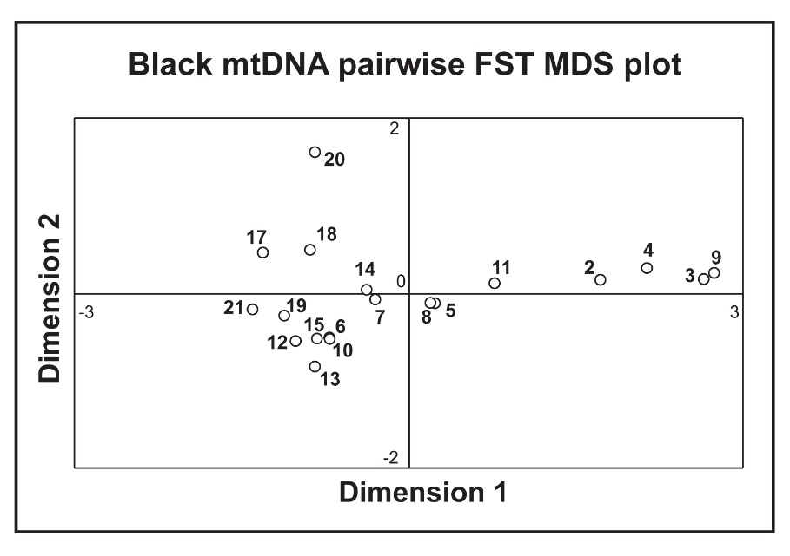
Supplemental Figure 2. Principal component analysis using genotypic data from six microsatellite loci for black rockfish populations. Shows a genetic break between Alaskan pops and continental pops. F_{ST}=0.021, 95% C.I. 0.011-0.030 among these regions.

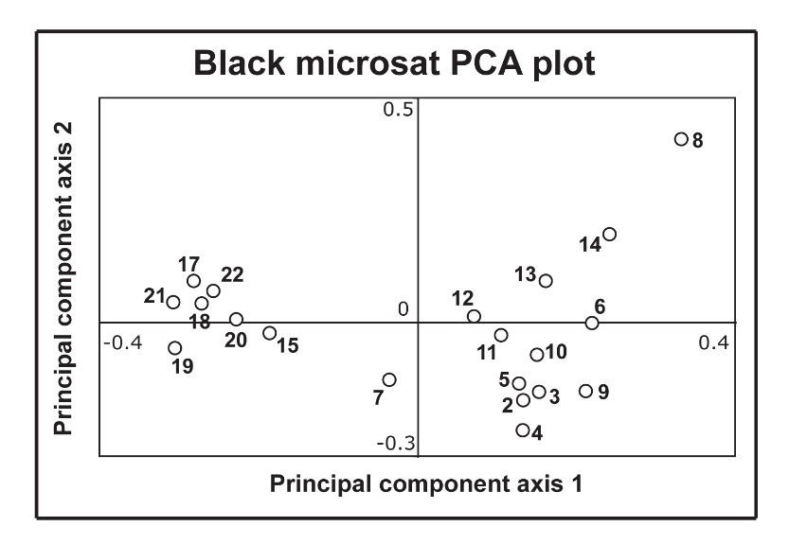

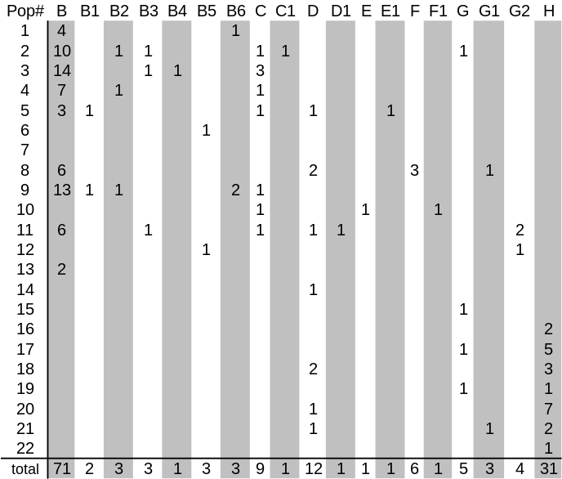
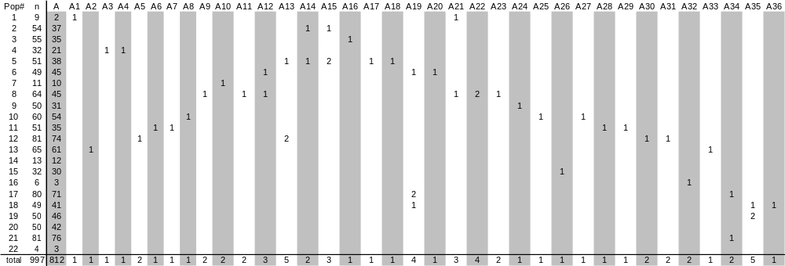
Supplemental Table 1. Number of haplotypes observed in black rockfish collections.

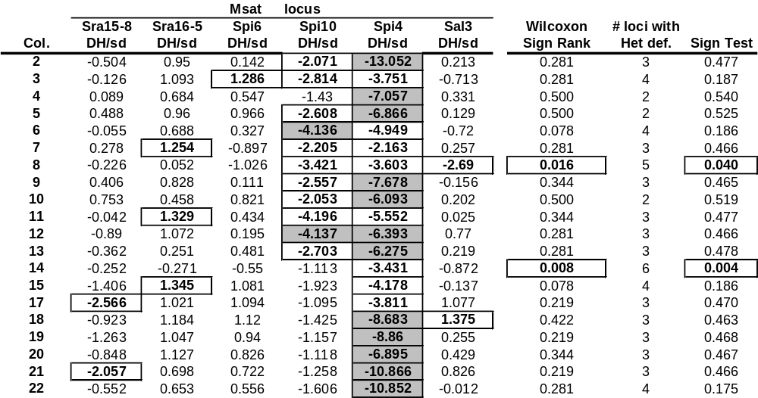
Supplemental Table 2. Observed versus expected heterozygosity across black rockfish collections based on a TPM model of microsatellites.

