Supplementary Information for
Pressure dependence in aqueous-based electrochemical CO₂ reduction
Liang Huang, Ge Gao, Chaobo Yang, Xiao-Yan Li, Rui Kai Miao, Yanrong Xue, Ke Xie, Pengfei Ou, Cafer T. Yavuz, Yu Han, Gaetano Magnotti,† David Sinton,† Edward H. Sargent,† Xu Lu†

Correspondence to: Email: Xu Lu (xu.lu@kaust.edu.sa); Edward H. Sargent (ted.sargent@utoronto.ca); David Sinton (sinton@mie.utoronto.ca); Gaetano Magnotti (gaetano.magnotti@kaust.edu.sa)
This PDF file includes:
Materials and Methods
Supplementary Figs. 1 to 20
References (1-12)
Materials and Methods
Electrodes preparation
Metal electrodes were prepared using galvanostatic electrodeposition in a three-electrode setup using an electrochemical workstation (BioLogic SP-150 Potentiostat). Commercial Cu foam (MTI Corporation, 99.9%, 0.30 mm thick) or carbon paper (Toray 120, Fuel Cell Store, 0.30 mm thick) was used as the working electrode. An Ag/AgCl electrode (CH Instruments, saturated KCl) was used as the reference electrode, and a Pt foil (Tianjin Aida Hengsheng Technology Development Co., Ltd, > 99.99%, 1 cm × 1 cm) was used as the counter electrode. All chemicals and reagents were used as received without further purification.
For the Cu electrode, a piece of Cu foam (1 cm × 2 cm) was washed by acetone (Sigma-Aldrich, ≥ 99.5%), ethanol (Sigma-Aldrich, ≥ 99.8%), 0.5 M HCl (Sigma-Aldrich, 37%), and deionized water (Millipore, 18.2 MΩ cm) successively, each for 5 mins under sonication. The Cu foam was then electrochemically anodized in 1.0 M KOH (Sigma-Aldrich, ACS reagent) for 20 mins at 10 mA cm⁻² to obtain Cu(OH)₂ nanowire arrays. Finally, the sample was electrochemically reduced in 0.5 M KHCO₃ (Macklin Inc., ≥ 99.9%) for 20 mins at -5 mA cm⁻² to form the Cu electrode. For Cu/PPy electrode, the aforementioned Cu(OH)₂ nanowire arrays were further anodized in 0.1 M pyrrole (Alfa Aesar, > 98.0%) and 0.01 M KOH for 2 mins at 5.0 mA cm⁻², followed by being reduced in 0.5 M KHCO₃ for 20 mins at -5 mA cm⁻² (Supplementary Fig. 17a).
For the Au electrode, the dendritic Au nanoparticles (Supplementary Fig. 3a) were formed on carbon paper (1 cm × 2 cm) through galvanostatic electrodeposition for 20 mins at -5.0 mA cm⁻². The electrolyte solution consisted of (i) 50 mM HAuCl₄ (Alfa Aesar, 99.9%) dissolved in 0.1 M H₂SO₄ (Sigma-Aldrich, 95.0-98.0%) as the Au precursor and (ii) 0.15 mM Pluronic F-127 (Innochem Co., Ltd., average molecular weight ~10,000) as the structure-directing agent.
For the Ag electrode, the dendritic Ag nanoparticles (Supplementary Fig. 3b) were formed on carbon paper using the same protocol as the Au electrode, except for the electrolyte solution. The electrolyte solution was 50 mM AgNO₃ (Sigma-Aldrich, ≥ 99.0%) dissolved in 0.4 M NH₃·H₂O (Sigma-Aldrich, 28.0-30.0% NH₃ basis) and 0.15 mM Pluronic F-127.
For Sn electrode, the hierarchical flake-like Sn nanoparticles (Supplementary Fig. 3c) were formed on carbon paper using the same protocol as the Au and Ag electrodes, except for the electrolyte solution. The electrolyte solution was 50 mM SnCl₂ (Innochem Co., Ltd., 99%) dissolved in 0.4 M Na₄P₂O₄ (Sigma-Aldrich, ≥ 95.0%) and 0.15 mM Pluronic F-127.
Material characterization
Scanning electron microscopy (SEM) images were collected using FEI Quanta 600 FEG ESEM operated at 15 kV. Transmission electron microscopy (TEM) images were acquired using FEI Tecnai G² Spirit Twin operated at 120 kV. High-resolution TEM (HRTEM), scanning TEM (STEM), and electron energy loss spectroscopy (EELS) were performed by FEI Titan 80-300 equipped with a field emission gun and spherical aberration corrector operated at 300 kV. EELS mapping was collected using a post-column filter in diffraction mode. X-ray photoelectron spectroscopy (XPS) was operated using Kratos Analytical AMICUS/ESCA 3400 equipped with an Mg-anode Kα excitation x-ray source (hν = 1253.6 eV) at 10 kV, 10 mA, and 2×10⁻⁶ Pa. The measured binding energies were calibrated based on C 1s binding energy at 284.8 eV. X-ray powder diffraction (XRD) was carried out using the Bruker D8 Advance with a Cu Kα radiation. Fourier transform infrared (FTIR) spectroscopy was performed using the Thermo Scientific Nicolet 6700 FTIR spectrometer.
High-pressure H-cell
The customized two-compartment high-pressure H-cell (Fig. 1a and Supplementary Fig. 8c) was made of Teflon-lined titanium. The two compartments were separated by a proton exchange membrane (Nafion 117, Fuel Cell Store). Each compartment contained 120 mL of 0.5 M KHCO₃ aqueous solution with a gas headspace < 15 mL, and was connected to an independent pressure regulator. The working electrode (1 cm × 0.5 cm) and reference electrode (Ag/AgCl with saturated KCl, Gaoss Union) were placed inside the cathode compartment, and the counter electrode (Pt foil, 1 cm × 2 cm) was placed inside the anode compartment. A small hole (diameter < 0.5 mm) was drilled on the top of the reference electrode to balance its internal and external pressure. Prior to the tests, electrolytes in each compartment were first purged for 5 mins using the feed gas (99.995% CO₂ or its mixture with 99.999% Ar, Air Liquide), and then saturated with the feed gas by stirring for 30 mins to reach equilibrium under the desired pressure (from 1 to 50 bar). The pressure of the two compartments were kept identical. The gas products in the headspace of the cathode compartment were sampled using 10 mL air-tight syringes from an outlet relief valve, and then injected into a gas chromatograph (GC) system.
Ambient-pressure gas-fed flow cell
The customized ambient-pressure gas-fed flow cell comprised three compartments made of poly(methyl methacrylate) (PMMA): a gas compartment with serpentine channel, a catholyte compartment, and an anolyte compartment (Supplementary Fig. 8a). The size of each compartment was 0.5 cm (height) × 0.5 cm (width) × 1 cm (length). The working electrode was housed between the gas and catholyte compartments, with the catalyst layer facing the catholyte. An Ag/AgCl electrode (saturated KCl) and a RuO₂/Ti foam (Gaoss Union, 1.5 cm × 1.5 cm) were used as the reference and counter electrode, respectively. The anolyte and catholyte compartments were separated by a Nafion 117 membrane. 0.5 M KHCO₃ electrolytes were supplied to the catholyte and anolyte compartments and recirculated at a constant flow rate of 10 mL min⁻¹ using a peristaltic pump (Longer Pump, BT100-2J). CO₂ was delivered to the gas compartment at a constant flow rate of 20 sccm using a mass flow controller (Cole-Parmer, Masterflex Proportional Flowmeter Controller), and the gas effluents were extracted for detection by GC.
High-pressure narrow-gap aqueous flow cell
The high-pressure narrow-gap aqueous flow cell was assembled by stacking the following components in order: a Cu/PPy cathode sandwiched by two polytetrafluoroethylene (PTFE) gaskets (0.03 cm thick with a 0.5 cm × 1 cm window as the reactive area) as the catholyte compartments, a Nafion 117 membrane, and a RuO₂/Ti foam anode sandwiched by two aforementioned PTFE gaskets as the anolyte compartments (Fig. 5a and Supplementary Fig. 19a). 1.0 M KHCO₃ catholyte and 0.5 M K₂SO₄ anolyte saturated with 50 bar CO₂ were supplied to the catholyte and anolyte compartments, respectively, and recirculated at a flow rate of 5 mL min⁻¹ using a high-pressure constant flow pump (Sanotac, SP6010).
Electrochemical measurements
All electrochemical measurements were conducted using an electrochemical workstation (BioLogic SP-150 Potentiostat) at room temperature. Cathode potentials in three-electrode systems (H-cells and gas-fed flow cell) were recorded with iR compensation and converted to the reversible hydrogen electrode (RHE) scale using the following equation:
E_{RHE} = E_{Ag/AgCl} + 0.197 V + 0.059 × pH.
Full-cell voltages of the high-pressure narrow-gap aqueous flow cell were measured using the chronopotentiometry method. The currents were normalized to the geometric area of the working electrodes.
Product analysis
Gas products were analyzed using a GC (Trace 1310, Thermo Scientific) equipped with Molecular Sieve 5A and Porapak N columns. Ar (Al Khafrah Industrial Gases, 99.999%) was used as the carrier gas. CO, CH₄, C₂H₄, C₂H₆, C₃H₆, and C₃H₈ were quantified using a flame ionization detector (FID) with a methanizer. H₂ was quantified using a thermal conductivity detector (TCD). The volumes of gas products were derived from the output peak areas based on calibration curves.
Liquid products were analyzed by a ¹H NMR (Bruker, 600 MHz) using water suppression method. Each liquid sample was prepared by mixing 490 µL of the electrolytes with 110 µL of the internal standards (20 ppm of dimethyl sulfoxide in D₂O).
The Faradaic efficiency (FE) of a specific product (p) was calculated using the following equation:
$${FE}_{p }\left(\%\right)=\frac{z×n×F}{Q}×100\%$$
where z denotes the number of the electrons transferred to one p molecule, n represents the total moles of the product, F is the Faradaic constant (F = 96,485 C mol⁻¹), and Q indicates the total number of electrons transferred. The partial current density toward p was determined by:
j_{p} = j_{total} × FE_{p}.
Operando Raman spectroscopy
The schematic of the custom-built operando Raman system is illustrated in Supplementary Fig. 9. The high-pressure H-cell was placed on a mechanical sample stage. The excitation source was a 532 nm continuous-wave narrow-band laser (Coherent, Inc. Verdi G18) with a maximum power of 18 W. The laser was highly focused by a spherical convex lens (focus length f = 500 mm) in the probing region and transmitted along the cathode surface. To locate the cathode surface (x = 0 µm), we first moved the sample stage until the laser beam was cut by the cathode, and then moved the sample stage backward until the laser beam fully appeared. The species concentrations against the distance from the cathode surface were acquired by controlling the sample stage for line scan. The Raman signal was collected by a Nikon micro lens (f = 105 mm, F#2.8) through the perpendicular window of the cathode compartment (Fig. 1a, Supplementary Figs. 8c and 9) and collimated by a digital single-lens reflex (DSLR) prime lens (Samyang, f = 135 mm, F#2.2). The combination of a 532 nm notch filter with a half-wave plate (HWP) and a wire grid polarizer was placed in the collimated beam to filter out the Rayleigh signal and stray light background. The beam was then rotated by 90º and passed through the slit of an astigmatism-free spectrometer (Princeton Instrument Isoplane 320). The design of the spectrometer avoided the bowing effect and allowed the integration along the spatial direction without degrading the spectral resolution. An electron multiplication charge-coupled devices (EMCCD) camera (Princeton Instruments, ProEM:1600 200) imaged the Raman signal with a 0.01 nm per pixel dispersion along the spectral direction. Full binning along the laser propagation direction and 1 s exposure time were applied to ensure a high signal-to-noise ratio¹. The spatial resolution along the laser propagation was about 8.6 mm, and the resolution along the vertical direction was around 50 μm.
As depicted in Supplementary Fig. 10, some Raman peaks of the key species (HCO₃⁻, HCOO⁻, and dissolved CO₂) overlapped. We therefore employed a hybrid fitting and calibration method to rigorously convert the areas under the Raman peak to concentrations. First, the Raman spectra were acquired for standard aqueous solutions of KHCO₃, HCOOK, and dissolved CO₂ with known concentrations (Supplementary Fig. 11). Taking HCOOK as an example, the spectra of its ν₂ and v₅ bands at a concentration of 0.4 M were fitted with the summation of the corresponding Voigt functions (Supplementary Fig. 12a), which settled the parameters of the center wavelength, Raman line shape, and area ratio of the two bands. Then, we fitted the spectra of 0.025, 0.05, 0.1, 0.2 and 0.3 M HCOOK based on the as-obtained parameters and set the peak area as the free parameter. In this way, the relationship between the area of fitted function and the HCOO⁻ concentration was established (Supplementary Fig. 13a). Following the same procedure, we can quantify the concentrations of other species in the vicinity of the cathode surface.
Theoretical methods
All density functional theory (DFT) calculations were performed by the Vienna ab initio simulation program (VASP)^{2,3}. The core-valence interactions were calculated by the project augmented wave (PAW) method with 450 eV as the cut-off energy^{4,5}. The generalized gradient approximation in the Perdew–Burke–Ernzerhof functional (GGA-PBE) was applied to describe the exchange-correlation correction effect⁶. The DFT-D3 method was used to consider the dispersion correction of the van der Waals force⁷. For the geometry optimization, the self-consistent iteration must reach 10⁻⁶ eV for the energy convergence and 0.01 eV Å⁻¹ for the force convergence.
The (3 × 3) Cu(111) model consisted of four Cu atomic layers, where the two bottom layers were fixed to mimic the bulk material and all other degrees of freedom were relaxed. The vacuum space was about 15 Å in z-axis. The k-points was set to be 3 × 3 × 1⁸. CO₂* coverages of 1/9, 2/9, and 3/9 monolayer (ML) were applied to calculate the reaction free energy of CO₂R. A water layer consisting of six water molecules covering the Cu(111) was created to calculate the activation energy barrier from CO₂ to COOH* and HCOO*. The climbing image nudged elastic band (CI-NEB) method was used to search for the minimum energy path⁹⁻¹¹.
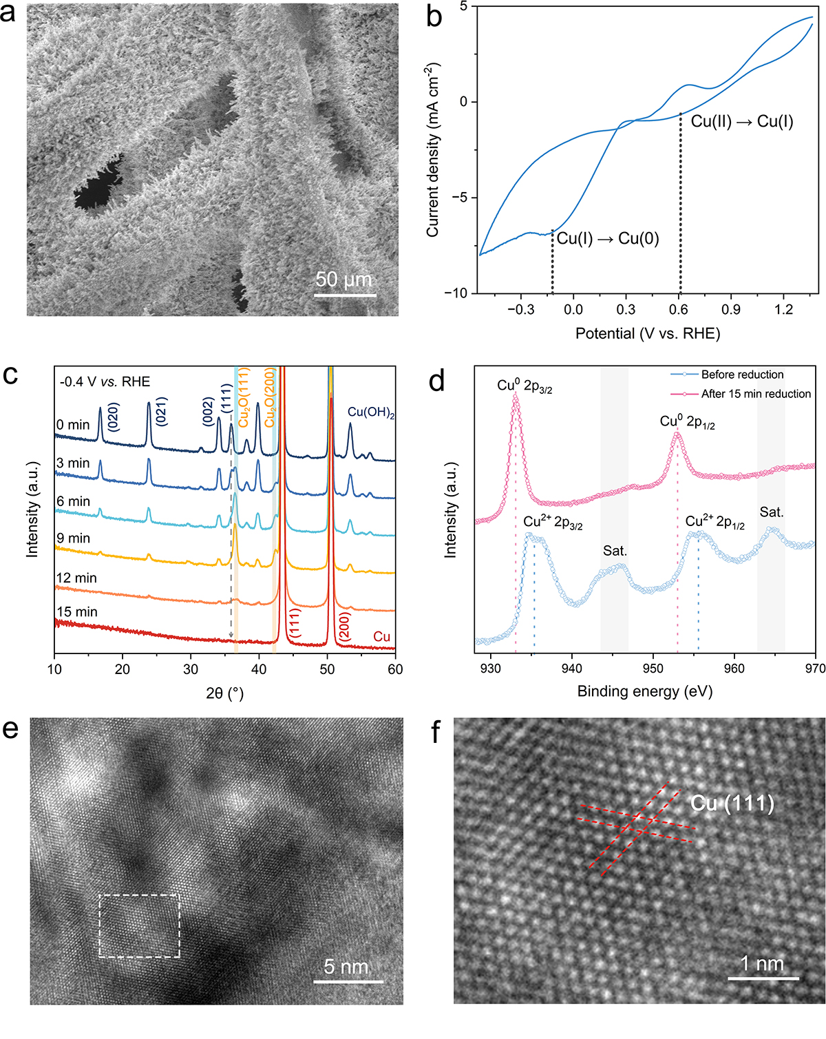
Supplementary Fig. 1 (a) SEM image of the as-prepared Cu catalyst. (b) Cyclic voltammogram of Cu(OH)₂ in Ar-saturated 0.5 M KHCO₃ aqueous solution with a scan rate of 50 mV s⁻¹. Two reduction peaks can be observed, corresponding to the Cu(II) → Cu(I) → Cu(0) process under reduction conditions¹². (c) Time-resolved operando XRD patterns of the catalyst showing its transition from Cu(OH)₂ to Cu at -0.4 V vs. RHE. (d) Cu 2p XPS spectra of the catalyst before and after the 15 min electroreduction in (c), confirming the transition from Cu(OH)₂ to Cu. (e) TEM image of the as-prepared Cu catalyst, indicating that the Cu crystals are highly crystalline. (f) Enlarged HRTEM image of the square-enclosed area in (e).

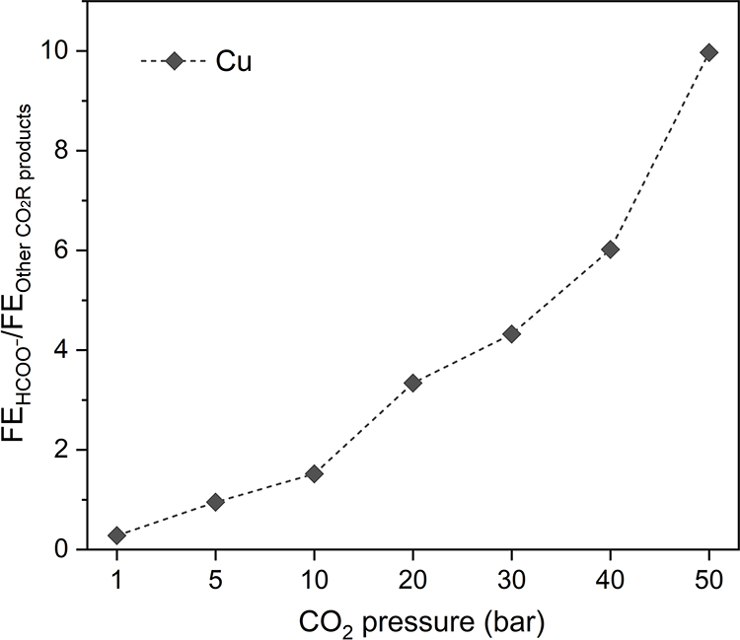
Supplementary Fig. 2 FE ratios of formate to other CO₂R products on the Cu catalyst under different pressures at -1.1 V vs. RHE.

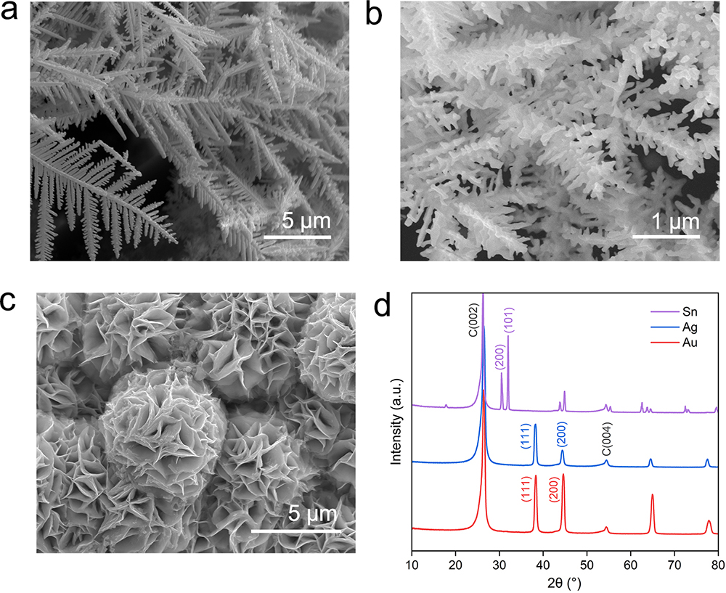
Supplementary Fig. 3 SEM images of the as-prepared (a) Au, (b) Ag, and (c) Sn catalysts. (d) XRD patterns of the as-prepared Au, Ag, and Sn catalysts.

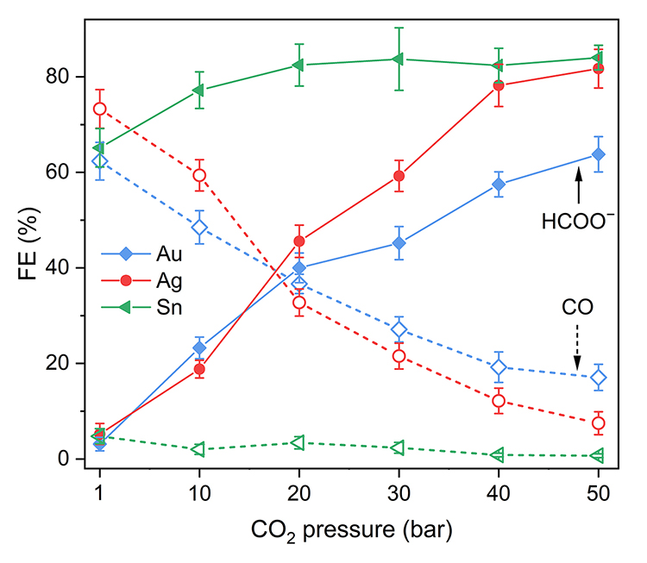
Supplementary Fig. 4 FEs toward formate and CO on Au, Ag, and Sn catalysts under different pressures at -1.1 V vs. RHE.

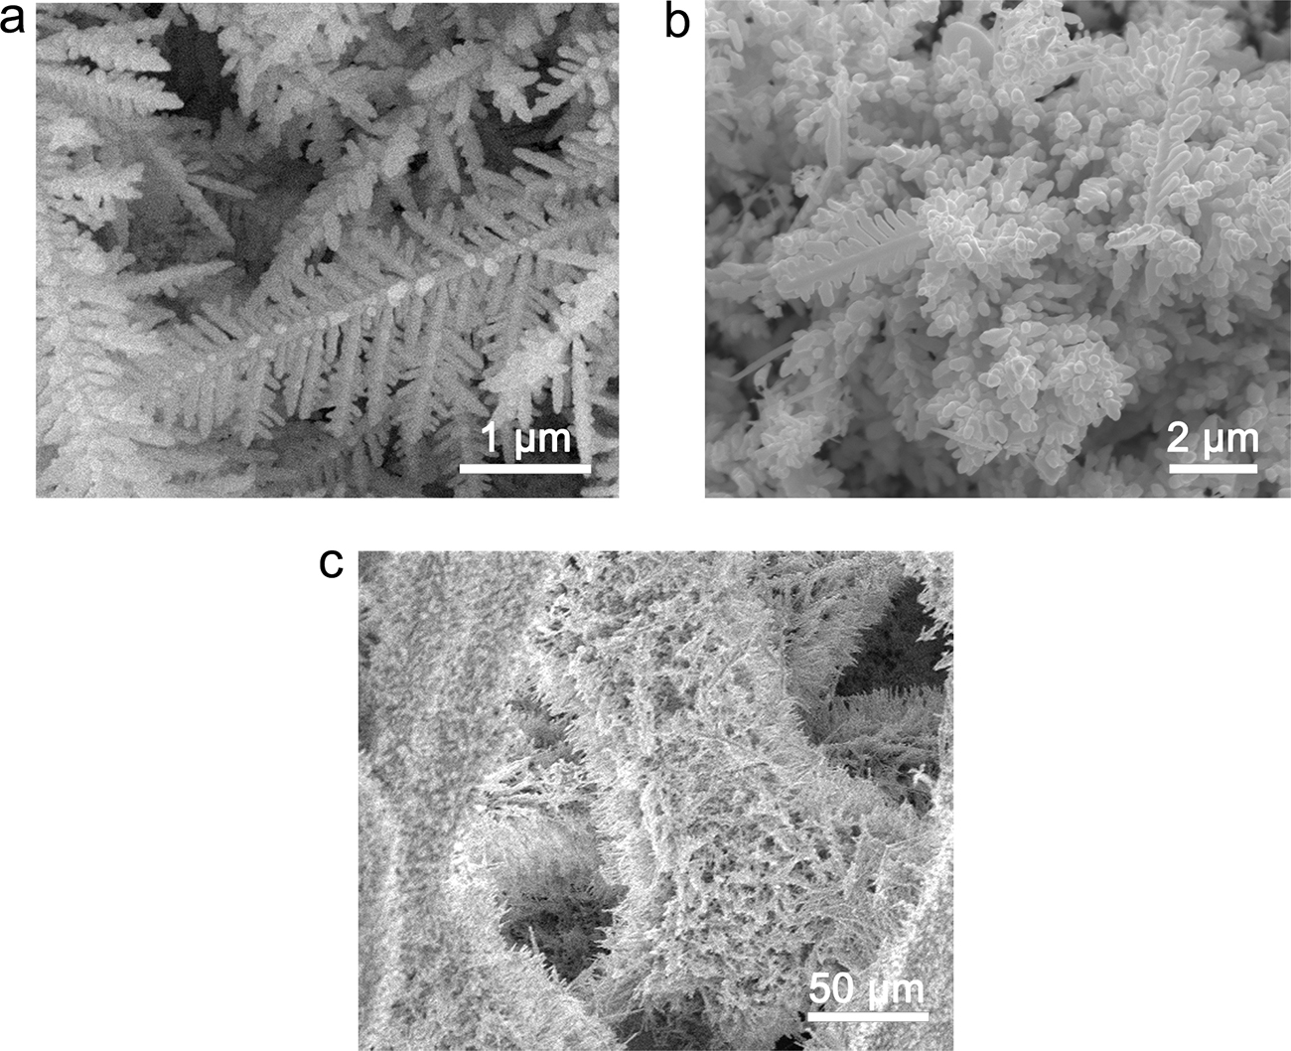
Supplementary Fig. 5 SEM images of (a) Au, (b) Ag, and (c) Cu catalysts after 1 h CO₂ electrolysis at -1.1 V vs. RHE under 50 bar.

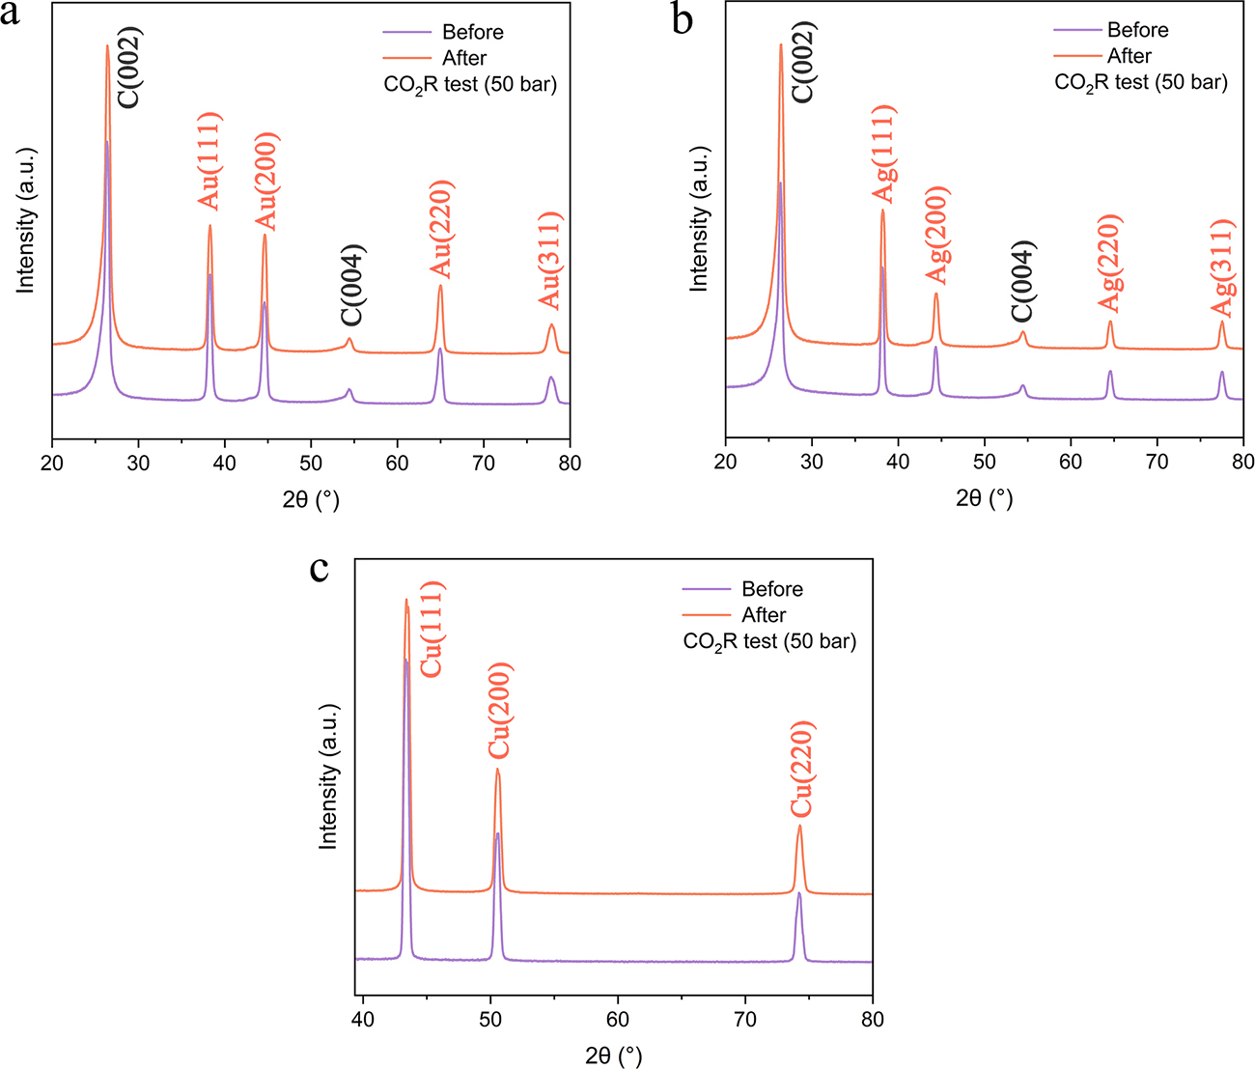
Supplementary Fig. 6 XRD patterns of (a) Au, (b) Ag, and (c) Cu catalysts before and after 1 h CO₂ electrolysis at -1.1 V vs. RHE under 50 bar.

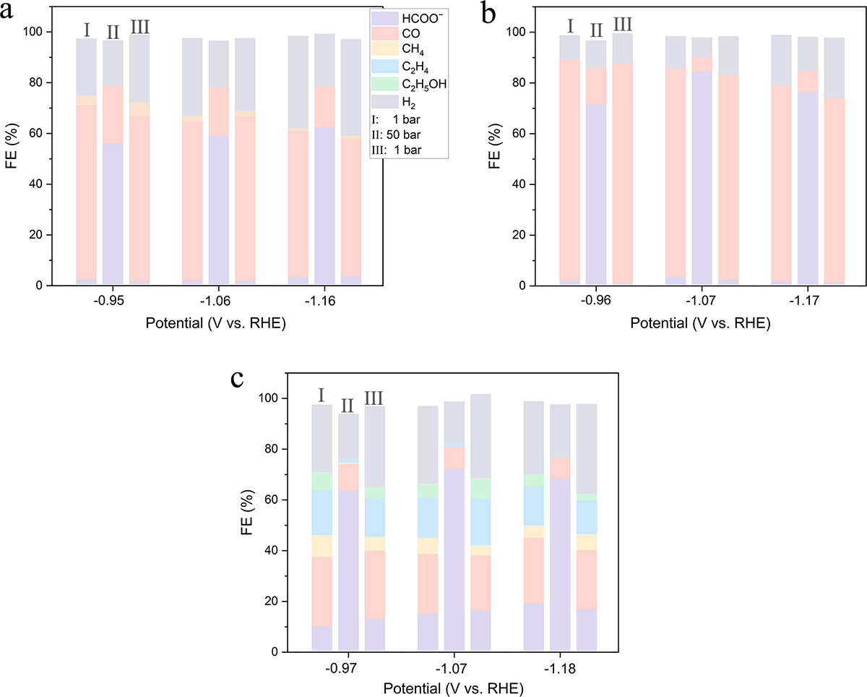

Supplementary Fig. 7 FEs toward CO₂R products and H₂ on (a) Au, (b) Ag, and (c) Cu catalysts that were successively operated under 1 bar, 50 bar, and 1 bar at cathode potentials ranging from -0.95 to -1.18 V vs. RHE.

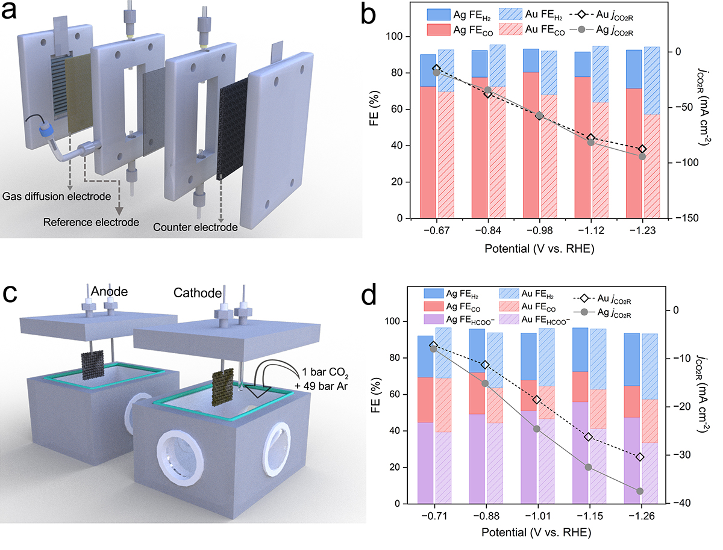
Supplementary Fig. 8 (a) Schematic of the ambient-pressure gas-fed flow cell. (b) FEs toward CO and H₂, and CO₂R partial current densities on the Au and Ag catalysts in the flow cell described in (a). (c) Schematic of the high-pressure H-cell filled with 50 bar CO₂/Ar mixture (1 bar CO₂ and 49 bar Ar). (d) FEs toward formate, CO and H₂, and CO₂R partial current densities on the Au and Ag catalysts in the H-cell described in (c).

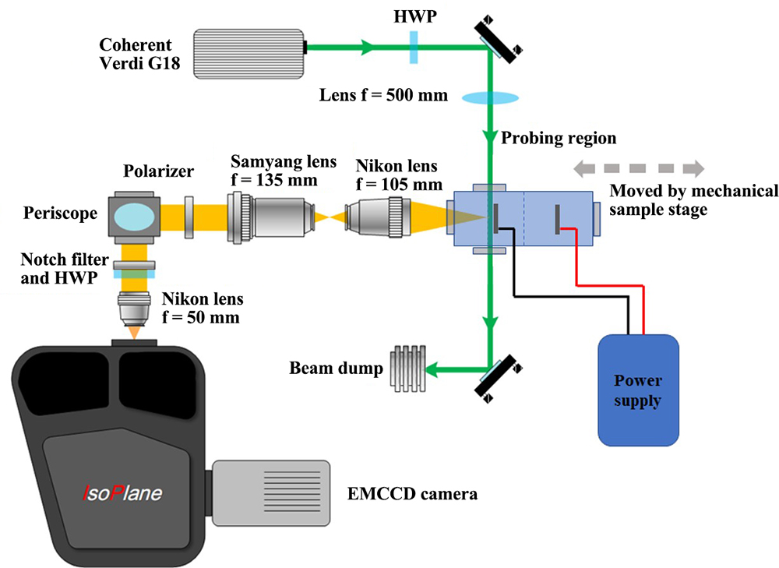
Supplementary Fig. 9 Schematic of the custom-built operando Raman system with the high-pressure H-cell.

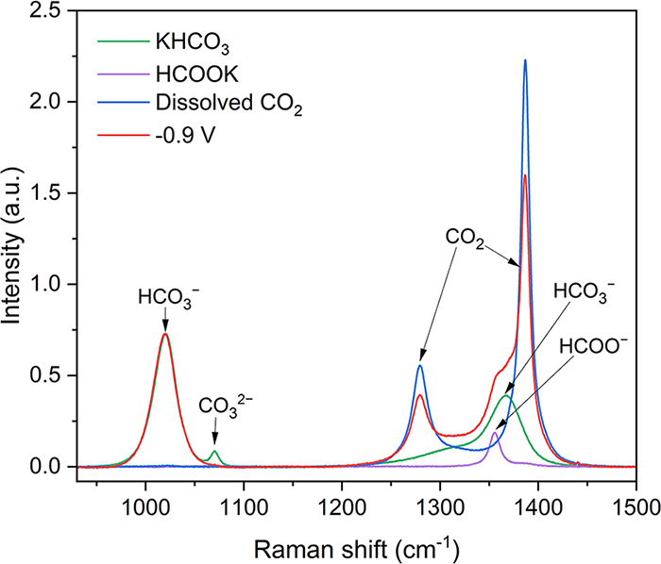
Supplementary Fig. 10 Operando Raman spectrum acquired on the Cu surface at -0.9 V vs. RHE under 50 bar, and the Raman spectra of KHCO₃ (0.5 M), HCOOK (0.05 M), and dissolved CO₂ (50 bar) in aqueous solutions.

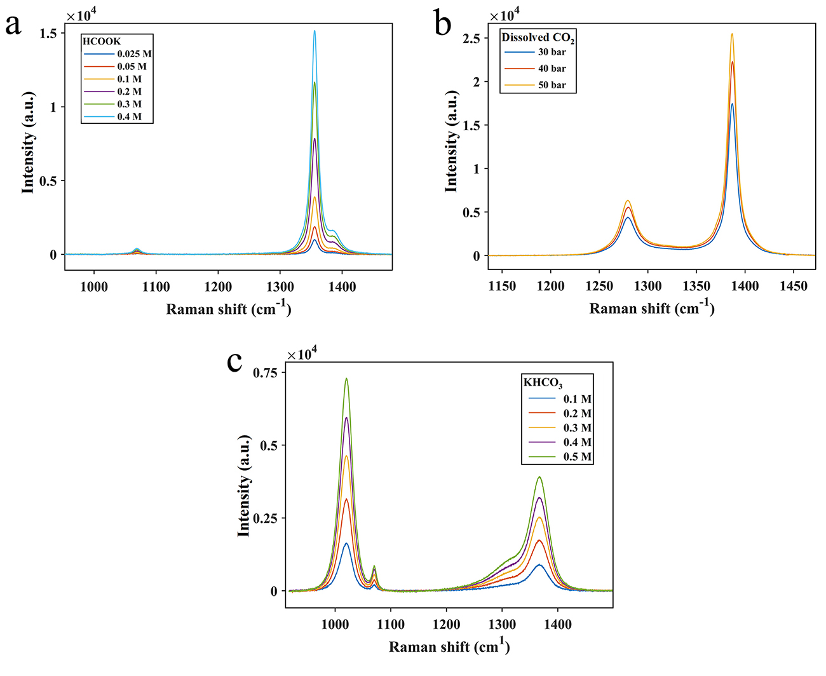
Supplementary Fig. 11 Raman spectra of (a) HCOOK, (b) dissolved CO₂, and (c) KHCO₃ aqueous solutions with various concentrations.

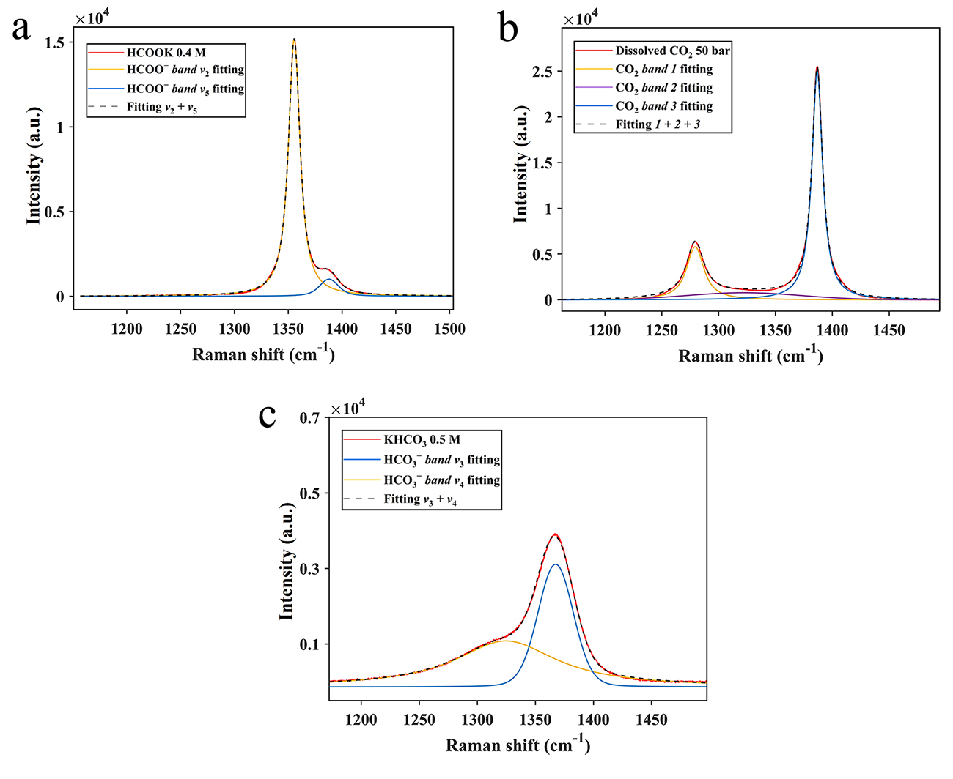
Supplementary Fig. 12 Band assignments and fitting curves for (a) HCOOK, (b) dissolved CO₂, and (c) KHCO₃ aqueous solutions with selected concentrations.

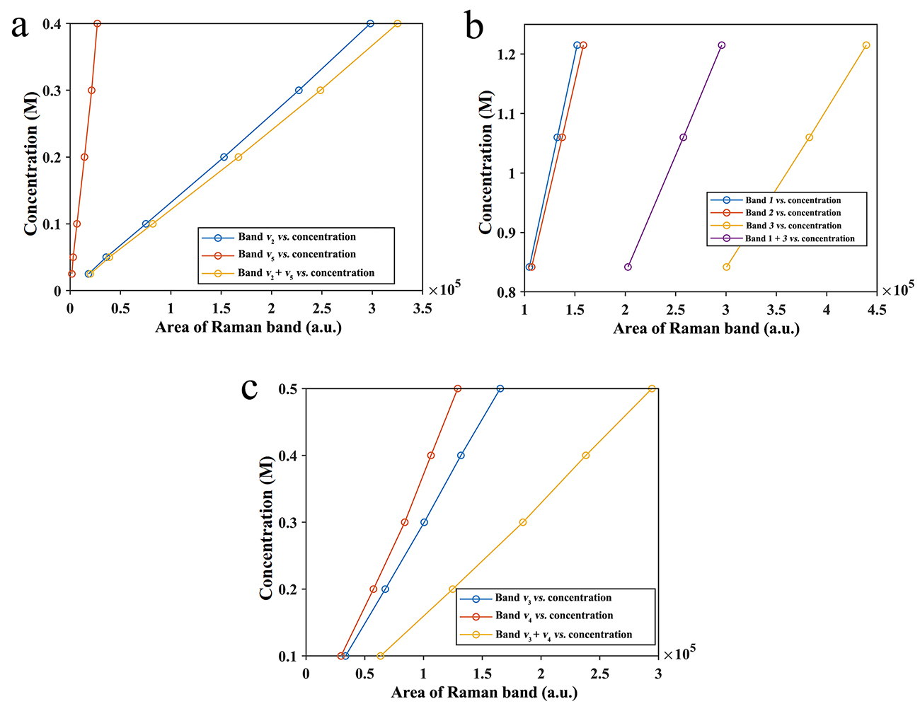
Supplementary Fig. 13 Calibration curves for (a) HCOO⁻, (b) dissolved CO₂, and (c) HCO₃⁻.

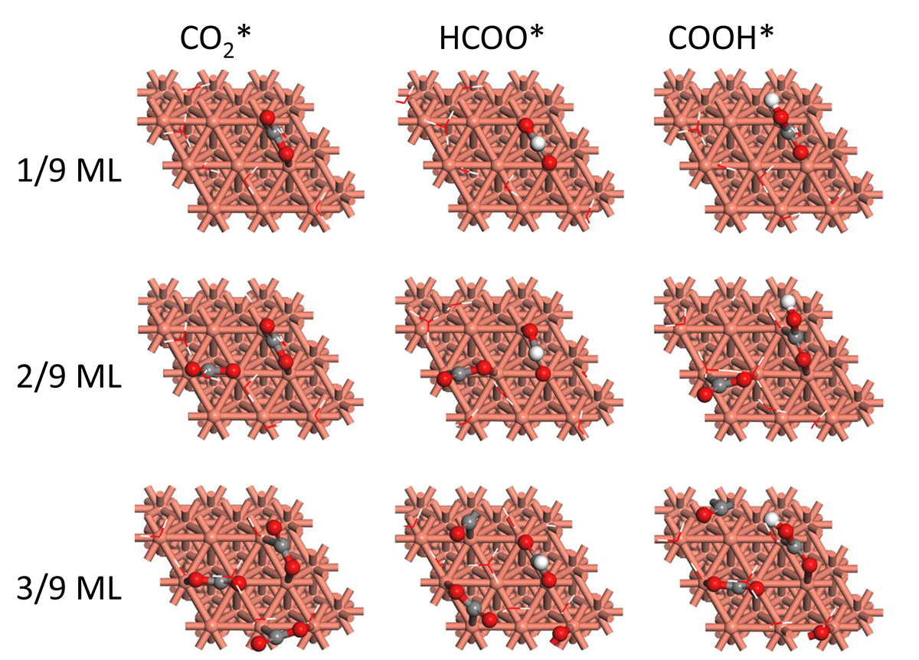
Supplementary Fig. 14 The most stable configurations for CO₂*, HCOO*, and COOH* adsorption with different CO₂* coverages. Red, O; white, H; grey, C. The water layer is depicted in stick model to clearly illustrate the intermediates.

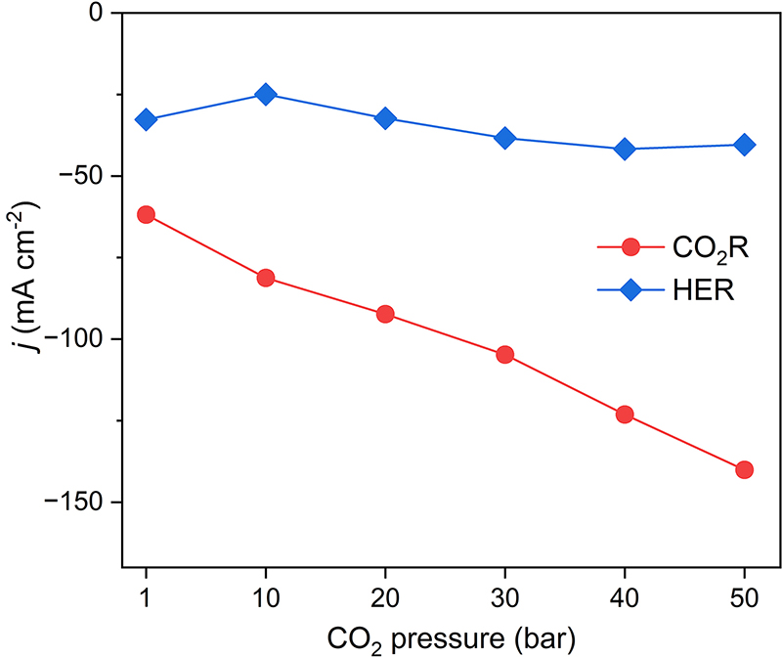
Supplementary Fig. 15 CO₂R and HER partial current densities on the Cu catalyst under different pressures at -1.1 V vs. RHE. The CO₂R reactivity increased significantly with higher pressure, whereas the HER reactivity remained largely the same. Therefore, the increase in OH⁻ production rate under high pressure was primarily attributed to CO₂R, instead of HER.

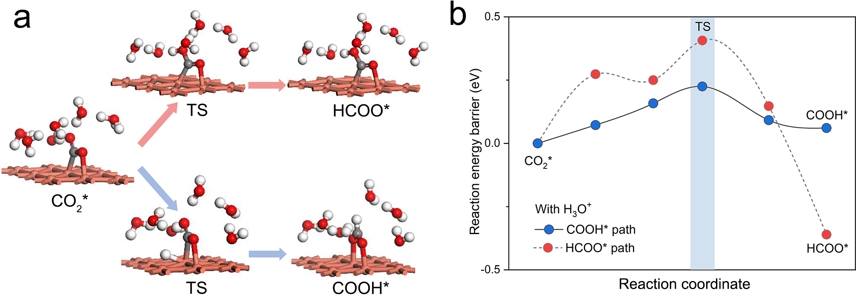
Supplementary Fig. 16 (a) DFT simulated atomic structures of initial, transition, and final states of CO₂R intermediates. (b) The activation energy barriers for CO₂* to HCOO* and COOH* pathways with hydronium ions in the water layer on the Cu(111) surface. Red, O; white, H; grey, C. The bottom three Cu layers are hidden for clear illustration.

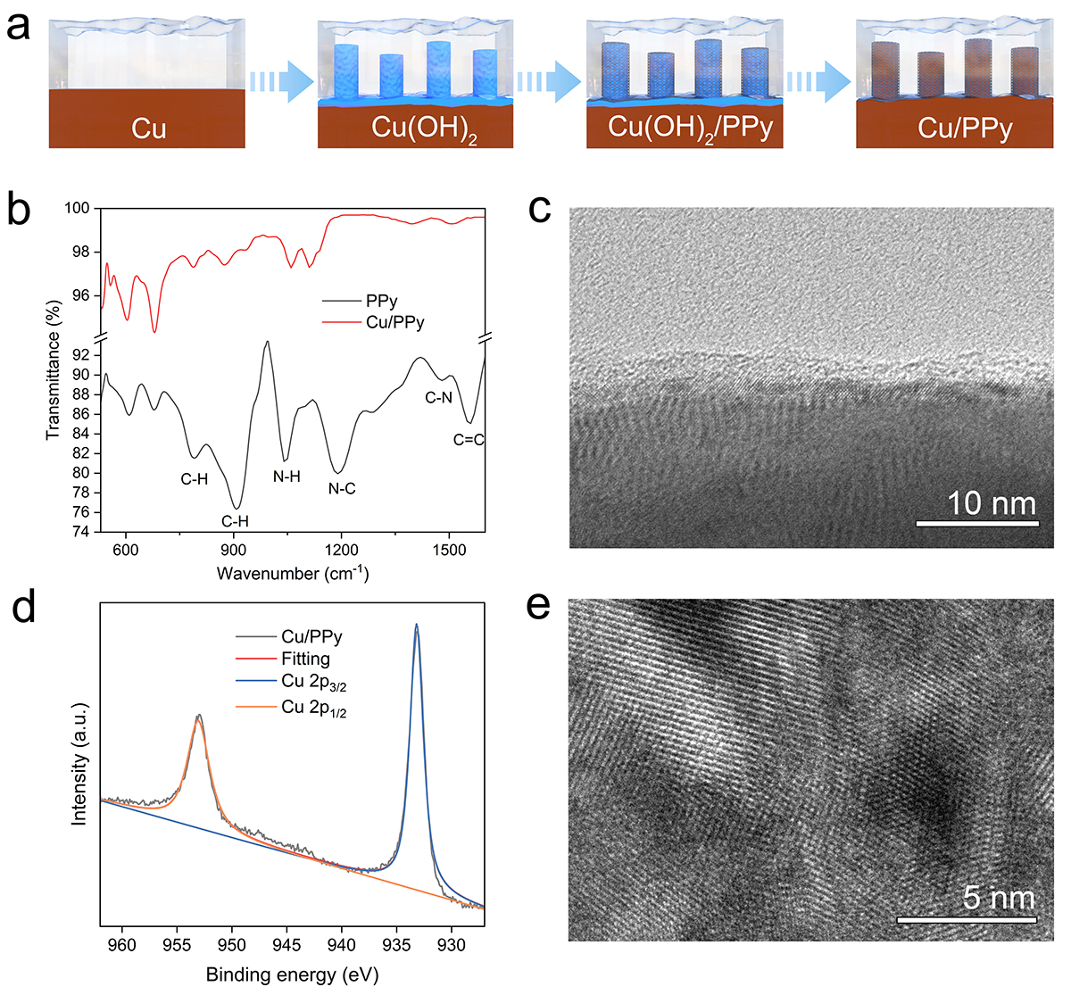
Supplementary Fig. 17 (a) Schematic illustration of the preparation of the Cu/PPy catalyst. (b) FTIR spectra of Cu/PPy and PPy. (c) TEM image, (d) deconvolution of Cu 2p XPS spectrum, and (e) HRTEM image of the Cu/PPy catalyst.

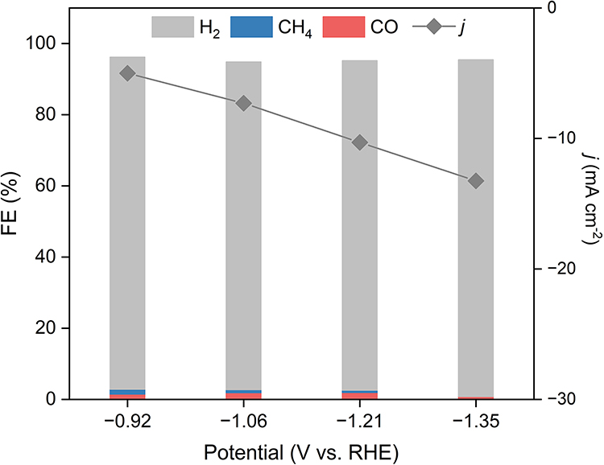
Supplementary Fig. 18 CO₂R performance on bare PPy in an ambient-pressure H-cell filled with CO₂ saturated 0.5 M KHCO₃ aqueous solution.

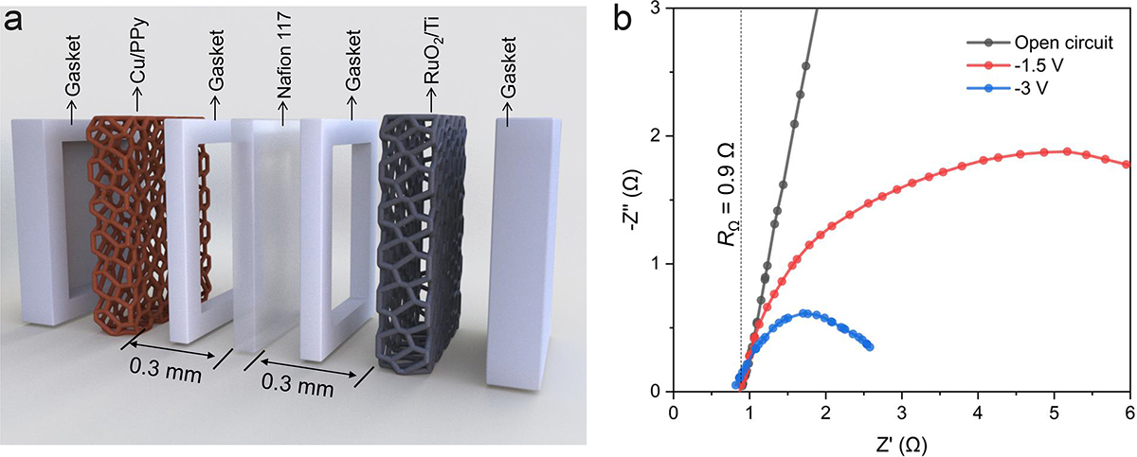
Supplementary Fig. 19 (a) Schematic and (b) electrochemical impedance spectroscopy (EIS) of the high-pressure narrow-gap aqueous flow cell.

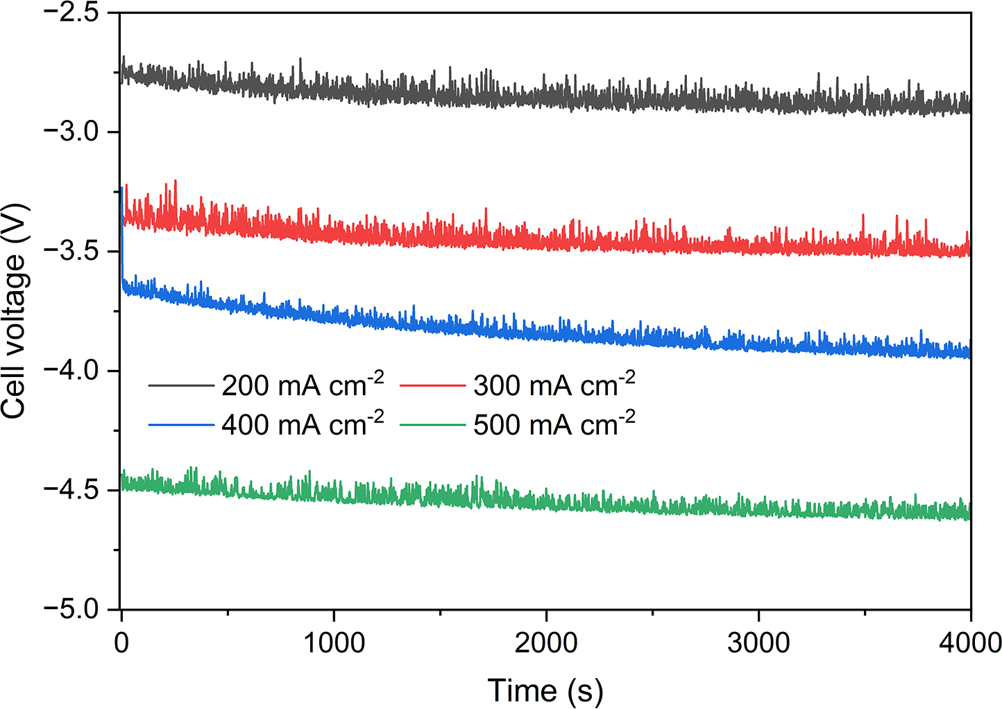
Supplementary Fig. 20 Chronopotentiograms at total current densities of 200, 300, 400 and 500 mA cm⁻² on Cu/PPy in the high-pressure narrow-gap aqueous flow cell fed by 50 bar PCO₂.

References
1. Yang, C., Tang, H. & Magnotti, G. High-speed 1D Raman analyzer for temperature and major species measurements in a combustion environment. Opt Lett 45, 2817-2820, (2020).
2. Kresse, G. & Hafner, J. Ab initio molecular dynamics for liquid metals. Phys. Rev., B Condens. Matter 47, 558-561, (1993).
3. Kresse, G. & Hafner, J. Ab initio molecular-dynamics simulation of the liquid-metal-amorphous-semiconductor transition in germanium. Phys. Rev., B Condens. Matter 49, 14251-14269, (1994).
4. Blochl, P. E. Projector augmented-wave method. Phys. Rev., B Condens. Matter 50, 17953-17979, (1994).
5. Kresse, G. & Joubert, D. From ultrasoft pseudopotentials to the projector augmented-wave method. Phys. Rev. B 59, 1758-1775, (1999).
6. Perdew, J. P., Burke, K. & Ernzerhof, M. Generalized gradient approximation made simple. Phys. Rev. Lett. 77, 3865-3868, (1996).
7. Grimme, S., Ehrlich, S. & Goerigk, L. Effect of the damping function in dispersion corrected density functional theory. J. Comput. Chem. 32, 1456-1465, (2011).
8. Monkhorst, H. J. & Pack, J. D. Special points for Brillouin-zone integrations. Phys. Rev. B 13, 5188-5192, (1976).
9. Yu, M. & Trinkle, D. R. Accurate and efficient algorithm for Bader charge integration. J. Chem. Phys. 134, 064111, (2011).
10. Henkelman, G., Uberuaga, B. P. & Jónsson, H. A climbing image nudged elastic band method for finding saddle points and minimum energy paths. J. Chem. Phys. 113, 9901-9904, (2000).
11. Sheppard, D., Xiao, P., Chemelewski, W., Johnson, D. D. & Henkelman, G. A generalized solid-state nudged elastic band method. J. Chem. Phys. 136, 074103, (2012).
12. Li, J. et al. Electroreduction of CO₂ to formate on a copper-based electrocatalyst at high pressures with high energy conversion efficiency. J. Am. Chem. Soc. 142, 7276-7282, (2020).

