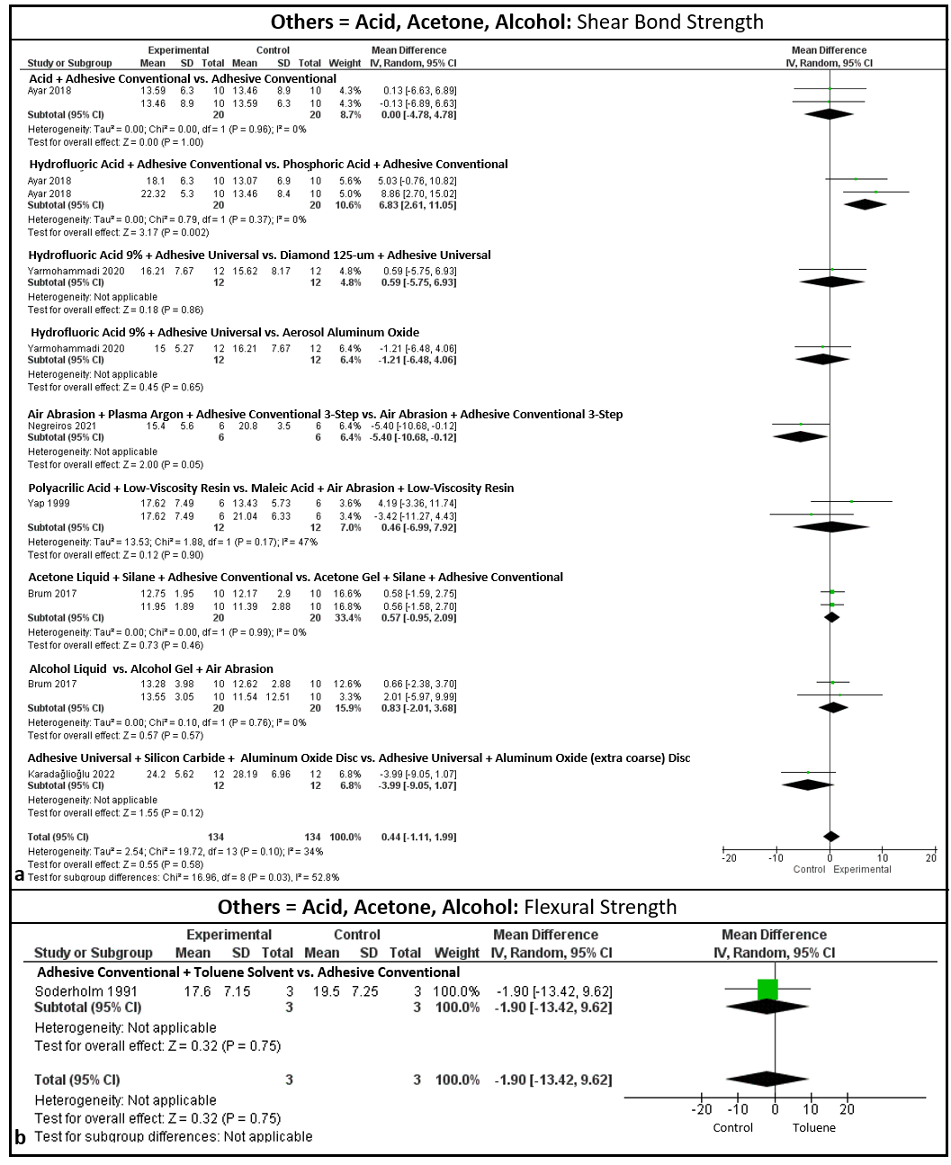
Fig. supplementary 5 Results of the analysis of the use of the different treatments: In "a" for shear test, only hydrofluoric acid before the conventional 2-step adhesive system that presented adhesion statistical (P<0,05) compared to the use of phosphoric acid and the conventional adhesive system of 2 steps. And the combination of air abrasion, argon plasma and conventional 3-step adhesive resulted in (P=0.05)

