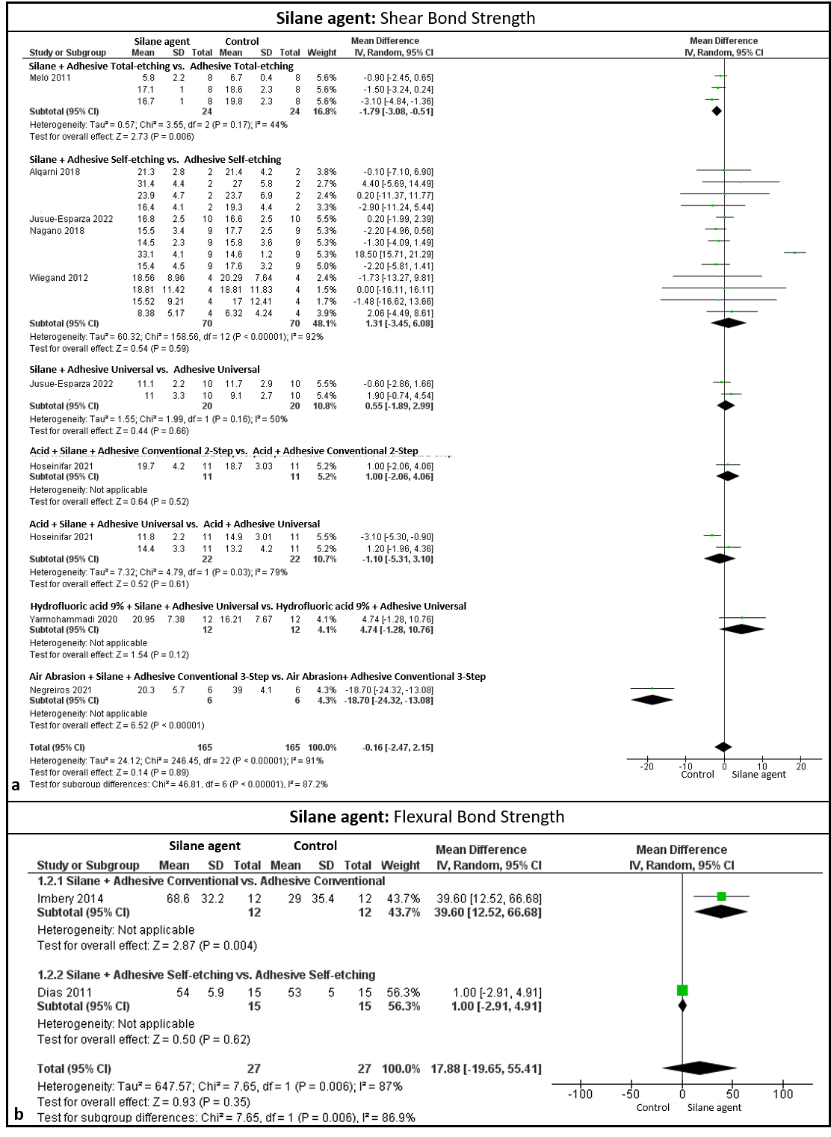
Fig. supplementary 1 Results of analysis of the use of silane agent: For the shear bond strength test, figure "a" the silane did not result in statistical adhesion, on the contrary, in some cases like using the silane before the total adhesive etching and before the conventional adhesive, the control group without the silane resulted in a statistical value (P<0.05). Already in figure "b" with the results of the flexural strength test resulted in a statistical difference (P<0.05) when using the silane before the conventional adhesive compared to its control

