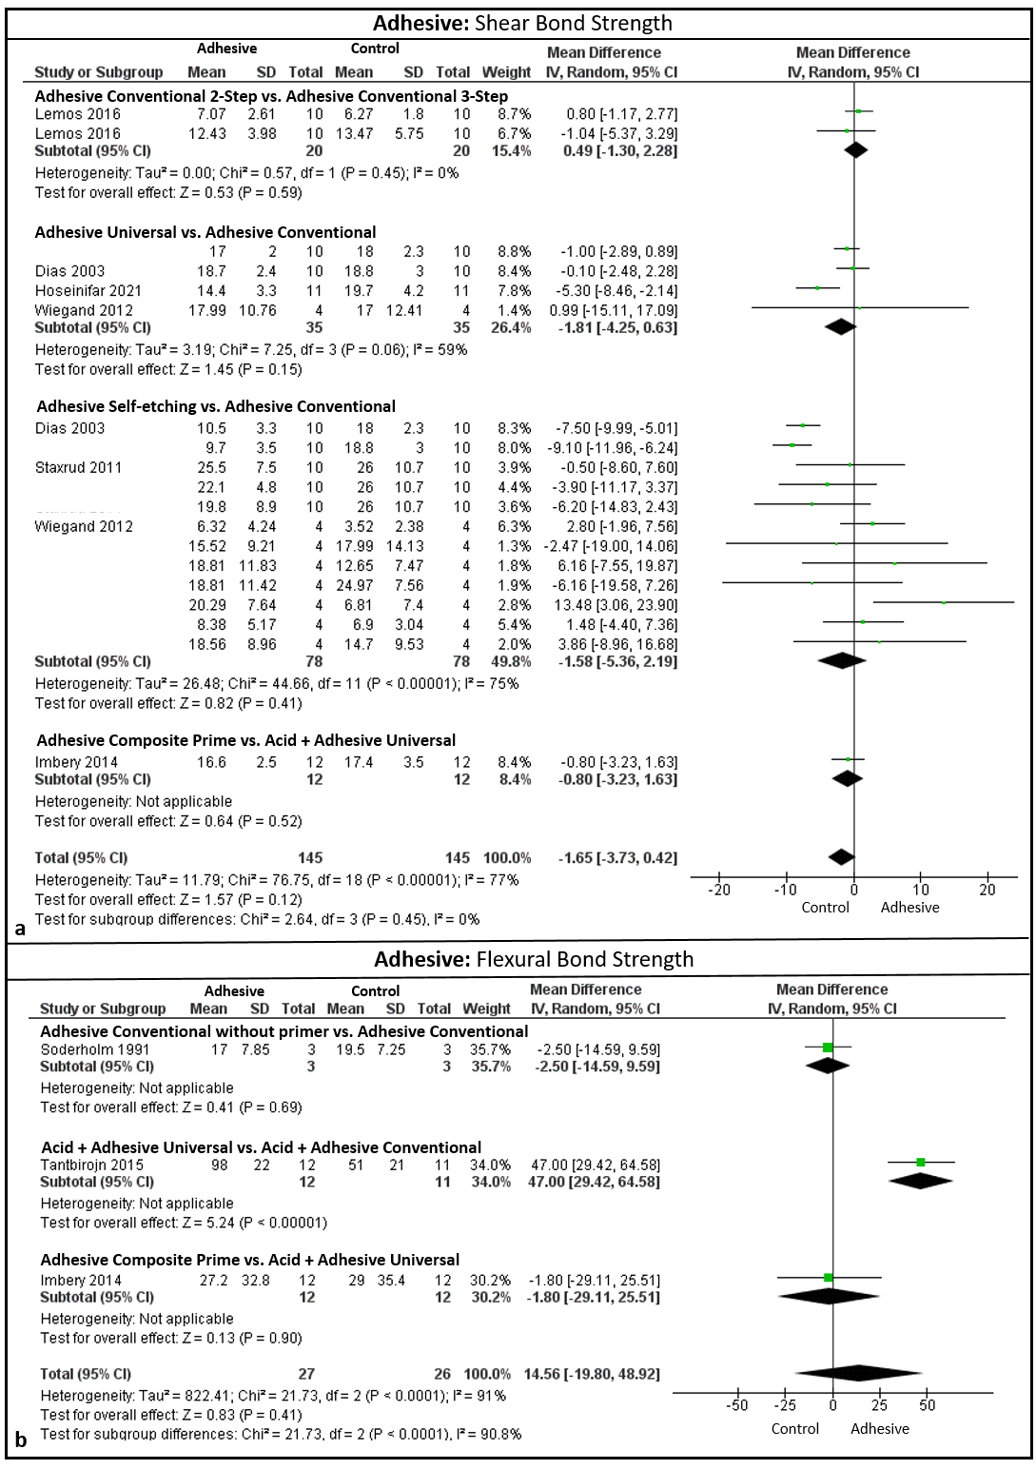
Fig. supplementary 3 Results of the analysis of the use of adhesive systems: In "a" the shear bond strength test, no treatment was shown to be superior to another. In "b" the flexural bond strength test only using the phosphoric acid and universal adhesive obtained statistically higher BSV compared to the conventional 3-step adhesive (p<0.05)

