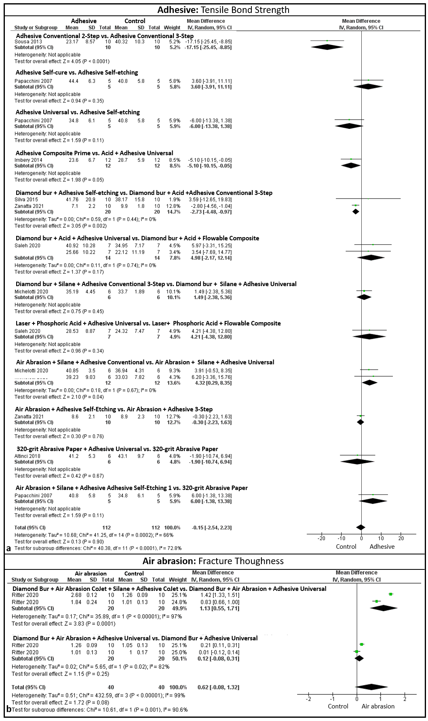
Fig. supplementary 4 In "a" results of the analysis of the use of adhesive systems for the tensile test: the comparisons that resulted in a significant difference were, the conventional 3-step adhesive (p<0.05), the universal adhesive (p=0.05), the use of diamond bur, phosphoric acid and conventional adhesive (p<0.05), and using the conventional 3-step adhesive after air abrasion and silane (p<0.05). In "b" the fracture thoughness test for air abrasion is evaluated: silane (P<0.05) associated with diamond bur + air abrasion + adhesive resulted in statistical adhesion

